# Data Visualization

# Assignment 1 (Group 42)

## Exercise 1:

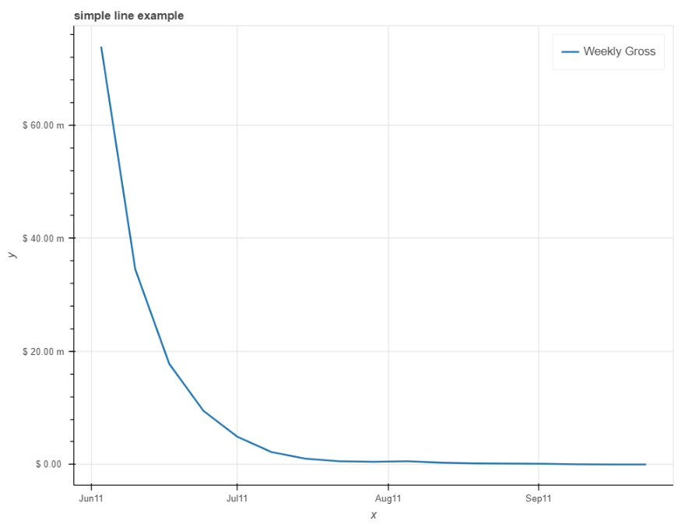

Figure 1 Data for x-men

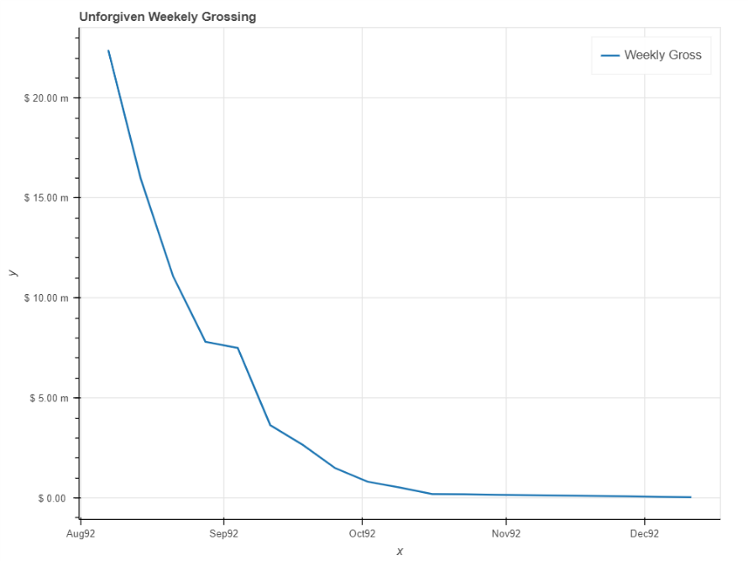

Figure 2 Data for Unforgiven

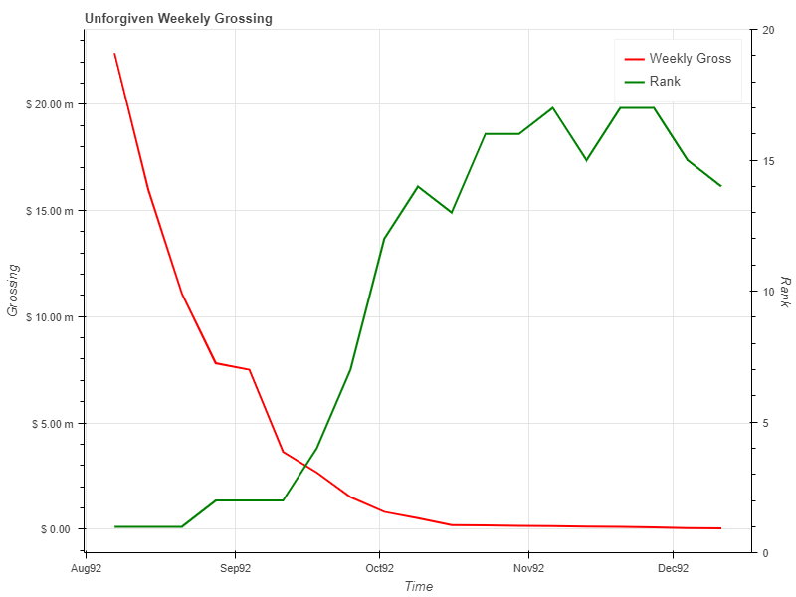

Figure 3 Data for Unforgiven

How is the weekly gross developing over time?

Ans - There is an exponential decrease in weekly grossing

Is there a correlation with the rank of the movie?

Ans - No we cannot see any correlation.

How long does the movie stay in the Top 10?

Ans - The movie stays in top 10 for about 2 months.

## Exercise 2:

## Exercise 3:

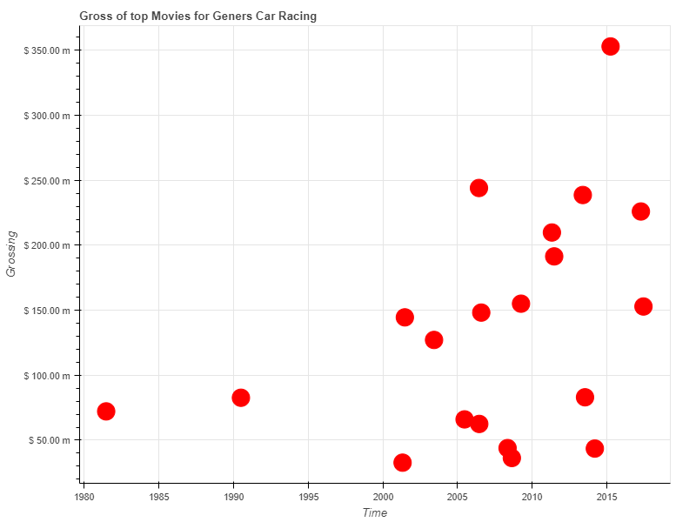

Figure 4 Data for Genre - Car Racing

Is there a time, when movies of your genre were very popular?

Ans - Yes after 2005 the movies in this Genre were very popular.

Which movie of your genre made the highest gross (when and how much)?

Ans - Furious 7 in 2015 with gross above 350 million dollars

How likely is it that a film from this genre becomes a great financial success?

Ans – It is very likely that the film in this genre be a financial success with an average grossing of about 150 million dollars.