Requirements Model
The requirements for an application are summarized by creating a model of the uses of the system. The UML construct used for this model is the use case developed by Jacobson [JCJO92] and discussed in Chapter 2. Figure 1 is an abbreviated version of the text format used for a use case Figure 2 shows the UML use case diagram for the Brickles example and Figure 4 through Figure 9 show the use case text descriptions. The use case diagram captures relationships between the use cases. Individual use cases are broken into “sub-use cases” using the uses and extends relationships. Later, in Chapter , we will use these relationships to structure the system test cases. The text descriptions captures the majority of the information for each use case. While the relationships are used to structure tests, the text descriptions are used to provide most of the information for a test case.

Use Case # 001
Actor: Player
Use Scenario: The user selects the PLAY option from the menu. The system responds by starting a game.
Alternative Paths: If a game is already in progress, the selection is ignored.
Exceptional Cases: If the game can not open the display, an error message is displayed and the program aborts.
Frequency: Low
Criticality: High
Risk: Medium
Figure 1 Example use case

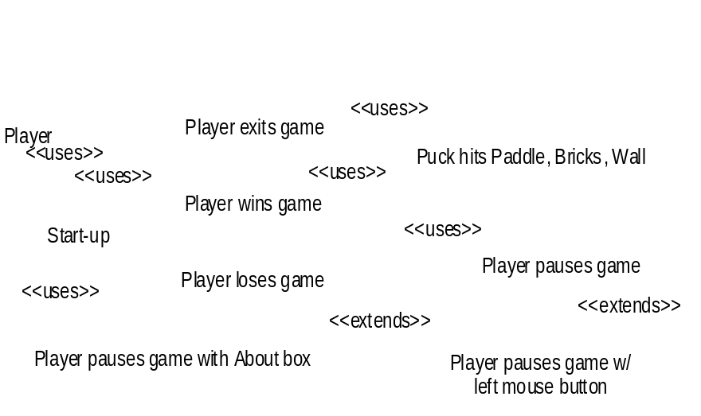
Figure 2 Brickles use case model.

Criteria | Interpretation for Requirements
Completeness | The use cases represent all of the functionality needed for a satisfactory product. No use case is included that is not required functionality.
Correctness | Each use case accurately represents a requirement.
Consistency | Any system functionality is specified in the same manner everywhere it is described.
Figure 3 Criteria for requirements inspection.
Acceptance testing often finds faults that result from problems with the requirements. The typical problems include missing requirements (an incomplete requirements model), requirements that contradict each other (an inconsistent model), and scenarios in which the system does not behave as the client intended (an incorrect model). Many of these problems can be identified much earlier than the acceptance test phase using guided inspection.
The criteria for evaluating the models is interpreted specifically for the Requirements Model in Figure 3. Completeness is a typical requirements problem for which the iterative, incremental process model is a partial solution. Guided inspection can offer further help by requiring a detailed examination by an independent group of domain experts and product definition people. This examination will identify many missing requirements much earlier than previously.
The detailed examination will also search for correctness faults. The act of writing the test cases for the guided inspection will identify many requirements that are not sufficiently precise to allow a test case to be written. Running the test cases will provide an opportunity for the independent group to identify discrepancies between the expected results in the test cases and the actual content of the requirements model.
The larger the system the more problem there is with consistency of the requirements. In addition to contradictions, there is often the need to identify places where one use case supersedes another. For example, one use case calls for an action to happen at least within ten seconds while another expects the same action to occur within seven seconds. The use of the end-to-end scenarios that trace a complete action will help locate these inconsistencies.
One feature of the requirements model, that affects how the inspection is organized, is that there is no UML model on which the requirements are based. So comparisons to the basis model refer to documents produced by marketing, system engineering or client organizations. Since this is a notorious source of defects, we will expend extra effort in verifying the requirements model.

Use Case # 001
Actor: Player
Use Scenario: The player starts the Brickles executable, plays the game and then selects the EXIT option on the FILE menu.
Alternative Paths:
Exceptional Cases:
Frequency: Low
Criticality: High
Risk: Low
Figure 4 Example use case #1
Use Case # 002
Actor: Player
Use Scenario: The player starts the Brickles executable, plays the game, breaks all of the bricks and wins the game.
Alternative Paths:
Exceptional Cases:
Frequency: Medium
Criticality: High
Risk: Medium
Figure 5 Example use case #2.
Use Case # 003
Actor: Player
Use Scenario: The player starts the Brickles executable, plays the game, loses all of the pucks and loses the game.
Alternative Paths:
Exceptional Cases:
Frequency: Medium
Criticality: High
Risk: Medium
Figure 6 Example use case #3.
Use Case # 004
Actor: Player
Use Scenario: The puck bounces against the paddle, breaks some bricks, hits a wall
Alternative Paths:
Exceptional Cases:
Frequency: High
Criticality: High
Risk: Medium
Figure 7 Example use case #4.
Use Case # 005
Actor: Player
Use Scenario: The player pauses the game by holding the left mouse button down.
Alternative Paths:
Exceptional Cases:
Frequency: Low
Criticality: Low
Risk: Medium
Figure 8 Example use case #5.
Use Case # 006
Actor: Player
Use Scenario: The player pauses the game by selecting the About.... menu entry.
Alternative Paths:
Exceptional Cases:
Frequency: Low
Criticality: Low
Risk: Medium
Figure 9 Example use case #6.
The roles for this inspection are assigned as shown in Figure 10
Domain Expert | Domain Expert, Marketing Representative, Client, Product Definition personnel
Tester | System Tester, Domain Expert
Developer | System Engineer
Figure 10 Roles in requirements inspection.
You will want to adapt these to your situation. The domain expert role provides the “correct” answers for test cases. In this case that means agreeing or disagreeing that a use case adequately represents the required functionality. Using the system testers in the tester role provides them an early look at the source of their test cases for the system and input into improving those use cases. We also use a second group of domain experts and product definition people to work with the system testers. This provides a source of scenarios that is independent of the people who wrote the requirements. Some organizations will have the use cases written by developers rather than a separate organization of system engineers and these developers will be the ones to execute test cases.
Tip | When dividing the domain experts into two groups, don’t divide based on ideology. That just precipitates theoretical debates. Divide the experts so that each team has representation from as many “camps” as possible.

The basic outline of “testing” the requirements model is given below along with an example using Brickles. The example is given in italics.

- Develop the ranking of use cases by computing the combined frequency and criticality information for the use cases. gives the ranking for Brickles.

- Determine the total number of test cases that can be constructed given the amount of resources available. It should be possible to estimate this number from historical data. We will assume we have time for fifteen test cases.
- Ration the tests based on the ranking. Figure 11 gives the numbers for Brickles. Note that only fourteen of the fifteen are assigned since it is impossible to evenly split the number of tests. The fifteenth test would be allocated to the category showing the most failures in the initial round of testing.
- Write scenarios based only on the knowledge of those in the domain expert’s role. The number of scenarios is determined by the values computed in Step 3. The Player starts the game, moves the paddle and has broken several bricks when he loses the puck. The system responds by providing a new puck.
- In a meeting of the producers of the requirements and the test scenario writers, the writer presents each scenario and the requirements modelers identify the use case that contains the test scenario as either a main scenario, extension, exception or alternative path that represents the scenario. If no match is found, it is listed as an incompleteness defect. If the scenario could be represented by two or more use cases (on the same level of abstraction), this is an inconsistency defect. In both of these cases, the first question asked is whether there is an incorrectness defect in the statement of a use case that if corrected would handle the scenario accurately. In the scenario provided in step 4 there is no mention of the limited number of pucks. The system may not be able to provide a puck if the supply is exhausted. The requirement should be explicit about a fixed number of pucks.
Use | Frequency | Criticality | Combined Value | Rank | Number of Test Cases
start Brickles | medium | high | high | 1 | 3
pause Brickles | low | low | low | 3 | 1
stop Brickles | medium | low | medium | 2 | 2
break brick | high | high | high | 1 | 3
wins | medium | high | high | 1 | 3
loses | medium | low | medium | 2 | 2

Figure 11 Brickles use cases.

Much of this effort will be reused in the testing of other models below. The ranking of use cases and construction of test cases will both produce reusable assets. The requirements model will serve as the basis for testing several other models and therefore these test cases can be reused.
Analysis Models
We will be concerned with two types of analysis models: domain and application analysis models. These two are both analysis models so they both are modeling existing knowledge. One models the knowledge in a domain while the other models knowledge about the product.
Domain Analysis Model
The domain analysis model represents information about a domain of knowledge that pertains to the application about to be constructed. As such, it is derived from the literature and knowledge about the domain as opposed to another UML model. Although many projects are satisfied with creating a domain model that is only a simple class diagram, most domains encompass standard algorithms and many refer to states that are characteristic of the concepts being represented. Figure 12 shows the interpretation of the evaluation criteria for a domain model.

Criteria |  | Interpretation for Domain Modeling
Completeness |  | The concepts are sufficient to cover the scope of content specified. Sufficient detail is given to describe concepts to the depth required.
Correctness |  | The descriptions of domain concepts are accurate, the algorithms will produce the expected results.
Consistency |  | Model elements should be consistent with the company’s definitions and meanings.
Figure 12 Criteria for Domain Model Inspection
The domain model is a representation of the knowledge in a domain as seen through the eyes of a set of domain experts. As is to be expected, there can be differences of opinion between experts. For this reason, we have found it useful to divide the available set of experts into two groups. One group, the larger, creates the domain model while the second group serves as the testers of that model. In Figure 13, group one is referred to as the developers and group two is referred to as both testers and domain experts. This check and balance between the groups provides a thorough examination of the model.
Figure 14 relates portions of the class diagram from the domain models for Brickles to its application analysis model. Note that there are two domains represented, Interactive Graphics and Games. The test cases for this model will come from the second group of domain experts. They consider how these concepts are used in typical applications with which they have had experience. The test cases will be written by a team composed of a system tester, who knows how to write test cases, and the second group of domain experts. A test case only states details down to the level of the domain concepts. Any actions are domain algorithms.

Role in Model Inspection |  | Role in Project
Domain Expert |  | Domain Expert
Tester |  | System Tester, Domain Expert
Developer |  | Domain Expert
Figure 13 Roles in Domain Model Inspection

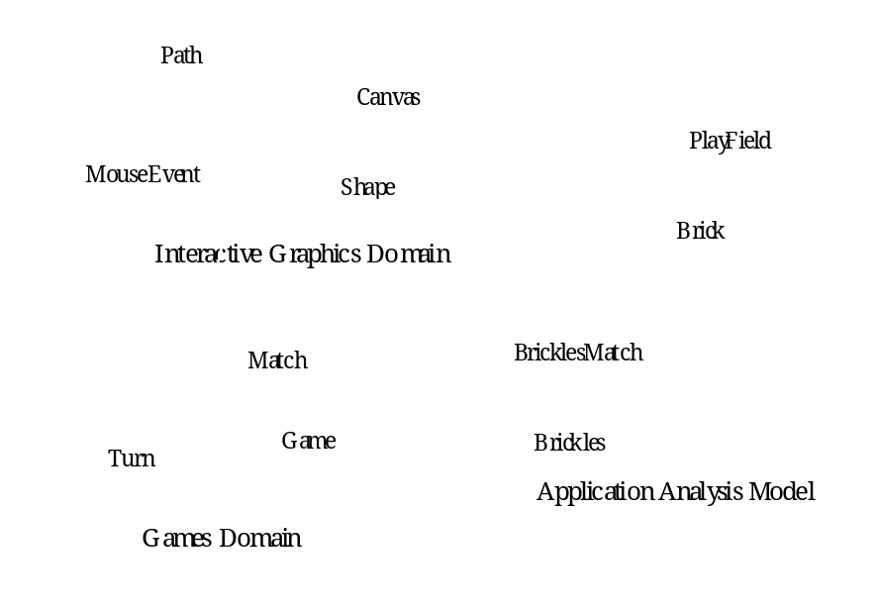
Figure 14 Mapping domain models onto application analysis model
A test case for the Interactive Graphics domain model would look like the following:
Assume that a canvas has been created and asked to display a shape. How will the canvas know where to locate the shape? It is expected that a mouseEvent would provide the coordinates to which a system user points.
Application Analysis Model
There will usually be multiple domain models for a large project. All of these contribute to the single application analysis model. Many parts of each domain model will be thrown away because they are outside the scope of this particular project. Some pieces of domain models will be merged to provide a single element in the application model. This makes judging completeness during the inspection more difficult since there is not a direct mapping from one model to another.
An analysis model can be too complete. That is, it can contain design information that the project team has erroneously made part of the requirements. This leads to an overly constrained design that may not be as flexible as possible. As the inspection team measures the test coverage of the model, they examine pieces that are not covered to determine whether they should be removed from the model.
Figure 2.13 shows the class diagram for the Application Analysis model for Brickles

Criteria |  | Interpretation for Application Analysis Model
Completeness |  | The ideas expressed in each use case can be represented by the concepts and algorithms in the model. No design information is included in the model.
Correctness |  | Experts agree with the attributes and behaviors assigned to each concept; on the steps in each algorithm; major states for each conceptual entity
Consistency |  | Where there are multiple ways to represent a concept of action, those ways are equivalent
Figure 15 Criteria for Application Analysis Model Inspection
Role in Inspection |  | Role in Project
Domain Expert |  | Domain Expert; System Engineer
Tester |  | System Tester
Developer |  | Application Developer
Figure 16 Roles in Application Analysis Model Inspection
.
A test case for the Application Analysis Model would look like the following:
Assume that a Match has been started and the PlayField has been constructed. How will a Paddle prevent a Puck from striking the Floor Boundary? It is expected that the Paddle will move into the trajectory of the Puck and collide with it. The collision will cause the Puck to change direction reflecting off the Paddle at a 90 degree angle to that of impact.
Design Models
There are three levels of design in an object-oriented project: architectural, mechanistic and detailed. We will focus on two basic design models that encompass those three levels: the architectural design model and the detailed class design model. The architectural model provides the basic structure of the application by defining how a set of interfaces are related. It also specifies the exact content of each interface. The detailed class model provides the precise semantics of each class and identifies the architectural interface to which the class corresponds.
Architectural Model
The architecture model is the skeleton of the entire application. It is arguably the most important model for the application so we will go into a fair amount of detail in this section. This is the model in which the non-functional requirements are blended with the functional requirements. This provides the opportunity to use the scenarios as a basis for modeling performance and other important architectural constraint.

Criteria |  | Interpretation for Architectural Design Model
Completeness |  | A sufficient set of interfaces are defined to provide all of the services needed for the application’s functionality. The relationship between the interfaces allow for the flow of control and data necessary to realize all of the uses described in the use case diagram.
Correctness |  | The architecture satisfies its constraints; uses the appropriate architectural patterns; represents the interactions between the interfaces.
Consistency |  | Each use of the system can be handled only in one set of interfaces.
Figure 17 Criteria for Architectural Design Model Inspection

Role in Inspection |  | Role in Project
Domain Expert |  | Domain Expert; System Engineer
Tester |  | System Tester
Developer |  | Architect
Figure 18 Roles in Architectural Design Model Inspection
An architectural design test case would look like:
Assume that the BricklesDoc and BricklesView objects have been constructed. A tick message is sent to every MovablePiece. How does the BricklesView receive the information necessary to update the BitMaps on the screen? It is expected that the BricklesDoc object will calculate the new position of each BitMap before it notifies the BricklesView that a change has occurred. The BricklesView object will call methods on the BricklesDoc object to obtain all of the information that it needs to update the display.
We will use the architecture of our Game framework to illustrate the variety of techniques considered in this section. We first implemented the framework in C++ using the Microsoft Foundation Classes (MFC) which imposes an architecture known as Document/View and is a variant of the canonical Model/View/Controller (MVC) architecture [Goldberg89]. The framework was then implemented in Java using the java.awt package which supports a slightly different form of MVC. In each of these efforts the user interface classes present the state of the game to the user. To achieve this, the user interface has to maintain some state itself. A typical fault for these systems would be for the state in the user interface to be different from the state maintained in the classes implementing the Model.

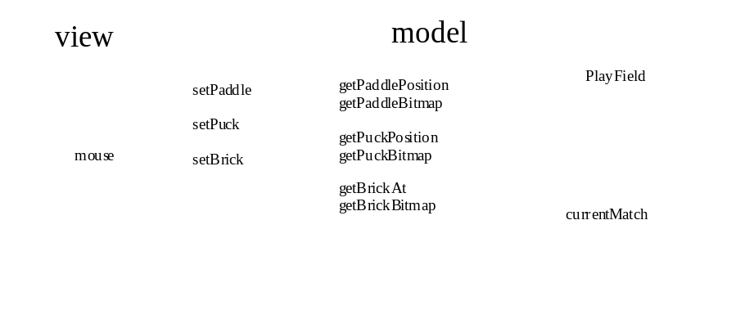
Figure 19 An architectural model for Brickles.
A software architecture is the basic structure that defines the system in terms of computational components and interactions among those components [ShGA96]. We will use the terms component and connector to describe the pieces of an architecture. In the UML notation, components of the architecture are represented as classes with interfaces. If the connectors between components do not have any explicit behavior they can be represented by simple relationships between classes. If the connectors do have state and/or meaningful behavior then they are represented by objects.
Representations for architectures
There are three types of information that are widely used to represent an architecture: relationships, states, and algorithms. The basic UML modeling language has the advantage that it can be used for all three design models as well as the analysis models. Using the same notation for all three levels of models eliminates the need to learn multiple notations. Notations such as the UML are sufficiently simple that no special tools are required, although for large models, tool support quickly becomes a necessity. Tools such as Rational’s Rose perform a variety of consistency checks on the static relationship model. With this type of representation, the test cases are manually executed using the technique discussed previously. However, UML does not have specific syntax for describing architectures so the concept/token mapping between the architecture and UML symbols is ad hoc.
Tools such as ObjectTime[Rational00] and BetterState[BetterState00] provide facilities for “animating” design diagrams and provide automatic checking of some aspects of the model. In particular, they support a simulation mechanism that can be used to execute scenarios. The diagrams are annotated with detailed scenario information as well as special simulation information. The developer can “play” scenarios and watch for a variety of faults to be revealed. This approach makes the creation of new scenarios (and test cases) easier by providing a generalized template. One advantage of this approach is the combination of easy model creation with powerful simulation facilities. Usually however, these tools have a limited set of diagram types. BetterState for example focuses on building a state model as the specification for the system. This leaves incomplete those static portions of the system that do not affect the state. The obvious benefit is that the scenarios are executed automatically. This makes it easier to run a wide range of scenarios at the price of more time needed to create the model initially. This approach is best suited to small, reactive systems or those systems whose requirements change very little during development.
Often these tools will assist in finding some types of faults as the model is entered into the tool. Consistency checks will prevent certain types of connections from being established. Scenarios are represented in some appropriate format such as a sequential file of input values that are read at appropriate times. The actions of the simulation are often represented by events. Event handlers can be used to “catch” and “generate” events at a high level without the need to write detailed algorithms. This level of execution is sufficient for verifying that required interfaces are provided. It obviously is not sufficient for determining whether the functionality is correctly implemented.
Finally, architectural description languages provide the capability to represent a system at a high level of abstraction. Languages such as Rapide[Luckham95], developed at Stanford University, allow the modeler to be as specific as they would like to be. The flow of computation is modeled by events that flow between components. One advantage of this approach is the control that this approach provides to the modeler. The language is sufficiently descriptive to support any level of detail that the modeler wishes to use unlike the tools discussed above which have a fixed level of representation. The disadvantage is that these models are programs with all of the problems associated with that level of detail.
When the model and test cases are represented in a programming language, the test execution can be performed automatically. The representation language may be a general purpose programming language used to implement a high level prototype or a special purpose architectural description language, such as Rapide, used to build a standard model. The level of detail represented in the prototype will determine how specific the testing can be.
Testing the Architecture
The Software Architecture Testing (SAT) [McGregor96] technique is a special type of Guided Inspection that requires the usual steps in testing any product: (1) test cases are constructed; (2) the tests are conducted on the product; and (3) the results of the test are evaluated for correctness. This technique is a “testing” technique because there are very specific test cases and there is the concept of an execution even if the execution is sometimes manual. The team that is assigned to drive this activity is divided as shown in Figure 18. Below we will provide additional detail on each of the steps.
Constructing Test Cases
Test cases for the architecture are constructed from the use cases as described previously. Each use case describes a family of scenarios that specifies the different types of results that can occur during a specific use of the system. The test cases for the architecture are defined at a higher level than the more detailed design models.
The test cases are essentially defined at a level that exercises the interfaces between subsystems. For example, for the Game framework, the essential interface is between a Model and a View. The Model is divided among the Puck, Paddle and BrickPile classes. The View is concentrated in the BricklesView class.
The Model/View architecture calls for most of the interaction to be from the View but with the Model notifying the View when a change has occurred to the Model. Since Brickles requires animation, we modified the architecture so that when the BricklesView object is created it is sent a series of messages that provide it with handles to the pieces of the Model.
The basic architectural model is given in Figure 19. With the analysis out of the way, the test cases can be selected. The two basic operations are (1) setup of the system and (2) repainting the screen after a move has occurred. Unlike many systems built on Model/View, there is no need to consider the ability to add additional views. We could define a test case for each operation; however, a single grand tour case can be defined in this case. Usually grand tours are too large and give little information if they fail, but in this case the second operation can not be realized without the first so it is a natural conjunction.
Test Execution
The tests are executed as described for each specific type of representation. We have used the UML notation so this will be an interactive session.
We execute the test case by constructing a message sequence diagram. The diagram reflects pre-conditions for a test case. The BricklesView object is created followed by a BricklesGame object. As the BricklesGame object is created, it creates a PlayField object that turn creates Puck, Paddle and BrickPile objects. The messages across the architectural boundaries are shown in bold italics in Figure .

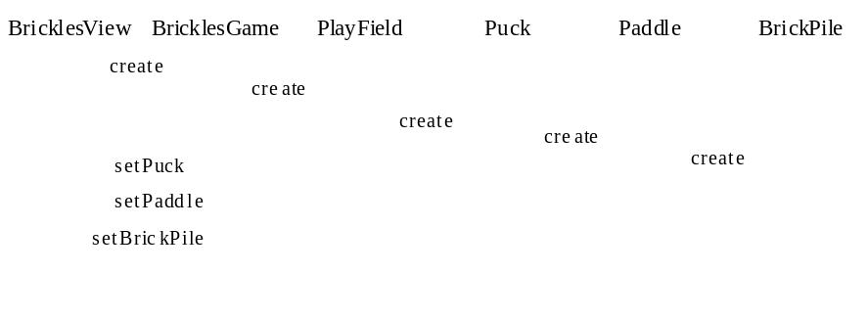
Figure 20 Test case execution.
Verification of Results
Usually for architectures, this step is fairly simple, even though for the detailed functionality of the final application it can be very difficult. When the output from the test is in the form of diagrams, the resulting diagrams must be verified after each test execution by domain experts. When the output is the result of an execution, the test results can be verified by having those domain experts construct event sequences that would be produced by a correctly performing architecture. The interpretation of the evaluation criteria is given in Figure 17.

A grand tour is a test case that combines a number of separate test cases into one run.

