ArcadeGame Product Line – Production Plan

ArcadeGame Team

July 2002

Table of Contents
1 Overview vi
1.1 Purpose vi
1.2 Readership vii
2 General Production Plan viii
3 Bill of Materials x
4 Schedule xi
5 Creating the Production Plan for a new Arcade Game xii
6 Building an Arcade Game xiii
6.1 Product Identification and Specification xiii
6.2 Product Architecture xiii
6.3 Element Specification and Icon Creation xiii
7 References xiv
r

List of Figures
Error! No table of figures entries found.

List of Tables

Overview

Purpose
The Sykes/McGregor ArcadeGame Product Line is producing a series of arcade games ranging from low obstacle count to high. More detailed information can be found in the ArcadeGame scope document. The purpose of this document is to provide a general production plan that is specialized by each product team to meet their needs.

Document Map
The Sykes/McGregor ArcadeGame Product Line is described in a series of documents. These documents are related to each other as shown in Figure DOCMAP. This map shows the order in which the documents should be read for the first time. Once the reader is familiar with the documents, the reader can go directly to the information needed.
This is the General production plan. To understand it the reader should be familiar with the Product Line Scope and the CONOPS. The production plan describes how individual products in the product line will be constructed. This general plan provides a high level view. There is a product-specific production plan for each product.

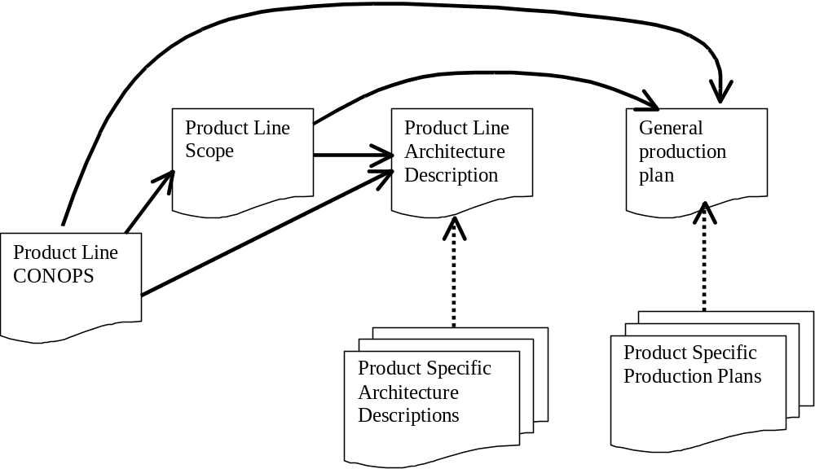
Figure DOCMAP

Readership
This document is intended to provide information to the product developers in the Sykes/McGregor ArcadeGame product line. This document summarizes the information from the domain engineering team about how to create a new arcade game from the product line assets.

General Production Plan
In this section we provide the general production plan from which product-specific production plans will be derived. In the next section we provide a detailed development process.

Production Strategy
The Sykes/McGregor ArcadeGame product line is a demonstration organization rather than a commercial product line. The strategy is to provide three products as well as the artifacts that define and support the product line operation.
The product line organization will develop the arcadeGame architecture and a set of C#.NET components using the .NET class libraries. The components will cover the complete functionality specified in the architecture including all variations.
Each product will be constructed by an independent team. The team will be responsible for the complete product development process as defined in section 3.

Deployment Strategy
The products in the product line will be deployed in the Common Language Runtime (CLR). The .NET philosophy is to allow programs to be platform independent. This will broaden the market for ArcadeGame products without increasing costs.

Product Development Process
The product line assets are not sufficiently developed to support automatic generation of the products. This product line will require the full development process described in [Chastek 02] and taken from the Product Builder pattern given in [Clements 02]. Figure PROCESS shows the complete set of activities from the pattern.

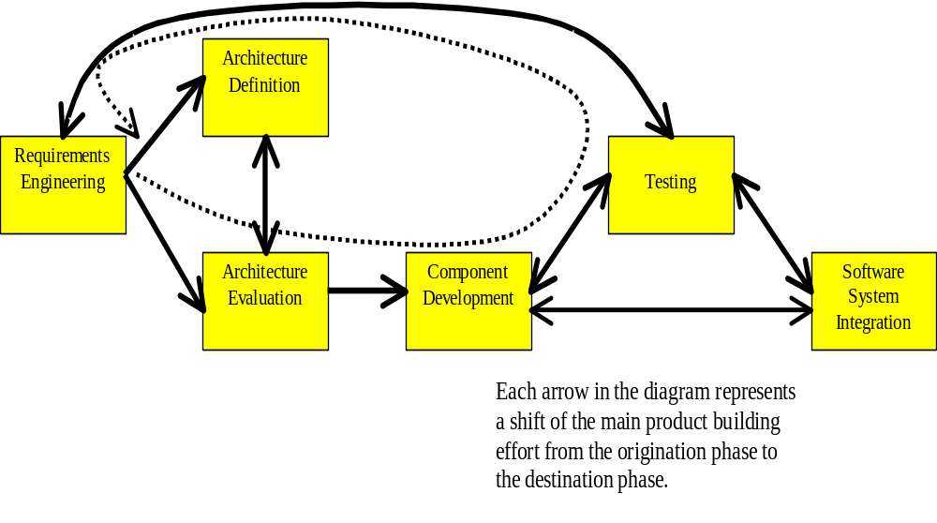Figure PROCESS

Requirements Engineering
Every production plan includes product requirements engineering as a required practice area since every product has specific, and to some degree unique, requirements. Most of the product requirements are derived from the product line requirements with choices being made at each variation point. Where there are deviations from the product line requirements, new requirements are written. Table PHASE1 summarizes the external interfaces of the “Requirements Engineering” practice area.
An individual requirement is the fundamental unit of traceability. Test cases, incremental development plans, and phased product deliveries are all associated with specific requirements. These pieces are identified as the requirements set for a product being created.
The product developers’ requirements engineering process includes selecting a set of requirements that is consistent and complete. A tool that uses pre-defined relationships between groups of requirements can manage the selection process. In response to selections made by a product developer, the tool guides the inclusion of all requirements within a group.
Alternatively, this process may be a manual process. Diagrams that show dependencies between requirements facilitate the manual selection of a product’s requirements from the larger product line requirements set. For example, a UML use case diagram shows a variety of dependencies between the use cases. Figure USE1 illustrates that if use C is to be included in a product’s requirements set, other related use cases must be selected as well.

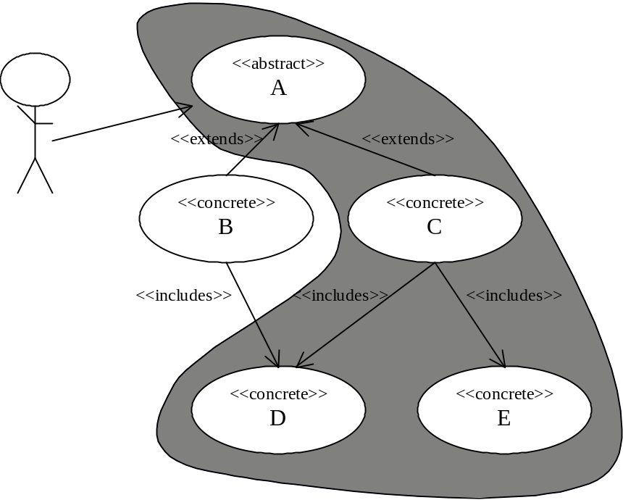
Figure USE1

Table PHASE1 – Requirements Engineering
Section Heading | Section Content
Description | The product developers develop the complete list of requirements for the specific product. The list is selected from the product line’s pre-defined set. Additional requirements may be added if approved by the appropriate authority.
Responsibility | The product team has responsibility for being certain that a consistent set of requirements have been chosen from the product line requirements. The core asset developers have a responsibility for ensuring that a sufficiently comprehensive set of requirements is available from which to select.
Input | Customer selection of a product and specific values for optional features
Entry Criteria | The development of a new product has been approved as within the scope of the product line organization.
Activities | Select requirements from the product line set  Add any additional requirements  Evaluate the requirements set for completeness, correctness, consistency
Output | A comprehensive description of the requirements for the product.
Exit Criteria | Move to the next phase if the requirements set is “complete enough” for examining the architecture.  Return to the product approval process if sufficient requirements are outside the product line set to raise questions about the validity of the product line analyses.
Metrics | Percentage of product requirements already belonging to the product line requirement set

Architecture Definition
Products that introduce new requirements beyond the product line require additional architecture definition work. If the deviation from the product line set of requirements is minor, the architect may be able to directly modify the architecture definition. If the deviation is major, the architect may wish to conduct an architecture evaluation prior to making final modifications to the architecture. Table PHASE2 summarizes the external interfaces of the “Architecture Definition” practice area.
The selection of specific requirements for a product will result in certain portions of the architecture being selected as well. In particular, certain variants will be selected at architecture variation points. If new requirements have been added, new variants may be defined at some of the variation points.
Table PHASE2 – Architecture Definition
Section Heading | Section Content
Description | New architecture structures may be created or existing structures modified. In this case the technique is applied incrementally to add the functionality for this specific product.
Responsibility | The product architecture team is responsible for making changes and additions.
Input | The requirements set including any requirements not satisfied by the current architecture.
Entry Criteria | The architects can begin modifying the architecture whenever additional requirements have been accepted into the project.
Activities | Application of architectural styles; definition of component interfaces
Output | Revised architecture, expanded to satisfy additional requirements
Exit Criteria | Exit this phase when all of the new requirements have been satisfied, including quality attributes
Metrics | The standard quality attribute measures are computed

The assets and tools available to the product developers may not allow new requirements. For example, the product developer may select from an automated checklist of requirements. In this case, the architecture definition activity will not be part of the process.
Architecture Evaluation
Any new architecture definition will require corresponding evaluation. As mentioned in Section 5, if new requirements have been proposed that will result in a major modification of the architecture, the architects may decide to use ATAM [Clements 02b] to investigate any proposed definitions. Table PHASE3 summarizes the external interfaces of the “Architecture Evaluation” practice area.
An incremental evaluation is performed that covers those portions of the architecture where new definition or modification has occurred. The ATAM scenarios can be associated with specific requirements. A set of scenarios is identified for use when a requirement is selected for inclusion in a product.
The architecture evaluation phase will not be included in the product building process, if no new requirements and no architecture definition are allowed. In this case, products are defined by choosing from a fixed set of requirements.
Table PHASE3 – Architecture Evaluation
Section Heading | Section Content
Description | The ATAM is used to evaluate the degree to which the architecture satisfies its requirements. In this case the evaluation is performed incrementally on anything that is being changed from the product line architecture.
Responsibility | The architecture team initiates the evaluation process that involves both core asset developers and product developers.
Input | An architecture description and a set of requirements the architecture is intended to satisfy.
Entry Criteria | This step is entered when a change is either proposed or actually made to the product line architecture
Activities | Create scenarios that are valid uses of the software, use these to investigate both new and pre-existing portions of the architecture
Output | A set of defects in the architecture
Exit Criteria | Exit this phase when sufficient scenarios have been investigated to cover new requirements
Metrics | Percentage of the architecture that has been touched during the simulated execution of the software

Component Development
Component development includes the tailoring of existing components and the development of new components. New component development may be required even if no new architecture definition has occurred. A particular variant may have been foreseen in the architecture but no implementation created for that specific component. When a need arises, the component is built. Initial or tailored versions of a component will be rigorously tested but may take a few iterations before their attributes satisfy the specified values. Table PHASE4 summarizes the external interfaces of the “Component Development” practice area.
As the product line and the market matures, the need for basic component development will decline. The potential for acquisition of components will increase as more vendors enter the market. The product line’s inventory of acceptable components will also increase as more variants are implemented.
Component development will not be a part of the product build process if the product line is constrained to a set of existing configurations. When component development is in the process, the plan will specify how development tools are used to ensure compatibility with the existing component inventory.
Table PHASE4 – Component Development
Section Heading | Section Content
Description | Implementations of the required specifications are created. A component may be assigned specific quality attribute targets including a portion of the performance budget.
Responsibility | The implementation specialists among the product developers develop or tailor the components. It is also possible that the component may be acquired rather than being built.
Input | The specifications from the architecture description plus a list of needed components and changes to existing components.
Entry Criteria | The architecture description is sufficiently complete to support initial efforts at component development and alteration.
Activities | Search for available products and purchase if feasible  Component design and implementation either from scratch or by modifying existing component
Output | Initially, candidate implementations and alterations of specified components; eventually, mature implementations that achieve expected quality values
Exit Criteria | Components accepted for incorporation into product
Metrics | Component reliability and testability measures; where applicable performance measures and other quality attribute requirements

Testing
Every production plan prescribes a set of testing activities that is tailored to the specific needs of the product line. The testing practice area defines several levels and types of testing. Table PHASE5 summarizes the external interfaces of the “Testing” practice area. The first level of testing that is applied is basic unit testing of each completed component. The process diagram in Figure PROCESS shows that testing may produce feedback to component development. This iteration continues until the component meets its functional and quality requirements. When no new component development is allowed during product building, no unit test activity is specified.
Components are fed into the software system integration where they are integrated with other components. Various types of interaction tests are then performed to ensure the integrated pieces continue to meet requirements. Eventually all the components needed to satisfy all of the system’s software requirements are integrated and tested.
Table PHASE5 – Testing
Section Heading | Section Content
Description | Various sized pieces of software are executed with test cases for which correct answers are known. The behavior during execution is observed and a judgment is made about the quality of the software.
Responsibility | Various persons are responsible depending upon the type of testing being discussed.
Input | The input to each test activity is the item to be tested and the specification for that item.
Entry Criteria | The item has reached sufficient stability to test some portion of the item.
Activities | Analyze specification to select test cases  Construct test cases  Execute test cases  Analyze test results
Output | The test cases applied during testing. The test results that indicate whether the item passed or failed each test case.
Exit Criteria | Exit to next phase if sufficient test cases are passed  Exit back to previous phase if sufficient test cases were failed
Metrics | Percentage of test cases passed  Percentage of item covered by tests

Software System Integration
Software system integration combines components to form a system or subsystem. This often is the main focus of product building. The production plan specifies how this integration can occur. Table PHASE6 summarizes the external interfaces of the “Software System Integration” practice area.
Table PHASE6 – Software System Integration
Section Heading | Section Content
Description | Product is constructed by integrating components.
Responsibility | The product developers are responsible for integrating the components.
Input | Tested components, product architecture
Entry Criteria | Some components have passed testing
Activities | Write glue code  Build integrated subsystem
Output | An integrated subsystem
Exit Criteria | Subsystem has passed interaction tests
Metrics | Percentage of requirements satisfied
The integration can result in an arrangement of components that has not been created before. As these new configurations are constructed they are fed back to the testing practice area to be verified.
Section 5 discusses how the techniques and activities needed to integrate the components are described in the production plan. This may include altering configuration files, property files, and build scripts.
Product lines that automatically generate the product from a selected list of requirements will not utilize the software system integration practice area. In this case, the automatically generated products will be tested at a system level and perhaps have other post-development testing techniques, such as user acceptance testing, applied.

Bill of Materials
This arcade game product line is being implemented in C#.NET. The assets are all implemented from scratch. No commercial or freeware components are being used. The bill of materials will not include a cost factor or licensing fee but the bill will provide a basis for tracking the use of each component.
Each arcade game will require:
Component Name | Description | Cost basis
PlayingField
Player

Schedule
This general schedule will use the process for building an arcade game described in section 2 and give basic ideas of sequence and duration of activities. The product-specific production plan, described in section 6 will discuss creating the schedule for a specific product.

Creating the Production Plan for a new Arcade Game
In this section we describe how to take this general production plan and produce the specific production plan for that game.

Process
The process may be modified as the product line matures. In particular a specific product team may not need to do any architecture definition or evaluation.

Schedule
The template schedule is modified to provide the exact dates for the schedule.

Bill of Materials
The Bill of Materials is defined for each product. It could be created automatically as the specific product variations are chosen.

Building an Arcade Game
In this section we describe how to build a new arcade game product from the assets of the product line.

Product Identification and Specification
A new product is given a specific name. The specification for the game is constructed by specializing the general product line use cases. This has three facets:

Variation Selection
The variation selection is accomplished by modifying the general build script to create a product specific build script.

Product Line Extension/Modification
Occasionally, additional functionality is required. This is provided by defining new components and adding them into the product.

Data Definitions
The specific attributes of game components such as the location, size, and color of obstacles must be defined in the driver component.

Product Architecture
The product architecture for this product line is basically unchangeable. Each product team will review the architecture but it is expected that the architecture will not change from one game to the next.

Element Specification and Icon Creation
Each game will have unique icons that are used for the moving and stationary sprites. These are created by the product developers and then positioned on the playing field of the game by TBA.

References
[Chastek 02] | Chastek, Gary and McGregor, John D. Guidelines for Developing a Product Line Production Plan, CMU/SEI-2002-TR-006, 2002.
[Clements 02] | Clements, P. & Northrop, L. Software Product Lines: Practices and Patterns, Addison-Wesley, 2002.
[Russ 00] | Russ, Melissa L. & McGregor, John D. A Software Development Process for Small Projects, IEEE Software, Sept/Oct 2000.

