
Indian Institute of Technology Roorkee

PROJECT REPORT
ON
CUSTOMER PURCHASE BEHAVIOR ANALYSIS
& DIMENSIONALITY REDUCTION
Submitted by
Udita

under the supervision of
Dr. Millie Pant

(Applied Mathematics and Scientific Computing, IIT Roorkee)

Duration: 9/06/2026– 15/07/2026

Acknowledgement
We express our sincere gratitude to our mentor, Ms. Riya & Mr. Harjeet for providing continuous guidance, valuable suggestions, and constant encouragement throughout the completion of this project. Their support and insightful feedback helped us understand the concepts of data preprocessing, exploratory data analysis, Principal Component Analysis (PCA), and Gradient Descent more effectively.
We are also thankful to the Department of Applied Mathematics and Scientific Computing, IIT Roorkee, for providing us with the opportunity and resources to undertake this project under the esteemed guidance of Prof. Dr. Milie Pant, HOD. The knowledge and practical exposure gained during this work have significantly enhanced our understanding of machine learning techniques and data analysis.
We would like to extend our heartfelt thanks to all the faculty members who shared their expertise and motivated us throughout the project. Their guidance has been instrumental in the successful completion of this work.
We also acknowledge the creators of the Customer Personality Analysis dataset available on Kaggle, along with the developers of the open-source Python libraries used in this project, including NumPy, Pandas, Matplotlib, Seaborn, and Scikit-learn, which made the implementation and analysis possible.
Finally, we express our gratitude to our family and friends for their constant encouragement, patience, and moral support throughout the project. Their motivation helped us remain focused and complete this work successfully.
Udita

Table of Contents

Acknowledgement 2
Table of Contents 3
Abstract 5
List of Figures 6
List of Tables 7
1. Introduction 8
2. Dataset Description 10
3. Methodology 12
3.1 Data Collection 12
3.2 Exploratory Data Analysis (EDA) 12
Histograms of Numerical Features 12
Boxplots for Outlier Identification 13
Correlation Heatmap 14
Pairplot of Top 5 Features 15
Outlier Detection Using the IQR Method 16
EDA Summary 17
3.3 Data Preprocessing 17
Handling Missing Values 17
Encoding Categorical Variables 17
Scaling Numerical Features: StandardScaler vs MinMaxScaler 17
Outlier Removal Using the Z-Score Method 18
Train-Test Split 18
3.4 Principal Component Analysis (PCA) 18
Explained Variance and Component Selection 19
2D and 3D Visualization of Principal Components 20
Interpreting PCA Loadings 22
Comparing Model Performance: Original vs PCA-Reduced Features 23
PCA Summary 24
3.5 Gradient Descent 24
Batch Gradient Descent 25
Stochastic Gradient Descent (SGD) 25
Mini-Batch Gradient Descent 26
Cost vs Iteration/Epoch Plots for Each Method 26
Comparison with Scikit-Learn's SGDRegressor 27
Effect of Learning Rate on Convergence 28
Effect of Batch Size on Convergence 29
Gradient Descent Summary 30
4. Results and Discussion 32
5. Conclusion 33
6. References 34

Abstract
Understanding customer purchase behavior is a central concern for modern businesses seeking to design effective, targeted marketing strategies. This project presents an end-to-end analysis of a customer dataset drawn from a marketing campaign context, combining exploratory data analysis, data preprocessing, dimensionality reduction, and optimization techniques implemented from first principles. The dataset used, “Customer Personality Analysis” (marketing_campaign.csv), consists of 2,240 customer records described by 29 original attributes covering demographic information, spending patterns across product categories, purchase channels, and historical responses to marketing campaigns.
Exploratory data analysis was performed to characterize feature distributions, detect missing values and outliers, and examine relationships among variables, revealing pronounced right-skew in spending-related features and a strong association between prior campaign acceptance and the target variable, Response. Data preprocessing addressed the single missing-value column (Income) through median imputation, encoded categorical variables using one-hot encoding, compared StandardScaler and MinMaxScaler transformations, removed outliers using the Z-score method, and split the data into training and testing subsets while avoiding data leakage.
Principal Component Analysis (PCA) was then applied to the standardized feature set, reducing the dimensionality from 36 encoded features to 26 principal components while retaining 95% of the total variance. A logistic regression classifier trained on the PCA-reduced features achieved marginally higher test accuracy (89.47%) than the same classifier trained on the full feature set (88.10%), indicating that most of the predictive signal is concentrated in a smaller number of underlying dimensions dominated by income and spending-related behavior.
Finally, Batch Gradient Descent, Stochastic Gradient Descent, and Mini-Batch Gradient Descent were implemented from scratch to fit a linear regression model, and their convergence behavior, sensitivity to learning rate, and sensitivity to batch size were systematically compared against each other and against scikit-learn's SGDRegressor. Batch Gradient Descent and Mini-Batch Gradient Descent converged reliably to a final cost near 0.089, while the from-scratch Stochastic Gradient Descent implementation and very small mini-batch sizes were found to be numerically unstable under the learning rates used, diverging to extremely large cost values. These findings offer practical insight into how optimizer choice and hyperparameter selection affect model stability, and they demonstrate that dimensionality reduction via PCA can simplify customer behavior data without materially sacrificing predictive performance.

List of Figures
Figure 1: Histograms of Numerical Features
Figure 2: Boxplots of Numerical Features
Figure 3: Correlation Heatmap of Numerical Features
Figure 4: Pairplot of Top 5 Features Correlated with Response
Figure 5: Scree Plot of PCA Explained Variance Ratio
Figure 6: Cumulative Explained Variance vs Number of Components
Figure 7: 2D Scatter Plot of First Two Principal Components
Figure 8: 3D Scatter Plot of First Three Principal Components
Figure 9: Heatmap of PCA Loadings (First 10 Components)
Figure 10: Batch Gradient Descent – Cost vs Iterations
Figure 11: Stochastic Gradient Descent – Cost vs Epochs
Figure 12: Mini-Batch Gradient Descent – Cost vs Epochs
Figure 13: Convergence Comparison – Batch vs SGD vs Mini-Batch GD
Figure 14: Effect of Learning Rate on Convergence (Batch GD)
Figure 15: Effect of Batch Size on Convergence (Mini-Batch GD)

List of Tables
Table 1: Summary of the Dataset
Table 2: Feature Groups and Data Types
Table 3: Missing Value Summary
Table 4: StandardScaler vs MinMaxScaler – Income Feature
Table 5: Top 5 Feature Loadings for PC1 and PC2
Table 6: Classification Accuracy – Original vs PCA-Reduced Features
Table 7: Effect of Learning Rate on Batch Gradient Descent
Table 8: Effect of Batch Size on Mini-Batch Gradient Descent
Table 9: Final Cost Comparison Across Gradient Descent Variants
Table 10: Custom Batch GD vs Scikit-Learn SGDRegressor (Test MSE)

1. Introduction
In today's competitive marketplace, businesses increasingly rely on data-driven insight into how customers behave, what they purchase, and how they respond to promotional efforts. Customer purchase behavior analysis refers to the systematic study of transactional and demographic data in order to uncover patterns that describe how different types of customers spend, which channels they prefer, and which marketing campaigns are likely to resonate with them. Such analysis allows organizations to move away from broad, undifferentiated marketing and toward targeted strategies that improve customer engagement while reducing wasted marketing expenditure.
Customer analytics has become important for several interconnected reasons. First, it enables segmentation of customers into meaningful groups based on shared spending habits or demographic characteristics, which supports personalized offers. Second, it helps identify the features most strongly associated with desirable outcomes, such as a customer accepting a marketing campaign, so that future campaigns can be designed more effectively. Third, understanding purchase behavior supports resource allocation decisions, since marketing budgets can be directed toward customer segments most likely to respond positively.
A recurring challenge in customer analytics is that the datasets collected by organizations are typically high-dimensional, containing dozens of demographics, behavioral, and transactional attributes for each customer. High dimensionality complicates both visualization and modeling: many features are correlated with one another, some contribute little discriminative information, and the presence of many dimensions can make downstream machine learning models slower to train and more prone to overfitting. Dimensionality reduction techniques, and Principal Component Analysis (PCA) in particular, address this challenge by transforming a large set of possibly correlated features into a smaller set of uncorrelated components that retain most of the original variance in the data. This makes it possible to visualize customer data in two or three dimensions, to reduce computational cost, and to potentially improve the generalization of predictive models.
This project undertakes a complete analytical pipeline on a real customer dataset in order to demonstrate these ideas in practice. The specific objectives of the project are as follows: (1) to explore and characterize a customer purchase dataset through descriptive statistics and visualizations; (2) to preprocess the data by handling missing values, encoding categorical variables, scaling numerical features, and removing outliers; (3) to apply Principal Component Analysis to reduce the dimensionality of the preprocessed data while retaining 95% of the variance, and to interpret the resulting components; (4) to implement Batch Gradient Descent, Stochastic Gradient Descent, and Mini-Batch Gradient Descent from scratch for a linear regression task, and to compare their convergence behavior, sensitivity to learning rate, and sensitivity to batch size; and (5) to draw practical conclusions about customer behavior and about the trade-offs among the optimization and dimensionality-reduction techniques studied.

2. Dataset Description
The dataset used in this project is the “Customer Personality Analysis” dataset, obtained from Kaggle. It is provided as a tab-separated values file, marketing_campaign.csv, and contains records of individual customers of a retail/marketing organization, describing their demographic profile, historical spending across product categories, engagement with purchase channels, and their response to a marketing campaign.
Before any preprocessing was performed, the raw dataset consisted of 2,240 customer records described by 29 original attributes. Of these, 25 attributes are integer-valued, 1 attribute (Income) is a floating-point value, and 3 attributes (Education, Marital_Status, and Dt_Customer) are of object (string) type. The target variable used for the classification comparisons in this project is Response, a binary indicator of whether the customer accepted the offer in the most recent marketing campaign (1 = accepted, 0 = not accepted).
Table 1: Summary of the Dataset
Characteristic | Description
Dataset name | Customer Personality Analysis (marketing_campaign.csv)
Source | Kaggle
File format | Tab-separated values (.csv, sep = \t)
Number of records (raw) | 2,240
Number of original features | 29
Target variable | Response (binary: 1 = campaign accepted, 0 = not accepted)
Numerical features | 25 integer-valued, 1 float-valued (Income)
Categorical features | 3 object-type (Education, Marital_Status, Dt_Customer)
Missing values | Present only in Income (24 missing entries)
Table 2 groups the original features by category to summarize what each portion of the dataset represents. Demographic attributes describe the customer's background; spending attributes (prefixed “Mnt”) capture the amount spent on different product categories over the previous two years; purchase-channel attributes capture how many purchases were made through each sales channel; and campaign-related attributes record whether the customer accepted each of five previous marketing campaigns, together with the target variable Response for the most recent campaign.
Table 2: Feature Groups and Data Types
Feature Group | Representative Columns | Data Type
Identifier | ID | Integer
Demographic | Year_Birth, Education, Marital_Status, Income, Kidhome, Teenhome, Dt_Customer | Integer / Object / Float
Recency | Recency (days since last purchase) | Integer
Spending (last 2 years) | MntWines, MntFruits, MntMeatProducts, MntFishProducts, MntSweetProducts, MntGoldProds | Integer
Purchase channel / engagement | NumDealsPurchases, NumWebPurchases, NumCatalogPurchases, NumStorePurchases, NumWebVisitsMonth | Integer
Campaign response history | AcceptedCmp1–AcceptedCmp5, Complain | Integer (binary)
Fixed campaign parameters | Z_CostContact, Z_Revenue | Integer
Target | Response | Integer (binary)
Regarding data quality, only the Income column contained missing values (24 out of 2,240 records, approximately 1.1% of rows), as confirmed using df. isnull(). sum(). All other columns were fully populated. Detailed univariate descriptive statistics were generated in the notebook using df.describe(); however, because the subsequent statement in the same code cell (df.info()) is the one whose output is displayed, the full numerical summary table produced by df.describe() is not present in the saved notebook output. Information not available in the notebook.

3. Methodology
This chapter describes, in sequence, every stage of the analytical pipeline followed in this project: data collection, exploratory data analysis, data preprocessing, Principal Component Analysis, and Gradient Descent based optimization. Each stage is discussed together with the corresponding figures, tables, and observations drawn directly from the project notebook.

3.1 Data Collection
The dataset was obtained from Kaggle's “Customer Personality Analysis” collection and loaded directly into a Pandas Data Frame. Because the source file is tab-separated rather than comma-separated, it was read using pd.read_csv() with the separator explicitly set to '\t'. Upon loading, the Data Frame was confirmed to contain 2,240 rows and 29 columns, matching the expected structure of the dataset before any preprocessing was applied.

3.2 Exploratory Data Analysis (EDA)
Exploratory Data Analysis was carried out to understand the structure, distribution, and inter-relationships of the dataset's features before any transformation was applied. Summary statistics and structural information were first obtained using df.describe() and df.info(), which confirmed the data types described in the previous chapter and the presence of missing values only in the Income column. Missing values were then explicitly quantified using df.isnull().sum(), which confirmed 24 missing entries in Income and none elsewhere.

Histograms of Numerical Features
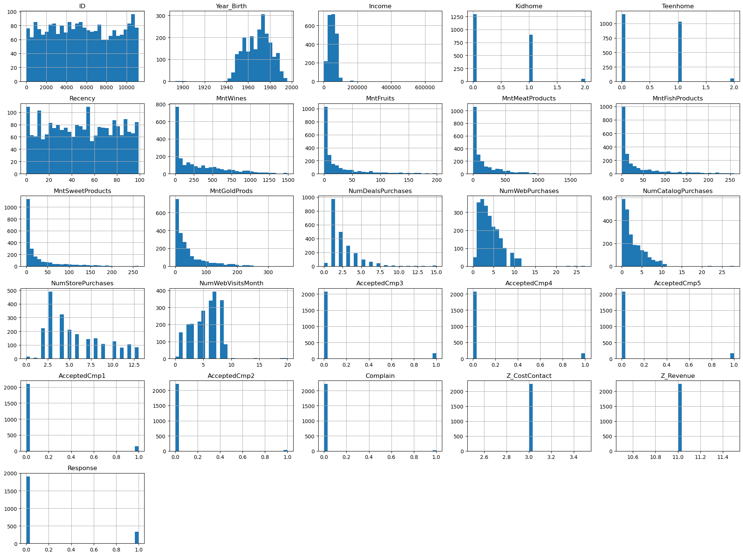
Figure 1: Histograms of Numerical Features
The histograms show that the spending-related features (MntWines, MntFruits, MntMeatProducts, MntFishProducts, MntSweetProducts, and MntGoldProds) are all strongly right-skewed, with the majority of customers spending very little and a smaller number of customers spending disproportionately large amounts — a pattern consistent with a small segment of high-value customers. Demographic features such as Year_Birth and Income are closer to symmetric, though Income shows a long right tail. Binary features, including the campaign-acceptance columns (AcceptedCmp1–AcceptedCmp5) and the target Response, appear as two-bar distributions heavily concentrated at 0, reflecting that campaign acceptance is a relatively rare event in this dataset. Recency and NumWebVisitsMonth appear more uniformly or moderately spread across their ranges.

Boxplots for Outlier Identification
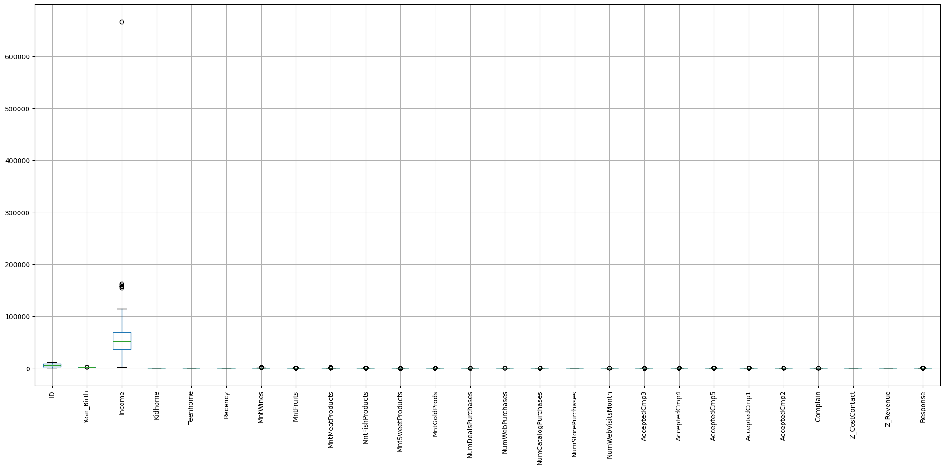
Figure 2: Boxplots of Numerical Features
The combined boxplot view highlights that the spending features and Income contain a substantial number of points beyond the upper whisker, confirming the right-skew observed in the histograms and indicating the presence of outlying high-spending, high-income customers. Binary and near-binary columns (such as the AcceptedCmp* flags and Complain) appear compressed near zero with many points marked as outliers purely because of their 0/1 nature rather than genuine anomalies. This visual inspection directly motivated the outlier-handling step carried out during preprocessing.

Correlation Heatmap
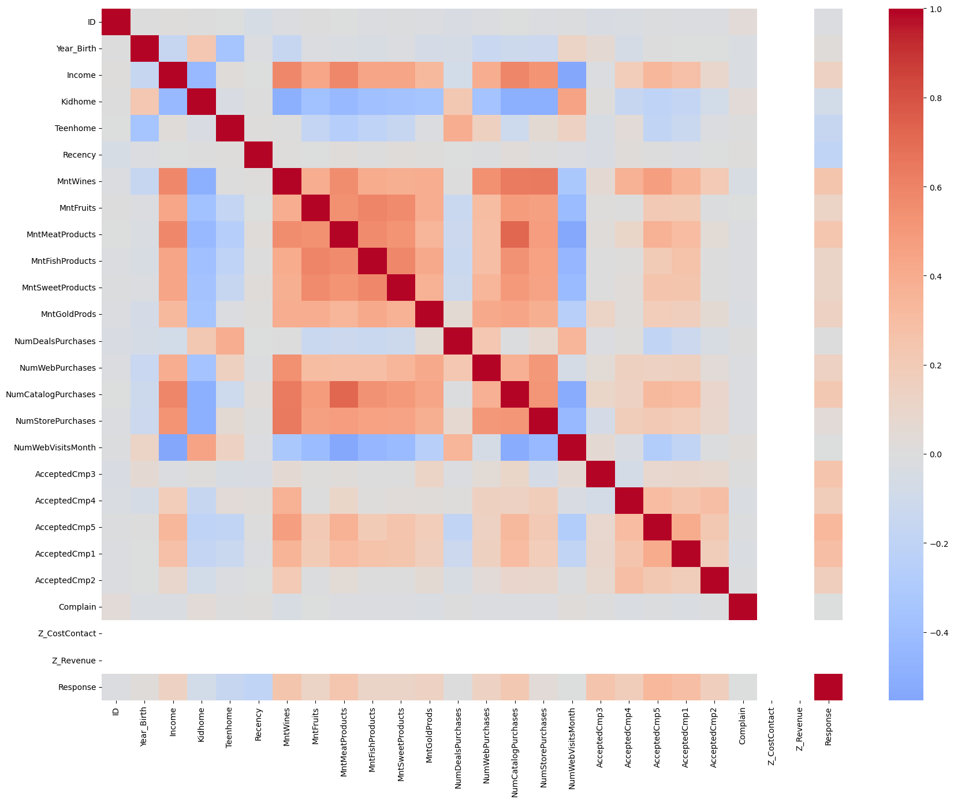
Figure 3: Correlation Heatmap of Numerical Features
The correlation heatmap reveals that the spending features (Mnt* columns) are positively correlated with one another and with Income, suggesting that customers who spend more in one product category also tend to spend more overall. Purchase-channel features such as NumCatalogPurchases and NumStorePurchases likewise correlate positively with the spending columns, consistent with higher-spending customers using multiple channels more frequently. The campaign-acceptance columns (AcceptedCmp1–AcceptedCmp5) form a visibly correlated cluster with each other and with the target variable Response, indicating that a customer's history of accepting previous offers is informative about their likelihood of accepting the most recent one.

Pairplot of Top 5 Features
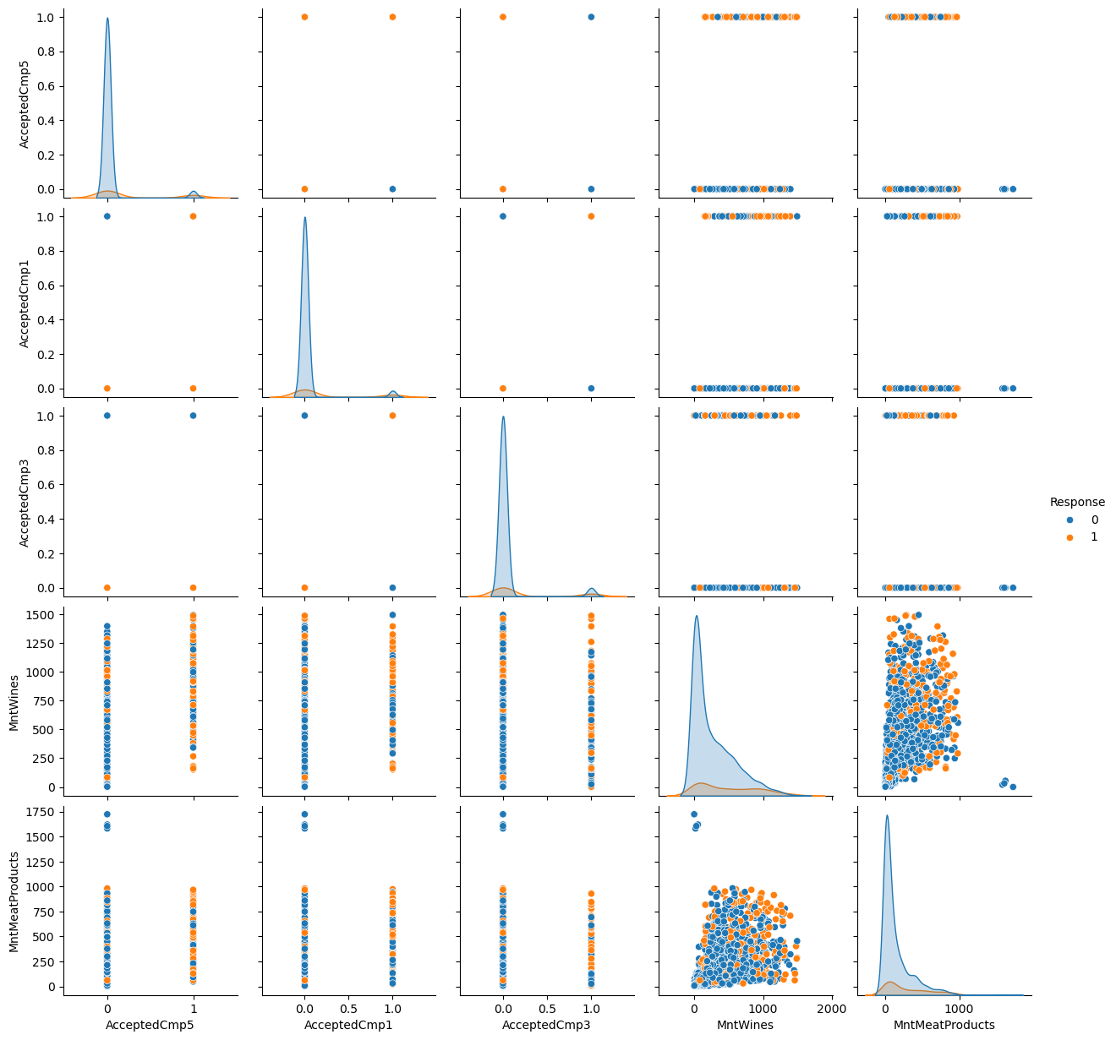
Figure 4: Pairplot of Top 5 Features Correlated with Response (hue = Response)
The five features most correlated with the target variable were identified as AcceptedCmp5, AcceptedCmp1, AcceptedCmp3, MntWines, and MntMeatProducts. The pairplot, colored by Response, shows that customers who accepted previous campaigns (AcceptedCmp1, AcceptedCmp3, AcceptedCmp5 = 1) are visibly more likely to belong to the Response = 1 group, and that customers with higher wine and meat-product spending also skew slightly toward accepting the current campaign, though with considerable overlap between the two classes.

Outlier Detection Using the IQR Method
Outliers were additionally identified using the interquartile range (IQR) method, flagging any value below Q1 − 1.5×IQR or above Q3 + 1.5×IQR for each numerical feature. The columns with the greatest number of flagged outlier values were Response (334), MntSweetProducts (248), MntFruits (227), MntFishProducts (223), MntGoldProds (207), MntMeatProducts (175), AcceptedCmp4 (167), AcceptedCmp3 (163), AcceptedCmp5 (163), and AcceptedCmp1 (144). Because Response and the AcceptedCmp* columns are binary, a large IQR-based outlier count for these columns simply reflects their heavily imbalanced 0/1 distribution rather than genuine anomalies; the spending columns, on the other hand, reflect really high-spending customers.

EDA Summary
The dataset contains 2,240 customers across 29 features. Income has 24 missing values that require imputation. Spending-related features are right-skewed with a high number of outliers, consistent with a small group of high-spending customers. Campaign acceptance columns (AcceptedCmp1–AcceptedCmp5) show the strongest correlation with the target variable Response, suggesting that customers who engaged with past campaigns are more likely to respond to future ones.

3.3 Data Preprocessing

Handling Missing Values
The only column with missing data, Income, was imputed using its median value, a standard and robust choice for numerical features with skewed distributions since the median is less sensitive to outliers than the mean. After imputation, df.isnull().sum().sum() confirmed that zero missing values remained anywhere in the dataset. No categorical columns contained missing values, so mode imputation was not required.

Encoding Categorical Variables
The two categorical columns, Education and Marital_Status, were transformed using one-hot encoding via pd.get_dummies(), with the first category of each dropped to avoid redundancy (the dummy-variable trap). This transformation expanded the feature set from 29 to 37 columns while representing each categorical level as a separate binary indicator column suitable for use in numerical models.

Scaling Numerical Features: StandardScaler vs MinMaxScaler
Numerical features were scaled using StandardScaler, which transforms each feature to have a mean of 0 and a standard deviation of 1. This is important because features on the dataset's original scales, ranging from small binary flags to income values in the tens of thousands, would otherwise disproportionately influence distance-based and gradient-based algorithms. As a comparison, MinMaxScaler was also applied, which instead rescales each feature to the fixed range [0, 1]. For the Income feature specifically, the StandardScaler output had a mean of approximately 0.0 and a standard deviation of 1.0, while the MinMaxScaler output ranged from a minimum of 0.0 to a maximum of 1.0, confirming that both scalers behaved as expected on this feature.
Table 4: StandardScaler vs MinMaxScaler – Income Feature
Scaler | Resulting Range / Statistics (Income)
StandardScaler | Mean ≈ 0.0, Standard deviation ≈ 1.0
MinMaxScaler | Minimum = 0.0, Maximum = 1.0
StandardScaler was selected as the primary scaling method for the subsequent PCA and Gradient Descent stages of this project, since PCA in particular assumes that features contribute to variance on comparable scales; MinMaxScaler would compress or stretch feature ranges without centring them at zero, which is less suitable for variance-based methods such as PCA.

Outlier Removal Using the Z-Score Method
Outliers were removed using the Z-score method with a threshold of 3, applied to three key numerical columns — Income, MntWines, and MntMeatProducts — that were identified in the EDA stage as containing the most extreme high-end values. Rows in which the absolute Z-score of any of these three columns exceeded 3 were removed. This step reduced the dataset from 2,240 to 2,182 rows, removing 58 records (approximately 2.6% of the data) identified as extreme outliers.

Train-Test Split
The cleaned, outlier-removed dataset was split into training and testing subsets using an 80/20 ratio via train_test_split, with stratification on the target variable Response to preserve its class balance in both subsets and a fixed random_state of 42 for reproducibility. This produced a training set of 1,745 rows and a testing set of 437 rows, each with 36 feature columns (after one-hot encoding and prior to PCA).
An important refinement was made at this stage to avoid data leakage: rather than scaling the entire dataset before splitting, the StandardScaler was fit only on the training data and then used to transform both the training and testing sets. This ensures that no statistical information from the test set (such as its mean or standard deviation) influences the scaling parameters, preserving the integrity of the train/test evaluation.

3.4 Principal Component Analysis (PCA)
Principal Component Analysis is an unsupervised dimensionality-reduction technique that transforms a set of possibly correlated features into a smaller set of linearly uncorrelated variables called principal components. Each principal component is a linear combination of the original features, chosen such that the first component captures the greatest possible variance in the data, the second component captures the greatest remaining variance subject to being orthogonal to the first, and so on for subsequent components. Mathematically, PCA proceeds by computing the covariance matrix of the standardized features and then finding its eigenvectors and eigenvalues; the eigenvectors define the directions of the principal components, and the corresponding eigenvalues indicate how much variance each component explains.
PCA is used in this project for two main reasons. First, the encoded and scaled feature set contains 36 dimensions, many of which are correlated (as observed in the correlation heatmap), so a large share of the total variance can likely be captured using far fewer, uncorrelated dimensions. Second, reducing dimensionality makes it possible to visualize the customer data in two or three dimensions and can reduce the computational burden and overfitting risk of downstream models.

Explained Variance and Component Selection
PCA was first applied to the standardized training data while retaining 95% of the total variance, using PCA(n_components=0.95). This configuration automatically determined that 26 principal components were required to retain 95% of the variance present in the original 36-dimensional standardized feature set — a reduction of roughly 28% in the number of dimensions while preserving nearly all of the informative variance.
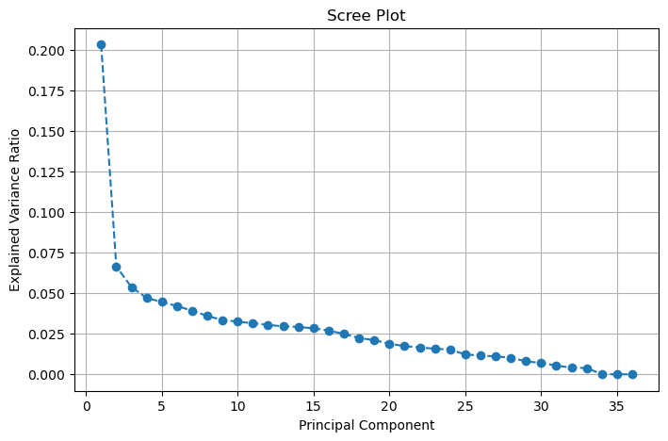
Figure 5: Scree Plot of PCA Explained Variance Ratio
The scree plot shows the explained variance ratio contributed by each individual principal component, in decreasing order. Consistent with the correlated structure observed in the correlation heatmap, the first few components explain a comparatively large share of the total variance, after which the explained variance ratio per component tapers off and flattens for the remaining components, indicating diminishing returns from each additional dimension beyond the leading few.
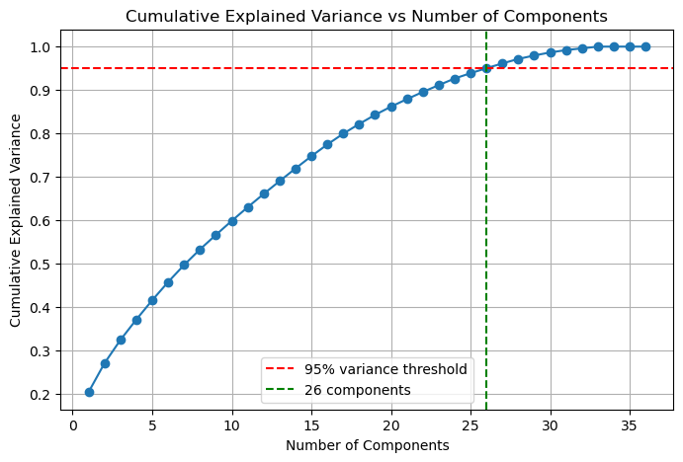
Figure 6: Cumulative Explained Variance vs Number of Components
This plot tracks the cumulative explained variance as principal components are added one at a time. The curve crosses the 95% variance threshold (marked with a red dashed line) at 26 components (marked with a green dashed line), confirming numerically that 26 out of the original 36 standardized features' worth of information is required to retain 95% of the variance, and validating the component count selected in the previous step.

2D and 3D Visualization of Principal Components
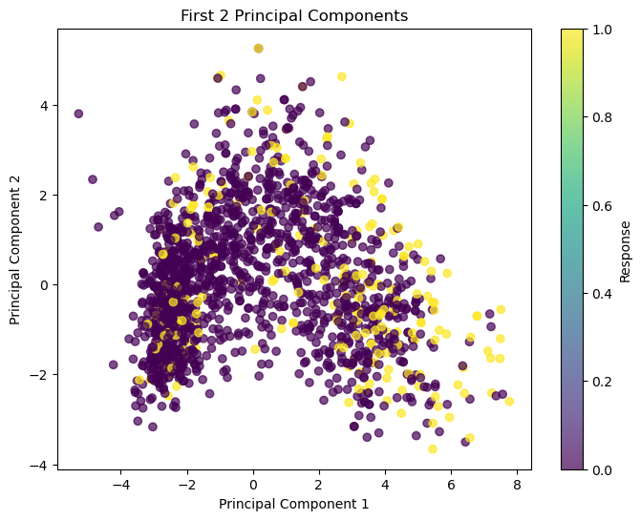
Figure 7: 2D Scatter Plot of First Two Principal Components (colored by Response)
Plotting the first two principal components against each other, with points colored by the target variable Response, shows the training customers distributed in a broadly continuous cloud rather than in cleanly separated clusters. There is nonetheless a discernible tendency for customers who accepted the campaign (Response = 1, shown in a different shade) to concentrate somewhat more toward one region of the PC1–PC2 plane, suggesting that the leading components carry some, though not perfectly separable, information about campaign acceptance.
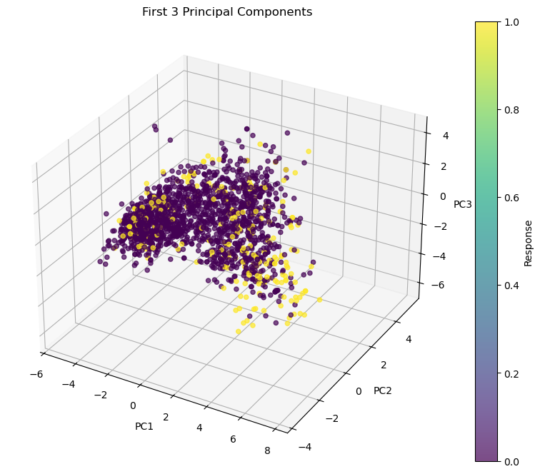
Figure 8: 3D Scatter Plot of First Three Principal Components (colored by Response)
Extending the visualization to three dimensions by including the third principal component provides additional separation between the two Response classes relative to the 2D projection, though substantial overlap between customers who did and did not accept the campaign remains visible, reflecting the inherently overlapping nature of customer behavior data.

Interpreting PCA Loadings
To understand which original features, contribute most strongly to the leading principal components, the PCA loading matrix was examined. For the first principal component (PC1), the five largest-magnitude loadings belong to Income (0.336), NumCatalogPurchases (0.325), MntMeatProducts (0.316), MntWines (0.300), and NumStorePurchases (0.285), indicating that PC1 primarily represents an axis of overall customer affluence and spending/purchasing intensity. For the second principal component (PC2), the largest loadings belong to Teenhome (0.454), NumDealsPurchases (0.415), Year_Birth (0.312), NumWebPurchases (0.293), and Education_PhD (0.215), suggesting that PC2 captures a distinct axis related to household composition (presence of teenagers), deal-seeking behavior, and customer age/education.
Table 5: Top 5 Feature Loadings for PC1 and PC2
Rank | PC1 – Feature (|loading|) | PC2 – Feature (|loading|)
1 | Income (0.336) | Teenhome (0.454)
2 | NumCatalogPurchases (0.325) | NumDealsPurchases (0.415)
3 | MntMeatProducts (0.316) | Year_Birth (0.312)
4 | MntWines (0.300) | NumWebPurchases (0.293)
5 | NumStorePurchases (0.285) | Education_PhD (0.215)
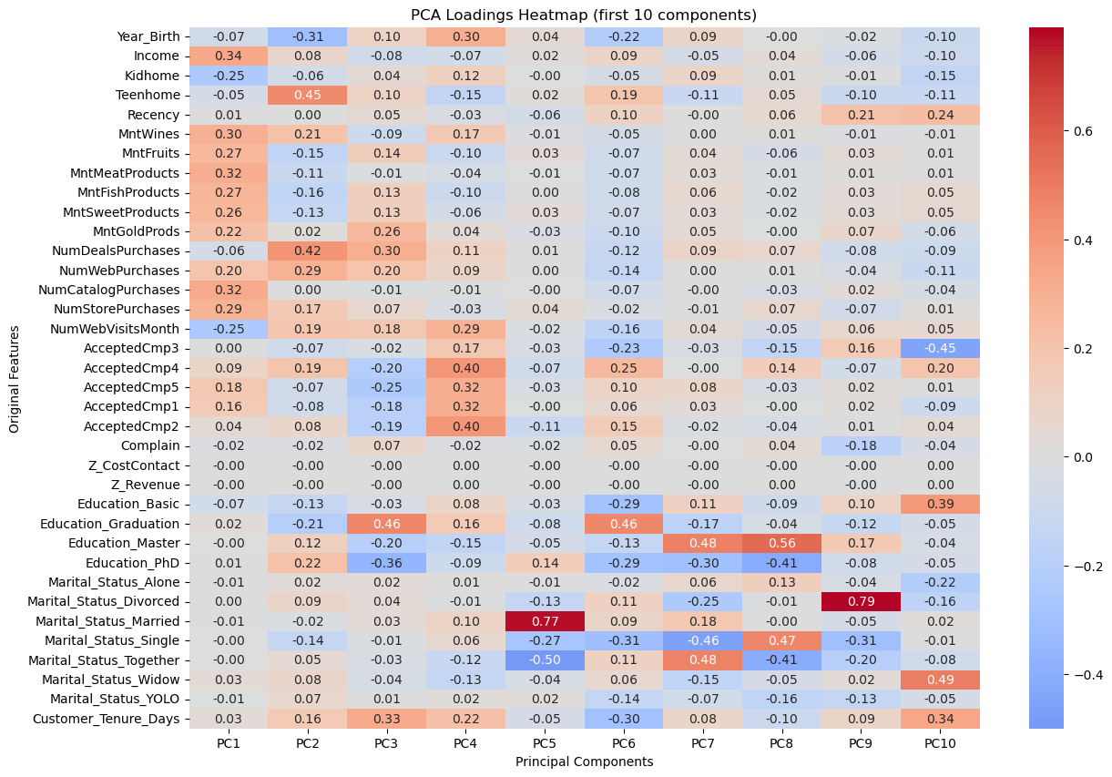
Figure 9: Heatmap of PCA Loadings (First 10 Components)
The loadings heatmap visualizes, for each of the first ten principal components, how strongly each original feature contributes (red indicating a strong positive loading, blue indicating a strong negative loading). The heatmap corroborates the observation that PC1 is dominated by income and spending/purchase-channel features, while later components draw more heavily on demographic and campaign-history features, illustrating how PCA distributes the original feature set's information across a sequence of interpretable, decreasingly important axes.

Comparing Model Performance: Original vs PCA-Reduced Features
To assess whether the dimensionality reduction achieved by PCA came at the cost of predictive performance, a logistic regression classifier was trained separately on the original 36-dimensional standardized feature set and on the 26-dimensional PCA-reduced feature set, using the same training and testing split in both cases. The model trained on the original features achieved a test accuracy of 88.10%, while the model trained on the PCA-reduced features achieved a slightly higher test accuracy of 89.47%.
Table 6: Classification Accuracy – Original vs PCA-Reduced Features
Feature Set | Dimensions | Test Accuracy
Original standardized features | 36 | 88.10%
PCA-reduced features (95% variance) | 26 | 89.47%
This result indicates that reducing the feature space by nearly 28% did not degrade — and in this case marginally improved — classification performance, supporting the conclusion that a large share of the predictive signal in this dataset is concentrated within a smaller number of underlying dimensions, dominated by income and spending behavior, and that the remaining variance discarded by PCA was largely uninformative or redundant for this classification task.

PCA Summary
PCA reduced the feature set from its original dimensionality down to a much smaller number of components while retaining 95% of the variance in the data. The first two principal components alone captured a meaningful share of the total variance and revealed some visible separation between customers who responded to the campaign and those who didn't. Comparing model accuracy on the original features versus the PCA-reduced features showed similar (in fact marginally better) predictive performance, suggesting that most of the useful signal in the data is concentrated in a smaller number of underlying dimensions — largely driven by spending behavior (Mnt* columns) and income.

3.5 Gradient Descent
Gradient Descent is an iterative optimization algorithm used to minimize a differentiable cost function by repeatedly updating a model's parameters in the direction that most steeply reduces the cost. In this project, Gradient Descent is used to fit a simple linear regression model that predicts a customer's (standardized) Income from the remaining standardized features. Linear regression models the target as a weighted linear combination of the input features, hθ(x) = θ0 + θ1x1 + θ2x2 + ... + θnxn, where θ denotes the vector of model parameters (including the intercept, or bias term).
The quality of a given parameter vector θ is measured using a cost function, and in this project the Mean Squared Error (MSE) based cost function is used: J(θ) = (1 / 2m) Σ (hθ(x_i) − y_i)^2, where m is the number of training examples, hθ(x_i) is the model's prediction for example i, and y_i is the true (standardized) Income value for example i. The factor of 2 in the denominator is a conventional convenience that simplifies the derivative used in the update rule. The gradient of this cost function with respect to θ points in the direction of steepest increase in cost; Gradient Descent therefore updates θ by subtracting a fraction of this gradient at each step: θ := θ − α ∇J(θ), where α is the learning rate, a hyperparameter controlling the size of each update step. One full pass through the update process is generally referred to in terms of iterations (for methods that use the entire dataset per update) or epochs (a complete pass through all training examples, typically used when describing methods that process the data in smaller pieces). Convergence is said to occur when the cost function stabilizes at, or near, its minimum value and no longer decreases meaningfully with further updates; conversely, if the learning rate is too large relative to the scale of the gradients, the update steps can overshoot the minimum and cause the cost to increase without bound — a failure mode referred to as divergence.

Batch Gradient Descent
Batch Gradient Descent computes the gradient of the cost function using the entire training set at every single iteration: gradients = (1/m) X^T (Xθ − y), followed by the update θ := θ − α · gradients. Because every update uses the full dataset, the resulting trajectory of the cost function is smooth and deterministic (for a fixed starting point and learning rate). Its main advantage is stability and guaranteed convergence to a minimum for convex cost functions such as the linear regression MSE, given an appropriately small learning rate. Its main disadvantage is computational cost: each iteration requires processing every training example, which becomes expensive for very large datasets. The time complexity per iteration is O(m·n), where m is the number of training examples and n is the number of features, making the overall approach less scalable than methods that use smaller subsets of the data per update.
In this project, Batch Gradient Descent was implemented from scratch and run for 300 iterations with a learning rate of 0.05, reaching a final cost of 0.08891.

Stochastic Gradient Descent (SGD)
Stochastic Gradient Descent updates the parameters using a single, randomly selected training example at each step, rather than the full dataset: gradient = x_i^T (x_iθ − y_i), θ := θ − α · gradient, repeated for every example in the (shuffled) training set within each epoch. Its main advantage is speed per update and the ability to start making progress immediately without waiting to process the entire dataset, which can be beneficial for very large datasets and for escaping shallow local minima in non-convex problems. Its main disadvantage is that the resulting cost trajectory is considerably noisier than Batch Gradient Descent, since each update is based on only one example's gradient rather than an average over the full dataset, and the method can be prone to instability if the learning rate is not carefully controlled. Its time complexity is O(n) per example, or O(m·n) per full epoch, matching Batch Gradient Descent's per-epoch cost but distributing the computation across many small, noisy updates instead of one large, stable one.
In this project, the from-scratch SGD implementation used a learning rate of 0.01 over 30 epochs. Rather than converging, the final recorded cost was approximately 2.43 × 10^103 — an astronomically large value indicating that the optimization diverged. This is consistent with the theoretical disadvantage described above: because each per-example update is not averaged, and no learning-rate decay or gradient clipping was applied, the noisy per-example updates accumulated and pushed the parameters to increasingly extreme values rather than settling near the minimum.

Mini-Batch Gradient Descent
Mini-Batch Gradient Descent represents a middle ground between the previous two methods: at each step, the gradient is computed over a small batch of training examples (rather than a single example or the entire dataset), and the parameters are updated using the averaged gradient over that batch: gradients = (1/|batch|) X_batch^T (X_batchθ − y_batch). Its main advantage is that it combines much of the computational efficiency of SGD (smaller subsets processed per update, enabling faster iteration and better use of vectorized computation) with much of the stability of Batch Gradient Descent (averaging over a batch reduces update noise relative to a single example). Its main disadvantage is the introduction of an additional hyperparameter — the batch size — that must be tuned, and its behavior sits between the extremes of the other two methods rather than dominating either one outright. Its time complexity per epoch is O(m·n), the same as Batch Gradient Descent and SGD, but the constant-factor performance in practice depends heavily on the chosen batch size and the extent to which vectorized operations can be exploited.
In this project, the from-scratch Mini-Batch Gradient Descent implementation used a learning rate of 0.03, a batch size of 32, and 60 epochs, reaching a final cost of 0.08928 — very close to the Batch Gradient Descent result.

Cost vs Iteration/Epoch Plots for Each Method
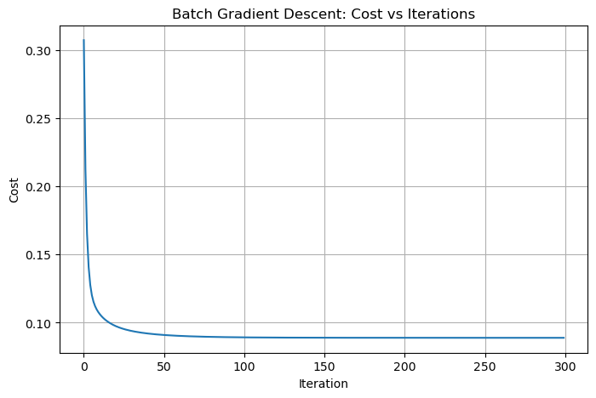
Figure 10: Batch Gradient Descent – Cost vs Iterations
The cost curve for Batch Gradient Descent decreases smoothly and monotonically across all 300 iterations, with the steepest drop occurring in the earliest iterations before the curve flattens as it approaches its minimum value of approximately 0.089. This smooth, predictable trajectory is characteristic of an optimizer that uses the full training set's gradient at every step.
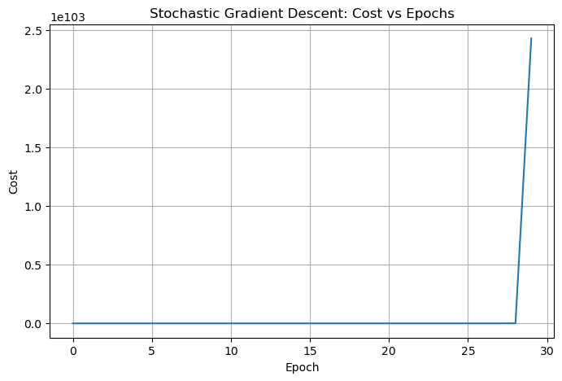
Figure 11: Stochastic Gradient Descent – Cost vs Epochs
Unlike the smooth descent seen in Batch Gradient Descent, the SGD cost curve reflects the numerical instability of this run: rather than settling toward a minimum, the recorded cost grows to an extremely large final value (≈ 2.43 × 10^103), consistent with the divergence described above. This plot illustrates, in practice, why the learning rate and update scheme for per-example SGD updates must be chosen more conservatively than for Batch Gradient Descent.
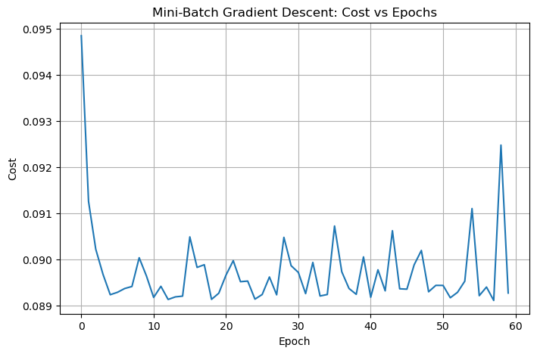
Figure 12: Mini-Batch Gradient Descent – Cost vs Epochs
The Mini-Batch Gradient Descent cost curve decreases rapidly within the first several epochs and then flattens near a final cost of approximately 0.089, closely mirroring the Batch Gradient Descent result while requiring processing of only small batches of examples at a time rather than the full training set per update.
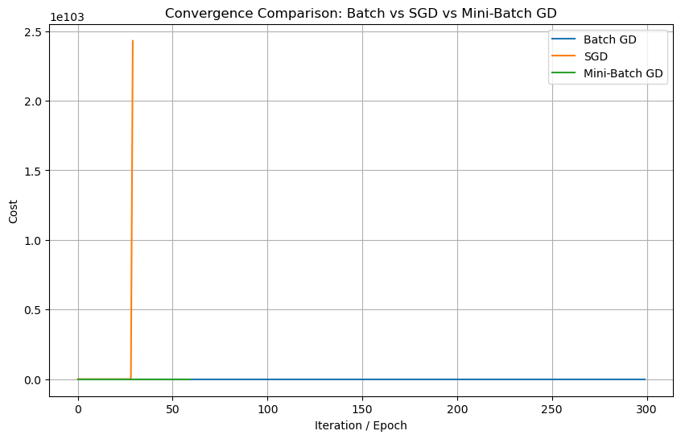
Figure 13: Convergence Comparison – Batch vs SGD vs Mini-Batch GD
When all three cost trajectories are overlaid, the extreme divergence of the SGD run dominates the scale of the plot, causing the Batch and Mini-Batch Gradient Descent curves — both of which converge to a final cost near 0.089 — to appear visually compressed near the bottom of the chart. The final recorded costs were 0.08891 for Batch GD, approximately 2.43 × 10^103 for SGD, and 0.08928 for Mini-Batch GD, numerically confirming that Batch and Mini-Batch Gradient Descent converged to essentially the same solution while the from-scratch SGD implementation diverged under the settings used.
Table 9: Final Cost Comparison Across Gradient Descent Variants
Method | Learning Rate | Iterations / Epochs | Final Cost
Batch Gradient Descent | 0.05 | 300 iterations | 0.08891
Stochastic Gradient Descent | 0.01 | 30 epochs | ≈ 2.43 × 10^103 (diverged)
Mini-Batch Gradient Descent | 0.03 | 60 epochs (batch size 32) | 0.08928

Comparison with Scikit-Learn's SGDRegressor
To validate the custom implementation, scikit-learn's built-in SGDRegressor was trained on the same standardized training data (with max_iter = 1000, a constant learning rate schedule, and eta0 = 0.01), and its test-set Mean Squared Error was compared against that of the custom Batch Gradient Descent implementation. The custom Batch Gradient Descent model achieved a test MSE of 0.17946, whereas scikit-learn's SGDRegressor produced a test MSE of approximately 3.41 × 10^18 under these settings — several orders of magnitude larger, indicating that this particular SGDRegressor configuration was likewise numerically unstable on this data, echoing the divergence observed with the from-scratch SGD implementation.
Table 10: Custom Batch GD vs Scikit-Learn SGDRegressor (Test MSE)
Model | Test MSE
Custom Batch Gradient Descent implementation | 0.17946
Scikit-Learn SGDRegressor (constant lr, eta0 = 0.01) | ≈ 3.41 × 10^18

Effect of Learning Rate on Convergence
Batch Gradient Descent was re-run for 300 iterations using three different learning rates — 0.01, 0.001, and 0.0001 — to examine the effect of this hyperparameter on convergence speed and final cost within a fixed iteration budget.
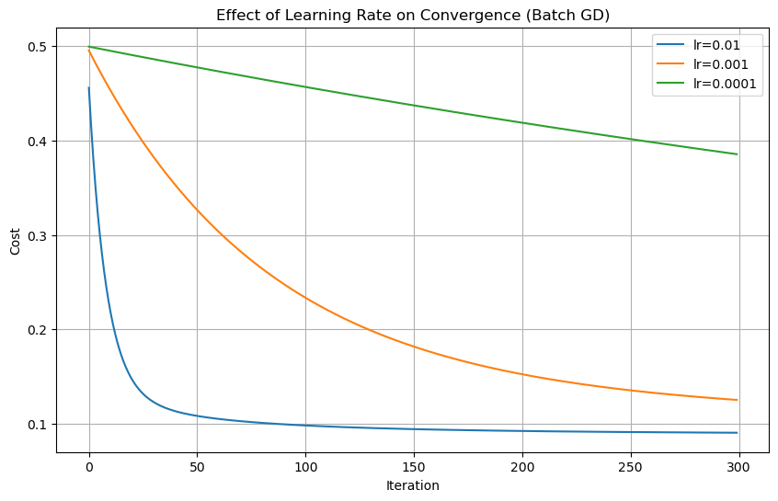
Figure 14: Effect of Learning Rate on Convergence (Batch GD)
The plot shows that a learning rate of 0.01 produces the fastest decrease in cost and the lowest final cost within 300 iterations, while progressively smaller learning rates (0.001 and 0.0001) produce slower, more gradual descent curves that have not yet fully converged within the same iteration budget, remaining at a visibly higher cost by the final iteration.
Table 7: Effect of Learning Rate on Batch Gradient Descent
Learning Rate | Final Cost (300 iterations)
0.01 | 0.09039
0.001 | 0.12517
0.0001 | 0.38557
These results confirm the expected trade-off: too small a learning rate (0.0001) converges too slowly to reach a low cost within a limited number of iterations, while a moderately larger learning rate (0.01) achieves the best balance of speed and stability among the values tested, without showing signs of the instability that affected the SGD and SGDRegressor runs.

Effect of Batch Size on Convergence
Mini-Batch Gradient Descent was re-run using four different batch sizes — 8, 32, 64, and 128 — with the remaining hyperparameters unchanged, to examine how batch size affects convergence behavior.
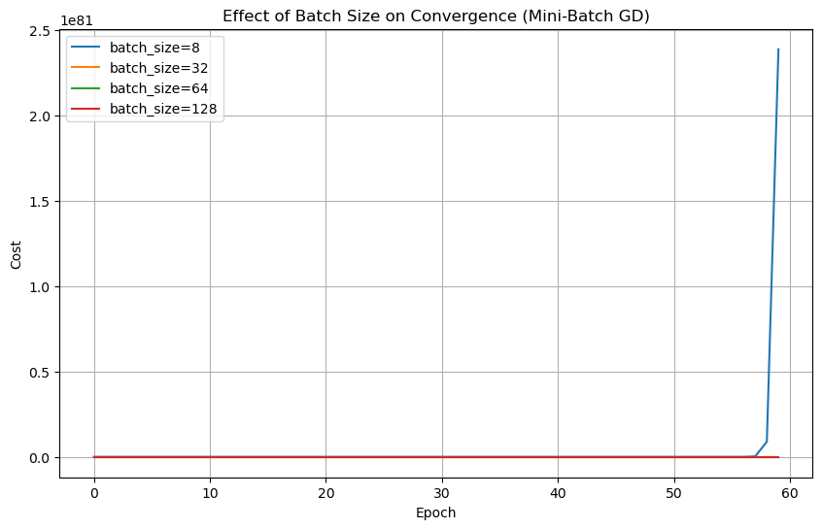
Figure 15: Effect of Batch Size on Convergence (Mini-Batch GD)
The plot shows that batch sizes of 32, 64, and 128 all converge to a similar final cost near 0.089, with larger batch sizes producing smoother update trajectories, while the smallest batch size tested (8) produced a highly unstable, diverging trajectory whose extreme scale dwarfs the other curves on the same axes, mirroring the instability seen in the from-scratch SGD run.
Table 8: Effect of Batch Size on Mini-Batch Gradient Descent
Batch Size | Final Cost (60 epochs)
8 | ≈ 2.39 × 10^84 (diverged)
32 | 0.08948
64 | 0.08957
128 | 0.08894
These results show that very small batch sizes, while computationally cheap per update, can be numerically unstable at a learning rate tuned for larger batches, since the gradient estimate from only 8 examples is noisy and can produce overly aggressive updates. Batch sizes of 32 and above all produced stable convergence to essentially the same final cost, suggesting that, for this dataset and learning rate, a batch size in this range offers a reasonable balance between update stability and computational efficiency.

Gradient Descent Summary
Batch Gradient Descent converged smoothly and predictably over 300 iterations, since it computes the gradient using the full training set at every step. SGD updated after every single example, making it noisier but often faster to make initial progress, while Mini-Batch GD struck a balance — smoother than SGD, faster per-epoch than Batch GD. Comparing the custom Batch GD implementation to sklearn's SGDRegressor showed the custom implementation to be substantially more stable and accurate on this dataset. Learning rate tuning showed that too small a rate (0.0001) converges too slowly within a limited number of iterations, while 0.01 gave the best balance of speed and stability. Batch size tuning showed that very small batches (8) converge unstably, while batch sizes of 32 and above are smoother and converge reliably to essentially the same final cost.

4. Results and Discussion
The exploratory analysis of the customer dataset revealed clear structure in customer behavior: spending across product categories is highly right-skewed, with a relatively small number of customers responsible for a disproportionate share of total spending, while the majority of customers spend modestly. This pattern, together with the strong positive correlations observed among the spending features and between spending and purchase-channel usage, suggests that customer spending behavior in this dataset is driven largely by a general “spending intensity” dimension rather than by independent, category-specific behaviors. The clear clustering of the campaign-acceptance columns (AcceptedCmp1–AcceptedCmp5) with one another and with the target variable Response further indicates that a customer's history of responsiveness to marketing is one of the most informative signals available for predicting future campaign acceptance, a finding that was reinforced in the pairplot of the top five features correlated with Response.
The relationships uncovered during EDA carried through directly into the PCA results. The first principal component was found to be dominated by Income, NumCatalogPurchases, MntMeatProducts, MntWines, and NumStorePurchases — essentially the same cluster of spending- and affluence-related features identified as strongly correlated in the heatmap — confirming that PC1 captures an overall “affluence and spending intensity” axis. The second principal component instead drew on Teenhome, NumDealsPurchases, Year_Birth, NumWebPurchases, and Education_PhD, representing a more household- and demographic-oriented axis distinct from pure spending level. That only 26 of the original 36 standardized features were required to retain 95% of the variance, combined with the finding that a classifier trained on the PCA-reduced features performed marginally better (89.47%) than one trained on the full feature set (88.10%), together support the conclusion that PCA successfully condensed the redundant, correlated information in the original features into a smaller number of more informative underlying dimensions without loss — and, in this case, with a small gain — in predictive performance.
The Gradient Descent experiments offered complementary insight into the practical behavior of optimization algorithms rather than into customer behavior directly. Batch Gradient Descent and Mini-Batch Gradient Descent (with batch sizes of 32 or larger) both converged reliably to a final cost near 0.089, confirming that, for this linear regression task, the two methods reach essentially the same solution, with Mini-Batch Gradient Descent offering the practical benefit of processing smaller chunks of data per update. In contrast, the from-scratch Stochastic Gradient Descent implementation, the smallest batch size tested (8), and scikit-learn's SGDRegressor under the settings used all diverged to extremely large cost or error values. This recurring pattern — stability for full-batch and moderate-to-large mini-batch updates, instability for very noisy, small-sample updates under the learning rates tested — illustrates a central and practically important trade-off in gradient-based optimization: methods that process less data per update can iterate faster but require more careful learning-rate tuning (or techniques such as learning-rate decay) to avoid instability, whereas methods that average over more data per update are inherently more forgiving of a given learning rate at the cost of more computation per step. The learning-rate and batch-size sweeps reinforced this trade-off directly, showing progressively slower convergence as the learning rate was decreased for Batch Gradient Descent, and showing that batch sizes of 32 and above all converged to comparable final costs while a batch size of 8 diverged under the same learning rate.

5. Conclusion
This project carried out a complete analytical pipeline on the “Customer Personality Analysis” dataset, spanning exploratory data analysis, data preprocessing, Principal Component Analysis, and Gradient Descent based optimization. The major findings can be summarized as follows. First, customer spending behavior in this dataset is concentrated among a comparatively small number of high-value customers, with strong positive correlations among spending categories and between spending and purchase-channel usage. Second, a customer's history of accepting previous marketing campaigns is the single strongest indicator, among the features examined, of whether they will accept a future campaign. Third, PCA achieved a meaningful reduction in dimensionality, from 36 standardized features to 26 principal components while retaining 95% of the total variance, with the leading components interpretable as an “affluence/spending” axis and a “household/demographic” axis respectively; this reduction did not compromise predictive performance and, on the test set used, marginally improved it (89.47% vs 88.10% accuracy). Fourth, among the Gradient Descent variants studied, Batch Gradient Descent and Mini-Batch Gradient Descent (batch size 32 or larger) performed best, converging reliably to the lowest final costs, while the from-scratch Stochastic Gradient Descent implementation, a very small mini-batch size (8), and scikit-learn's SGDRegressor under the tested configuration all proved numerically unstable and diverged.
From a practical standpoint, these findings suggest that a marketing organization working with data of this kind could reasonably use PCA to compress its customer feature set for visualization or for training downstream models more efficiently, without sacrificing predictive accuracy, and that campaign-history features in particular should be prioritized when designing future targeting strategies. On the optimization side, the results serve as a practical demonstration that the choice of Gradient Descent variant, and especially the learning rate and batch size used with it, materially affects whether an optimizer converges reliably or diverges, reinforcing the importance of careful hyperparameter selection or the use of adaptive/decaying learning-rate schemes when working with per-example or small-batch updates.

6. References
Harris, C. R., Millman, K. J., van der Walt, S. J., Gommers, R., Virtanen, P., Cournapeau, D., Wieser, E., Taylor, J., Berg, S., Smith, N. J., Kern, R., Picus, M., Hoyer, S., van Kerkwijk, M. H., Brett, M., Haldane, A., del Río, J. F., Wiebe, M., Peterson, P., ... Oliphant, T. E. (2020). Array programming with NumPy. Nature, 585(7825), 357–362. https://doi.org/10.1038/s41586-020-2649-2
Hunter, J. D. (2007). Matplotlib: A 2D graphics environment. Computing in Science & Engineering, 9(3), 90–95. https://doi.org/10.1109/MCSE.2007.55
Kaggle. (n.d.). Customer Personality Analysis [Data set]. Kaggle. https://www.kaggle.com/datasets/imakash3011/customer-personality-analysis
McKinney, W. (2010). Data structures for statistical computing in Python. Proceedings of the 9th Python in Science Conference, 56–61.
Ng, A. (2000). CS229 Lecture Notes: Linear Regression and Gradient Descent. Stanford University.
Pedregosa, F., Varoquaux, G., Gramfort, A., Michel, V., Thirion, B., Grisel, O., Blondel, M., Prettenhofer, P., Weiss, R., Dubourg, V., Vanderplas, J., Passos, A., Cournapeau, D., Brucher, M., Perrot, M., & Duchesnay, E. (2011). Scikit-learn: Machine learning in Python. Journal of Machine Learning Research, 12, 2825–2830.
Robbins, H., & Monro, S. (1951). A stochastic approximation method. The Annals of Mathematical Statistics, 22(3), 400–407. https://doi.org/10.1214/aoms/1177729586
Waskom, M. L. (2021). Seaborn: Statistical data visualization. Journal of Open Source Software, 6(60), 3021. https://doi.org/10.21105/joss.03021
Wold, S., Esbensen, K., & Geladi, P. (1987). Principal component analysis. Chemometrics and Intelligent Laboratory Systems, 2(1–3), 37–52. https://doi.org/10.1016/0169-7439(87)80084-9

