Table S3. Mutations identified in the whole genome sequencing data of LL-37 resistant isolate 1 (original mutant DA16874). Genes examined in this study are marked in bold.
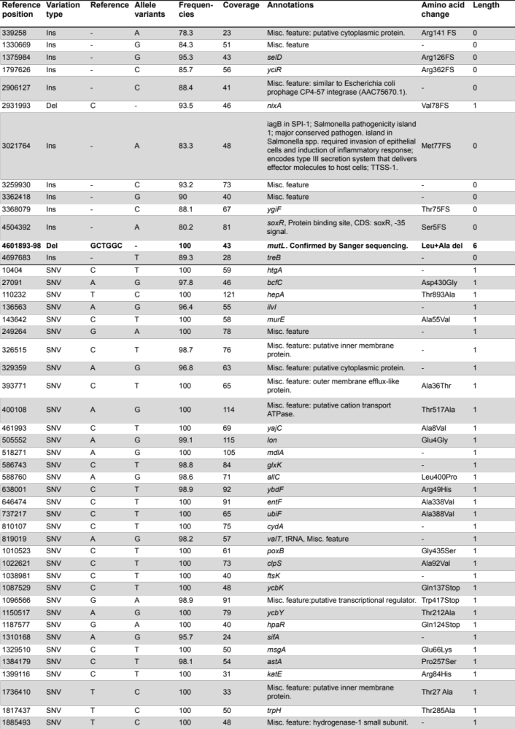
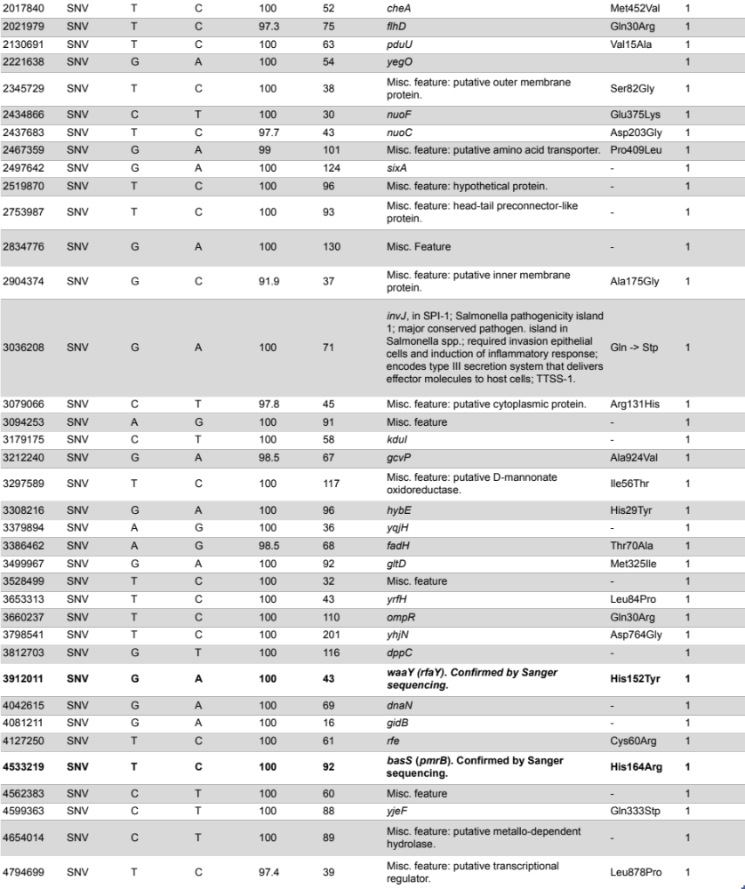
SNV, single nucleotide change; Ins, insertion; Del, deletion; -, no amino acid change or not applicable.

