Table S4. Mutations identified in the whole genome sequencing data of LL-37 resistant isolate 2 (original mutant DA17847). Genes examined in this study are marked in bold.
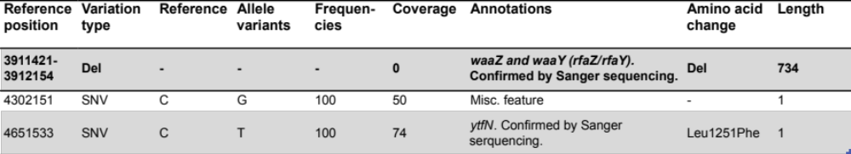
SNV, single nucleotide change; Ins, insertion; Del, deletion; -, no amino acid change or not applicable.

