Table S5. Mutations identified in the whole genome sequencing data of Wheat germ histone resistant isolate 1 (original mutant DA16875). Genes examined in this study are marked in bold.
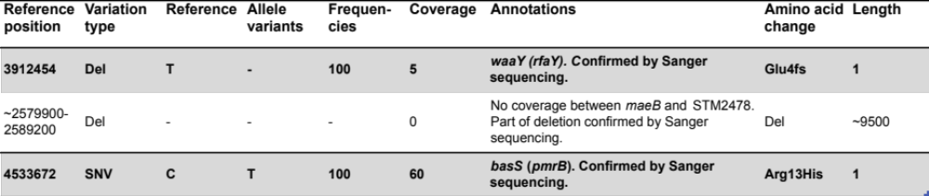
SNV, single nucleotide change; Ins, insertion; Del, deletion; -, no amino acid change or not applicable.

