Table S6. Mutations identified in the whole genome sequencing data of CNY100HL resistant isolate 1 (original mutant DA17610). Genes examined in this study are marked in bold.
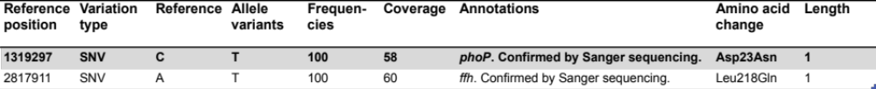
SNV, single nucleotide change; Ins, insertion; Del, deletion; -, no amino acid change or not applicable.

