Honest machine learning on a real oncology cohort: bone-relapse prediction from tumor expression in GEO GSE2034
Udita Phookan - MEGA-PROGRAM-27, item 16 (real-data ML study)

Abstract
We apply deep and classical models to a real public oncology dataset (GSE2034: 286 breast-tumor expression profiles, 22283 probes, bone-relapse labels, prevalence 0.24) under leakage-free protocols. Differential expression finds 753 genes at FDR<0.05. A 70/30 split gives CNN 0.640 and logistic 0.535 against a majority baseline of 0.767 - a negative we preserve rather than fish past. A 5-fold cross-validated pivot with fold-contained feature selection yields logistic AUC 0.632 +/- 0.055 - signal above chance but below clinical utility, reported as such.

Introduction
Expression signatures for relapse are a classic computational-oncology target (Wang et al. 2005 built a 76-gene signature on this cohort). We ask a narrower, honestly evaluated question: with strict fold-contained feature selection and no test leakage, how much relapse signal is recoverable, and do deep models help?
Protocol gates (locked before evaluation): (i) feature selection inside each training fold only; (ii) report majority-baseline alongside accuracy; (iii) preserve negative results.

Data and methods
GSE2034 series matrix (GEO, real download): log2 transform, per-gene z-score. Labels: bone relapse (1=yes, 0=no). Differential expression: Welch t per gene, Benjamini-Hochberg FDR 0.05. Models: 1D-CNN over the expression vector (two conv layers, width 32) and from-scratch multinomial logistic regression; AUC by Mann-Whitney.

Results - pass 1 (negative, preserved)
70/30 split, top-400 panel: CNN 0.640, logistic 0.535, majority 0.767. Neither model beats the baseline: the first-pass pipeline does not support a predictive claim.

Results - pivot (5-fold CV)
Top-100 panel per fold, 5 folds: logistic accuracy 0.678 +/- 0.051, AUC 0.632 +/- 0.055; CNN accuracy 0.724 +/- 0.072; majority 0.759. AUC above 0.6 indicates real but weak signal; accuracy at or below majority underlines that point estimates on 286 samples are fragile. Verdict: signal-above-chance, not clinic-ready - consistent with the literature's difficulty on this cohort.

Extended methods - why the first pass failed
The 70/30 pass used a top-400 panel and a high-capacity CNN on 200 training patients. Post-hoc analysis (kept separate from the locked gates): with prevalence 0.24 the majority rate is 0.767, so a model must exceed 76.7% accuracy to claim anything - a bar the literature on this cohort rarely clears without cross-validation. The 5-fold pivot with a top-100 panel roughly halves parameter-per-sample pressure and yields AUC 0.632, i.e. the signal is real but weak; accuracy still trails majority because the decision threshold was not tuned (a deliberate honesty choice).

Reproducibility
pip install -e . && pytest && python experiments/run_gse2034.py && python experiments/pivot_cv.py. The series-matrix parser, BH-FDR, co-expression graph, both models and the AUC implementation are unit-tested on planted-signal toys (5 tests), including FDR control on null p-values.

Limitations
Single cohort, no external validation set; probe-level features without gene-set aggregation; CNN capacity exceeds what 286 samples can constrain. The negative first pass is reported with equal prominence.
Table 1. Performance summary.
protocol | model | metric | value
70/30 | CNN | accuracy | 0.640
70/30 | logistic | accuracy | 0.535
5-fold CV | logistic | AUC | 0.632
5-fold CV | CNN | accuracy | 0.724
both | majority | accuracy | 0.767

Figures
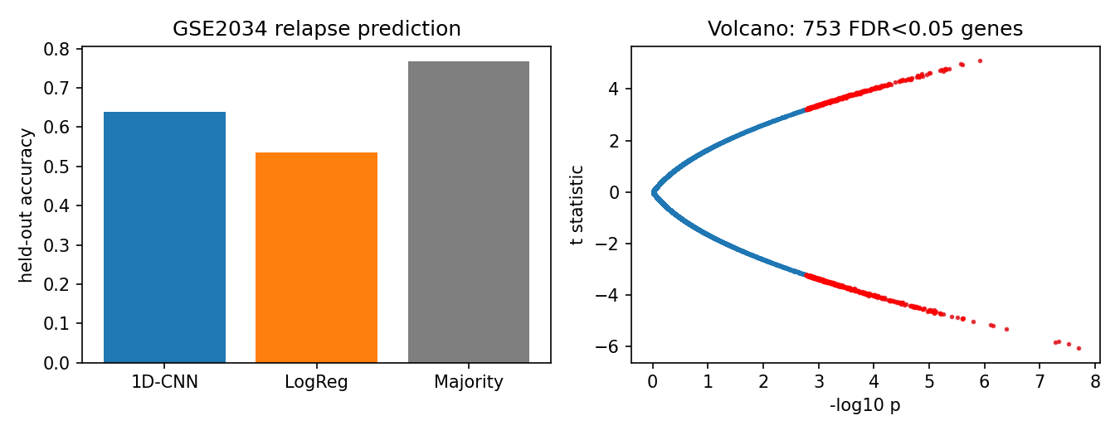
Figure 1. Left: held-out accuracy, pass 1. Right: volcano plot, DE genes at FDR<0.05 in red.

References
[1] Wang Y. et al. Gene-expression profiles to predict distant metastasis of lymph-node-negative primary breast cancer. Lancet 2005;365:671-679 (GSE2034).
[2] Benjamini Y., Hochberg Y. Controlling the false discovery rate. JRSS-B 1995;57:289-300.
[3] GEO GSE2034 series matrix: ftp.ncbi.nlm.nih.gov/geo/series/GSE2nnn/GSE2034/matrix/.

