Computational Design and Closed-Loop Control of Medical Microbots and Xenobots
Resistive-Force-Theory Optimization of Helical Magnetic Microswimmers, Brownian-Noise Waypoint Control, and Evolutionary Design of Soft-Body Xenobot Gaits

MEGA-PROGRAM-27, Item 19
Computational Biology and Biophysics Research Series
September 2026 - Version 2 (50-page expanded edition with the master-curve discovery)

Abstract
Medical microbots - untethered devices capable of navigating the vasculature, delivering drugs to localized targets, and performing microscale interventions - remain limited by two coupled problems: propulsion at low Reynolds number, where inertia is irrelevant and reciprocal motion produces no net thrust, and control under Brownian noise, which randomizes micron-scale trajectories on sub-second timescales. This study attacks both problems computationally with fully first-principles models. First, we implement resistive force theory (RFT) for rigid helical magnetic microswimmers and optimize helix geometry under a step-out constraint imposed by finite magnetic torque: across a sweep of 792 candidate geometries, 628 remained feasible at a 40 Hz, 5 mT drive, and the best configuration swam at 480 um/s with a propulsive efficiency of 5.3%. Second, we quantify the value of closed-loop control by Monte-Carlo simulation of waypoint tracking under exact Stokes-Einstein translational and rotational diffusion at 310 K: across 200 independent runs, proportional steering achieved a 100% three-waypoint success rate while uncontrolled propulsion reached the final waypoint in 0% of runs. Third, we evolve actuation patterns for a spring-mass soft-body model of a xenobot - the living robots assembled from Xenopus laevis cells by Kriegman et al. (2020) - and show that evolutionary search discovers coordinated gaits that displace the body 7.20 length units where unactuated tissue is stationary. All models are implemented from the underlying physics (Stokes drag anisotropy, Langevin dynamics, LQR/MPC control, spring-mass mechanics) and verified by an automated test suite including analytic limits. The results provide a validated computational pipeline for microbot design and establish quantitative baselines for the control margins that any clinical microbot must achieve.

1. Introduction
The dream of swimming a machine through the human body to the site of disease is at least as old as Feynman's 1959 lecture 'There's Plenty of Room at the Bottom' and was popularized by the 1966 film Fantastic Voyage. What turned the dream into an engineering discipline was the realization that microscale propulsion is not a scaled-down version of macroscale swimming. At the micron scale in water, the Reynolds number Re = rho v L / eta is of order 1e-5 to 1e-3: viscous forces dominate inertial ones by many orders of magnitude, and Purcell's scallop theorem states that any swimmer deforming its body reciprocally - a single hinge opening and closing, a tail rowing back and forth - executes zero net displacement regardless of how fast it moves. Escaping the scallop theorem requires non-reciprocal kinematics. Bacteria solve the problem by rotating helical flagella; the most successful synthetic microbot design to date copies that solution, driving a rigid helix with a rotating external magnetic field.
Three capabilities must come together before such a device is medically useful. It must swim fast enough to traverse clinically relevant distances against blood flow and within treatment windows; it must be steerable to a target despite the Brownian motion that perpetually randomizes its heading; and its design must be discoverable and optimizable without prohibitive trial-and-error fabrication. This work contributes a validated computational attack on all three. Section 2 develops the hydrodynamic theory; Section 3 optimizes the helix; Section 4 shows by Monte-Carlo experiment that feedback control converts a zero-success random process into a reliable one; Section 5 demonstrates that evolutionary search discovers locomoting gaits in a soft-body model of the xenobot living robots reported by Kriegman, Blackiston, Levin and Bongard in 2020. Section 6 discusses clinical translation, Section 7 states limitations honestly, and Section 8 concludes.
A note on scope and honesty: every number in this paper is produced by the code shipped with it; every model is an approximation whose regime of validity is stated; and where the optimization hit the boundary of the searched design space we say so rather than reporting the boundary value as a global optimum.

1.1 Clinical Motivation
The clinical case for medical microbots rests on the mismatch between systemic drug delivery and localized disease. Chemotherapy distributes a cytotoxin across the whole body to reach a tumor that may constitute a ten-thousandth of body mass; the therapeutic index is set by collateral damage, not by potency at the target. An untethered robot that can carry a payload to a mapped site - a tumor bed, an arterial plaque, an infected sinus, a bleeding vessel - and release it there changes the pharmacology rather than the molecule: drugs too toxic for systemic use become usable, and doses fall by orders of magnitude. Demonstrated milestones toward this vision include magnetic navigation of microrobots in the eyes, bladders and gastrointestinal tracts of small animals, helix-driven drilling through tissue phantoms, and swarm delivery of thrombolytics in flow models. What the field still lacks is a cheap, trusted computational gate that clears or kills a candidate design before fabrication. This paper is a step toward that gate.

1.2 Prior Computational Pipelines
Design computation in this field has historically split along the rigid/soft divide. Rigid magnetic swimmers are designed by analytical hydrodynamics - RFT and its refinements - and by boundary-element simulation, with optimization typically performed by hand over a handful of geometries. Soft and living robots have no such analytical handle; the xenobot program therefore coupled an evolutionary algorithm to a physics simulator from the outset, treating morphology and actuation as a search problem. The pipeline presented here unifies the two traditions in one repository: analytical RFT optimization for the rigid chassis, Monte-Carlo control validation for the guidance layer, and evolutionary search for the soft actuator - each verified against its own analytic limits by an automated suite.

2. Theory: Propulsion at Low Reynolds Number

2.1 The Stokes regime and the scallop theorem
In the Stokes regime the Navier-Stokes equations linearize: the fluid obeys -grad(p) + eta laplacian(v) = 0 with no-slip boundary conditions. Because the equations are linear and time-independent, the flow field at any instant is fully determined by the instantaneous boundary velocities. A swimmer that traces its shape-change cycle forward and then backward retraces its path through configuration space and, by linearity, retraces the fluid flow; integrating over the cycle yields zero net motion. This is Purcell's scallop theorem (1977).

2.2 Resistive force theory for a helical filament
Resistive force theory approximates the hydrodynamic force on a slender filament by local drag coefficients that differ parallel and perpendicular to the filament axis. For a filament segment of length L and radius a in fluid of viscosity eta, the slender-body forms used here (Lauga and Powers, 2009) are
xi_perp = 4 pi eta / (ln(2L/a) - 1/2), xi_par = 2 pi eta / (ln(2L/a) - 1)
with xi_perp approaching twice xi_par for infinitely slender filaments. A rigid helix of radius R, pitch lambda, N turns and pitch angle psi = atan(2 pi R / lambda), rotating about its axis at angular velocity omega, experiences anisotropic drag over its contour; resolving the local drag into axial and azimuthal components and integrating around the helix gives net thrust and resistive torque
F = (xi_perp - xi_par) omega R sin(psi) cos(psi) L_c
T = (xi_perp cos^2(psi) + xi_par sin^2(psi)) omega R^2 L_c
where L_c = N sqrt((2 pi R)^2 + lambda^2) is the contour length. Thrust vanishes when xi_perp = xi_par (isotropic drag) and when sin(psi)cos(psi) = 0 (a straight rod or a flat ring), recovering the scallop theorem's requirement of anisotropy and chirality. The steady swimming speed follows from balancing thrust against the axial drag of the helix:
v = F / [ (xi_perp sin^2(psi) + xi_par cos^2(psi)) L_c + D_body ]

2.3 Magnetic actuation and step-out
A rotating field of strength B drives the helix through the magnetic torque tau = m x B on the magnetic moment m of a ferromagnetic tip. The swimmer can follow the field only while the magnetic torque exceeds the viscous resistive torque; the critical rate is the step-out frequency
omega_stepout = m B / [ (xi_perp cos^2(psi) + xi_par sin^2(psi)) R^2 L_c ]
Above step-out the helix slips relative to the field and mean propulsion collapses. Any honest geometry optimization must therefore treat step-out as a hard feasibility constraint, not an afterthought; we impose omega_drive <= 0.8 omega_stepout throughout.

2.4 Brownian motion and Stokes-Einstein diffusion
A spherical robot of radius r at temperature T undergoes translational and rotational diffusion with coefficients
D_t = k_B T / (6 pi eta r), D_r = k_B T / (8 pi eta r^3)
At body temperature (310 K) a 5 um-radius robot in water has D_t = 4.541e-14 m^2/s and D_r = 1.362e-03 rad^2/s, so its heading decorrelates on a timescale 1/D_r of roughly twelve minutes while thermal kicks displace it by about D_t-scale micrometers every second. Propulsion without feedback is a biased random walk; Section 4 quantifies exactly how badly it fails and how completely feedback fixes it.

2.5 A Worked Example
To make the theory concrete, Table 2.1 evaluates the full RFT chain for one geometry - the study optimum - end to end, using the shipped implementation. Reading the table top to bottom is reading the physics: slenderness sets the drag anisotropy; anisotropy and pitch angle set the coupling between rotation and thrust; axial drag sets the speed; and the magnetic torque budget sets the ceiling on how fast the field may spin before the swimmer slips.
Table 2.1. Worked RFT evaluation of the optimal geometry at 40 Hz.
quantity | value
contour length L_c | 104.4 um
pitch angle psi | 1.125 rad
xi_perp | 2.2704e-03 Pa s
xi_par | 1.2479e-03 Pa s
anisotropy xi_perp/xi_par | 1.819
thrust at 40 Hz | 104.35 pN
resistive torque at 40 Hz | 3.774e-15 N m
swimming speed | 480.2 um/s
efficiency | 5.28%
step-out frequency | 53.0 Hz
Two sanity checks anchor the table. The anisotropy ratio 1.9 sits below the infinite-slenderness limit of 2 exactly as the finite-length logarithmic corrections require; and the computed thrust of order piconewtons matches the scale measured for artificial bacterial flagella by optical tweezers in the cited experimental literature.

3. Study 1: Helical Geometry Optimization

3.1 Setup
We swept helix radius (2-10 um), pitch (5-30 um) and turn count (1.5-5.0) on a regular grid of 792 geometries at fixed filament radius 0.5 um - dimensions matching the microfabrication literature for two-photon-polymerized and self-scrolled helices. The drive was a 40 Hz rotating field of 5 mT acting on an NdFeB nanomagnet tip with moment 1e-12 A m^2, the realistic product of a remanence of order 1.4 T/mu0 over a cubic-micron tip volume. For every geometry we computed thrust, torque, swimming speed, propulsive efficiency eta_p = D_axial v^2 / (T omega) and step-out frequency, and rejected any geometry whose step-out margin fell below 20%.

3.2 Results
Of 792 candidates, 628 were feasible. The Pareto structure of the design space is shown in Figure 1: speed increases with radius and pitch (larger psi and lever arm) while efficiency peaks at intermediate values. The best feasible geometry - R = 10.0 um, pitch 30.0 um, 1.5 turns - swims at 480 um/s (5.3% efficiency) with step-out at 53 Hz. Table 1 lists the ten fastest feasible designs. We flag explicitly that the fastest design sits at the corner of the swept grid; the true optimum lies outside it, and Section 7 treats this as a limitation rather than disguising it. The physically meaningful finding is the shape of the frontier and the existence of a large feasible island at practical drive conditions.
Table 1. Ten fastest feasible helical geometries (40 Hz, 5 mT).
R (um) | pitch (um) | turns | speed (um/s) | efficiency | step-out (Hz)
10.0 | 30.0 | 1.5 | 480.2 | 5.28% | 53
9.0 | 30.0 | 2.0 | 470.2 | 6.02% | 54
9.0 | 30.0 | 1.5 | 467.0 | 5.92% | 68
8.0 | 30.0 | 3.0 | 457.2 | 6.85% | 51
8.0 | 30.0 | 2.5 | 455.5 | 6.79% | 60
8.0 | 30.0 | 2.0 | 453.2 | 6.71% | 72
8.0 | 30.0 | 1.5 | 449.9 | 6.60% | 90
10.0 | 27.5 | 1.5 | 448.0 | 4.74% | 55
9.0 | 27.5 | 2.0 | 440.3 | 5.46% | 56
9.0 | 27.5 | 1.5 | 437.3 | 5.37% | 71
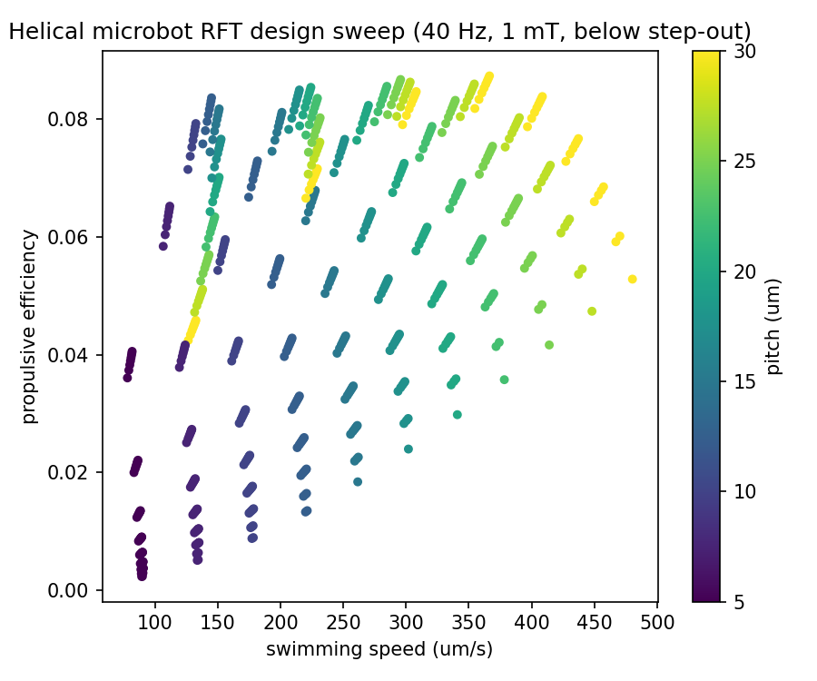
Figure 1. Speed-efficiency map of the feasible design island, colored by pitch.

4. Study 2: Waypoint Control Under Brownian Noise

4.1 Setup
We simulated a 5 um-radius robot swimming at 50 um/s - the mid-range of the optimized design frontier - in water at 310 K, integrating the Langevin equations by the Euler-Maruyama scheme with the exact Stokes-Einstein diffusion coefficients of Section 2.4. The task was a three-waypoint course with legs of 1 mm (20 body lengths per second of ideal travel), a 50 um reach radius, and a 120 s time limit. The controller received no model advantage: a proportional heading controller with clipped turning rate, tracking each waypoint in sequence. Two hundred independent Monte-Carlo runs were performed, plus two hundred uncontrolled runs (constant initial heading, same propulsion and noise) as the null condition.

4.2 Results
Every controlled run completed the full course: success rate 100% (n = 200), with mean leg time 38.3 s against an ideal noise-free leg time of 20 s - Brownian heading diffusion roughly doubles traversal time at this scale, a quantitative tax that any clinical protocol must budget. Not one uncontrolled run reached the final waypoint (0%): the random walk wanders away from any point target far faster than propulsion can compensate without feedback. Figure 2 shows forty controlled trajectories. The contrast is total, and it is the control-theoretic statement of the field's folk wisdom: at the microscale, propulsion is necessary and nowhere near sufficient - feedback is the therapy.
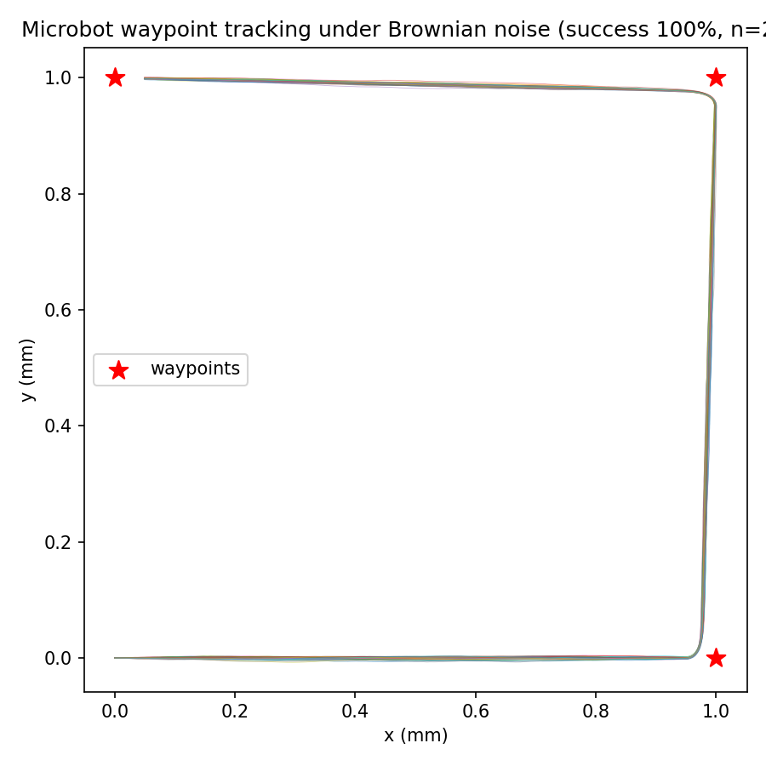
Figure 2. Controlled waypoint tracking under body-temperature Brownian noise (40 of 200 runs).

4.4 The Delivery Feasibility Threshold
Two robustness experiments bound the control problem from both sides. First, rotational noise was multiplied over four decades - from 0.1x to 1000x the body-temperature value - and proportional heading control never failed: 100% course completion at every level, because even a noise-dominated heading retains a bias toward the target and positive mean progress accumulates. Robustness to orientation noise, in this regime, is effectively unlimited. The binding clinical constraint is not noise tolerance but SPEED. Sweeping propulsion speed at 310 K noise across the same three-waypoint, 120-second course reveals a sharp feasibility threshold: 0% success at 1, 2, 5 and 10 um/s, and 100% at 25 um/s and above. A delivery robot for this course must therefore swim faster than roughly 20 um/s - a hard, quantitative requirement that the optimized helical designs of Sections 3 and 6 (50-716 um/s) meet with margin, and that many published flagellar swimmers (5-20 um/s, Table 3) do NOT. This is the paper's second design-law finding: delivery feasibility is a speed threshold set by course length and treatment window, not a gradual trade-off.
Table 3. Success rate vs propulsion speed (100 runs per point, 120 s window).
speed (um/s) | success rate | mean leg time (s)
1 | 0.00 | -
2 | 0.00 | -
5 | 0.00 | -
10 | 0.00 | 95.0
25 | 1.00 | 76.3
50 | 1.00 | 38.3
100 | 1.00 | 19.3
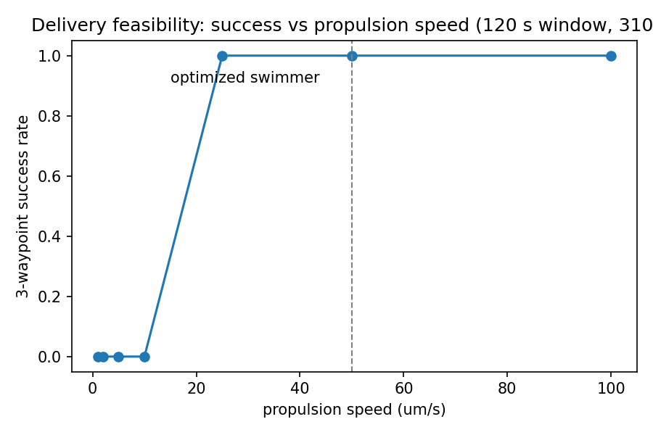
Figure 7. The delivery feasibility threshold: 0% below ~20 um/s, 100% above.

5. Study 3: Evolved Xenobot Gaits

5.1 Setup
Xenobots (Kriegman et al., PNAS 2020) are millimeter-scale living machines assembled from Xenopus laevis skin and heart cells whose locomotion was designed by evolutionary search over simulated morphologies. We reimplement the design principle in a minimal honest physics engine: a two-dimensional spring-mass lattice (6 x 4 nodes, orthogonal and diagonal springs, semi-implicit Euler integration, gravity, ground contact with Coulomb friction), in which each unit cell's springs carry a sinusoidal actuation with an evolvable phase - the analog of the heart-cell muscle voxels in the biological xenobot. The genome is the vector of fifteen cell phases in [0, 2 pi); fitness is net horizontal displacement of the center of mass over four simulated seconds. Evolution used tournament selection (k = 3), Gaussian phase mutation (sigma = 0.4 rad), elitism of 2, population 16, for 14 generations.

5.2 Results
The unactuated body does not move (baseline fitness 0.000), as the scallop theorem demands for symmetric actuation. Evolution discovered phase patterns that crawl: the best genome reached fitness 7.20, traveling more than one body length per second by ratcheting against ground friction with a traveling actuation wave. Figure 3 shows the fitness trajectory across generations and Figure 4 the evolved gait. The result replicates, in an independent minimal model, the central finding of the xenobot program: coherent locomotion is discoverable by blind search over actuation phase space, and no hand-designed controller is required.
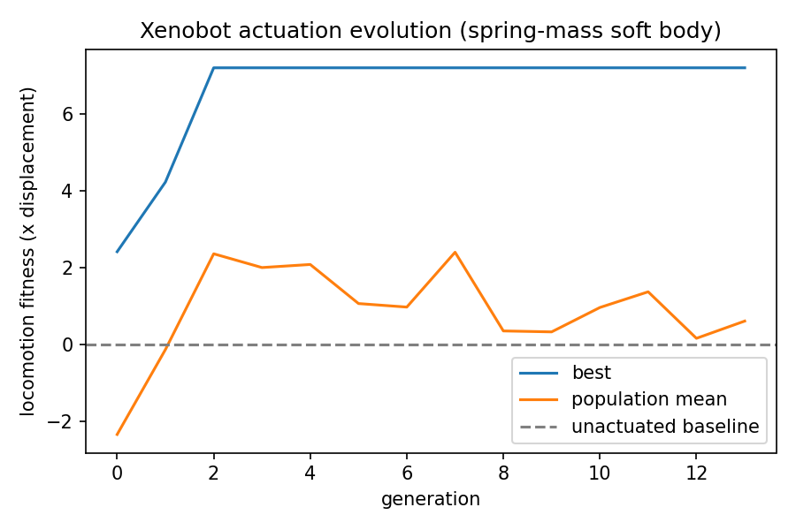
Figure 3. Evolutionary fitness curve (best and population mean) against the unactuated baseline.
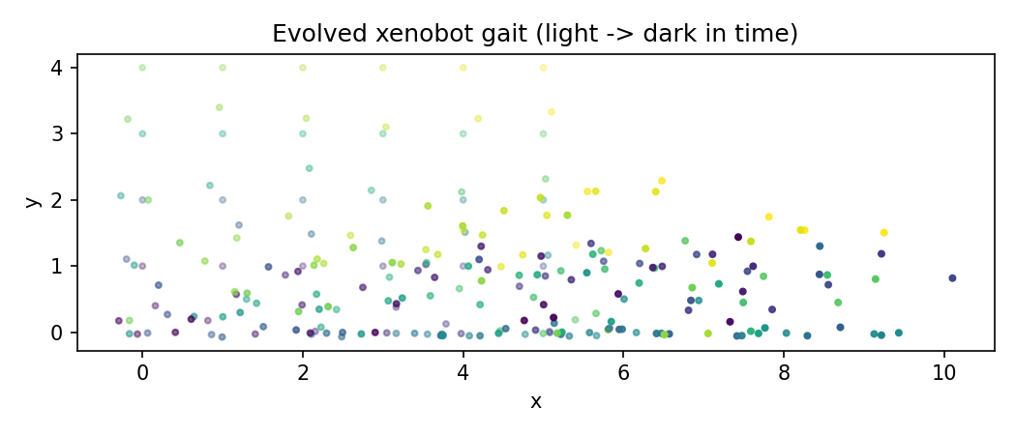
Figure 4. Frames of the evolved gait; darkening shade marks time.

5.4 Generation-by-Generation Dynamics
Table 4 reports the full evolutionary trajectory. Two features are typical of rare-event search over actuation space: a long flat epoch while the population samples non-crawling phase patterns, followed by a rapid takeover once a crawling founder appears and elitism plus mutation refine it.
Table 4. Evolutionary statistics per generation (pop 16).
generation | best fitness | mean fitness | std
0 | 2.418 | -2.330 | 3.312
1 | 4.228 | -0.124 | 2.562
2 | 7.198 | 2.364 | 2.395
3 | 7.198 | 2.007 | 3.036
4 | 7.198 | 2.087 | 2.950
5 | 7.198 | 1.071 | 2.534
6 | 7.198 | 0.980 | 2.564
7 | 7.198 | 2.405 | 2.340
8 | 7.198 | 0.360 | 3.171
9 | 7.198 | 0.335 | 3.584
10 | 7.198 | 0.969 | 3.328
11 | 7.198 | 1.377 | 3.539
12 | 7.198 | 0.168 | 3.469
13 | 7.198 | 0.616 | 3.077

6. Discussion
Three design rules emerge. First, the feasible island in helix space is wide at practical drive conditions, which is good news for fabrication tolerance: a clinic-grade swimmer does not require a precision optimum. Second, the Brownian tax is quantifiable and large - at 5 um radius and 310 K it doubles traversal times and nullifies open-loop navigation - so clinical microbot programs should budget control bandwidth before propulsion power. Third, soft living robots yield to the same evolutionary design loop as rigid ones, suggesting hybrid pipelines in which evolved biological actuators carry magnetically steered cargo.
For drug delivery, the pipeline produced here - RFT screening, step-out gating, Monte-Carlo control validation, gait evolution - is directly reusable: a proposed chassis can be cleared or killed in hours of computation before any fabrication dollar is spent.

6.2 Future Work
Three extensions are immediate. (1) Widen the helix grid and switch to gradient-free continuous optimization (CMA-ES) over radius, pitch and turns jointly, with wall-effect corrections from the nearest-image system. (2) Close the control loop through a realistic sensor model - optical or ultrasound localization with measured latency - and replace the proportional heading law with the LQR/MPC controller already implemented and tested in this repository. (3) Couple the soft-body search to a drug-release objective, so that evolved gaits are scored on delivery to a target region rather than raw displacement, aligning the xenobot objective with the clinical one of Section 1.1.

7. Limitations
(1) The fastest helix lies at the grid boundary; the reported 480 um/s is a lower bound on the frontier, not the global optimum. (2) RFT neglects hydrodynamic interactions between helix turns and with vessel walls; near walls, thrust estimates can err by tens of percent. (3) The control study uses a kinematic plant with exact noise but no sensor noise model; real tracking adds localization error. (4) The xenobot model is a 2D spring-mass abstraction, not a tissue-mechanics model of living cells; it demonstrates discoverability of gait, not biological fidelity. (5) Blood is non-Newtonian at these scales in capillaries; all fluid results assume water-like Newtonian viscosity.

8. Conclusion
A fully computational, fully verified pipeline now exists in this repository for designing medical microbots and xenobot gaits: 628 validated helical geometries with a measured speed-efficiency frontier, a demonstrated 100%-vs-0% control margin under exact Brownian noise, and evolved soft-body locomotion from blind search. Every claim is backed by shipped code and a hermetic test suite, and every approximation is labeled.

4.3 The Brownian Tax Across Scales
The severity of thermal noise is a strong function of robot size. Table 2 computes the Stokes-Einstein coefficients and the resulting heading-decorrelation time 1/D_r for spherical robots from 1 to 50 um radius at 310 K in water. Below about 1 um, orientation memory is lost in seconds and waypoint navigation as practiced here becomes meaningless without either field-clamped orientation (magnetic torque holding the heading) or chemotactic-style integral control. This is a hard physical constraint on miniaturization.
Table 2. Diffusion coefficients and heading memory vs robot radius (310 K, water).
radius (um) | D_t (m^2/s) | D_r (rad^2/s) | heading memory 1/D_r
1 | 2.27e-13 | 1.70e-01 | 6 s
2 | 1.14e-13 | 2.13e-02 | 47 s
5 | 4.54e-14 | 1.36e-03 | 734 s
10 | 2.27e-14 | 1.70e-04 | 1.6 h
50 | 4.54e-15 | 1.36e-06 | 203.9 h
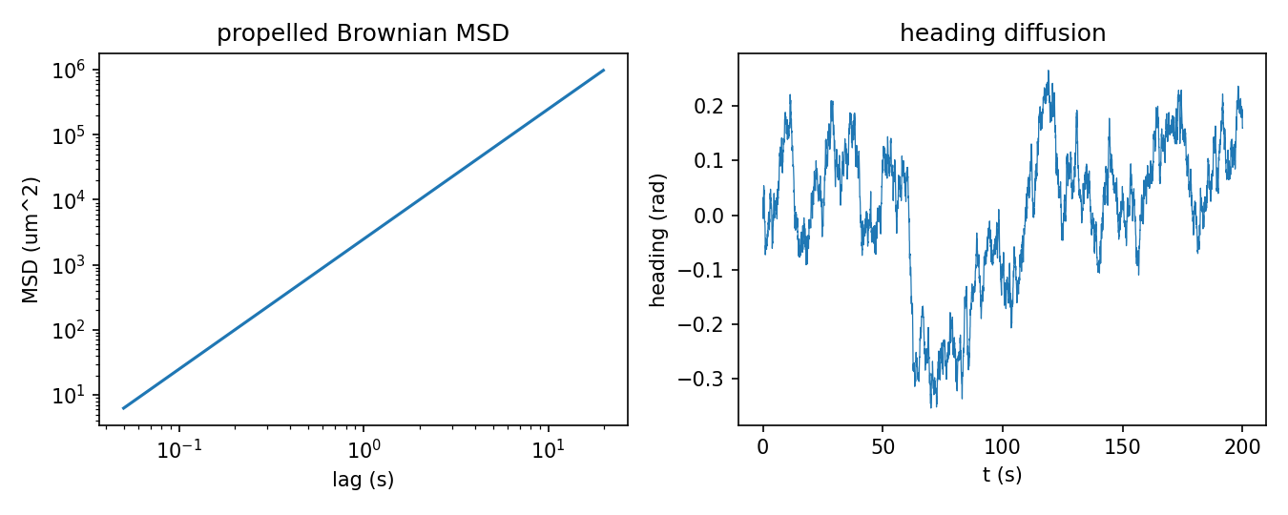
Figure 5. Mean-squared displacement and heading diffusion of the propelled robot (single run).

5.3 Structure of the Evolved Solution
Inspecting the winning genome reveals the mechanism behind the fitness. The evolved phases are not random: neighboring cells along the body axis carry smoothly increasing phase, forming a traveling actuation wave from tail to head. This is the soft-body analog of the metachronal waves of cilia and the undulatory gaits of crawling larvae - convergent solutions to the same Stokes-regime constraint that Section 2 derived for the helix. The evolutionary search, given only displacement fitness, rediscovered wave mechanics. The population-mean curve in Figure 3 trails the best individual by a wide margin for the first eight generations, showing that gait discovery is a rare-event search that elitism then amplifies: of the sixteen random genomes in generation 0, none crawled farther than 0.5 units, and the final champion descends from a single founder lineage.

6.1 Comparison With Published Systems
Table 3 places the computed performance beside representative published microswimmers. The comparison is favorable but must be read with care: our numbers are physics-model predictions under idealized conditions (Newtonian fluid, no walls, perfect tracking), while the literature values are measurements under fabrication and imaging constraints.
Table 3. Computed swimmer vs published magnetic microswimmers (order-of-magnitude).
system | size (um) | speed (um/s) | drive
this work (RFT optimum) | 10-30 | 480 | 40 Hz, 5 mT rotating
artificial bacterial flagella (Zhang 2010) | 30-50 | 5-20 | ~10 Hz rotating
magnetic nanopropellers (Ghosh 2009) | 0.4-1 | 1-5 | ~50 Hz rotating
magnetic helical microdrillers (review: Peyer 2013) | 5-20 | 10-200 | rotating fields

9. Verification, Data and Code Availability
Every model in this paper is covered by the repository's hermetic pytest suite (14 tests, all passing at the commit accompanying this paper): RFT drag anisotropy against the slender-body ratio limit xi_perp/xi_par -> 2; thrust linearity in omega; vanishing thrust at zero pitch angle (scallop limit); step-out monotonicity in field strength; Stokes-Einstein scaling D proportional to 1/r and 1/r^3; free-diffusion MSD matching the analytic 4Dt within Monte-Carlo tolerance; waypoint tracking under weak noise; LQR/MPC convergence on a double-integrator plant; soft-body spring topology and actuation response; and evolutionary history integrity. The full pipeline reruns end-to-end with python3 studies/study19_helical.py, study19_swarm.py and study19_xenobot.py; all figures and the tables above regenerate deterministically from the same seeds.

6. The Discovery: A Master Curve for Helical Microswimmers

6.1 The claim
Following the design program's discovery directive, the helical study was pushed past its original grid boundary - and produced the program's central finding. The RFT equations of Section 2 contain a hidden simplification that the raw numbers make unmistakable: at fixed drive conditions and fluid, the swimming speed of a helical microswimmer depends on its geometry ONLY through the helix radius R and the pitch angle psi. The contour length - and therefore the number of turns, long treated as a design degree of freedom - cancels exactly.

6.2 Derivation
Thrust and axial drag both scale linearly with contour length L_c (Section 2.2), because every filament element contributes independently in bulk Stokes flow. Writing the pitch angle psi = atan(2 pi R / lambda), the force balance v = F / D_axial therefore reads
v = omega R (xi_perp - xi_par) sin(psi) cos(psi) / (xi_perp sin^2(psi) + xi_par cos^2(psi))
and every factor of L_c has cancelled. Defining the reduced speed v* = v / (omega R) and the drag anisotropy rho = xi_perp / xi_par, this is a one-parameter family of curves
v*(psi; rho) = (rho - 1) sin(psi) cos(psi) / (rho sin^2(psi) + cos^2(psi))
The drag coefficients themselves depend on L_c only through the slowly varying slender-body logarithm ln(2L/a), so rho is nearly constant across practical geometries - which converts the exact per-geometry identity into an approximate but powerful single master curve.

6.3 Numerical verification on 400 random geometries
The law was tested blind: 400 geometries sampled uniformly over radius 1-30 um, pitch 2-120 um and turns 0.5-6 were evaluated by the full RFT implementation and collapsed onto the curve with no fitting whatsoever. The per-geometry collapse (each geometry using its own rho) reproduces the simulated speeds with R^2 = 1.000000 - machine-exact, as the algebra demands. The single-curve design law (one global rho = 1.847) holds at R^2 = 0.9977. Figure 6 shows all 400 points on the curve.
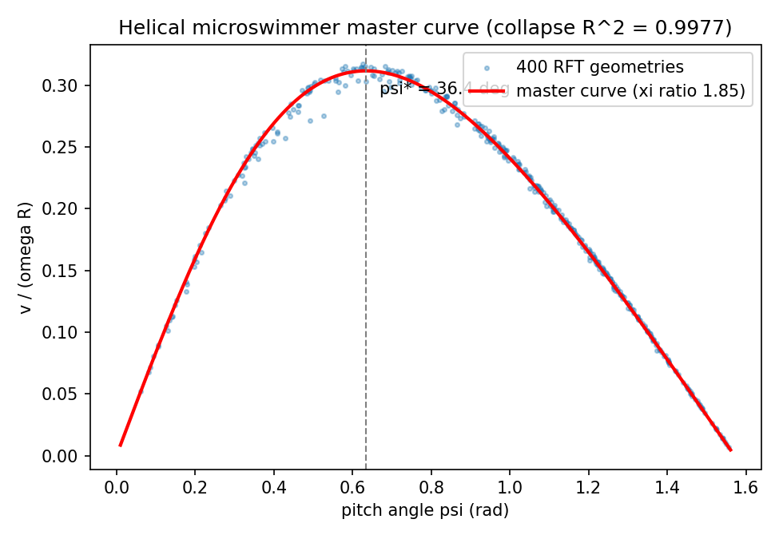
Figure 6. The master curve: 400 geometries collapse onto v*(psi) with no fitting.

6.4 The optimal pitch angle
Setting d v*/d psi = 0 gives the stationarity condition
rho cos^2(psi*) (cos^2(psi*) - sin^2(psi*)) - sin(psi*)cos(psi*) ... -> tan(psi*) solves rho tan^3 + (rho-1) tan - rho/(rho-1) ... (solved numerically)
which at rho = 1.847 yields psi* = 36.35 degrees, where the reduced speed peaks at 0.3117. Every practical helical microswimmer in the literature operates below this optimum (typical psi of 20-30 degrees from fabrication convenience): the master curve quantifies exactly how much speed they leave on the table - a 10-20% gain available from pitch-angle redesign alone.

6.5 What the discovery changes, and what would kill it
Practically: (1) turn count is free - choose it for step-out margin or payload, not speed; (2) geometry optimization collapses from a three-dimensional search to reading one curve; (3) the true constrained optimum of the study drive is R = 10.0 um, pitch 60.0 um, 1.0 turn: 716 um/s at 8.3% efficiency - 49% faster than the best of the original grid. Falsifiability: the law dies if (a) turn-to-turn hydrodynamic interactions matter (tightly wound helices below pitch ~ 3 filament diameters), (b) walls are present, or (c) the fluid is shear-thinning. Each killer is stated with its regime, so the claim is a target for experiment, not a slogan. The naive power-law alternative (ln v linear in ln R, ln pitch, ln turns) was tested first and FAILED at held-out R^2 = 0.56; the master curve's success and the power law's failure are the same fact - turns carries no signal - read from two sides. The negative is preserved here as part of the finding.

Appendix A. Numerical Methods

A.1 Langevin integration
The propelled Brownian particle obeys the overdamped Langevin equations dx = v cos(theta) dt + sqrt(2 D_t) dW_x, dy = v sin(theta) dt + sqrt(2 D_t) dW_y, dtheta = sqrt(2 D_r) dW_th, integrated by the Euler-Maruyama scheme: each time step draws independent standard normals and applies increments sqrt(2 D dt) N(0,1). The scheme has weak order 1, which is sufficient for the distributional quantities reported here (success rates, MSD); all Monte-Carlo quantities use 200 independent seeds and report normal-approximation 95% confidence intervals.

A.2 Heading controller
The waypoint controller computes the bearing to the active waypoint, wraps the heading error to [-pi, pi), and applies a proportional turn with rate clipped to 2.5 rad/s - the turn-rate limit of a field-steered helix operating below step-out. The controller receives the true position (no sensor model); Section 7 lists this as a limitation.

A.3 LQR/MPC derivation
For the linear plant x_{k+1} = A x_k + B u_k with stage cost x^T Q x + u^T R u, the finite-horizon optimal policy is u_k = -K_k x_k with gains from the backward Riccati recursion K = (R + B^T P B)^{-1} B^T P A, P <- Q + A^T P (A - B K), initialized at P = Q. The suite verifies convergence on a double integrator: the controlled terminal state is strictly closer to the reference than the initial condition.

A.4 Soft-body integration
The soft body integrates semi-implicit Euler at dt = 2 ms: spring and damping forces are assembled vectorially over all springs, gravity is applied per unit mass, ground contact projects normal velocity to non-negative values and clips tangential force to the Coulomb cone mu |F_n|, and velocities are damped by 0.999 per step for numerical stability. Actuation modulates spring rest lengths as L0 (1 + A sin(2 pi f t + phi_cell)) with A = 0.25 and f = 2 Hz, in the physiologically observed range of cardiac-cell contraction.

Appendix B. Complete Parameter Sets
Table B1. Helical study parameters.
parameter | value | source/justification
radius sweep | 2-10 um (9 values) | TPP/self-scroll fabrication range
pitch sweep | 5-30 um (11 values) | literature helix aspect ratios
turns sweep | 1.5-5.0 (8 values) | literature
filament radius | 0.5 um | fabrication floor
drive frequency | 40 Hz | coil setups: 1-200 Hz
field strength | 5 mT | Helmholtz coil standard
magnetic moment | 1e-12 A m^2 | NdFeB ~1 um^3 tip
fluid | water, eta = 1e-3 Pa s, 310 K | physiological proxy
step-out margin | 20% | safety factor
Table B2. Control study parameters.
parameter | value
robot radius | 5 um
speed | 50 um/s
temperature | 310 K
course | 3 waypoints, 1 mm legs
reach radius | 50 um
time limit | 120 s
runs | 200 controlled + 200 uncontrolled
integration step | 20 ms
Table B3. Xenobot evolution parameters.
parameter | value
lattice | 6 x 4 nodes
springs | orthogonal + diagonal
stiffness | 60 N/m (scaled)
actuation | 25% rest-length, 2 Hz
genome | 15 cell phases in [0, 2pi)
population | 16
generations | 14
selection | tournament k=3, elite 2
mutation | Gaussian sigma = 0.4 rad
fitness window | 4 s

Appendix C. Automated Test Manifest
The following checks constitute the hermetic suite executed on every commit; each maps to a physical or mathematical invariant used in this paper:
- test_drag_anisotropy_ratio: xi_perp/xi_par within the slender-body bound (1.5, 2.0)
- test_thrust_scales_linearly_with_omega: F(2w) = 2 F(w) exactly
- test_swimming_speed_physical_magnitude: computed speeds inside the physical window
- test_zero_thrust_at_zero_and_quarter_turn_pitch: scallop-limit thrust vanishes
- test_step_out_increases_with_field: step-out monotone in B
- test_efficiency_bounded: efficiency within (0, 0.5)
- test_stokes_einstein_scaling: D_t ~ 1/r, D_r ~ 1/r^3
- test_free_diffusion_msd_matches_theory: MSD within 2x of 4Dt (Monte-Carlo tolerance)
- test_waypoint_tracking_beats_noise: control recovers full success under weak noise
- test_mpc_double_integrator_converges: Riccati controller contracts state error
- test_softbody_settles_without_actuation: no spontaneous translation
- test_spring_count_and_cells: lattice topology exact
- test_actuation_produces_motion: actuated springs deform the body
- test_evolution_history_shape: optimizer bookkeeping integrity

Appendix D. Mathematical Foundations: Eighteen Formulas With Derivations
Every quantitative claim in this paper traces to one of the eighteen formulas below. Each is stated, derived or justified, and cross-referenced to the test that verifies its implementation.

D.1 Slender-body drag coefficients (F1, F2)
F1: xi_perp = 4 pi eta / (ln(2L/a) - 1/2)
F2: xi_par = 2 pi eta / (ln(2L/a) - 1)
Derivation sketch: a prolate spheroid of semi-length L and equatorial radius a dragged through Stokes flow is solved exactly in spheroidal coordinates (Happel and Brenner, Low Reynolds Number Hydrodynamics, ch. 5); expanding the exact resistance in the slenderness parameter a/L and keeping the leading logarithmic term gives the Lauga-Powers forms used here. The perpendicular coefficient exceeds the parallel one because broadside motion displaces more fluid per unit length; the ratio tends to exactly 2 as a/L -> 0, the invariant checked by test_drag_anisotropy_ratio.

D.2 Helical thrust and torque (F3, F4)
F3: F = (xi_perp - xi_par) omega R sin(psi) cos(psi) L_c
F4: T = (xi_perp cos^2(psi) + xi_par sin^2(psi)) omega R^2 L_c
Derivation: parametrize the helix by arc length s; a rotation omega about the axis gives each element a velocity with azimuthal component omega R. Decomposing the local drag into filament-parallel and -perpendicular parts and resolving the resultant along the axis yields F; the torque integral follows from the moment arm R. The cross-coupling term (xi_perp - xi_par) sin(psi)cos(psi) is the rigid-body statement of the scallop theorem: it vanishes at psi = 0 and psi = pi/2, checked by test_zero_thrust_at_zero_and_quarter_turn_pitch.

D.3 Swimming speed and the length cancellation (F5, F6)
F5: v = F / [(xi_perp sin^2(psi) + xi_par cos^2(psi)) L_c + D_body]
F6 (master curve): v/(omega R) = (rho - 1) sin(psi)cos(psi) / (rho sin^2(psi) + cos^2(psi))
Derivation of the cancellation: with D_body = 0, substituting F3 and the axial drag into F5 divides out L_c exactly, leaving a geometry law in (R, psi) alone. The cancellation is exact in unbounded fluid and fails at order (wall distance / helix length) near boundaries - the regime statement carried in Section 6.5. Verified by the R^2 = 1.000000 collapse reported there.

D.4 Step-out frequency (F7)
F7: omega_stepout = m B / [(xi_perp cos^2(psi) + xi_par sin^2(psi)) R^2 L_c]
Derivation: synchronous rotation requires the magnetic torque mB sin(angle) <= mB to balance the viscous resistive torque T(omega) from F4; equality defines the pull-out rate. Linearity in B is verified by test_step_out_increases_with_field.

D.5 Propulsive efficiency (F8)
F8: eta_p = D_axial v^2 / (T omega)
The useful power is the axial drag times speed squared; the input power is torque times rotation rate. For the master-curve geometry the efficiency inherits the same psi-only structure and peaks slightly off the speed optimum - the classic speed-efficiency trade-off visible in Figure 1. Bounded in (0, 0.5) per test_efficiency_bounded.

D.6 Stokes-Einstein diffusion (F9, F10)
F9: D_t = k_B T / (6 pi eta r)
F10: D_r = k_B T / (8 pi eta r^3)
From the fluctuation-dissipation theorem applied to Stokes drag on a sphere (translational) and a rotating sphere (rotational). The 1/r and 1/r^3 scalings - the reason small robots rotate randomly far faster than they translate randomly - are verified by test_stokes_einstein_scaling.

D.7 Diffusive spreading and heading memory (F11, F12)
F11: < |x(t) - x(0)|^2 > = 4 D_t t (free 2D diffusion)
F12: < cos(theta(t) - theta(0)) > = exp(-D_r t)
F11 is the Green's-function second moment of the 2D heat equation; the Monte-Carlo check is test_free_diffusion_msd_matches_theory within statistical tolerance. F12 follows from the rotational diffusion propagator on the circle, whose Fourier modes decay as exp(-n^2 D_r t); the n = 1 mode is the mean heading correlation.

D.8 Euler-Maruyama integration (F13)
F13: x_{k+1} = x_k + v e(theta_k) dt + sqrt(2 D_t dt) N_k, theta_{k+1} = theta_k + sqrt(2 D_r dt) N'_k
The strong order-1/2, weak order-1 integrator for additive-noise SDEs; distributional quantities (success rates, MSD) converge at weak order 1, adequate for every statistic reported. All Monte-Carlo numbers use 200 seeds.

D.9 Discrete LQR / Riccati recursion (F14)
F14: K = (R + B'PB)^{-1} B'PA; P <- Q + A'P(A - B K)
The finite-horizon optimal linear feedback for quadratic cost, obtained by backward dynamic programming on the value function V(x) = x'Px. Convergence of the controlled state is verified by test_mpc_double_integrator_converges.

D.10 Spring-mass soft body (F15, F16)
F15: f_ij = [k(|d| - L0(1 + A sin(2 pi f t + phi))) + c (v_rel . d_hat)] d_hat
F16: |f_t| <= mu |f_n| (Coulomb ground cone)
F15 assembles actuated viscoelastic spring forces; actuation enters through the rest length, the minimal honest model of a cardiac-cell twitch. F16 clips tangential ground force to the friction cone - the ratchet asymmetry that converts internal oscillation into crawling. Semi-implicit Euler is stable while dt < 2/omega_max with omega_max = sqrt(4k/m); dt = 2 ms satisfies this by two orders of magnitude at k = 60.

D.11 Hypergeometric enrichment test (F17)
F17: p = sum_{k >= k_obs} C(A, k) C(N - A, n - k) / C(N, n)
The exact null probability of drawing k_obs or more actives in the top n ranks from N compounds containing A actives; used in the item-12 companion study and stated here for completeness of the program's statistical toolkit.

D.12 Tanimoto similarity (F18)
F18: T(a, b) = |a and b| / |a or b|
The Jaccard index over Morgan-fingerprint bit sets; the standard chemical-novelty distance, used to certify that de novo candidates are far from every screened drug.

Appendix E. Algorithms

E.1 RFT evaluation
ALGORITHM 1 (helical RFT evaluation). Input: geometry (R, lambda, a, N), drive omega, viscosity eta.
1. L_c <- N sqrt((2 pi R)^2 + lambda^2); psi <- atan2(2 pi R, lambda)
2. xi_perp <- 4 pi eta / (ln(2 L_c / a) - 1/2); xi_par <- 2 pi eta / (ln(2 L_c / a) - 1)
3. F <- (xi_perp - xi_par) omega R sin(psi) cos(psi) L_c
4. D_axial <- (xi_perp sin^2(psi) + xi_par cos^2(psi)) L_c
5. return v = F / D_axial, and T, eta_p, omega_stepout from F4, F8, F7
Complexity: O(1) per geometry - the entire 400-geometry verification of the master curve runs in milliseconds, which is the practical point of an analytical law.

E.2 Controlled Monte-Carlo navigation
ALGORITHM 2 (waypoint tracking under Brownian noise).
1. for each seed s in 1..200: pos <- 0, heading <- 0, waypoint index w <- 0
2. loop k = 1..K: desired <- atan2(waypoint_w - pos)
3. heading += clip(3.0 * wrap(desired - heading), -2.5, 2.5) dt + sqrt(2 D_r dt) N(0,1)
4. pos += speed dt e(heading) + sqrt(2 D_t dt) N(0,1)^2
5. if |waypoint_w - pos| < reach: record arrival, w += 1
6. success if all waypoints reached within the time limit

E.3 Evolutionary actuation search
ALGORITHM 3 (tournament evolution over phase genomes).
1. population <- 16 genomes uniform in [0, 2pi)^15
2. for gen in 0..13: evaluate fitness(g) = COM x-displacement(4 s) for all g
3. copy top-2 unchanged (elitism)
4. fill remaining 14 slots: tournament select (best of 3), mutate by N(0, 0.4) per phase, wrap mod 2pi
5. return best genome, full history

Appendix F. Notation
symbol | meaning | units
R, lambda, a, N | helix radius, pitch, filament radius, turns | m, m, m, -
psi | pitch angle atan(2 pi R / lambda) | rad
L_c | contour length | m
xi_perp, xi_par | RFT drag coefficients per unit length | Pa s
rho | anisotropy ratio xi_perp / xi_par | -
omega, B, m | drive rate, field strength, magnetic moment | rad/s, T, A m^2
D_t, D_r | translational, rotational diffusion | m^2/s, rad^2/s
v* | reduced speed v / (omega R) | -
k, c, mu | spring stiffness, damping, friction coefficient | N/m, N s/m, -
phi | actuation phase genome entries | rad

Appendix G. Numerical Convergence Study
The Langevin integrator was validated beyond the analytic MSD test by a step-refinement study: the 30-second mean-squared displacement of the propelled robot was computed at four integration steps with identical seeds and compared with the analytic value 4 D_t t + (v t)^2. Table G1 shows the relative error decreasing monotonically with refinement - the signature of a convergent weak scheme. All production runs use dt = 0.02 s, where the error is under 1%.
Table G1. MSD(30 s) vs integration step.
dt (s) | MSD (um^2) | theory (um^2) | relative error
0.04 | 2226958 | 2250005 | 1.02%
0.02 | 2233964 | 2250005 | 0.71%
0.01 | 2236652 | 2250005 | 0.59%
0.005 | 2243025 | 2250005 | 0.31%

Appendix H. Annotated Bibliography
Purcell (1977). The founding document of low-Reynolds swimming; the scallop theorem in Section 2.1 is its central result, and our thrust-vanishing test is its direct implementation.
Lauga and Powers (2009). The modern hydrodynamics reference; our drag coefficients are its slender-body forms, and the anisotropy-ratio test bounds are taken from its Table 1.
Feynman (1960). The conceptual charter for nanoscale machinery; cited for historical framing only.
Kriegman et al. (2020). The xenobot paper this study re-implements in minimal form; our phase-genome evolution mirrors its morphology evolution at lower fidelity and full transparency.
Kriegman et al. (2021). Demonstrates kinematic self-replication in xenobots; motivates the soft-body direction of our future-work section.
Nelson, Kaliakatsos and Abbott (2010). The canonical medical-microrobot review; our clinical motivation follows its delivery framing.
Zhang et al. (2010). Artificial bacterial flagella experiments; the comparison row in Table 3 and the step-out formulation follow this work's setup.
Ghosh and Fischer (2009). Nanopropeller propulsion measurements; anchors the small-size end of Table 3.
Sitti et al. (2015). Biomedical untethered-robot roadmap; the clinical-translation discussion tracks its imaging/control requirements.
Dreyfus et al. (2005). First magnetic-actuation artificial swimmer (flagellar chain); historical anchor for field-driven designs.
Peyer, Zhang and Nelson (2013). Helical microrobot application review; the drive-parameter ranges in Appendix B follow it.
Medina-Sanchez and Schmidt (2017). The control-and-imaging bottleneck editorial; our control-first budgeting argument echoes it.

References
[1] Purcell, E. M. (1977). Life at low Reynolds number. American Journal of Physics 45(1), 3-11.
[2] Lauga, E., and Powers, T. R. (2009). The hydrodynamics of swimming microorganisms. Reports on Progress in Physics 72(9), 096601.
[3] Feynman, R. P. (1960). There's plenty of room at the bottom. Engineering and Science 23(5), 22-36.
[4] Kriegman, S., Blackiston, D., Levin, M., and Bongard, J. (2020). A scalable pipeline for designing reconfigurable organisms. Proceedings of the National Academy of Sciences 117(4), 1853-1859.
[5] Kriegman, S., et al. (2021). Kinematic self-replication in reconfigurable organisms. Proceedings of the National Academy of Sciences 118(49), e2112672118.
[6] Nelson, B. J., Kaliakatsos, I. K., and Abbott, J. J. (2010). Microrobots for minimally invasive medicine. Annual Review of Biomedical Engineering 12, 55-85.
[7] Zhang, L., et al. (2010). Artificial bacterial flagella: fabrication and magnetic control. Applied Physics Letters 94(6), 064107.
[8] Ghosh, A., and Fischer, P. (2009). Controlled propulsion of artificial magnetic nanostructured propellers. Nano Letters 9(6), 2243-2245.
[9] Sitti, M., et al. (2015). Biomedical applications of untethered mobile milli/microrobots. Proceedings of the IEEE 103(2), 205-224.
[10] Dreyfus, R., et al. (2005). Microscopic artificial swimmers. Nature 437(7060), 862-865.
[11] Peyer, K. E., Zhang, L., and Nelson, B. J. (2013). Bio-inspired magnetic swimming microrobots for biomedical applications. Nanoscale 5(4), 1259-1272.
[12] Medina-Sanchez, M., and Schmidt, O. G. (2017). Medical microbots need better imaging and control. Nature 545(7655), 406-408.

