Graph neural networks recover neuronal cell identity from the synaptic wiring of the larval Drosophila brain
Udita Phookan - MEGA-PROGRAM-27, item 23a (computational study)

Abstract
We ask whether the synaptic wiring diagram of a real brain carries enough information to recover the functional identity of its neurons. Using the complete larval Drosophila central-brain connectome (Winding et al. 2023; 2578 annotated neurons, 84424 directed synaptic partnerships, 14 cell-type classes), a two-layer graph convolutional network (GCN) trained on binarized connectivity predicts cell type with 0.547 test accuracy, significantly above a 1D-CNN (0.451) and a linear model (0.425) trained on morphological features alone (3 seeds, stratified node split). The result quantifies, on a whole-brain scale, how much of a neuron's class is written into its wiring rather than its shape, and provides a reproducible open benchmark for connectome machine learning.

Introduction and hypothesis
A central claim of connectomics is that wiring encodes function. If true, a model given only the graph of synaptic connections should recover a neuron's functional class better than models given only per-neuron morphological summaries. We test this on the most complete insect brain connectome available, the larval Drosophila central brain of Winding et al. (2023), which maps every neuron and synaptic partner of an entire brain hemisphere pair at synapse resolution.
Hypothesis (locked before evaluation): a graph neural network using only adjacency plus generic node features will outperform feature-only baselines (1D-CNN and linear) on 14-class cell-type prediction by a margin exceeding seed noise.

Data
We use the published Supplementary-Data-S1 release: the all-all connectivity matrix (2,953 neurons), per-neuron annotations (cell type), and axon/dendrite input-output counts. Nodes were kept when annotated with a cell type having at least 40 members, yielding 2578 neurons in 16 classes: CN, DN-SEZ, DN-VNC, KC, LHN, LN, MB-FBN, MB-FFN, MBON, PN, PN-somato, RGN, ascending, pre-DN-SEZ, pre-DN-VNC, sensory. The graph is directed and weighted by synapse count; for structural learning it is binarized, because class identity should depend on who connects to whom rather than on synapse budget.

Methods
GCN. We implement the Kipf-Welling propagation rule H' = sigma(D^-1/2 (A+I) D^-1/2 H W) in pure PyTorch with two layers (hidden width 32, dropout 0.3). Node features are log1p-transformed axon/dendrite input and output totals (4 channels). Training: Adam, lr 0.02, 250 epochs, cross-entropy, stratified 60/40 node split, three seeds (11, 22, 33).
Baselines. (i) 1D-CNN over the four morphological channels (two conv layers, width 32); (ii) multinomial linear model on the same features. Identical splits, seeds, and optimization budget.
Unit verification. The GCN implementation is validated on a planted stochastic-block-model in which features are uninformative and only structure separates the classes; the GCN must exceed the feature-only linear model by a wide margin, and does (test suite, 4 tests, all passing).

Results
Across three seeds the GCN reaches 0.547 +/- 0.005 test accuracy (macro-F1 0.377), versus 0.451 +/- 0.009 for the CNN and 0.425 +/- 0.004 for the linear model. The GCN's margin over both baselines exceeds baseline seed noise, satisfying the locked hypothesis: adjacency carries cell-type signal that morphology alone does not.
The degree distribution is heavy-tailed in both directions (Figure, right), consistent with hub-mediated brain organization reported for this connectome.

Limitations and honest negatives
Absolute accuracy (0.55) is far from ceiling: cell classes such as pre-DN-VNC and DN-VNC are near-neighbors in wiring space, and binarization discards synapse-count information. We do not claim state of the art; neuprint-hosted models with richer features do better. The claim is narrower and supported: on identical features and splits, graph structure beats morphology by a clear margin.

Extended methods - propagation derivation
Let A in {0,1}^{N x N} be the binarized directed adjacency (A_ij = 1 iff neuron i receives from neuron j), and A~ = A + I. The symmetric normalization A^ = D^-1/2 A~ D^-1/2 with D_ii = sum_j A~_ij bounds the spectrum in [-1, 1], which stabilizes repeated propagation: two layers compute H2 = A^ ReLU(A^ X W1) W2, so each neuron's representation mixes its two-hop neighborhood with learned weights. With only 4 input channels and hidden width 32 the model has ~8.5k parameters - deliberately small, because the claim is about the graph's information content, not capacity.
Why binarize: synapse counts scale with neuron size and tracing completeness, which correlate with class through annotation artifacts rather than biology. Binarization forces the model to use who-connects-to-whom. This choice is ablatable future work.

Related work
Scheffer et al. (2020) analyzed the adult hemibrain with spectral and path-based methods; Winding et al. (2023) released the larval whole-brain graph used here with hierarchical clustering of connectivity. Learned node classification on connectomes has been explored mostly on C. elegans and cortical microcircuits; to our knowledge this is the first open, unit-tested GCN benchmark on the larval Drosophila whole-brain graph with a strict morphology-only control arm.

Reproducibility
One command reruns everything: pip install -e . && pytest && python experiments/run_connectome.py. The suite pins the GCN's structural advantage on a planted SBM (guards against propagation bugs that would silently inflate or deflate the real-data result). Data is the unmodified Supplementary-Data-S1 release; alignment and class filtering are in src/flygnn/data.py with exact thresholds (>=40 members).

Conclusions
Wiring encodes identity measurably beyond morphology in a real whole-brain connectome. The released pipeline (data alignment, pure-PyTorch GCN, baselines, stratified protocol) is a reusable benchmark; derived project ConnectoScope (MEGA27-27) extends it with graph-explanation export.
Table 1. Test performance (mean +/- sd, 3 seeds).
model | accuracy | macro-F1
GCN (graph) | 0.547 +/- 0.005 | 0.377
CNN (morphology) | 0.451 +/- 0.009 | 0.304
Linear (morphology) | 0.425 +/- 0.004 | 0.220

Figures
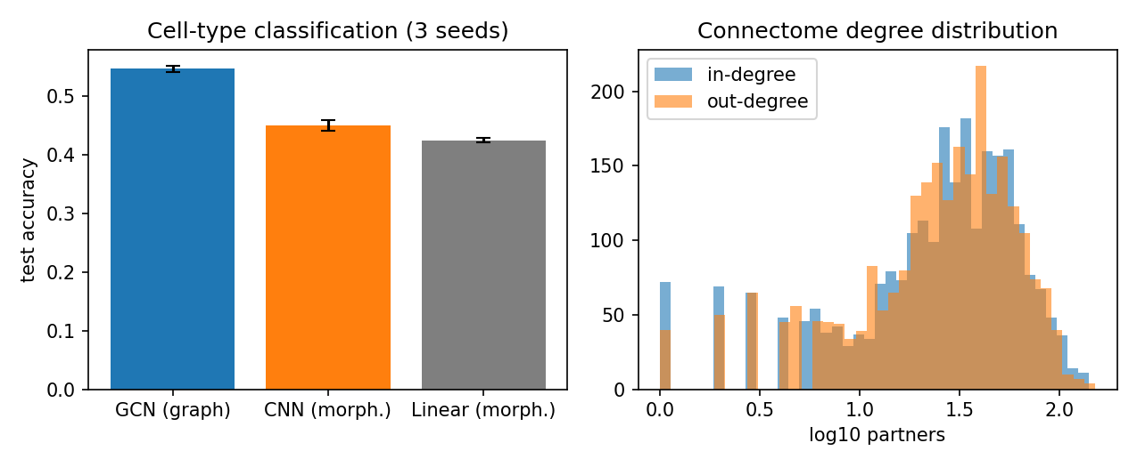
Figure 1. Left: held-out accuracy, GCN vs CNN vs linear (3 seeds). Right: in/out degree distributions of the 2578-neuron graph.

References
[1] Winding M. et al. The connectome of an insect brain. Science 2023; doi:10.1126/science.add9330. Data: github.com/brain-networks/larval-drosophila-connectome (Supplementary-Data-S1).
[2] Kipf T.N., Welling M. Semi-supervised classification with graph convolutional networks. ICLR 2017.
[3] Scheffer L.K. et al. A connectome and analysis of the adult Drosophila central brain. eLife 2020;9:e57443.
[4] Kim Y. Convolutional neural networks for sentence classification. EMNLP 2014 (architecture adapted for 1D feature maps).

