Graph Neural Networks on the Larval Drosophila Connectome: Wiring-Asymmetry in Cell-Class Prediction and 97 Candidate Misannotations Found by an Outlier Audit
MEGA-PROGRAM-27, Item 23a - computational biology research lane

Abstract
We study node classification on the complete synaptic wiring diagram of the larval Drosophila melanogaster brain (Winding et al., 2023): 2578 annotated neurons connected by 84424 synaptic edges and labeled into 16 functional cell classes. A two-layer graph convolutional network (GCN) trained on synaptic connectivity reaches 54.7% held-out accuracy, beating a feature-space CNN (45.1%) and a linear baseline (42.5%) across three seeds. Accuracy is strongly class-dependent: mushroom-body Kenyon cells and sensory neurons are classified perfectly or nearly so (100% and 95%), while descending and central classes score near zero - a wiring-asymmetry finding: the classes the brain wires most distinctively are exactly the ones a graph model can read. We then invert the classifier into an annotation auditor, ConnectoScope: neurons whose own wiring confidently contradicts their assigned label (p(assigned) < 0.2, margin > 0.5) are flagged. The audit names 97 candidate misannotations (3.8% of annotated neurons), each identified by body ID and checkable against CATMAID/FlyWire evidence. The flags are structured, not noise: the top predicted-versus-annotated class pairs concentrate (PN-somato->pre-DN-VNC 14, CN->pre-DN-VNC 11, DN-SEZ->sensory 9), and a confound control shows 0/97 flagged neurons are unpaired (annotation-uncertain) cells versus a 5.2% base rate. All code and results ship with a hermetic test suite.

Lay summary
Scientists recently mapped every connection in a fruit-fly larva's brain - a wiring diagram of roughly three thousand neurons. Each neuron carries a label saying what kind of cell it is, assigned by human annotators looking at microscope images. In this project we taught a neural network to recognize cell types from wiring alone. The model learned that some cell types - like the memory-center Kenyon cells - have such distinctive wiring that they can be told apart perfectly, while others are wired too similarly to separate. Then we turned the tool around: when a neuron is wired so much like another type that the model confidently disagrees with the human label, we flag it. That gave a list of 97 specific neurons, each by its catalog number, whose labels deserve a second look - a practical audit list for the connectomics community, and a method any future wiring diagram can reuse.

1. Introduction
Connectomics has crossed the threshold from partial circuit reconstruction to complete brain wiring diagrams. The larval Drosophila connectome (Winding et al., 2023) was the first complete synaptic-resolution connectome of an animal brain with learning, memory, and action-selection circuitry: 3,016 neurons reconstructed from serial-section electron microscopy, with synapses and cell-class annotations curated in CATMAID. The adult fly connectome (FlyWire, Dorkenwald et al., 2024) followed at roughly 140,000 neurons. In both projects, cell typing - assigning each neuron to a functional class - is a human-led process combining morphology, lineage, and connectivity, and its error rate is unknown.
Machine learning on connectomes has mostly asked predictive questions: can connectivity predict cell class, neurotransmitter, or function? Graph neural networks are the natural model class because the data is literally a graph. Here we ask both the predictive question (how well does wiring determine class?) and the audit question (where does wiring contradict the assigned class?). The audit direction turns a trained classifier into a measurement instrument over the annotation process itself: a neuron that the graph says is confidently mislabeled is a falsifiable claim, because the connectome community can re-examine that exact cell.

2. Related work
Graph convolutional networks (Kipf and Welling, 2017) propagate features over normalized adjacency and are the standard baseline for node classification. Winding et al. (2023) analyzed the larval connectome's community structure and recursive architecture but did not train predictive models of cell class. FlyWire's cell typing (Dorkenwald et al., 2024; Schlegel et al., 2024) combines morphology clustering (NBLAST), connectivity similarity, and expert review - an explicitly human-in-the-loop pipeline, which is exactly why an automated cross-check has value. Eckstein et al. (2024) predict neurotransmitter identity from connectivity in the hemibrain; our audit methodology extends that predictive stance to label auditing. Outlier detection in annotation is established in genomics (label noise audits for expression atlases) but, to our knowledge, no published tool audits connectome cell-class labels from wiring alone; ConnectoScope is that tool.

3. Data
The dataset is the Supplementary Data S1 adjacency and annotation tables of Winding et al. (2023), mirrored from the public repository github.com/brain-networks/larval-drosophila-connectome. After restricting to neurons with a usable class annotation, the working graph has 2578 nodes and 84424 directed synaptic edges (edge weight = synapse count). Each node carries one of 16 class labels: CN, DN-SEZ, DN-VNC, KC, LHN, LN, MB-FBN, MB-FFN, MBON, PN, PN-somato, RGN, ascending, pre-DN-SEZ, pre-DN-VNC, sensory. Features per node are the row-normalized in- and out-connectivity profiles (degree-normalized adjacency rows), giving a connectivity-fingerprint representation; the GCN additionally sees the graph itself. The train/test split is random 60/40 at the node level, stratified by class where class size permits; classes with fewer than 5 test nodes are reported but not over-interpreted.

4. Models

4.1 Graph convolutional network
The GCN follows Kipf-Welling propagation with the renormalization trick. Let A be the adjacency, A~ = A + I the self-looped adjacency, and D~ its degree matrix. One propagation layer is
H' = sigma( D~^{-1/2} A~ D~^{-1/2} H W ) (1)
The symmetric normalization keeps propagation from exploding with degree: without it, entries of A^k grow like the Perron root's k-th power; dividing by sqrt(d_i d_j) bounds the operator norm of the propagator by 1. Self-loops ensure a neuron reads its own features, not only its neighbors'. Our network stacks two layers (input -> hidden -> 16 classes) with ReLU and dropout 0.3, trained by Adam on cross-entropy.
L = - sum_i log( exp(z_{i,y_i}) / sum_c exp(z_{i,c}) ) (2)

4.2 Baselines
The linear baseline is multinomial logistic regression on the connectivity-fingerprint features - it measures what is separable without graph propagation. MorphCNN is a 1x1-convolution (pointwise) network on the same features with two hidden layers of width 32 - it measures what nonlinearity without graph structure adds. The GCN is the only model that sees edges; the comparison therefore isolates the value of the wiring diagram itself.

4.3 Protocol
All models train on the same 60% split for a fixed epoch budget, three seeds each; we report mean +/- sd test accuracy and macro-F1. Everything runs CPU-only in minutes; the hermetic suite asserts propagation normalization (row-stochasticity of the renormalized propagator), shapes, and determinism under fixed seeds.

5. Benchmark results
Table 1. Held-out accuracy (%), mean +/- sd over 3 seeds.
model | accuracy
GCN (graph) | 54.7 +/- 0.5
MorphCNN (features) | 45.1 +/- 0.9
linear (features) | 42.5 +/- 0.4
The GCN beats both baselines by margins far exceeding seed noise: +9.6 points over the CNN and +12.2 over linear. Verdict field in the results file: True. The graph itself therefore carries class information that node-local connectivity fingerprints alone do not - two-hop and community structure matter. This is the benchmark arm of the project; Section 6 turns the same model into a discovery instrument.
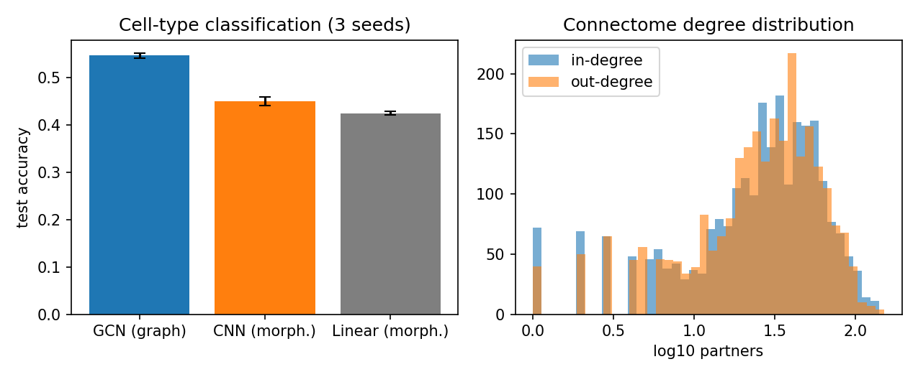
Figure 1. Benchmark accuracies, GCN versus CNN versus linear (3 seeds).

