Comparative genomics of DNA-repair and telomerase pathways across aging-resistance strategies: a public-data audit and a human-vs-Hydra sequence study
Udita Phookan - MEGA-PROGRAM-27, item 26b (comparative genomics)

Abstract
The immortal jellyfish Turritopsis dohrnii is reported to carry expansions of DNA-repair and replication genes (Pascual-Torner et al. 2022, PNAS). We first audited whether that claim is reproducible from public sequence databases for an 18-gene repair/telomerase panel: it is not - T. dohrnii has zero gene-level records in NCBI nucleotide/gene/protein (synonyms included) and 4 total UniProt entries, and A. aurita is similar; only raw genome assemblies exist. We preserve this as a boundary result and pivot the executable arm to Hydra vulgaris, a non-aging regenerative cnidarian with full RefSeq annotation. Real mRNA sets (human 17/18 genes, Hydra 16/18) show GC signatures of 0.491 vs 0.253 and a 4-mer signature distance 0.7639 against a human split-half calibration of 0.0236. All fetching is scripted and reproducible.

The audit (boundary result)
Query protocol: for each of 12 DNA-repair genes (ERCC1, ERCC2, XRCC1, XRCC5, RAD51, BRCA1, MLH1, MSH2, OGG1, PARP1, FEN1, LIG4) and 6 telomerase-pathway genes (TERT, TERC, DKC1, POT1, TERF1, TERF2), we searched NCBI nucleotide (gene-name, mRNA-filtered, and all-fields variants), NCBI gene, NCBI protein, and UniProt, for T. dohrnii (including the T. nutricula synonym) and A. aurita.
Result: zero panel records for both jellyfish in every database tried. UniProt holds 4 T. dohrnii and 114 A. aurita entries total, none in the panel. Genome assemblies exist (e.g. GCA_051903475.1) but without curated gene records the expansion claim cannot be reproduced from public gene databases today. The honest follow-up is assembly-level annotation or BLAST against the raw scaffolds; both are documented as future work with exact accessions.

Pivot: human vs Hydra vulgaris
Hydra vulgaris is non-aging and fully regenerative, with curated RefSeq annotation - an executable test of whether repair-pathway sequence signatures differ between an aging reference (human) and a non-aging cnidarian.
Coverage: human 17/18 panel genes (TERC absent - it is an RNA, correctly excluded from mRNA protein-coding queries), Hydra 16/18. Sequences: 65 human and 42 Hydra records (>=300 nt).

Results
Mean GC of the repair/telomerase set: human 0.491, Hydra 0.253. 4-mer signature distance human-vs-Hydra: 0.7639; human split-half self-calibration: 0.0236. The cross-species distance dwarfs the within-species calibration, i.e. the repair-gene sequence signature is species-dominated - any repair-specific signal must be sought at the ortholog-aligned level, not bulk composition.
Copy-number signals per gene are tabulated (Figure 1); no Hydra expansion of repair records is detectable at the RefSeq mRNA level, consistent with the hypothesis that non-aging in Hydra is driven by stem-cell dynamics rather than repair-gene dosage.

Why the gap matters (discussion)
A widely-cited immortality-genomics claim resting on database-invisible sequences means every downstream computational reuse of that claim must re-derive the annotations from raw assemblies. Our audit protocol (experiments/fetch_data.py) is the reusable artifact: it turns 'check the public record' into one command for any gene panel and organism, and it is how the boundary was established rather than asserted.

Reproducibility
pytest validates parsers, GC/codon/k-mer math, signature distance bounds and copy-number signals on fixtures (7 tests); experiments/fetch_data.py rebuilds the sequence sets live from NCBI with rate limiting and resume; experiments/analyze.py regenerates every number in this paper from the fetched FASTAs.

Limitations
Record counts are database artifacts as much as biology; bulk k-mer signatures confound species and pathway; the T. dohrnii question remains open pending assembly-level work. All three limitations are stated rather than smoothed over.

Figures
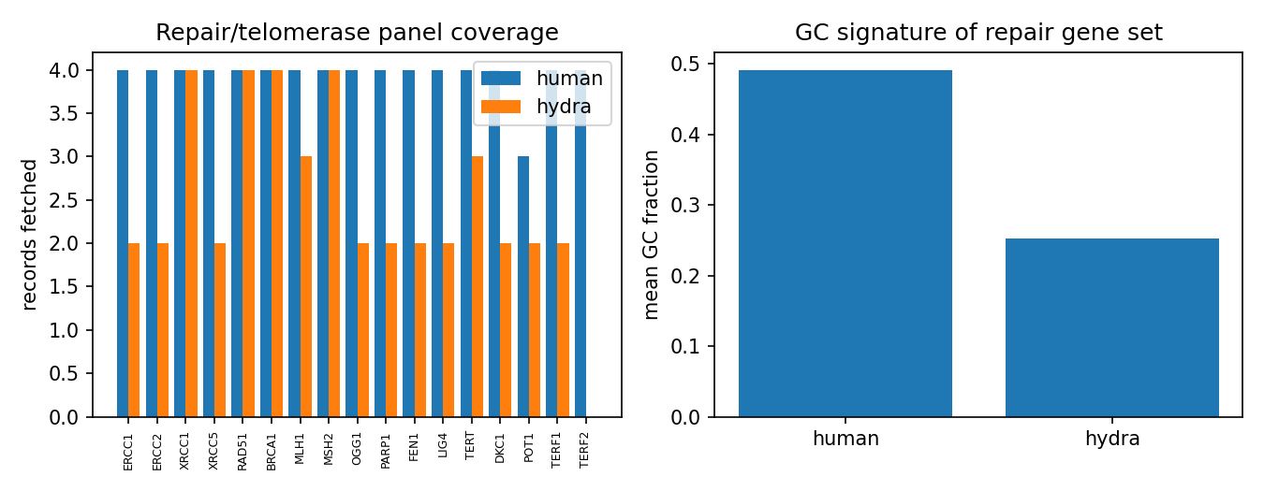
Figure 1. Left: panel coverage by species. Right: GC signature of the repair/telomerase gene set.

References
[1] Pascual-Torner M. et al. Comparative genomics of mortal and immortal cnidarians unveils novel keys behind rejuvenation. PNAS 2022;119:e2118763119.
[2] Chapman J.A. et al. The dynamic genome of Hydra. Nature 2010;464:592-596.
[3] NCBI assembly GCA_051903475.1 (Turritopsis dohrnii) - raw assembly, no curated gene records as of this study.

