Synopsis on
A Calibrated Multi-Agent RAG System for Indian Law: Design and Empirical Evaluation
Submitted by
Group ID: IT118
241H0360116 Udita Uniyal
For the award of the degree of
B.Tech Information Technology, V Semester
Under the Supervision of
Prof. Nisheeth Joshi, PhD
Professor, Speech and Language Processing Lab,
Centre for Artificial Intelligence,
Faculty of Mathematics and Computing

Department of Computer Science
Banasthali Vidyapith
Session 2026-27

Table of Contents
1. Introduction
2. Literature Review
3. Motivation/Justification and Relevance
4. Objectives
5. Methodology
6. Tools and Techniques
7. Expected Outcome of the Research
8. References

1. Introduction
On 1 July 2024 India replaced three foundational legal codes on a single day. The Indian Penal Code of 1860, which defines what counts as a crime, was replaced by the Bharatiya Nyaya Sanhita, 2023. The Code of Criminal Procedure of 1973, governing arrest, bail and trial, was replaced by the Bharatiya Nagarik Suraksha Sanhita. The Indian Evidence Act of 1872 was replaced by the Bharatiya Sakshya Adhiniyam. The offences are largely the same. The section numbers are not.
Both codes remain live law simultaneously. Which applies depends on when the conduct happened, not when the question is asked: conduct before 1 July 2024 is still governed by the old code, preserved by the savings provisions of the new Acts and by section 6 of the General Clauses Act, 1897 [15]. Article 20(1) of the Constitution separately forbids applying a heavier punishment retrospectively.
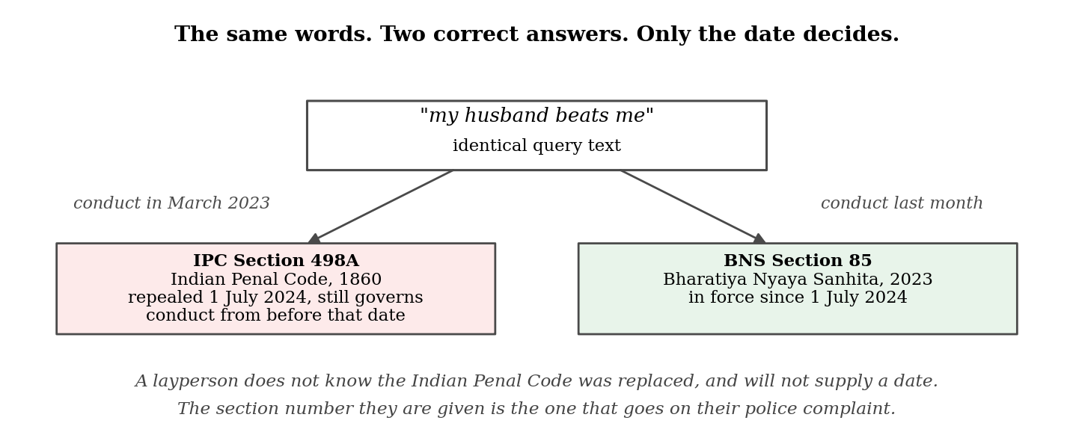
Figure 1: The research problem. The same question has two correct answers, separated only by the date of the conduct.
Figure 1 states the problem. "My husband beats me" maps to Section 498A of the Indian Penal Code if the conduct occurred in March 2023, and to Section 85 of the Bharatiya Nyaya Sanhita if it occurred last month. The words are identical; only the date decides. A person asking that question does not know the Indian Penal Code exists, let alone that it was replaced, and will not supply a date unprompted.
1.1 Retrieval-Augmented Generation
The system studied here is a Retrieval-Augmented Generation system, or RAG. It answers in two steps rather than one: it searches a document collection for the passages most relevant to the question, then passes them to a large language model to compose an answer using only what it was given [3]. The intent is that it quotes real sources rather than producing text from memory, which matters in law, where an invented section number is not a harmless error.
Search here is dense retrieval: search by meaning rather than exact words. Each passage and each question becomes a list of 1,536 numbers called an embedding, and passages whose embeddings point in a similar direction to the question's are returned. Its strength is that it needs no shared vocabulary. That strength is the source of the failure measured here: to a dense retriever, Section 420 of the old code and Section 318 of the new describe the same offence in nearly the same words.
This work builds such a system for Indian statutory law and measures where and why it fails: the system is the instrument, the measurement is the contribution. The corpus is four statutes totalling 1,899 indexed passages; the evaluation set is 518 questions, each carrying the section that correctly answers it, recorded before any output was seen.
2. Literature Review
Four bodies of work bear on this problem: Indian legal natural language processing, evaluation of legal RAG systems, retrieval over law that changes with time, and confidence calibration.
2.1 Indian legal natural language processing
The closest prior work is ILSIC [1], from Findings of EACL 2026. It builds a corpus of queries written by laypeople rather than lawyers, covering over 500 Indian statutes, for Legal Statute Identification: deciding which provision a described situation falls under. Its central finding is directly relevant. Models trained on the language of court judgments perform poorly on the language ordinary people use, establishing the layperson setting as a distinct and harder problem.
ILSIC does not address the recodification; its corpus predates it. The same holds for Indian legal NLP resources generally, which were assembled before July 2024 and are built on the numbering of the repealed codes.
2.2 Evaluation of legal retrieval systems
Magesh et al. [4] audited three commercial legal research tools and found all three produced hallucinated citations at material rates. Their methodological contribution matters as much: they separate an answer being correct from an answer being grounded in the sources actually retrieved. That distinction is adopted here as one of the three correctness definitions in Section 5.4.
Benchmarks here are typically small: the AILA shared tasks at FIRE used 50 and 10 test queries in successive years, and COLIEE Task 3 between 73 and 109. Resource papers are larger, ILSIC reporting 836. The set built here, at 518 queries, is deliberately constructed rather than sampled.
2.3 Retrieval over law that changes with time
Nearest in spirit is de Martim [2], which models legal material as a temporal knowledge graph supporting point-in-time version retrieval, so a query can ask what a provision said on a given date. That is the right solution for a statute amended over time, where each provision has a linear version history.
India's 2024 transition is a different shape: not one instrument amended through versions, but one repealed and another enacted in its place, with many-to-many renumbering. Section 379 of the old code, theft, corresponds to Section 303(2) of the new, which additionally introduces community service for a first offence below a monetary threshold. A system that merely translated numbers would still be wrong about the law. Version-aware retrieval over a single instrument does not, by construction, address a cross-instrument replacement.
2.4 Confidence calibration
A confidence score is a number a system attaches to its own answer to indicate how far it should be trusted. Calibration asks whether that number means what it claims: a perfectly calibrated system reporting 70 per cent confidence is correct on 70 per cent of those occasions. Guo et al. [8] showed modern neural networks are systematically overconfident and established Expected Calibration Error as the standard measure. Platt scaling [7] is the standard remedy, fitting a two-parameter logistic function mapping a score onto a probability. Both are used here.
2.5 The gap
The layperson setting has been studied but not across the recodification; legal RAG evaluation has established the grounding distinction but on pre-2024 corpora; temporal retrieval has been solved for versioned single instruments but not cross-instrument replacement; and calibration has been studied for classifiers but not for the composite retrieval-confidence scores these systems deploy. A full-text arXiv search for "recodification" with "legal" returns no results. This work therefore claims only that the author is not aware of prior work framing the Indian recodification as a retrieval problem, since repositories outside arXiv were not exhaustively searched.
3. Motivation/Justification and Relevance
India has a population exceeding 1.4 billion and a severe shortage of accessible legal guidance. A system answering plain-language legal questions with accurate statutory citations would matter most to those least able to obtain that information otherwise. That is the reason to build one. The reason to measure it carefully before trusting it is sharper: the section number a citizen is given is the number that goes onto their police complaint, and a wrong one can mean a complaint drafted under a repealed provision, delay at the police station, or an admission the person did not understand they were making.
The reason to measure it carefully before trusting it is sharper. The section number a citizen is given is the number that goes onto their police complaint. A wrong number can mean a complaint drafted under a repealed provision, delay at the police station, or an admission the person did not understand they were making.
The methodological emphasis has a separate justification. An earlier version of this system reported favourable results on two hand-picked examples. Those results could not be reproduced, because no retrieval score had been written to disk and no correct answer recorded in advance. Measurement infrastructure is therefore treated here as a primary deliverable.
4. Objectives
Each objective is stated so that it is answerable by a measurement rather than an opinion, and each is mapped to its result in Section 7.
1. To construct an annotated evaluation set of Indian legal queries in which each query carries the statutory section that correctly answers it, recorded before any system output is seen, spanning both the repealed and the current criminal codes.
2. To instrument the pipeline so that every retrieval score, routing decision, confidence signal and citation is written to disk, making every reported number reproducible from a stored record.
3. To measure whether retrieval accuracy differs between queries naming the repealed Indian Penal Code and queries naming the Bharatiya Nyaya Sanhita now in force, and whether any such difference is directional.
4. To determine whether the failure is a property of dense retrieval specifically, by comparing it against lexical retrieval and a fusion of the two, and to identify the mechanism responsible.
5. To evaluate whether the composite confidence score discriminates correct answers from incorrect ones, whether it is calibrated, and whether each constituent signal contributes information.
6. To establish whether retrieval failure is observable in the written output, or whether the generating model conceals it by citing provisions retrieval did not supply.
5. Methodology
5.1 System architecture
The system is a sequential pipeline of eight stages. Two call a large language model; the other six are deterministic rules or vector search. The split is deliberate: a rule produces the same output every time and can be tested, whereas a model call cannot, and a failure inside it cannot be attributed to one cause. Confining the model to two stages makes a change in behaviour traceable to a component rather than to sampling. Each stage boundary is a typed contract enforced by Pydantic, so a malformed output fails at the boundary rather than propagating.
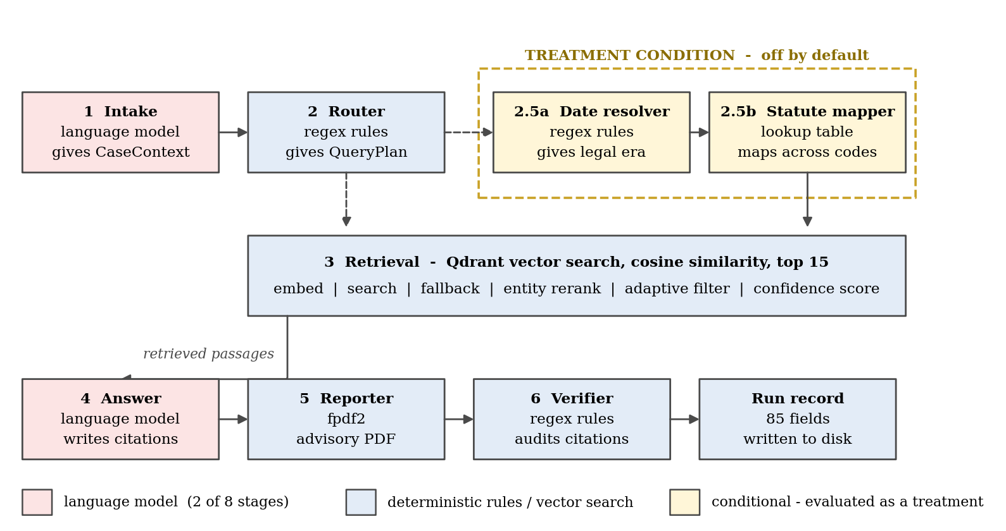
Figure 2: The eight-stage pipeline in execution order. Two stages call a language model. The date resolver and statute mapper are conditional and are evaluated as a treatment condition.
Two stages do not run by default. The date resolver reads the query for any indication of when the conduct occurred and converts it into a legal era; the statute mapper then translates extracted section numbers across the recodification, so a query naming a repealed provision can also be searched under its replacement. Both are activated by an explicit flag and evaluated as a treatment condition against the pipeline without them. This is an experimental design, not an incomplete implementation.
5.2 Corpus construction
Four statutes were ingested, with text extracted by PyMuPDF and an optical character recognition fallback that activates only when a page yields fewer than twenty extractable characters. The corpus is entirely English; the recognition stage is configured for additional scripts, but no non-English statutory text has been ingested and no multilingual capability is claimed or evaluated.
Chunking is section-bounded rather than windowed. Most systems cut documents into overlapping fixed-length windows; here text is split at statutory section headings, so one section becomes one passage and a provision is never divided mid-sentence. Only a section exceeding 800 tokens is sub-divided, targeting 450 tokens per piece. There is no overlap: the pieces share a section number, so context is carried by metadata.
Table 1: Corpus composition, a census of the live index.
Statute | Status | Passages | Share
Code of Criminal Procedure, 1973 | Repealed 1 July 2024 | 742 | 39.07%
Indian Penal Code, 1860 | Repealed 1 July 2024 | 595 | 31.33%
Bharatiya Nyaya Sanhita, 2023 | In force | 424 | 22.33%
Consumer Protection Act, 2019 | In force | 138 | 7.27%
Total |  | 1,899 | 100.00%

The Bharatiya Nagarik Suraksha Sanhita and Bharatiya Sakshya Adhiniyam were deliberately not ingested. The corpus boundary is declared in code as an explicit set, and retrieval consults it to detect when a query requires a statute the index does not hold. Such questions are unanswerable by construction and counted as such rather than scored as failures.
5.3 The evaluation set
Four query sets were constructed, totalling 518 unique questions, each carrying the section that correctly answers it, fixed before any output was seen. Three are certain by construction: the query was generated from a known section, so that section is the answer by definition. Only the layman set required judgement, in reading a described situation and deciding which provision governs it.
Table 2: The four evaluation query sets.
Query set | n | Construction | What it isolates
Generated retrieval | 200 | By construction | Baseline retrieval across all four statutes
Paired recodification | 99 | By construction | The same offence asked once under each code
Paired dated conflict | 99 | By construction | Named code and conduct date disagree
Layman situation | 120 | Judgement | Ordinary language, no statutory vocabulary
Total | 518

5.4 Three definitions of a correct answer
Asking whether the system answered correctly is not one question. Three things might be meant:
• Retrieved at k: the correct section appeared among the k passages the search returned. A property of retrieval alone.
• Cited: the correct section appears in the citations of the written answer. A property of the generated text.
• Grounded: every section the answer cited was genuinely present in the passages supplied to the model. The strict definition, which detects a model citing from memory rather than from evidence.
These come apart: Section 7.1 reports a finding that holds under the first and vanishes under the other two, so every result names its definition. Retrieval is likewise measured at three points, since passages are transformed between database and model: they arrive in similarity order, are reordered to promote passages containing section numbers from the query, then filtered by score. Every figure names its stage.
5.5 Verification infrastructure
A metric that crashes is harmless because it is noticed; one that quietly returns a plausible but wrong number is not. Four safeguards address this: 237 automated tests, including tests whose correct output was worked out by hand before the code was written; one shared measurement library imported by every experiment; an independent re-derivation inside each experiment that halts if two routes to a number disagree; and no hand transcription of any figure, each being extracted from a stored results file by a filter that halts rather than guess. These have caught real errors, including two in the measurement code itself, one of which silently returned zero correct answers out of 617 while raising no error.
These have detected real errors, including two defects in the measurement code itself. One silently returned zero correct answers out of 617 while raising no error and producing entirely plausible figures. That class of failure is why the infrastructure exists.
6. Tools and Techniques
6.1 The composite confidence score
The system computes one confidence value from three signals: the mean similarity of the five best passages, capturing the quality of the best evidence while ignoring the weak tail; the gap between the best and fifth-best similarity, intended to detect a single lucky match among poor results; and entity coverage, the fraction of section numbers named in the query that appear in the retrieved text. They combine as a fixed weighted sum.
C = 0.55 m + 0.15 (1 - g) + 0.30 e (1)
Here m is the mean of the top five similarity scores, e is entity coverage, and g is the normalised gap of Equation (2). Where the query names no section number, e takes a neutral 0.5 rather than counting as a failure. The result is clamped to a maximum of 1.0 and rounded to four decimal places.
g = min( ( s1 - s5 ) / 0.3 , 1.0 ) (2)
The sign of the second term deserves attention, and Section 7.1 reports what measurement found. A large gap between best and fifth-best is ordinarily read as evidence of a clear winner; the deployed formula subtracts it, treating a large gap as evidence of doubt.
The confidence value selects one of three response tiers determining the disclaimer attached to the answer: below 0.38 low, 0.38 to below 0.55 medium, 0.55 and above high. These thresholds were fixed before any evaluation score was recorded, so they cannot have been tuned to the evaluation data.
6.2 Retrieval and the adaptive filter
Retrieval returns the fifteen passages closest to the query embedding by cosine similarity. A threshold then discards the weakest, keeping any passage above the value in Equation (3), subject to a floor of three passages always passing regardless of score.
t = max( s_top - 0.15 , 0.35 ) (3)
6.3 Comparison retrievers
Two alternative methods were evaluated as comparison arms. Neither is part of the deployed system, which is dense-only. BM25 [5] is lexical, scoring documents by which query words literally appear, weighted by frequency and rarity. Rarity is inverse document frequency, Equation (4), where N is the passage count and n the number containing the term.
idf(q) = ln( ( N - n + 0.5 ) / ( n + 0.5 ) ) (4)
The two ranked lists were combined by Reciprocal Rank Fusion [6], scoring each passage by the reciprocal of its rank in each list with a constant of 60 as specified in the original work.
RRF(d) = SUM over lists of 1 / ( 60 + rank(d) ) (5)
6.4 Statistical methods
Discrimination is measured by the area under the receiver operating characteristic curve, AUROC [11]: pick one correct and one incorrect answer at random, and AUROC is the probability the correct one scored higher. A value of 0.5 is a coin flip, meaning the score carries no information; below 0.5 means it is actively misleading.
Calibration is measured by Expected Calibration Error [8], which sorts answers by confidence, bins them, and averages the distance between each bin's claimed confidence and its observed accuracy; the Brier score [12] is reported alongside, and Platt scaling [7] is applied on a stratified split. Intervals for proportions use the Wilson score interval [9], which unlike the normal approximation does not claim certainty at zero or one; others use the bootstrap [10] with 10,000 resamples under a fixed seed. Where several phrasings of one situation appear, the cluster bootstrap resamples situations rather than rows, because three phrasings are not three independent observations.
6.5 Software
FastAPI with Pydantic typed contracts between stages; Qdrant for vectors, cosine similarity over 1,536-dimensional text-embedding-3-small embeddings; generation pinned to one named provider endpoint at temperature zero with a fixed seed, so runs are reproducible. Extraction uses PyMuPDF and pdfplumber with Tesseract; reports use fpdf2. Analysis uses NumPy, pandas, SciPy and Matplotlib; the comparison retriever uses rank-bm25; tests run under pytest.
7. Expected Outcome of the Research
This section separates results already obtained, reported with sample sizes and confidence intervals, from outcomes still expected, stated as plans rather than findings.
7.1 Results obtained
Six findings are established, computed from 617 analysed query runs drawn from 859 recorded executions. Table 3 summarises them; each is reported with the correctness definition and retrieval stage that produced it.
First, retrieval across the recodification fails asymmetrically. A query naming the repealed Indian Penal Code retrieves predominantly correct text 97.0% of the time against a chance baseline of 31.3%, that baseline being the share of the index the statute occupies and therefore what a retriever ignoring the question entirely would score. A query naming the Bharatiya Nyaya Sanhita, the code in force, manages 51.5% against 22.3%. Both rest on 33 queries per arm, with 95 per cent Wilson intervals of [84.7%, 99.5%] and [35.2%, 67.5%]. The system is most reliable on the law that no longer applies.
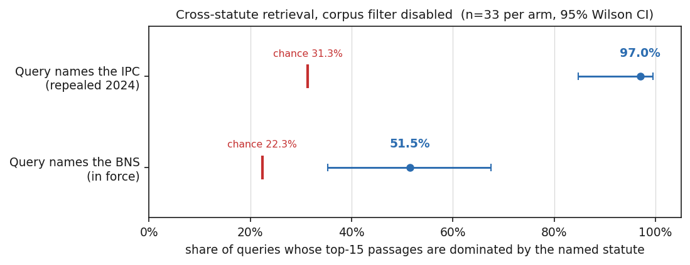
Figure 3: Cross-statute retrieval accuracy with 95 per cent Wilson intervals. Red marks indicate the chance baseline.
Second, this is not an artefact of choosing dense retrieval. Lexical retrieval does not repair the failure; it inverts it, raising accuracy on queries naming the code in force to 97.0% while collapsing accuracy on queries naming the repealed code to 0.0%, below its chance baseline. Fusing the two yields 45.5% and 78.8%, beating neither method at what it was individually good at.
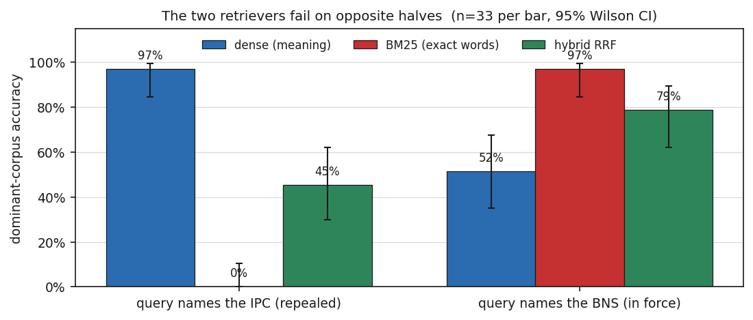
Figure 4: Dense, lexical and fused retrieval on the same queries. The two methods fail on opposite halves of the set.
Third, the mechanism lies in how the statutes are drafted. The word "sanhita" occurs in 30 of the 1,899 passages and every one belongs to the Bharatiya Nyaya Sanhita, giving an inverse document frequency of 4.12 and making it a perfect signpost. The word "penal" occurs in 110 passages, but only 23 belong to the Indian Penal Code while 82 belong to the Code of Criminal Procedure. The drafters of 1860 had no occasion to write "penal" inside the Penal Code; the procedure code refers to it constantly. The repealed statute's own name has become, statistically, a word belonging to a different book.
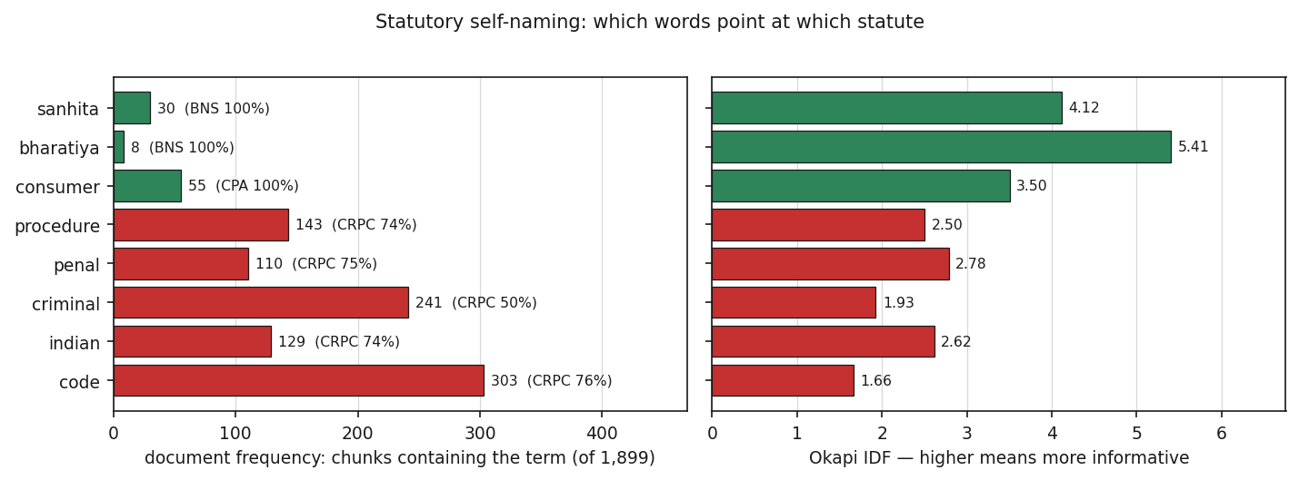
Figure 5: Document frequency and inverse document frequency of statute-identifying terms across the index.
Fourth, the composite confidence score discriminates worse than a single quantity the system already computes: 0.663 against 0.784 for the highest similarity from the same search. Two of the composite's own three inputs also beat the blend.
The cause is identified rather than merely observed. The gap term as deployed, entering Equation (1) at weight 0.15, reaches an AUROC of 0.270. A value that far below 0.5 is not an absence of information but inverted information: the signal points systematically the wrong way. Without the inversion the same quantity reaches 0.730. Recomputing the composite with the sign corrected raises it to 0.721, a significant improvement that still falls significantly short of the single similarity score. The sign error accounts for roughly half the shortfall; the remainder is the blend itself.
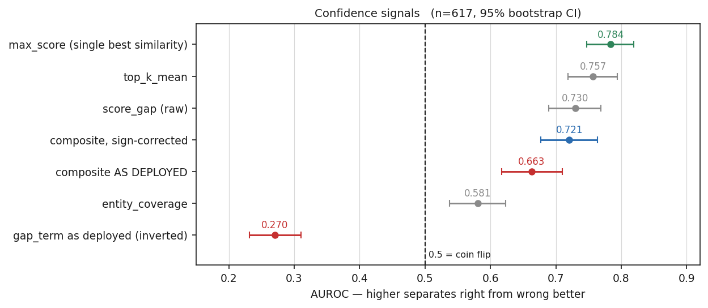
Figure 6: Discrimination of each confidence signal with 95 per cent bootstrap intervals. The dashed line marks 0.5, the value of a coin flip.
Fifth, no confidence threshold makes selective answering viable. The largest fraction of questions answerable while holding the error rate at or below 10 per cent is 0.000 for the composite -- a measured value, not a missing one, since no threshold anywhere on the curve achieves that rate. Expected Calibration Error is 0.241 for the composite against 0.127 for the single similarity score, lower being better.
Sixth, the failure is invisible in the answers. Measured on what was retrieved, the gap between the two arms of the paired set is +0.545, clustered interval [0.303, 0.758]. Measured on what the answer cited it is -0.030, interval [-0.121, 0.061], which contains zero. The generating model supplies correct section numbers from its own training regardless of what search returned, so a reviewer assessing this system by reading its answers would conclude it works.
Table 3: Summary of obtained results.
Finding | Value | 95% interval | n | Definition
IPC-named retrieval accuracy | 97.0% | [84.7%, 99.5%] | 33 | Dominant corpus
BNS-named retrieval accuracy | 51.5% | [35.2%, 67.5%] | 33 | Dominant corpus
Composite confidence AUROC | 0.663 | [0.617, 0.710] | 617 | Retrieved at k
Single similarity AUROC | 0.784 | [0.747, 0.819] | 617 | Retrieved at k
Deployed gap term AUROC | 0.270 | [0.232, 0.311] | 617 | Retrieved at k
Coverage at 10% error | 0.000 | not applicable | 617 | Retrieved at k
IPC minus BNS gap, retrieved | +0.545 | [0.303, 0.758] | 66 | Retrieved at 15
IPC minus BNS gap, cited | -0.030 | [-0.121, 0.061] | 66 | Cited

7.2 A constraint on interpretation
One limitation bears on every retrieval figure above. Where a gold label names a subsection, such as Section 318(4), and the index stores only the parent section, no retriever can score that query correct under strict matching. Only 85.7% of the 518 queries have a gold section the index can return at all, and for queries naming the Bharatiya Nyaya Sanhita the ceiling is 33.3%. Figures must be read against that ceiling, not against 100 per cent. On the reachable subset, dense retrieval attains the ceiling exactly.
7.3 Expected outcomes
Three outcomes are expected and not yet obtained. The first is independent validation of the gold labels, all of which were decided by a single annotator. Three of the four sets are certain by construction and carry limited annotation risk, but the layman set required judgement, and no second reader has verified those decisions. The expected outcome is validation of approximately thirty queries by a second annotator with legal training, reported with an inter-annotator agreement statistic. This is the largest outstanding threat to validity and the highest priority.
The second is submission for peer review, targeting the 49th European Conference on Information Retrieval, ECIR 2027, held 21 to 25 March 2027 in Southampton, United Kingdom. The short paper and reproducibility track closes on 12 October 2026, with notification on 7 December 2026. A separate resource paper track closing 2 November 2026 is a plausible second route, since the annotated evaluation set is itself a reusable artefact.
The third concerns language coverage, stated as a direction rather than a claim. The corpus is entirely English and no multilingual capability is claimed. Two properties make extension tractable: ingestion already tags each passage with a detected language, and the optical character recognition stage is already configured for Devanagari, Tamil and Telugu, so ingesting regional-language statutory material is a configuration change rather than a redesign. A nearer observation is available within the present set: twelve of the 120 layman queries are code-mixed, using Hindi vocabulary in Roman script, which is how a large fraction of Indian users type. That is a register rather than a language and is not currently reported as a separate stratum. Doing so, then extending to multilingual statutory text, is the next phase.
8. References
[1] S. Paul, R. Dogra, P. Goyal, and S. Ghosh, "ILSIC: Corpora for identifying Indian legal statutes from queries by laypeople," in Findings of the Association for Computational Linguistics: EACL 2026, 2026.
[2] H. de Martim, "Deterministic legal agents: A canonical primitive API for auditable reasoning over temporal knowledge graphs," arXiv:2510.06002, Oct. 2025, rev. Apr. 2026.
[3] P. Lewis et al., "Retrieval-augmented generation for knowledge-intensive NLP tasks," in Advances in Neural Information Processing Systems, vol. 33, 2020, pp. 9459-9474.
[4] V. Magesh, F. Surani, M. Dahl, M. Suzgun, C. D. Manning, and D. E. Ho, "Hallucination-free? Assessing the reliability of leading AI legal research tools," Journal of Empirical Legal Studies, 2025.
[5] S. Robertson and H. Zaragoza, "The probabilistic relevance framework: BM25 and beyond," Foundations and Trends in Information Retrieval, vol. 3, no. 4, pp. 333-389, 2009.
[6] G. V. Cormack, C. L. A. Clarke, and S. Buettcher, "Reciprocal rank fusion outperforms Condorcet and individual rank learning methods," in Proc. 32nd ACM SIGIR Conf. on Research and Development in Information Retrieval, 2009, pp. 758-759.
[7] J. Platt, "Probabilistic outputs for support vector machines and comparisons to regularized likelihood methods," in Advances in Large Margin Classifiers, MIT Press, 1999, pp. 61-74.
[8] C. Guo, G. Pleiss, Y. Sun, and K. Q. Weinberger, "On calibration of modern neural networks," in Proc. 34th Int. Conf. on Machine Learning, 2017, pp. 1321-1330.
[9] E. B. Wilson, "Probable inference, the law of succession, and statistical inference," Journal of the American Statistical Association, vol. 22, no. 158, pp. 209-212, 1927.
[10] B. Efron and R. J. Tibshirani, An Introduction to the Bootstrap. New York, NY, USA: Chapman and Hall/CRC, 1993.
[11] J. A. Hanley and B. J. McNeil, "The meaning and use of the area under a receiver operating characteristic (ROC) curve," Radiology, vol. 143, no. 1, pp. 29-36, 1982.
[12] G. W. Brier, "Verification of forecasts expressed in terms of probability," Monthly Weather Review, vol. 78, no. 1, pp. 1-3, 1950.
[13] The Bharatiya Nyaya Sanhita, 2023 (Act No. 45 of 2023), Government of India. Commenced 1 July 2024.
[14] The Bharatiya Nagarik Suraksha Sanhita, 2023 (Act No. 46 of 2023), Government of India. Commenced 1 July 2024.
[15] The General Clauses Act, 1897 (Act No. 10 of 1897), s. 6, Government of India.

