P1: Choosing DBMS Environment

By 2047262 (Udit Gupta)

1. **Logging on to SQL interface**

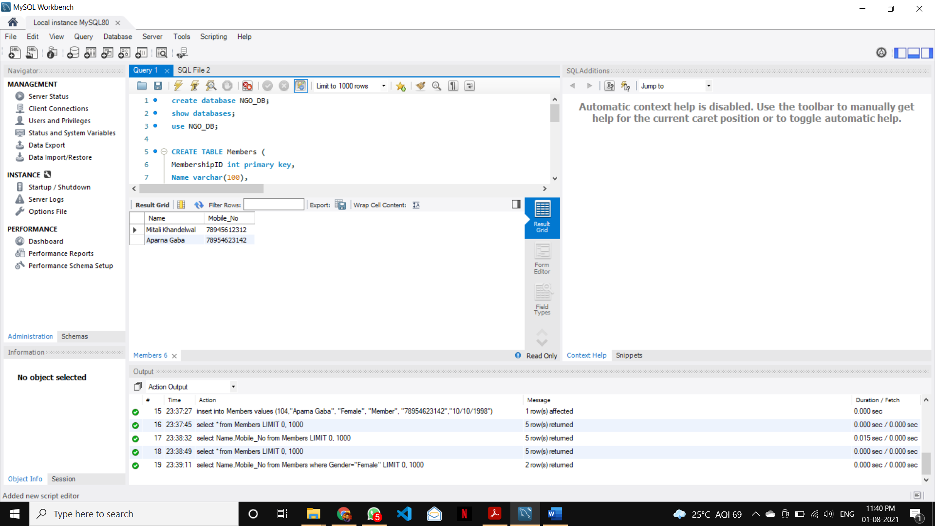

1. **Choosing and Describing Tables**
   1. Choosing Database:

**create database NGO_DB;**

**show databases;**

**use NGO_DB;**

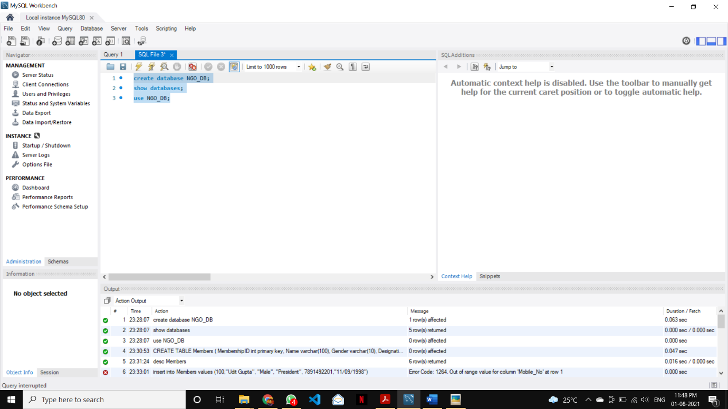

* 1. Describing Tables

**CREATE TABLE Members (**

**MembershipID int primary key,**

**Name varchar(100),**

**Gender varchar(10),**

**Designation varchar(100),**

**Mobile_No varchar(20),**

**DOB varchar(50)**

**);**

1. **Elements of the SQL Query**
   1. **Inserting Data into Table**

**insert into Members values (100,"Udit Gupta", "Male", "President", "7891492201","11/09/1998");**

**insert into Members values (101,"Mitali Khandelwal", "Female", "Scretary", "78945612312","10/11/2001");**

**insert into Members values (102,"Sopan Sharma", "Male", "Treasurer", "7661120420","14/05/1998");**

**insert into Members values (103,"Nishant Jain", "Male", "Member", "9659487562","07/04/1999");**

**insert into Members values (104,"Aparna Gaba", "Female", "Member", "78954623142","10/10/1998");**

* 1. **Showing the table**

**select * from Members;**

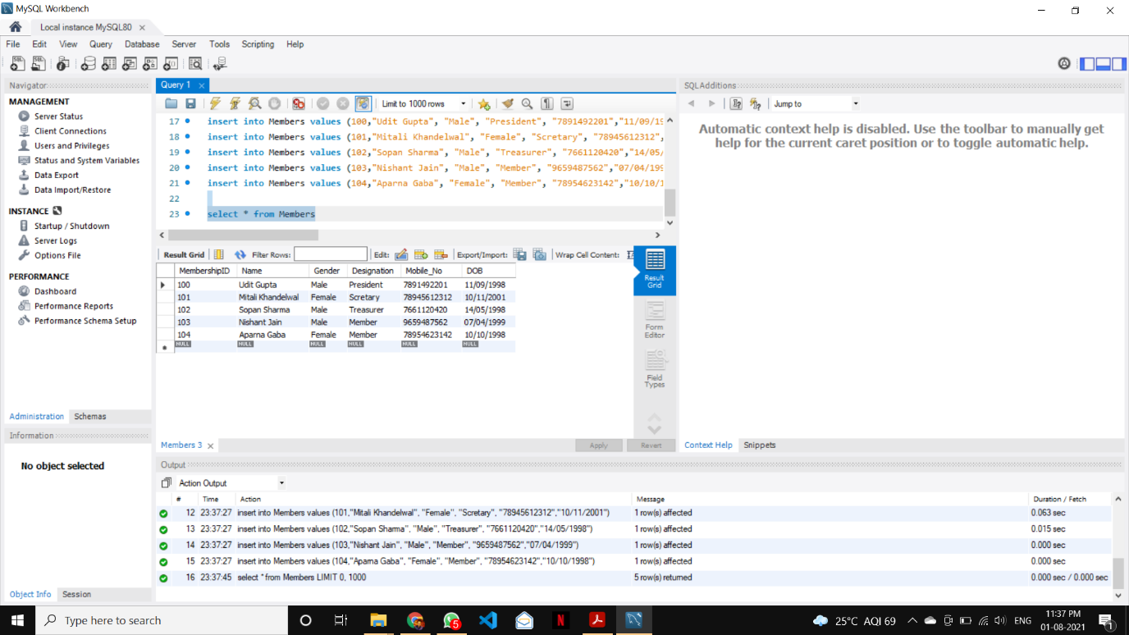

1. **The System Dummy Table**

**select * from dual;**

1. **Selecting Tables and Columns**

**select Name,Mobile_No from Members;**

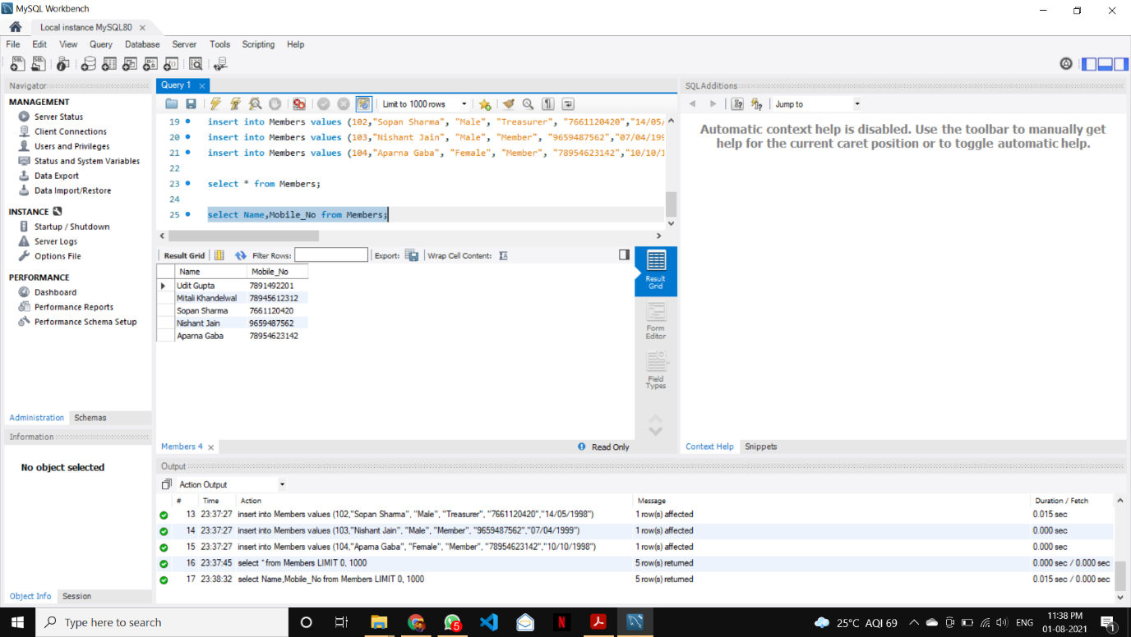

**select Name,Mobile_No from Members where Gender="Female";**

