# P4: Filtering Data Using WHERE

By 2047262 (Udit Gupta)

**a) 1. =, <, >, >=,<=,<>**

**select * from members where MembershipID=101;**

**select * from members where MembershipID<103;**

**select * from members where MembershipID>103;**

**select * from members where MembershipID<=103;**

**select * from members where MembershipID>=103;**

**select * from members where MembershipID<>103;**

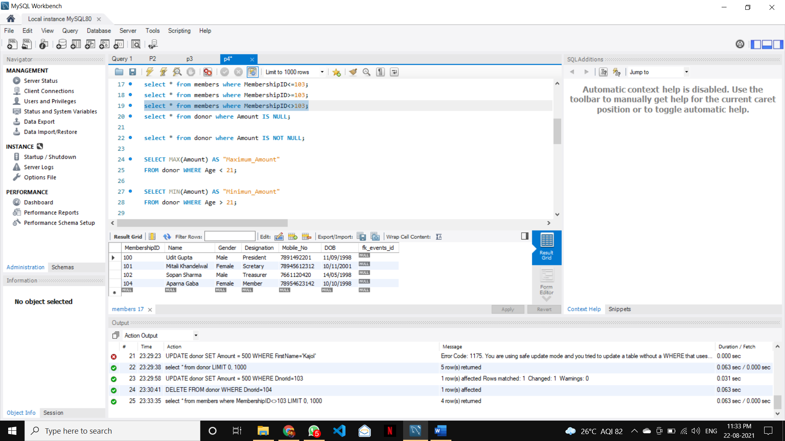

**2. null values**

**select * from donor where Amount IS NULL;**

**3. not null values;**

**select * from donor where Amount IS NOT NULL;**

**4. min, max, avg, count with “where” keyword**

**SELECT MAX(Amount) AS "Maximum_Amount"**

**FROM donor WHERE Age < 21;**

**SELECT MIN(Amount) AS "Minimun_Amount"**

**FROM donor WHERE Age > 21;**

**SELECT AVG(Amount) Avg_Amount FROM donor WHERE age>=21;**

**SELECT COUNT(*) FROM members WHERE Gender='male';**

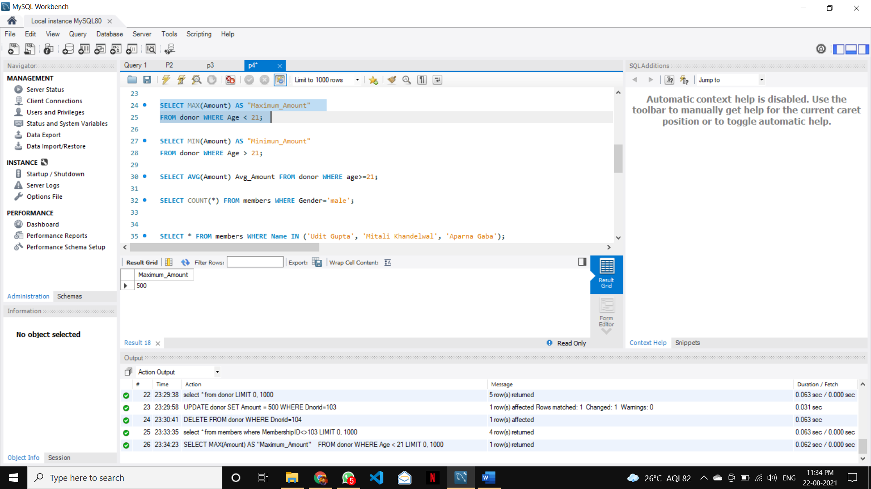

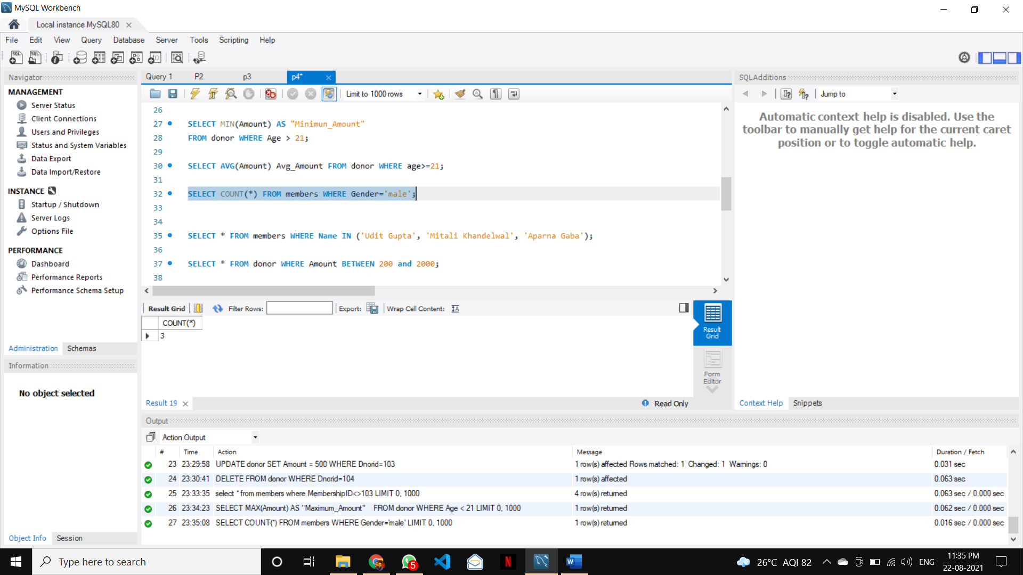

**b) 1. IN**

**SELECT * FROM members WHERE Name IN ('Udit Gupta', 'Mitali Khandelwal', 'Aparna Gaba');**

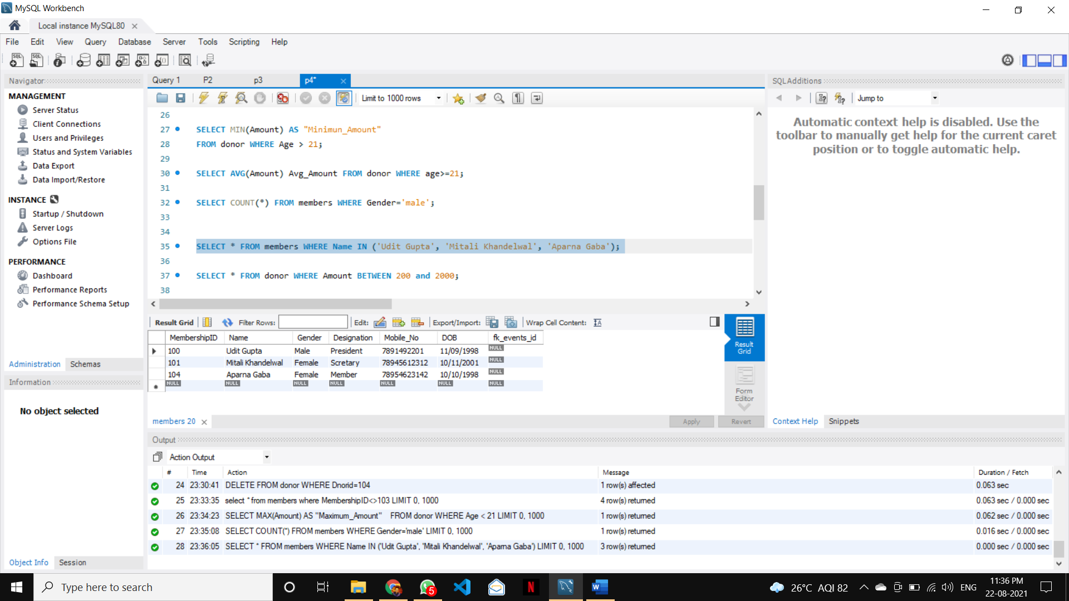  
**2. BETWEEN**

**SELECT * FROM donor WHERE Amount BETWEEN 200 and 2000;**

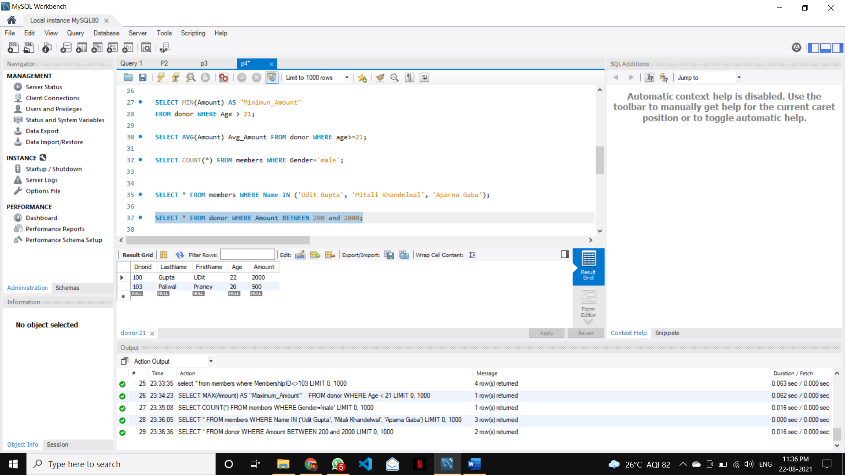  
**3. LIKE (Wildcard characters %, _ )**

**SELECT * FROM members WHERE Designation LIKE 'Mem%';**

**SELECT * FROM members WHERE Gender LIKE 'Fem_le';**

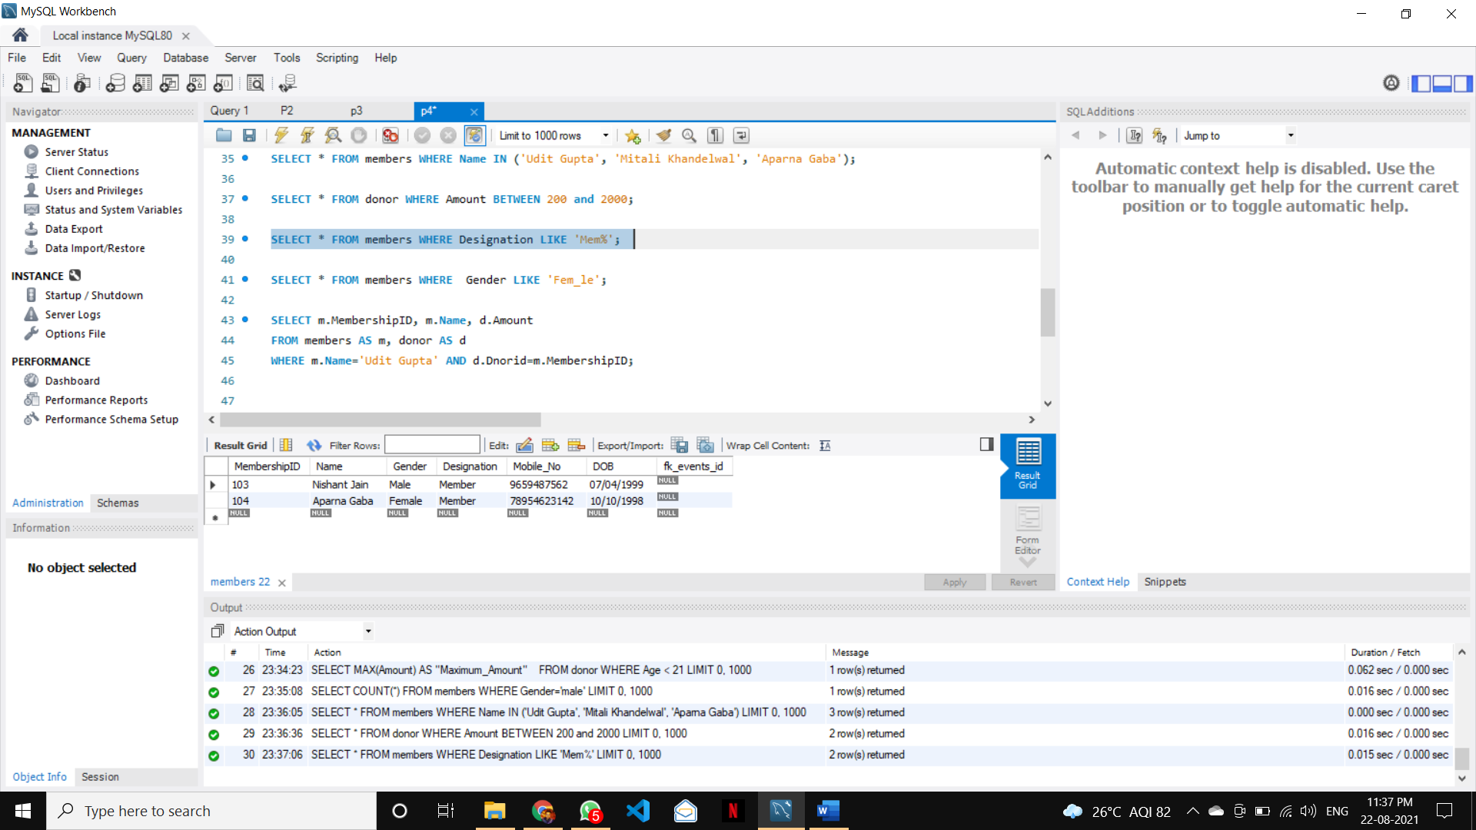

**4. Aliases**

**SELECT m.MembershipID, m.Name, d.Amount**

**FROM members AS m, donor AS d**

**WHERE m.Name='Udit Gupta' AND d.Dnorid=m.MembershipID;**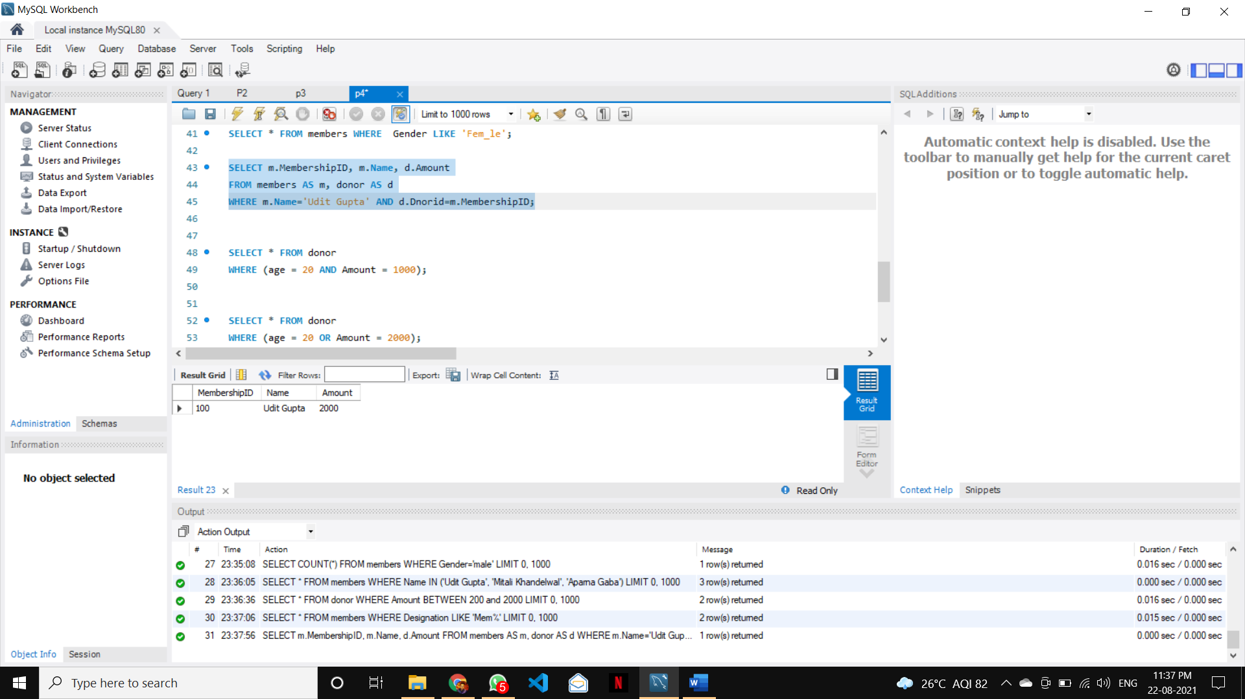

**c) 1. AND, OR, NOT (combine keywords, operators)**

**SELECT * FROM donor**

**WHERE (age = 20 AND Amount = 500);**

**SELECT * FROM donor**

**WHERE (age = 20 OR Amount = 2000);**

**SELECT * FROM donor**

**WHERE Amount IS NOT NULL;**

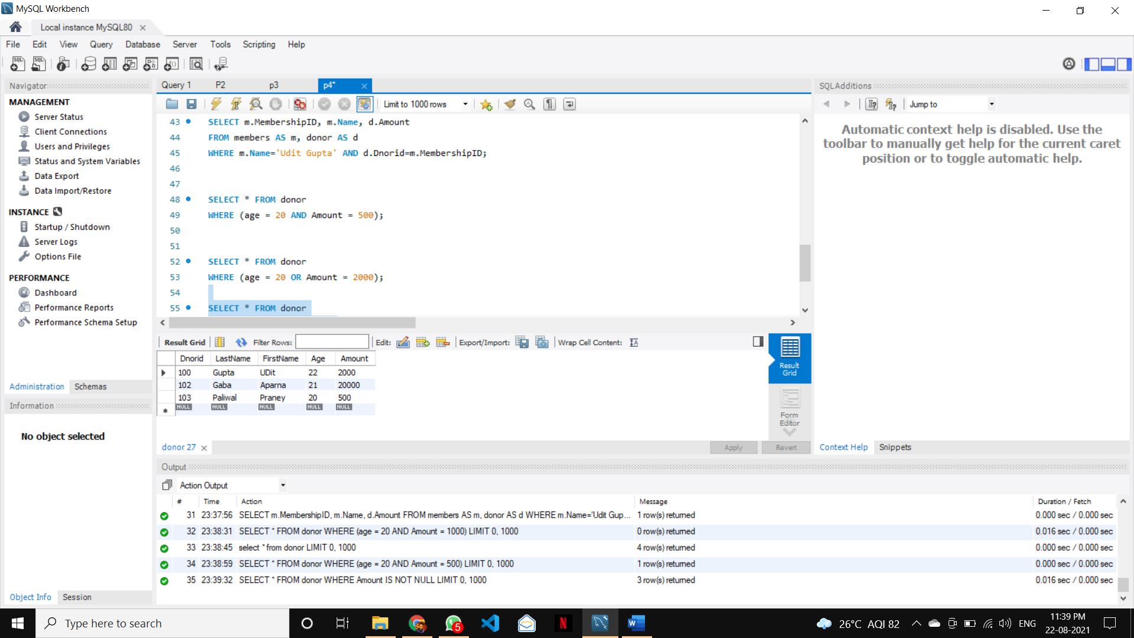

**UPDATE donor SET Amount = 500 WHERE Dnorid=103;**

**DELETE FROM donor WHERE Dnorid=104;**

