Project Report — Phase I
Project title: KGCR — Knowledge Graph-Based Cloud Configuration Recommendation Repository: KGCR_Cloud_Project_2026 Course: BCSE355L — Cloud Architecture Design Project Course instructor: Dr. Priya V Team: Udit (lead), Manya, Tanmoy Cloud platform: Amazon Web Services

1. Abstract
Cloud misconfiguration remains a leading cause of data breaches, and the tools meant to prevent it each cover one edge of the problem. Posture management products detect violations only after deployment. Policy-as-code engines such as Checkov evaluate one resource at a time, justify a finding only by restating the rule that fired, and cannot see a defect that lives in the relationship between two individually compliant resources. FinOps platforms find waste but are blind to compliance. Nothing recommends a configuration at design time, grounds it in a regulatory clause, optimises cost and compliance together, and explains itself well enough to survive an audit.
This project builds that missing middle. Controls from PCI-DSS v4.0 and the CIS AWS Foundations Benchmark, the resources and dependencies of an AWS estate, and the history of past runs are encoded in one knowledge graph, so recommendation, review, cost reasoning and explanation become operations over a single structure. Because the estate is a graph, a defect can be a path rather than a property: a cardholder data store reachable from the internet through a chain in which every resource passes its own check. Review is reframed as design with recovered intent — the system reconstructs what an estate was built to achieve, reports calibrated confidence per field, and reviews against that reconstruction rather than a fixed checklist. Each conclusion is explained as the reasoning subgraph linking a configuration choice to its controlling clause and its cost consequence.
The planned AWS deployment spans three accounts. AWS Config, CloudTrail and Cost and Usage Reports feed Amazon S3; Lambda and Glue normalise that evidence into Neo4j on EC2; SageMaker trains the models; API Gateway and Cognito expose and authenticate the interface; IAM separates harvesting from writing; CloudWatch, Budgets and SNS provide monitoring, cost control and notification.
(296 words)

2. Literature survey
Fifteen papers, all published 2023–2026 in IEEE, Springer, Elsevier, ACM or MDPI venues, with the full table of Method / Dataset / Advantages / Limitations / Research Gap.
See Literature_Survey.md.

3. Research gap analysis
Per student, five papers each, written independently.
- Udit — papers 1–5: Research_Gap_Udit.md
- Manya — papers 6–10: Research_Gap_Manya.md (to be written by Manya)
- Tanmoy — papers 11–15: Research_Gap_Tanmoy.md (to be written by Tanmoy)

4. Objectives
Six measurable objectives — see Objectives.md.

5. Novelty summary
See Novelty.md.

6. Proposed architecture
Diagram | File
1 — AWS Cloud Architecture | `architecture/AWS_Architecture.png`
2 — Complete System Architecture | `architecture/System_Architecture.png`

Two supporting flowcharts expand the decision logic of the two entry conditions; see `architecture/README.md`.

7. Dataset details
See `dataset/dataset_description.md`. In summary: the corpus is generated, not downloaded — 180 synthetic AWS estates carrying 2,331 resources, each with its originating intent as ground truth, plus a 12-estate relational defect set.

8. AWS services planning
Every service planned for the implementation, with its purpose. This is a planning table, which is what Phase-I asks for; the final column states honestly what is running today.
AWS service | Purpose in this project | Status
Amazon EC2 | Host Neo4j Community (the knowledge graph store) and the analysis workload | Planned
Amazon S3 | Evidence landing bucket for Config, CloudTrail and cost data; corpus and artefact storage | Planned
Amazon RDS | Represents the cardholder data store in the estates under analysis | Planned
AWS Lambda | ETL of harvested evidence into the graph schema; Advisor and Explainer inference | Planned
AWS Glue | Batch normalisation of large Config and Cost and Usage Report extracts | Planned
Amazon SageMaker | Train and host the recommender and the intent reconstructor | Planned — the reconstructor currently trains locally with scikit-learn
Amazon Bedrock | Structured intent extraction from a natural-language request, and verbalisation of an explanation. Never used to decide compliance | Planned
Amazon API Gateway | REST surface backing the kgcr CLI | Planned
Amazon Cognito | Authenticate architects, auditors and learners | Planned
AWS IAM | Cross-account roles enforcing separation of duties: Agent 2 read-only for harvesting, Agent 1 write-only for applying | Terraform authored in src/aws/, not yet applied
AWS Config | Resource inventory and relationships — the primary input to the estate graph | Planned
AWS CloudTrail | API audit events, supporting evidence-retention controls | Planned
AWS Cost and Usage Reports | Per-resource cost attribution for the joint cost/compliance objective | Planned
Amazon EventBridge | Scheduled and change-driven triggers for re-harvesting and drift detection | Planned
Amazon CloudWatch | Logs, metrics and alarms across all three accounts | Planned
AWS Budgets | Cost alarms, provisioned as code before any workload runs | Terraform authored in src/aws/, not yet applied
Amazon SNS | Deliver compliance findings and budget breach notifications | Planned
Amazon VPC, subnets, security groups, NAT, Internet Gateway | The network topology whose relationships the multi-hop defect analysis reasons over | Planned
AWS KMS | Encryption keys for the evidence bucket and the estates under analysis | Planned
Elastic Load Balancing | Ingress in the estates under analysis | Planned
AWS Organizations | Three-account structure: prod-payments, dev-staging, shared-security | Planned

Stated plainly: what runs today is a local Python pipeline (src/backend/) plus authored but unapplied Terraform (src/aws/). Phase-I asks for a service plan, and this is it; the gap between plan and implementation is stated rather than concealed, and Diagram 1 carries the same note.

9. Implementation progress
Component | Status | Evidence
Reproducibility spine — deterministic seeding, canonical hashing, run records | Done | src/backend/kgcr/, 30 tests
Intent-first corpus generator and dependency graph | Done | src/backend/kgcr/corpus/, 45 tests
Defect taxonomy DF-1…DF-7 and the relational (DF-7) test set | Done | src/backend/kgcr/defects/, 34 tests
Checkov labelling and the empirical relational-defect gate | Partial | src/backend/kgcr/labelling/, 8 tests, results/p4_df7_checkov_evidence.json
Intent reconstruction with per-field calibration | Done (structural baseline) | src/backend/kgcr/reconstruction/, 13 tests, results/reconstruction_report.json
Cross-account IAM and budget alarms as Terraform | Authored, not applied | src/aws/
Ontology encoding (L1), recommender, Advisor, Explainer | Not started / blocked | See CHANGELOG.md §1

Test suite: 130 tests passing. Quality gates — ruff check, ruff format --check, mypy (strict) and pytest — run in CI on Python 3.11 and 3.12 on every push.

Results obtained so far
- Multi-hop detection (objective O2). Across 12 relational-defect estates, the graph recovers
all 12 paths while Checkov, including its graph checks, returns a verdict on the sensitive sink that is byte-identical to the clean parent estate in all 12 cases. This is the empirical form of the project's central claim.
- Intent reconstruction and calibration (objective O4). On the 180-estate corpus with an
estate-level split, structurally encoded axes reconstruct at 1.000 accuracy with expected calibration error at or below 0.052. iam_shape, which the estate carries no structural trace of, reconstructs at 0.417 accuracy with ECE 0.282 — confidently wrong. Reporting that miscalibration rather than hiding it is why confidence is reported per field and never pooled.

10. Expected contribution matrix
Activity | Udit | Manya | Tanmoy
Literature survey (5 papers each) | ✓ | ✓ | ✓
Research gap analysis (5 papers each) | ✓ | ✓ | ✓
Cloud environment, IAM, multi-account setup | ✓
Backend development and CLI | ✓
Knowledge graph, ontology, corpus |  | ✓
Database and graph store integration |  | ✓
AI / machine learning |  |  | ✓
Explainability and evaluation |  |  | ✓
Frontend development |  |  | ✓
AWS cloud services | ✓ | ✓ | ✓
Testing | ✓ | ✓ | ✓
Documentation | ✓ | ✓ | ✓
Presentation | ✓ | ✓ | ✓
GitHub commits | ✓ | ✓ | ✓

11. Repository
URL: https://github.com/uditdaftary/KGCR_Cloud_Project_2026
Branch model: main ← develop ← feature/udit | feature/manya | feature/tanmoy. Each member works only on their own feature branch and merges into develop by pull request after review.
KGCR_Cloud_Project_2026/
├── README.md, LICENSE, .gitignore
├── docs/ Project_Report, Literature_Survey, Research_Gap, Objectives, Novelty, FD-01…FD-08, PMD
├── architecture/ AWS_Architecture.png, System_Architecture.png, condition flowcharts
├── dataset/ raw/, processed/, dataset_description
├── src/ frontend/, backend/, ml_model/, aws/
├── results/ relational-defect evidence, reconstruction report
└── presentation/

12. Limitations stated up front
- The corpus is synthetic. No real financial-sector estate is used, and results have not yet been
checked against human-authored insecure configurations (Corpus D is planned, not present).
- The AWS deployment is planned, not built. The Terraform for budget alarms and cross-account IAM is
authored but has not been applied to live accounts.
- The compliance encoding (L1) is not yet written. Defect definitions cite control URIs that will
resolve once the encoding is hand-authored, and by project rule that content is written by a human rather than generated.
- Intent reconstruction is a structural-feature baseline, not the graph neural network it is
intended to become, and its calibration on the weakest axis is poor by design of the experiment rather than by accident.

AWS Architecture
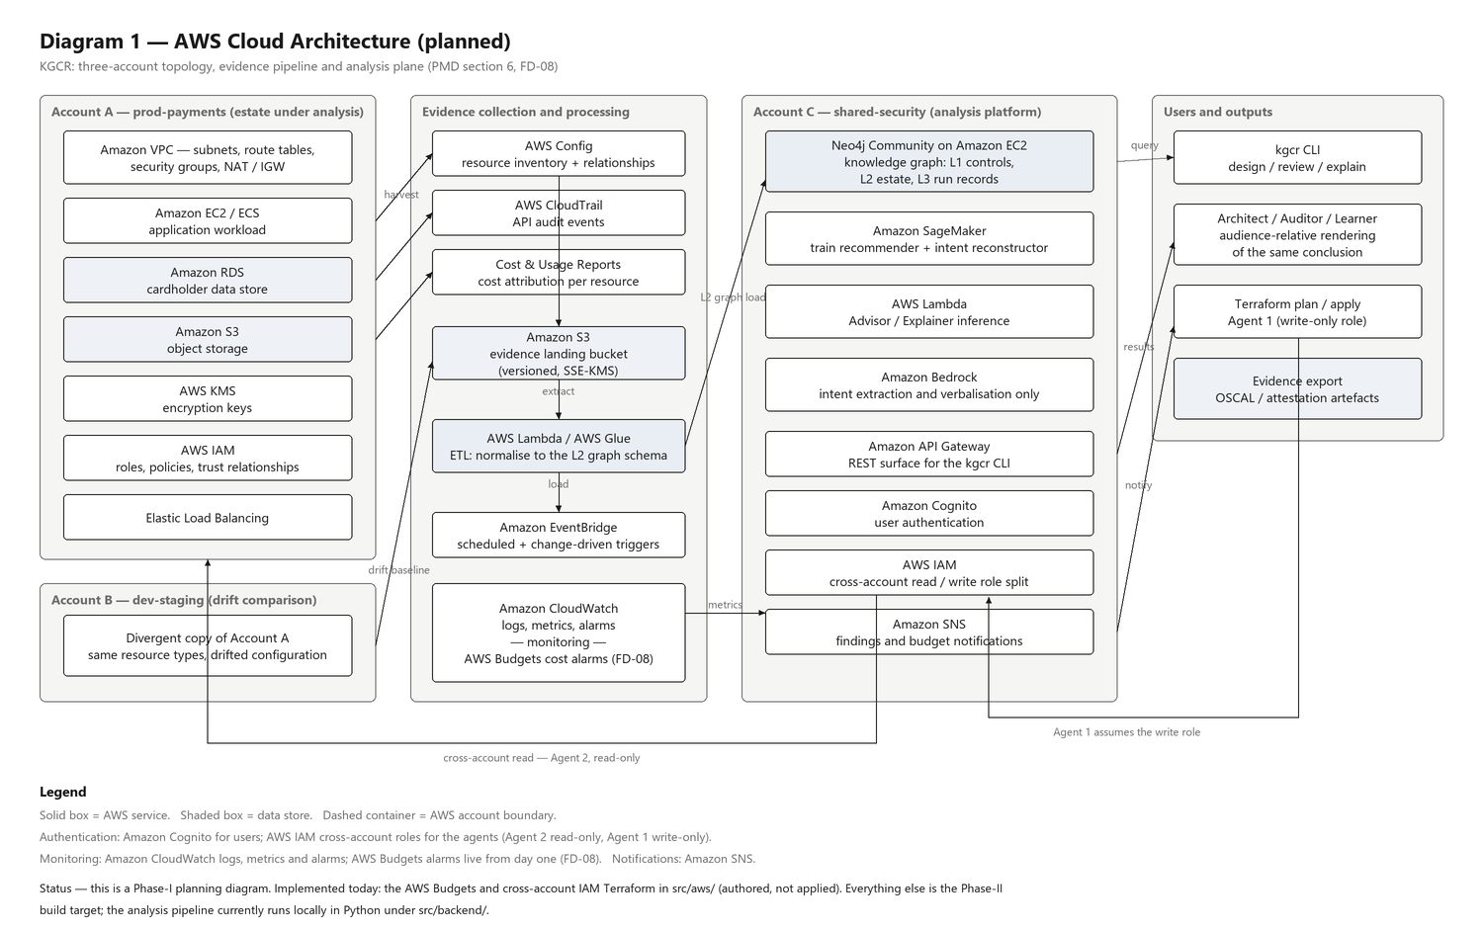

System Architecture
