Lab Report 1
Exercise
1.(a)
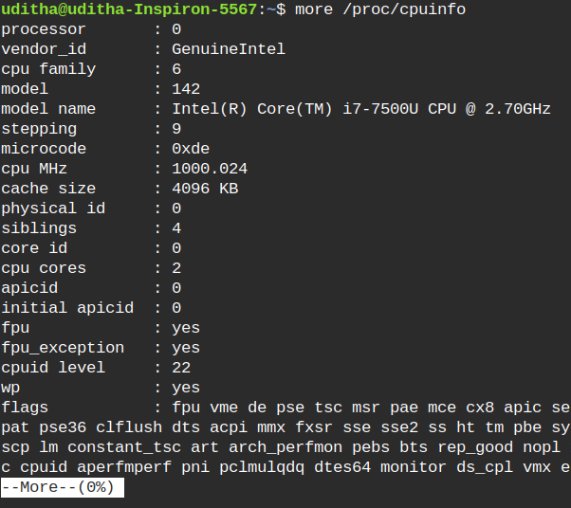
b. cores=2
c. Processors=1
d. frequency of each processor
e. physical memory=
f. free memory
g.total no. of forks since the boot up of this machine
h context switches the system has performed since startup

2.
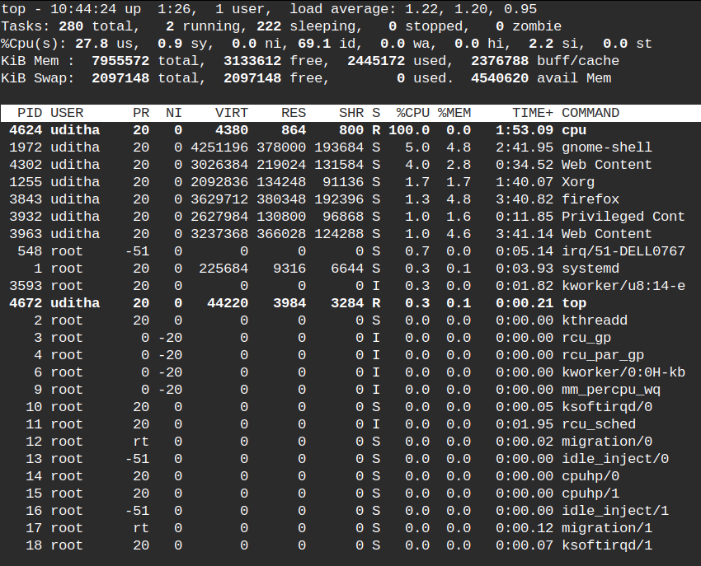
(a)PID of the process running the cpu command
(b)This process consumes cpu and memory
(c)Current state of the process is

3.
