

Cold Diffusion: Inverting Arbitrary Image Transforms Without Noise
Deep Learning
Project Update 2

Team Members
Udith Kumar Tene
Varshitha
05/10/2023

Table of Contents
Introduction 3
Dataset 3
Dataset Annotation 4
Data Processing Class 4
Dataset Link 4
Method 5
Model components and training 6
Deblurring 6
Backbone 6
Model Training 7
Fine tuned Model Results 8
Mini De-blurring Model Implementation 10
Training Mini Model 11
Mini Model Test Results 13
Conclusion 13
References 13

Introduction
Diffusion models have recently emerged as powerful tools for generative modeling. Diffusion models can successfully learn the underlying distribution of training data, and thus generate diverse, high quality images. Diffusion models come in many flavors, but all are built around the concept of random noise removal; one trains an image restoration/denoising network that accepts an image contaminated with Gaussian noise, and outputs a denoised image. At test time, the denoising network is used to convert pure Gaussian noise into a photo-realistic image using an update rule that alternates between applying the denoiser and adding Gaussian noise.
The existence of cold diffusions that require no Gaussian noise (or any randomness) during training or testing raises questions about the limits of our theoretical understanding of diffusion models. It also unlocks the door for potentially new types of generative models with very different properties than conventional diffusion seen so far.
Cold Diffusion model can solve many problems,
Image genration from
- Deblurring
- Inpainting
- Super-Resolution
- Snowification

Note: In this project we are implementing the deblurring diffusion model.

Dataset
The paper has trained and tested the Cold diffusion model on multiple state of the art datasets, like MNSIST, CelebA, CIFAR10, AFHQ.
As a part of our project implementation we scoped our dataset to plants, flowers, trees. The data goal of our implementation is to test the de-blurring, In-painting images regeneration using the Cold Diffusion Model. Our dataset consists of 134 images captured from University surroundings.
Total Images | 134
Training set | 107
Test set | 14
Validation Set | 13

Dataset Annotation
For this model training images are sufficient. The implementation does not require image annotations.

Data Processing Class
We divided the total dataset of 134 images into train, test, valid datasets list. And then used the image list to construct data loader.
We adopted the data processing class from the original paper implementation. As a part the data processing we do scaling of 1.12 on image size, apply random crop, random horizontal flip on the Training dataset and validation. For test dataset we no need apply transformations, so we resized the image to the model expected image size and then converted into torch tensor.
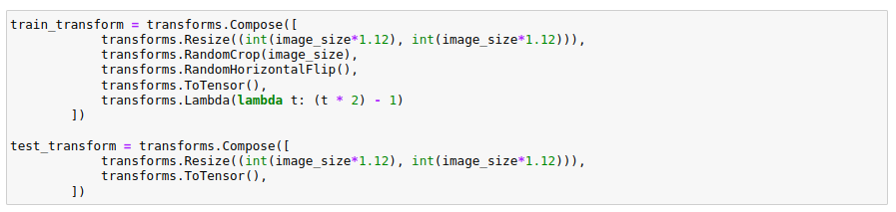
We constructed data loaders for train, test and validation dataset with a batch size of 8.
Using matplotlib we visualized the data.

Dataset Link
https://drive.google.com/file/d/1Fj74MzVimsyygN1pJv9KqWIwcAuMU9eU/view

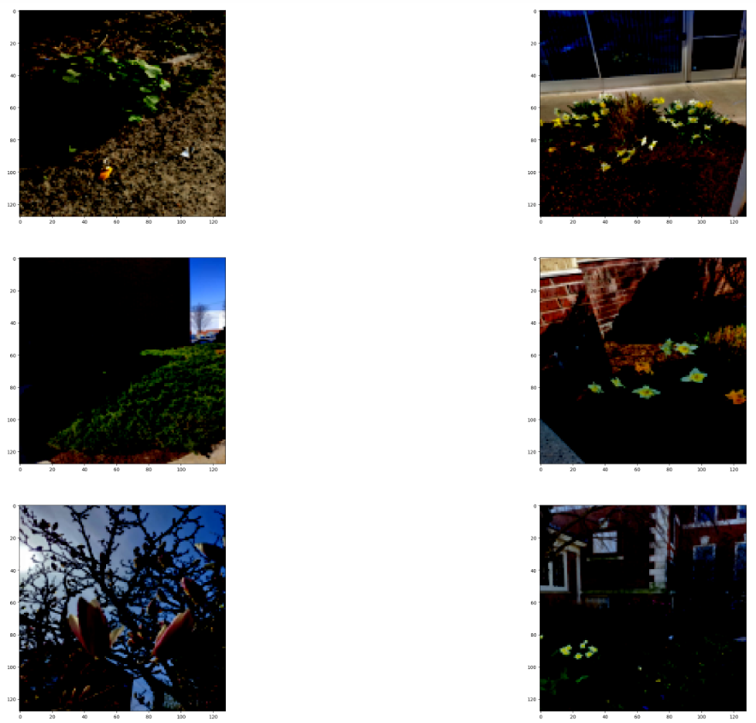

Method
We adapted the deblurring diffusion algorithm from the original implementation for this project. Standard diffusion models are built around two components. First, there is an image degradation operator that contaminates images with Gaussian noise. Second, a trained restoration operator is created to perform denoising. The image generation process alternates between the application of these two operators. In this work, we consider the construction of generalized diffusions built around arbitrary degradation operations. These degradations can be randomized (as in the case of standard diffusion) or deterministic.

Model components and training
Given an image x0 ∈ R N , consider the degradation of x0 by operator D with severity t, denoted xt = D(x0, t). The output distribution D(x0, t) of the degradation should vary continuously in t, and the operator should satisfy D(x0, 0) = x0.
In the standard diffusion framework, D adds Gaussian noise with variance proportional to t. In generalized formulation, choose D to perform various other transformations such as blurring,
masking out pixels, downsampling, and more, with severity that depends on t. A restoration operator R that (approximately) inverts D. This operator has the property that R(xt, t) ≈ x0. In practice, this operator is implemented via a neural network parameterized by θ. The restoration network is trained via the minimization problem min θ.

Deblurring
The implementation train a deblurring model by minimizing the loss and then use Algorithm to invert this blurred diffusion process for which the implementation trained a DNN to predict the clean image xˆ0. Qualitatively, the implementation can see that images created using the sampling process are sharper and in some cases completely different as compared to the direct reconstruction of the clean image. Quantitatively the implementation can see that the reconstruction metrics such as RMSE and PSNR get worse when the implementation use the sampling process, but on the other hand FID with respect to held-out test data improves. The qualitative improvements and decrease in FID show the benefits of the generalized sampling routine, which brings the learned distribution closer to the true data manifold.

Backbone
Backbone architecture of the diffusion model is Unet and a Gaussian mixture model.
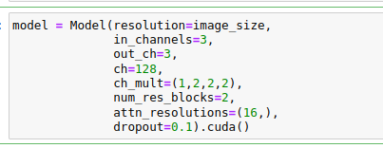

Unet Backbone

When using blur as a degradation, the fully degraded images do not form a nice closed-form distribution that the implementation can sample from. They do, however, form a simple enough distribution that can be modeled with simple methods. Note that every image x0 degenerates to an xT that is constant (i.e., every pixel is the same color) for large T. Furthermore, the constant value is exactly the channel-wise mean of the RGB image x0, and can be represented with a 3-vector. This 3-dimensional distribution is easily represented using a Gaussian mixture model (GMM). This GMM can be sampled to produce the random pixel values of a severely blurred image, which can be deblurred using cold diffusion to create a new image.
Our generative model uses a blurring schedule where the implementation progressively blur each image with a Gaussian kernel of size 27x27 over 300 steps. The standard deviation of the kernel starts at 1 and increases exponentially at the rate of 0.01. the implementation then fit a simple GMM with one component to the distribution of channel-wise means. To generate an image from scratch, the implementation sample the channel-wise mean from the GMM, expand the 3D vector into a 128 × 128 image with three channels, and then apply Algorithm.

Model Training
For model training we took the deblurring-diffusion-pytorch implementation and did the changes to data loader and Trainer class as per our implementation. We did a couple of experiments.
We could not able to get the pretrained model from the internet, So we trained the model with CIFAR10 dataset as training the model on a large dataset can learn many features. The original paper implementation has training for CIFAR10, MNIST, CelebA. We thought CIFAR10 would be the nearest dataset to our dataset. So trained the model for 10000 iterations and used the pretrained model for finetuning.
- Fine-tuning the pretrained model on CIFAR10
- Training from the scratch
Experiment 1 | Hyperparameters | Training results
Finetuning on CIFAR10 pretrained model | batch_size=32  train_steps=10000  sample_steps=  step_start_ema=10  image_size=32  standard deviation for blur routines = 0.1  Blurr kernel =3  ema_decay = 0.0995
Training from the scratch | batch_size=8  train_steps=400  sample_steps=20  step_start_ema=10  image_size=32  standard deviation for blur routines = 0.1  Blurr kernel =3  ema_decay = 0.0995 | 0: 0.49554237723350525  0: 0.5038366317749023  100: 0.16964934766292572  100: 0.15051405131816864  tensor([-0.0540, -0.1258, -0.2446], device='cuda:0')  Mean of last 100: 0.2002873245147195  200: 0.15733128786087036  200: 0.16094720363616943  tensor([-0.0886, -0.1613, -0.5133], device='cuda:0')  Mean of last 200: 0.1536932305460519  300: 0.12078545987606049  300: 0.15449999272823334  tensor([-0.3532, -0.1258, 0.1461], device='cuda:0')  Mean of last 300: 0.14067888669300788  training completed

Fine tuned Model Results
We calculated FID, SSIM, RMSE as the measurement of model performance. RMSE is commonly used in supervised learning applications, as RMSE uses and needs true measurements at each predicted data point. , SSIM The Structural Similarity Index (SSIM) is a perceptual metric that quantifies image quality degradation caused by processing such as data compression or by losses in data transmission. Frechet inception distance (FID) is used as the feature similarity metric for our experiments. scores for degraded and reconstructed images are measured with respect to the testing data. The qualitative improvements and decrease in FID show the benefits of the generalized sampling routine, which brings the learned distribution closer to the true data manifold.
Experiment | Measures
From the scratch trained model | The FID of blurry images with original image is -3.2510669732322226e-24  The RMSE of blurry images with original image is 0.19094885885715485  The SSIM of blurry images with original image is 0.240148663520813  The FID of deblurred images with original image is -1.3978857896663208e-14  The RMSE of deblurred images with original image is 0.18333688378334045  The SSIM of deblurred images with original image is 0.18809793889522552  Hence the improvement in FID using sampling is 1.3978857893412142e-14  The FID of direct deblurred images with original image is -3.2510669732322226e-24  The RMSE of direct deblurred images with original image is 0.1777535229921341  The SSIM of direct deblurred images with original image is 0.2364310771226883  Hence the improvement in FID using direct sampling is 0.0

Original Test Image batch | Reconstructed Sample batch (Trained model from scratch)
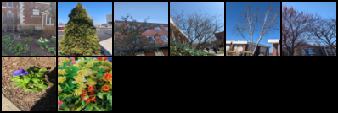 | 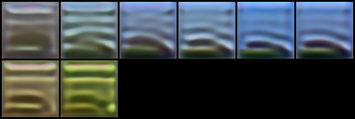
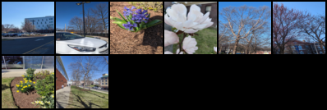 | 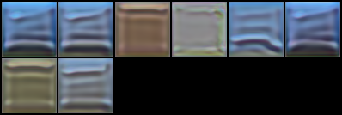

Original Test Image batch | Reconstructed Sample batch (Trained model on CIFAR10)
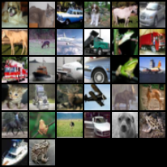 | 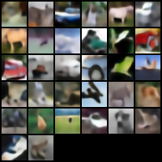
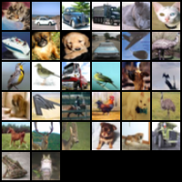 | 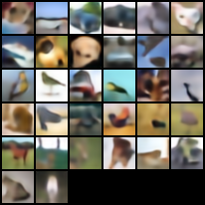

Mini De-blurring Model Implementation
We went through the source code of the paper implementation and understand that the deblurring model has 2 stages. The first one is the fundamental model implemented with ResNet architecture like residual blocks, which can do the up sampling and down sampling of the given input image data. The second stage has a Gaussian Blurring component which does the sampling of the input images and introduces blur into the images.
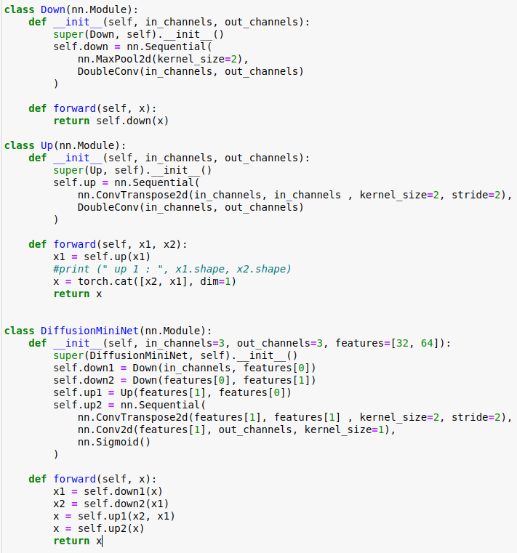
This mini Net model consists of two down-sampling blocks and two up-sampling blocks, with each block consisting of two convolutional layers with ReLU activation, followed by batch normalization in the case of the convolutional layers. The down-sampling blocks reduce the spatial resolution of the feature maps while increasing the number of channels, and the up-sampling blocks perform the opposite operation. The final layer is a 1x1 convolution followed by a sigmoid activation, which outputs a probability map of the same size as the input image.
The MiniNet class takes as input the number of input and output channels (in_channels and out_channels, respectively) and a list of feature map sizes for the two down-sampling blocks (features). By default, the model is set up to take in 3 input channels (e.g. RGB images) and output a single-channel probability map. The feature map sizes for the down-sampling blocks are set to [32, 64] by default, but these can be adjusted to other values as needed. The Mini-Net model can be used as a diffusion model if the input and output data have similar characteristics, such as images with similar spatial dimensions and similar contrast levels.
The input image size of our dataset is 3 x 32x 32. The output of the mini network model is 3 x 32 x 32 which is then passed to the Gaussian Diffusion model. To the Gaussian diffusion model, we pass the arguments, sampling steps, ie the number of times the images can be sampled with Gaussian kernel blur.

Training Mini Model
To train the mini model, we used Trainer class from the reference implementation. The sampling routine is Incremental and we used L1 loss for calculating loss in the generated samples. We trained the model with Adam optimizer, with a learning rate of 2e^5.

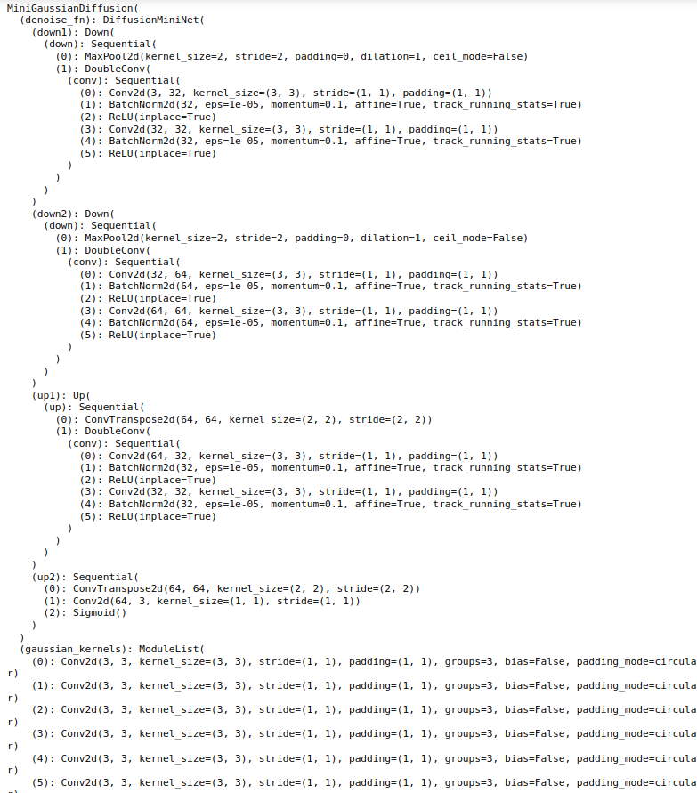

Mini Model Test Results
The mini Model is tested of the test dataset, the following are the few samples that are generated from a test batch.
Original Image | 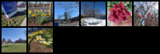
Sampling at 0 | 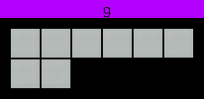
Sampling at 9 | 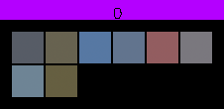
Sampling at 19 | 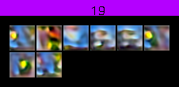

Conclusion
Through this project we studied the feasibility and effectiveness of using PyTorch for training deblurring diffusion models, and highlights the importance of hyperparameter tuning and training in achieving high performance. The proposed model can be further improved and adapted to handle different types of blur and noise, and can be used as a powerful tool in various image processing and computer vision applications.

References
- https://arxiv.org/pdf/2208.09392.pdf
- https://github.com/lucidrains/denoising-diffusion-pytorch
- https://github.com/arpitbansal297/Cold-Diffusion-Models
- https://github.com/arpitbansal297/Cold-Diffusion-Models/blob/main/deblurring-diffusion-pytorch/deblurring_diffusion_pytorch/deblurring_diffusion_pytorch.py

