**Water Leakage Detection App**

**Udit Sarkar, Jan 2025**

**Project Description**

This is a leak detection web app. This reads data of multiple sensors that are fitted on a pipeline through Lorawan server, evaluates the data and displays whether a leakage is created or not on the UI.

**Admin and User Interfaces**

This app has 2 interfaces, one for admin , another for user. 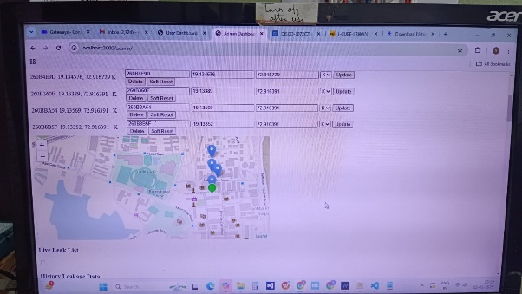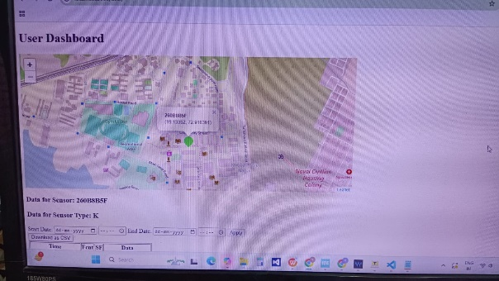

The following functionalities are for Admin interface:

1. **Add/Delete/Update Sensor**: Admin can add a sensor by entering the sensorId, sensor location, and the sensor type. These are also editable. Admin also can delete a sensor.
2. **List of Sensors**: There is a table listing all the added sensors.
3. **Hard Reset:** Admin can delete all the sensor and their related datas.
4. **Soft Reset:**  This button is to remove all the history datas for a sensor.
5. **Interactable Map:** There is a map where all the sensors are shown, the sensor marker will be green when there is no leakage detection by the sensor and red for leakage detection by the sensor.
6. **Live Leak List:** This is a table that will list all the sensors that are detecting leakage in the pipeline, along with their type, time of leakage detection, distance of the leakage from the sensor. Once the leakage is fixed the sensor from the list will be removed.
7. **History Of Leakage Data:** This is a table that shows the history of leakage detection. There is a toggle button to show and hide it. Also this has a filter functionality to filter the data according to date , and download the data as csv file.
8. **Data Table:** On clicking over the marker of a particular sensor this will display all the history data of that sensor. On top of it SensorId and sensor type will also be displayed. The data in the table contains Time, Fcnt, SF and the encrypted data. Also there is a filtering option according to data and time and a download as csv button.

The following are the functionalities for User Interface:

1. **List of Sensors**
2. **Interactable Map**
3. **Live Leak List**
4. **History Of Leakage Data**
5. **Data Table**