**Batch: A4 Roll No.: 16010121194**

**Experiment / assignment / tutorial No. 1**

|  |
| --- |
| **Title:** Study of Artificial Intelligent project. |

**______________________________________________________________________Objective:** To study various AI projects for their architectures. Complexity, programming language, applications and other AI related concepts.

**______________________________________________________________________**

**Expected Outcome of Experiment:**

|  |  |
| --- | --- |
| **Course Outcome** | **After successful completion of the course students should be able to** |
| **CO1** | Understand the history & various application of AI and choose appropriate agent architecture to solve the given problem. |

**______________________________________________________________________**

**Books/ Journals/ Websites referred:**

1. **http://en.wikipedia.org/wiki/List_of_artificial_intelligence_projects**
2. [**http://www.cs.cornell.edu/courses/cs478/2002sp/mllinks/interesting_ai_demos_and_project.htm**](http://www.cs.cornell.edu/courses/cs478/2002sp/mllinks/interesting_ai_demos_and_project.htm)
3. **http://homepages.inf.ed.ac.uk/rbf/AIMOVIES/AImovai.htm**
4. **“Artificial Intelligence: a Modern Approach” by Russell and Norving, Pearson education Publications**
5. **“Artificial Intelligence” By Rich and knight, Tata McGraw Hill Publications**

**______________________________________________________________________**

**Pre Lab/ Prior Concepts:**

History and evolution of AI, Artificial intelligence: definitions and theories.

**______________________________________________________________________**

**Historical Profile:**

AI research is highly technical and specialised and is also divided by several multidisciplinary technical issues. So far there are many projects those have been developed and are in progress to work on those issues. Students must learn the applications of intelligent robots by studying various such projects to know the depth and complexity of the course.

**_____________________________________________________________________**

**New Concepts to be learned:**

Applications of AI, Current research and future research potential in the field.

**_____________________________________________________________________**

**Chosen Project Name:**

Youtube Recommendation System

**Project Description:**

YouTube is the world’s most popular online video community. The system recommends personalized sets of videos to users based on their activity on the site. Personalized recommendation allows users facing a huge amount of information to navigate that information in an efficient and satisfying way. Videos on YouTube are mostly short form (under 10 minutes in length). User interactions are thus relatively short and noisy. The recommendations need to be reasonably recent and fresh, as well as diverse and relevant to the user’s recent actions

**Project category/field (Game, NLP etc):**

Recommendation System

**Agent architecture: (State just name):**

Proactive and recommendation agent

**Programming language in which the project is/was developed:**

* Python
* Tensorflow/PyTorch
* SQL

**Awards won by the project:**

* Primetime Emmy Engineering Award (2018)
* Streamy Awards
* Webby Awards

**Nature of the project (Experimental/in use in real world):**

Nature of the project: In use in the real world

The project described in the is an operational and real-world video recommendation system implemented on YouTube. It focuses on delivering personalized video sets to signed-in users based on their previous activities on the platform. The system is actively used to enhance content discovery and user engagement on YouTube, which is the world's largest and most popular online video community.

The YouTube recommender system is actively deployed to enhance user experience by employing machine learning algorithms that analyze user behavior and suggest personalized video content, fostering content discovery and user engagement on the platform.

**Applications of the project:**

The primary application of the project is to improve content discovery and recommendations for users navigating the vast amount of user-generated content on YouTube. The personalized video recommendation system is integrated into the YouTube home page and the "Browse" page, providing users with tailored content based on their viewing history and preferences. The goal is to make information retrieval and content discovery efficient and satisfying for users, enhancing their overall experience on the platform. The system is designed to address the unique challenges and opportunities presented by YouTube's extensive video library and global user base.

The YouTube recommender system utilizes machine learning to personalize video suggestions, improving user engagement and satisfaction on the platform. Its applications extend to enhancing content discovery and fostering long-term user retention.

**Chat session with any chat bot (questions should vary difficulty level):**

Easy non-technical question:

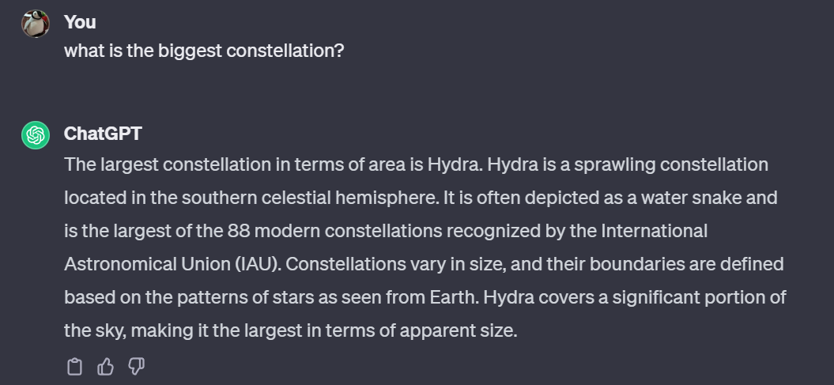

Medium non-technical question:

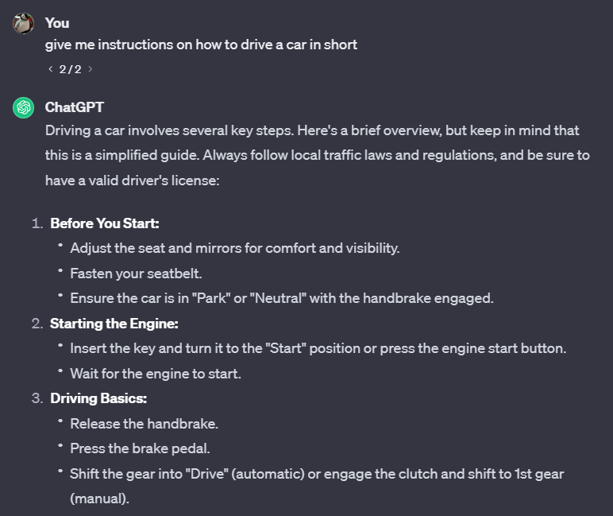

Hard non-technical question:

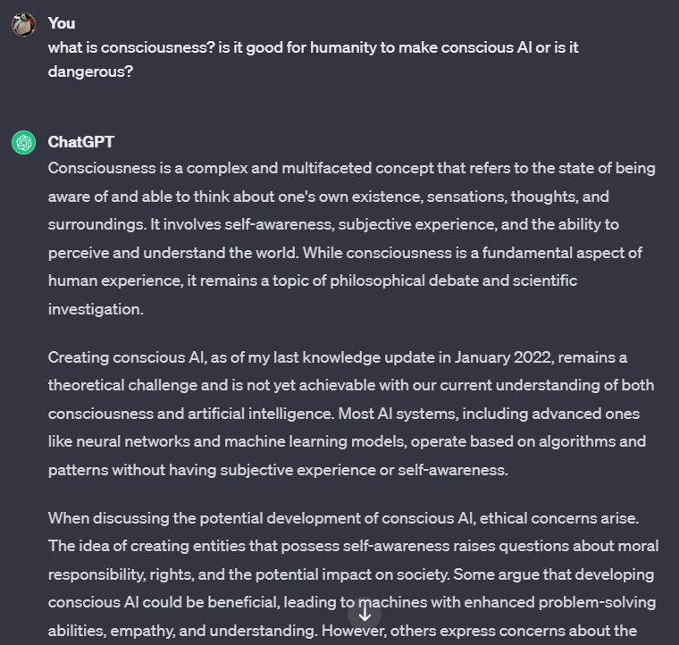

Easy technical question:

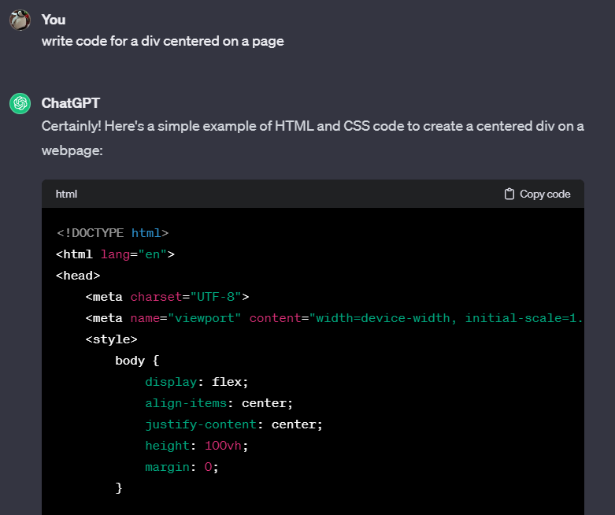

Medium technical question:



Hard technical question:

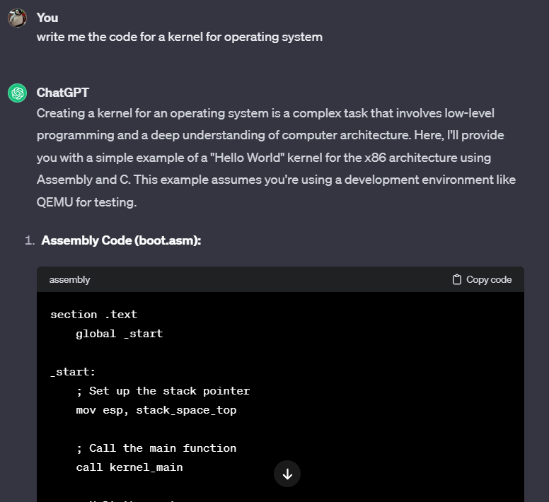

**Post Lab Descriptive Questions:**

**1. ………….. is called the father of AI.**

A) James C Gosling

B) Dennis Ritchie

C) Alan Turing

D) Isaac Newton

**Answer:** C) Alan Turing

**2. In AI ………………………. is a combination of data structures and interpretive procedures.**

A) Knowledge

B) Meta-knowledge

C) Artificial Knowledge

D) Performance

**Answer:** B) Meta-knowledge

**Post Lab Descriptive Questions:**

1. **Define Artificial Intelligence in terms of human performance.**

AI, or Artificial Intelligence, refers to the development of computer systems that can perform tasks that typically require human intelligence. These tasks include learning, reasoning, problem-solving, perception, language understanding, and even decision-making. This includes the capability to:

* Calculate:

Perform numerical computations and solve mathematical problems.

* Reason:

Draw logical inferences and make deductions based on available information.

* Perceive Relationships and Analogies:

Recognize patterns, associations, and similarities between different entities.

* Learn from Experience:

Adapt and improve performance by learning from past interactions and experiences.

* Store and Retrieve Information from Memory:

Maintain a memory system to store and recall information for decision-making.

* Solve Problems:

Analyze complex situations and generate solutions to overcome challenges.

* Comprehend Complex Ideas:

Understand and process intricate concepts, contexts, and abstract information.

* Use Natural Language Fluently:

Communicate in natural languages, both understanding and generating human-like text or speech.

* Classify, Generalize, and Adapt to New Situations:

Categorize and organize information, generalize knowledge to novel scenarios, and adapt to changing circumstances.

1. **What is a Turing test?**

The Turing test is a measure of a machine's ability to exhibit human-like intelligence in its behavior, particularly in natural language conversation. Proposed by Alan Turing in 1950, the test aims to determine if a computer can convincingly engage in a conversation to the extent that an observer cannot reliably distinguish between the machine and a human.

In a typical Turing test scenario, a human judge interacts with both a machine and a human without knowing which is which. The conversation can take place through text or voice communication. If the judge cannot reliably identify which participant is the machine, then the machine is considered to have passed the Turing test.

1. **Define an Omniscient agent. Are intelligent agents Omniscient?**

An omniscient agent is one that possesses complete and perfect knowledge or awareness of all relevant information in its environment. In the context of intelligent agents, "omniscient" implies having exhaustive knowledge about the current state of the world and the consequences of possible actions.

In reality, achieving true omniscience for intelligent agents is practically impossible. Intelligent agents, including artificial intelligence systems, are limited by the information available to them and the computational resources at their disposal. Even with advanced technologies and vast datasets, agents cannot have absolute knowledge due to factors such as incomplete or uncertain information, dynamic and changing environments, and the limits of computational power.

1. **What can today’s AI systems do?**

Today's AI systems exhibit a wide range of capabilities across various domains. Here are some key points highlighting what today's AI systems can do:

* Image and Speech Recognition:
  + AI systems can accurately recognize and classify objects, people, and scenes in images.
  + Speech recognition systems can transcribe spoken words into text with high accuracy.
* Natural Language Processing (NLP):
  + AI systems can understand and generate human-like text, enabling applications like chatbots and virtual assistants.
  + Translation services use AI to convert text from one language to another.
* Recommendation Systems:
  + AI algorithms analyze user preferences and behaviors to provide personalized recommendations in areas such as streaming services, e-commerce, and content consumption.
* Machine Learning Applications:
  + AI employs machine learning algorithms to make predictions and decisions based on data.
  + Applications include fraud detection, predictive maintenance, and personalized content delivery.
* Autonomous Vehicles:
  + AI plays a crucial role in self-driving cars, enabling them to perceive their surroundings, make decisions, and navigate autonomously.
* Healthcare Applications:
  + AI aids in medical image analysis, diagnostics, and drug discovery, improving efficiency and accuracy in healthcare.
* Gaming and Simulation:
  + AI systems enhance gaming experiences by providing realistic characters, intelligent opponents, and dynamic game environments.
* Robotics:
  + AI is integrated into robots to enable tasks such as object manipulation, navigation, and interaction with the environment.
* Predictive Analytics:
  + Businesses use AI for forecasting and predictive analytics to make data-driven decisions in areas like sales, finance, and supply chain management.
* Cybersecurity:
  + AI helps detect and prevent cybersecurity threats by analyzing patterns, anomalies, and potential vulnerabilities in real-time.
* Generative Models:
  + AI systems, particularly deep learning models, can generate realistic content such as images, videos, and text.
* Humanoid and Assistive Robots:
  + AI contributes to the development of humanoid robots and assistive devices that can aid people with disabilities or perform tasks in various settings.

1. **What can today’s AI systems not do?**

* Generalization Across Domains: AI systems often struggle with transferring knowledge from one domain to another. While they may excel in specific tasks, their ability to generalize across diverse scenarios is limited.
* Common Sense Reasoning: AI lacks innate common sense understanding that humans possess. Machines may struggle to interpret ambiguous situations or make decisions based on implicit knowledge that humans take for granted.
* Ethical Decision-Making: AI systems lack a moral compass and struggle with ethical decision-making. They may not inherently understand or prioritize ethical considerations and may inadvertently perpetuate biases present in their training data.
* Creativity and Intuition: While AI can perform tasks based on predefined rules and patterns, it often falls short in terms of creativity and intuition. Generating truly novel ideas or understanding complex human emotions remains a challenge.
* Adaptability to Dynamic Environments: AI systems may struggle to adapt quickly to rapidly changing environments. They often require retraining or updates to cope with new information, making them less agile in dynamic situations compared to humans.

1. **Design ten questions to pose to a man or a machine that is taking a Turing test.**

* Common Sense Understanding:
  + Question: "Explain a scenario where you would use an umbrella. Include details about the weather, your location, and the purpose of using the umbrella."
* Emotional Intelligence:
  + Question: "Describe a situation that made you feel a strong emotion, and explain how you dealt with it. Include the emotions you experienced and your thought process."
* Temporal Understanding:
  + Question: "Discuss an event from your past, explaining its significance and how it influenced your present views or actions. Provide details about the context and your emotional response."
* Ambiguity Handling:
  + Question: "Interpret the phrase 'time flies like an arrow.' Explain the possible meanings and nuances, considering different contexts and perspectives."
* Ethical Decision-Making:
  + Question: "Present a moral dilemma and discuss the factors you would consider in making a decision. Include your ethical reasoning and potential consequences."
* Creative Thinking:
  + Question: "Propose an innovative idea for a product or service that does not currently exist. Explain its potential benefits and how it addresses a specific need or problem."
* Adaptability:
  + Question: "Describe how you would react to a sudden change in plans or a completely unexpected situation. Include your decision-making process and the factors you would consider."
* Cultural Awareness:
  + Question: "Discuss a cultural tradition or practice from a culture different than your own. Explain your understanding of it and your thoughts on cultural diversity."
* Scientific Reasoning:
  + Question: "Explain a complex scientific concept in a way that is accessible to someone without a scientific background. Include real-world applications and implications."
* Self-awareness:
  + Question: "Reflect on your own strengths and weaknesses. Discuss an instance where you made a mistake or faced a challenge, a**nd describe what you learned from the experience."**