**Dynamic Resource Allocation in Cloud Computing**

Submitted in partial fulfilment of the requirements of the degree of Master of Technology

by

Your Name (Roll No.)

Supervisors: Supervisor Name (Supervisor)

Designation

Co-Supervisor Name (Co-Supervisor)

Designation



Department of Computer Science and Engineering NIT Warangal

India

# Acknowledgement

I would like to express my heartily gratitude towards XXX (Supervisor) Sir and XXX (Co-Supervisor) Sir for their valuable guidance, supervision, suggestions, en- couragement and the help throughout the semester, for the completion of my project work. They kept me going when I was down and gave me the courage to keep mov- ing forward.

I also want to thank evaluation committee for their valuable suggestions and con- ducting smooth presentation of the project.

# Declaration

I declare that this written submission represents my ideas, my supervisor’s ideas and co-supervisor’s ideas in my own words and where others’ ideas or words have been included, I have adequately cited and referenced the original sources. I also declare that I have adhered to all principles of academic honesty and integrity and have not misrepresented or fabricated or falsified any idea/data/fact/source in my submission. I understand that any violation of the above will be cause for disciplinary action by the Institute and can also evoke penal action from the sources which have thus not been properly cited or from whom proper permission has not been taken when needed.

(Signature) Your Name Roll No.

**APPROVAL SHEET**

This Dissertation Work entitled **"Project Title"** by **Your Name (Roll No.)** is approved for

the degree of Master of Technology

**Examiners**

**Supervisors**

**XXX (Supervisor)**

**XXX(Co-Supervisor)**

**Chairman**

**Name of Head CSE (HOD)**

NIT Warangal

# Certificate

This is to certify that the Dissertation work entitled **"Project Title"** is a bonafide record of work carried out by **"Your Name (Roll No.)"**, submitted to the Supervisor Name of "Department of Computer Science and Engineering", in partial fulfilment of the requirements for the award of the degree of Master of Technology at "National Institute of Technology, Warangal" during the academic year 2024-2025.

(Signature) **Supervisor Name** Designation Supervisor

"Department of Computer Science and Engineering"

(Signature)

**Co-Supervisor Name**

Designation Co-Supervisor

"Department of Computer Science and Engineering"

# Abstract

Write the abstract of your project

**Keywords** —- Write at least 4 keywords

|  |  |
| --- | --- |
| **Contents** |  |
| **Acknowledgement** | **ii** |
| **Declaration** | **iii** |
| **Certificate** | **ii** |
| **Abstract** | **iii** |
| **1 Introduction** | **1** |
| 1.1 Subsection1 . . . . . . . . . . . . . . . . . . . . . . . . . . | 1 |
| 1.2 Subsection2 . . . . . . . . . . . . . . . . . . . . . . . . . . | 1 |
| 1.2.1 Subsection1 . . . . . . . . . . . . . . . . . . . . . . | 1 |
| 1.2.2 Subsection2 . . . . . . . . . . . . . . . . . . . . . . | 1 |
| 1.3 Objectives . . . . . . . . . . . . . . . . . . . . . . . . . . . | 1 |
| **2 Background** | **2** |
| **3 Related Work** | **3** |
| 3.1 Work done on Contradiction detection . . . . . . . . . . . . | 3 |
| **4 Proposed Solution** | **4** |
| 4.1 System overview . . . . . . . . . . . . . . . . . . . . . . . | 4 |
| 4.2 Tools used . . . . . . . . . . . . . . . . . . . . . . . . . . | 5 |
| 4.3 Tools Developed . . . . . . . . . . . . . . . . . . . . . . . | 5 |
| 4.4 Algorithms . . . . . . . . . . . . . . . . . . . . . . . . . . | 5 |

**CONTENTS** **v**

## Experiments 6

## Conclusion and Future Work 7

## References 8

# List of Figures

* 1. Cleaned data 4

**Chapter 1**

# Introduction

* 1. **Subsection1**
  2. **Subsection2**
     1. **Subsection1**
     2. **Subsection2**
        1. Bullet point
        2. Bullet point
        3. Bullet point
        4. Bullet point

## Objectives

* Bullet point
* Bullet point

**Chapter 2**

# Background

In this chapter, first, we present the background and definitions of essential concepts, in the context of this project.

**Chapter 3**

# Related Work

Here you can see the way how you can cite the references.

## 3.1 Work done on Contradiction detection

A little amount of work has been conducted so far on contradiction detection in past . *Condoravdi et al (2003)*[1].

**Chapter 4**

# Proposed Solution

In this chapter, we are going to discuss the approach.

## System overview

For this system ...

This is the sample way of including the image in latex

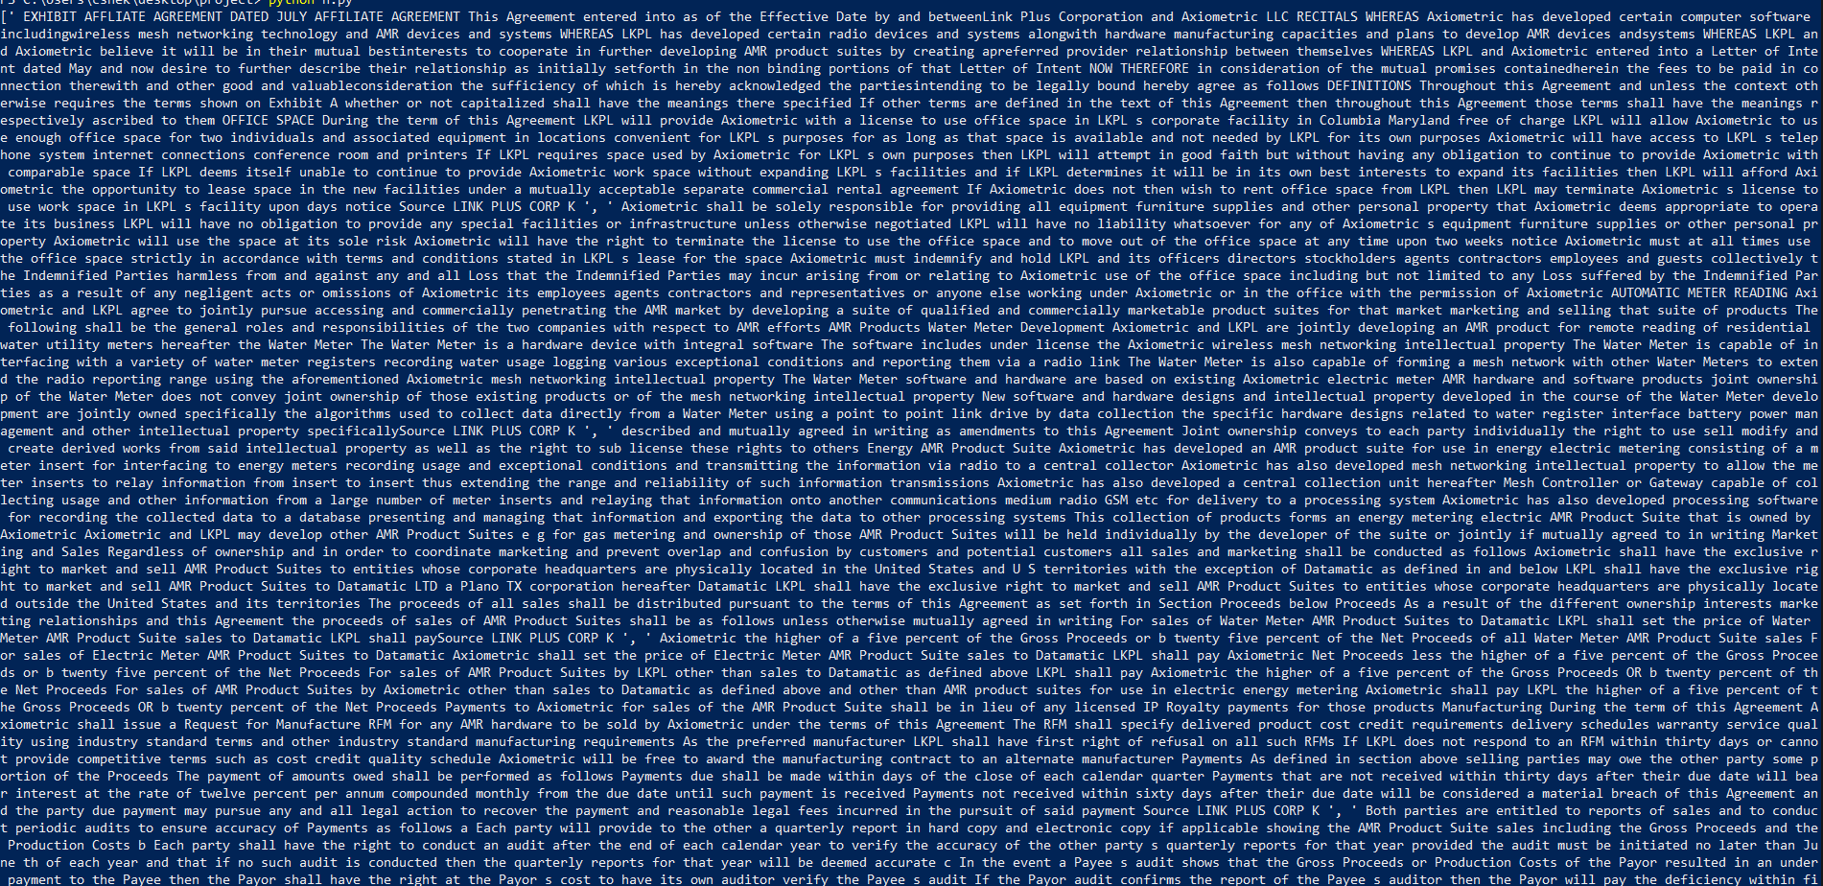

*Figure 4.1: Cleaned data*

* + - * 1. **Tools used** **5**

## Tools used

Following are the tools required to build the system..

## Tools Developed

Following are the tools developed to build the system..

## Algorithms

Following are the Algorihms..

**Chapter 5**

# Experiments

**Chapter 6**

# Conclusion and Future Work

**Bibliography**

[1] Cleo Condoravdi, Dick Crouch, Valeria De Paiva, Reinhard Stolle, and Daniel Bobrow. Entailment, intensionality and text understanding. In *Proceedings of the HLT-NAACL 2003 workshop on Text meaning*, pages 38–45, 2003. 3.1