Libraries Used

1. annotated-types==0.7.0
2. asttokens==2.4.1
3. blinker==1.8.2
4. cachelib==0.9.0
5. catboost==1.2.7
6. certifi==2024.8.30
7. charset-normalizer==3.4.0
8. click==8.1.7
9. colorama==0.4.6
10. comm==0.2.2
11. contourpy==1.3.0
12. cycler==0.12.1
13. dash==2.18.1
14. dash-bootstrap-components==1.6.0
15. dash-core-components==2.0.0
16. dash-extensions==1.0.18
17. dash-html-components==2.0.0
18. dash-table==5.0.0
19. dash_daq==0.5.0
20. dash_renderer==1.9.1
21. dataclass-wizard==0.22.3
22. dateparser==1.2.0
23. debugpy==1.8.5
24. decorator==5.1.1
25. EditorConfig==0.12.4
26. empath==0.89
27. et-xmlfile==1.1.0
28. executing==2.0.1
29. Flask==3.0.3
30. Flask-Caching==2.3.0
31. fonttools==4.54.1
32. fpdf==1.7.2
33. graphviz==0.20.3
34. h11==0.14.0
35. h2==4.1.0
36. h5py==3.12.1
37. hpack==4.0.0
38. hyperframe==6.0.1
39. idna==3.10
40. importlib_metadata==8.5.0
41. ipykernel==6.29.5
42. ipython==8.26.0
43. itsdangerous==2.2.0
44. jedi==0.19.1
45. Jinja2==3.1.4
46. joblib==1.4.2
47. jsbeautifier==1.15.1
48. jupyter_client==8.6.2
49. jupyter_core==5.7.2
50. kiwisolver==1.4.7
51. langdetect==1.0.9
52. MarkupSafe==3.0.1
53. matplotlib==3.9.2
54. matplotlib-inline==0.1.7
55. more-itertools==10.5.0
56. nest-asyncio==1.6.0
57. nltk==3.9.1
58. ntlm-auth==1.5.0
59. numpy==1.26.4
60. oauthlib==3.2.2
61. openpyxl==3.1.5
62. packaging==24.1
63. pandas==2.2.3
64. parso==0.8.4
65. pillow==10.4.0
66. platformdirs==4.2.2
67. plotly==5.24.1
68. pluggy==1.5.0
69. prompt_toolkit==3.0.47
70. psutil==6.0.0
71. pure_eval==0.2.3
72. pydantic==2.9.2
73. pydantic_core==2.23.4
74. Pygments==2.18.0
75. pyparsing==3.2.0
76. python-dateutil==2.9.0.post0
77. pytz==2024.2
78. pywin32==306
79. pyzmq==26.2.0
80. regex==2024.9.11
81. requests==2.32.3
82. retrying==1.3.4
83. ruff==0.4.10
84. scikit-learn==1.5.2
85. scipy==1.14.1
86. seaborn==0.13.2
87. setuptools==75.1.0
88. six==1.16.0
89. stack-data==0.6.3
90. tenacity==9.0.0
91. threadpoolctl==3.5.0
92. tornado==6.4.1
93. tqdm==4.66.5
94. traitlets==5.14.3
95. typing_extensions==4.12.2
96. tzdata==2024.2
97. tzlocal==5.2
98. urllib3==2.2.3
99. wcwidth==0.2.13
100. Werkzeug==3.0.4
101. wheel==0.44.0
102. wordcloud==1.9.3
103. zipp==3.20.2

Importing of Libraries

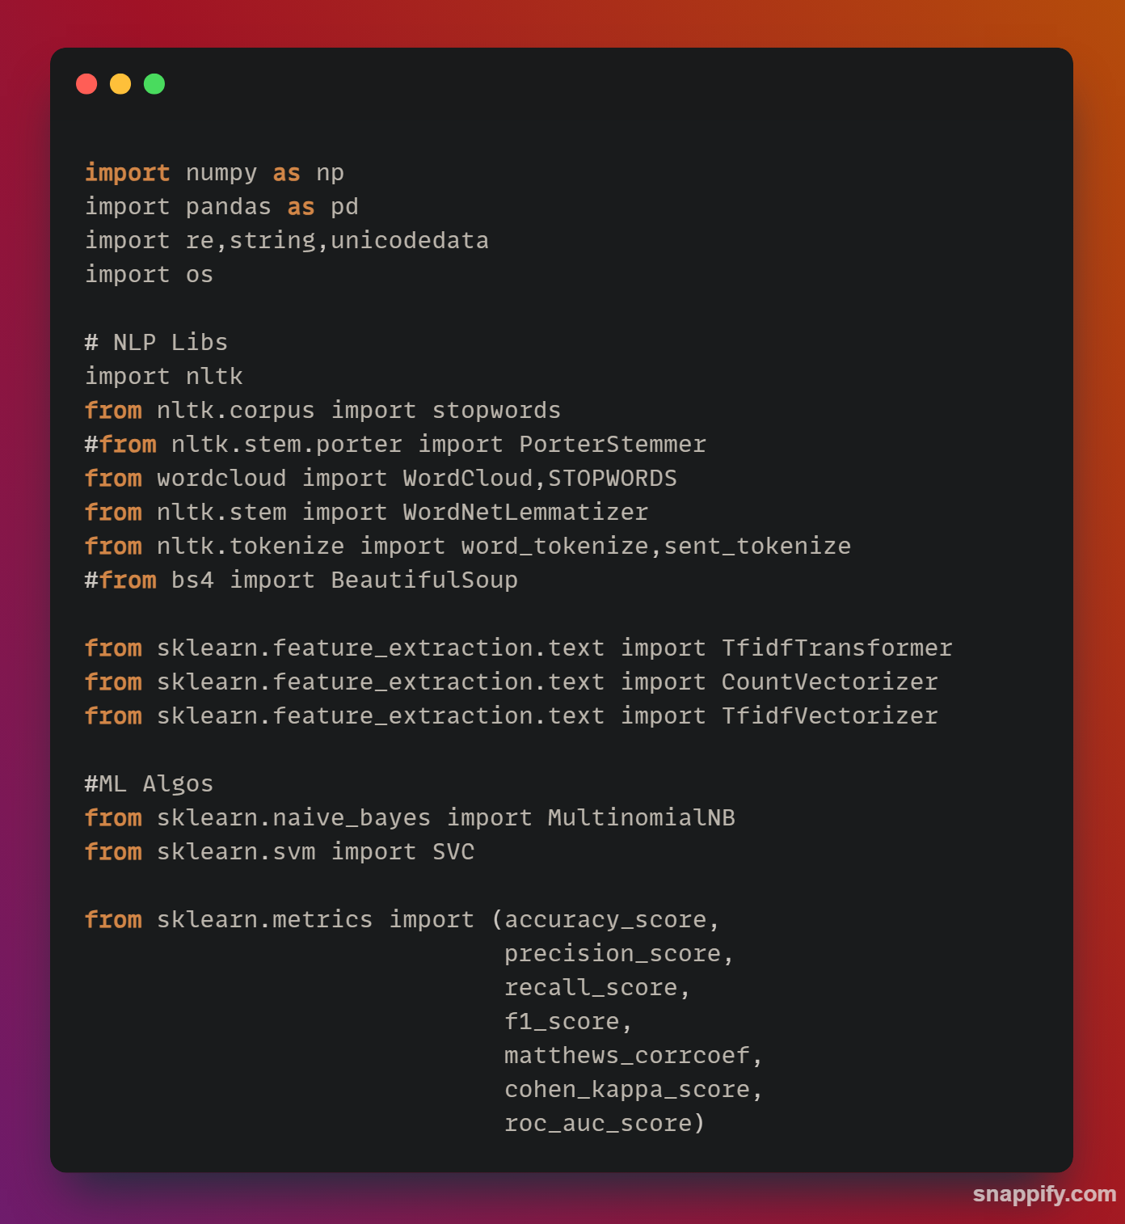

Data Frame

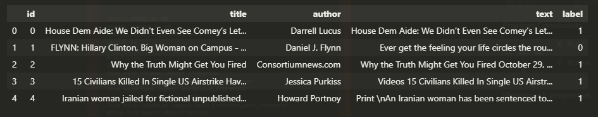

NLP preprocessing

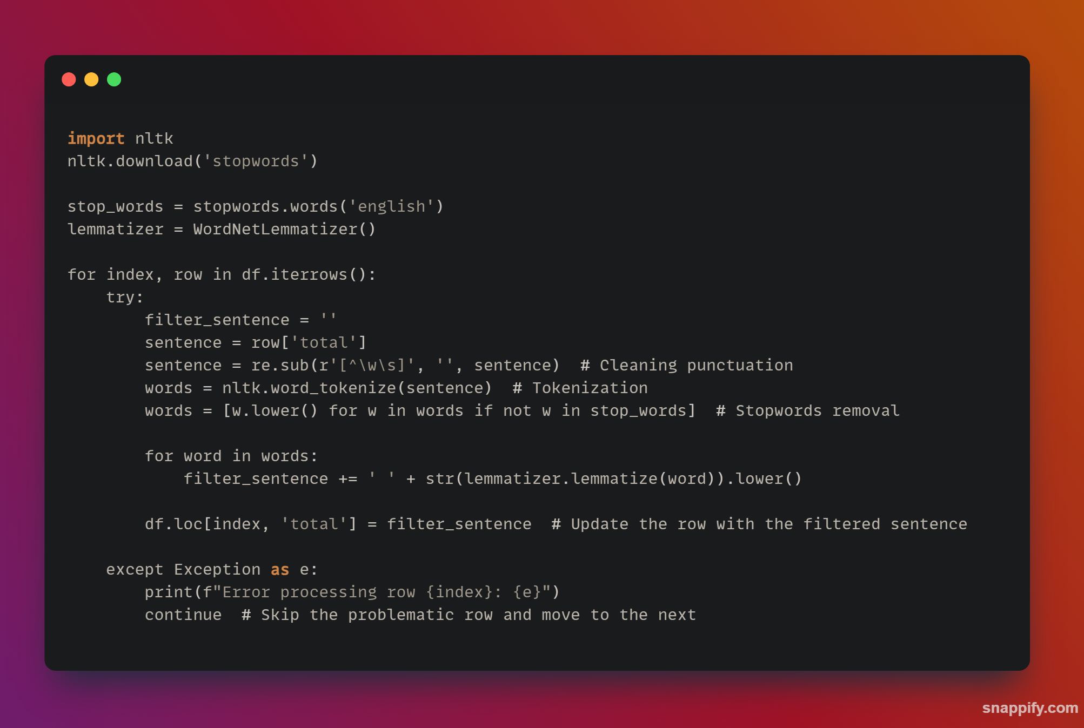

Metrics Used for Evaluating Results

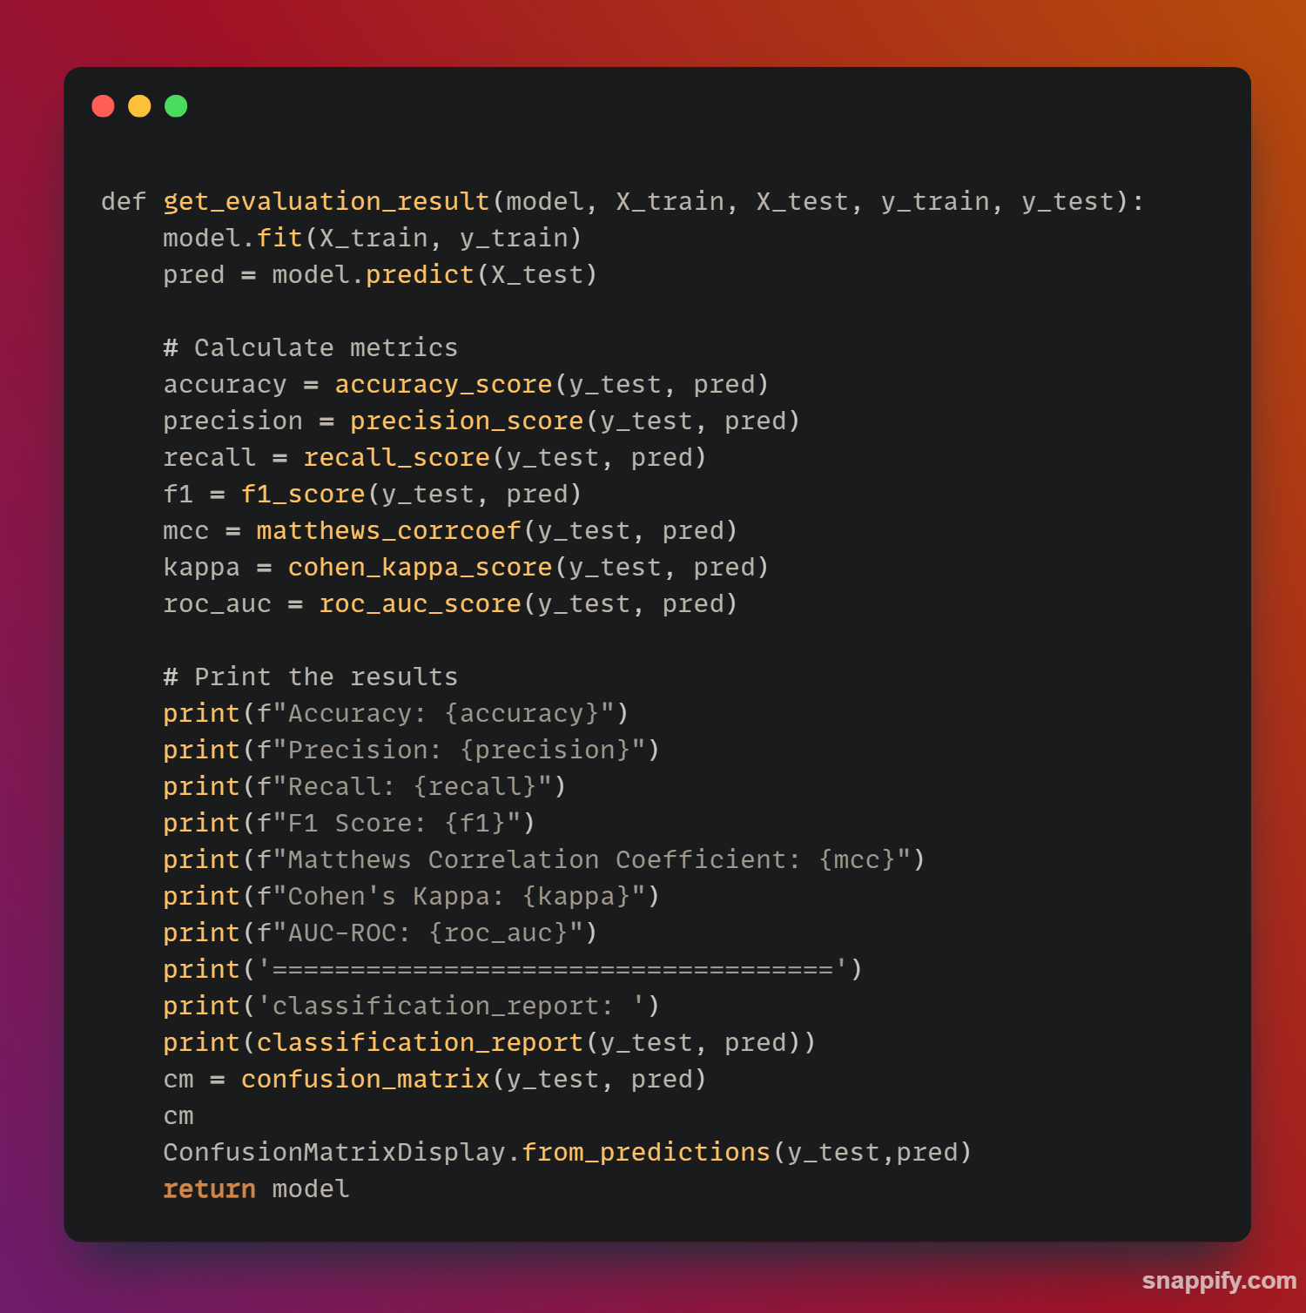

1. Decision Tree

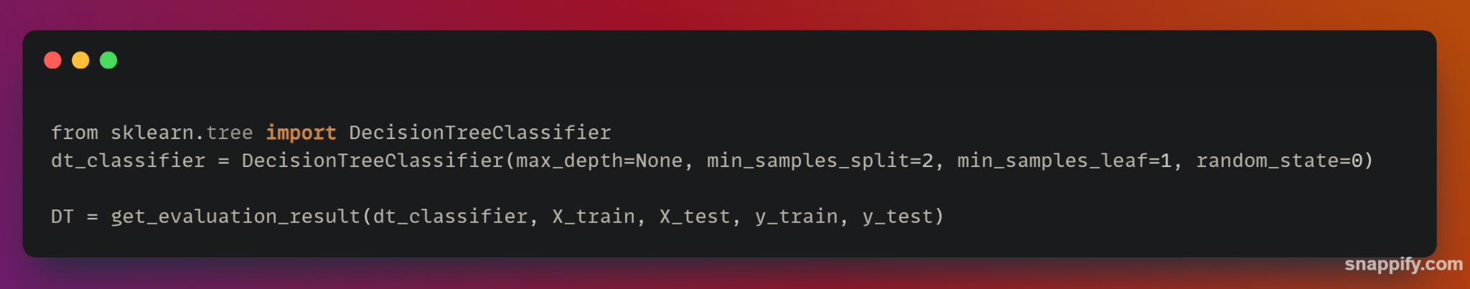

Result

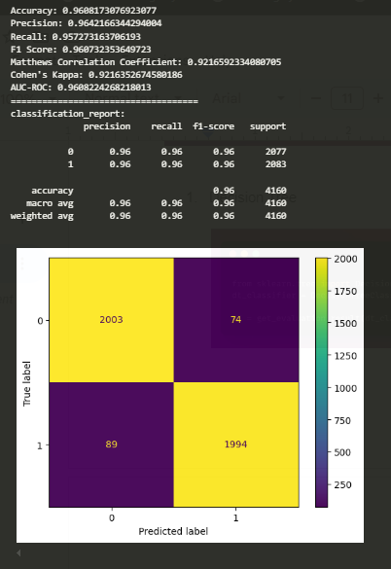

1. Random Forest

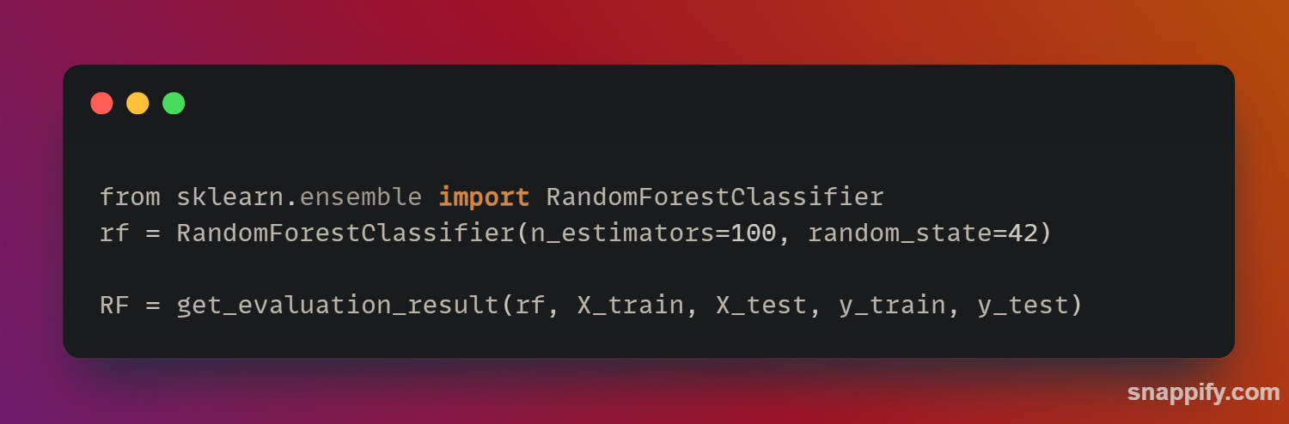

Result

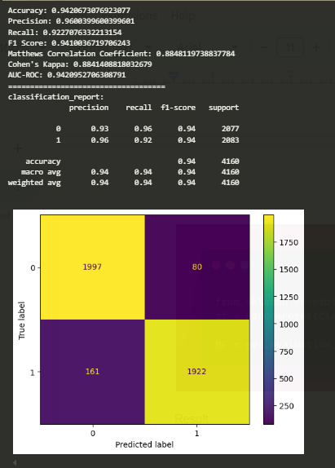

1. Adaboost

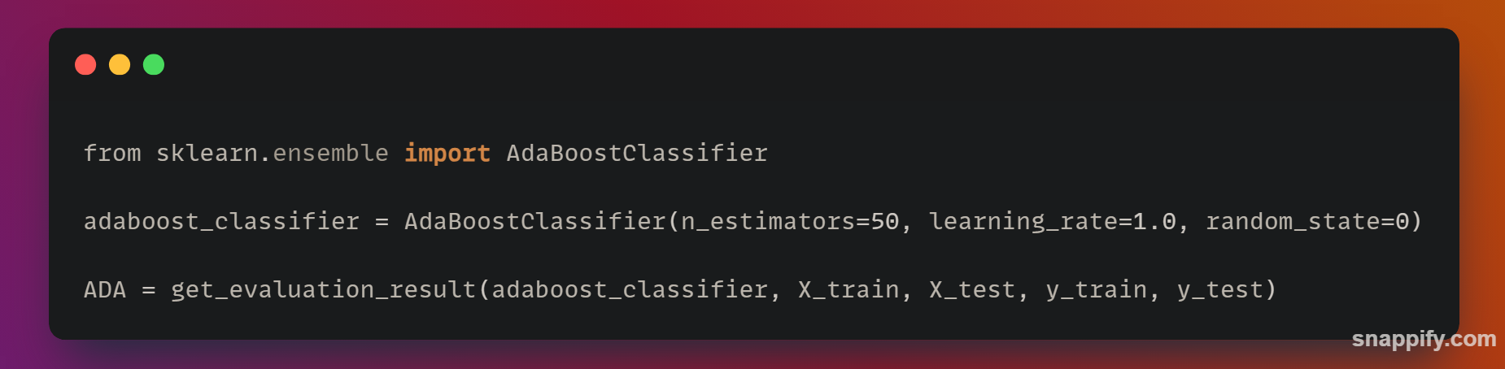

Result

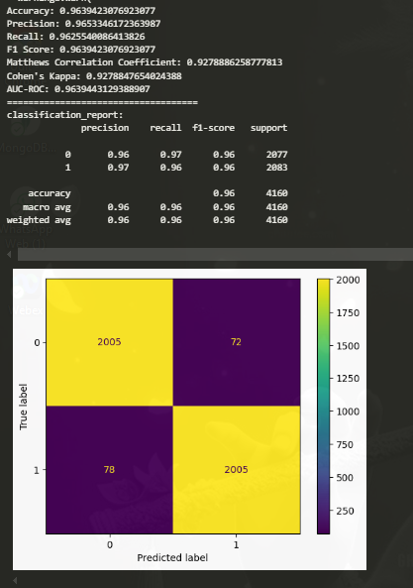

1. Perceptron

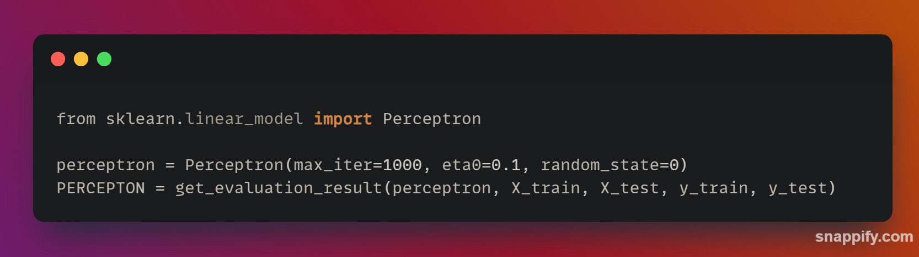

Result :

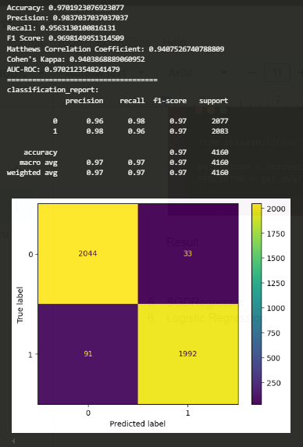

1. SGDRegressor

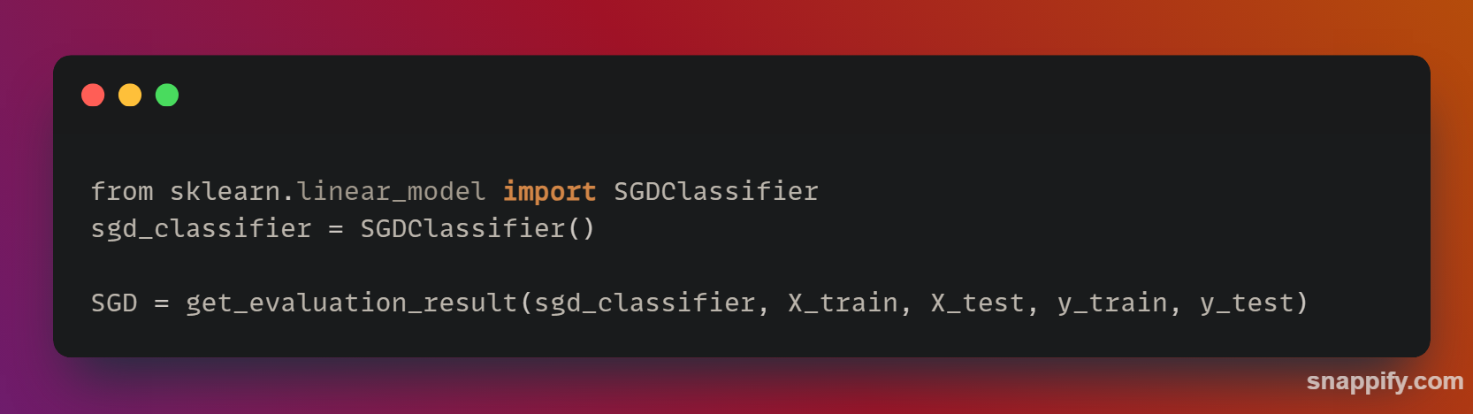

Result

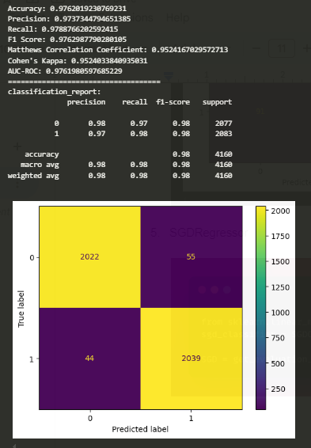

1. Logistic Regression

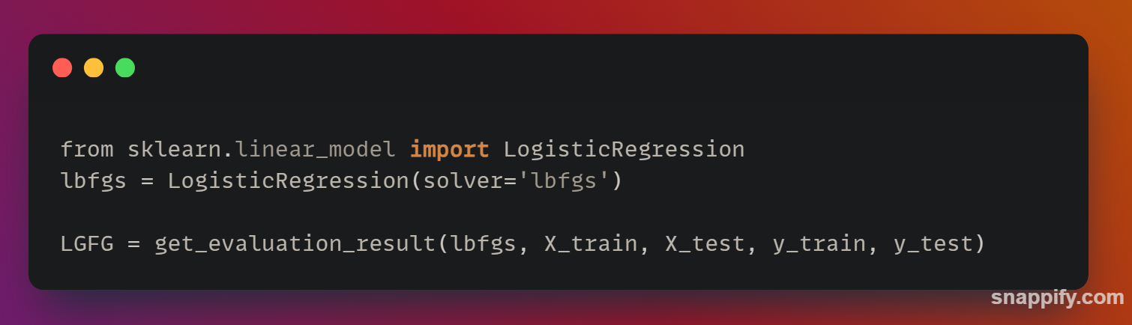

Result

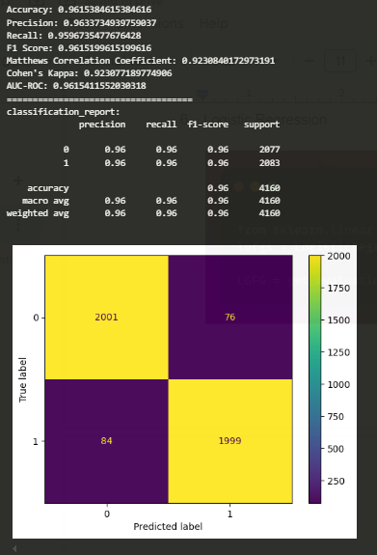

User Interface

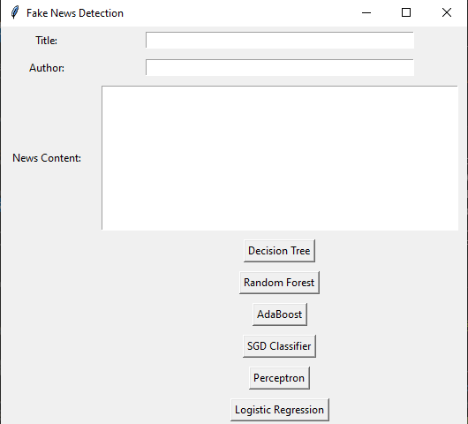

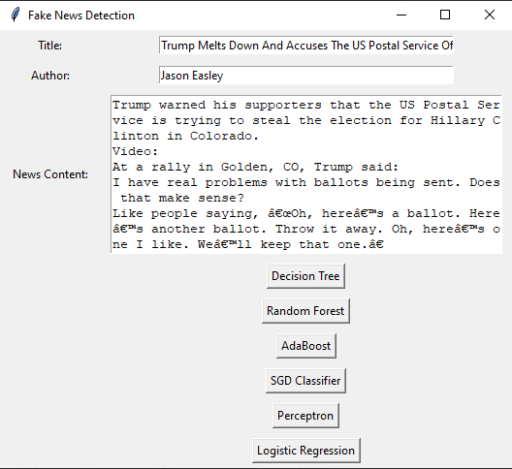

Result

