**PREDICTION OF PARKINSON'S DISEASE USING CATBOOST, XGBOOST AND RANDOM FOREST ALGORITHMS**

**Himani Sheoran*1, Udit Jain*2, Umang Tiwari*3**

**Ms. Zameer Fatima*4**

*1,*2,*3,Student, Department of Computer Science and Engineering, Maharaja Agrasen Institute of Technology , Delhi, India.

*4Assistant Professor, Department of Computer Science and Engineering, Maharaja Agrasen Institute of Technology, India.

# ABSTRACT

We are predicting Parkinson’s Disease with the help of voice Dataset which helps to treat the people in early stages. Parkinson's disease is a neurological disorder that leads to shaking and difficulty in walking, balance, and coordination. In worst cases, Patients have great difficulty walking or standing even they are not able to live alone and require a wheelchair to move around an assistance is needed in all daily activities. Besides motor symptoms, the person may see, hear, or experience things that are not real (hallucinations), or believe things that are not true (delusions). Parkinson’s disease patients typically have a low-volume voice with a monotone quality. The speech pattern of Parkinson’s patient is often produced in short bursts with inappropriate silences between words and long pauses before initiating speech. The voice dataset have the features like MDVP:Fo(Hz) - Average vocal fundamental frequency, MDVP:Fhi(Hz) - Maximum vocal fundamental frequency, jitter, simmer, etc. First we balanced the data cause it is imbalance using SMOTE (Synthetic Minority Oversampling Technique) and then train and test different model like Random Forest, Catboost, XGboost.

**Keywords:** Machine Learning, Parkinson’s Disease, SMOTE, Hyperparameter Tuning, Xgboost, Catboost, Random Forest Classifier.

# INTRODUCTION

Parkinson's disease is a nervous system disorder that affects movement. Sometimes symptoms starting with a barely noticeable tremor in just one hand. Tremors in this disorder are common, but also commonly causes stiffness or slowing of movement. In the early stages of Parkinson's disease, someone may show little or no expression or arms may not swing while walking and speech may become soft or slurred. In Parkinson's disease, certain nerve cells (called as neurons) in the brain gradually break down or die. Most of the symptoms are due to a loss of neurons that produce a chemical messenger in your brain called dopamine. When dopamine levels starts decrease, it causes abnormal brain activity, leading to impaired movement and other symptoms of Parkinson's disease. Parkinson’s disease causes vocal impairment that effects speech, motor skills, and other functions. Hence, in this paper, there is an attempt to explore a better machine learning based model for an early detection of Parkinson’s Disease from the voice samples.

# METHODOLOGY

Followings are the steps that has been taken to build the efficient model for early detection of Parkinson’s Disease:

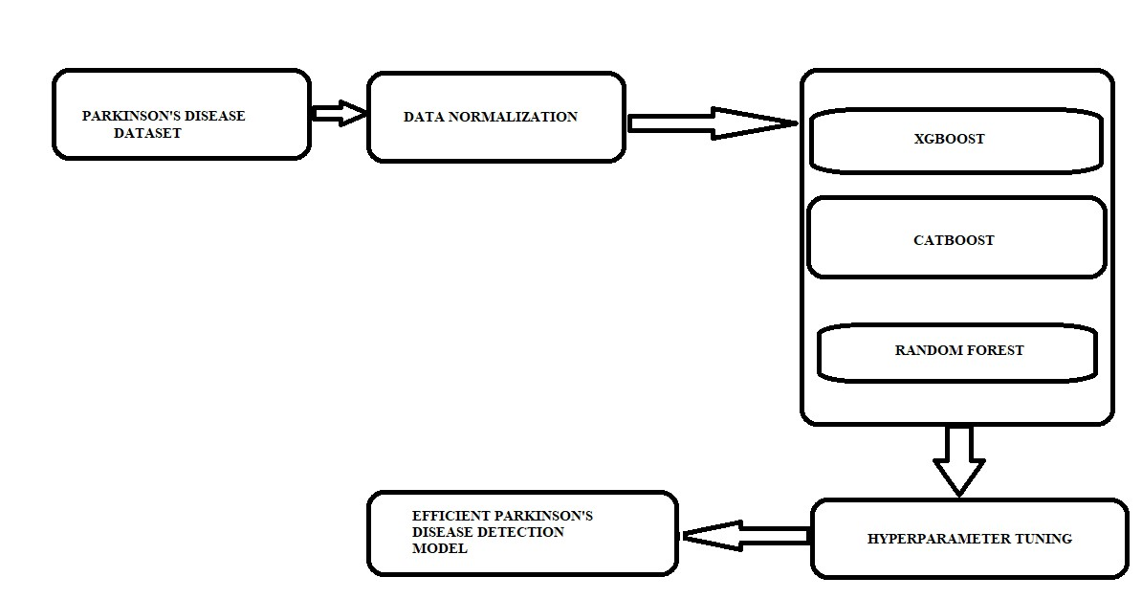

**Dataset Detail:**

- Average vocal fundamental frequency

MDVP:Fhi(Hz) - Maximum vocal fundamental frequency

MDVP:Flo(Hz) - Minimum vocal fundamental frequency

MDVP:Jitter(%),MDVP:Jitter(Abs),MDVP:RAP,MDVP:PPQ,Jitter:DDP– Severalmeasures of variation in fundamental frequency

MDVP:Shimmer,MDVP:Shimmer(dB),Shimmer:APQ3,Shimmer:APQ5,MDVP:APQ,Shimmer:DDA - Several measures of variation in amplitude

NHR,HNR - Two measures of ratio of noise to tonal components in the voice status - Health status of the subject (one) - Parkinson's, (zero) - healthy

RPDE,D2 - Two nonlinear dynamical complexity measures DFA - Signal fractal scaling exponent

spread1,spread2,PPE - Three nonlinear measures of fundamental frequency variation

**Data Preprocessing:**

This step contains two process which is Normalization and balancing the dataset which is explain in detail below: **Normalization:**

Normalization is a technique which is applied as part of data preparation in machine learning. The need of normalization is to change the values of numeric columns in the dataset to a common scale, without changing differences in the ranges of values.

**Balance Dataset:**

Balancing of the dataset is required when there is a class in minority which made the dataset made the dataset biased towards the other class. We balanced our data using SMOTE (Synthetic Minority Oversampling Technique) with the help of imbalance library.

# MODELING AND ANALYSIS

**Models:**

Following are the models that we used:

XGBOOST:

XGBoost is a gradient boosting library. It helps to implements machine learning algorithms under the Gradient Boosting framework. XGBoostis a parallel tree boosting which solves many Machine Learning problems in a fast and simple way. The same code runs on distributed environment and solves many machine learning problems.

CATBOOST:

CatBoost is a recently open sourced machine learning algorithm developed by Yandex. It Reduce time spent on parameter tuning, because CatBoost provides great results with default parameters. It helps to improve your training results that allows you to use non-numeric factors, instead of having to pre-process your data or spend time and effort turning it to numbers.

RANDOM FOREST:

Random forest is the ensemble technique that work on the large numbers of decision trees .Each individual tree in the random forest gives a class prediction and the class with the most votes becomes our model’s prediction.

**Hyperparameter Tuning:**

The aim of hyperparameter tuning is to get the best possible parameter for our model. We did Hyperparameter tuning with the help of GridSearchCV cause it searches for best set of hyperparameters from a grid of hyperparameters values.

**MATHEW CORRELATION COFFECIENT (MCC):**

The Matthews correlation coefficient (MCC) or phi coefficient is used to measure of the quality of binary classifications, introduced by biochemist Brian W. Matthews in 1975. The range of values of MCC lie between -1 to +1. MCC takes all the four value of values of confusion matrix into account. If the MCC value is close to 1 means that both classes are predicted well.

Where TP is the True Positive, TN is the True Negative, FP is the False Positive and FN is the False Negative.

# RESULTS AND DISCUSSION

|  |  |  |
| --- | --- | --- |
| **Algorithm** | **MCC** | **Accuracy** |

*Accuracy Comparison

*MCC Comparison

# CONCLUSION

Early detection of Parkinson’s diseases is very useful as it will helps to prevent the patients from worst stage. From this study we analyse the different machine learning algorithm like CatBoost, XGBoost and Random Forest and got a efficient Parkinson’s Disease prediction model with high accuracy.

# REFERENCES

http://parkinson.org/understanding-parkinsons

• https://techterms.com/definition/javascript

• https://www.ninds.nih.gov/Disorders/All-Disorders/Parkinsons-Disease-Information-Page

• https://www.healthline.com/health/parkinsons

• Chang Su, Jie Tong & Fei Wang , Mining genetic and transcriptomic data using machine learning approaches in Parkinson’s disease. *npj Parkinson's Disease* volume 6, Article number: 24 (2020)

• PeterDrotára,JiříMekyskaa,IrenaRektorováb,LuciaMasarováb,ZdenekSmékala,MarcosFaundez-Zanuyc, Analysis of in-air movement in handwriting: A novel marker for Parkinson's disease. *Computer Methods and Programs in Biomedicine,* Volume 117, Issue 3, December 2014, Pages 405-411

• Bjoern M. Eskofier; Sunghoon I. Lee; Jean-Francois Daneault; Fatemeh N. Golabchi; Gabriela Ferreira-Carvalho; Gloria Vergar, Recent machine learning advancements in sensor-based mobility analysis: Deep learning for Parkinson's disease assessment.*2016 38th Annual International Conference of the IEEE Engineering in Medicine and Biology Society (EMBC)*

• PeterDrotára, JiříMekyskaa, IrenaRektorováb, LuciaMasarováb, ZdeněkSmékala, MarcosFaundez-Zanuy, Evaluation of handwriting kinematics and pressure for differential diagnosis of Parkinson's disease. *Artificial Intelligence in Medicine,* Volume 67, February 2016, Pages 39-46

• Jie Mei1, Christian Desrosiers and Johannes Frasnelli, Machine Learning for the Diagnosis of Parkinson's disease: A Review of Literature. *Aging Neurosci*, 06 May 2021