RELIABLE EXPLAINABLE AI FRAMEWORK FOR SOFTWARE DEFECT PREDICTION

This document provides a detailed, step-by-step walkthrough of the model training and testing
phases across four experimental pipelines.

Case 1: Within-Project Baseline (WP-Base).
Train and test on the same dataset using stratified k-fold cross-validation. Uses fixed decision threshold (τ = 0.5), SMOTE on training folds, and evaluates explanation reliability using the Ketata et al. framework (Generalizability, Concordance, Stability → Reliability Index).

Case 2: Within-Project Proposed (WP-Prop).
Same k-fold setting as Case 1, but introduces probability calibration (isotonic regression for MLP/AdaBoost), F1-optimized threshold tuning, and replaces reliability metrics with behavior-grounded measures (GLR, Hit@k, ECE → Reliability Score).

Case 3: Cross-Project Baseline (CP-Base).
Train on the entire source dataset, test on the entire target dataset. Repeated across 5 seeded runs. Uses fixed τ = 0.5 and the Ketata et al. reliability framework.

Case 4: Cross-Project Proposed (CP-Prop).
Same cross-project transfer as Case 3, but applies CalibratedClassifierCV (sigmoid/Platt scaling) for all models, F1-optimized threshold tuning, and behavior-grounded reliability metrics (GLR, Hit@k, ECE → Reliability Score).

Pipelines Overview :
- Within Dataset Software Defect Prediction
8 Datasets * 8 Models * 2 Approaches = 128 Combinations
- Cross Dataset Software Defect Prediction
12 Dataset Pairs * 8 Models * 2 Approaches = 192 Combinations

References :
- Haldar, S., & Capretz, L. F.
"Explainable Software Defect Prediction from Cross Company Project Metrics Using Machine Learning."
Proceedings of the 7th International Conference on Intelligent Computing and Control Systems (ICICCS), Madurai, India, pp. 150–157, May 2023.
- Ketata, F., Al Masry, Z., Yacoub, S., & Zerhouni, N.
"A Methodology for Reliability Analysis of Explainable Machine Learning: Application to Endocrinology Diseases."
IEEE Access, 2024. DOI: 10.1109/ACCESS.2024.3431691
System Architecture

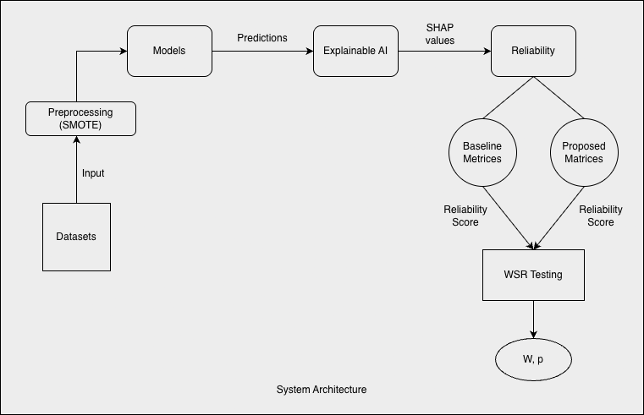

Phases :

- Datasets Selection
- Preprocessing
- Models Training and Testing
- Explainable AI Implementation
- Reliability Evaluation
- WSR Testing

DATASETS SELECTION

- Within Dataset Software Defect Prediction

The following datasets from the NASA PROMISE repository were used for evaluating the Reliable Explainable AI (XAI) Framework for Software Defect Prediction (SDP)
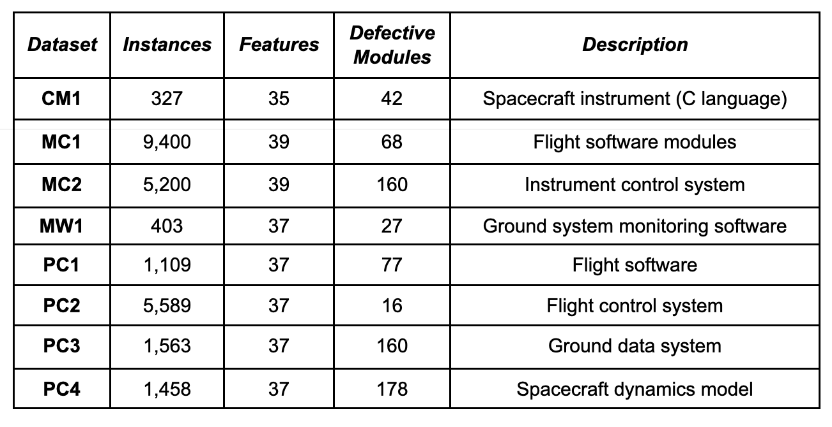

- Cross Dataset Software Defect Prediction :

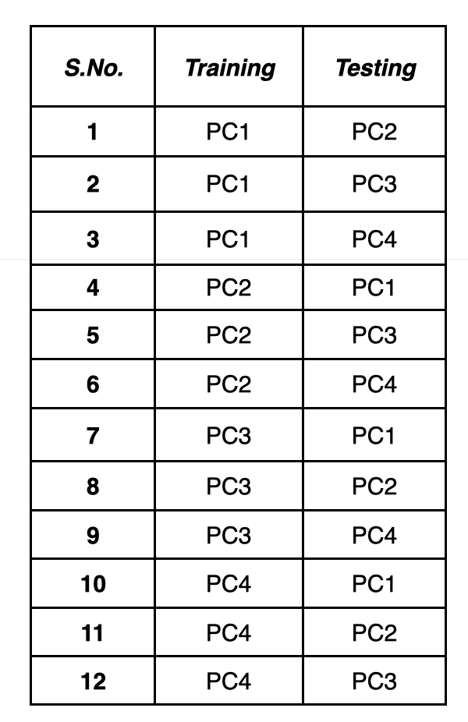
- 4 datasets are used: PC1, PC2, PC3, PC4
- Train ≠ Test is strictly enforced
- Direction matters (A → B ≠ B → A)
- Total 12 cross-project combinations are evaluated
- Each combination is tested across multiple ML models and reliability metrics

MODELS SELECTION

- Random Forest
- Extra Trees
- Gradient Boosting
- AdaBoost
- XGBoost
- LightGBM
- CatBoost
- MLP

PREPROCESSING STEPS

- Dataset resolution and loading (.arff, .csv)
- Target column selection (Defective, bug, class, etc.)
- Target binarization (Converts labels to binary 0/1)
- Feature numeric conversion (Converts all feature columns to numeric)
- Missing/constant cleanup (Fills missing values using forward-fill then backward-fill)
- Type optimization (Casts float columns to float32)
- Train-test feature alignment (First tries exact feature-name intersection and If not enough overlap, tries metric-name mapping)
- Class-imbalance handling (SMOTE - because it balances the minority defect class by generating realistic new samples (without losing majority data), improving learning while avoiding data leakage)

PIPELINES OVERVIEW

- Within-Dataset (Baseline)
  - Load one dataset (CM1/PC1/PC2/PC3/PC4/MC1/MC2/MW1), detect target, and binarize labels (defect vs non-defect).
  - Keep numeric features, remove constant columns, fill missing values, cast to float32.
  - Use stratified 5-fold CV.
  - Apply SMOTE only on training fold (no leakage).
  - Train one of 8 models (RF, ET, GB, AdaBoost, XGB, LGBM, CatBoost, MLP).
  - Test on held-out fold with AUC, F1, Precision, Recall.
  - Compute SHAP-based reliability metrics (generalizability/concordance/stability style scores).

- Within DataSet (Proposed: Added on top of baseline)
  - Keep same CV setup and 8-model evaluation.
  - Apply train-only feature scaling (StandardScaler) with train-fit, then transform val/test.
  - Use validation split inside training fold for probability calibration.
  - Calibrate probabilities (isotonic-style calibration in your notebooks).
  - Tune decision threshold on validation calibrated probabilities (F1-oriented threshold search).
  - Evaluate test fold using calibrated probabilities + tuned threshold.
  - Add calibration/reliability metrics: Brier score, ECE, GLR_mean, Hit@k, and final ReliabilityScore (combined reliability index).

- Cross-Project / Cross-Dataset (Baseline)
  - Use directed source→target project pairs (train on source, test on different target).
  - Preprocess source and target separately with same cleaning pipeline.
  - Align source-target features (exact overlap, and mapping fallback where needed).
  - Run repeated experiments (seeded repeats) instead of random within-project split.
  - Apply SMOTE only on source training data.
  - Train model on source and test directly on target.
  - Report target performance (AUC, F1, Precision, Recall), overfit gap, and repeat-wise reliability summaries.

- Cross-Project (Proposed: Added on top of baseline)
  - Keep same source→target transfer protocol.
  - Use train-only scaling + optional calibration pipeline before target evaluation.
  - Tune threshold on validation part of source-side training, then apply to target predictions.
  - Evaluate target with calibrated probabilities and tuned threshold.
  - Compute proposed reliability block on target: GLR_mean, Hit@k, ECE, Brier, and combined ReliabilityScore.
  - Keep SHAP analysis leakage-safe (train-side background/model handling, test-side evaluation).
Common Components (Shared Across Pipelines)

This section documents all components that are reused across two or more pipelines

1.Dataset Loading and Target Inference

All four pipelines begin by loading the raw dataset from disk and identifying the binary target
column.

1.1. File Reading

Datasets are stored as .arff or .csv files. The loading functions detect the file extension and
dispatch accordingly.

Cases 1 & 3 use load_dataset(dataset, target_col) which calls _read_arff(path) (via scipy.io.arff.loadarff) or _read_csv(path) (via pandas.read_csv). After reading, byteencoded columns are decoded to UTF-8 strings using _decode_bytes_cols(df).

Cases 2 & 4 use load_and_preprocess(data_path) which internally calls load_dataset_auto(data_path) for the same format detection, followed by infer_target_and_features(df) for automatic target column detection.

1.2 Target Column Identification

Cases 1 & 3: The function _auto_find_target(df, hint) scans column names against a priority list: TARGET_CANDIDATES = ["Defective", "defective", "defects", "bug", "bugs", "class", "label", "target", "c"]. If a hint is provided (from the dataset registry), that column is used directly. Otherwise, the first matching candidate is selected; if no match is found, the last column is used as a fallback.

Cases 2 & 4: The function infer_target_and_features(df) uses a scoring system. Each column is scored by _score_target_candidate(colname, series, position, total_cols) which awards: +2.0 if the column name contains a keyword from _KEYWORDS = ["defect", "bug", "fault", "class", "label", "target", "isdefect", "is_defect"]; +1.0 if it is the last column; +2.0 if the column is binary (checked via_is_binary_col); and +1.0 if the defect rate is between 5% and 95%. The highest-scoring binary column is selected.

1.3 Target Binarization

Cases 1 & 3: _binarize_target(y: pd.Series) → pd.Series. For numeric columns: values in {0,1} are kept as-is; values in {1,2} are mapped to {0,1}; otherwise, y > 0 maps to 1. For string columns: values like "true", "yes", "defect", "bug", "1" map to 1; values like "false", "no", "clean", "0" map to 0.

Cases 2 & 4: _coerce_binary(series: pd.Series) → pd.Series. Similar logic but additionally handles {-1, +1} encoding (mapped via (y+1)//2), and has a broader string mapping including "faulty"→1, "non-defective"→0, "positive"→1, "negative"→0.

Input: Raw pandas Series (any dtype).
Output: Integer Series with values in {0, 1}, where 1 = defective.

2. Feature Preprocessing

2.1 Numeric Conversion

All pipelines convert feature columns to numeric types.
Cases 1 & 3 use to_numeric_features_only(df) which calls pd.to_numeric(col, errors='ignore') on
each object-typed column, then r
etains only numeric columns via df.select_dtypes(include=[np.number]).

Cases 2 & 4 use a similar function that applies pd.to_numeric(col, errors='coerce') (coercing failures to NaN) and drops all-NaN columns.

2.2 Constant Column Removal

The function drop_constant_and_fillna(X: pd.DataFrame) → pd.DataFrame (Cases 1 & 3) or an inline check (Cases 2 & 4) identifies columns where nunique(dropna=False) ≤ 1 and drops them, as zero-variance features carry no discriminative information.

2.3 Missing Value Imputation

All pipelines apply forward-fill followed by backward-fill: X.fillna(method='ffill').fillna(method='bfill'). This sequential imputation ensures no NaN values remain. If no missing values are detected, this step is skipped.

2.4 Float32 Casting

Cases 1 & 3 cast all float columns to float32 via _to_float32(df) for memory efficiency and compatibility with tree-based model libraries.

3. Class Imbalance Handling via SMOTE

All four pipelines use SMOTE (Synthetic Minority Over-sampling Technique) from imblearn.over_sampling.SMOTE to address class imbalance. SMOTE is applied exclusively to training data; it is never applied to test/target data.
Mathematical Formulation:

For each minority-class sample xᵢ, SMOTE selects one of its k nearest minority-class neighbors
x and generates a synthetic sample:

x_syn = x + λ · (x_nn − x ), λ ~ U(0, 1)

where λ is drawn uniformly from [0, 1], interpolating between the original sample and its
neighbor.

Neighbor count: k = min(smote_k_max, max(1, n − 1)), where n is the number of minority ₊ ₊
samples. This adaptive formula prevents SMOTE from failing when the minority class is
extremely small (e.g., PC2 with only 16 defective modules).

Implementation:

Cases 1 & 3 invoke SMOTE inline: SMOTE(random_state=seed, k_neighbors=k).fit_resample(X_train, y_train).

Cases 2 & 4 use a wrapper function safe_smote(Xtr, ytr, random_state) that catches exceptions and falls back to the original data if SMOTE fails.

Input: X_train (pd.DataFrame, shape [n, d]), y_train (pd.Series, shape [n]). Output: X_fit
(pd.DataFrame, shape [n', d]), y_fit (pd.Series, shape [n']), where n' > n due to synthetic
samples.

4. Model Definitions

Eight classifiers are used across all pipelines. The hyperparameters differ between pipelines;
the table below shows each pipeline's configuration.

Model | Case 1 (WP-B) | Case 2 (WP-P) | Case 3 (CP-B) | Case 4 (CP-P)
Random Forest | 800 trees, depth=12, leaf=3, balanced_sub | 600 trees, depth=None, leaf=2, balanced_sub | 400 trees, depth=12, leaf=3, balanced_sub | 800 trees, depth=None, leaf=2, balanced_sub
ExtraTrees | 800 trees, depth=12, leaf=3 | 800 trees, depth=None, leaf=1 | 400 trees, depth=12, leaf=3 | 1200 trees, depth=None, leaf=1
GradientBoosting | 400 est, lr=0.05, depth=3 | 800 est, lr=0.05, depth=3 | 300 est, lr=0.05, depth=3 | 1000 est, lr=0.05, depth=3
AdaBoost | 400 est, lr=0.05 | 800 est, lr=0.05, base=DT(depth=2) | 300 est, lr=0.05 | 1000 est, lr=0.05, base=DT(depth=2)
XGBoost | 600 est, depth=6, lr=0.05 | 1200 est, depth=6, lr=0.05 | 400 est, depth=6, lr=0.05 | 1500 est, depth=6, lr=0.05
LightGBM | 700 est, lr=0.05, balanced | 1500 est, lr=0.03, leaves=31 | 500 est, lr=0.05, balanced | 2000 est, lr=0.03, leaves=31
CatBoost | 700 iter, depth=6, lr=0.05, balanced | 1200 iter, depth=6, lr=0.05 | 500 iter, depth=6, lr=0.05, balanced | 1500 iter, depth=6, lr=0.05
MLP | PyTorch: 2L×128, dropout=0.15, 20 epochs | sklearn: (256,128,64), adam, early_stop | PyTorch: 2L×128, dropout=0.15, 15 epochs | sklearn: (256,128,64), adam, early_stop, 500 iter

Model construction functions:

Cases 1 & 3 use build_model(model_name, cfg, random_state) → BaseModel which dispatches via a name-matching dictionary to subclasses of BaseModel (e.g., RandomForestModel, ExtraTreesModel, MLPModel). Cases 2 & 4 use make_model(name, random_state) which returns raw sklearn/xgboost/lightgbm/catboost estimator instances directly. MLP implementation difference:

In Cases 1 & 3, the MLP is a custom PyTorch module (TorchMLP) trained with torch.optim.Adam and F.binary_cross_entropy_with_logits with inverse-class-frequency weighting. In Cases 2 & 4, the MLP is sklearn.neural_network.MLPClassifier with architecture (256, 128, 64), Adam solver, and early stopping.

5. Prediction and Probability Output

All models produce class probabilities via model.predict_proba(X), which returns a numpy array of shape [n, 2] where column 0 is P(non-defective) and column 1 is P(defective). The positive-class probability p = predict_proba(X)[:, 1] is used for all subsequent computations.

For the PyTorch MLP (Cases 1 & 3), raw logits are passed through torch.sigmoid and clipped
to [1e-6, 1−1e-6] to prevent log(0) errors in downstream loss calculations.

6. Predictive Metrics
The following classification metrics are computed in all four pipelines:

AUC (Area Under the ROC Curve): Computed via sklearn.metrics.roc_auc_score(y_true, p). Measures the probability that a randomly chosen defective module receives a higher predicted probability than a randomly chosen nondefective module. Range: [0, 1], where 0.5 = random guessing.

F1-Score: The harmonic mean of Precision and Recall: F1 = 2 · (Precision · Recall) / (Precision + Recall). Computed via sklearn.metrics.f1_score(y_true, y_hat, zero_division=0).

Precision: Precision = TP / (TP + FP). The fraction of predicted defective modules that are truly defective. Computed via sklearn.metrics.precision_score(y_true, y_hat, zero_division=0).

Recall: Recall = TP / (TP + FN). The fraction of truly defective modules that the model correctly
identifies. Computed via sklearn.metrics.recall_score(y_true, y_hat).

Decision rule: The binary prediction y_hat is obtained by thresholding: y_hat = I[p ≥ τ], where τ is either fixed at 0.5 (baseline pipelines) or optimized (proposed pipelines).

Case 1: Within-Project → Baseline

Entry point: run_reliability_kfold(X, y, cfg, model_name) in Pipeline 1.

Core idea: Train and test on the same dataset using 5-fold stratified cross-validation with fixed
threshold τ = 0.5. Evaluate both predictive performance and explanation reliability using the
Ketata et al. framework.

1. Data Splitting

Stratified k-fold cross-validation is initialized via StratifiedKFold(n_splits=5, shuffle=True, random_state=cfg.rng) from sklearn.model_selection. This produces 5 train/test index pairs where each fold preserves the original class distribution.

Input: X (pd.DataFrame, [N, d]), y (pd.Series, [N]).
Output: For each fold: train indices tr (array, ~80% of N), test indices te (array, ~20% of N).

2. Per-Fold Training

For each fold (fold = 1, 2, ..., 5), the following steps are executed:

2.1 Seed Setting

A fold-specific seed is computed as seed = cfg.rng + fold and applied via set_seed(seed) which sets seeds for random, numpy, torch, and os.environ['PYTHONHASHSEED'].

2.2 SMOTE on Training Fold

SMOTE is applied to the training fold only. The output (Xfit, yfit) replaces the original training data for model fitting.

2.3 Model Training

The model is instantiated via build_model(model_name, cfg, random_state=seed) and fitted: model.fit(Xfit, yfit). For tree-based models, this delegates to SklearnTreeLike.fit() which casts features to float32 and stores column names in self._cols. For the PyTorch MLP, MLPModel.fit() creates a TorchMLP network, constructs a DataLoader from TensorDataset, and trains for cfg.mlp_epochs (default 20) epochs with weighted BCE loss.

Input: Xfit (pd.DataFrame, [n', d]), yfit (pd.Series, [n']).
Output: Fitted model object with learned parameters.
3. Per-Fold Evaluation

3.1 Train Metrics

Probabilities on the original training fold (not SMOTE-augmented): p_tr = model.predict_proba(Xtr)[:, 1]. Binary predictions: yhat_tr = (p_tr >= 0.5).astype(int). AUC, F1, Precision, Recall are computed using sklearn metrics.

3.2 Test Metrics

Probabilities on the held-out test fold: p_te = model.predict_proba(Xte)[:, 1]. Binary predictions: yhat_te = (p_te >= 0.5).astype(int). The same four metrics are computed.

OverfitGap is computed after all folds as OverfitGap = mean(Train_AUC) − mean(Test_AUC). A large gap indicates poor generalization.

4. SHAP Explainability (Within-Project Baseline)

SHAP (SHapley Additive exPlanations) is used to interpret model predictions. The implementation is in SklearnTreeLike.shap_importance(X_bg, X_eval) → pd.Series.

4.1 Background Data Preparation
A background dataset is created for SHAP by subsampling the SMOTE-augmented training data. In fast mode (default), k = min(cfg.fast_shap_k, len(X_bg)) samples are selected (default fast_shap_k = 64). The function _kmeans_background(df, k, rng) uses shap.kmeans(df, k) to produce k representative cluster centroids. If that fails, it falls back to random subsampling.

4.2 SHAP Value Computation

For tree-based models: Uses shap.TreeExplainer(model, data=bg, feature_perturbation='tree_path_dependent', model_output='probability'). TreeExplainer computes exact SHAP values in O(TLD²) time, where T = number of trees, L = max leaves, D = max depth.

For MLP: Uses shap.KernelExplainer(f, bg, link='identity') where f is a wrapper around predict_proba. KernelSHAP approximates Shapley values via weighted linear regression over sampled feature coalitions, with nsamples = cfg.shap_nsamples (default 300, halved in fast mode).

Mathematical definition: For model f and input x with d features, the SHAP value for feature j is:
φ_j(x) = Σ_{S ⊆ F\{j}} [|S|! (d-|S|-1)! / d!] · [f(x_{S∪{j}}) − f(x_S)]

where F = {1,...,d} is the full feature set, S is a subset not including j, x_S denotes x with only features in S active (others marginalized), and the combinatorial weight ensures fair credit distribution across all orderings.

Output aggregation: The function _mean_abs_by_feature(sv, n_features) converts raw SHAP values (which may be a list of arrays for multi-output models) into a 1D array of mean absolute SHAP values per feature:
s_j = (1/N) · Σ_{i=1}^{N} |φ_j(x_i)|

This returns a pd.Series indexed by feature names, named 'mean|SHAP|'. This is computed separately for training data (g_tr) and test data (g_te) in each fold.

Input: X_bg (pd.DataFrame, background), X_eval (pd.DataFrame, evaluation set).
Output: pd.Series of shape [d] with mean |SHAP| per feature.

4.3 Fast Mode Shortcut

When cfg.fast_mode = True (default), the training SHAP importance g_tr is set to a copy of the test SHAP importance g_te (g_tr = g_te.copy()) to skip the expensive second SHAP computation. This means Generalizability will be artificially high (~1.0) in fast mode. When fast_mode is False, a separate SHAP computation is performed on training data via model.shap_importance(Xfit, Xtr).

5. Reliability Evaluation (Ketata et al. Framework)

The reliability of model explanations is assessed using three dimensions from Ketata et al., each based on Spearman rank correlation. The helper function spearman_rank_corr(a, b) → float aligns two pd.Series by index intersection and returns scipy.stats.spearmanr(a.values, b.values).correlation.

5.1 Generalizability (G)

Measures whether SHAP feature rankings from training data agree with rankings from test data:

G = (1/K) · Σ_{j=1}^{K} ρ(rank(s_train^(j)), rank(s_test^(j)))

where K = 5 (number of folds), ρ is the Spearman rank correlation, s_train^(j) and s_test^(j) are the mean |SHAP| vectors for fold j computed on training and test data respectively.

Code: spearman_rank_corr(g_tr, g_te) computed per fold, then averaged across folds in the summary.

5.2 Concordance (C)

Evaluates agreement between SHAP-based feature rankings and permutation importance rankings on the test set.

Step 1: Select top K features by SHAP value: top_shap = g_te.sort_values(ascending=False).head(K).index, where K = cfg.concordance_top_k (default 25).

Step 2: Compute permutation importance on the test set for these features. For each of cfg.perm_repeats (default 15) iterations: for each feature c, permute its values in X_test, compute the resulting AUC, and record the AUC drop Δ = max(base_AUC − AUC_permuted, 0). Rank these drops across features and accumulate percentile ranks.

Step 3: Average the accumulated ranks over all repetitions to get perm_rank (pd.Series). Convert both SHAP importance and permutation importance to percentile ranks via .rank(pct=True).

Step 4: Find the intersection of top-K features from both rankings. Compute Spearman correlation between the two ranking vectors restricted to these overlapping features:

C = ρ(rank(s_SHAP)[overlap], rank(s_perm)[overlap])

Input: Test predictions p_te, test labels y_te, SHAP importance g_te.
Output: Float in [-1, 1].

5.3 Stability (S)

Quantifies the consistency of SHAP explanations across different folds by computing the mean pairwise Spearman correlation:

S = [2 / K(K−1)] · Σ_{i<j} ρ(rank(s^(i)), rank(s^(j)))

where the summation is over all C(K, 2) = 10 unique pairs of folds (for K = 5). The function _mean_pairwise_spearman(series_list) implements this, iterating over all fold pairs and averaging the Spearman correlations.

Input: List of 5 pd.Series (one SHAP importance vector per fold).
Output: Float in [-1, 1].

5.4 Reliability Index (RI)

The composite RI synthesizes G, C, and S into a single score:
RI = [φ(G) + φ(C) + φ(S)] / 3, where φ(z) = (z + 1) / 2
The normalization function φ maps Spearman correlations from [-1, +1] to [0, 1]. The function rescale01_rho(rho) → float implements this. RI is bounded in [0, 1], where 1 indicates perfect reliability.

6. Output Format

Summary DataFrame (1 row): columns include Model, Train_AUC_mean, AUC_mean, F1_mean, Precision_mean, Recall_mean, Generalizability_mean, Concordance_mean, Stability, ReliabilityIndex, OverfitGap.

Artifacts dict: Contains 'per_fold' (DataFrame with per-fold metrics and reliability values), 'mean_importance_test' (pd.Series of mean SHAP importance across folds, sorted descending).

