Git Assignment

Add:

The git add command adds a file or folder to the staging area. Files in the staging area are those that you want to add to your next commit. Git add does not modify or otherwise affect your repository or files.

The Git Version control System does not have a simple save feature. Git uses a process called committing. This is where you create a record of all the changes made to files since the last commit.
This process involves a few different command line operations. The first step in saving file or folder changes to a Git repository is to use the git add command. This command lets you select which files you want to commit to a repository by moving the directory to the staging area.

The workflow for changing a file or folder in a Git repository looks like this:
- On your computer, update a file or folder in the Git repository.
- Use git add to add those changes to the staging area.
- Use git commit to move changes from the staging area to a commit.
- Use git push to push those changes to the main repository.To save a file in Git, you need to use the git add and git commit commands. In this tutorial, we discuss the first of these—the git add command.

Step1:
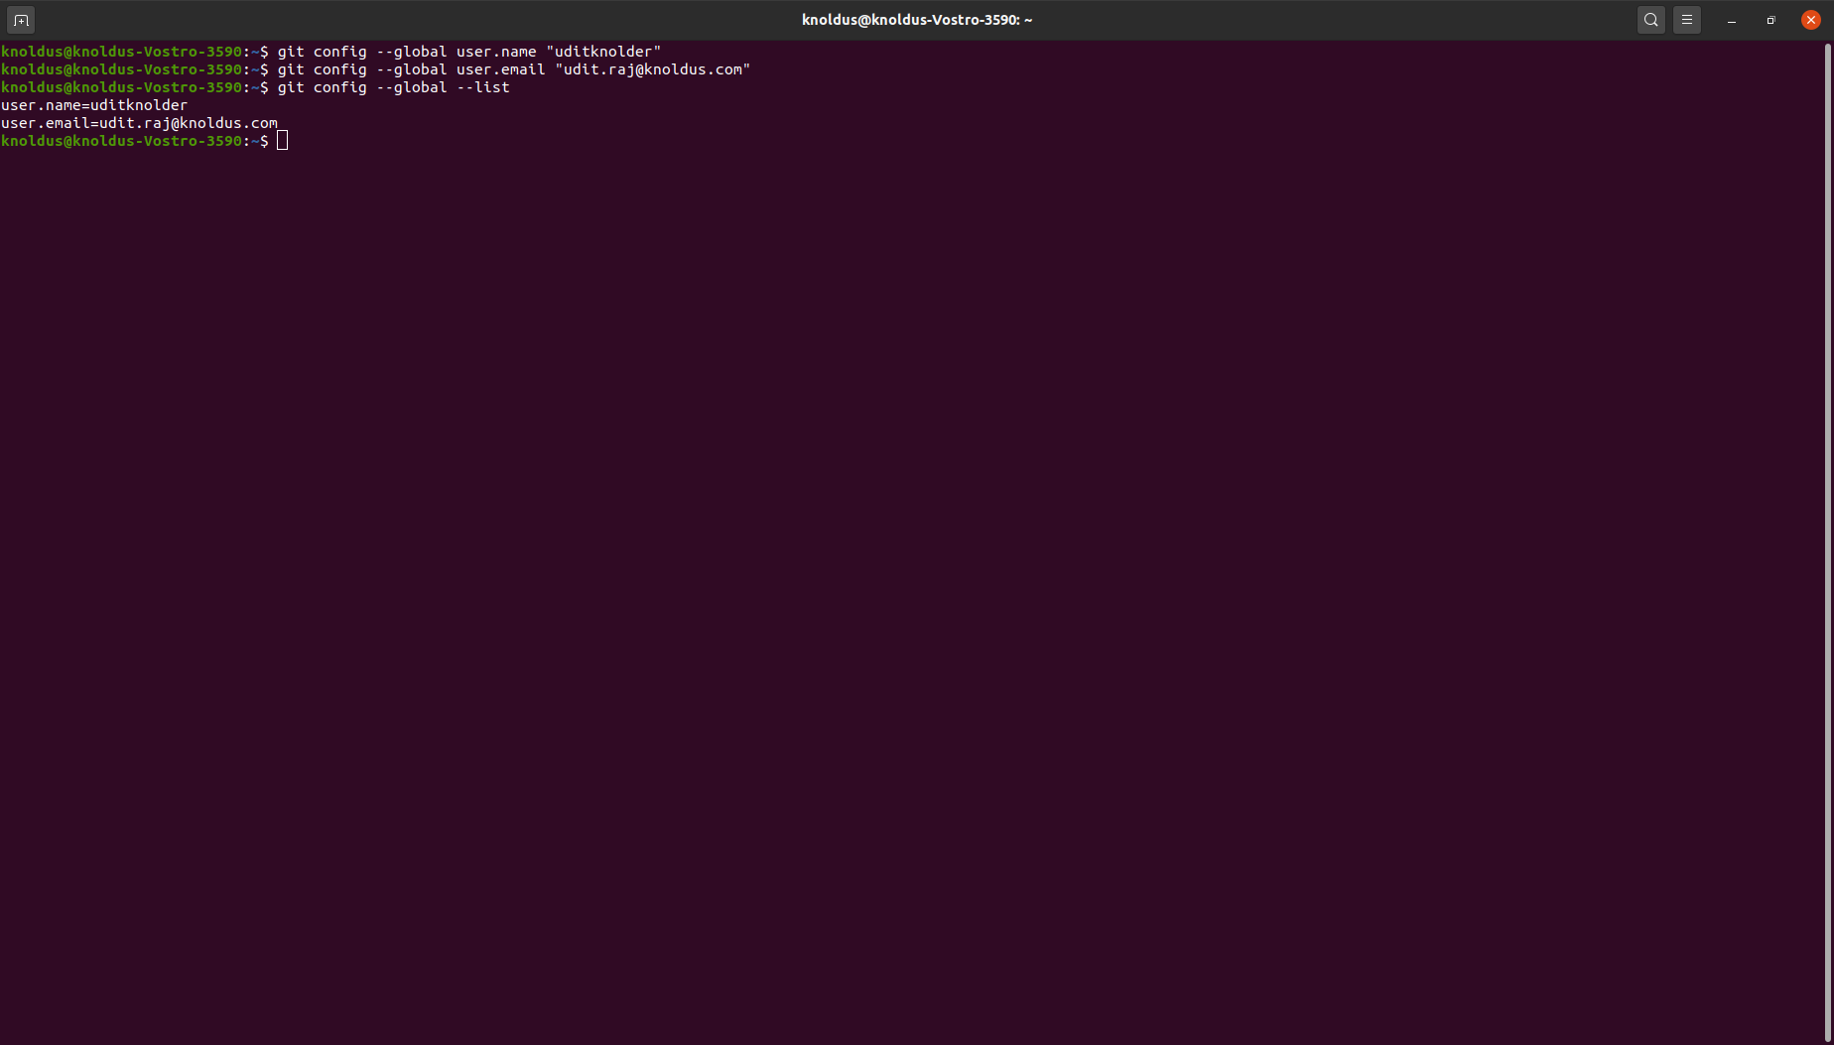

Step2:

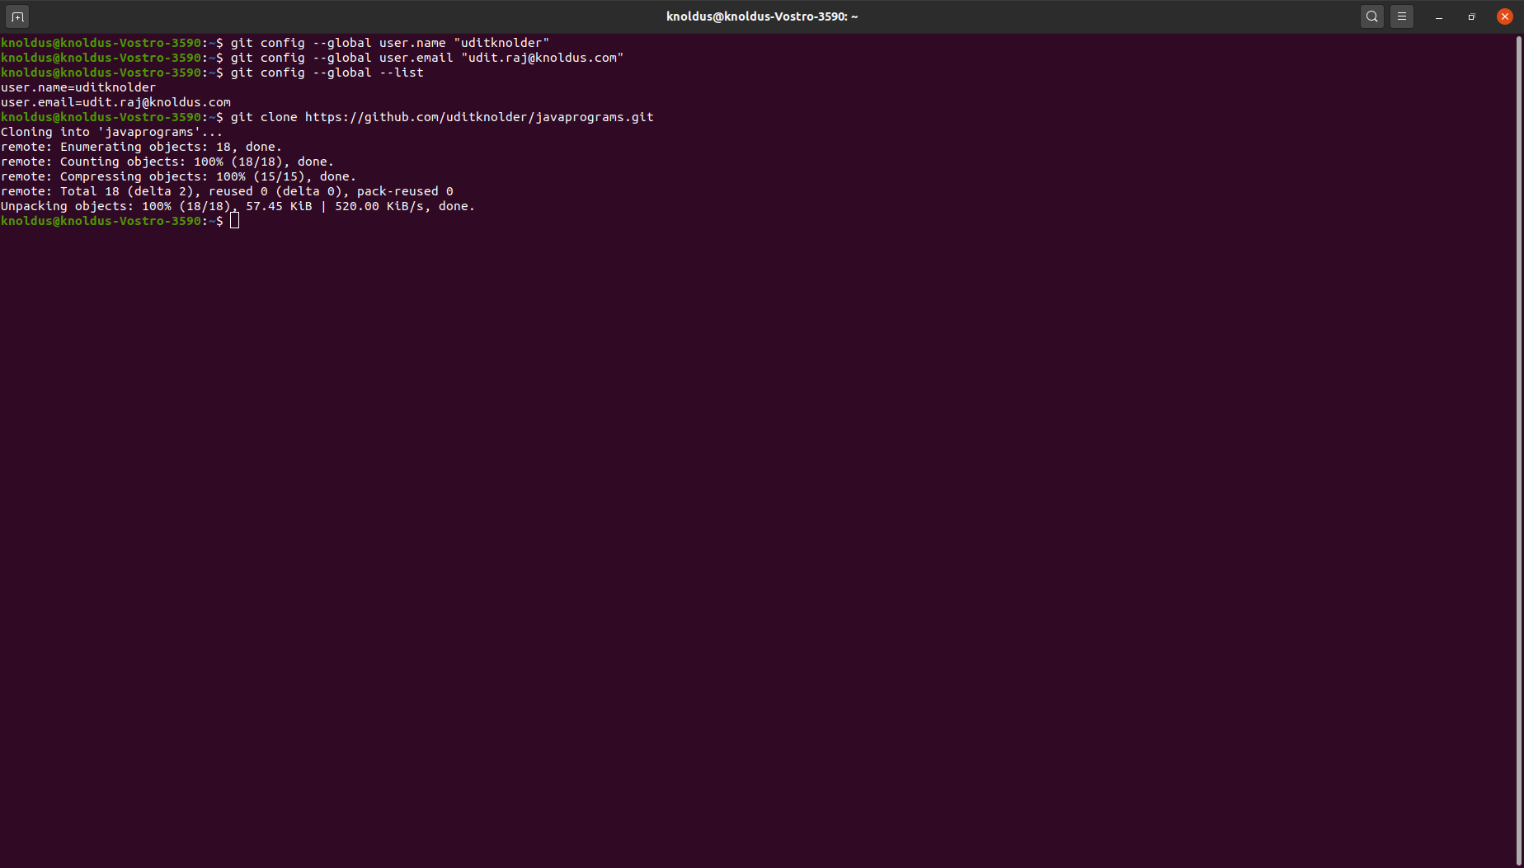

Step3 :

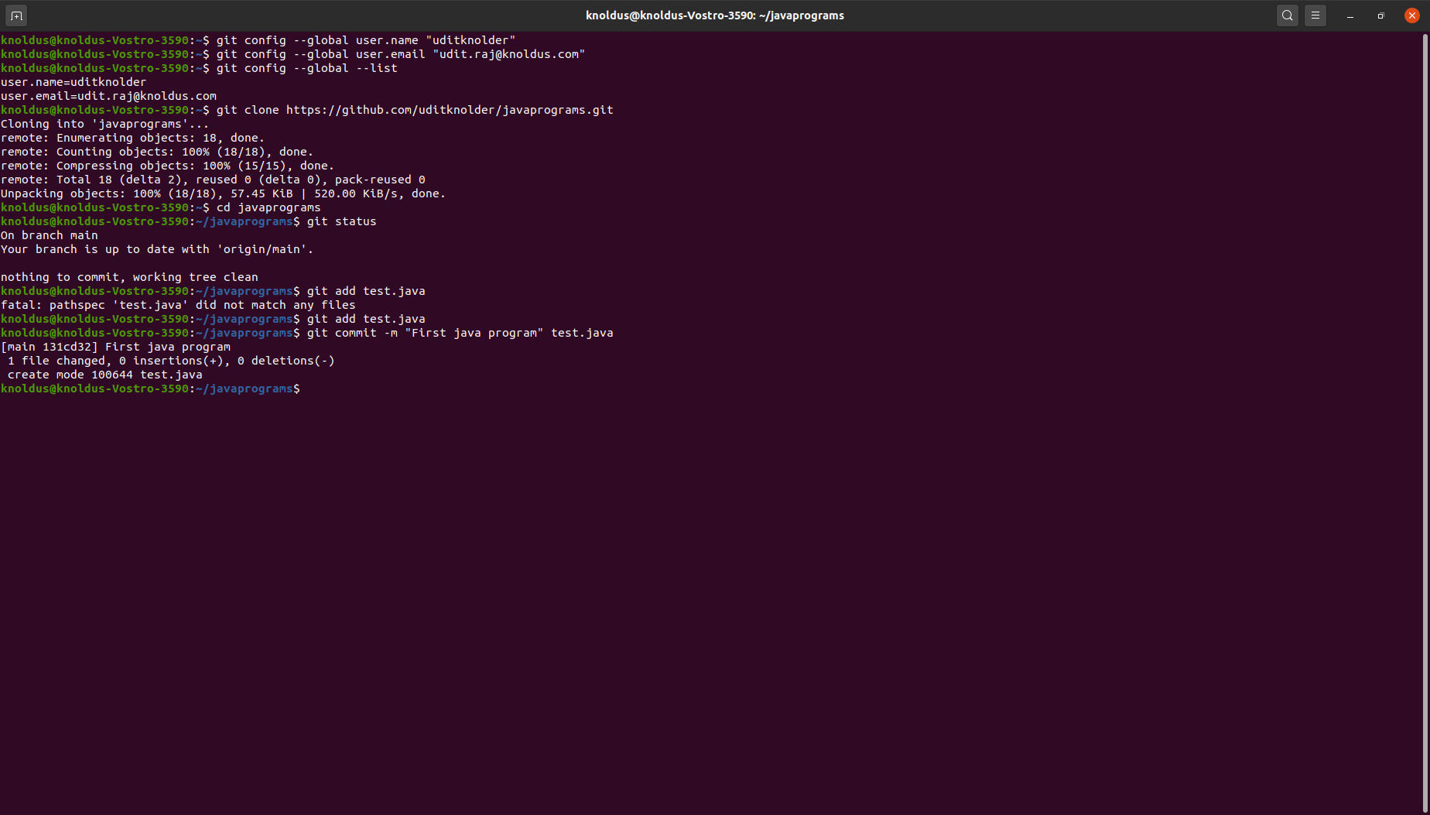

Step4:

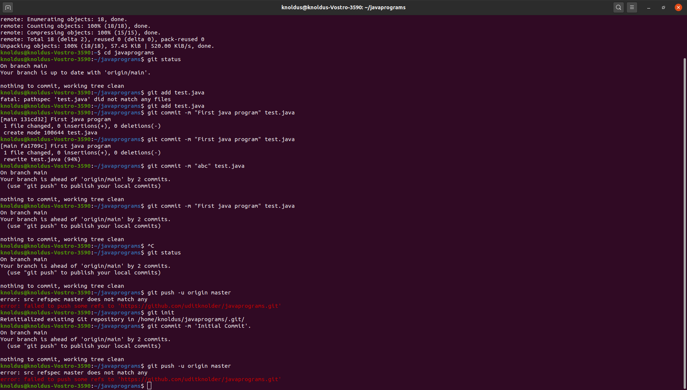

Step5:

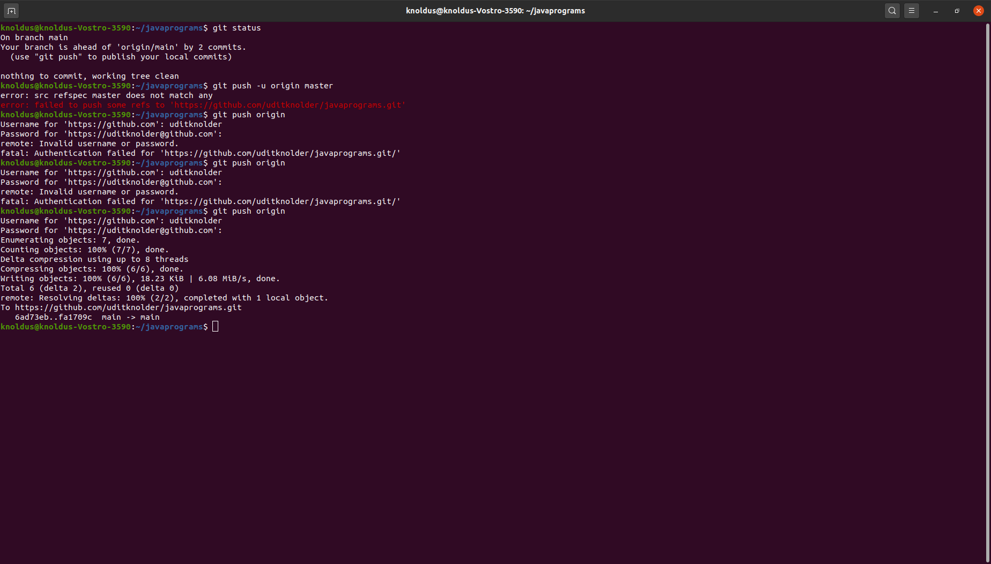

Step6:

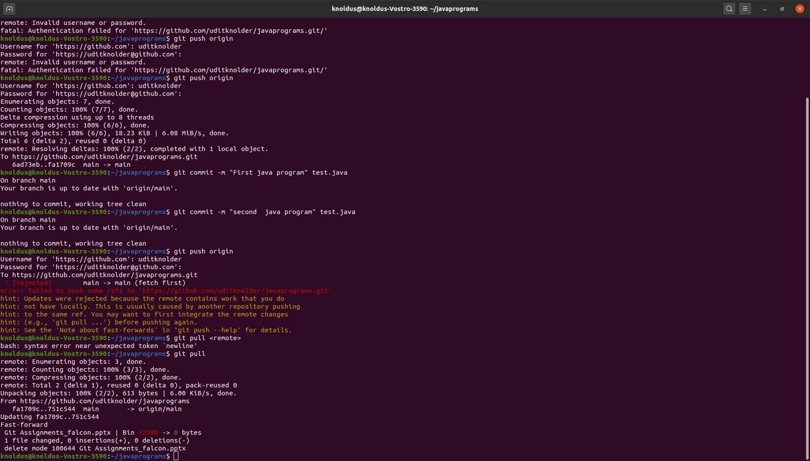

Step7:

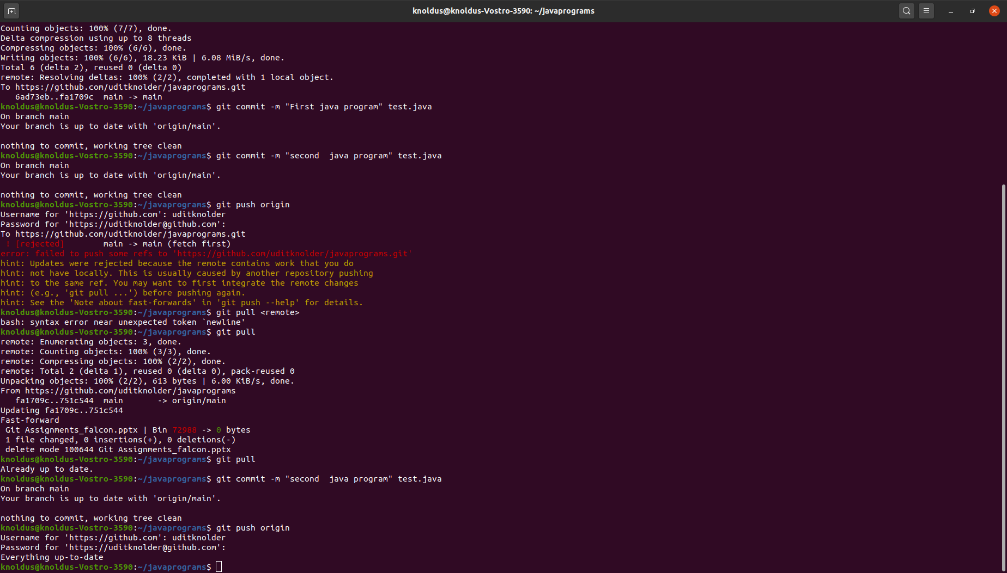

Step8:

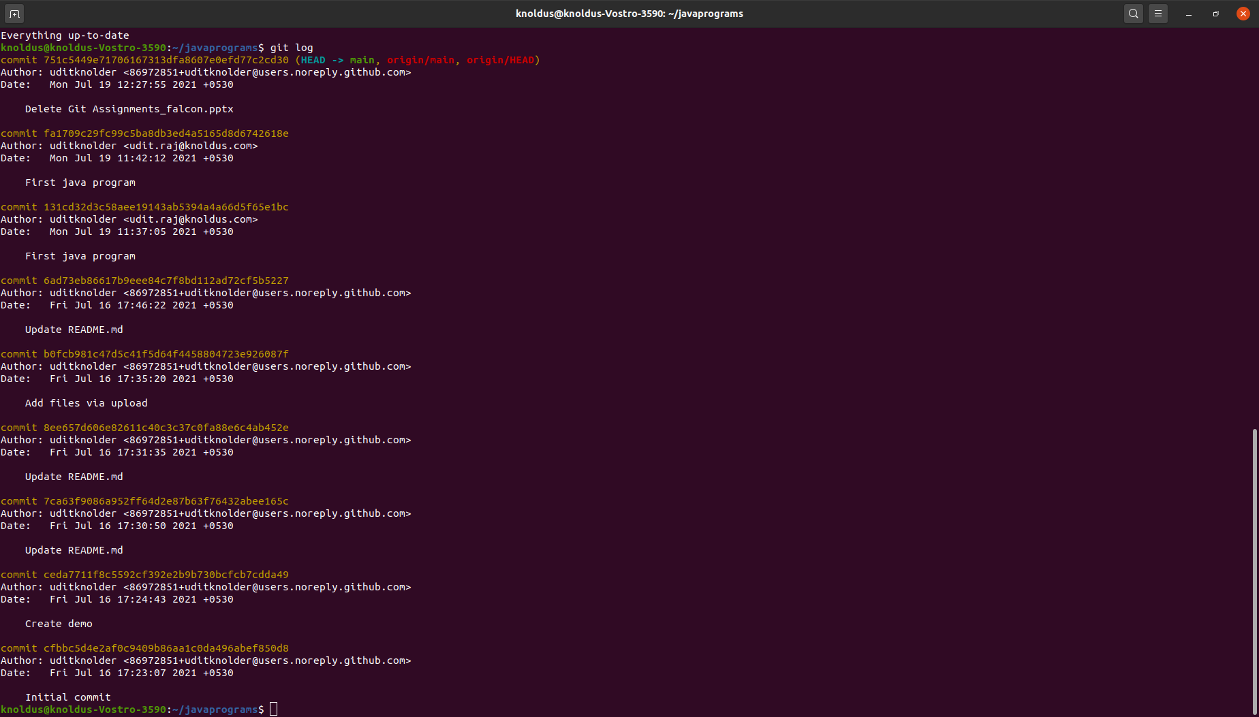

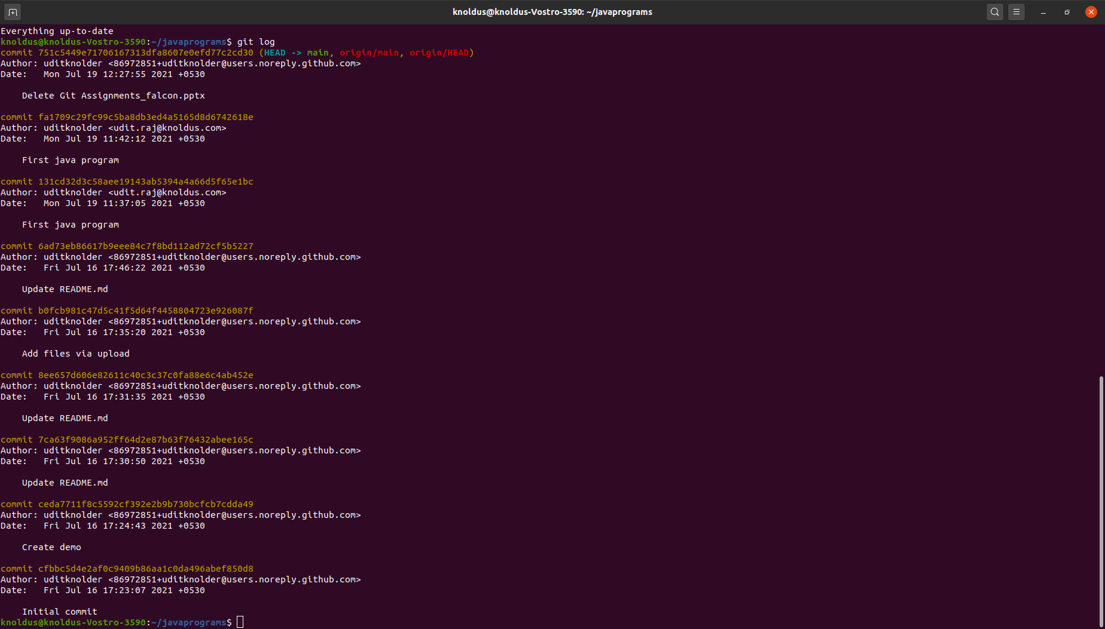
Step9:

Repository: https://github.com/uditknolder/javaprograms

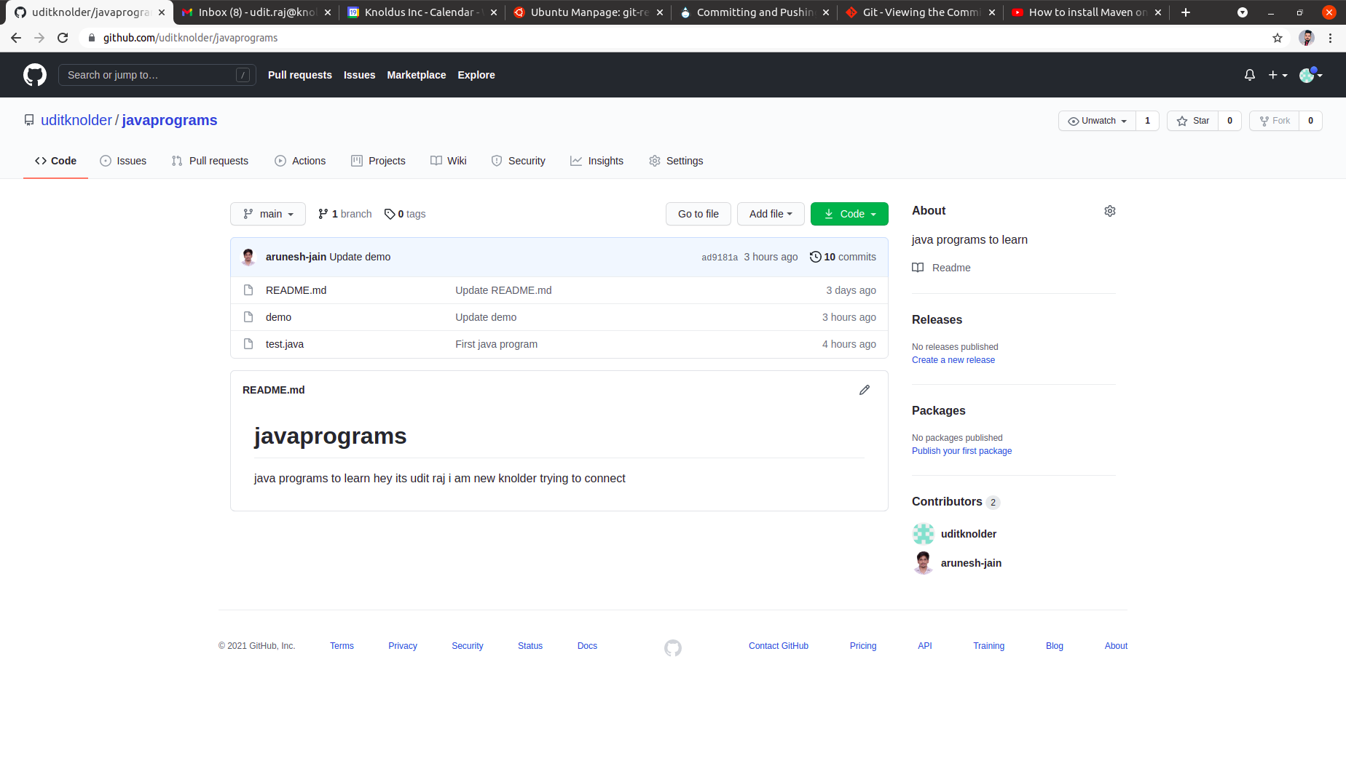
Submitted By:Udit Raj

