

Programme Name:Bachelor of Computer Science(Hons.)

Course Code: CSC2515

Course Name: Object Oriented Programming

Assignment : A1

Date of Submission: 23rd November 2021

**Submitted By: Submitted To:**

Student Name:Udit Kumar Mahato Faculty Name:Prakash Chandra Prasad

IUKL ID: 0042003900006 Department: PO office(BCS)

Semester: 3rd Semester

Intake:September 2020

There are THREE (3) questions in this section. Answer ALL Questions in the Answer Booklet.

1. Write JAVA programs that accept alphanumeric strings from the user and identify each character

in the string as whether it is alphabet or number.

CODE:-

import java.util.Scanner;  
public class IdentifyDataType {  
 public static void main(String[] args) {  
 Scanner sc=new Scanner(System.*in*);  
 System.*out*.println("Enter the string that you want to check : ");  
 String mainStore=sc.nextLine();  
 //Defined alphabets and numbers  
 String numStore="0123456789";  
 String alphabetStore="abcdefghijklmnopqrstuvwxyzABCDEFGHIJKLMNOPQRSTUVWXYZ";  
 //loop to check alphabets  
 for(int i=0;i<mainStore.length();i++){  
 char st=mainStore.charAt(i);  
 //loop to print alphabets  
 for (int j=0;j<26;j++){  
 if(st==alphabetStore.charAt(j)){  
 System.*out*.println(st+"- alphabet");  
 }  
 }  
 //loop to print numbers  
 for (int k=0;k<10;k++){  
 if(st==numStore.charAt(k)){  
 System.*out*.println(st+"- number");  
 }  
 }  
 }  
 sc.close();  
 }  
}

OUTPUT:

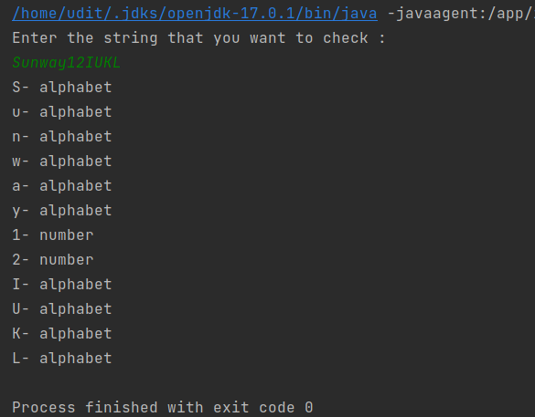

2. Explain the concept of a jagged array in JAVA and write a JAVA program to demonstrate a

jagged array.

(10 marks)

**Ans:-**A jagged array is an array of arrays whose member arrays can be of different sizes.

That means we can create a 2-D array but with a varying number of columns in each row. These types of arrays are Jagged arrays.

Here is an example of jagged array:-

int[][] arr= new int[][] {  
 {10, 20, 30 ,40},  
 {50, 60, 70, 80, 90, 100},  
 {110, 120},  
 {1,2,3,4,5,10}  
}

CODE:-

// write a JAVA program to demonstrate a jagged array.  
  
public class JaggedArray {  
 public static void main(String[] args) {  
 //Declared and Initialized jagged array  
 int[][] jaggedArr= new int[][] {  
 {10, 20, 30 ,40},  
 {50, 60, 70, 80, 90, 100},  
 {110, 120},  
 {1,2,3,4,5,10}  
 };  
  
 //loop to print all the elements of the above jagged array

System.*out*.println("Here is the Jagged array ");  
 for (int i = 0; i < jaggedArr.length; i++) {  
 for (int j = 0; j < jaggedArr[i].length; j++)  
 System.*out*.print(jaggedArr[i][j] + " ");  
 System.*out*.println();  
 }  
 }  
}

OUTPUT:-

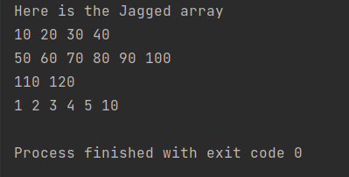

3. Write a JAVA program to calculate transpose of a given matrix.

(10 marks)

CODE:

CODE:

//Write a JAVA program to calculate transpose of a given matrix  
import java.util.Scanner;  
public class TransposeMatrix {  
 public static void main(String[] args) {  
 //scanner to take input from user  
 Scanner sc=new Scanner(System.*in*);  
 System.*out*.println("Enter the 3*3 matrix that you want to transpose :");  
 //array to take matrix input  
 int [][] matrix=new int[3][3];  
 //loop to take matrix as input  
 for (int i=0;i<3;i++){  
 for(int j=0;j<3;j++){  
 matrix[i][j] =sc.nextInt();  
 }  
 }  
 //loop to print the matrix  
 System.*out*.println("The matrix you entered is : ");  
 for (int i=0;i<3;i++){  
 for(int j=0;j<3;j++){  
 System.*out*.print(matrix[i][j]+" ");  
 }  
 System.*out*.println(" ");  
 }  
 //loop to transpose the matrix  
 System.*out*.println("The transpose of the matrix you entered is : ");  
 for(int i=0;i<3;i++){  
 for(int j=0;j<3;j++){  
 System.*out*.print(matrix[j][i]+ " ");  
 }  
 System.*out*.println(" ");  
 }  
 }  
}

OUTPUT:-

