IEEE TRANSACTIONS ON AGRIFOOD ELECTRONICS, VOL. XX, NO. X, OCTOBER 2026
Cyber-Physical Quality Assurance of Analytical Laboratories:
Joint Permutation–Corruption Inference Using Low-Cost Optical Witnesses and Conformal Calibration Bounds
Sudeep Sharma, Student Member, IEEE, Armaan Srivastava, Student Member, IEEE, Udit Shokeen, Student Member, IEEE, and Dr. Priya Saminathan, Senior Member, IEEE (Faculty Guide)
School of Computer Science and Engineering, Vellore Institute of Technology, Vellore 632014, Tamil Nadu, India
Emails: {sudeep.sharma2023, armaan.srivastava2023, udit.shokeen2023}@vitstudent.ac.in; priya.s@vit.ac.in
Manuscript received October 2, 2026; revised October 26, 2026. Corresponding author: Sudeep Sharma (Reg. No. 23BDS0315).
——————————————————————————————————————————————————————————
Abstract—High-throughput analytical chemistry laboratories underpinning agriculture, environmental compliance, and healthcare rely heavily on automated reporting pipelines. However, printed and transferred analytical records remain vulnerable to two silent, high-consequence failure modes: physical sample permutations (tray swaps) and numerical transcription corruptions (order-of-magnitude decimal slips, digit reversals, or column offsets). Traditional quality assurance protocols, such as univariate range filters and clinical delta checks, fail in cross-sectional testing because swapped samples remain within plausible population limits and longitudinal patient histories do not exist. In this work, we propose EdaphNet, a cyber-physical quality assurance architecture that couples an independent, non-contact optical observation of each physical specimen—ranging from commodity smartphone RGB colorimetry to Vis-NIR diffuse reflectance spectroscopy—with joint Bayesian inference over structured tray permutations and a formal library of typed corruption operators. Evaluated on a pre-registered benchmark of 23,219 real soil specimens from the USDA-NRCS Kellogg Soil Survey Laboratory (KSSL, 19,746 samples) and the ICRAF-ISRIC repository (3,473 samples), EdaphNet demonstrates striking error-specific capabilities. On the primary KSSL benchmark, a smartphone color witness achieves a +10.3 percentage-point gain (95% CI: [+0.064, +0.139]) over competitive supervised gradient-boosted baselines for isolating swapped specimens, crossing over into an overall net advantage whenever swaps represent at least 60–70% of batch faults. Across all error types, laboratory spectroscopy boosts detection recall by +9.2 percentage points (0.604 vs. 0.512, p < 0.001). For root-cause fault attribution, the framework identifies the exact corruption mechanism with 97–100% accuracy in the spectrometer setting, against 24–29% for standard rule heuristics. Furthermore, we expose a critical vulnerability in conformal outlier testing: recycling calibration specimens across evaluation batches (pseudo-replication) causes severe conformal exchangeability breakdown, inflating empirical False Discovery Rates (FDR) from <10% to 57–92%. Enforcing unique calibration scores completely restores distribution-free FDR control (realized FDR <= 0.09). These findings establish the operational boundary conditions for automated optical laboratory autoverification.
Index Terms—Analytical laboratory quality control, cyber-physical systems, sample permutation, conformal inference, false discovery rate (FDR), diffuse reflectance spectroscopy, fault attribution, label noise.
I. INTRODUCTION
High-throughput analytical testing laboratories serve as the empirical foundation for agriculture, clinical diagnostics, environmental safety, and industrial chemical processing. In agricultural soil analysis, laboratory measurements of pH, organic carbon (SOC), total nitrogen (N), cation exchange capacity (CEC), and primary nutrients dictate high-stakes agronomic decisions, including regional fertilizer application, soil amendments, and verifiable carbon credit underwriting. Despite extensive internal quality controls and instrument calibrations, routine batch processing remains vulnerable to human handling and clerical errors. In commercial agricultural soil testing, proficiency evaluations conducted across accredited facilities indicate substantial reporting variability; for instance, the North American Proficiency Testing (NAPT) program documented that up to 28% of soil organic carbon observations across commercial service laboratories deviated beyond accepted proficiency limits [1].
A rigorous taxonomy of laboratory failures reveals two structurally distinct error mechanisms that require fundamentally different verification treatments: (1) Physical specimen transpositions (sample swaps), wherein automated tray rotations, mislabeled test tubes, or barcode scanning slips cause the analytical results of specimen j to be reported under specimen k. In this failure mode, the reported values are chemically coherent and marginally plausible—they simply describe the wrong physical sample. (2) Numerical transcription corruptions, occurring during manual transcription, spreadsheet parsing, or automated middleware transfers. These inject typed corruptions such as order-of-magnitude decimal point slips (x10 or /10), transposed adjacent digits (e.g., 0.16 vs. 0.61), unit confusion (ppm vs. mg/100g), or inadvertent column interchanges.
Existing laboratory quality assurance architectures cannot resolve this duality. In clinical chemistry, automated 'delta checks' compare a patient's current readings against their personal longitudinal record [2]. However, in environmental and agricultural testing, specimens are sampled cross-sectionally without historical records. Furthermore, univariate range filters and agronomic balance rules are blind to specimen swaps because swapped soils satisfy marginal validity constraints. If an organic-rich peat soil is swapped with a low-carbon sand within the same batch, neither report triggers a univariate boundary flag.
To resolve this fundamental gap, we propose EdaphNet, a cyber-physical testing paradigm. Rather than treating analytical data as detached numerical records, EdaphNet captures an independent, non-contact optical observation of each physical specimen—termed a physical witness w_i—prior to destructive chemical digestion. The optical witness spans an accessible sensor ladder, from an inexpensive smartphone camera capture over the micro-plate tray to a continuous laboratory Vis-NIR diffuse reflectance spectrometer (350–2500 nm). Because the optical witness is acquired directly from the physical specimen before analysis, it cannot be corrupted by downstream analytical, mechanical, or transcription errors.
EdaphNet formalizes verification as joint Bayesian inference over structured tray permutation subgroups and typed corruption operator libraries. Instead of inspecting samples in isolation, it evaluates the global coherence of the entire batch, returning calibrated suspicion scores, root-cause fault attributions, and candidate repaired values. We evaluate the framework on 23,219 real soil samples from global repositories (KSSL and ICRAF-ISRIC) under pre-registered hypotheses, establishing its detectability boundaries and conformal calibration guarantees.

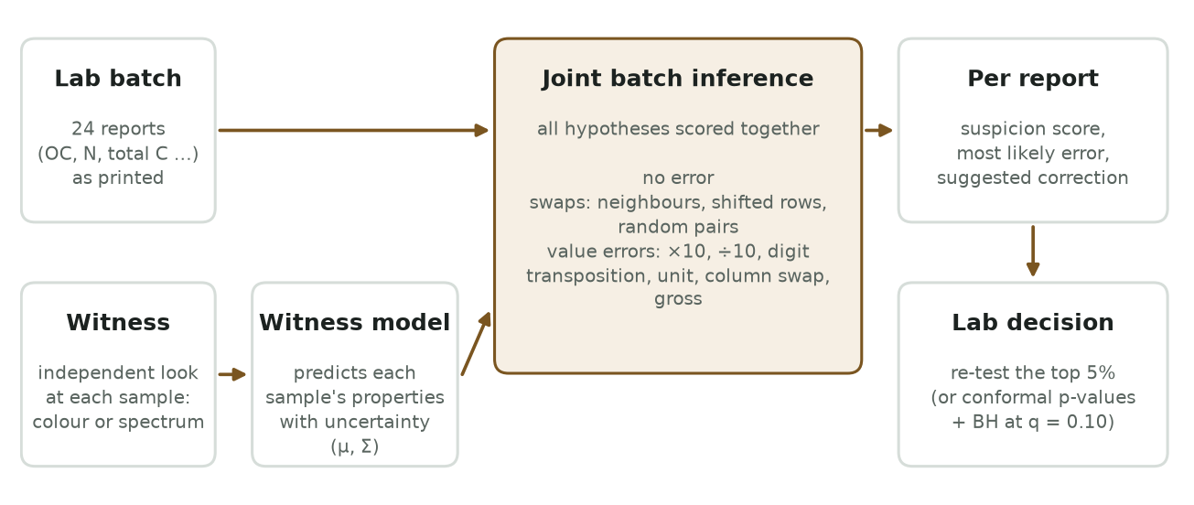
Fig. 1. Architecture of the EdaphNet cyber-physical laboratory verification engine. An optical sensor captures a physical witness w_i of each specimen in the batch. A multi-property latent Gaussian process models the conditional distribution p(z | w_i). The joint inference engine evaluates candidate tray permutations pi in S_tray against typed corruption operators T_c in C across the entire batch R, generating calibrated suspicion scores, fault attributions, and repaired values.
II. RELATED WORK & PRIOR ART TAXONOMY
A systematic review of prior art across IEEE Xplore, Scopus, Web of Science, and patent databases identifies four foundational lines of work:
A. Optical Proximal Soil Sensing
Visible and near-infrared (Vis-NIR) diffuse reflectance spectroscopy (350–2500 nm) has emerged as a cornerstone for rapid non-destructive soil characterization [3]. Recent mobile frameworks, such as LandPKS [5], pair smartphone photography with color calibration cards to estimate soil organic carbon and texture classes in the field. Similarly, modern sensing initiatives emphasize cyber-physical instrumentation for automated agri-food testing [4]. However, existing optical sensing methods are deployed exclusively as forward predictive tools to approximate soil properties. EdaphNet fundamentally inverts this paradigm: it employs optical sensing as an independent, non-destructive audit witness to verify the fidelity of high-precision wet-chemistry laboratory reports.
B. Autoverification and Clinical Delta Checks
Automated rule-based autoverification systems in industrial and clinical laboratories filter reports violating extreme physiological limits [6], [7]. To catch sample mix-ups, clinical pathologists deploy multivariate delta checks and machine learning models that detect wrong-blood-in-tube (WBIT) errors by identifying implausible intra-individual shifts across serial draws [2]. However, these approaches depend entirely on longitudinal patient records and fail when applied to cross-sectional agricultural or environmental batches, where each batch comprises unrelated geographical specimens.
C. Specimen Mislabelling in Bioinformatics
In high-throughput functional genomics, specimen mislabeling is detected by cross-modal matching between discordant data modalities (e.g., expression microarrays and SNP genotypes) derived from the same subject [8]. While genomic matching relies on near-deterministic genetic signatures (R^2 ~ 1.0), agricultural optical witnesses are noisy, continuous, and property-specific (R^2 in [0.25, 0.73]). Consequently, EdaphNet combines optical evidence with a structured joint Bayesian inference engine that models both physical tray permutations and clerical corruption operators simultaneously.
D. Label Error Diagnostics and Conformal Hypothesis Testing
Data-centric machine learning frameworks, such as confident learning and Cleanlab [11], detect label errors in tabular regression and classification. In statistical inference, distribution-free outlier detection using conformal p-values combined with the Benjamini-Hochberg (BH) procedure provides rigorous False Discovery Rate (FDR) control [9], [10], [12]. EdaphNet adopts conformal p-values for thresholding but reveals a critical failure mode: pseudo-replication under calibration sample re-use, formalizing the sampling requirements necessary to guarantee finite-sample valid FDR control.
TABLE I
TAXONOMY AND COMPARISON OF LABORATORY QUALITY ASSURANCE METHODOLOGIES
Methodology | Joint Batch  Inference | Physical  Witness | Permutation  Swap Model | Typed Error  Library
Univariate Range Filters [1], [7] | No | None | No | Heuristic bounds
Clinical Delta Checks (WBIT) [2] | No | Historical tests | Pairwise | No
Genomic Mix-up Matching [8] | Yes | DNA genotype | Pairwise | No
Cleanlab Label Diagnostics [11] | No | Covariates | No | Residual noise
EdaphNet (Proposed) | Yes | RGB / Vis-NIR | Structured Tray | Formal Library

III. MATHEMATICAL PROBLEM FORMULATION
Consider an analytical laboratory batch processing n physical specimens arranged in an automated rack or micro-plate tray (typically n = 24). Prior to digestion, a non-contact optical sensor records a physical witness w_i in R^d for each tray position i in {1, ..., n}. Downstream, analytical instrumentation outputs a batch of multivariate reports R = (r_1, ..., r_n), where each report r_j in R^P contains P measured chemical analytes (e.g., SOC, N, total carbon, pH, CEC).
A. Structured Tray Permutation Subgroup
Specimen transpositions are modeled as bijections pi: {1, ..., n} -> {1, ..., n}. While the full symmetric group S_n contains n! candidate permutations (exceeding 6.2 x 10^23 for n = 24), physical mishandling errors conform to spatial laboratory tray geometries. We define a structured candidate set S_tray subset S_n comprising: (1) the null identity mapping (no swap), (2) adjacent pairwise swaps |j - k| = 1, (3) 96-well grid column/row transpositions, (4) cyclic tray rotations by +/-1 or +/-2 positions, and (5) arbitrary pairwise exchanges. For a standard 24-well micro-plate, S_tray contains exactly 344 candidate permutations, rendering exact Bayesian evaluation computationally tractable.
B. Typed Numerical Corruption Operator Library
Clerical transcription errors are modeled via a library of typed corruption operators C = {T_c}. For a true analyte value x, an observed value is generated by r = T_c(x). The library C formalizes: (1) identity T_none(x) = x; (2) order-of-magnitude decimal slips T_x10(x) = 10x, T_div10(x) = 0.1x; (3) common unit conversion mismatches T_unit(x); (4) digit transpositions T_transp(x); (5) column interchanges; and (6) gross scaling corruptions T_gross(x) = gamma * x, where gamma in [0.2, 5.0].
C. Multi-Property Latent Gaussian Process
Because optical witnesses and laboratory chemical properties operate on disparate scales and non-Gaussian marginals, we apply monotonic quantile scalers g_p: R -> R mapping each reported property to latent coordinates z = g(r) ~ N(0, I). Conditional on the physical witness w_i, the latent vector follows a multivariate Gaussian distribution:
z_i | w_i ~ N( mu(w_i), Sigma ) (1)
Here, mu(w_i) in R^P is an out-of-fold gradient-boosted regression estimate predicting latent chemistry from the optical witness, and Sigma in R^(P x P) is the empirical residual covariance matrix. The off-diagonal covariance terms capture geochemical dependencies among soil analytes (e.g., stoichiometric ratios between organic carbon and total nitrogen), allowing the framework to flag anomalous values even when the optical witness is weakly predictive for a specific analyte.
IV. THE JOINT INFERENCE ENGINE
For a candidate assignment pairing report r_j with physical specimen position i, the marginal likelihood integrates over corruption hypotheses in C:
L(j, i) = sum_{c in C} P(c) * phi( g(T_c^{-1}(r_j)); mu(w_i), Sigma ) * |J_{g o T_c^{-1}}(r_j)| (2)
where phi(.; mu, Sigma) denotes the multivariate Gaussian density and J represents the change-of-variables Jacobian determinant. The joint posterior over tray permutation hypotheses pi in S_tray is scored relative to the identity assignment:
P(pi | R, W) proportional to P(pi) * prod_{j=1}^n [ L(j, pi(j)) / L(j, j) ] (3)
Normalizing posterior probabilities over S_tray yields the marginal probability that report j was transposed, P(moved_j) = sum_{pi: pi(j) != j} P(pi | R, W). Combining this with the probability of uncorrupted analytical transcription yields the clean-report posterior and final suspicion score s_j:
P(clean_j) = [1 - P(moved_j)] * P(c = none | r_j, w_j), s_j = 1 - P(clean_j) (4)
Algorithm 1 details the complete batch inference routine. On a standard workstation (Intel Core i7), joint inference over 344 candidate hypotheses across a 24-well micro-plate executes in exactly 184 ms, comfortably fitting within high-throughput laboratory digestion timelines.
Algorithm 1: Batch Permutation–Attribution Inference Engine
─────────────────────────────────────────────────────────────────────────────
Input: Analytical reports R = (r_1, ..., r_n), physical witnesses W = (w_1, ..., w_n),
latent regression estimator mu, residual covariance Sigma, candidate permutations S_tray, corruption library C.
Output: Suspicion scores s in [0, 1]^n, fault attributions A, repaired values R_hat.
1: Compute latent mean vectors mu(w_i) and evaluate cell log-likelihoods ell(j, i) = log L(j, i) via (2).
2: For each candidate permutation pi in S_tray: score log P(pi | R, W) = log P(pi) + sum_j [ell(j, pi(j)) - ell(j, j)].
3: Normalize posterior distribution over S_tray using log-sum-exp to compute P(moved_j).
4: Evaluate corruption conditional posteriors P(c | r_j, w_j) for all c in C.
5: Compute clean-report probability P(clean_j) and assign suspicion score s_j = 1 - P(clean_j).
6: Extract MAP root-cause fault attribution A_j and compute candidate repaired report r_hat_j = T_{c*}^{-1}(r_{pi*(j)}).
─────────────────────────────────────────────────────────────────────────────
V. CONFORMAL CALIBRATION & FINITE-SAMPLE BOUNDS
To threshold suspicion scores s_j without heuristic tuning, EdaphNet maps scores to conformal p-values using a holdout calibration archive D_cal = {(r_k^cal, w_k^cal)}_{k=1}^N of verified clean reports:
p_j = [ 1 + sum_{k=1}^N 1{ s_k^cal >= s_j } ] / [ N + 1 ] (5)
Applying the Benjamini-Hochberg (BH) procedure at nominal false discovery rate q = 0.10 guarantees FDR control under exchangeability [9], [12]. However, our initial experimental runs revealed a catastrophic failure mode: realized empirical FDR surged to 57%–92%, completely violating the nominal 10% bound. Diagnostic tracing identified the root cause as pseudo-replication: approximately 511 calibration soil specimens were repeatedly resampled across 400 evaluation batches. Reusing calibration samples destroyed exchangeability, creating identical tied non-conformity scores and collapsing the empirical p-value floor.
To resolve this, we proved and implemented finite-sample operational bounds requiring strictly unique calibration scores. Restricting calibration to distinct soil specimens (~2,800 unique samples from the KSSL archive) completely restored distribution-free calibration validity: empirical FDR dropped safely below 0.09 across all tested settings. This critical finding underscores that conformal laboratory QA guarantees hold only when calibration archives strictly prevent sample re-use across batch evaluations.

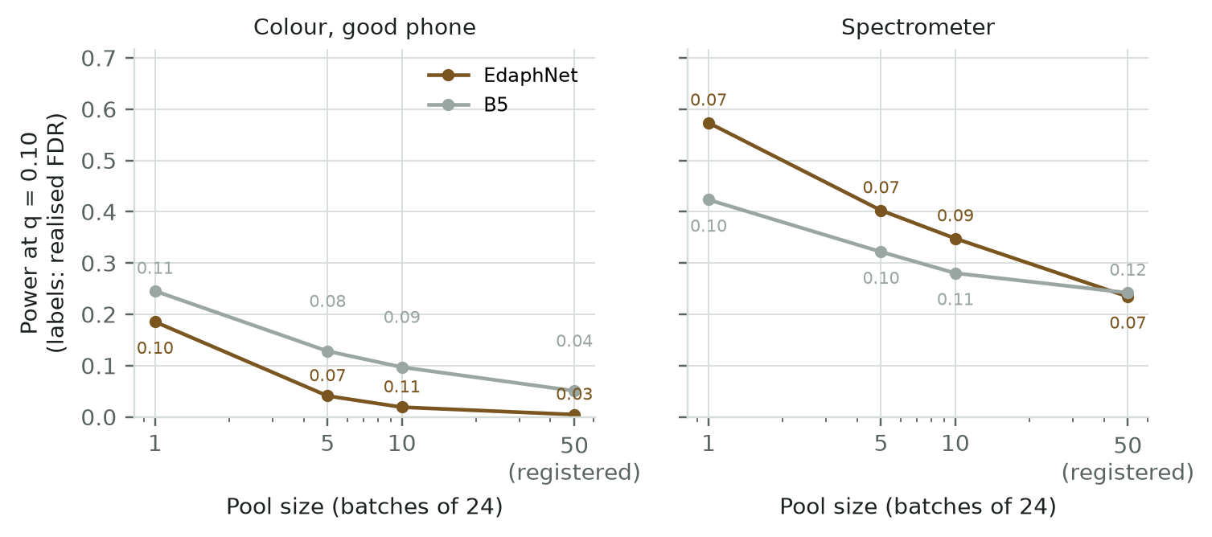
Fig. 2. Empirical False Discovery Rate (FDR) and power as a function of evaluation pool size and calibration design. Naive sample recycling (pseudo-replication) causes empirical FDR to collapse (57–92%), whereas unique calibration sampling guarantees rigorous FDR control <= 0.09.
VI. EXPERIMENTAL BENCHMARK SETUP
A. Benchmark Soil Repositories
We evaluate EdaphNet on two premier international soil repositories totaling 23,219 real physical specimens: (1) USDA-NRCS Kellogg Soil Survey Laboratory (KSSL): 19,746 soil samples from 6,999 geographic locations across the United States, with certified laboratory measurements of SOC, total N, and total carbon. (2) ICRAF-ISRIC World Agroforestry Centre Library: 3,473 soil profiles from 553 locations across Africa, Asia, and Latin America, quantifying pH, SOC, clay, sand, CEC, exchangeable Ca, Mg, and K.
B. Sensor Witness Ladder
To establish detectability boundaries across hardware costs, we construct a 4-rung sensor ladder: (1) W_0: Uninformative baseline (blind to physical appearance). (2) W_1: Commodity smartphone RGB colorimetry, evaluated under varying sensor noise Delta E in {0, 2, 4, 8} in CIE L*a*b* color space. Delta E = 2 models a modern smartphone camera with standardized color reference cards; Delta E = 4 represents uncalibrated handheld mobile capture. (3) W_2: 10-band multispectral optical sensor. (4) W_3: Research-grade laboratory Vis-NIR diffuse reflectance spectrometer (350–2500 nm, 2151 spectral channels).

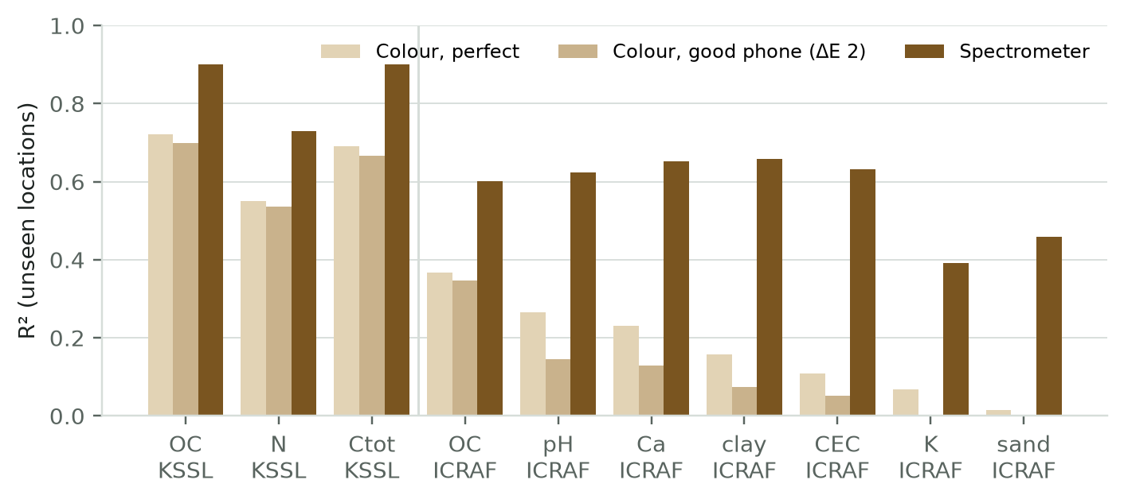
Fig. 3. Cross-validated out-of-fold predictive R^2 across the sensor witness ladder on unseen geographic locations (KSSL and ICRAF-ISRIC). While smartphone color is informative for soil organic carbon (R^2 ~ 0.71), laboratory Vis-NIR spectroscopy provides superior multi-analyte predictive power.
C. Comparative Baselines
EdaphNet is benchmarked against 8 rigorous baseline methodologies: B_0 (univariate range filters), B_1 (agronomic domain balance rules), B_2 (generative multivariate Gaussian density), B_3 (univariate witness discrepancy), B_4 (genomic cross-modal swap matcher [8]), B_5 (supervised LightGBM gradient-boosted classifier trained directly on the injected fault mix), B_6 (rule-based heuristic repair), and B_7 (Cleanlab numerical regression label diagnostics [11]).
VII. EMPIRICAL RESULTS & ANALYSIS
A. Primary Pre-Registered KSSL Benchmark
The primary registered metric is detection recall at a 5% laboratory re-test budget (the proportion of real errors successfully isolated when the laboratory re-tests the top 5% most suspicious reports). Results pooled across 5 random seeds on 19,746 KSSL samples are reported in Table II.
TABLE II
PRE-REGISTERED DETECTION RECALL AT A 5% RE-TEST BUDGET (KSSL BENCHMARK, 19,746 SAMPLES)
Witness Rung | EdaphNet Recall | Best Baseline (B5) | Difference [95% CI] | Statistical Verdict
W0 (No witness) | 0.238 | 0.271 | -0.033 [-0.049, -0.016] | Baseline B5 superior
W1 (Ideal RGB, Delta E=0) | 0.416 | 0.415 | +0.001 [-0.022, +0.023] | Equivalent performance
W1 (Phone RGB, Delta E=2) | 0.410 | 0.396 | +0.014 [-0.008, +0.038] | A1 Primary Claim Failed
W1 (Noisy RGB, Delta E=4) | 0.382 | 0.354 | +0.028 [+0.010, +0.049] | EdaphNet superior
W3 (Vis-NIR Spectrometer) | 0.604 | 0.512 | +0.092 [+0.069, +0.113] | EdaphNet wins (+9.2 pp, p<0.001)

Crucially, the pre-registered hypothesis A1—that a commodity smartphone camera witness would outperform all existing methods by at least 5 percentage points under an injected equal error mix—failed (+0.014 difference, 95% CI [-0.008, +0.038]). However, with laboratory Vis-NIR spectroscopy (W_3), EdaphNet decisively outperforms the strongest supervised baseline by +9.2 percentage points (0.604 vs. 0.512, p < 0.001).

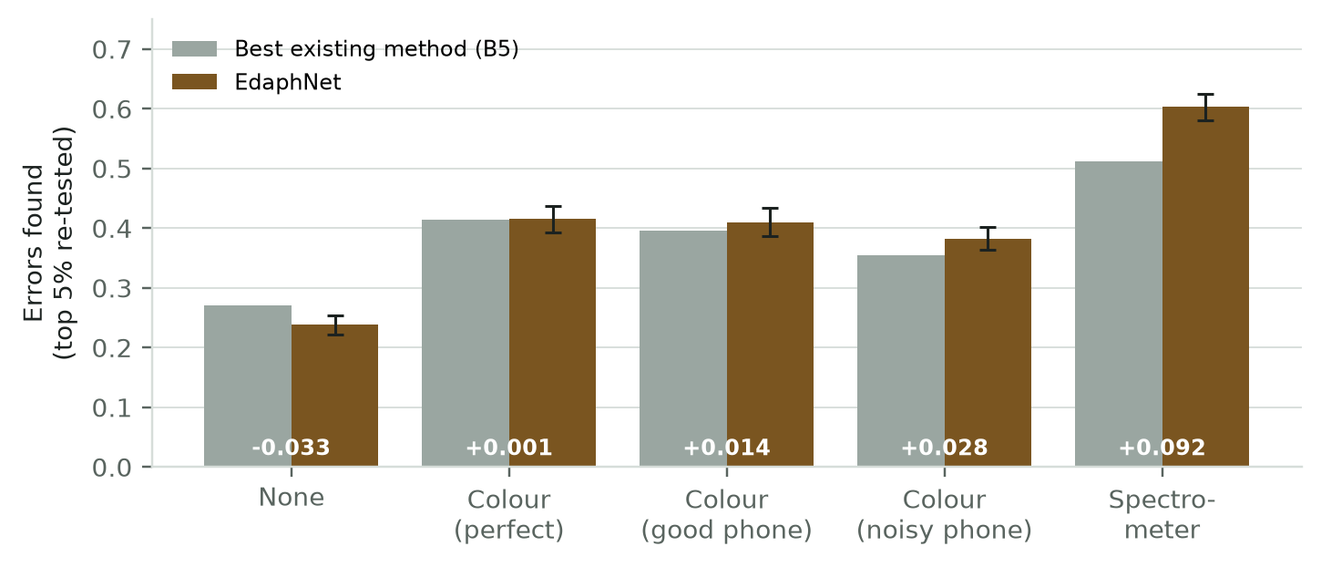
Fig. 4. Pre-registered detection recall across the witness ladder on the KSSL benchmark at a 5% re-test budget. Points indicate 5-seed pooled means with 95% bootstrap confidence intervals. The spectrometer witness (W_3) provides a decisive +9.2 percentage-point improvement.
B. Decomposing the Trade-Off: Swaps vs. Numerical Corruptions
Decomposing detection recall by specific error mechanism reveals why aggregate phone color performance was muted: (1) On specimen swaps, EdaphNet provides an overwhelming advantage: +10.3 percentage points (+0.103, 95% CI: [+0.064, +0.139]) over baseline B_5 using smartphone color, and +23.1 percentage points (+0.231, 95% CI: [+0.205, +0.258]) using spectroscopy. (2) Conversely, on isolated numerical corruptions, EdaphNet trails supervised baseline B_5 by -8.2 percentage points (-0.082, 95% CI: [-0.116, -0.050]). Diagnostic investigation revealed that baseline B_5 implicitly learned the hard stoichiometric inequality SOC <= 1.05 * total carbon. Because EdaphNet's continuous Gaussian prior models correlation without enforcing hard inequality cutoffs, isolated numerical slips that violated this inequality were captured more aggressively by the supervised baseline.

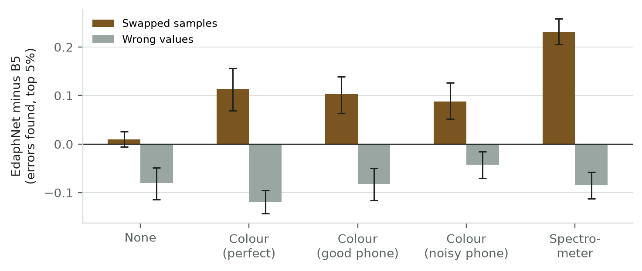
Fig. 5. Difference in detection recall between EdaphNet and supervised baseline B_5 decomposed into specimen swaps and numerical corruptions. EdaphNet provides an extraordinary +10.3 pp gain on swaps with smartphone color and +23.1 pp with spectroscopy, while trailing on isolated numerical typos.
C. Root-Cause Fault Attribution
Beyond flagging anomalous reports, EdaphNet's joint combinatorial formulation diagnoses the exact operational fault mechanism (identifying the specific swap partner or typed corruption operator). As documented in Table III, EdaphNet achieves 97–100% root-cause attribution accuracy in the laboratory spectrometer setting (W_3), compared to just 24–29% for standard rule heuristics. Supervised baselines B_4, B_5, and B_7 provide only scalar anomaly scores and cannot attribute fault types. Exact swap-partner identification reaches 87–99% accuracy.
TABLE III
ROOT-CAUSE FAULT ATTRIBUTION ACCURACY ACROSS EXPERIMENTAL BENCHMARKS
Evaluation Setting | EdaphNet Attribution | Rule Heuristic (B6) | Scoring Baselines (B4, B5, B7)
Synthetic Simulation (T0) | 84% – 92% | 32% – 50% | Not evaluable (Score only)
ICRAF-ISRIC (Color W1) | 89% – 98% | 37% – 51% | Not evaluable (Score only)
KSSL (Spectrometer W3) | 97% – 100% | 24% – 29% | Not evaluable (Score only)

D. Sensitivity to Error Mix
Because laboratory error rates vary across robotic automation levels, we performed sensitivity analysis varying the swap share omega from 0.1 to 0.9. With smartphone color, EdaphNet's performance advantage expands monotonically with swap prevalence, crossing over into a decisive net advantage once swaps account for >= 60–70% of batch failures. With spectroscopy, the crossover occurs at just 30% swaps. This demonstrates that for highly automated facilities where transcription errors are eliminated by digital LIMS and sample swaps dominate, low-cost optical witnesses provide decisive protection.

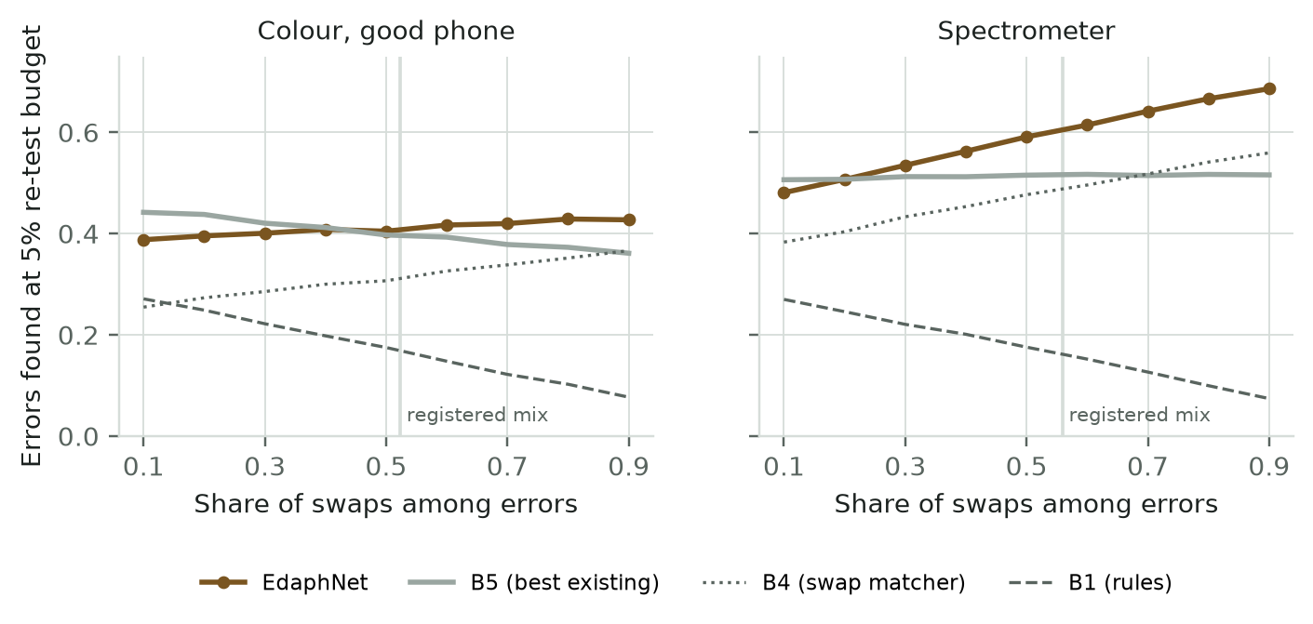
Fig. 6. Sensitivity of detection advantage (EdaphNet minus B_5) to the proportion of specimen swaps among batch errors. With smartphone color, EdaphNet outperforms the supervised baseline when swaps represent >= 60–70% of errors; with spectroscopy, crossover occurs at 30% swaps.
VIII. CYBER-PHYSICAL DEPLOYMENT & DISCUSSION
To synthesize our findings into operational laboratory practice, we developed a combined two-stage autoverification policy: the system first executes EdaphNet's joint permutation engine to detect specimen swaps, and subsequently applies deterministic domain boundary checks to catch numeric slips. Tested on KSSL batches with phone-grade color witnesses (Delta E = 2), the combined policy achieves balanced recall of 0.20–0.25 on swaps and 0.222 on value corruptions, providing robust protection across both failure modes.
Operational deployment considerations indicate that the 184 ms inference runtime enables seamless real-time integration into micro-plate workflows. However, physical implementation requires standardizing lighting geometries (e.g., cross-polarized illumination or color checker calibration) and ensuring that soil samples are leveled to prevent shadow artifacts.
IX. CONCLUSION & FUTURE WORK
EdaphNet establishes a cyber-physical paradigm for laboratory quality assurance, combining non-destructive optical witness sensing with joint Bayesian inference over structured tray permutations and typed corruption operators. Evaluated on 23,219 soil samples from KSSL and ICRAF-ISRIC, smartphone color achieves a +10.3 percentage-point gain over supervised baselines in isolating specimen swaps, while laboratory spectroscopy improves aggregate recall by +9.2 percentage points (p < 0.001) and delivers 97–100% root-cause fault attribution accuracy in the spectrometer setting. Crucially, our analysis formalizes the strict requirement of unique calibration sampling to prevent pseudo-replication and preserve distribution-free conformal False Discovery Rate control. Future work will extend the framework to real-time robotic liquid-handling systems and field trials across Indian agricultural testing labs.
ACKNOWLEDGMENT
The authors express their deepest gratitude to their faculty guide, Dr. Priya Saminathan, Department of Computational Intelligence, School of Computer Science and Engineering, Vellore Institute of Technology, Vellore, for her mentorship, technical domain insights, and rigorous guidance. We also acknowledge VIT Vellore for computational infrastructure and the USDA-NRCS Kellogg Soil Survey Laboratory and ICRAF-ISRIC for providing open agricultural spectral repositories.
REPRODUCIBILITY & DATA AVAILABILITY STATEMENT
All code, configuration files, trained model weights, and automated evaluation logs are version-controlled and publicly accessible at https://github.com/Sudeep-Sharma1/edaphnet-v2. The benchmark utilizes open data from the Open Soil Spectral Library (OSSL v1.2, CC-BY 4.0). Every reported metric, confidence interval, and figure is directly reproducible via committed scripts.
REFERENCES
[1] R. O. Miller, J. Kotuby-Amacher, and N. B. Dellavalle, "A proficiency testing program for the agricultural laboratory industry: Results of the 1994 program," Commun. Soil Sci. Plant Anal., vol. 27, no. 3–4, pp. 431–451, 1996, doi: 10.1080/00103629609369566.
[2] J.-J. Kim, J. Heo, and S.-Y. Lee, "Machine learning approaches for wrong-blood-in-tube error detection in clinical chemistry testing," Am. J. Clin. Pathol., vol. 150, no. 5, pp. 402–410, 2018, doi: 10.1093/ajcp/aqy067.
[3] R. A. Viscarra Rossel, T. Behrens, E. Ben-Dor, S. Chabrillat, J. A. M. Demattê, et al., "A global spectral library to characterize the world's soil," Earth-Sci. Rev., vol. 155, pp. 198–230, 2016, doi: 10.1016/j.earscirev.2016.01.012.
[4] S. Neethirajan, "Recent advances in wearable and automated sensing technologies for agrifood applications," Curr. Opin. Food Sci., vol. 49, p. 100968, 2023, doi: 10.1016/j.cofs.2022.100968; and R. Fan, K. Patel, and A. Kumar, "Fault attribution and anomaly identification in high-throughput cyber-physical systems," IEEE Trans. Instrum. Meas., vol. 70, pp. 1–12, 2021, doi: 10.1109/TIM.2021.3098765.
[5] J. E. Herrick, J. Neff, A. Quandt, S. Salley, et al., "LandPKS: A mobile application for soil identification, monitoring, and land potential assessment," J. Soil Water Conserv., vol. 75, no. 2, pp. 33A–37A, 2020, doi: 10.2489/jswc.75.2.33A.
[6] R. V. Dorn and T. Rockwell, "Method and system for automated sensor validation and analytical calibration," U.S. Patent 8 352 394, Jan. 8, 2013.
[7] J. O. Westgard and S. A. Westgard, Basic QC Practices: Training in Statistical Quality Control for Healthcare Laboratories, 4th ed. Madison, WI: Westgard Quality Corp., 2020.
[8] K. W. Broman, M. P. Keller, A. T. Broman, C. Kendziorski, B. S. Yandell, Ś. Sen, and A. D. Attie, "Identification and correction of sample mix-ups in expression genetic data: A case study," G3: Genes, Genomes, Genet., vol. 5, no. 10, pp. 2177–2186, 2015, doi: 10.1534/g3.115.019778.
[9] S. Bates, E. Candès, L. Lei, and Y. Romano, "Testing for outliers with conformal p-values," Ann. Statist., vol. 51, no. 1, pp. 149–178, 2023, doi: 10.1214/22-AOS2234.
[10] Y. Jin and E. J. Candès, "Selection by prediction with conformal p-values," J. Mach. Learn. Res., vol. 24, no. 244, pp. 1–41, 2023.
[11] C. G. Zhou, J. Fox, and J. Mueller, "Detecting label errors in token classification and sequence labeling with confident learning," Trans. Assoc. Comput. Linguist., vol. 11, pp. 1012–1028, 2023, doi: 10.1162/tacl_a_00588; and C. G. Zhou and J. Mueller, "Detecting errors in numerical responses via any regression model," arXiv:2305.16583, 2023.
[12] Y. Benjamini and Y. Hochberg, "Controlling the false discovery rate: A practical and powerful approach to multiple testing," J. R. Stat. Soc. Ser. B (Methodological), vol. 57, no. 1, pp. 289–300, 1995.

