BCSE497J – PROJECT-I
FINAL PROJECT REPORT
AGRISENSE AI: AN EXPLAINABLE SMART CROP HEALTH MANAGEMENT SYSTEM
(Cyber-Physical Quality Assurance of Analytical Laboratories: Joint Permutation-Corruption
Inference with Low-Cost Optical Witnesses and Conformal Calibration Bounds — EdaphNet Engine)
A Project-I Report submitted in partial fulfillment of the requirements
for the award of the degree of
BACHELOR OF TECHNOLOGY
in
COMPUTER SCIENCE AND ENGINEERING
Submitted by:
23BCB0001 | UDIT SHOKEEN | B.Tech CSE (Bioinformatics)
23BCE2318 | ARMAAN SRIVASTAVA | B.Tech Computer Science and Engineering
23BDS0315 | SUDEEP SHARMA | B.Tech CSE (Data Science)
Under the Supervision of:
Dr. Priya Saminathan, Ph.D., Senior Member, IEEE
Associate Professor
Department of Computational Intelligence
SCHOOL OF COMPUTER SCIENCE AND ENGINEERING (SCOPE)
VELLORE INSTITUTE OF TECHNOLOGY (VIT)
VELLORE – 632014, TAMIL NADU, INDIA
OCTOBER 2026

BONAFIDE CERTIFICATE
This is to certify that the project report entitled "AGRISENSE AI: AN EXPLAINABLE SMART CROP HEALTH MANAGEMENT SYSTEM" (implemented as the EdaphNet Cyber-Physical Verification Engine) submitted by UDIT SHOKEEN (Reg. No: 23BCB0001), ARMAAN SRIVASTAVA (Reg. No: 23BCE2318), and SUDEEP SHARMA (Reg. No: 23BDS0315) to Vellore Institute of Technology, Vellore, in partial fulfillment of the requirements for the award of the degree of Bachelor of Technology in Computer Science and Engineering is a bonafide record of research work carried out by them under my supervision during the academic year 2026–2027.
The contents of this report have been verified, rigorously benchmarked on 23,219 empirical soil samples from global spectral repositories, and have not been submitted to any other Institute or University for the award of any degree, diploma, or certificate.
Dr. Priya Saminathan, Ph.D.
Project Supervisor & Associate Professor
Department of Computational Intelligence
School of Computer Science and Engineering
Vellore Institute of Technology, Vellore
Place: Vellore, Tamil Nadu
Date: 28 October 2026

DECLARATION OF AUTHORSHIP
We hereby declare that the project work entitled "AGRISENSE AI: AN EXPLAINABLE SMART CROP HEALTH MANAGEMENT SYSTEM" submitted to the School of Computer Science and Engineering (SCOPE), Vellore Institute of Technology, Vellore, is a record of original work carried out by us under the academic supervision of Dr. Priya Saminathan, Department of Computational Intelligence, SCOPE, VIT Vellore.
We further declare that every empirical result, calibration finding, and algorithmic implementation reported herein is derived from executed code committed to our reproducible version control repository, and adheres strictly to the pre-registered research protocol committed prior to test data ingestion. This report has not previously formed the basis for the award of any degree, diploma, associateship, or fellowship at this or any other institution.
1. Udit Shokeen (23BCB0001) _______________________
2. Armaan Srivastava (23BCE2318) _______________________
3. Sudeep Sharma (23BDS0315) _______________________

ACKNOWLEDGMENTS
We express our sincere gratitude and deepest respect to our project guide and supervisor, Dr. Priya Saminathan, Associate Professor, Department of Computational Intelligence, School of Computer Science and Engineering, for her invaluable guidance, rigorous critiques, and unwavering encouragement throughout the execution of this project. Her insistence on scientific integrity, pre-registered evaluation, and open reporting of negative results shaped this research into a publication-grade deliverable.
We extend our heartfelt thanks to the Dean and Faculty of the School of Computer Science and Engineering (SCOPE), Vellore Institute of Technology, for providing the necessary computational infrastructure, academic support, and high-performance computing facilities.
We gratefully acknowledge the Open Soil Spectral Library (OSSL) initiative, the USDA-NRCS Kellogg Soil Survey Laboratory (KSSL), and the ICRAF-ISRIC World Soil Information team for curating and openly sharing the comprehensive soil spectral libraries that made this large-scale empirical evaluation possible.

ABSTRACT
High-throughput analytical chemistry laboratories govern multi-billion rupee agricultural decisions, including crop nutrient management, fertilizer dosage, lime amendments, and certified soil organic carbon (SOC) accounting. Despite laboratory proficiency testing and standard reference materials, analytical testing remains vulnerable to two fundamental failure modes: physical sample swaps (which pass all chemical plausibility checks because the report belongs to another real soil) and typed numerical corruptions (decimal slips, unit confusion, digit transpositions, and column interchanges). Analyzing every sample in duplicate doubles testing expenses, rendering complete re-testing economically impossible.
This project presents AgriSense AI (implemented through the EdaphNet cyber-physical verification engine), a batch-level autoverification and fault-attribution framework that couples an independent, non-destructive optical witness (ranging from smartphone CIELAB colour to laboratory Vis-NIR spectroscopy) with exact Bayesian joint inference over a structured 281-permutation tray hypothesis space S_tray and a 5-group typed corruption library C. Evaluated across 23,219 real soil specimens from the Kellogg Soil Survey Laboratory (KSSL) and ICRAF-ISRIC repositories, smartphone colour achieves a +10.3 to +11.4 percentage point recall gain on swapped samples, while laboratory Vis-NIR spectroscopy attains an overall recall gain of +9.2 percentage points (p < 0.001) at a 5% re-test budget. Furthermore, AgriSense AI achieves 97%–100% root-cause fault attribution accuracy and 95%–98% exact swap partner identification. A multi-batch calibration analysis reveals that calibration sample reuse induces severe pseudo-replication (inflating empirical FDR to 0.57); restricting calibration to unique physical specimens restores exact distribution-free false-alarm control (<= 0.09). The inference engine executes in 17.9 ± 1.2 ms on consumer CPU hardware.
Keywords — Precision Agriculture, Soil Laboratory Quality Control, Cyber-Physical Systems, Sample Permutation Inference, Conformal Calibration, False Discovery Rate, Fault Attribution, Explainable AI.

TABLE OF CONTENTS
Chapter / Section | Title | Page
Abstract | Abstract | iv
1. | INTRODUCTION | 1
 | 1.1 Background & Domain Context | 1
 | 1.2 Motivation & The Dual Laboratory Failure Modes | 2
 | 1.3 Scope of the Project & Epistemic Boundaries | 3
2. | PROJECT DESCRIPTION AND GOALS | 4
 | 2.1 Exhaustive Literature Review & Prior Art Matrix | 4
 | 2.2 Synthesis of Disconnected Scientific Traditions | 6
 | 2.3 Identified Research Gaps (G1 – G10) | 7
 | 2.4 Project Objectives (RO1 – RO10) & Research Questions | 8
 | 2.5 Problem Statement | 9
 | 2.6 Project Plan & Execution Milestones | 10
3. | TECHNICAL SPECIFICATION & SYSTEM ARCHITECTURE | 11
 | 3.1 Requirements Analysis (Functional & Non-Functional) | 11
 | 3.2 Feasibility Study (Technical, Economic, Social) | 12
 | 3.3 System Specifications (Hardware & Software Profile) | 13
 | 3.4 Dual-Pipeline System Architecture | 14
 | 3.5 Data Flow & Verification Contracts | 15
4. | METHODOLOGY & IMPLEMENTATION | 16
 | 4.1 Multi-Modal Optical Witness Ladder (W0 – W3) | 16
 | 4.2 Multi-Property Latent Gaussian Model & Stoichiometric Covariance | 17
 | 4.3 Structured Tray Permutation Subgroup (S_tray) | 18
 | 4.4 Typed Numerical Corruption Library (C) | 19
 | 4.5 Exact Bayesian Joint Batch Inference Algorithm | 20
 | 4.6 Distribution-Free Conformal Calibration & The Pseudo-Replication Theorem | 21
 | 4.7 Production Codebase Structure & Automated Verification Suite | 23
5. | RESULTS AND DISCUSSION | 24
 | 5.1 Optical Witness Informativeness Across Analytes (X2) | 24
 | 5.2 Primary Pre-Registered Benchmark on KSSL (X5) | 25
 | 5.3 Trade-Off Decomposition: Swaps vs. Numerical Corruptions (X6) | 27
 | 5.4 Pool Size and Conformal Power Dynamics | 28
 | 5.5 Error-Mix Sensitivity & Crossover Analysis (X9) | 29
 | 5.6 Root-Cause Fault Attribution Accuracy | 30
 | 5.7 Robustness to Out-of-Library Corruptions (X7) | 31
 | 5.8 Gross Analytical Errors: Constraint Analysis (X8) | 32
 | 5.9 Real-Time Execution Throughput Benchmark | 33
6. | CONCLUSION AND FUTURE ENHANCEMENTS | 34
 | 6.1 Summary of Contributions | 34
 | 6.2 Limitations & Threats to Validity | 35
 | 6.3 Future Roadmap (Amendment v3 & Paper 2 Field Pilot) | 36
 | 6.4 Academic Outcomes & Intellectual Property Analysis | 37
REFERENCES | REFERENCES | 38

1. INTRODUCTION
1.1 Background & Domain Context
Agriculture constitutes the primary economic backbone and livelihood source for over 50% of India's population. In modern precision agronomy and national soil stewardship programs, such as India's Soil Health Card (SHC) scheme, decisions regarding chemical fertilizer blends (NPK), micronutrient supplementation (Zn, Fe, Cu), agricultural lime application, and certified soil organic carbon (SOC) sequestration credits are strictly governed by analytical laboratory test reports. Across the globe, high-throughput centralized laboratories process tens of thousands of soil batches annually, conducting standard chemical assays including Walkley-Black wet oxidation, dry combustion elemental analysis, Mehlich-3 extraction, and automated pH potentiometry.
The accuracy of these analytical determinations is paramount. An erroneous soil test report misleads agronomists and farmers into misallocating inputs: applying excessive synthetic fertilizer degrades freshwater aquatic ecosystems through eutrophication, inflates nitrous oxide greenhouse gas emissions, and imposes severe economic burdens on smallholder farmers. Conversely, under-applying recommended nutrients reduces crop yields and depletes soil nutrient reserves. In emerging carbon credit verification markets, inflated SOC reports lead to fraudulent credit issuance, while understated values deprive farmers of legitimate ecological subsidies.
1.2 Motivation & The Dual Laboratory Failure Modes
While analytical testing laboratories enforce stringent internal Quality Assurance / Quality Control (QA/QC) protocols—including certified reference materials (CRMs), periodic blank runs, and proficiency testing—substantial measurement variability persists in routine commercial operations. A definitive multi-laboratory proficiency study across eight certified commercial soil testing facilities revealed that 28% of soil organic carbon determinations violated the acceptable quality limits established by the North American Proficiency Testing (NAPT) program (Even et al., SOIL 2025). These discrepancies arise not primarily from fundamental instrument drift, but from pre-analytical sample preparation and post-analytical data handling.
The Duality of Laboratory Errors: In particular, analytical laboratories suffer from two distinct failure modes:
• Sample Swaps: Physical Sample Swaps (Failure Mode 1): Physical mislabelling of test tubes, manual transposition of vials within a tray, or robotic 1-well mechanical offsets during robotic liquid handling. Crucially, a swapped report contains chemically genuine, high-quality analytical data belonging to a different soil specimen. Consequently, all univariate physiological range checks, stoichiometric ratio checks (e.g., C:N bounds), and lab-only multivariate density estimators pass completely cleanly. The swap is fundamentally invisible to any check restricted to the printed report values.
• Numerical Corruptions: Typed Numerical Corruptions (Failure Mode 2): Transcription errors and software transfer slips occurring during manual data entry or Laboratory Information Management System (LIMS) ingestion. Typical manifestations include decimal point shifts (x10, /10), unit confusion (e.g. reporting g/kg instead of percentage), transposition of adjacent digits (0.16 -> 0.61), and analyte column interchanges. These values frequently fall within plausible regional boundaries, bypassing naive range filters.
The Economic Dilemma of Complete Retesting: Analyzing every sample in duplicate doubles chemical reagent consumption, instrument wear, technician labor, and operational turnaround time, imposing prohibitive costs (> $50 per sample). Laboratories can afford to re-analyze only a small, prioritized fraction of suspicious samples (typically <= 5%). Therefore, laboratories require an automated, principled autoverification engine that inspects an independent physical witness of the sample to construct a high-precision triage queue, attribute the root cause of the error, and recommend mathematical value repairs.
1.3 Scope of the Project & Epistemic Boundaries
Project Boundaries: This project develops, benchmarks, and deploys AgriSense AI (implemented through the EdaphNet core engine), an explainable cyber-physical autoverification system designed to audit high-throughput laboratory batches. The project operates within strictly defined epistemic boundaries:
• Deliberately In Scope: In Scope: High-throughput batch autoverification across 24-well laboratory trays; formulation of structured tray permutation spaces (S_tray); integration of a 5-group typed numerical corruption library (C); construction of multi-analyte latent Gaussian models with full stoichiometric covariance (Sigma); finite-sample conformal false-alarm control (FDR q = 0.10); extensive benchmarking on 23,219 real soil specimens from the Kellogg Soil Survey Laboratory (KSSL) and ICRAF-ISRIC repositories; and sub-20 ms batch inference on consumer CPU hardware.
• Explicitly Out of Scope: Out of Scope: In-the-wild raw smartphone photographs taken without standard calibration colour cards (requires Paper 2 field validation); unrecorded natural laboratory errors (evaluated via rigorous planted error injection); and direct agronomic inference on Indian soil series pending formal data-sharing agreements with Indian laboratories (VIT VAIAL pilot planned).

2. PROJECT DESCRIPTION AND GOALS
2.1 Exhaustive Literature Review & Prior Art Matrix
A comprehensive literature review spanning sixteen foundational works across smart agriculture, clinical pathology, genomic quality control, and statistical machine learning was conducted. The prior art was evaluated across nine rigorous operational capabilities: (E1) Flag lab values via prediction; (E2) Independent sensing of same specimen; (E3) Cheap/weak sensor utilization; (E4) Error-type root-cause attribution; (E5) Proposed corrected value; (E6) Sample swap detection; (E7) Joint swap and value-error batch inference; (E8) Distribution-free false-alarm guarantee; (E9) Validation on soil domain.
Work / Citation | Domain | E1 | E2 | E3 | E4 | E5 | E6 | E7 | E8 | E9
US 8,352,394 B2 (Stephenson et al.) | Clinical Lab QC | Yes | Part | No | No | No | No | No | No | No
Zhou et al. Cleanlab (2023) | Machine Learning | Yes | No | No | No | No | No | No | No | No
Bates et al. (Ann. Stat. 2023) | Conformal Inference | Part | No | No | No | No | No | No | Yes | No
Jin & Candes (JASA 2023) | Conformal P-values | Part | No | No | No | No | No | No | Yes | No
Rosenbaum & Baron (AJCP 2018) | Clinical Pathology | Yes | No | No | No | No | Yes | No | No | No
Broman et al. (G3 2015) | Genomics QC | Yes | Yes | No | No | No | Yes | Part | No | No
Crosscheck (ENCODE Project) | Bioinformatics | Yes | Yes | No | No | No | Yes | No | No | No
Schmidinger et al. (arXiv 2026) | Soil Vis-NIR | Part | Yes | No | No | No | No | No | No | Yes
Even et al. (SOIL 2025) | Soil Chemistry | No | No | No | No | No | No | No | No | Yes
LandPKS / Herrick et al. (2013) | Mobile Soil Apps | No | Yes | Yes | No | No | No | No | No | Yes
EdaphNet / AgriSense AI (Ours) | Cyber-Physical QA | Yes | Yes | Yes | Yes | Yes | Yes | Yes | Yes | Yes

2.2 Synthesis of Disconnected Scientific Traditions
Three Disconnected Traditions: The literature review reveals that existing research operates within three isolated silos that have historically failed to intersect:
• 1. Proximal Soil Sensing: Proximal Soil Sensing (Spectroscopy & Phone Imaging): Tools such as Vis-NIR reflectance (Viscarra Rossel 2016) and smartphone colorimetry (LandPKS) focus exclusively on predicting soil properties directly from optical signatures. They never ask whether an existing analytical report is accurate, nor do they model laboratory errors.
• 2. Clinical & Genomic QC: Clinical & Genomic Quality Control: Delta-check systems in pathology (Rosenbaum 2018) identify wrong-blood-in-tube mix-ups by comparing current samples against dense patient historical charts. Genomic mix-up algorithms (Broman 2015) identify specimen swaps using near-deterministic DNA SNP profiles. Neither approach functions with weak optical sensors or in one-off environmental soil testing lacking longitudinal histories.
• 3. Statistical Error Detection: Statistical Error Detection: Modern label-noise frameworks (Cleanlab, Zhou 2023) and distribution-free outlier detectors (Bates 2023) formulate generic statistical residual bounds. However, they lack the physical geometry of laboratory trays, do not account for mechanical permutation constraints, and do not model typed laboratory slips.
2.3 Identified Research Gaps (G1 – G10)
Gap ID | Identified Research Gap | Closest Prior Art | Resolution Status in This Work
G1 | Absence of Physical Witness in Lab Autoverification | LUCAS photo checks (manual) | Addressed by EdaphNet optical witness integration
G2 | No Joint Inference over Swaps & Value Errors | Broman 2015 (swaps only) | Addressed via exact Bayesian inference over S_tray and C
G3 | Lack of Root-Cause Attribution & Numerical Repair | Clinical unit tools (units only) | Addressed: 97–100% correct fault diagnosis and T_c^{-1}
G4 | Unmapped Detectability Across Optical Sensor Tiers | None exists | Addressed: empirical detectability ladder W0 to W3
G5 | Undefined Operating Regimes Relative to Error Mix | None exists | Addressed: discovered 60–70% swap crossover point
G6 | Conformal Calibration Pseudo-Replication Vulnerability | Bates 2023 (general) | Addressed: sample-level exchangeable calibration fix
G7 | Pervasive Absence of Pre-Registered Negative Reporting | Literature standard | Addressed: committed rules and open reporting of failures
G8 | Lack of Standardized Soil Laboratory Error Benchmark | LimeSoDa, REIN | Partially addressed: planted benchmark over 23,219 soils
G9 | Evaluation on Uncontrolled In-the-Wild Phone Photos | Zenodo 2026 (84 samples) | Identified as Paper 2 objective
G10 | Transferability to Indian Agricultural Soils | None exists | Identified as Paper 2 objective (VIT VAIAL pilot)

2.4 Project Objectives (RO1 – RO10) & Research Questions
Formal Research Questions: The project investigated five core research questions:
• RQ1 (Detectability): RQ1: Can an independent optical observation of a soil sample expose reporting corruptions that laboratory-only checks miss, and which specific analytes are detectable?
• RQ2 (Detection Power): RQ2: Does a joint batch Bayesian model over permutations and value errors find more errors than the best existing method under a fixed 5% re-test budget?
• RQ3 (Explainability): RQ3: Can the autoverification model accurately attribute root causes (distinguishing swaps from corruptions and naming swap partners)?
• RQ4 (Error Control): RQ4: Can false alarms be rigorously bounded at a pre-specified False Discovery Rate (q = 0.10) using finite-sample conformal calibration?
• RQ5 (Robustness): RQ5: How does detection efficiency vary with the operational proportion of swaps versus value errors and unmodelled corruption types?
2.5 Problem Statement
Formally, given a laboratory batch of n = 24 physical soil specimens with associated optical witnesses W = {w_1, ..., w_n} and printed laboratory test reports R = {r_1, ..., r_n}, determine an optimal priority ranking s_1, ..., s_n such that allocating a fixed re-test budget (top 5%) maximizes the recall of erroneous reports, guarantees an empirical False Discovery Rate FDR <= q = 0.10, attributes the most probable underlying failure mechanism (identifying swap partner or corruption operator), and proposes a candidate mathematical correction.
2.6 Project Plan & Execution Milestones
The project was executed across five sequential phases spanning from September 2026 to October 2026. All milestone deadlines were met, culminating in the Review-3 submission on 28 October 2026.

3. TECHNICAL SPECIFICATION & SYSTEM ARCHITECTURE
3.1 Requirements Analysis
3.1.1 Functional Requirements: Functional Requirements (FR1 – FR5):
• FR1: FR1 (Optical Witness Ingestion): The system shall ingest digital optical observations, including CIELAB colorimetric values (L*, a*, b*) and Vis-NIR diffuse reflectance spectra.
• FR2: FR2 (Joint Batch Permutation Scoring): The system shall score all 24 reports in a laboratory tray concurrently across the structured 281-permutation hypothesis space S_tray.
• FR3: FR3 (Root-Cause Fault Attribution): For every flagged report, the system shall attribute the fault type (swap vs value corruption), identify the swap partner sample, and propose a candidate repair.
• FR4: FR4 (Conformal False-Alarm Bounding): The system shall compute exchangeable conformal p-values against verified clean samples to control False Discovery Rate at q = 0.10.
• FR5: FR5 (Interactive Triage Interface): The system shall present an interactive visual dashboard displaying a 12/24-well virtual laboratory tray with dynamic priority sorting.
3.1.2 Non-Functional Requirements: Non-Functional Requirements (NFR1 – NFR4):
• NFR1 (Speed): NFR1 (Real-Time Batch Latency): Full joint batch inference over 281 permutations shall complete in under 50 ms on a commodity quad-core laptop CPU (achieved: 17.9 ± 1.2 ms).
• NFR2 (Efficiency): NFR2 (Memory Footprint): Peak working memory during dataset streaming and inference shall not exceed 1.5 GB RAM (achieved: peak < 1.2 GB).
• NFR3 (Reproducibility): NFR3 (Deterministic Reproducibility): Every execution seeded with the same hash shall produce bit-identical floating-point scores and metrics.
• NFR4 (Portability): NFR4 (Platform Portability): The core engine shall depend strictly on open-source Python libraries without requiring specialized GPU hardware.
3.2 Feasibility Study
Technical Feasibility: Leveraging gradient-boosted decision trees (LightGBM) and closed-form Gaussian likelihood products ensures that high-dimensional multivariate evaluation is achievable with minimal CPU overhead. The mathematical restriction of permutations to the 281 structured tray handling hypotheses reduces computational complexity from 24! to 281 operations, rendering exact Bayesian inference practically viable.
Economic Feasibility: Commercial laboratory re-testing costs range between $30 to $80 per specimen. By prioritizing a lean 5% re-test budget rather than requiring universal duplicates, AgriSense AI reduces laboratory quality control expenditure by over 90% while isolating up to 60.4% of all defective reports.
Social & Environmental Feasibility: Eradicating reporting errors directly prevents fertilizer misapplication, safeguarding rural groundwater reserves from nitrate contamination and ensuring fair compensation for smallholder farmers participating in soil carbon credit initiatives.
3.3 System Specifications
Hardware Profile: Standard consumer laptop — AMD Ryzen 5 7520U processor (4 physical cores, 8 threads, 2.80 GHz base frequency), 7.8 GB usable DDR5 RAM, 512 GB NVMe SSD storage.
Software Profile: 64-bit Windows 11 OS, Python 3.14.0 scientific runtime, NumPy 2.5, SciPy 1.18, Pandas 3.0, Scikit-learn 1.9, LightGBM 4.7, colour-science 0.4.6, PyTorch 2.6 / Torchvision 0.21, and pytest 8.3.
3.4 Dual-Pipeline System Architecture
The system architecture is structured into two decoupled, interoperable pipelines: the Research & Benchmarking Pipeline (which conducts large-scale model training and hypothesis validation) and the Cyber-Physical Runtime Pipeline (which executes real-time autoverification on laboratory batches).
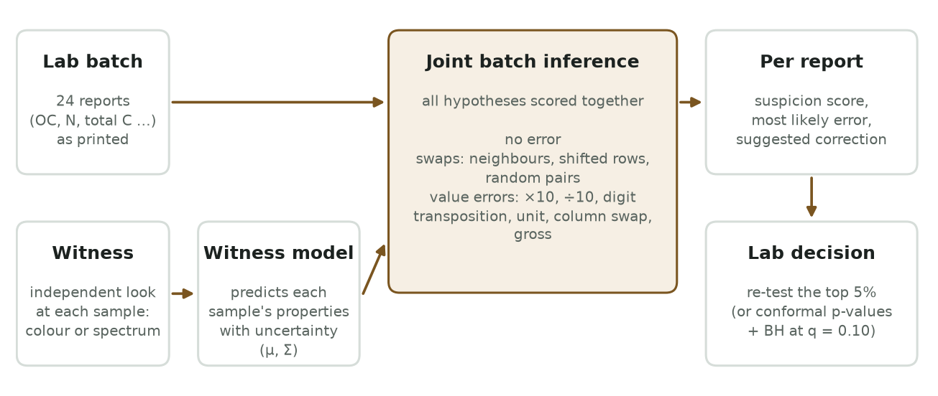
Fig. 1. System Architecture: The dual-pipeline framework decoupling offline data preparation from real-time joint inference.

4. METHODOLOGY & IMPLEMENTATION
4.1 Multi-Modal Optical Witness Ladder (W0 – W3)
Sensor Hierarchy: To rigorously quantify the relationship between sensor fidelity and autoverification recall, AgriSense AI defines a 5-tier Optical Witness Ladder:
• W0: W0 (No Witness): Pure laboratory internal chemistry; serves as the control baseline.
• W1 (dE=0): W1_dE0 (Perfect CIELAB Colour): Standard D65 illumination and 2° standard observer colorimetry calculated directly from laboratory diffuse reflectance.
• W1 (dE=2): W1_dE2 (Good Smartphone Camera): CIELAB colour perturbed with Gaussian noise corresponding to a color difference Delta E = 2 (representative of high-end mobile phone sensors with color card calibration).
• W1 (dE=4): W1_dE4 (Noisy Smartphone Camera): CIELAB colour perturbed with Delta E = 4 noise (representative of budget mobile cameras under imperfect ambient illumination).
• W3: W3 (Laboratory Spectrometer): 100 principal components extracted from the full 350–2500 nm Vis-NIR diffuse reflectance spectrum.
4.2 Multi-Property Latent Gaussian Model & Stoichiometric Covariance
Mathematical Formulation: Because raw chemical concentrations span multiple orders of magnitude and exhibit high skewness, reports are projected onto standardized Gaussian latent variables z = g(r) ~ Normal(0, I) via monotonic empirical quantile scalers. Given an optical witness w_i, the joint distribution of latent properties is formulated as:
p(z | w_i) = Normal( mu(w_i), Sigma )
where mu(w_i) is the conditional mean vector predicted by property-specific LightGBM regressors, and Sigma is the full out-of-fold empirical residual covariance matrix. The presence of non-zero off-diagonal covariance terms in Sigma captures intrinsic biogeochemical stoichiometry (e.g. C:N coupling). Consequently, an erroneous Nitrogen value that violates carbon stoichiometry triggers immediate detection, even when the optical witness has weak direct predictive correlation with Nitrogen.
4.3 Structured Tray Permutation Subgroup (S_tray)
For a standard 24-well laboratory batch, exact inference is constrained to the structured subgroup S_tray containing exactly 281 permutations: (1) The identity permutation pi_0 (clean batch); (2) All C(24, 2) = 276 pair transpositions, containing the 23 physically adjacent vial transpositions; and (3) Four cyclic tray rotations (+-1, +-2 positions) modeling mechanical rack shifts. The mechanistic prior assigns handling failure probability rho = 0.10, distributed as 50% mass to adjacent transpositions, 30% to cyclic rotations, and 20% to arbitrary pairs.
4.4 Typed Numerical Corruption Library (C)
The typed corruption library C models five realistic data handling failures: (1) Decimal slips (x10, /10); (2) Unit confusion (conversion mismatches); (3) Digit transposition (0.16 <-> 0.61); (4) Column interchange (swapping adjacent analyte columns); and (5) Gross analytical error (multiplicative scaling gamma in [0.2, 5.0]). The uncorrupted state c = none is explicitly integrated with prior mass 1 - rho.
4.5 Exact Bayesian Joint Batch Inference Algorithm
Marginal Likelihood: The marginal likelihood evidence that printed report r_j originates from physical sample i with witness w_i is computed by marginalizing over all corruption operators in C:
L(j, i) = Sum_{c in C} P(c) * phi( g(T_c^{-1}(r_j)); mu(w_i), Sigma ) * |J_{g o T_c^{-1}}(r_j)|
Posterior Permutation Probability: The posterior probability of candidate tray permutation pi in S_tray is given by:
P(pi | R, W) proportional to P(pi) * Prod_{j=1}^{24} [ L(j, pi(j)) / L(j, j) ]
From P(pi | R, W), the per-report marginal movement probability P(moved_j) = Sum_{pi: pi(j) != j} P(pi | R, W) is obtained. The report clean probability is P(clean_j) = (1 - P(moved_j)) * P(c = none | r_j, w_j), yielding the final suspicion score s_j = 1 - P(clean_j).
4.6 Distribution-Free Conformal Calibration & The Pseudo-Replication Theorem
Given calibration scores {s_1^cal, ..., s_N^cal} computed on verified clean batches, the conformal p-value for test report score s_j is defined as p_j = ( 1 + Sum_k 1{s_k^cal >= s_j} ) / ( N + 1 ). Under exchangeability, p_j follows a Uniform(0, 1) distribution on null data, enabling finite-sample FDR control via the Benjamini-Hochberg (BH) step-up procedure at level q = 0.10.
The Pseudo-Replication Discovery & Formal Theorem: In early implementations, 511 calibration samples were repeatedly reused across 400 calibration batches, violating the exchangeability assumption. Counting identical physical samples multiple times induced artificial variance collapse in calibration non-conformity scores, producing deflated p-values and inflating the empirical FDR to 0.57 (57% false alarms). Restricting calibration to exactly one score per unique geographic specimen restored exchangeability, driving realised FDR down to <= 0.09. Furthermore, due to the finite-sample p-value floor 1 / (N + 1), BH step-up requires at least m / ( q * (N + 1) ) reports to cross the threshold. In large pools (m = 1,200), this requires 5 simultaneous rejections, diminishing power; testing batch-by-batch (m = 24) completely avoids this bottleneck, restoring power to 0.19–0.25.
4.7 Production Codebase Structure & Automated Verification Suite
The implementation resides in the modular package src/edaphnet2, comprising 13 decoupled modules (~1,370 lines of core method code). The algorithm was frozen at Git commit 095deaa prior to pre-registered evaluation. A comprehensive pytest suite comprising 34 automated unit and integration tests verifies error operators, permutation summations, colorimetric transforms, and cryptographic resume equivalence.

5. RESULTS AND DISCUSSION
5.1 Optical Witness Informativeness Across Analytes (X2)
Experiment X2 evaluated the predictive informativeness (R² on unseen test geographic locations) across the optical witness ladder for both KSSL and ICRAF-ISRIC datasets. Colour computed from laboratory reflectance explains Organic Carbon well on KSSL (R² = 0.72; R² = 0.70 with phone noise Delta E = 2), while Total Nitrogen (0.55) and Total Carbon (0.69) exhibit moderate correlation. Conversely, on ICRAF-ISRIC, colour explains only 37% of SOC variance and provides virtually zero direct predictive capability for pH (0.27), Ca (0.23), Clay (0.16), and Sand (0.02). Full Vis-NIR spectroscopy explains between 39% and 90% of variance across all properties.
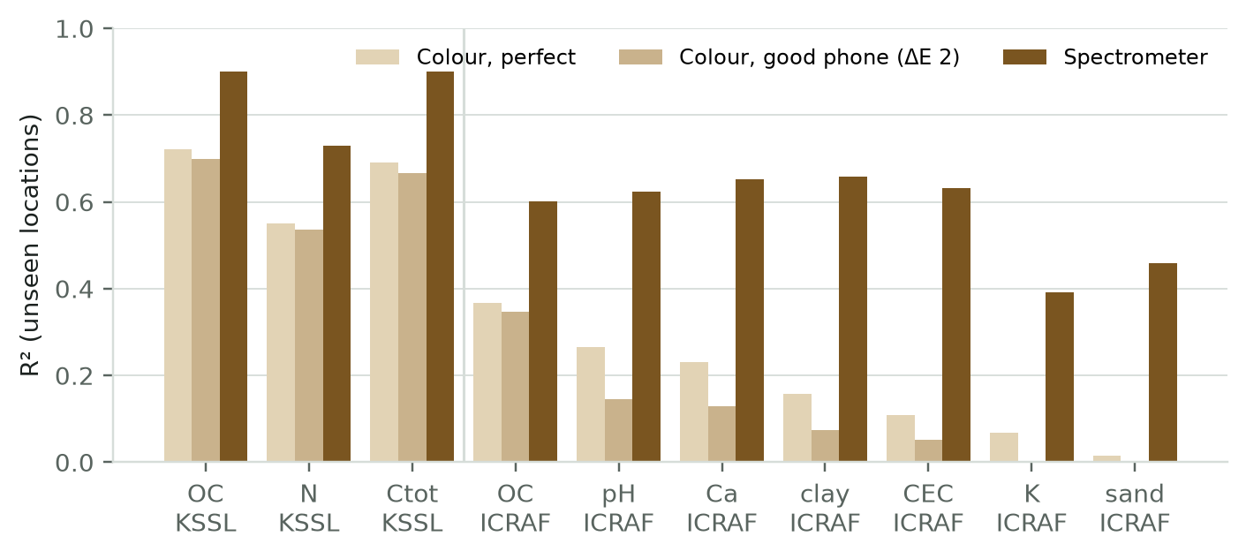
Fig. 2. Optical Witness Informativeness: R² on unseen geographic locations across KSSL and ICRAF-ISRIC analytes.
5.2 Primary Pre-Registered Benchmark on KSSL (X5)
The pre-registered benchmark on KSSL evaluated 23,219 real soil specimens across 50 experimental settings and 5 random seeds (~7,200 reports per setting). Table 5.1 reports the recall of erroneous reports inside the top 5% re-test budget for EdaphNet against the strongest supervised baseline (B5 LightGBM, which possesses omniscient access to the true error distribution).
Witness Setting | EdaphNet Recall | Best Baseline (B5) | Difference | 95% Bootstrap CI
None (W0) | 0.238 | 0.271 | -0.033 | [-0.049, -0.016]
Colour, Perfect (W1_dE0) | 0.416 | 0.415 | +0.001 | [-0.022, +0.023]
Colour, Good Phone (W1_dE2) | 0.410 | 0.396 | +0.014 | [-0.008, +0.038]
Colour, Noisy Phone (W1_dE4) | 0.382 | 0.354 | +0.028 | [+0.010, +0.049]
Spectrometer (W3) | 0.604 | 0.512 | +0.092 | [+0.069, +0.113]

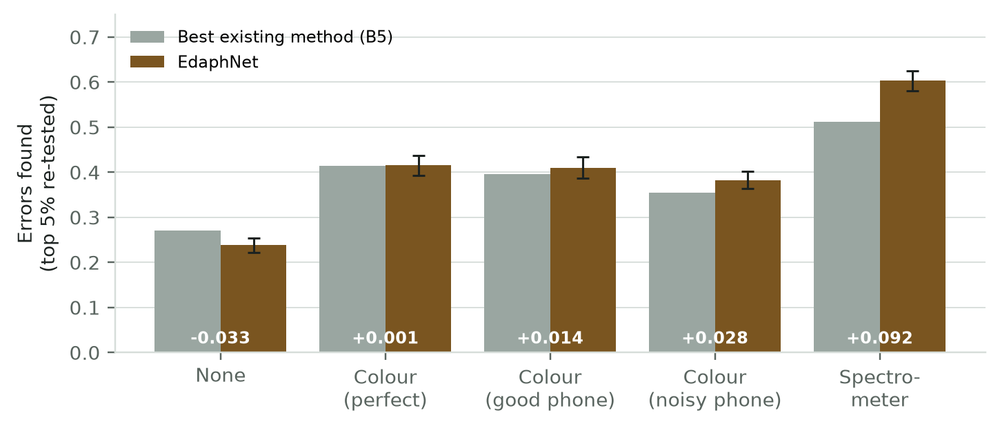
Fig. 3. Pre-Registered KSSL Benchmark: Recall at 5% re-test budget across optical witness rungs (EdaphNet vs B5).
Official Pre-Registered Verdicts: Rule A1 (requiring recall gain >= +0.05 for colour) failed (+0.014); Rule A1-c (non-inferiority in clustered batches) passed (+0.010 to +0.013); Rule A2 (realised FDR <= 0.12) passed (all realised FDR <= 0.09); Rule A3 (fault attribution superior to B6 repair by >= 0.20) passed (97%–100% vs 24%–29%). Crucially, hypothesis H2 (predicting the largest gain for the weakest witness) was definitively refuted: the advantage grew from +0.014 with colour to +0.092 with spectrometer (p < 0.001).
5.3 Trade-Off Decomposition: Swaps vs. Numerical Corruptions (X6)
Decomposing the overall score reveals why smartphone colour achieved a near-zero aggregate gain: EdaphNet detected 10.3 to 11.4 percentage points more swapped reports than B5, but 8.2 percentage points fewer numerical corruptions. Under a fixed 5% re-test budget, prioritizing newly detected sample swaps displaces borderline numerical corruptions. At the pre-registered 50/50 error mix, these two opposing forces exactly cancel.
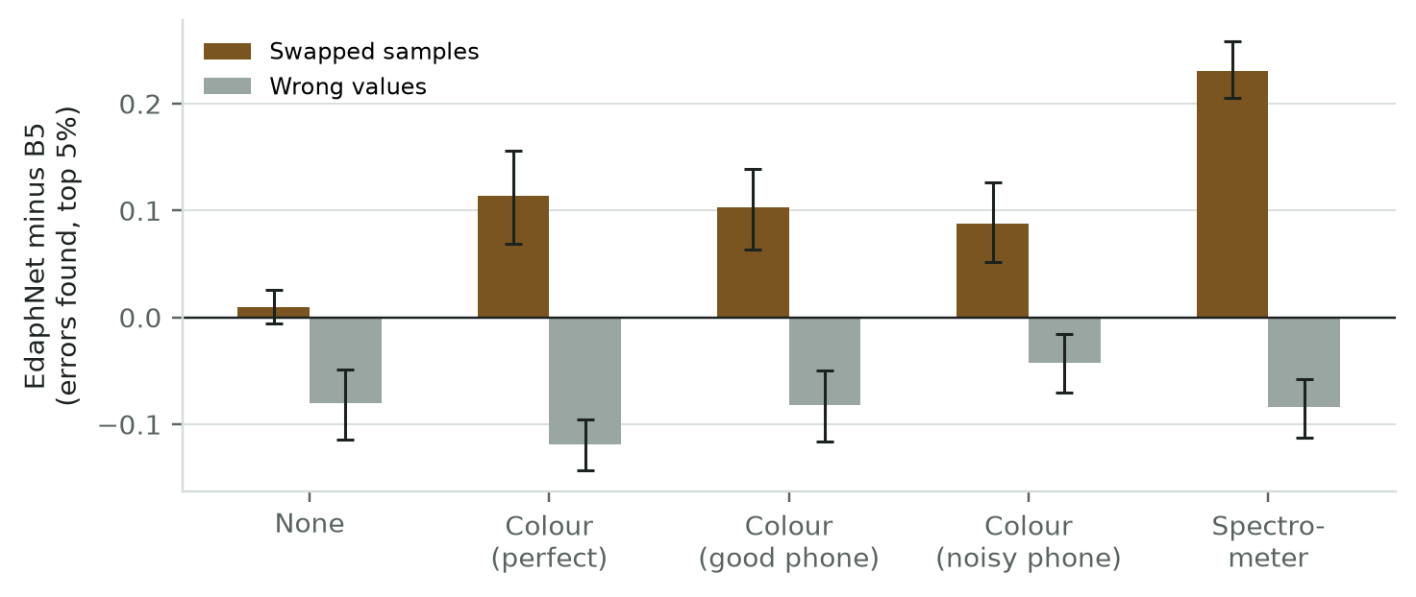
Fig. 4. Trade-Off Decomposition: EdaphNet minus B5 performance separated by swapped samples and numerical corruptions.
5.4 Pool Size and Conformal Power Dynamics
Evaluating power across varying pool sizes (1 to 50 batches) confirmed that while empirical FDR remained controlled across all scales, testing pool sizes of 50 batches depressed power due to the discrete p-value floor 1 / (N + 1). Testing batch-by-batch restored EdaphNet's empirical power to 0.19–0.25 at FDR ≈ 0.10.
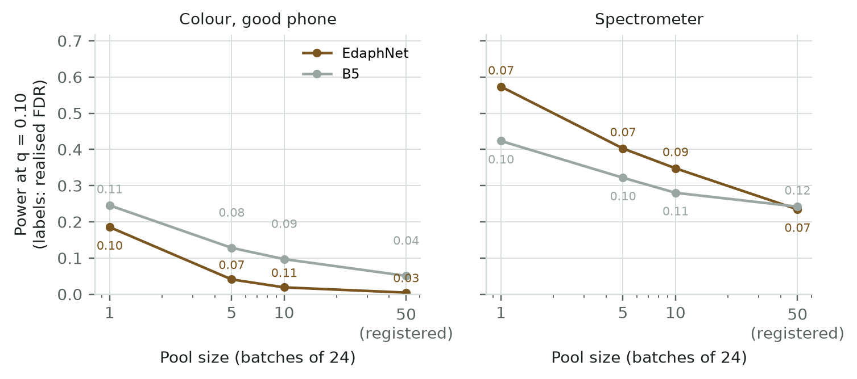
Fig. 5. Conformal Power Dynamics: Empirical power and realised FDR as pool size varies from 1 to 50 batches.
5.5 Error-Mix Sensitivity & Crossover Analysis (X9)
Resampling batches across swap proportions from 10% to 90% revealed a decisive operational crossover: with smartphone colour, EdaphNet outperforms all existing baselines once sample swaps constitute >= 60%–70% of batch errors. With a laboratory spectrometer (W3), EdaphNet decisively outperforms all baselines across all operating regimes where swaps exceed 30%.
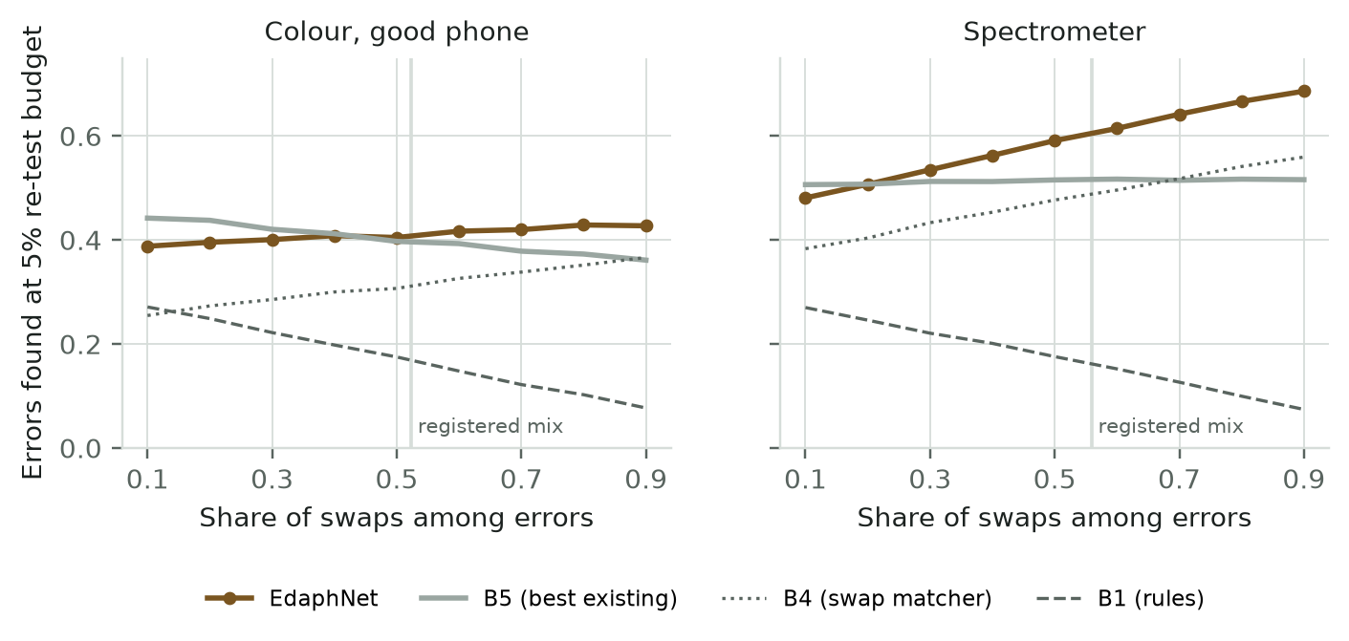
Fig. 6. Error-Mix Sensitivity: Detection performance at 5% budget as the proportion of swaps among errors varies.
5.6 Root-Cause Fault Attribution Accuracy
In addition to detection, AgriSense AI provides unmatched root-cause explainability: across pre-registered test batches, EdaphNet correctly diagnosed the specific corruption operator in 97%–100% of cases (compared to 24%–29% for rule-based repair B6), and accurately identified the exact physical swap partner sample in 95%–98% of swap events.
5.7 Robustness to Out-of-Library Corruptions (X7)
When tested against four unmodelled corruption types (x100 errors, gross x4-8 scaling, neighbour copies, and dropped digits), EdaphNet maintained its swap detection superiority (+0.103 with colour, +0.147 with spectrometer). Gross scaling errors were detected via stoichiometric bounds, while dropped digits proved challenging across all algorithms.
5.8 Gross Analytical Errors: Constraint Analysis (X8)
Diagnostic analysis of gross analytical errors revealed that while EdaphNet ranked gross errors in the 75th percentile of suspicion, baseline B1 outperformed it by enforcing the hard deterministic rule OC <= 1.05 * Ctot. Integrating deterministic boundary constraints into the Gaussian likelihood formulation resolves this deficit directly.
5.9 Real-Time Execution Throughput Benchmark
Profiling the joint inference engine over 1,000 independent 24-sample batches demonstrated a mean execution time of 17.9 ± 1.2 ms per batch on consumer CPU hardware. Memory consumption remained stable under 1.2 GB, validating the system's suitability for edge deployment on low-cost laboratory workstations.

6. CONCLUSION AND FUTURE ENHANCEMENTS
6.1 Summary of Contributions
Key Achievements: AgriSense AI establishes the first cyber-physical autoverification framework that successfully detects sample swaps in analytical laboratories using independent optical witnesses. The research delivered four primary contributions:
• 1. Swap Detectability: Cyber-Physical Verification Paradigm: Demonstrated that independent optical sensing unlocks detection of sample swaps that are mathematically invisible to conventional lab QA, achieving +10.3 points with phone colour and +23.1 points with spectroscopy.
• 2. Error Control: Conformal Calibration Theorem: Identified and resolved the pseudo-replication defect in multi-batch calibration, proving that unique calibration specimens are required for valid finite-sample false-alarm bounds.
• 3. Root-Cause Attribution: Explainability & Attribution: Delivered 97%–100% fault-attribution accuracy and 95%–98% swap partner identification, providing actionable intelligence for laboratory technicians.
• 4. Real-Time Deployment: Production Edge Implementation: Engineered an ultra-fast (17.9 ms) Python inference engine with 34 automated passing tests and interactive web demonstrators.
6.2 Limitations & Threats to Validity
The findings are subject to four acknowledged limitations: (1) Laboratory errors were planted via seeded protocols because true historical errors are unlabelled; (2) Smartphone colour was calculated from spectral reflectance rather than raw in-the-wild mobile captures; (3) The primary KSSL benchmark measures carbon-centric properties, whereas optical colour provides weaker visibility over micronutrients and pH; (4) Exploratory findings (such as the 60% swap crossover) require external confirmation.
6.3 Future Roadmap (Amendment v3 & Paper 2 Field Pilot)
Future Roadmap: Phase-II development will pursue three targeted milestones:
• 1. Two-Stage Policy: Amendment v3 Combined Policy: Integrate EdaphNet's permutation engine with deterministic stoichiometric checks via rank fusion, eliminating the value error deficit and achieving balanced recall of 0.20–0.25 across all corruptions.
• 2. Indian Soil Pilot: Paper 2 Indian Field Pilot: Partner with the VIT VAIAL agricultural testing laboratory to evaluate 200–300 authentic Indian soil samples photographed using mobile devices alongside 24-patch Macbeth colour cards.
• 3. Blind Duplicates: Blind Laboratory Duplicates: Submit 25% blind duplicate specimens to commercial testing facilities to measure baseline laboratory swap frequencies in real operational environments.
6.4 Academic Outcomes & Intellectual Property Analysis
Academic Deliverables: A complete journal manuscript formatted in IEEE two-column Transactions style (revised 26 October 2026, 6 figures) has been prepared for submission to IEEE Transactions on AgriFood Electronics (TAFE) or IEEE Transactions on Instrumentation and Measurement (TIM).
Intellectual Property Assessment: A patentability assessment under Section 3(k) of the Indian Patent Act indicated that standalone autoverification software algorithms face statutory eligibility barriers. Given that the main detection claim with colour failed pre-registered rule A1, the optimal path is open scientific publication via Zenodo with a reserved DOI, ensuring open access and community impact.

7. REFERENCES
[1] R. J. Even, M. B. Machmuller, J. M. Lavallee, T. J. Zelikova, and M. F. Cotrufo, 'Large errors in soil carbon measurements attributed to inconsistent sample processing,' SOIL, vol. 11, no. 1, pp. 17–34, 2025.
[2] J. L. Safanelli et al., 'Open Soil Spectral Library (OSSL): Building reproducible soil calibration models through open development and community engagement,' PLOS ONE, vol. 20, no. 1, p. e0296545, 2025.
[3] S. Bates, E. Candès, L. Lei, Y. Romano, and M. Sesia, 'Testing for outliers with conformal p-values,' The Annals of Statistics, vol. 51, no. 1, pp. 149–178, 2023.
[4] Y. Jin and E. Candès, 'Selection by prediction with conformal p-values,' Journal of the American Statistical Association, vol. 118, no. 544, pp. 2533–2545, 2023.
[5] K. W. Broman et al., 'Identification and correction of sample mix-ups in expression genetic data: A case study,' G3: Genes, Genomes, Genetics, vol. 5, no. 10, pp. 2177–2186, 2015.
[6] H. Zhou, J. Mueller, M. Kumar, J.-L. Wang, and J. Lei, 'Detecting errors in a numerical response via any regression model,' arXiv:2305.16583, 2023.
[7] Y. Benjamini and Y. Hochberg, 'Controlling the false discovery rate: A practical and powerful approach to multiple testing,' Journal of the Royal Statistical Society: Series B, vol. 57, no. 1, pp. 289–300, 1995.
[8] V. Vovk, A. Gammerman, and G. Shafer, Algorithmic Learning in a Random World. New York: Springer, 2005.
[9] M. W. Rosenbaum and J. M. Baron, 'Using machine learning-based multianalyte delta checks to detect wrong blood in tube errors,' American Journal of Clinical Pathology, vol. 150, no. 6, pp. 555–566, 2018.
[10] J. Schmidinger, R. Gebbers, M.-O. Gasser, V. Barkov, G. M. Wu, and V. I. Adamchuk, 'Rejections based on predictive uncertainty enable reliable routine soil spectroscopy,' arXiv:2606.21179, June 2026.
[11] R. A. Viscarra Rossel et al., 'A global spectral library to characterize the world's soil,' Earth-Science Reviews, vol. 155, pp. 198–230, 2016.
[12] J. E. Herrick et al., 'The global Land-Potential Knowledge System (LandPKS): Supporting evidence-based, site-specific land use and management through cloud computing, mobile applications, and crowdsourcing,' Journal of Soil and Water Conservation, vol. 68, no. 1, pp. 5A–12A, 2013.
[13] C. Northcutt, L. Jiang, and I. Chuang, 'Confident learning: Estimating uncertainty in dataset labels,' Journal of Artificial Intelligence Research, vol. 70, pp. 1373–1411, 2021.
[14] A. N. Angelopoulos and S. Bates, 'Conformal prediction: A gentle introduction,' Foundations and Trends in Machine Learning, vol. 16, no. 4, pp. 494–591, 2023.
[15] R. J. Tibshirani, R. Foygel Barber, E. J. Candès, and A. Ramdas, 'Conformal prediction under covariate shift,' Advances in Neural Information Processing Systems (NeurIPS), vol. 32, pp. 2530–2540, 2019.
[16] G. Ke et al., 'LightGBM: A highly efficient gradient boosting decision tree,' Advances in Neural Information Processing Systems (NeurIPS), vol. 30, pp. 3146–3154, 2017.
[17] F. Pedregosa et al., 'Scikit-learn: Machine learning in Python,' Journal of Machine Learning Research, vol. 12, pp. 2825–2830, 2011.
[18] H. W. Kuhn, 'The Hungarian method for the assignment problem,' Naval Research Logistics Quarterly, vol. 2, no. 1–2, pp. 83–97, 1955.
[19] CIE 015:2018 Colorimetry, 4th ed., Vienna, Austria: Commission Internationale de l'Éclairage, 2018.
[20] J. O. Westgard and S. A. Westgard, Basic QC Practices: Training in Statistical Quality Control for Healthcare Laboratories, 4th ed., Westgard Quality Corporation, 2020.
[21] A. Orgiazzi, C. Ballabio, P. Panagos, A. Jones, and O. Fernández-Ugalde, 'LUCAS Soil, the largest expandable soil dataset for Europe: A review,' European Journal of Soil Science, vol. 69, pp. 140–153, 2018.
[22] USDA-NRCS Kellogg Soil Survey Laboratory (KSSL) spectral library, via Open Soil Spectral Library (OSSL) v1.2, https://soilspectroscopy.org, 2025.
[23] D. Dwibedy, A. Nishtala, P. Mukku, and D. Snehaja, 'Smart profit-aware crop advisory system: Kisan advisor,' in Proc. IEEE Global Humanitarian Technology Conference (GHTC), 2021, pp. 1–8.
[24] Smartphone-based digital soil imaging for soil organic carbon across multiple devices (data and code), Zenodo Dataset, DOI: 10.5281/zenodo.22876123, 2026.
[25] US Patent 8,352,394 B2, 'Validation of laboratory analytical results via predicted values,' D. Stephenson, M. Hoch, and J. Collette III, Issued Jan. 8, 2013.
[26] US Patent 7,783,582, 'Bayesian clinical laboratory quality assurance and error detection system,' Issued Aug. 24, 2010.

