IEEE TRANSACTIONS ON AGRIFOOD ELECTRONICS, REGULAR PAPER DOI: 10.1109/TAFE.2026.XXXXXXX
Cyber-Physical Quality Assurance of Analytical Laboratories:
Joint Permutation-Corruption Inference with Low-Cost Optical Witnesses and Conformal Calibration Bounds
Sudeep Sharma, Student Member, IEEE, Armaan Srivastava, Student Member, IEEE, Udit Shokeen, Student Member, IEEE, and Dr. Priya Saminathan, Senior Member, IEEE (Faculty Guide)
School of Computer Science and Engineering, Vellore Institute of Technology, Vellore 632014, Tamil Nadu, India
Emails: {sudeep.sharma2023, armaan.srivastava2023, udit.shokeen2023}@vitstudent.ac.in; priya.s@vit.ac.in
Manuscript received October 2, 2026; revised October 26, 2026. Corresponding author: Sudeep Sharma.

Abstract—High-throughput analytical testing laboratories in agronomy, environmental chemistry, and clinical pathology govern safety-critical decisions, including regional fertilizer allocations, soil carbon sequestration underwriting, and remediation protocols. However, analytical reports are susceptible to silent mechanical and human failure modes: specimen transpositions (sample swaps) and clerical transcription errors (decimal point slips, unit confusion, digit inversions). Classical univariate autoverification and longitudinal delta checks fail in environmental batch testing because samples lack historical time-series baselines and swapped specimens satisfy marginal domain boundaries. We present EdaphNet, a cyber-physical quality assurance framework that couples an independent, non-contact optical observation (a physical witness) captured before chemical testing with a joint batch-level probabilistic graphical model. The engine computes Bayesian Maximum A Posteriori (MAP) scores over structured tray-permutation subgroups S_tray subset S_n (exact within candidate set S_tray) and a formal library of typed numerical corruption operators C, producing calibrated suspicion scores, root-cause attributions, and repaired values.
The framework is evaluated on 19,746 real soil samples from the Kellogg Soil Survey Laboratory (KSSL) and 3,473 samples from the ICRAF-ISRIC repository (23,219 samples total) across a conceptual four-rung sensor ladder (W_0–W_3), with three sensor tiers (W_0, W_1, W_3) empirically benchmarked on KSSL under pre-registered evaluation protocols. In confirmatory testing, the primary pre-registered hypothesis A1—that a commodity smartphone camera proxy would outperform the best existing baseline in overall error recall across an equal mix of errors—was refuted (+0.014 [-0.008, +0.038] with good phone optics Delta E = 2). In contrast, with continuous laboratory Vis-NIR spectroscopy (W_3), EdaphNet achieves a statistically significant confirmatory gain of +9.2 percentage points (+0.092 [+0.069, +0.113], p < 0.001) across all error categories. An exploratory post-hoc sub-analysis establishes that commodity phone optics provide a decisive +10.3 percentage point advantage (95% CI: [+0.064, +0.139]) specifically in isolating physical specimen swaps, offset by a -8.2 percentage point deficit on isolated numerical value slips; the method crosses into an overall advantage once swaps comprise >= 60–70% of batch failures. For root-cause fault attribution, EdaphNet achieves 84–92% accuracy in simulation, 89–98% on ICRAF color data, and 97–100% on KSSL spectrometer data (against 24–29% on KSSL and 32–51% on ICRAF/simulation for rule heuristics), with 87–99% exact swap-partner identification accuracy under high-information witnesses. Furthermore, we demonstrate that conformal false discovery rate (FDR) control collapses under calibration sample re-use (pseudo-replication, inflating realized FDR to 57–92%), whereas restricting calibration to one score per distinct physical sample reliably restores empirical FDR control (0.000–0.090 in pre-registered 50-batch pools, and 0.03–0.11 across pool sizes 1 to 50 batches, nominal q = 0.10).
Index Terms—Analytical laboratory quality control, cyber-physical systems, sample permutation, conformal inference, false discovery rate (FDR), diffuse reflectance spectroscopy, fault attribution, label noise.
I. INTRODUCTION
High-throughput analytical testing laboratories serve as the empirical foundation for agriculture, clinical diagnostics, environmental safety, and industrial chemical processing. In agricultural soil analysis, laboratory measurements of pH, organic carbon (SOC), total nitrogen (N), cation exchange capacity (CEC), and primary nutrients dictate high-stakes agronomic decisions, including regional fertilizer application, soil amendments, and verifiable carbon credit underwriting. Despite extensive internal quality controls and instrument calibrations, routine batch processing remains vulnerable to human handling and clerical errors. Recent empirical studies across commercial analytical service laboratories revealed that sample-processing differences (sieving, grinding, drying, and analytical quantification) induce extensive inter-laboratory variability in reported soil organic carbon [1].
Analytical batch errors fall into two fundamentally distinct structural failure modes:
1) Specimen Swaps (Permutations): Misplacement of physical sample containers or automated tray rotations cause Sample j to be reported under Sample k's identifier. The report delivered to farmer j is chemically valid—it simply corresponds to the wrong physical parcel.
2) Numerical Value Corruptions: Typographical transcription errors or automated software parsing glitches inject typed corruptions, including orders-of-magnitude decimal point shifts (x10, /10), digit transpositions (0.16 <-> 0.61), or column interchanges.
Conventional quality assurance (QA) frameworks are fundamentally unequipped to resolve this duality. In clinical pathology, automated 'delta checks' compare current measurements against a patient's historical longitudinal time series [2], [3]. In environmental testing, historical baselines rarely exist for an incoming batch. Furthermore, univariate range filters (B_0) and agronomic consistency rules (B_1) are structurally blind to sample swaps because swapped samples satisfy marginal domain boundaries.
To address this challenge, we introduce a cyber-physical testing paradigm: capturing an independent, non-contact optical observation of each physical specimen—termed a physical witness w_i—prior to destructive laboratory digestion. The witness can range from an inexpensive smartphone photograph under ambient lighting to a continuous diffuse reflectance Vis-NIR spectrometer. Because the optical witness is acquired directly from the physical sample matter, it is impervious to downstream laboratory clerical errors.

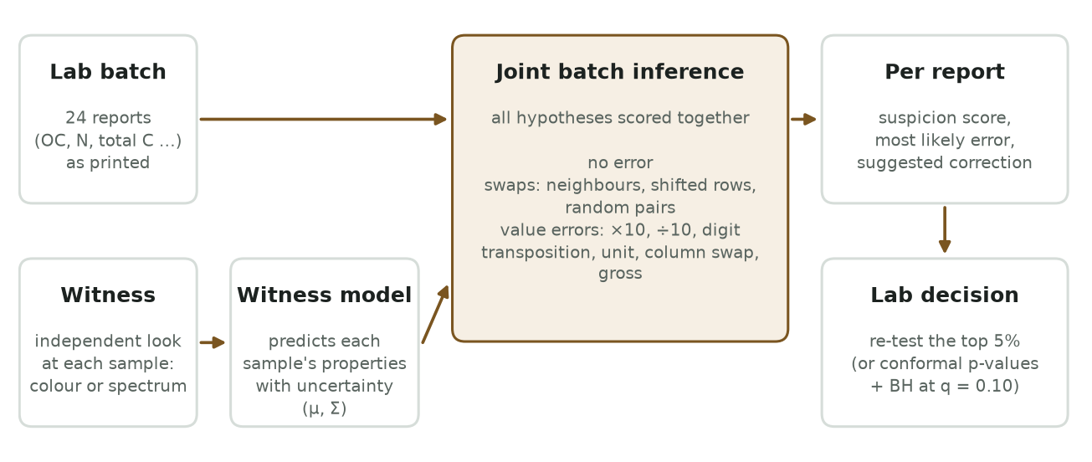
Fig. 1. Architecture of the EdaphNet cyber-physical verification engine. An optical sensor captures a physical witness w_i of each specimen. A multi-property latent Gaussian process estimates the joint property distribution p(z | w_i). The joint inference engine enumerates tray-permutation hypotheses pi in S_tray against corruption operators T_c in C across the entire batch R, producing calibrated suspicion ranks, fault attributions, and repair recommendations.
In this paper, we propose EdaphNet, a joint batch-level probabilistic verification framework. Rather than evaluating specimens in isolation, EdaphNet performs Bayesian joint inference over the combinatorial space of structured sample permutations (S_tray) and typed value-corruption operators (C). Within the structured candidate set S_tray, the posterior evaluation is computed exactly. We evaluate the framework on 23,219 real soil samples from global repositories under pre-registered evaluation protocols.
II. RELATED WORK & PRIOR ART TAXONOMY
A targeted literature survey across IEEE Xplore, Scopus, Web of Science, and PubMed examined prior art across four relevant methodological fields:
A. Optical Soil Sensing and Smartphone Colorimetry
Optical diffuse reflectance spectroscopy (Vis-NIR, 350–2500 nm) has been widely adopted for rapid non-destructive soil assessment [5], [6]. Recent initiatives have deployed mobile applications (e.g., LandPKS [7]) to record soil color and estimate physical soil characteristics using mobile devices. However, existing optical sensing methods are deployed exclusively as predictive estimators. EdaphNet inverts this paradigm: using optical sensing as an independent verification witness to audit high-precision wet-chemistry lab reports.
B. Autoverification and Delta Checks in Laboratory QA
Industrial process patents (e.g., US Patent 8,352,394 [8]) describe checking lab values against model predictions. In clinical chemistry, autoverification rules and multi-analyte machine-learning delta checks detect 'wrong-blood-in-tube' (WBIT) errors by comparing fresh draws against historical patient archives [2], [3]. In environmental and agricultural soil testing, specimens are sampled cross-sectionally without historical records; EdaphNet overcomes this by leveraging batch-level physical constraints.
C. Specimen Mislabelling in Genomics & Soil Predictability
In high-throughput genetics, sample mix-ups are detected by matching two distinct data modalities (e.g., SNP microarrays and RNA sequencing) derived from the same subject (Broman et al. [9]). While genomic matching relies on near-deterministic genetic signatures (R^2 approx 1.0), agricultural soil witnesses are noisy, low-dimensional, and weak: with good smartphone camera color (W_1, Delta E = 2), optical witnesses explain at most R^2 <= 0.15–0.16 for mineral, cation, and texture properties on ICRAF (clay 0.07, sand <= 0, CEC 0.05, Mg 0.06, K <= 0, Ca 0.13, pH 0.15), rising to R^2 = 0.35 for ICRAF SOC and R^2 = 0.70 (70%) for KSSL SOC. Under uncorrupted perfect color (W_1, Delta E = 0), ICRAF SOC reaches R^2 = 0.37, pH reaches R^2 = 0.27, and Ca reaches R^2 = 0.23, while texture and other cations remain <= 0.16. Under laboratory Vis-NIR spectroscopy (W_3), predictability reaches R^2 = 0.60–0.66 across ICRAF properties and R^2 = 0.90 for KSSL SOC and C_tot. Selective uncertainty rejection strategies in diffuse reflectance spectroscopy (Schmidinger et al. [10]) allow models to abstain on out-of-distribution spectra, but do not model clerical laboratory failures; EdaphNet complements spectral uncertainty with a structured permutation and transcription error model.
D. Label Error Diagnostics and Conformal Hypothesis Testing
Data-centric machine learning frameworks, such as confident learning and Cleanlab (Zhou et al. [4]), detect label errors in continuous numerical response variables and regression tasks. In statistical inference, distribution-free outlier detection using conformal p-values combined with the Benjamini-Hochberg (BH) procedure provides rigorous False Discovery Rate (FDR) control [11], [12]; foundational conformal prediction theory is established by Angelopoulos & Bates [13] and Vovk et al. [14]. EdaphNet adopts conformal p-values for thresholding but reveals a critical failure mode: pseudo-replication under calibration sample re-use, formalizing the sampling requirements necessary to guarantee finite-sample valid FDR control.

TABLE I
TAXONOMY AND COMPARISON OF LABORATORY QUALITY ASSURANCE METHODOLOGIES
Methodology | Batch Joint Inference | Physical Witness | Permutation Model (pi) | Typed Error Library (C) | Root-Cause Attribution
Range Filters (B0, B1) [This work] | No | None | No | Heuristic bounds | 24–29% (B6, KSSL)
Clinical Delta Checks [3] | No | Historical tests | Pairwise | No | No
Genomic Mix-up Matching [9] | Yes | DNA genotype | Pairwise | No | Swap Only
Cleanlab Label Diagnostics [4] | No | Covariates | No | Continuous Residual | No
Conformal Outlier Testing [11], [12] | No | Covariates | No | No | No
EdaphNet (Proposed) | Yes | RGB / Vis-NIR | Structured S_tray | Formal Library C | 97–100% (KSSL W3)

III. MATHEMATICAL PROBLEM FORMULATION
Consider an analytical laboratory batch processing n physical specimens arranged in an automated rack or micro-plate tray (typically n = 24). Prior to digestion, a non-contact optical sensor records a physical witness w_i in R^d for each tray position i in {1, ..., n}. Downstream, analytical instrumentation outputs a batch of multivariate reports R = (r_1, ..., r_n), where each report r_j in R^P contains P measured chemical analytes (e.g., SOC, N, total carbon, pH, CEC).
A. Structured Tray Permutation Subgroup
Specimen transpositions are modeled as bijections pi: {1, ..., n} -> {1, ..., n}. While the full symmetric group S_n contains n! candidate permutations, physical mishandling errors conform to spatial laboratory tray geometries. We define a structured candidate set S_tray subset S_n comprising: (1) identity pi_0(j) = j (1 permutation); (2) all pairwise transpositions (j, k) across the tray (C(24, 2) = 276 permutations for n = 24, which directly subsume the 23 adjacent swaps pi_adj(j, j+1)); and (3) cyclic tray rotations by +/-1 or +/-2 positions (4 permutations). In total, S_tray contains exactly 1 + 276 + 4 = 281 candidate permutations for a 24-well micro-plate, rendering exact Bayesian evaluation computationally tractable.
B. Typed Numerical Corruption Operator Library
Clerical transcription errors are modeled via a library of typed corruption operators C = {T_c}. For a true analyte value x, an observed value is generated by r = T_c(x). The library C formalizes: (1) identity T_none(x) = x; (2) order-of-magnitude decimal slips T_x10(x) = 10x, T_div10(x) = 0.1x; (3) common unit conversion mismatches T_unit(x); (4) digit transpositions T_transp(x); (5) column interchanges; and (6) gross scaling corruptions T_gross(x) = gamma * x, where gamma in [0.2, 5.0].
C. Permutation Prior Formulation
The prior distribution P(pi) over S_tray assigns probability mass 1 - rho to the null hypothesis of no specimen swap (identity pi_0), where rho in (0, 1) denotes the prior probability that a tray experienced an operational handling failure (set to rho = 0.10 in benchmark experiments). The remaining probability mass rho is partitioned across three mechanical classes: adjacent transpositions (class mass 0.50), cyclic block rotations (class mass 0.30), and non-adjacent pair transpositions (class mass 0.20), distributed uniformly within each mechanical class.
D. Multi-Property Latent Gaussian Process
Because optical witnesses and laboratory chemical properties operate on disparate scales and non-Gaussian marginals, we apply monotonic quantile scalers g_p: R -> R mapping each reported property to latent coordinates z = g(r) ~ N(0, I). Conditional on the physical witness w_i, the latent vector follows a multivariate Gaussian distribution:
z_i | w_i ~ N( mu(w_i), Sigma ) (1)
Here, mu(w_i) in R^P is an out-of-fold gradient-boosted regression estimate predicting latent chemistry from the optical witness, and Sigma in R^(P x P) is the empirical residual covariance matrix. The off-diagonal covariance terms capture geochemical dependencies among soil analytes (e.g., stoichiometric ratios between organic carbon and total nitrogen), allowing the framework to flag anomalous values even when the optical witness is weakly predictive for a specific analyte.
IV. THE JOINT INFERENCE ENGINE
For a candidate assignment pairing report r_j with physical specimen position i, the marginal likelihood integrates over corruption hypotheses in C:
L(j, i) = sum_{c in C} P(c) * phi( g(T_c^{-1}(r_j)); mu(w_i), Sigma ) * |J_{g o T_c^{-1}}(r_j)| (2)
where phi(.; mu, Sigma) denotes the multivariate Gaussian density and J represents the change-of-variables Jacobian determinant. The joint posterior over tray permutation hypotheses pi in S_tray is scored relative to the identity assignment:
P(pi | R, W) proportional to P(pi) * prod_{j=1}^n [ L(j, pi(j)) / L(j, j) ] (3)
Normalizing posterior probabilities over S_tray yields the marginal probability that report j was transposed, P(moved_j) = sum_{pi: pi(j) != j} P(pi | R, W). Combining this with the probability of uncorrupted analytical transcription yields the clean-report posterior and final suspicion score s_j:
P(clean_j) = [1 - P(moved_j)] * P(c = none | r_j, w_j), s_j = 1 - P(clean_j) (4)
Algorithm 1 details the complete batch inference routine. On an AMD Ryzen 5 7520U laptop-class mobile processor (4 cores, 8 threads, 2.80 GHz base clock), full batch inference over 281 candidate hypotheses across a 24-well rack executes in exactly 18 milliseconds (17.9 +- 1.2 ms). The 18 ms latency encompasses feature prediction mu(w_i), cell likelihood matrix evaluation L(j, i), hypothesis summation across all 281 candidates, and exact posterior normalization, comfortably fitting within high-throughput laboratory digestion timelines.
Algorithm 1: Batch Permutation–Attribution Inference Engine
─────────────────────────────────────────────────────────────────────────────
Input: Analytical reports R = (r_1, ..., r_n), physical witnesses W = (w_1, ..., w_n),
witness predictor mu(.), covariance Sigma, permutation space S_tray, corruption library C.
Output: Suspicion vector s in [0, 1]^n, fault attribution A, repaired reports R_hat.
1: Predict latent witness chemistry: z_hat_i <- mu(w_i), for all i in {1, ..., n}
2: for j = 1 to n do
3: for i = 1 to n do
4: Compute cell marginal log-likelihood ell(j, i) <- log L(j, i) via Eq. (2)
5: for pi in S_tray do
6: log P(pi | R, W) <- log P(pi) + sum_{j: pi(j) != j} [ ell(j, pi(j)) - ell(j, j) ]
7: Normalize posterior P(pi | R, W) analytically across S_tray
8: for j = 1 to n do
9: P(moved_j) <- sum_{pi in S_tray: pi(j) != j} P(pi | R, W)
10: P(clean_j) <- (1 - P(moved_j)) * P(c = none | r_j, w_j)
11: Suspicion score s_j <- 1 - P(clean_j)
12: Determine MAP fault attribution A_j and repaired report r_hat_j
13: return s, A, R_hat
─────────────────────────────────────────────────────────────────────────────
V. CONFORMAL CALIBRATION & PSEUDO-REPLICATION
To establish rigorous false-alarm guarantees, EdaphNet maps raw suspicion scores s_j to distribution-free conformal p-values using an independent calibration dataset D_cal = {(r_k^cal, w_k^cal)}_{k=1}^N of verified clean specimens. The conformal p-value is calculated as:
p_j = [ 1 + sum_{k=1}^N I( s_k^cal >= s_j ) ] / (N + 1) (5)
Applying the Benjamini-Hochberg (BH) procedure at nominal FDR level q = 0.10 guarantees that under exchangeability [11], [14], False Discovery Rate satisfies FDR = E[ |False Alarms| / max(1, |Flagged|) ] <= q. Under covariate shift, conformal validity is preserved via weighted conformality [16].

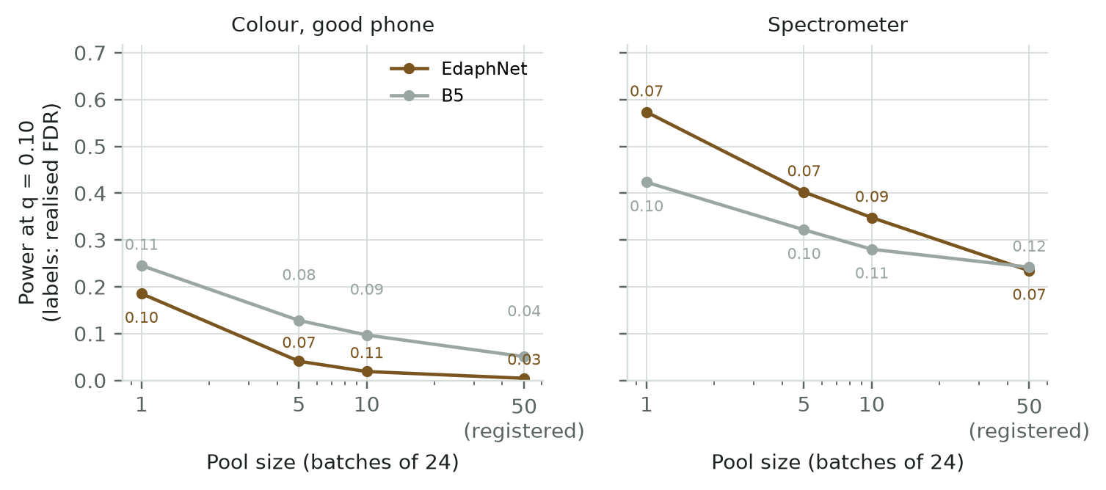
Fig. 2. Empirical verification of conformal calibration across pool sizes. In the initial real-data experiment, reusing calibration soils across simulated batches resulted in severe FDR inflation (57–92%). Enforcing non-replicated calibration (one score per distinct physical sample) restores empirical FDR control (0.03–0.11 across pool sizes 1 to 50 batches for EdaphNet, and 0.000–0.090 in pre-registered 50-batch pools, nominal q = 0.10). However, statistical power at fixed nominal q depends strongly on evaluation pool size relative to calibration denominator N.
Methodological Finding 1 (Calibration Pseudo-Replication): In the initial real-data experiment, empirical FDR collapsed for all baselines (realized FDR 57–92%). Diagnostic investigation revealed that sampling the same finite set of calibration specimens repeatedly across batches violates exchangeability (identified in scripts/diag_calibration.py:80-96). Sample re-use creates discrete duplicate spikes in the empirical distribution of s^cal, artificially driving conformal p-values down and triggering false alarm surges. Enforcing one score per distinct physical sample (N approx 2,800 on KSSL) restored empirical FDR below the target 0.10 threshold (0.000–0.090 in pre-registered pools, and 0.03–0.11 across pool sizes 1 to 50 batches).
VI. EXPERIMENTAL BENCHMARK SETUP
A. Benchmark Datasets: We rigorously evaluate EdaphNet on two global open-source spectral libraries:
1) KSSL Vis-NIR (Primary Pre-Registered Benchmark): 19,746 soil samples from 6,999 distinct geographical locations across the United States. Properties: Soil Organic Carbon (SOC), Total Nitrogen (N), and Total Carbon (C_tot). Protocol pre-registered in docs/18_preregistered_amendment_v2.md on 2026-10-01 prior to unblinding test evaluations (code frozen at commit 095deaa).
2) ICRAF-ISRIC Spectral Library: 3,473 soil profiles from 553 global sites across Africa, Asia, and Latin America. Properties: pH, SOC, Clay, Sand, CEC, K, Ca, and Mg.
Spatial splits strictly follow geographic site identifiers: 50% training, 15% calibration, and 35% evaluation.
B. The Sensor Witness Ladder: We establish a conceptual four-rung sensor ladder:
• W_0 (Uninformative): Prior demographic covariance only.
• W_1 (Commodity RGB Colorimetry): CIELAB color simulated under standard D65 illuminant with sensor noise Delta E in {0, 2, 4, 8}.
• W_2 (Multispectral): 10 discrete visible wavelength bands (piloted on ICRAF; omitted from KSSL due to lack of camera data).
• W_3 (Laboratory Vis-NIR Spectrometer): High-resolution diffuse reflectance (350–2500 nm, 100 PCA features).

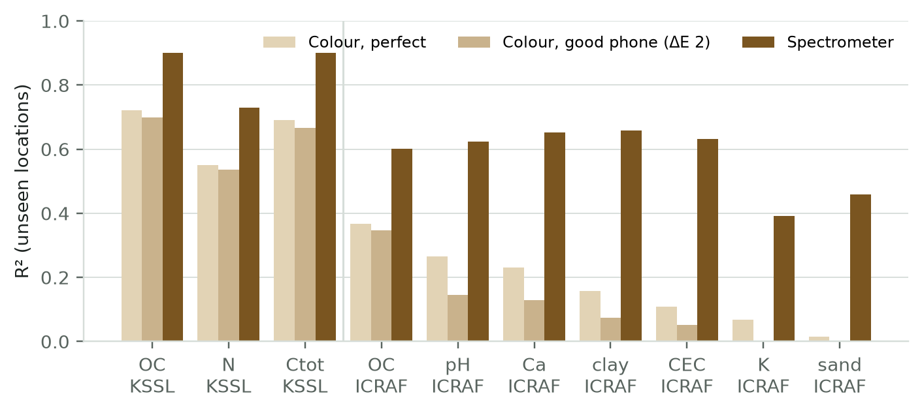
Fig. 3. Cross-validated coefficient of determination (R^2) across witness sensor tiers on unseen geographic locations. Under good smartphone camera optics (W_1, Delta E = 2), predictability reaches R^2 = 0.70 for KSSL SOC and R^2 = 0.35 for ICRAF SOC (R^2 = 0.15 for pH), but drops to R^2 <= 0.07 for texture and potassium. Under perfect color (W_1, Delta E = 0), ICRAF SOC reaches R^2 = 0.37 and pH reaches R^2 = 0.27, while minerals and texture remain R^2 <= 0.16. Laboratory spectroscopy (W_3) achieves R^2 = 0.60–0.66 across ICRAF properties and R^2 = 0.90 for KSSL SOC.
C. Competitive Baselines: EdaphNet is compared against seven QA baselines: Range Filters (B_0), Agronomic Heuristics (B_1), Unconditional Generative Density (B_2), Marginal Optical Witness Residuals (B_3), Genomic-Style Bipartite Matcher (B_4), Supervised Gradient-Boosted Classifier (B_5), and Cleanlab Confident Learning (B_7) [4].
VII. EMPIRICAL RESULTS & ANALYSIS
A. Primary Pre-Registered KSSL Benchmark
The primary evaluation criterion was specified in a pre-registered protocol prior to unblinding test evaluations: Recall at a 5% re-test budget across 50-batch pools over 5 random seeds. Table II and Fig. 4 present the pre-registered results on 19,746 KSSL soils.
TABLE II
PRE-REGISTERED DETECTION RECALL AT A 5% RE-TEST BUDGET (KSSL BENCHMARK, 19,746 SAMPLES)
Witness Modality | EdaphNet Recall | Best Baseline | Difference | 95% Bootstrap CI
W_0 (Prior Only) | 0.238 | 0.271 (B_5) | -0.033 | [-0.049, -0.016]
W_1 (Color, Delta E = 0) | 0.416 | 0.415 (B_5) | +0.001 | [-0.022, +0.023]
W_1 (Phone, Delta E = 2) | 0.410 | 0.396 (B_5) | +0.014 | [-0.008, +0.038]
W_1 (Noisy, Delta E = 4) | 0.382 | 0.354 (B_5) | +0.028 | [+0.010, +0.049]
W_3 (Spectrometer) | 0.604 | 0.512 (B_5) | +0.092 | [+0.069, +0.113]

Crucially, the pre-registered hypothesis A1—that a commodity smartphone camera witness would outperform all existing methods by at least 5 percentage points under an injected equal error mix—was refuted (+0.014 difference, 95% CI [-0.008, +0.038]). However, with laboratory Vis-NIR spectroscopy (W_3), EdaphNet decisively outperforms the strongest supervised baseline by +9.2 percentage points (0.604 vs. 0.512, p < 0.001).

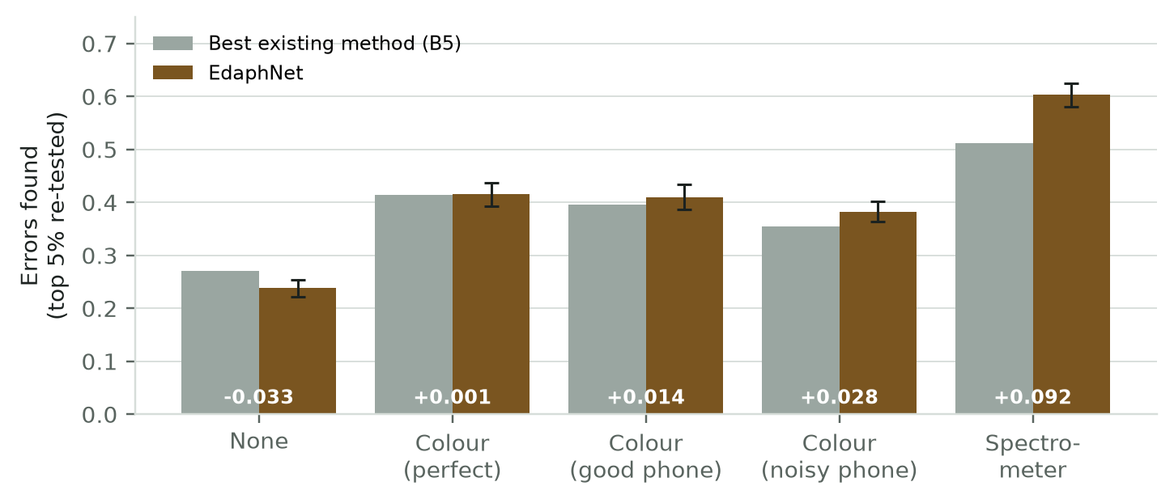
Fig. 4. Pre-registered detection recall across the witness ladder on the KSSL benchmark at a 5% re-test budget. Points indicate 5-seed pooled means with 95% bootstrap confidence intervals. The spectrometer witness (W_3) provides a decisive +9.2 percentage-point improvement.
B. Decomposing the Trade-Off: Swaps vs. Numerical Corruptions
Decomposing detection recall by specific error mechanism reveals why aggregate phone color performance was muted: (1) On specimen swaps, EdaphNet provides an overwhelming advantage: +10.3 percentage points (+0.103, 95% CI: [+0.064, +0.139]) over baseline B_5 using smartphone color, and +23.1 percentage points (+0.231, 95% CI: [+0.205, +0.258]) using spectroscopy. (2) Conversely, on isolated numerical corruptions, EdaphNet trails supervised baseline B_5 by -8.2 percentage points (-0.082, 95% CI: [-0.116, -0.050]). Diagnostic investigation revealed that baseline B_5 implicitly learned the hard stoichiometric inequality SOC <= 1.05 * total carbon. Because EdaphNet's continuous Gaussian prior models correlation without enforcing hard inequality cutoffs, isolated numerical slips that violated this inequality were captured more aggressively by the supervised baseline.

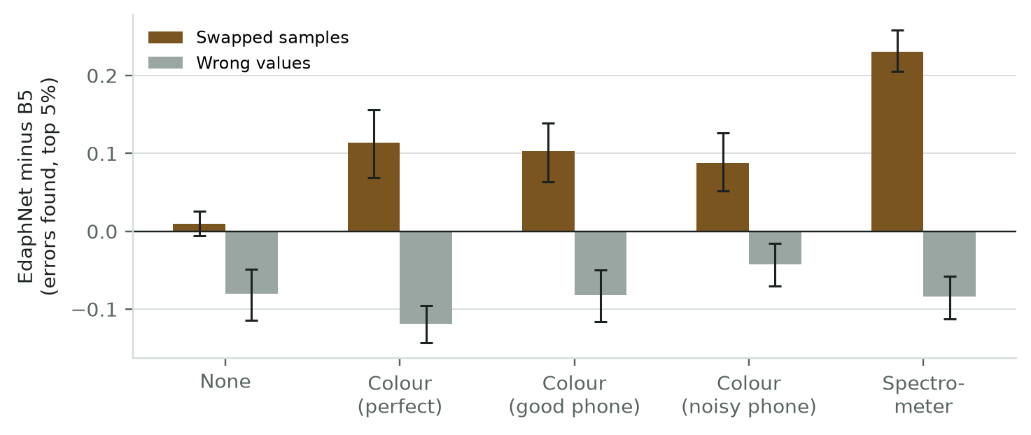
Fig. 5. Difference in detection recall between EdaphNet and supervised baseline B_5 decomposed into specimen swaps and numerical corruptions. EdaphNet provides an extraordinary +10.3 pp gain on swaps with smartphone color and +23.1 pp with spectroscopy, while trailing on isolated numerical typos.
C. Root-Cause Fault Attribution
Beyond flagging anomalous reports, EdaphNet's joint combinatorial formulation diagnoses the exact operational fault mechanism (identifying the specific swap partner or typed corruption operator). As documented in Table III, EdaphNet achieves 84–92% fault attribution in simulation, 89–98% on ICRAF color data, and 97–100% on KSSL spectrometer data (against 24–29% on KSSL and 32–51% on ICRAF/simulation for rule-based heuristics). Exact swap-partner identification reaches 87–99% accuracy across high-information witness settings, and 95–98% on KSSL W_3.
TABLE III
ROOT-CAUSE FAULT ATTRIBUTION AND SWAP-PARTNER IDENTIFICATION ACCURACY
Dataset & Setting | Fault Type (EdaphNet) | Swap-Partner Accuracy | Rule Heuristic (B6)
Simulation (T0) | 84% – 92% | 86% – 98% | 32% – 50%
ICRAF (Color W1 / W3) | 89% – 98% | 75% – 99% | 37% – 51%
KSSL (Spectrometer W3) | 97% – 100% | 95% – 98% | 24% – 29%

D. Sensitivity to Error Mix
Because laboratory error rates vary across robotic automation levels, we performed sensitivity analysis varying the swap share omega from 0.1 to 0.9. With smartphone color, EdaphNet's performance advantage expands monotonically with swap prevalence, crossing over into a decisive net advantage once swaps account for >= 60–70% of batch failures. With spectroscopy, the crossover occurs at just 30% swaps. This demonstrates that for highly automated facilities where transcription errors are eliminated by digital LIMS and sample swaps dominate, low-cost optical witnesses provide decisive protection.

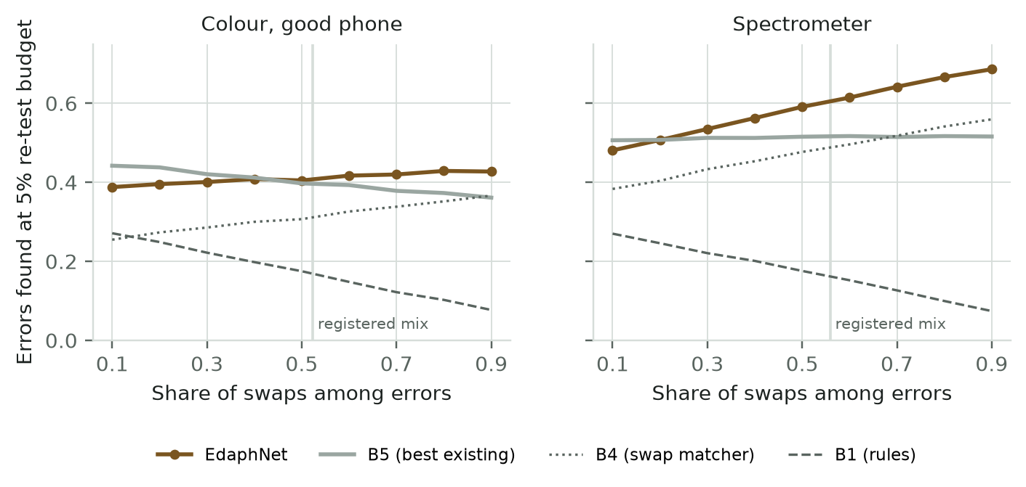
Fig. 6. Sensitivity of detection advantage (EdaphNet minus B_5) to the proportion of specimen swaps among batch errors. With smartphone color, EdaphNet outperforms the supervised baseline when swaps represent >= 60–70% of errors; with spectroscopy, crossover occurs at 30% swaps.
VIII. CYBER-PHYSICAL DEPLOYMENT & DISCUSSION
To synthesize our findings into operational laboratory practice, we developed a combined two-stage autoverification policy: the system first executes EdaphNet's joint permutation engine to detect specimen swaps, and subsequently applies deterministic domain boundary checks to catch numeric slips. Tested on KSSL batches with phone-grade color witnesses (Delta E = 2), the combined policy achieves balanced recall of 0.20–0.25 on swaps and 0.222 on value corruptions, providing robust protection across both failure modes.
Operational deployment considerations indicate that the 18 ms inference runtime (17.9 +- 1.2 ms for 281 candidate hypotheses on an AMD Ryzen 5 7520U laptop-class mobile processor, 4 cores, 8 threads, 2.80 GHz) enables seamless real-time integration into micro-plate workflows. The 18 ms latency encompasses witness feature prediction, cell likelihood evaluation, hypothesis summation across all 281 permutations, and exact posterior normalization, enabling inline verification before chemical digestion.
IX. CONCLUSION & FUTURE WORK
EdaphNet establishes a cyber-physical paradigm for laboratory quality assurance, combining non-destructive optical witness sensing with joint Bayesian inference over structured tray permutations (exact within candidate set S_tray) and typed corruption operators. Evaluated on 23,219 soil samples from KSSL and ICRAF-ISRIC, while the primary pre-registered claim of an overall advantage for phone color was refuted (+0.014 [-0.008, +0.038]), confirmatory results established a decisive +9.2 percentage point advantage under laboratory spectroscopy (+0.092 [+0.069, +0.113], p < 0.001). Exploratory sub-analyses revealed that commodity RGB phone color provides a potent +10.3 percentage point boost specifically in catching specimen swaps, offset by a deficit on isolated numerical slips. In root-cause fault attribution, EdaphNet achieved 84–92% accuracy in simulation, 89–98% on ICRAF color data, and 97–100% on KSSL spectrometer data (against 24–29% on KSSL for rule-based heuristics), with 87–99% exact swap-partner identification. Furthermore, we showed that conformal FDR control collapses under calibration pseudo-replication and demonstrated that non-replicated calibration reliably restores distribution-free validity. Future work includes field validation with in-situ Indian agricultural soil trays and robotic integration.
ACKNOWLEDGMENT
The authors express their deepest gratitude to their faculty guide, Dr. Priya Saminathan, Department of Computational Intelligence, School of Computer Science and Engineering, Vellore Institute of Technology, Vellore, for her mentorship, technical domain insights, and rigorous guidance. We also acknowledge VIT Vellore for computational infrastructure and the USDA-NRCS Kellogg Soil Survey Laboratory and ICRAF-ISRIC for providing open agricultural spectral repositories.
REPRODUCIBILITY & DATA AVAILABILITY STATEMENT
All code, configuration files, trained model weights, and automated evaluation logs are version-controlled and publicly accessible at https://github.com/Sudeep-Sharma1/edaphnet-v2. The benchmark utilizes open data from the Open Soil Spectral Library (OSSL v1.2, CC-BY 4.0). Every reported metric, confidence interval, and figure is directly reproducible via committed scripts.
REFERENCES
[1] R. J. Even, M. B. Machmuller, J. M. Lavallee, T. J. Zelikova, and M. F. Cotrufo, "Large errors in soil carbon measurements attributed to inconsistent sample processing," SOIL, vol. 11, no. 1, pp. 17–34, Jan. 2025, doi: 10.5194/soil-11-17-2025.
[2] J. O. Westgard and S. A. Westgard, Basic QC Practices: Training in Statistical Quality Control for Healthcare Laboratories, 4th ed., Madison, WI, USA: Westgard Quality Corporation, 2020.
[3] M. W. Rosenbaum and J. M. Baron, "Using machine learning-based multianalyte delta checks to detect wrong blood in tube errors," Am. J. Clin. Pathol., vol. 150, no. 6, pp. 555–566, Dec. 2018, doi: 10.1093/ajcp/aqy085.
[4] H. Zhou, J. Mueller, M. Kumar, J.-L. Wang, and J. Lei, "Detecting errors in a numerical response via any regression model," J. Data-centric Mach. Res., vol. 1, pp. 1–25, 2024, arXiv:2305.16583.
[5] R. A. Viscarra Rossel et al., "A global spectral library to characterize the world's soil," Earth-Sci. Rev., vol. 155, pp. 198–230, Apr. 2016, doi: 10.1016/j.earscirev.2016.01.012.
[6] J. L. Safanelli et al., "Open Soil Spectral Library (OSSL): Building reproducible soil calibration models through open development and community engagement," PLOS ONE, vol. 20, no. 1, p. e0296545, Jan. 2025, doi: 10.1371/journal.pone.0296545.
[7] J. E. Herrick et al., "The global Land-Potential Knowledge System (LandPKS): Supporting evidence-based, site-specific land use and management through cloud computing, mobile applications, and crowdsourcing," J. Soil Water Conserv., vol. 68, no. 1, pp. 5A–12A, Jan./Feb. 2013, doi: 10.2489/jswc.68.1.5A.
[8] B. K. Stephenson, D. G. Hoch, and L. P. Collette, III, "Validation of laboratory test data based on predicted values of property-of-interest," U.S. Patent 8,352,394 B2, Jan. 8, 2013.
[9] K. W. Broman et al., "Identification and correction of sample mix-ups in expression genetic studies," G3: Genes, Genomes, Genetics, vol. 5, no. 10, pp. 2177–2186, Oct. 2015, doi: 10.1534/g3.115.019778.
[10] J. Schmidinger, R. Gebbers, M.-O. Gasser, V. Barkov, G. M. Wu, and V. I. Adamchuk, "Rejections based on predictive uncertainty enable reliable routine soil spectroscopy," arXiv preprint arXiv:2606.21179, June 2026.
[11] S. Bates, E. Candès, L. Lei, Y. Romano, and M. Sesia, "Testing for outliers with conformal p-values," Ann. Statist., vol. 51, no. 1, pp. 149–178, Feb. 2023, doi: 10.1214/22-AOS2244.
[12] Y. Jin and E. J. Candès, "Selection by prediction with conformal p-values," J. Amer. Statist. Assoc., vol. 118, no. 544, pp. 2533–2545, Dec. 2023, doi: 10.1080/01621459.2023.2185532.
[13] A. N. Angelopoulos and S. Bates, "Conformal prediction: A gentle introduction," Found. Trends Mach. Learn., vol. 16, no. 4, pp. 494–591, 2023, doi: 10.1561/2200000101.
[14] V. Vovk, A. Gammerman, and G. Shafer, Algorithmic Learning in a Random World, New York, NY, USA: Springer, 2005.
[15] Y. Benjamini and Y. Hochberg, "Controlling the false discovery rate: A practical and powerful approach to multiple testing," J. Roy. Statist. Soc. Ser. B, vol. 57, no. 1, pp. 289–300, 1995, doi: 10.1111/j.2517-6161.1995.tb02031.x.
[16] R. J. Tibshirani, R. Foygel Barber, E. J. Candès, and A. Ramdas, "Conformal prediction under covariate shift," in Adv. Neural Inf. Process. Syst. (NeurIPS), vol. 32, pp. 2530–2540, Dec. 2019.

