**Install and Run the assignment on Local machine.**

* Npm install
* Yarn start
* Open <http://localhost:3000/>

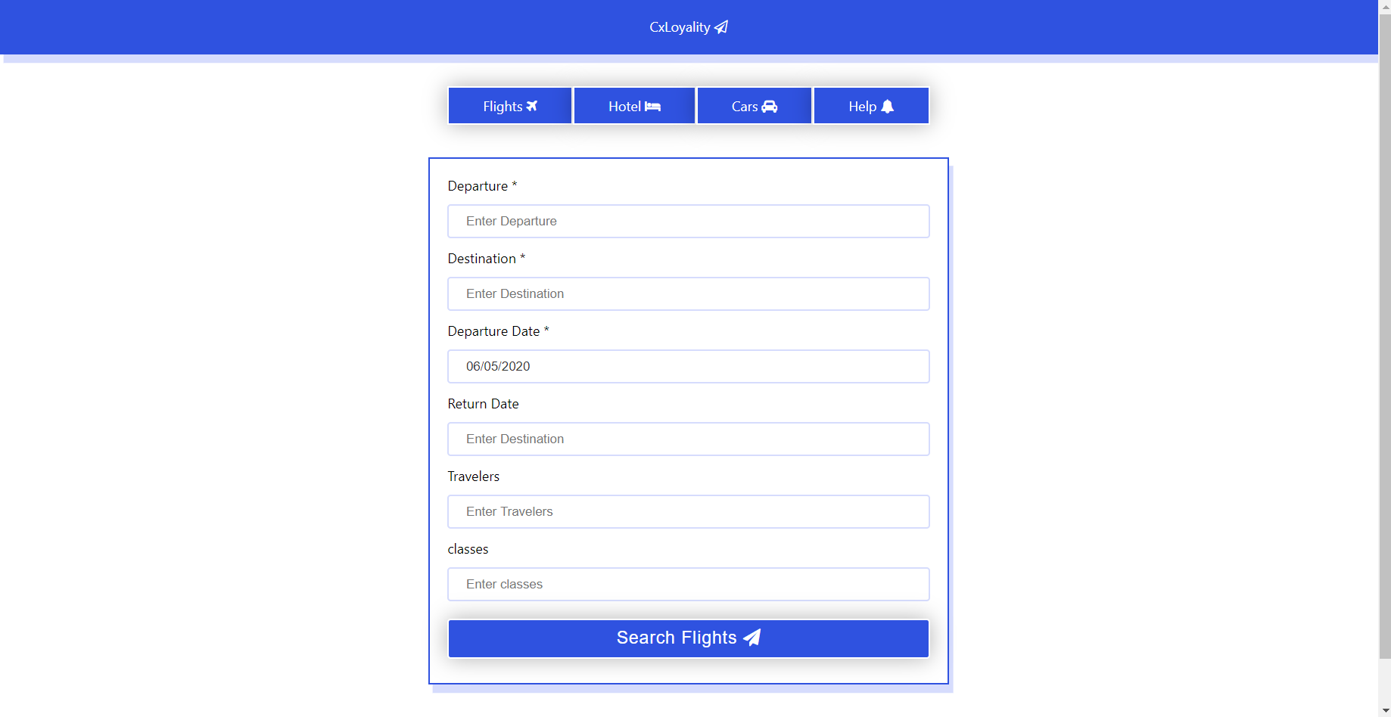

* Add the values in **Departure** and **Destination** with **Date (within 5 days)**.
* For now  **not accepting** the value from **Return date, Travelers, Classes.**
* Tab is implemented without Bootstrap support. (As per requirement / instruction).
* This is **dummy data** so for now only showing flights **Pune to Mumbai & Pune to Nagpur.**
* Once you fill the form and press the search button it will redirect to search result page.
* 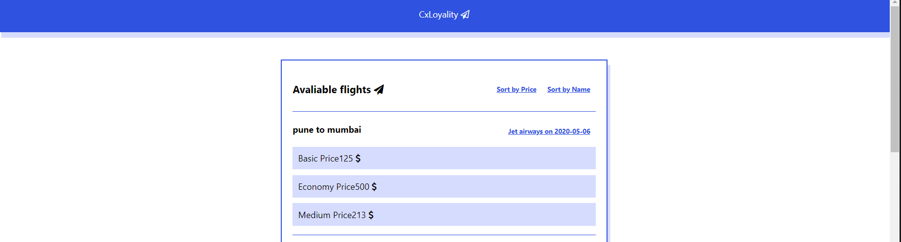
* Now you can see the search result here.
* Two **sort** method implemented **sort by Flight name and Basic Price.**

**Mobile first approach**

Assignment is Built with **Mobile first approach** and its compatible in Mobile, Tablet and Desktop as well.

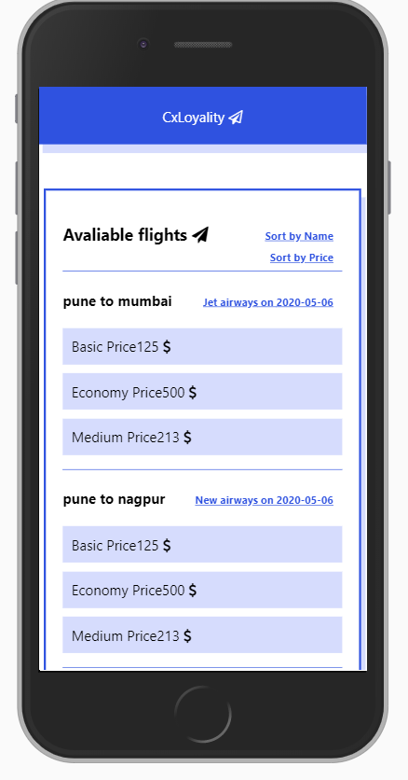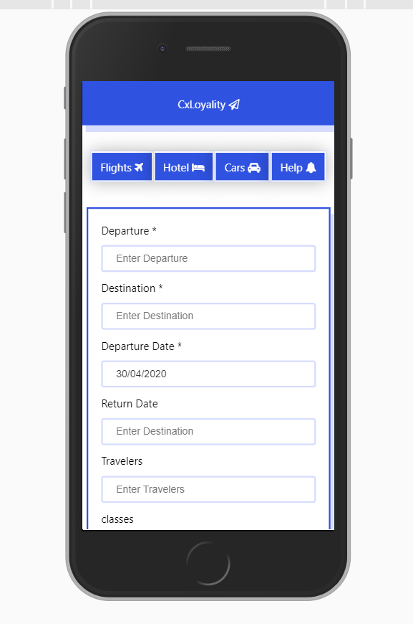 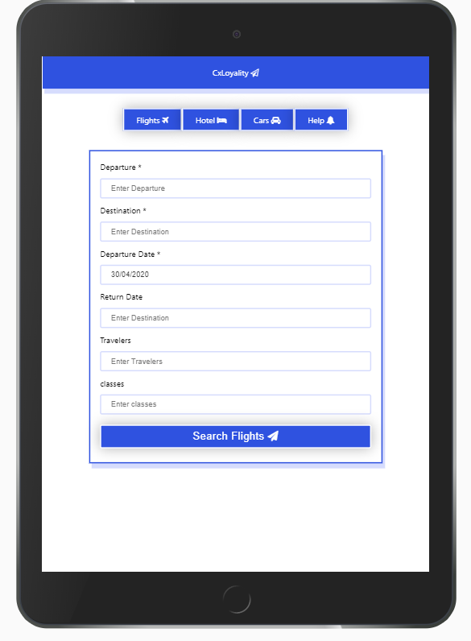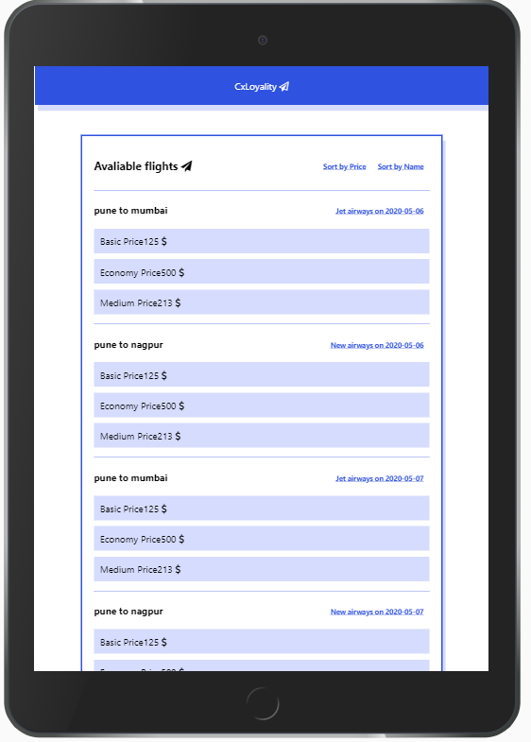

**Technology Used in Assignment.**

**React JS.**

* **Core React JS**
* **Context API for state Management**
* **React Router**
* **React Date picker**

**SCSS / CSS**

**Thank you.**