Gold biorecovery: recovery model review
  - Capture, elution and reduction; evidence, corrections and wiki priorities
6 September 2026
Tier 3, synthesis. Technical review for the recovery modeller and wet-lab team. This report describes the implemented model, its verification and the measurements it still needs. It is not evidence of experimental recovery. Built to RECOVERY.docx. Source documents remain unchanged.

1. Review verdict
The staged approach is useful for iGEM, but its output is a conditional scenario, not yet an accurate prediction of the working process. Conservation, stage interfaces and sensitivity analysis are the right tools. The main defect was treating borrowed kinetics and a passing test suite as stronger evidence than they are. The model is valuable when it shows what needs measuring and which decisions depend on those measurements.
The audit corrected the curve fitter, uncertainty runner, rank handling, low-concentration equilibrium calculation and protein dilution equation. It also withdrew unsupported harvest recommendations and the claim that reduction uncertainty does not matter. The decisions and original conclusions are preserved in ISSUES.md, items 84–89.
Finding | Consequence | Treatment
Reduction kinetics come from different systems and mechanisms | Complete conversion is not established | Keep the nominal case and show the full declared kinetic range
Observed maximum was forced to complete conversion by the fitter | An incomplete trace could give misleading fitted rates | Fit calibrated concentrations without rescaling the maximum
Protein dilution continued at stationary biomass | Reported yield and harvest time were inconsistent with the growth equation | Use actual specific growth; withdraw the old optimum
Sensitivity runner requested a removed stage and mishandled equal ranks | The existing suite missed execution and statistical failures | Add regression checks and correct both paths
Death coefficient had the wrong time dimension | Growth-and-damage capture timing was not defensible | Leave its replacement null; remove that harvest recommendation
The reported final quantity excluded collection and volume changes | “Recovered gold” could imply more than was computed | Report metal formed per initial litre under explicit transfer assumptions

2. Scope and mass balance
The boundary begins with dissolved gold supplied by the leach and ends with gold assigned to the metallic state. Leaching and GolB expression are inputs to this part; physical collection is outside it. Their uncertainties and compatibility still affect whether the process works.
Write the capture efficiency as $η_{c}$, the fraction of captured gold eluted as $η_{e}$, and the fraction of eluate gold reduced as $η_{r}$. Their product is the fraction of feed gold converted to metal:
$$η_{metal}=η_{c}η_{e}η_{r}.$$
This multiplication is valid for amount fractions. The reference calculation assumes equal stage volumes, quantitative transfers and separately supplied protein at the target concentration. If washing or lysate addition changes volume, calculate the next concentration from transferred amount divided by actual volume. Dilution alone cannot create gold or extra binding sites.
The report scenario uses a feed of 29 µM, biomass of 5 g dry weight/L, a wash of 6 h and a reduction batch of 24 h. These are scenario settings in recovery_audit.yaml, not new measurements. The other parameters come from recovery_chain.yaml.
Stage | Gold amount per initial litre | Fraction of the preceding stage
Feed | 29 µmol/L | Reference input
Captured | 0.45497 µmol/L | 1.5689 %
Eluted | 0.36538 µmol/L | 80.3077 %
Metal, reference kinetics | 0.36538 µmol/L | Approximately 100 %
The reference total is 1.2599 % of feed gold. Under the slow corner of both declared kinetic ranges, reduction is only 0.1211 % of the eluate; metal output falls to approximately 0.000443 µmol per initial litre. This is a scenario comparison, not a confidence interval. Unknown chemistry can also fail outside this selected range.
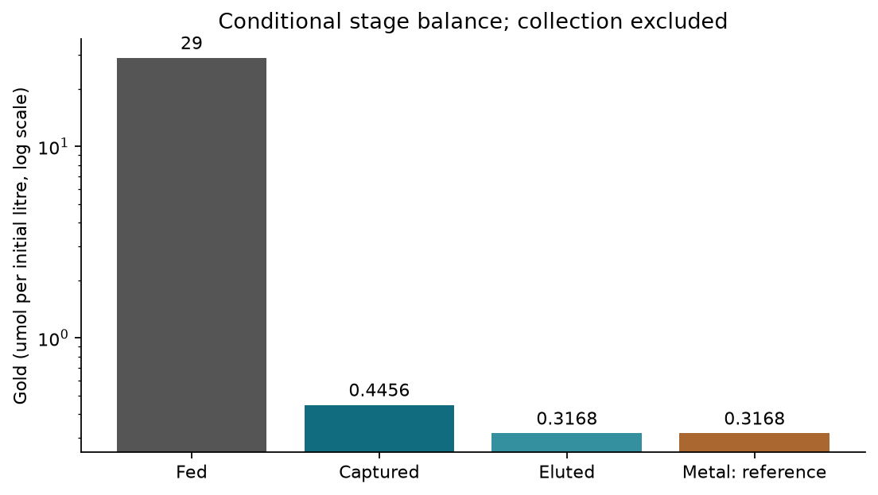
Conditional stage amounts on a logarithmic axis. Reduction uses the reference proxy; collection is excluded.
Every value in this table is reproducible through src/recovery_audit.py::stage_amounts; the plotted grid and inputs are recorded in audit_results.json.

3. Capture: the strongest part of the approach

3.1 Equilibrium is a useful first calculation
Let total gold concentration be $A_{T}$, free gold be $A$, bound gold be $C$, and available site concentration be $S$. The display capacity per dry biomass is $q_{max}$ and biomass is $X$, so $S=q_{max}X$. The apparent dissociation constant is $K_{Au}$. Conservation and the Langmuir isotherm give:
$$A=A_{T}−C, C=\frac{SA}{K_{Au}+A}.$$
Substitution gives a quadratic. For $b=S+K_{Au}+A_{T}$, the physical root is most stably evaluated as:
$$C=\frac{2SA_{T}}{b+\sqrt{(A_{T}−S)^{2}+K_{Au}(K_{Au}+2A_{T}+2S)}}.$$
It conserves gold and never binds more than the site inventory. The rationalised form avoids subtracting nearly equal numbers at very low feed. Zero feed has zero bound gold and a reporting convention of zero captured fraction.
The display cascade is recomputed through Joint 2, rather than copying a site count into the figure. It gives $q_{max}=0.0913135$ µmol/g and $S=0.456568$ µM at the reference biomass. The apparent affinity remains $K_{Au}=0.1$ µM, by the standing decision in ISSUES.md, item 1.
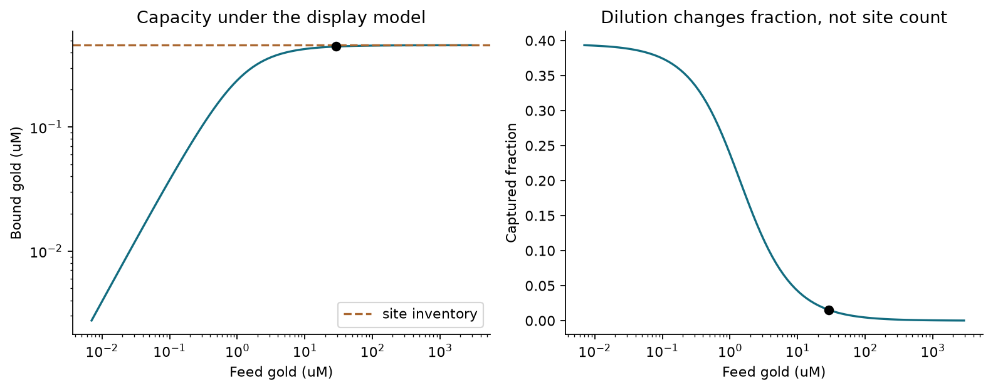
Bound amount and captured fraction tell different stories. The marked point uses the report feed; the dashed ceiling is the modelled site inventory.
At this feed, predicted occupancy is nearly complete and capacity is the constraint within the GolB-only model. Increasing biomass or active display is therefore worth testing. This is not proof that those changes will work proportionally in the real vessel. The capacity is derived, not measured; background cell adsorption is excluded, and surface accessibility, folding, speciation, competition and transport may alter the response. Item 69 records why background adsorption needs a control.
At low feed, the captured fraction approaches $S/(K_{Au}+S)$, rather than necessarily reaching unity. A lower feed improves the fraction but does not establish greater throughput per original volume. A fair dilution comparison must keep gold amount and total biomass accounted for.

3.2 What must be measured before recommending a harvest
The previous growth-and-damage calculation used a death coefficient with units inconsistent with its damage state. Several repairs are dimensionally possible; none is uniquely supported. The replacement remains null. The previously recommended capture harvest time is withdrawn, and its timing plots are not part of this report. See items 73 and 88.
Use binding curves and endpoints for engineered cells, unmodified cells and a cell-free blank, in both simple gold solution and representative leachate. Measure dissolved and cell-associated gold, biomass and viability. This tests capacity, apparent affinity, transport and matrix effects without presuming that loss from solution means GolB binding. Polythionate/copper compatibility remains an upstream-interface concern, especially items 44 and 60.

4. Elution: a provisional first-order release model
Let $C_{0}$ be the gold actually bound at harvest and $ϕ$ the residual fraction that the chosen empirical model never elutes. Let $U$ be the remaining elutable loading. The first-order candidate is:
$$U(0)=(1−ϕ)C_{0}, \frac{dU}{dt}=−k_{elute}U,$$
$$η_{e}=(1−ϕ)(1−e^{−k_{elute}t}).$$
The reference uses $ϕ=0.03$ and $k_{elute}=0.22$ h⁻¹; its 6 h elution releases 71.1 % of bound gold. Both values come from S60 under 0.1 M thiourea, 0.1 M sulfuric acid, 50 °C and 1 g sorbent/L. They are not measurements on GolB.
First order is a provisional simplification, not proof of a molecular mechanism. It avoids making the working rate depend on initial gold loading, but must still be fitted to the project comb under the selected wash chemistry.
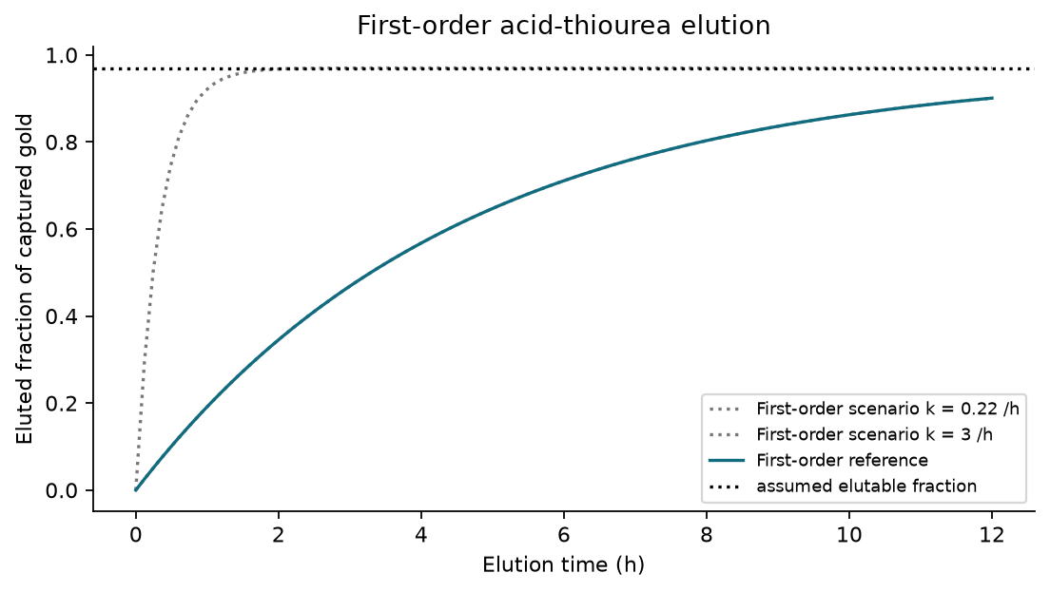
Compare empirical elution laws and rate scenarios. The same numerical rate constant in two different laws is an illustrative comparison, not a common fitted parameter.
The useful communication is that the recoverable fraction and the approach to it answer different questions. For the reference, 95 % of its ceiling requires 13.6 h; waiting cannot exceed that assumed ceiling. However, a flat experimental trace could also reflect reagent depletion, inactivation or measurement limits. It does not by itself establish an irreversible fraction.
Fit first-order and PSO alternatives to the same measured time course using residuals and withheld observations. Repeat at different loadings. Test actual eluate compatibility with the reduction step: improving desorption alone is not necessarily an improvement in total metal formed. The thesis-level mechanistic detail can stay in the technical report; the wiki needs this trade-off, the measured curve when available, and its design consequence.

5. Reduction: the largest unresolved scientific claim

5.1 What the implemented model says
Let dissolved gold be $A$, metallic gold be $B$, reduced protein be $E_{r}$, total protein be $E_{T}$, and dithionite be $R_{d}$. The spent protein is $E_{o}=E_{T}−E_{r}$. Effective nucleation and growth constants are $k_{n}$ and $k_{g}$. The implemented rate and balances are:
$$v=(k_{n}+k_{g}B)A\frac{E_{r}}{E_{T}}, \dot{A}=−v, \dot{B}=v,$$
$$v_{rech}=\frac{k_{rech}E_{o}R_{d}}{1+A/K_{inh}},$$
$${\dot{E}}_{r}=−νv+v_{rech}−k_{ox}E_{r}, {\dot{R}}_{d}=−ν_{rech}v_{rech}.$$
The recharge constant is 0.1 µM⁻¹ h⁻¹ and the inhibition scale is 500 µM. The protein oxidation constant is 0.02 h⁻¹; it does not represent gold reoxidation. The model assumes initially reduced protein. Its disulfide cycle and direct recharge are hypotheses. The methyl-viologen mediator used in the source experiment has no kinetic equation here. See items 49 and 88.
If seed particles are added, conversion counts only newly formed metal:
$$η_{r}=\frac{B(t)−B(0)}{A(0)}.$$
The electron ledger is an upper bound, not a conversion prediction. Under the assumed two-electron protein/dithionite bookkeeping and one electron per Au(I):
$$η_{r}≤min\left(1,\frac{2E_{T}+2R_{d}(0)}{A(0)}\right).$$
Oxygen losses and incomplete availability can reduce what is achieved. The reference protein target is 0.2 g/L, or approximately 2.857 µM, and dithionite is 50 µM. The nominal electron inventory is ample, but does not demonstrate that electrons reach Au(I)-thiourea or that recoverable particles form.

5.2 Why the reference rate is not validation
The source experiment S35 uses the project’s protein with Au(III). The reference $k_{n}=0.96$ h⁻¹ instead borrows an electron-transfer estimate from a different enzyme, MerA, and uses it as particle nucleation. That transfer changes enzyme, precursor, medium and observable. It is not a measured rate for this recovery vessel. The detailed S74 kinetics table was not independently accessible in this audit; the repository’s earlier source record is retained with that limitation.
The code also keeps these effective constants fixed when protein is varied. It therefore does not implement a general enzyme-dose dependence. Claims that increasing protein is useless, or that lowering the protein target is safe, cannot be established from that sweep alone.
For donor excess and no seed, the closed form can check the integration. With $R=k_{g}A(0)/k_{n}$, the time to a fraction $f$ is:
$$t_{f}=\frac{ln((1+fR)/(1−f))}{k_{n}+k_{g}A(0)}.$$
Autocatalytic growth overtakes nucleation only if $R>1$; the exact crossing uses $f=1/R$ in that expression. The shortcut $1/(k_{g}A(0))$ is not the exact crossing time. At the reference proxy the delivered gold reaches 95 % in about 3.1 h under donor excess. That is conditional mathematics, not a validated batch-duration recommendation.

5.3 Show the full range
The declared nucleation range is 5.0e-5–14.0 h⁻¹; the growth range is 0.0032–2.1 µM⁻¹ h⁻¹. These combine different literature/proxy scenarios and are not measured bounds on this protein. Their rectangular combination is a stress test, not an inferred joint distribution.
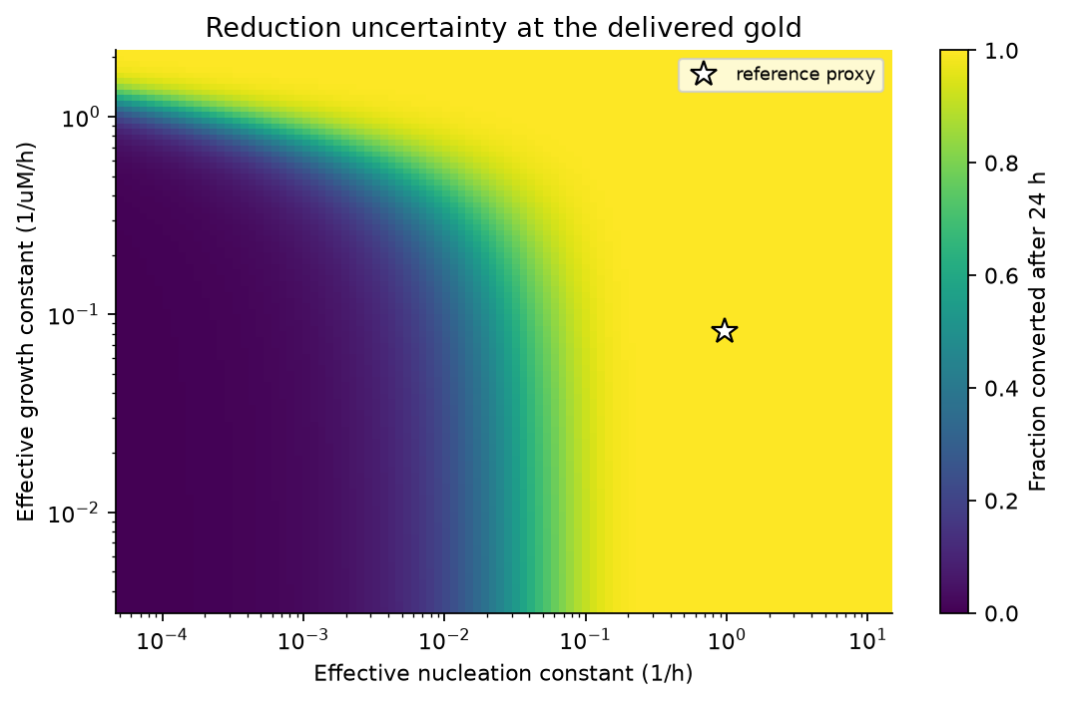
Simulated reduction after the reference batch across both complete YAML kinetic ranges. The reference proxy is marked. Colour indicates conversion, not probability.
The slow corner gives 0.1211 % reduction while the reference is effectively complete. Reduction uncertainty cannot be dismissed. The old tornado sampled a much narrower range around the reference, masking this conclusion. Its generator now reads both full kinetic ranges. One-at-a-time bar lengths still depend on the ranges chosen and cannot be ranked as universal biological importance. A zero effect upstream can also mean that a pathway was omitted, not that it is harmless.

5.4 A valid measurement-and-fitting loop
Measure in the actual Au(I)-thiourea matrix, with blanks that separate direct chemical reduction, protein contribution and matrix effects. Quantify gold remaining in solution and independently assess the metallic product so that adsorption, precipitation and nanoparticle formation are distinguishable. Record an early-time region, the transition if present, and a sufficiently long endpoint. Repeat across initial gold and protein concentrations.
An uncalibrated absorbance trace at a fixed wavelength is not a metal mass balance. Optical response changes as particles grow or aggregate. Use a validated calibration over the relevant particle/medium conditions or pair spectra with quantitative gold measurements and particle characterization S75. The corrected fitter accepts calibrated metal concentration, absolute dissolved gold under justified loss assumptions, or an explicitly calibrated optical signal and measured blank. It never scales the last or largest observation to complete conversion.
Report residuals and parameter correlation, and test prediction on a held-out concentration. The returned covariance errors assume the selected model and noise treatment; they do not include calibration or mechanistic uncertainty. Near a first-order curve, the growth constant may be weakly identifiable even when the optimizer returns a number. A single time course cannot guarantee identification of both constants.

6. Protein production: corrected balance, unresolved calibration
Let biomass be $X$, carrying capacity be $X_{cap}$, and the induced maximum specific growth rate be $μ_{eff}$. Actual specific growth is $g=μ_{eff}(1−X/X_{cap})$. Per-cell transcript and protein counts are $m$ and $p$, transcription/translation parameters are $α,N,β$, and decay constants are $δ_{m},δ_{p}$. With induction indicator $I$:
$$\dot{X}=gX, \dot{m}=αNI−(δ_{m}+g)m,$$
$$\dot{p}=βm−(δ_{p}+g)p.$$
The previous implementation used $μ_{eff}$ in the dilution terms, even when $g$ was zero. The corrected code passes an independent analytic test for a stationary culture. This repair supersedes the old eight-hour harvest and protein-deficit conclusions, item 87.
It does not make the proxy predictive. Continued synthesis after biomass stops growing is uncalibrated. Zero protein decay gives no finite plateau; the upper expression proxy can produce impossible protein fractions. Its old “physical ceiling” was calibrated against the previous equation and is not valid here. Measure growth, soluble active protein over time and its stability before selecting harvest time or concluding the target dose is achievable. The protein-production curve should stay out of the main wiki results until this calibration is available.

7. What belongs on the wiki
Use WIKI_RECOVERY.md as the recovery-only draft. Four figures are enough: the stage balance; capture amount alongside fraction; elution law/ceiling comparison; and reduction across the full kinetic scenario range. After experiments, replace illustrative rate curves with observations, fitted models and a held-out prediction panel. Do not publish historical PRCC values, uncalibrated harvest optima, or a generic “100 % recovery” headline.
The official 2026 Best Model criteria ask about the approach, usefulness, relevant data and example value. This work can demonstrate those through an explicit question, reproducible assumptions, a decision informed by the model, and tests against relevant measurements. The award is a judged assessment; this review cannot certify a medal.
Verification consists of the full test suite, YAML parsing, execution of the notebook, documentation checks and regenerated report figures. The added tests check balances, incomplete synthetic data and the previously broken ensemble. Verification checks the implementation. Validation still requires evidence that these equations describe this chemistry.

