Gold recovery model
  - Capture, elution and donor-coupled reduction
7 September 2026

Purpose and principal result
This model follows dissolved gold through binding to GolB-displaying cells, elution into a separate liquid, and reduction to metallic gold. Its purpose is to identify process constraints, compare explicit operating scenarios, and specify the measurements needed for prediction. The endpoint is new metal formed, before physical collection; neither particle size nor product purity is predicted.
The reference calculation is a single-occupancy GolB-site model, limited primarily by its assumed binding-site inventory. Even complete reduction cannot recover gold that remained in the capture liquid. This site inventory is not a proven ceiling on total whole-cell gold accumulation. A directly relevant surface-GolB study reports additional whole-cell evidence that the earlier review missed; the capture investigation explains the corrected scope and the capacity measurements needed. However, the declared range of reduction kinetics also admits very low conversion within the batch duration. The useful conclusion is therefore conditional: improve and measure capture capacity, while measuring reduction kinetics before relying on a high overall yield.
Quantity | Reference | Slow kinetic scenario
Feed gold | 29 µmol | 29 µmol
Captured gold | 0.445643 µmol | 0.445643 µmol
Eluted gold | 0.316798 µmol | 0.316798 µmol
New metal after the reduction batch | 0.316798 µmol | 0.000383026 µmol
New metal / original feed | 1.092407% | 0.001321%
These are simulated amounts, not measured recoveries. The reference uses a 1 L feed, 1 L capture liquid and 1 L eluate, with protein supplied separately at the specified final concentration and negligible added volume. These volumes are an explicit reporting basis, not a proposed vessel specification. The slow scenario changes both reduction rate constants to the lower ends of their recorded ranges and leaves every other input unchanged.
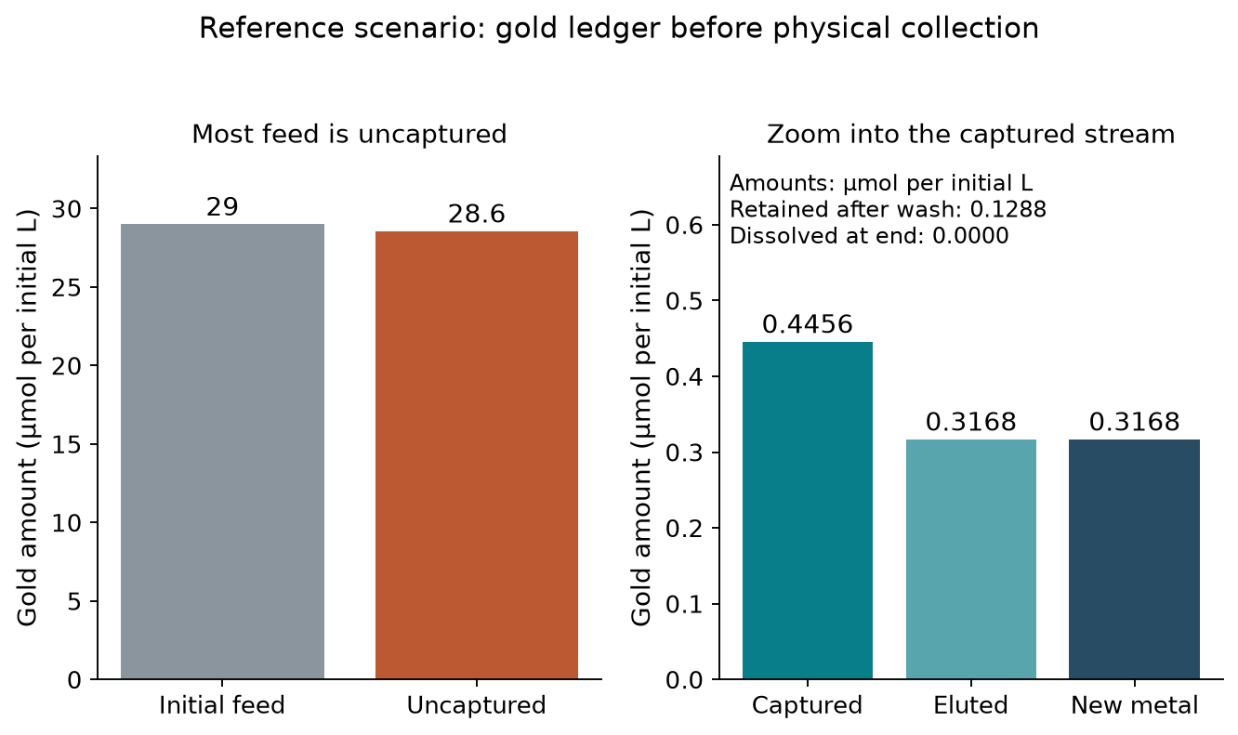
Gold entering and leaving each stage. Amounts share the original feed basis; remaining dissolved gold and uneluted gold are retained in the accounting.

1. Process accounting and capture
The model carries amounts between stages and concentrations within each vessel. Let the feed concentration be $A_{f}$ in µmol/L and its volume be $V_{f}$ in L. The initial gold amount is $n_{f}=A_{f}V_{f}$ in µmol. If the capture volume is $V_{c}$ in L, its total gold concentration is $A_{T}=n_{f}/V_{c}$. A different volume does not itself create or remove gold; any concentration operation represented this way assumes quantitative transfer and has no modelled cost or loss.
The dry capture biomass is $m_{X}$ in g. Its specific binding capacity is $q$ in µmol/g, giving a site concentration $S=qm_{X}/V_{c}$ in µmol/L. The capacity is recomputed from the upstream expression model through the interface function, rather than copied as an independent input. It assumes accessible, functional binding sites and the adopted binding stoichiometry. Expression therefore gives a conditional single-occupancy capacity, not total whole-cell accumulation or proof of activity in real leachate. Whole-cell capacity in the project matrix remains unmeasured; it is represented explicitly by a null parameter.
Let $K_{d}$ be the gold dissociation constant in µmol/L and $C$ the bound gold concentration in µmol/L. Equilibrium binding and conservation require
$$C=\frac{S(A_{T}−C)}{K_{d}+A_{T}−C}.$$
The implemented, numerically stable solution is
$$C=\frac{2SA_{T}}{S+K_{d}+A_{T}+\sqrt{(A_{T}−S)^{2}+K_{d}[K_{d}+2(A_{T}+S)]}}.$$
The captured amount is $n_{c}=CV_{c}$ and the capture fraction is $n_{c}/n_{f}$. The zero-feed case returns zero. This formulation prevents binding more gold than was fed or more than the available sites can hold. In the capacity-limited regime, the bound amount approaches $qm_{X}$; increasing affinity cannot overcome that inventory ceiling. Diluting a fixed feed and fixed biomass is not equivalent to increasing capacity, and may reduce binding by lowering free concentration.
This is an equilibrium calculation. It does not determine capture duration, mass-transfer resistance, growth, death or site damage. In particular, binding in a clean solution cannot establish binding in the upstream sulfur-containing mixture. The unresolved leachate compatibility issue remains material (ISSUES 44); the uncalibrated damage coefficient is not replaced by a guessed timing model.

2. Elution and mixing
Let $f_{r}$ be the fraction of bound gold that remains nonelutable, $k_{e}$ the first-order elution rate in h⁻¹, and $t_{e}$ the wash duration in h. The eluted fraction $η_{e}$ and eluted amount $n_{e}$ in µmol are:
$$η_{e}=(1−f_{r})(1−e^{−k_{e}t_{e}}), n_{e}=n_{c}η_{e}.$$
Its marginal gain is
$$\frac{dη_{e}}{dt_{e}}=(1−f_{r})k_{e}e^{−k_{e}t_{e}}.$$
This separates an assumed chemistry ceiling from the decreasing benefit of additional elution time. The reference elution releases about 71.1% of captured gold after 6 h; the assumed ceiling is 97%. Extending elution cannot overcome that ceiling. A longer elution can be assessed against throughput and measured protein stability, but the model does not assign an economic optimum.
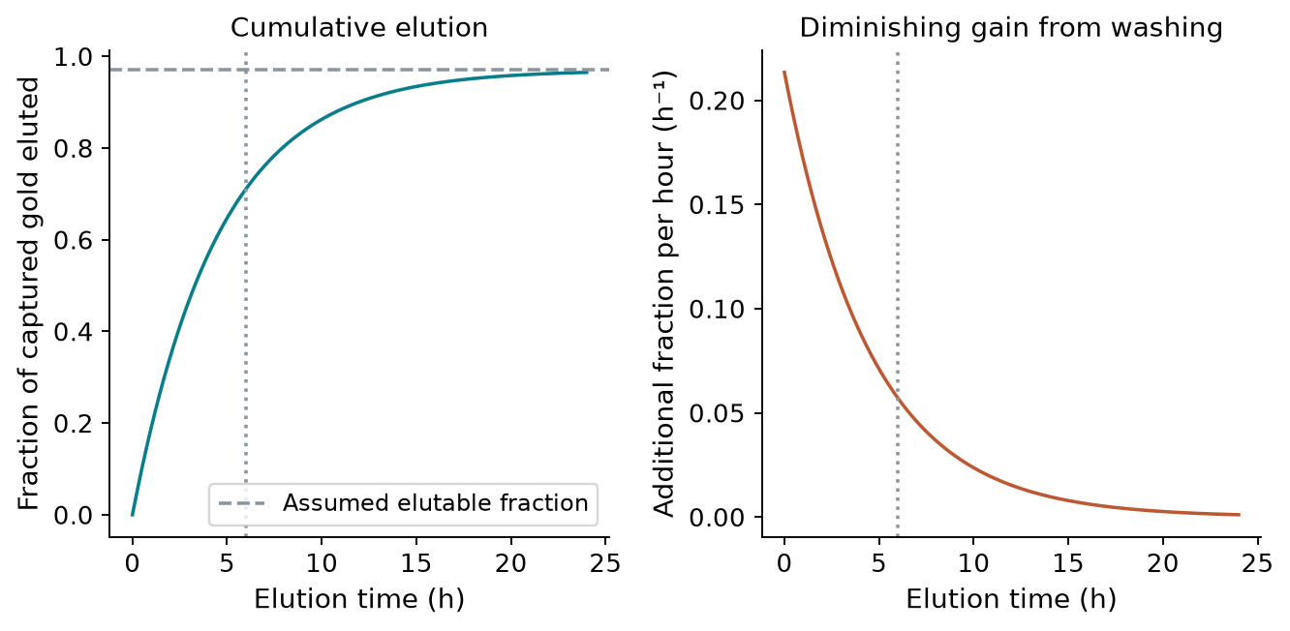
Elution fraction and additional fraction released per hour. The curve is a provisional first-order scenario, not a validated molecular mechanism.
Holding $k_{e}$ fixed while changing biomass, loading, elution chemistry or volume is an untested transfer assumption. The sorption literature motivates this functional form; it does not establish desorption kinetics for GolB cells. Fit competing forms to an actual elution time course before choosing between them (Ho and McKay, 1999; S62).
Let the eluate volume be $V_{e}$ and the added lysate volume be $V_{l}$, both in L. The reduction volume is $V_{r}=V_{e}+V_{l}$ and initial dissolved gold is $A_{0}=n_{e}/V_{r}$ in µmol/L. If protein is supplied by lysate with concentration $E_{l}$ in µmol/L, its final concentration is $E_{T}=E_{l}V_{l}/V_{r}$. The program requires that lysate concentration explicitly. A target protein dose is a separate supply mode; it does not assert that expression and lysis can produce the target. The selected protein concentration is not total lysate protein, and the model currently assumes that the specified protein is redox competent.

3. Reduction: kinetics and reducing-capacity balance
Dissolved gold is $A$, total metallic gold is $B$, reduced protein is $E_{r}$, oxidised protein is $E_{o}$, and recharge donor is $D$, all in µmol/L. Total protein is conserved as $E_{T}=E_{r}+E_{o}$. Time is measured in h. Initial seed metal concentration is $B_{seed}$ and initial donor concentration is $D_{0}$, both in µmol/L. The initial conditions are $A=A_{0}$, $B=B_{seed}$, $D=D_{0}$, and, in the reference, $E_{r}=E_{T}$. A partially reduced initial pool is also supported.
The effective nucleation constant is $k_{n}$ in h⁻¹ and the effective growth constant is $k_{g}$ in L µmol⁻¹ h⁻¹. The dimensionless protein-availability factor is $g_{E}$, defined below. The reaction rate $v$ in µmol L⁻¹ h⁻¹ is
$$v=(k_{n}+k_{g}B)A g_{E}.$$
The two terms describe nucleation and autocatalytic growth. This is a Finke–Watzky-inspired reduced description, not a resolved enzyme mechanism or a particle population model. Its original experimental basis differs from this protein and gold complex (Watzky and Finke, 1997). Metal concentration serves as an effective growth proxy; particle surface area, size and aggregation are not resolved. Seeded predictions consequently require seed-specific calibration.
In the default model, the protein factor is $g_{E}=E_{r}/E_{T}$, with zero reaction when no protein is present. The constants are effective rates held fixed as protein dose changes. A second, explicitly hypothetical option uses $g_{E}=E_{r}/E_{ref}$, where $E_{ref}$ is a fixed reference protein concentration. It assumes both rate terms scale linearly with available reduced protein. The alternatives agree at the reference dose, but need not agree elsewhere. Neither should be used as an established enzyme-dose law.
The protein recharge constant is $k_{c}$ in L µmol⁻¹ h⁻¹, the gold inhibition constant is $K_{i}$ in µmol/L, and the protein oxidation constant is $k_{o}$ in h⁻¹. The recharge rate is
$$v_{c}=\frac{k_{c}E_{o}D}{1+A/K_{i}}.$$
Let $ν$ be protein reducing equivalents consumed per gold atom reduced, and $ρ$ the donor molecules consumed per protein equivalent recharged. The state equations are
$$\dot{A}=−v, \dot{B}=v, {\dot{E}}_{r}=−νv+v_{c}−k_{o}E_{r}, \dot{D}=−ρv_{c}.$$
The reference stoichiometry assumes one two-electron protein equivalent and one two-electron donor equivalent. Thus $ν=0.5$ mol/mol for Au(I) and $ρ=1$ mol/mol. This is bookkeeping based on the proposed redox mechanism, not a measured coupling efficiency. The precursor oxidation state and recharge yield need confirmation. Protein oxidation consumes reducing capacity here; it does not redissolve metallic gold. Direct reduction by dithionite, donor decomposition, irreversible protein inactivation and competing electron sinks are not separately represented.
To check reducing capacity, the model integrates cumulative oxidation loss $L$ in µmol/L of protein equivalents using $\dot{L}=k_{o}E_{r}$. Every trajectory must satisfy the following identities, where $E_{r,0}$ is the initial reduced protein concentration in µmol/L:
$$A+B=A_{0}+B_{seed},$$
$$E_{r}+\frac{D}{ρ}+ν(B−B_{seed})+L=E_{r,0}+\frac{D_{0}}{ρ}.$$
The second identity is an electron balance expressed in protein equivalents. The reduction fraction $η_{r}$ has the rate-independent ceiling
$$η_{r}≤min\left(1,\frac{E_{r,0}+D_{0}/ρ}{νA_{0}}\right).$$
Oxidation can make the attainable conversion lower than this ceiling. Newly formed metal is $(B−B_{seed})V_{r}$, so seed is never counted as product. The solver checks finite states, physical bounds and both balances; it returns the integrated values without clipping an invalid output into the allowed range.

4. Inputs and what supports them
Clear name (existing symbol) | Reference value | Evidence
Feed gold concentration (Au_feed) | 29 µmol/L | Reporting scenario; recovery_audit.yaml
Single-occupancy binding capacity (q_max) | 0.0913135 µmol/g | Derived expression joint; ISSUES 62
Reference biomass concentration (X_max) | 5 g/L | Operating assumption
Gold dissociation constant (K_Au) | 0.7 µmol/L | GolB-based literature proxy; S78, ISSUES 1
Nonelutable fraction (phi) | 0.03 fraction | Transferred assumption; ISSUES 28
First-order elution rate (k_elute) | 0.22 h⁻¹ | Acid-thiourea lower-bound proxy; S60
Elution time (t_elute_h) | 6 h | Reporting time
Effective nucleation rate (k_nuc) | 0.96 h⁻¹ | Cross-system proxy; S74, ISSUES 84
Effective autocatalytic growth rate (k_grow) | 0.082 L µmol⁻¹ h⁻¹ | Cross-system proxy; ISSUES 84
Protein oxidation rate (k_ox) | 0.02 h⁻¹ | Unmeasured assumption
Protein recharge rate (k_rech) | 0.1 L µmol⁻¹ h⁻¹ | Unmeasured assumption
Gold inhibition constant (K_inh) | 500 µmol/L | Unmeasured assumption
Initial recharge donor (Rech_0) | 50 µmol/L | Design choice; S35 gives reagent identity
Final redox-protein concentration (E_tot) | 2.85714 µmol/L | Target dose, not measured supply
Protein equivalents per gold (nu) | 0.5 mol/mol | Proposed two-electron mechanism; S63
Donor per protein recharge (nu_rech) | 1 mol/mol | Assumed coupling; ISSUES 90
Reduction duration (t_reduce_h) | 24 h | Design choice
Nucleation scenario range | 5e-05–14 h⁻¹ | Declared scenarios; not a confidence interval
Growth scenario range | 0.0032–2.1 L µmol⁻¹ h⁻¹ | Declared scenarios; not a confidence interval
Clear names describe each parameter’s role; the existing symbols remain in the parameter files for reproducibility. Those files now include descriptive names, units and evidence notes. The public process interface uses names such as feed_gold_concentration_uM, biomass_mass_g, elution_volume_L, nucleation_rate_per_h and final_protein_concentration_uM.
The nucleation reference is a cross-system enzyme proxy, not a measurement of particle formation by the selected protein. The growth constant is also transferred from other chemistry. Their recorded intervals are scenario ranges, not probability distributions. Calling an input insensitive at one operating point does not establish its value or justify omitting its uncertainty. All primary-source mappings and qualifications are retained in SOURCES.md, especially S35, S39, S62–S75.

5. What the analyses establish
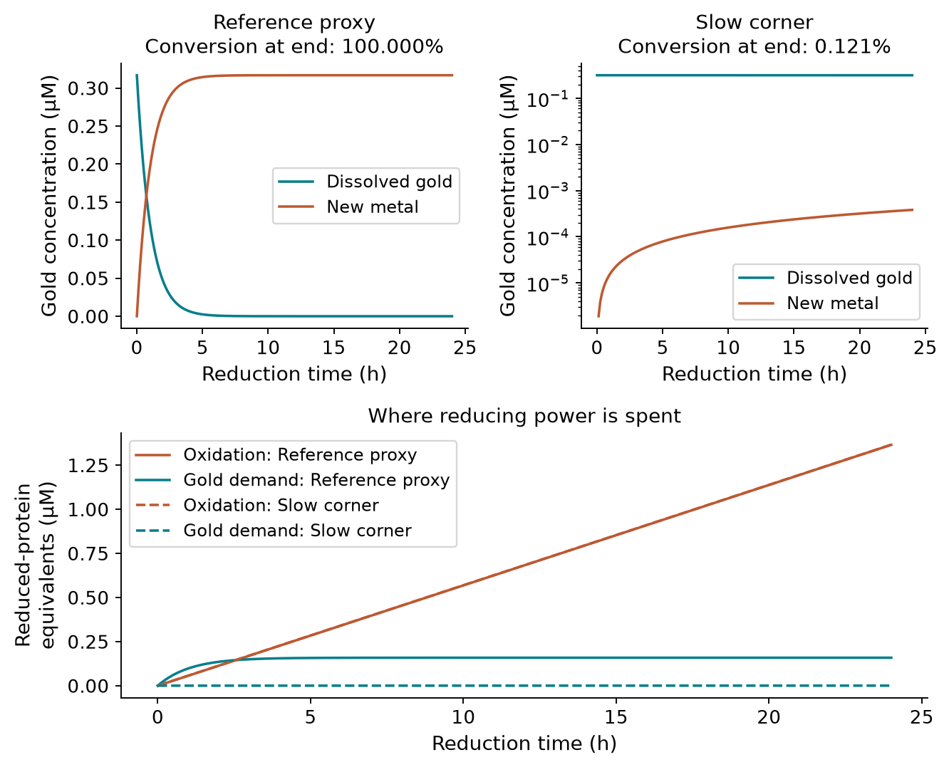
Reference and slow-rate reduction trajectories, including donor use. Different gold conversion scales keep the slow scenario visible.
The reference reaches essentially complete conversion of the small eluate inventory within 24 h. The slow corner converts about 0.121% of that inventory within 24 h. A sufficient donor inventory therefore does not establish a sufficient reaction rate. In the reference trajectory, gold reduction consumes about 0.183 µmol/L of protein reducing equivalents, whereas the assumed oxidation route consumes about 1.37 µmol/L over 24 h. This comparison exposes the consequence of the assumed oxidation constant; it is not a measured loss or evidence for a particular oxygen-control strategy. The full kinetic map shows where that distinction matters while holding feed, protein, donor and batch duration fixed.
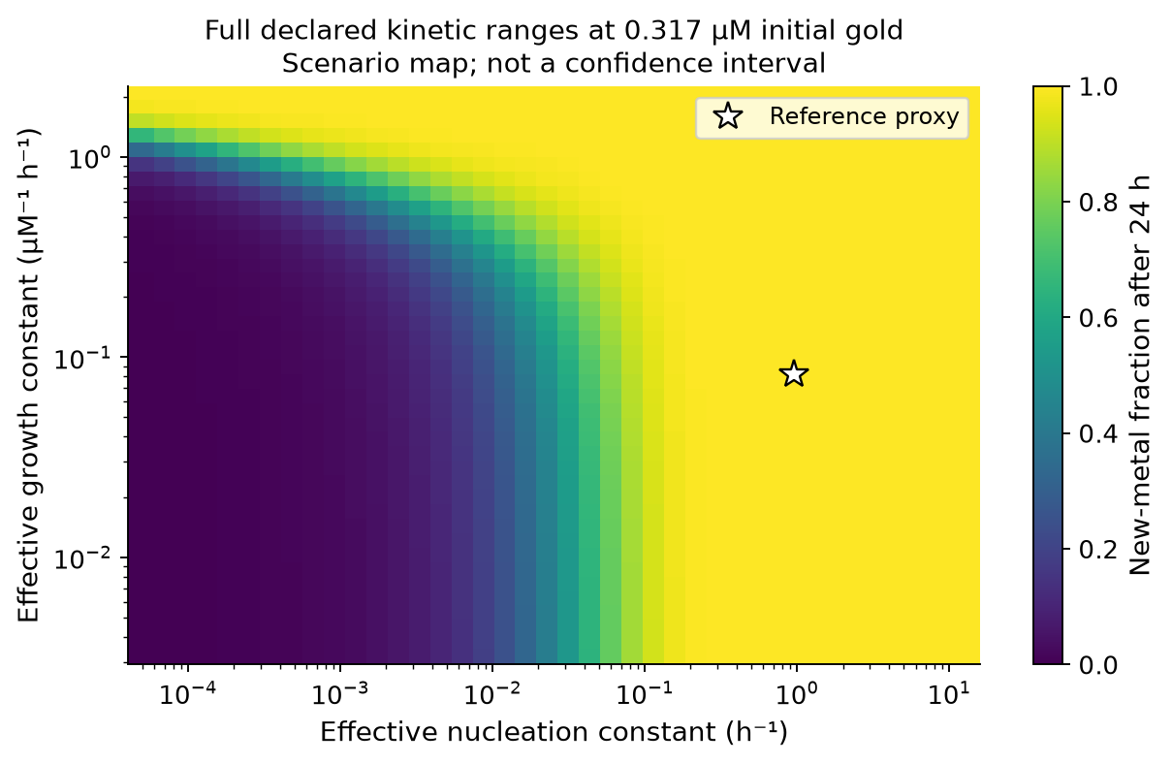
Conversion across the full declared nucleation and growth ranges after the reference batch duration. Colours show conditional conversion, not likelihood or a confidence interval.
At the reference capture capacity, even ideal elution and reduction cannot exceed the captured fraction of the feed. Under the assumed elution ceiling, the achievable amount is lower still. These inventory limits remain useful before kinetics are calibrated. In contrast, an assertion that reduction is always unimportant is contradicted by the slow scenario.
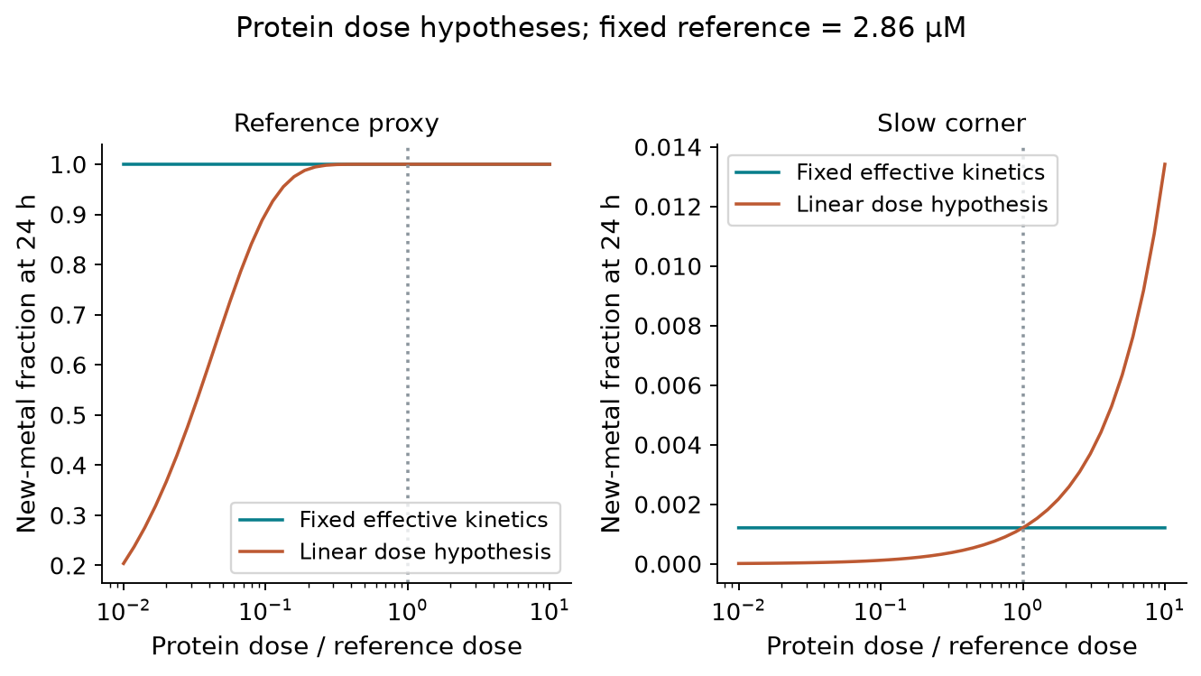
Protein-dose comparison under two explicit rate-scaling assumptions. Dose responses are hypotheses to distinguish experimentally, not recommended doses.
A nearly flat response at a saturated endpoint cannot establish that protein has no kinetic effect. Nor can increasing protein be justified by a simulation that normalises away its rate dependence. The dose comparison makes this structural uncertainty visible. Early time courses at different doses would be more informative than complete-conversion endpoints alone.
The useful design priorities are therefore to measure functional capture capacity in the actual liquid, establish an elution time course, and determine whether the reduction trace is compatible with the assumed kinetic and protein-dose forms. Seed addition and concentrating eluate can then be tested as conditional changes, with added seed and liquid volumes fully accounted for. The model does not yet demonstrate an optimum for either intervention.

6. Calibration, verification and remaining limits
Calibration should measure the same quantities that the equations represent. For capture, quantify feed and remaining soluble gold at known biomass and volume, including a control without displayed binding protein. For elution, measure gold in the wash and remaining with the biomass over time. For reduction, quantify dissolved gold and independently establish metallic product; include protein-free, donor-free and inactive-protein controls to distinguish chemical reduction and nonspecific loss from the proposed protein route.
The existing fitter accepts calibrated absolute concentrations. It never forces the largest observed signal to mean complete conversion. A single optical signal is not automatically metallic gold concentration because particle properties affect extinction (S75). Dissolved-gold disappearance is also insufficient if adsorption or other losses are unaccounted for. The available closed-form fitter assumes donor excess and no seed; traces with substantial donor depletion or seeding require fitting the full trajectory model. Fitted covariance alone does not cover uncertain chemistry or parameter transfer. Reserve independent conditions for prediction checks and examine residuals rather than relying only on a fit score.
Computational verification covers capture inventory limits, very dilute feeds, the independent donor-excess closed form, zero-rate and zero-protein limits, seed subtraction, donor starvation, gold and reducing-capacity conservation, volume changes, lysate dilution and calibrated incomplete-trace fitting. The protein-yield helper also refuses harvest times outside the simulated window. These checks establish implementation consistency, not experimental accuracy.
The implemented model can now support transparent scenario analysis. Its main remaining uncertainties are functional sites in real leachate, elution kinetics, active protein supply, precursor chemistry and reduction-rate transfer. Those uncertainties must stay attached to the results until measurements replace the proxies. The upstream biological feasibility issues remain outside this recovery calculation; a successful downstream simulation does not resolve them.

Reproducibility
The model is implemented in recovery_process.py, recovery_chain.py and reduction.py. Parameter values and scenario volumes live in recovery_chain.yaml, recovery_audit.yaml and recovery_process.yaml. The expression joint is recomputed on every reference run.
Run build_recovery_model.py with --figures to regenerate this report, its numerical tables and figures. The machine-readable figure results are results.json. The earlier recovery review and ISSUES 84–90 preserve the audit trail; this report presents the current model rather than that history.

