Biorecovery
This section explains how the biorecovery model connects the capture comb, gold release and reduction to metallic gold. It uses literature-derived working parameters, and its predictions will be updated with measurements from the project system.

From leaching to biorecovery
The previous stage dissolves gold from printed circuit boards. After the remaining solids are filtered out, the liquid contains dissolved gold and copper. GolB-displaying Escherichia coli are grown on the flat leaves of a branched comb. The comb is dipped into the filtered liquid, removed after capture, washed and transferred to the gold-release stage.
Biorecovery is represented in three steps:
- GolB on the comb captures dissolved gold.
- Acidic thiourea releases the captured gold into a smaller liquid volume.
- A reductase converts dissolved Au(I) into metallic Au(0).

Capturing dissolved gold
Gold enters the stage mainly as gold-thiosulfate. GolB binds metal through the two cysteine sulfur atoms in its Cys-X-X-Cys motif. The capture chemistry is represented by the simplified reaction scheme:
$$Au(S_{2}O_{3})_{2}^{3-}+GolB\text{-}(SH)_{2}⇌Au\text{-}GolB+\text{released thiosulfate}$$
Copper able to bind GolB can occupy the same effective capacity:
$$Cu_{effective}+GolB\text{-}(SH)_{2}⇌Cu\text{-}GolB$$
A capacity occupied by copper is unavailable to gold. The simplified model therefore represents copper as an effective reversible competitor. Permanent damage to GolB is assumed negligible.

Symbols
Symbol | Meaning | Unit
[Au] | Dissolved Au(S₂O₃)₂³⁻ | µM
[Cu_effective] | Copper represented as able to compete with gold | µM
[Au-GolB] | Gold bound to the comb per capture volume | µM
[Cu-GolB] | Copper bound to the comb per capture volume | µM
[S_free] | Unoccupied effective capture capacity | µM
[S_total] | Total effective capture capacity on the comb | µM
q_Au | Gold loading per gram of attached dry biomass | µmol/g
m_X | Dry biomass attached to the comb | g
A_wet | Wetted leaf area, counting both sides | m²
ρ_X | Attached dry biomass per wetted area | g/m²
V_capture | Liquid volume contacted by the comb | L
k_on,Au, k_on,Cu | Association-rate constants | µM⁻¹ h⁻¹
k_off,Au, k_off,Cu | Dissociation-rate constants | h⁻¹
K_Au, K_Cu | Equilibrium dissociation constants | µM

Connecting the comb to capture capacity
At complete surface coverage, the attached biomass is:
$$m_{X}=ρ_{X}A_{wet}$$
The maximum effective gold loading of that biomass is:
$$Q_{Au,comb}=q_{Au}m_{X}$$
The effective capacity used in the concentration model is:
$$[S_{total}]=\frac{Q_{Au,comb}}{V_{capture}}$$
The working literature value is q_Au = 4.62 µmol/g dry cells [S76]. The area therefore controls how much biomass the hardware supports, while q_Au controls the capacity of that biomass.
With ρ_X = 0.212 g/m² and complete coverage, one square metre supplies:
$$4.62 μmol/g×0.212 g/m^{2}=0.979 μmol Au/m^{2}$$

Time-dependent capture model
The gold-binding rate is:
$$r_{Au}=k_{on,Au}[Au][S_{free}]-k_{off,Au}[Au\text{-}GolB]$$
Gold in solution and gold on the comb change together:
$$\frac{d[Au]}{dt}=-r_{Au}$$
$$\frac{d[Au\text{-}GolB]}{dt}=r_{Au}$$
The equivalent copper equations are:
$$r_{Cu}=k_{on,Cu}[Cu_{effective}][S_{free}]-k_{off,Cu}[Cu\text{-}GolB]$$
$$\frac{d[Cu_{effective}]}{dt}=-r_{Cu}$$
$$\frac{d[Cu\text{-}GolB]}{dt}=r_{Cu}$$
Both metals draw from the same capacity:
$$[S_{free}]=[S_{total}]-[Au\text{-}GolB]-[Cu\text{-}GolB]$$
At the start of capture:
$$[Au\text{-}GolB]_{0}=0$$
$$[Cu\text{-}GolB]_{0}=0$$
The main time graph uses the gold-only working model with k_on,Au = 1.0 µM⁻¹ h⁻¹ [S57], K_Au = 0.7 µM [S78] and:
$$k_{off,Au}=K_{Au}k_{on,Au}=0.7 h^{-1}$$
It shows dissolved gold decreasing and captured gold increasing after the comb is dipped.
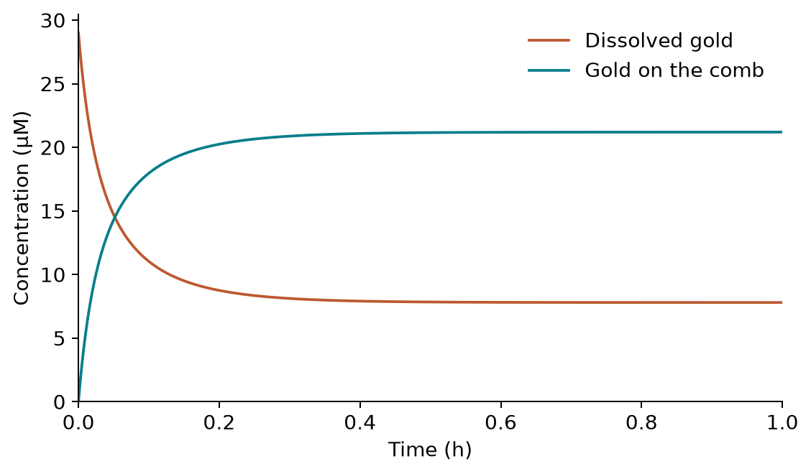
Figure 1. Capture over time. The comb transfers gold from the liquid to GolB until the available capacity approaches equilibrium.
Copper equilibrates in seconds [S80], so no time-varying copper curve is plotted. Copper appears only in the equilibrium competition graph, at different effective competing copper concentrations.

Equilibrium capture
At equilibrium:
$$[Au\text{-}GolB]_{eq}=\frac{[S_{total}]×([Au]_{eq}/K_{Au})}{1+[Au]_{eq}/K_{Au}+[Cu_{effective}]_{eq}/K_{Cu}}$$
$$[Cu\text{-}GolB]_{eq}=\frac{[S_{total}]×([Cu_{effective}]_{eq}/K_{Cu})}{1+[Au]_{eq}/K_{Au}+[Cu_{effective}]_{eq}/K_{Cu}}$$
The free equilibrium concentrations are found from the two balances:
$$[Au]_{0}=[Au]_{eq}+[Au\text{-}GolB]_{eq}$$
$$[Cu_{effective}]_{0}=[Cu_{effective}]_{eq}+[Cu\text{-}GolB]_{eq}$$
The dissociation constants are related to the rate constants by:
$$K_{Au}=k_{off,Au}/k_{on,Au}$$
$$K_{Cu}=k_{off,Cu}/k_{on,Cu}$$
Smaller K means stronger apparent binding. The working selectivity is:
$$α=K_{Cu}/K_{Au}=52$$
Using K_Au = 0.7 µM gives:
$$K_{Cu}=52×0.7 μM=36.4 μM$$

Capture graphs
The stage uses two separate graphs:
- Capture over time. The comb transfers gold from the liquid to GolB until the available capacity approaches equilibrium.
- Capacity against comb area. Increasing wetted area increases capture only until the dissolved-gold inventory becomes limiting.
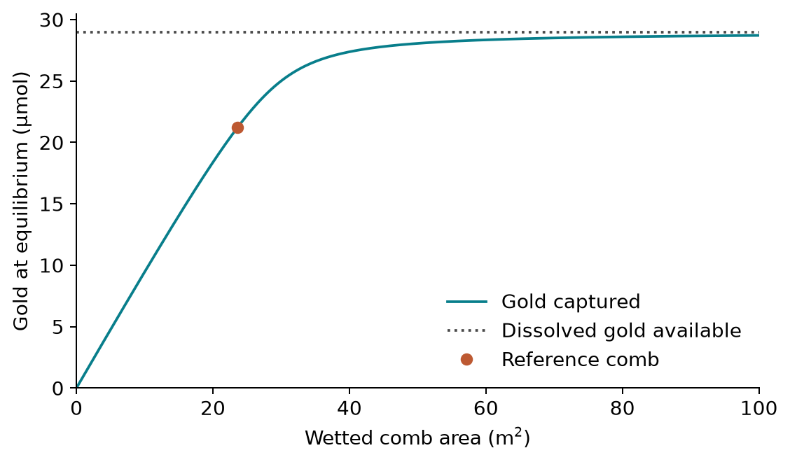
Figure 2. Capacity against comb area. Increasing wetted area increases capture only until the dissolved-gold inventory becomes limiting.
After introducing competition, a third graph shows equilibrium gold capture against [Cu_effective]₀. The main process baseline uses [Cu_effective]₀ = 0 µM because the upstream model predicts Cu(II), rather than competing Cu(I), at the late handoff. The 818 µM case deliberately treats the upstream model’s peak Cu(II) inventory as though it could all compete reversibly. It is therefore an upper-bound stress test, not the expected feed composition Part I result.
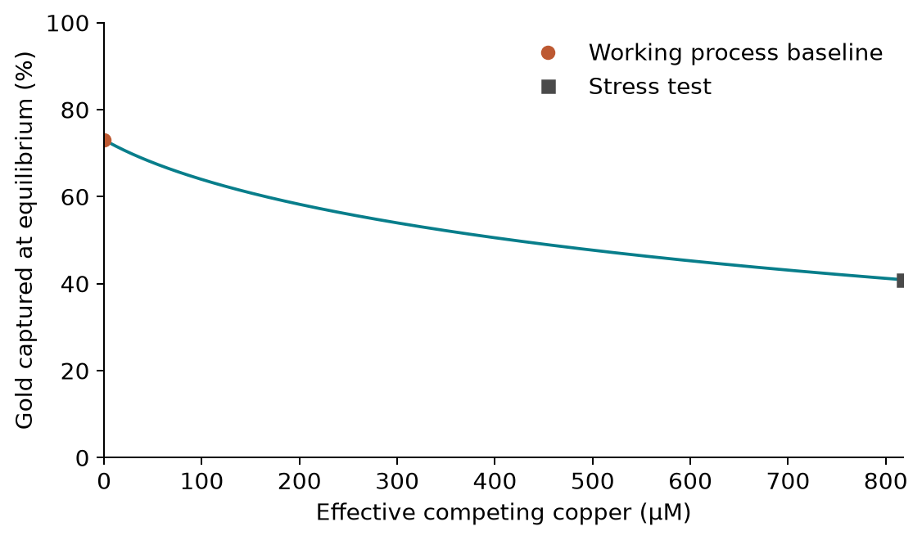
Figure 3. Equilibrium gold capture against [Cu_effective]₀. The 818 µM case is an upper-bound stress test, not the expected feed composition.
For the reference case, the competition model gives:
Case | Gold captured at equilibrium | Interpretation
No effective competing copper | 73.10% | Working process baseline
818 µM effective competing copper | 40.91% | Deliberately conservative stress test

Comb growth and area
Before capture, attached biomass can be described by logistic growth:
$$\frac{dm_{X}}{dt}=μ_{att}m_{X}\left(1-\frac{m_{X}}{m_{X,max}}\right)$$
$$m_{X}(t)=\frac{m_{X,max}}{1+\frac{m_{X,max}-m_{X,0}}{m_{X,0}}e^{-μ_{att}t}}$$
$$m_{X,max}=ρ_{X}A_{wet}$$
The working geometric value ρ_X = 0.212 g/m² represents one complete cell layer. It is derived from a 2.0 µm²/cell footprint and 2.36 × 10¹² cells/g dry weight. Both sides of every wetted leaf count toward A_wet.
For example, supporting 5 g of dry biomass as one complete layer requires:
$$A_{wet}=5 g/0.212 g/m^{2}=23.6 m^{2}$$
At q_Au = 4.62 µmol/g, that biomass has a working gold capacity of:
$$Q_{Au,comb}=4.62 μmol/g×5 g=23.1 μmol$$
This equation shows the expected shape of attached growth, but it does not yet predict clock time because m_X,0 and μ_att have not been measured. The current numerical model starts from a fully colonised comb and uses the area-defined capacity. A timed growth graph should be added only after those two measurements are available.

Competition calculation
The reference example uses 29 µM dissolved gold, [S_total] = 23.1 µM, K_Au = 0.7 µM and K_Cu = 36.4 µM.
Solving the two metal balances with these values gives 73.10% capture when [Cu_effective]₀ = 0 µM and 40.91% capture in the 818 µM stress test.

Capture assumptions
# | Assumption | Why it is used | Consequence if it is wrong
1 | The liquid is well mixed and its volume is constant. | This keeps the model to binding rather than fluid transport. | Poor mixing makes the predicted capture time too short.
2 | One completely covered cell layer supplies ρ_X = 0.212 g/m². | It connects comb geometry to biomass before hardware measurements exist. | Capacity changes in direct proportion to the true attached biomass density.
3 | q_Au = 4.62 µmol/g transfers to the project comb. | It is the closest whole-cell GolB loading measurement [S76]. | Every predicted comb capacity changes in direct proportion to the measured project value.
4 | Gold and effective copper bind one shared class of sites reversibly. | It gives the smallest model that represents competition. | Multiple site classes or irreversible binding change the competition curve.
5 | Permanent GolB damage is negligible. | No project measurement currently quantifies it. | Site damage would lower [S_total] and make both capture scenarios optimistic.
6 | The working baseline contains no effective competing copper. | The upstream late-handoff copper is modelled as Cu(II), not Cu(I). | Residual competing copper moves the result from the baseline toward the stress-test curve.
7 | The GolS gold/copper selectivity transfers to GolB, giving K_Cu = α K_Au = 36.4 µM. | No matched GolB gold/copper measurement exists, and GolS is the closest matched experiment [S79]. | A different true GolB selectivity moves the whole competition curve, and with it the 40.91% stress-test result.
8 | Effective copper competition reaches equilibrium within the capture contact. | Cu(I) binding to related Cys-X-X-Cys proteins is complete in seconds [S80], while the contact lasts hours. | If copper binds slowly, early capture would retain more gold than the equilibrium competition graph shows.
The cost of assumptions 2 and 3 is especially direct: their product sets the capacity per square metre. They should therefore be replaced first.

Obtaining capture parameters and proposed experiments
K_Au = 0.7 µM comes from soluble GolB, while α = 52 comes from a matched GolS gold/copper response [S78–S79]. The project should measure:
- Attached dry biomass per unit wetted area and its growth over time.
- Gold remaining in the liquid and gold retained by the comb over time.
- A gold-loading isotherm in the filtered project liquid.
- Gold capture with and without copper under the same solution conditions.
- Gold and copper lost during washing.

Transferring captured gold between stages
The model passes amounts, rather than concentrations, between vessels. Gold retained after washing is:
$$n_{Au,bound}=V_{capture}[Au\text{-}GolB]_{pre\text{-}elution}$$
Gold transferred into the eluate is:
$$n_{Au,eluted}=η_{Au,elute}n_{Au,bound}$$
The reduction volume contains the eluate and the reductase preparation:
$$V_{reduction}=V_{elution}+V_{reductase}$$
The starting gold concentration for reduction is:
$$[Au(I)\text{-}TU]_{0}=\frac{n_{Au,eluted}}{V_{reduction}}$$
This amount ledger prevents a concentration from one vessel being copied directly into a vessel with a different volume.

Releasing gold from the comb
After capture, the comb is removed and washed. Acidic thiourea then transfers the retained gold into solution:
$$Au\text{-}GolB+2 TU→[Au(TU)_{2}]^{+}+GolB$$
TU is thiourea. The forward arrow shows that rebinding is neglected while thiourea is in excess.

Symbols
Symbol | Meaning | Unit
[Au-GolB]₀ | Gold on the comb at the start of elution | µM
[Au-GolB]_elutable | Gold that can still be released | µM
[Au-GolB]_remaining | Total gold remaining on the comb | µM
f_Au,res | Fraction remaining after complete elution | dimensionless
k_elute | First-order release rate | h⁻¹
η_Au,elute | Fraction of starting comb gold released | dimensionless

Elution model
Initially:
$$[Au\text{-}GolB]_{elutable,0}=(1-f_{Au,res})[Au\text{-}GolB]_{0}$$
The elutable gold follows first-order release:
$$\frac{d[Au\text{-}GolB]_{elutable}}{dt}=-k_{elute}[Au\text{-}GolB]_{elutable}$$
$$[Au\text{-}GolB]_{elutable}(t)=(1-f_{Au,res})[Au\text{-}GolB]_{0}e^{-k_{elute}t}$$
Total gold remaining on the comb is:
$$[Au\text{-}GolB]_{remaining}(t)=f_{Au,res}[Au\text{-}GolB]_{0}+[Au\text{-}GolB]_{elutable}(t)$$
The fraction released into the eluate is:
$$η_{Au,elute}(t)=(1-f_{Au,res})(1-e^{-k_{elute}t})$$
Elution graph finding. Gold release is fastest at the start and slows as the elutable pool is depleted. At six hours the working model has transferred 71.1% of the pre-elution gold to the eluate. The remaining and released curves sum to 100%, which provides a visual mass-balance check.
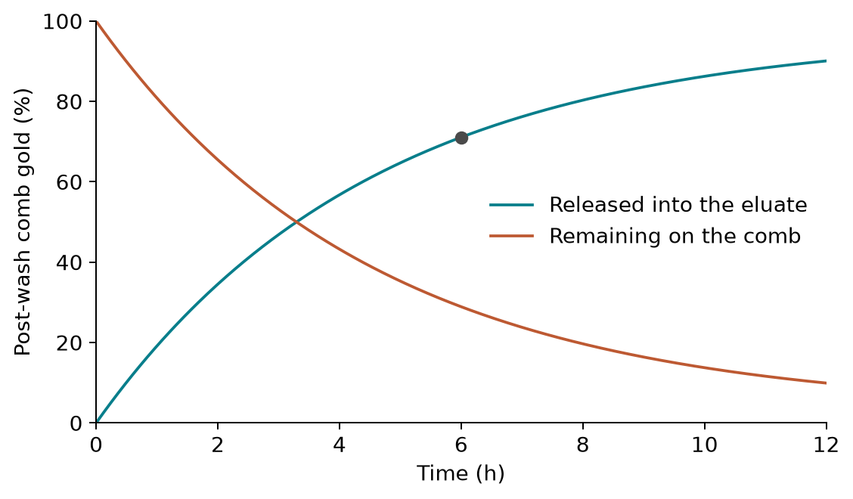
Figure 4. Gold release is fastest at the start and slows as the elutable pool is depleted. At six hours the working model has transferred 71.1% of the pre-elution gold to the eluate.

Elution parameters, evidence and experiment
The working condition comes entirely from one acid-thiourea study [S60]:
Quantity | Working value
Thiourea | 0.1 M
Sulfuric acid | 0.1 M
Temperature | 50 °C
Sorbent-to-liquid ratio | 1 g/L
f_Au,res | 0.03
k_elute | 0.22 h⁻¹
S60 reports more than 90% release at 12 hours and up to 97% overall. The first-order fit to those two numbers gives:
$$k_{elute}=-ln(1-0.90/0.97)/12 h=0.22 h^{-1}$$

Reducing dissolved gold to metal
The eluate carries gold as soluble gold(I)-thiourea. In a separate reagent arm, reductase-producing cells are grown and induced, and the reductase preparation is mixed with the eluate. This mixing sets both the starting gold concentration and the reductase concentration.

Producing the reductase
The reductase is produced inside E. coli. Its available quantity therefore depends on culture growth and protein expression before the cells are lysed. Let X_R be reductase-producing dry biomass, m*_R be a translation-weighted transcript state and p_R be reductase molecules per cell. The three expression constants cannot be identified separately, so the model uses their measurable product, G_R = α_R N_R β_R.

Symbols
Symbol | Meaning | Unit
X_R | Reductase-producing dry biomass | g/L
m*_R | Translation-weighted transcript state | protein min⁻¹ cell⁻¹
p_R | Reductase molecules per cell | protein/cell
g_R | Instantaneous specific growth rate | min⁻¹
μ_R | Maximum specific growth rate of E. coli | h⁻¹
X_R,max | Carrying capacity of the culture | g/L
α_R | Promoter strength | mRNA min⁻¹ per plasmid copy
N_R | Plasmid copy number | copies/cell
β_R | Translation rate | protein min⁻¹ per mRNA
G_R | Lumped expression constant, α_R N_R β_R | protein min⁻² cell⁻¹
I | Induction switch, zero before and one after | dimensionless
δ_m,R | Transcript degradation rate | min⁻¹
δ_p,R | Protein turnover rate | min⁻¹
The culture model is:
$$g_{R}=μ_{R}\left(1-\frac{X_{R}}{X_{R,max}}\right)$$
$$\frac{dX_{R}}{dt}=g_{R}X_{R}$$
$$\frac{dm_{R}^{*}}{dt}=G_{R}I-(δ_{m,R}+g_{R})m_{R}^{*}$$
$$\frac{dp_{R}}{dt}=m_{R}^{*}-(δ_{p,R}+g_{R})p_{R}$$
I is zero before induction and one after induction. Growth dilutes both mRNA and intracellular protein through g_R.
After harvesting and lysis, the active reductase concentration in the lysate is:
$$R_{lysate}(t)=p_{R}(t)X_{R}(t)n_{cells/g}y_{lysis}F_{conc}×{10}^{6}/N_{A}$$
Here, n_cells/g converts dry biomass to cells, y_lysis is the recovered soluble-active fraction, F_conc is the concentration factor and N_A is Avogadro’s constant. Mixing the lysate with the eluate gives:
$$[R_{total}]_{0}=R_{lysate}(t_{harvest})V_{reductase}/V_{reduction}$$
The literature recipe induces at OD600 = 0.9 and harvests four hours later [S35]. The production curve is a provisional description of how protein changes with cultivation time. It does not yet set [R_total]₀, because active-protein recovery and the lysate concentration factor have not been measured. The reduction reference scenario therefore uses the separate design target of 0.2 g/L reductase after mixing.
The reduction is represented as:
$$[Au(TU)_{2}]^{+}+e^{-}→Au(0)+2 TU$$
For this model, all Au(0) formed is counted as recovered gold.

Symbols
Symbol | Meaning | Unit
[Au(I)-TU] | Dissolved gold(I)-thiourea | µM
[Au(0)] | Solid gold atoms per suspension volume | µM
[R_red] | Reduced reductase | µM
[R_ox] | Oxidised reductase | µM
[R_total] | Total reductase | µM
[D] | Dithionite electron donor | µM
k_nucleation | Effective initial particle-formation rate | h⁻¹
k_growth | Effective particle-growth rate | µM⁻¹ h⁻¹
ν_R,Au | Reduced-reductase equivalents used per Au(I) | mol/mol
ν_D,R | Dithionite equivalents used per reductase recharge | mol/mol

Reduction model
The reduction rate contains initial particle formation and growth on existing gold:
$$r_{Au,reduce}=(k_{nucleation}+k_{growth}[Au(0)])×[Au(I)\text{-}TU]×\frac{[R_{red}]}{[R_{total}]}$$
The gold balances are:
$$\frac{d[Au(I)\text{-}TU]}{dt}=-r_{Au,reduce}$$
$$\frac{d[Au(0)]}{dt}=r_{Au,reduce}$$
The fraction converted to newly formed metallic gold is:
$$η_{Au,reduce}(t)=\frac{[Au(0)]_{t}-[Au(0)]_{0}}{[Au(I)\text{-}TU]_{0}}$$
Reduction graph finding. Under the reference scenario, dissolved Au(I)-thiourea falls while Au(0) rises to near-complete conversion. For the unseeded baseline, [Au(0)]₀ = 0, so the curves sum to 100%, providing a second visual mass-balance check.
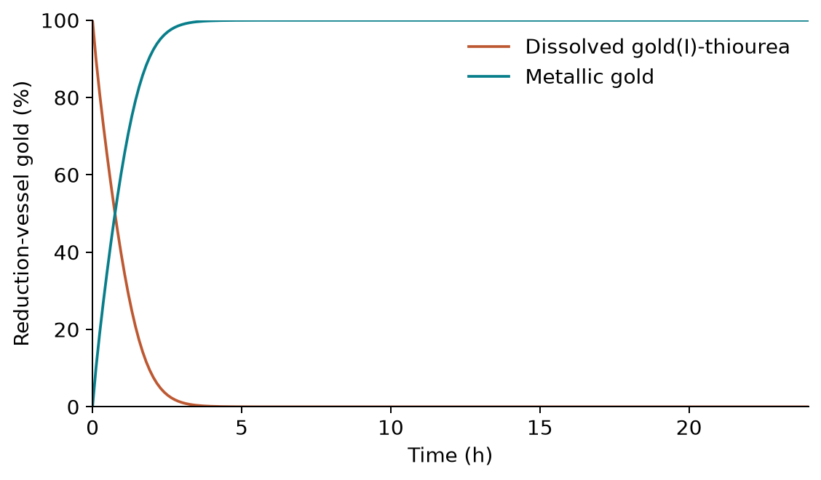
Figure 5. Under the reference scenario, dissolved Au(I)-thiourea falls while Au(0) rises to near-complete conversion.

Reductase recharge
Electron transfer oxidises the reductase:
$$[R_{ox}]=[R_{total}]-[R_{red}]$$
Dithionite recharges it through the redox system:
$$r_{recharge}=\frac{k_{recharge}[R_{ox}][D]}{1+[Au(I)\text{-}TU]/K_{Au,inhibition}}$$
$$\frac{d[R_{red}]}{dt}=-ν_{R,Au}r_{Au,reduce}+r_{recharge}-k_{ox}[R_{red}]$$
The working stoichiometries are ν_R,Au = 0.5 mol reductase/mol Au and ν_D,R = 1 mol donor/mol reductase recharge. Methyl viologen, present at 0.1 µM in the source experiment, is treated as an instantaneous electron shuttle and is therefore included within the effective recharge step.

Reduction parameters, evidence and experiment
The fixed reference trajectory uses:
Quantity | Working value | Source status
k_nucleation | 0.96 h⁻¹ | Enzyme-scaled literature proxy
k_growth | 0.082 µM⁻¹ h⁻¹ | Centre of the literature-anchored range
Initial dithionite | 50 µM | Process design value
Methyl viologen | 0.1 µM | Source experimental recipe
The source reductase experiment used Au(III), dithionite and methyl viologen, whereas this stage receives Au(I)-thiourea [S35]. The first project experiment should therefore test whether the complete reductase system converts Au(I)-thiourea at all. If activity is observed, dissolved gold or the particle signal should be measured frequently during the initial period and then to a clear plateau. That time course is used to fit k_nucleation and k_growth for this system.
The protein-production experiment should measure cell density, intracellular reductase and soluble active reductase after lysis across cultivation time. These measurements set the harvest time, lysis yield and the R_lysate(t) curve used by the model.

Fixed parameters and adaptable design inputs
The wiki must generate this table and the graphs from the same parameter object, so a displayed value cannot drift from the calculation.
Symbol | Value | Unit | Status | Source
q_Au | 4.62 | µmol/g dry biomass | Measured in another GolB whole-cell system | [S76]
ρ_X | 0.212 | g dry biomass/m² | Provisional geometric derivation | params/capture_design.yaml
k_on,Au | 1.0 | µM⁻¹ h⁻¹ | Literature proxy | [S57]
K_Au | 0.7 | µM | Soluble-GolB literature proxy | [S78]
α = K_Cu/K_Au | 52 | dimensionless | Related-protein selectivity proxy | [S79]
K_Cu | 36.4 | µM | Derived working scenario | αK_Au
[Cu_effective]₀ stress | 818 | µM | Upper-bound reinterpretation of upstream Cu(II) peak | Part I model; tests/test_leach.py
f_Au,res | 0.03 | dimensionless | Transferred elution proxy | [S60]
k_elute | 0.22 | h⁻¹ | Derived from the same elution study | [S60]
G_R | 500 | protein min⁻² cell⁻¹ | Lumped expression proxy | params/recovery_chain.yaml
δ_m,R | 0.20 | min⁻¹ | Literature-derived | params/expression.yaml
δ_p,R | 0.005 | min⁻¹ | Protein-turnover proxy | params/recovery_chain.yaml
μ_R | 1.2 | h⁻¹ | E. coli growth rate, adopted from Part II | params/recovery_chain.yaml
X_R,0 | 0.02 | g dry biomass/L | Inoculation assumption | params/recovery_chain.yaml
X_R,max | 2.0 | g dry biomass/L | Conservative medium design value | params/recovery_chain.yaml
y_lysis | 0.70 | dimensionless | Lysis-literature proxy | params/recovery_chain.yaml
n_cells/g | 2.36 × 10¹² | cells/g dry weight | Interpolated from a literature curve at μ = 1.2 h⁻¹ | [S30]; params/conversions.yaml
[R_total]₀ target | 2.86 | µM | Design target derived from 0.2 g/L and 70 kDa | params/recovery_chain.yaml
k_nucleation | 0.96 | h⁻¹ | Enzyme-scaled reference proxy | [S51, S52, S74]
k_growth | 0.082 | µM⁻¹ h⁻¹ | Literature-anchored reference proxy | [S51–S53]
[D]₀ | 50 | µM | Reduction design value | params/recovery_chain.yaml; [S35]
k_recharge | 0.10 | µM⁻¹ h⁻¹ | Unmeasured working proxy | params/recovery_chain.yaml
K_Au,inhibition | 500 | µM | Unmeasured working proxy | params/recovery_chain.yaml
k_ox | 0.02 | h⁻¹ | Unmeasured working proxy | params/recovery_chain.yaml
ν_R,Au | 0.5 | mol/mol | Mechanism-based stoichiometry | [S63]
ν_D,R | 1.0 | mol/mol | Stoichiometric model value | params/recovery_chain.yaml
The following quantities remain design inputs rather than fixed parameters: V_elution, V_reductase, F_conc, capture contact time and wash time. The comb-growth values m_X,0 and μ_att also remain unmeasured. The page must not report a numerical growth duration or total process time until these inputs are chosen or measured.
The interactive model is deliberately small. It changes only:
- wetted comb area;
- capture-liquid volume;
- starting dissolved-gold concentration; and
- copper competition, using an off/on stress-test switch.
Time remains the horizontal axis of the kinetic graphs rather than a user input. Changing the three continuous design inputs or the copper switch updates comb capacity, captured gold, eluted gold and recovered Au(0) through the full amount ledger. The fixed parameters and their sources remain visible in a dropdown.

Model outputs
For the 23.6 m², 5 g dry-biomass reference in 1 L containing 29 µM gold, the model gives:
Output | Main baseline | Copper stress test
Effective comb capacity | 23.1 µmol | 23.1 µmol
Gold captured at equilibrium | 73.10% | 40.91%
Gold released after 6 h | 71.1% of captured gold | 71.1% of captured gold
Gold reaching reduction | 52.0% of biorecovery feed | 29.1% of biorecovery feed
Without effective copper competition, capture leaves 26.9% of the dissolved gold in the leachate. Elution then lowers the amount entering reduction to 52.0% of the dissolved gold entering biorecovery. Under the fixed reference reduction parameters, conversion of that remaining gold is nearly complete, giving approximately 52.0% overall recovery.
In the upper-bound copper stress test, only 29.1% of the original gold reaches reduction and is recovered as Au(0). This is a 22.9 percentage-point decrease from the main baseline. The model therefore identifies comb capacity, copper competition and elution as the main limits at this operating point; the reference reduction step is not limiting.

End-to-end animation
The final animation follows one gold inventory through the complete model:
PCB gold → dissolved gold after leaching → gold captured on the comb → gold released into the eluate → gold converted to recovered Au(0)
For each stage it displays the gold amount, the fraction retained from the previous stage and the cumulative process time:
$$n_{Au,leached}=η_{Au,leach}n_{Au,PCB}$$
$$n_{Au,captured}=η_{Au,capture}n_{Au,leached}$$
$$n_{Au,eluted}=η_{Au,elute}n_{Au,captured}$$
$$n_{Au,recovered}=η_{Au,reduce}n_{Au,eluted}$$
$$η_{Au,biorecovery}=n_{Au,recovered}/n_{Au,leached}$$
$$η_{Au,PCB\text{-}to\text{-}metal}=η_{Au,leach}η_{Au,biorecovery}$$
Here, η_Au,leach is supplied by the upstream leaching model; it is not a parameter fitted in this section. The open outputs table uses dissolved gold entering biorecovery as its baseline. The animation may additionally show the PCB-relative result only when the upstream leaching output is supplied.
If the comb culture, reductase culture and leaching run in parallel, the preparation time is the longest of those three branches:
$$t_{preparation}=max(t_{leach}, t_{comb\text{-}growth}, t_{reductase\text{-}growth})$$
The total process time is then:
$$t_{total}=t_{preparation}+t_{capture}+t_{wash}+t_{elution}+t_{reduction}$$
The animation always reports recovered gold. It reports total time only when all five duration inputs are available; otherwise it labels the unfinished duration explicitly instead of substituting a guess. Changing wetted comb area, capture volume or starting dissolved gold updates the biorecovery amounts throughout the same sequence.

Discussion: what the model changes
The reference calculation turns the biological model into two design requirements. First, the hardware team must provide about 23.6 m² of wetted leaf area to support the assumed 5 g dry biomass monolayer. Second, the wet lab should prioritise attached biomass density, comb gold loading and elution measurements because these quantities control the largest losses. The current reference reduction trajectory is not the bottleneck, but its chemistry must still be demonstrated with Au(I)-thiourea before it is treated as validated.
The copper stress test is a robustness question, not the process baseline. It shows that capture could fall from 73.10% to 40.91% if the full upstream copper inventory behaved as a reversible GolB competitor. This result supports measuring copper speciation at the handoff rather than designing the whole process around the stress case.

Limitations
The model transfers capacity, affinity, elution and reduction-rate values from related systems. It assumes complete attached-cell coverage, ideal mixing and no permanent loss of GolB activity. It does not yet predict comb cultivation time, washing time or an absolute end-to-end duration. Reduction ends at Au(0); downstream particle collection is outside the model, so all Au(0) formed is counted as recovered.

Conclusion
For the reference comb and dissolved-gold feed, the model predicts 52.0% recovery to Au(0), falling to 29.1% in the conservative copper stress test. The next design gains should come from increasing verified comb capacity and improving gold release, while targeted experiments replace the transferred parameters.

References
S76. Wei W., Zhu T., Wang Y., Yang H., Hao Z., Chen P. R., Zhao J. (2012). Engineering a gold-specific regulon for cell-based visual detection and recovery of gold. Chemical Science 3, 1780–1784. DOI: https://doi.org/10.1039/C2SC01119K. Archived primary manuscript. Official supplementary methods.
S57. Tsuruta (2004). “Biosorption and recycling of gold using various microorganisms.” Journal of General and Applied Microbiology 50(4), 221-228. doi:10.2323/jgam.50.221
S78. Nazir R., Mohsin M., Siddiqi T. O. (2022). “Real time optical detection of gold in living cells through genetically-encoded probe.” RSC Advances 12, 23193-23203. doi:10.1039/D2RA02574D: https://doi.org/10.1039/D2RA02574D. Open full text: https://pubs.rsc.org/en/content/articlehtml/2022/ra/d2ra02574d.
S80. Kay K. L., Zhou L., Tenori L., Bradley J. M., Singleton C., Kihlken M. A., Ciofi-Baffoni S., Le Brun N. E. (2017). “Kinetic analysis of copper transfer from a chaperone to its target protein mediated by complex formation.” Chemical Communications 53(8), 1397-1400. doi:10.1039/c6cc08966f: https://doi.org/10.1039/c6cc08966f.
S79. Checa S. K., Espariz M., Audero M. E. P., Botta P. E., Spinelli S. V., Soncini F. C. (2007). “Bacterial sensing of and resistance to gold salts.” Molecular Microbiology 63, 1307-1318. doi:10.1111/j.1365-2958.2007.05590.x: https://doi.org/10.1111/j.1365-2958.2007.05590.x. Publisher full text: https://onlinelibrary.wiley.com/doi/10.1111/j.1365-2958.2007.05590.x.
S60. Son J., Hong Y., Han G., Nguyen T. S., Yavuz C. T., Han J.-I. (2019). “Gold recovery using porphyrin-based polymer from electronic wastes: gold desorption and adsorbent regeneration.” Science of the Total Environment 704, 135405. doi:10.1016/j.scitotenv.2019.135405
S35. Erasmus M., Idris O. A., Adetunji A. I., Cason E. D. (2024). “Biogenic synthesis and characterization of gold nanoparticles using transformed mesophilic Escherichia coli BL21 and thermophilic Thermus thermophilus HB27.” Biologia 79:2605-2619. doi:10.1007/s11756-024-01733-2
S30. Dennis P. P., Bremer H., via BioNumbers. E. coli dry mass per cell against growth rate. https://book.bionumbers.org/how-big-is-an-e-coli-cell-and-what-is-its-mass/ ✅ verified 2026-08-11.
S51. Finke–Watzky kinetics: the mechanism, the challenge, and the reply. Watzky & Finke 1997, J. Am. Chem. Soc.; Finke’s explicit lag-and-growth-time formulas, J. Phys. Chem. C (2017); Whitehead, Özkar & Finke, “Particle Size Is a Primary Determinant for Sigmoidal Kinetics… A ‘Disproof’ of the F–W Mechanism,” Chem. Mater. (2019); and the published Response, Chem. Mater. (2020), doi:10.1021/acs.chemmater.0c00780.
S52. Fitted Finke–Watzky constants for gold. Two systems, neither of them protein-mediated:
S74. Ng W. L., Chan K. W. K. et al. (2024). “Engineering a Metal Reductase for the Bioremediation of Anthropogenic Electronic Wastes: From Hg(II) to Au(III) and Ag(I) Enzymatic Reduction.” JACS Au 4(7), 2529–2539. doi:10.1021/jacsau.4c00297: https://doi.org/10.1021/jacsau.4c00297. Retrieved as full text from PubMed Central, PMC11200239 / PMID 38938813, on 2026-08-24.
S53. Wang, Yan, Ye, Chen et al. (2022). “Identification and Characterization of a Au(III) Reductase from Erwinia sp. IMH.” JACS Au 2(6), 1435–1442. doi:10.1021/jacsau.2c00170
S63. Erasmus M., Cason E. D., van Marwijk J., Botes E., Gericke M., van Heerden E. (2014). “Gold nanoparticle synthesis using the thermophilic bacterium Thermus scotoductus SA-01 and the purification and characterization of its unusual gold reducing protein.” Gold Bulletin 47, 245-253. doi:10.1007/s13404-014-0147-8

