Bioleaching Modelling [Sequential] — Process Summary
Gold must first be dissolved before it can be captured. Our process uses thiosulfate for this job, so the first modelling stage asks how the engineered cells can supply TetH and how that enzyme can prepare the leachant.
Stage 1: Creating the Leachant

Stage 1A: Biological Input (Enzymes)
Question: How can bacteria produce thiosulphate?
Bacteria produce tetrathionate hydrolase, an enzyme that breaks down tetrathionate to thiosulphate, which is then extracted and purified. It is modelled by a protein production model.
bacteria → TetH enzyme (E)
Model
It is modelled by a protein production model with synthesis, degradation, and dilution.
Transient: $\frac{d\left[E\right]}{dt} = k_{syn} · X - (k_{deg} + μ) · E$
Steady State: ${\left[E\right]}_{culture} = \frac{k_{syn} · X}{k_{deg}+ μ}$
Design Decisions?
The culture volume required to charge one litre of Stage 2 to a target enzyme concentration E₂ follows directly. The enzyme concentration needed can change.
$$\frac{V_{culture}}{V_{stage 2} } = \frac{E_{2}}{{\left[E\right]}_{culture}}$$
Assumptions:
- Enzyme synthesis rate is linear.
- Constant bacterial biomass.
- Enzyme production occurs at optimised bacterial growth conditions.
Analysis:
Using standard E. coli protein synthesis parameters, the culture reaches steady state in 55 minutes. A litre of culture yields approximately 7.791 × 10⁻³ µmol L⁻¹ of TetH, if using generic E. Coli values for the enzyme production, equivalent to about 4692 molecules per cell — roughly 0.5% of the cell's total protein, which is a modest and realistic burden.

Stage 1B: Output (Thiosulphate)
TetH converts tetrathionate to thiosulphate in the reaction below.
S₄O₆²⁻ + H₂O → S₂O₃²⁻ + S⁰ + SO₄²⁻ + 2H⁺
Design Decisions
- Should tetrathionate conversion occur in the same bioreactor as the PCB leaching?
- How long should the conversion process be?
Model
Thiosulphate follows a Michaelis-Menten enzyme model, with a constant enzyme concentration.
$$v=\frac{k_{cat}∙E_{2}∙\left[S_{4}O_{6}^{2-}\right]}{\left(K_{m}+ \left[S_{4}O_{6}^{2-}\right]\right)}$$
If thiosulphate production and PCB leaching are done in separate bioreactors, the rate of change between sulphur species are the following:
$$\frac{d\left[S_{4}O_{6}^{2-}\right]}{dt}=-v ; \frac{d\left[S_{2}O_{3}^{2-}\right]}{dt}=v$$
If thiosulphate production and PCB leaching are done in the same bioreactor, additional terms are needed to model the effect of gold leaching, copper leaching, and copper parasitic reactions on tetrathionate and thiosulphate.
$$\frac{d\left[S_{4}O_{6}^{2-}\right]}{dt}= -v+ R_{Cu, para}$$
$\frac{d\left[S_{2}O_{3}^{2-}\right]}{dt}$ $=v-R_{Cu, para}-\left(\frac{2}{V}\right)·R_{Au}-\left(\frac{1}{V}\right)·R_{Cu}$
Initial Conditions
Initial conditions are based on tetrathionate broth production protocol stoichiometry. Final values are below.
30 g/L ÷ 248.18 g/mol = 120.88 mmol S₂O₃²⁻ 6 g ÷ 253.81 g/mol = 23.64 mmol I₂
→ S₄O₆²⁻ = 23.64/1.02 = 23.2 mM S₂O₃²⁻ = (120.88 − 47.28)/1.02 = 72.1 mM
Assumptions
- Enzymes produced in the previous stage are extracted with 100% efficiency.
- Enzymes are operating in optimal conditions (temperature, pH, agitation rate).
- Initial conditions from tetrathionate broth stoichiometry.
- Only the reactions of interest occur in non-negligible amounts. All other sulphur species are relevant or present.
- All produced sulphur species are stable and do not degrade or oxidise over the conversion period.
Analysis
Design Question 1:
Sequential Model:
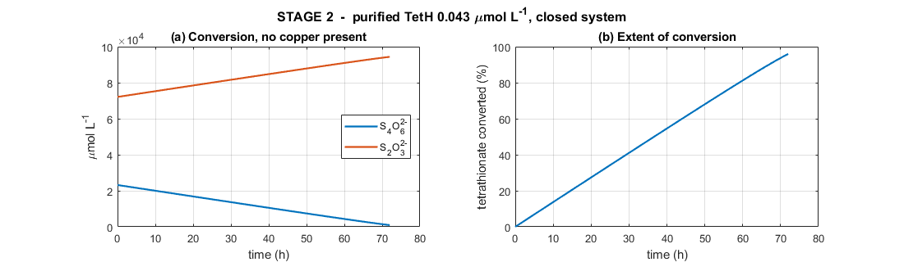
Simultaneous Model:
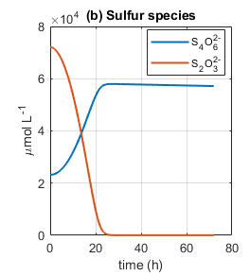
In a simultaneous model, tetrathionate concentration does not fall as expected, but rises from due to Cu (II)’s parasitic reaction with thiosulphate. This reaction, along with leaching, uses up thiosulphate. This implies that parasitic tetrathionate regeneration has a greater impact on tetrathionate than enzymatic conversion, making it harder to produce a large batch of thiosulphate. This creates a futile cycle: the enzyme converts S₄O₆²⁻ into S₂O₃²⁻, and Cu (II) converts S₂O₃²⁻ straight back into S₄O₆²⁻.
With a sequential model, the reaction is zero-order and looks linear rather than exponential. Tetrathionate concentration decreases, while thiosulphate concentration rises. The final product is 94.4 mM thiosulphate, which is close to the 0.1 M concentration reported as optimal for thiosulfate gold leaching. Thus, the sequential model was chosen?
Design Decision 2:
The set enzyme concentration from stage 1 determines the number of litres and time taken for maximum thiosulphate concentration. For example, an enzyme concentration of E₂ = 0.043 µmol L⁻¹ takes a total conversion of 3 days and needs 9.1 L of culture per litre compared to E₂ =0.129 µmol L⁻¹, which takes 1 day but needs 27 L of culture.

Stage 2: Leaching Gold
The thiosulphate from Stage 1 is mixed with crushed PCB powder to produce leached gold ions. Gold can be oxidised directly by oxygen or by Cu(II).
4Au⁰ + 8S₂O₃²⁻ + O₂ + 2H₂O → 4Au(S₂O₃)₂³⁻ + 4OH⁻ (O₂ route)
Au⁰ + 2S₂O₃²⁻ + Cu(II) → Au(S₂O₃)₂³⁻ + Cu(I) (Cu(II) route)
However, thiosulphate also leaches other metals, the most prominent being copper. Copper can also be oxidised directly by oxygen or by Cu(II).
4Cu⁰ + O₂ + 8S₂O₃²⁻ + 2H₂O → 4[Cu(S₂O₃)₂]³⁻ + 4OH⁻ (O₂ route)
Cu⁰ + Cu²⁺ + 4S₂O₃²⁻ → 2[Cu(S₂O₃)₂]³⁻ (Cu(II) route)
Copper ions also react with themselves and thiosulphate in other auxiliary reactions.
4Cu(I) + O₂ + 2H₂O → 4Cu(II) + 4OH⁻ (re-oxidation)
2Cu(II) + 2S₂O₃²⁻ → 2Cu(I) + S₄O₆²⁻ (parasitic)
Design Decisions
- Should oxygen be the only oxidant?
- Should ammonia be added as copper lixiviant?
- Should oxygen be in excess or rate-limited?
Model
A Langmuir surface kinetics model with a shrinking surface area was used to model gold leaching as thiosulphate particles have to interact with limited metallic gold surface areas over time. Parallel pathways were used to represent the use of both oxygen and Cu(II) as oxidants.
Gold Leaching:
$$R_{Au} = A_{Au}(t)·\frac{\left[S_{2}O_{3}^{2-}\right]}{K_{S}+\left[S_{2}O_{3}^{2-}\right]} · \left[k_{Au,O_{2}}·\frac{\left[O_{2}\right]}{K_{O_{2}}+\left[O_{2}\right]} + k_{Au,Cu}·\frac{\left[Cu\left(II\right)\right]}{K_{Cu}+\left[Cu\left(II\right)\right]} \right]$$
$$\frac{dn_{Au}}{dt} = -R_{Au}$$
$$d\frac{\left[AuO_{3}^{2-}\right]}{dt} = +\frac{R_{Au}}{V}$$

Copper Leaching:
Copper was modelled as two ions: Cu(I) and Cu(II). Copper leaching action was modelled with a similar Langmuir surface kinetics model with parallel pathways for oxygen and Cu(II) oxidants. A shrinking core model was used since copper appears in bulk in PCBs compared to gold, which appears as thin plates on minimal parts of the PCBs. Mass action kinetic models were used for the other copper reactions.
$$v_{1B} = A_{Cu}(t)·\frac{\left[S_{2}O_{3}^{2-}\right]}{K_{S}+\left[S_{2}O_{3}^{2-}\right]}·\{ {2k}_{Cu,O_{2}}·\frac{\left[O_{2}\right]}{K_{O_{2}}+\left[O_{2}\right]} + {4k}_{Cu, Cu^{2+}}·\frac{\left[Cu\left(II\right)\right]}{K_{Cu}+\left[Cu\left(II\right)\right]} \}$$
$$v₂ = R_{Au}$$
$$v₃ = k₃·[Cu(II)]·[S₂O₃²⁻]$$
$$v₄ = k₄·[O₂]·[Cu(I)]$$

$$d\frac{\left[Cu\left(II\right)\right]}{dt} = 4·v₄ - \left(\frac{1}{V}\right)·v₁B - \left(\frac{1}{V}\right)·v₂ - 2·v₃$$
$$\frac{d\left[Cu\left(I\right)\right]}{dt} = \left(\frac{1}{V}\right)·2·v₁B + \left(\frac{1}{V}\right)·v₂ + 2·v₃ - 4·v₄$$
Initial Conditions
Initial conditions are based on Stage 1’s final tetrathionate and thiosulphate values.
Assumptions
- Metallic gold is assumed to be a shrinking surface area due to its presence as thin metal surfaces.
- Metallic copper is assumed to be a shrinking volume due to its large presence in PCBs.
- Environmental conditions (pH, temperature, pulp density, agitation rate, etc) are optimised for gold leaching.
- There are idealised physics conditions such perfect mixing, no mass-transfer resistance, uniform spherical particles with no agglomeration, isothermal operation, and a uniform gold film thickness across all particles)
- All complexes are stable and do not degrade naturally.
- Other metals are leached in negligible amounts and have little impact on thiosulphate concentrations.
Analysis
Design Questions 1 & 2
W/o ammonia [0 mM]
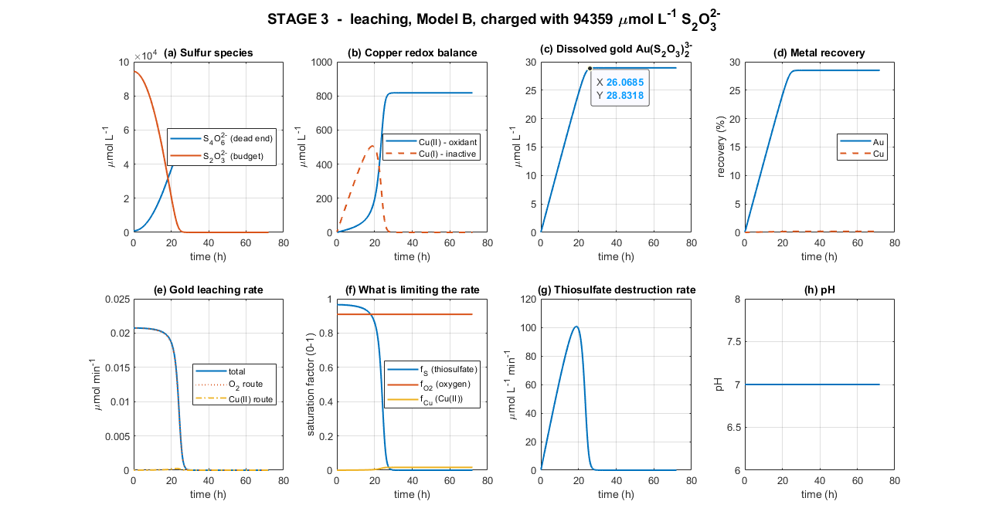
W/ Ammonia [260 mM]
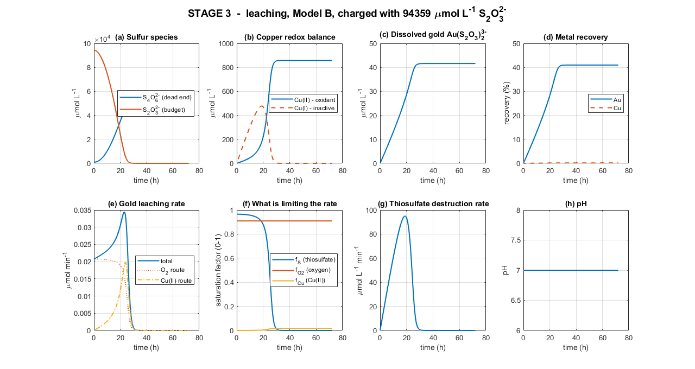
When no ammonia is present, the Cu(II) oxidation rout is effectively null. Gold leaching is minimal, with only 19.69% in 24h and 28.93% leached in 72 hours. When ammonia is present (approximately 260 mM), the Cu(II) oxidant route activates, and thus gold leaching is more effective, with 36.6% metallic gold leached in 24h, and 40.97% leached as a maximum in 29h. This supports the decision to design around a one-day batch rather than assuming that a three-day residence time is automatically better.
Both models show that the thiosulphate is the limiting reagent in gold leaching due to parasitic regeneration of tetrathionate. Ammonia acted as lixiviant for copper, but had minimal impact, with only 0.0017% increase in the thiosulphate share allotted to gold leaching.
Design Decision 3:
Previous ammonia models for Design Questions 1 and 2 assumed excess oxygen. Assuming a rate-limited oxygen supply based on kL_{A},oxygen woul oxygen concentration [O₂] can be modelled with the equation below.
$$\frac{d[O_{2}]}{dt}=kLA×\left(C^{*}-\left[O_{2}\right]\right)-\left(\frac{0.25R_{Au}+0.25R_{cu}}{4V}+0.25v_{4}\right)$$
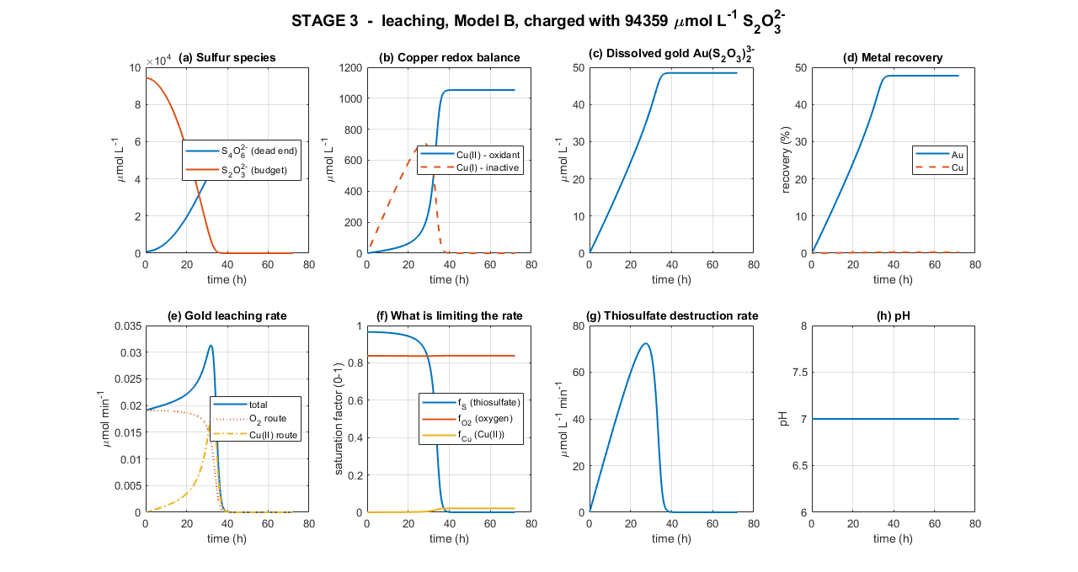
With a rate-limited oxygen, it seems that a greater share of thiosulphate is used for gold leaching, with a 7% increase in maximum gold leaching since there is less oxygen to convert Cu(I) to Cu(II). However, it comes at a cost of time, with a limited oxygen rate extending leaching time by 8-9 hours.

Parameters

Stage 1A
Symbol | Meaning | Unit | Value / source
[E] | Active TetH in the culture | µmol L⁻¹ | 4.75×10⁻³ (steady state)
X | Biomass concentration | cell L⁻¹ | 1×10¹²
k_syn | Enzyme synthesis rate per cell | µmol cell⁻¹ min⁻¹ | $1.43356 ×{10}^{-16}$(cascade-matched) [17]
k_deg | Enzyme degradation rate | min⁻¹ | 1.1×10⁻³ [4]
Μ | Growth-dilution rate | min⁻¹ | 0.0173 (40 min doubling) [16]
Symbol | Meaning | Unit | Value / source

Stage 1B
[S₄O₆²⁻] | Tetrathionate concentration | µmol L⁻¹ | state variable; initial 23 200
[S₂O₃²⁻] | Thiosulfate concentration | µmol L⁻¹ | state variable; initial 72 100
E₂ | Purified TetH in the conversion vessel | µmol L⁻¹ | 0.043 (design variable)
k_cat | Turnover number of TetH | min⁻¹ | 125 (2.5 U mg⁻¹ × 50 kDa) [1][2]
K_m | Michaelis constant | µmol L⁻¹ | 300 (species range 50–2400) [2]
Y | Stoichiometric yield (S₂O₃ per S₄O₆) | — (dimensionless) | 1 [1]
t₂ | Stage-2 duration | Min | 4 320 (3 days)

Stage 2:
Symbol | Meaning | Unit | Value / source
n_Au | Solid gold remaining | µmol | state variable; initial 101.5
n_Cu | Solid copper remaining | µmol | state variable; initial 472 069
A_Au | Exposed gold area (thin film, constant) | m² | 2.07×10⁻³
A_Cu | Exposed copper area (shrinking particle) | m² | 3.35×10⁻³ initial
m_Au / m_Cu | Metal mass on the boards | Kg | 20×10⁻⁶ / 30×10⁻³ (100 g L⁻¹ PCB)
ρ_Au / ρ_Cu | Metal densities | kg m⁻³ | 19 300 / 8 960
t_film | Gold plating thickness | M | 0.5×10⁻⁶
D | Crushed particle size | M | 6×10⁻³
k_Au,O₂ | Gold rate constant, O₂ route | µmol m⁻² min⁻¹ | 6 [9][10]
k_Au,Cu | Gold rate constant, Cu(II) route | µmol m⁻² min⁻¹ | 21.0 (ammonia-free) [20] / 1500 (with ammonia) [11][12]
k_Cu,O₂ / k_Cu,Cu | Copper rate constants | µmol m⁻² min⁻¹ | 200 / 200 [13]
K_O₂ | O₂ half-saturation | µmol L⁻¹ | 50 [10]
K_S | Thiosulfate half-saturation | µmol L⁻¹ | 3,376 (= 1/K_ads) [18]
K_Cu | Cu(II) half-saturation | µmol L⁻¹ | 5×10⁴ [12]
k₁, k₃ | Parasitic rate constants | L µmol⁻¹ min⁻¹ | 1.20×10⁻⁵ (ammonia-free)/ 1×10⁻⁵ (with ammonia) [6][7]
k₄ | Cu(I) re-oxidation rate constant | L µmol⁻¹ min⁻¹ | 1×10⁻⁴ [7]
[O₂] | Dissolved oxygen (held constant) | µmol L⁻¹ | 500

Rpm | Stirrer rotation speed |  | 600 (example) | rev/min | Equipment specs
N_p | Shaped-based power number |  | 5.0 | dimensionless | Standard engineering constant for a Rushton turbine (a flat-bladed disc impeller); tabulated in mixing handbooks (e.g. Van't Riet's own paper, and standard bioreactor engineering references like Garcia-Ochoa & Gomez 2009)
Ρ | Density of the liquid being stirred |  | 1000 | kg/m³ | Standard physical constant for water at ~25°C
D_i | Impeller diameter |  | 0.04 | m | Equipment specs
V | Working liquid volume |  | 0.001 (= 1 L) | m³ | Equipment specs
0.6 | Gassing correction factor |  | 0.6 | dimensionless | Empirical rule of thumb from bioreactor engineering literature
P/V | Power input per unit volume |  | 307.2 (calculated) | W/m³ | Derived from the equation above
Symbol |  | Meaning |  | Unit | Value / source
[O₂] |  | Dissolved oxygen concentration |  | µmol L⁻¹ | state variable; initial 259 (air-saturated water at t=0 — see note below)
Q_air |  | Air pump flow rate |  | L min⁻¹ | Equipment specs
Rpm |  | Stirrer rotation speed |  | rev min⁻¹ | Equipment specs
D_T |  | Tank internal diameter |  | M | Equipment specs
D_i |  | Impeller diameter |  | M | Equipment specs
V |  | Working liquid volume |  | m³ | Equipment specs
A_x |  | Tank cross-sectional area |  | m² | 7.854×10⁻³ [Derived]
u_g |  | Superficial gas velocity |  | m s⁻¹ | 1.06×10⁻³ (= Q_air/A_x, derived)
N_p |  | Power number (impeller shape factor) |  | — | 5.0; standard constant for a Rushton turbine [Van't Riet 1979]
Ρ |  | Liquid density |  | kg m⁻³ | 1000; standard physical constant, water at 25°C
gassing factor |  | Power reduction under aeration |  | — | 0.6;[Garcia-Ochoa & Gomez 2009]
P/V |  | Power input per unit volume |  | W m⁻³ | 307.2 [Derived]
kLa |  | Volumetric O₂ mass transfer coefficient |  | min⁻¹ | 1.68 [Derived] [Van't Riet 1979]
C* |  | O₂ saturation concentration (air, 25°C) |  | µmol L⁻¹ | 259 [APHA Standard Methods DO tables; cross-checked via Henry's Law, k_H=769 L·atm/mol]

References
Y. Kanao et al., "Tetrathionate hydrolase from the acidophilic microorganisms," Front. Microbiol., vol. 15, 1338669, 2024.
[2] Y. Kanao, K. Kamimura, and T. Sugio, "Purification of a tetrathionate hydrolase from Acidithiobacillus ferrooxidans," J. Biotechnol., vol. 132, pp. 16–22, 2007.
[3] U. Alon, An Introduction to Systems Biology, 2nd ed. Boca Raton, FL: CRC Press, 2019.
[4] M. R. Maurizi, "Proteases and protein degradation in Escherichia coli," Experientia, vol. 48, pp. 178–201, 1992.
[5] G. E. Briggs and J. B. S. Haldane, "A note on the kinetics of enzyme action," Biochem. J., vol. 19, pp. 338–339, 1925.
[6] J. J. Byerley, S. A. Fouda, and G. L. Rempel, "Kinetics and mechanism of the oxidation of thiosulphate ions by copper(II) ions in aqueous ammonia solution," J. Chem. Soc. Dalton Trans., pp. 889–893, 1973.
[7] P. L. Breuer and M. I. Jeffrey, "The reduction of copper(II) and the oxidation of thiosulfate and oxysulfur anions in gold leaching solutions," Hydrometallurgy, vol. 70, pp. 163–173, 2003.
[8] G. Senanayake, "Analysis of reaction kinetics, speciation and mechanism of gold leaching and thiosulfate oxidation by ammoniacal copper(II) solutions," Hydrometallurgy, vol. 75, pp. 55–75, 2004.
[9] S. Zhang and M. J. Nicol, "An electrochemical study of the dissolution of gold in thiosulfate solutions Part I: Alkaline solutions," J. Appl. Electrochem., vol. 33, pp. 767–775, 2003.
[10] O. Sitando et al., "A review of factors affecting gold leaching in non-ammoniacal thiosulfate solutions," Hydrometallurgy, vol. 178, pp. 151–175, 2018.
[11] M. G. Aylmore and D. M. Muir, "Thiosulfate leaching of gold — a review," Miner. Eng., vol. 14, no. 2, pp. 135–174, 2001.
[12] D. Maharaj, T. Moyo, and J. Petersen, "Ammonium thiosulfate leaching of gold from electronic printed circuit boards," J. S. Afr. Inst. Min. Metall., vol. 124, no. 12, pp. 711–718, 2024.
[13] E. Salinas-Rodríguez et al., "Leaching of copper contained in waste printed circuit boards using the thiosulfate–oxygen system," Materials, vol. 15, no. 7, 2354, 2022.
[14] O. Levenspiel, Chemical Reaction Engineering, 3rd ed. New York, NY: Wiley, 1999.
[15] P. L. Breuer and M. I. Jeffrey, "An electrochemical study of gold leaching in thiosulfate solutions containing copper and ammonia," Hydrometallurgy, vol. 65, pp. 145–157, 2002.
[16] H. Bremer and P. P. Dennis, "Modulation of chemical composition and other parameters of the cell at different exponential growth rates," EcoSal Plus, vol. 3, no. 1, 2008.
[17] R. Milo et al., "BioNumbers — the database of key numbers in molecular and cell biology," Nucleic Acids Res., vol. 38, pp. D750–D753, 2010.
[18] G. Senanayake, "A surface adsorption/reaction mechanism for gold oxidation by copper(II) in ammoniacal thiosulfate solutions," J. Colloid Interface Sci., vol. 286, pp. 253–257, 2005.
[19] T. Kanao et al., "Recombinant tetrathionate hydrolase from Acidithiobacillus ferrooxidans requires exposure to acidic conditions for proper folding," FEMS Microbiol. Lett., vol. 309, no. 1, pp. 43–47, 2010.

