Bioleaching Modelling [Sequential] — Process Overview
Three-stage model: enzyme harvest → thiosulfate conversion → leaching
Unlike the simultaneous model, where it is assumed that the process is carried out simultaneously in one vessel, the sequential model assumes the bioleaching process occurs in three separate vessels. Bacteria express tetrathionate hydrolase (TetH), which is then harvested, extracted and purified. The purified enzyme is mixed with tetrathionate broth to generate thiosulfate. Only afterwards are crushed PCB powder and biosorbent cells introduced into the thiosulfate solution.
Stage | Vessel contents | Purpose
1 | E. coli culture | Express TetH, then harvest, extract and purify
2 | Purified TetH + tetrathionate broth | Convert tetrathionate to thiosulfate
3 | Thiosulfate liquor + crushed PCB | Leach gold (and unavoidably copper)

Separating the stages changes the simultaneous model structure in three ways:
- The enzyme concentration in Stage 2 becomes a fixed input rather than a state variable, so k_syn, k_deg and μ disappear from the reaction vessel because there are no cells in it.
- Stage 2 contains no copper, so the parasitic reaction and both leaching sinks vanish and what remains is a closed two-state system with an analytical solution.
- Stage 3 has no thiosulfate source: the leachant is a fixed budget charged at the start and depleted.

Stage 1: Enzyme Production and Harvest
Bacteria produce tetrathionate hydrolase, which is then extracted and purified. This stage determines how much enzyme is available per litre of culture, and therefore how much culture must be grown to charge Stage 2. It does not appear in the Stage-2 or Stage-3 differential equations.^{[1]}
Reaction
bacteria → TetH enzyme (E) → harvested, extracted, purified
Model
Within the culture vessel the enzyme is governed by production, first-order degradation and dilution by growth ^{[3]}:
$$\frac{d\left[E\right]}{dt} = k_{syn} · X - (k_{deg} + μ) · E$$
Because the culture reaches steady state in 1/(k_deg + μ) ≈ 55 min, far faster than any downstream process, only the steady state is needed:
$${\left[E\right]}_{culture} = \frac{k_{syn} · X}{k_{deg}+ μ} = 4.75 × 10⁻³ µmol L⁻¹ ≈ 2 860 molecules per cell$$
The culture volume required to charge one litre of Stage 2 to a target enzyme concentration E₂ follows directly:
$$\frac{V_{culture}}{V_{stage 2} } = \frac{E_{2}}{{\left[E\right]}_{culture}}$$
Parameters
Symbol | Meaning | Unit | Value / source
[E] | Active TetH in the culture | µmol L⁻¹ | 4.75×10⁻³ (steady state)
X | Biomass concentration | cell L⁻¹ | 1×10¹²
k_syn | Enzyme synthesis rate per cell | µmol cell⁻¹ min⁻¹ | $1.43356 ×{10}^{-16}$(cascade-matched) [17]
k_deg | Enzyme degradation rate | min⁻¹ | 1.1×10⁻³ [4]
Μ | Growth-dilution rate | min⁻¹ | 0.0173 (40 min doubling) [16]
Assumptions
The following assumptions were made when creating this model:
- Fold/active fraction f = 0.5 assumed.
- Enzyme synthesis rate can be modelled as a linear protein synthesis model. Since it is linear, it does not model heavy metabolic burden and its limitations.
- Thus, the synthesis rate is generated using average E. coli values from the golB site density model rather than specific TetH values.
- Biomass X is constant.
- Bacterial growth conditions are optimized to produce standard biomass concentrations.
- Produced enzymes can be extracted with 100% efficiency and no activity loss.
- Tetrathionate production requires an arbitrary concentration (0.043 µmol L⁻¹) of enzymes.
Analysis
A litre of culture yields approximately 7.791 × 10⁻³ µmol L⁻¹ of TetH, if using generic E. Coli values for the enzyme production, rather than specific TetH parameter values. equivalent to about 4692 molecules per cell — roughly 0.5% of the cell's total protein, which is a modest and realistic burden. Charging Stage 2 to 0.043 µmol L⁻¹ therefore requires 5.5 litres of culture per litre of conversion vessel, corresponding to 2.15 mg of purified TetH. The protein mass is trivial; the culture volume is the real constraint, and it is the quantity that expression engineering (promoter strength, copy number, RBS) acts on.
0.007791 umol/L (4692 molecules/cell)
Because the enzyme approaches steady state exponentially, τ ≈ 55 min is only the characteristic timescale, not the time to be practically finished. Solving for when the culture reaches 95% and 99% of [E]_culture gives t₉₅ = 162.8 min (2.71 h) and t₉₉ = 250.3 min (4.17 h) - see Supplementary Material for the derivation. In practice, therefore, enzyme production is complete well within half a working day, which is negligible next to the multi-day timescales of Stage 2 and Stage 3, and confirms that culture volume, not culture time, is what should be optimised at this stage.

Stage 2: Tetrathionate to Thiosulfate
Reactions
TetH hydrolyses tetrathionate via a disulfane-monosulfonic-acid intermediate ^{[1]}, lumped into a single overall reaction:
S₄O₆²⁻ + H₂O → S₂O₃²⁻ + S⁰ + SO₄²⁻ + 2H⁺
Because there is no copper in this vessel, the parasitic regeneration reaction 2Cu(II) + 2S₂O₃²⁻ → 2Cu(I) + S₄O₆²⁻ cannot occur, and there is no gold or copper surface to consume thiosulfate. All loss terms vanish.
Feed Composition
The 46 g L⁻¹ broth base contains 30 g L⁻¹ sodium thiosulfate pentahydrate and no tetrathionate. Tetrathionate is generated in situ when the iodine solution (6 g I₂ + 5 g KI in 20 mL) is added at the point of use:
I₂ + 2S₂O₃²⁻ → 2I⁻ + S₄O₆²⁻
Iodine is the limiting reagent, so only part of the thiosulfate is converted:
30 g/L ÷ 248.18 g/mol = 120.88 mmol S₂O₃²⁻ 6 g ÷ 253.81 g/mol = 23.64 mmol I₂
→ S₄O₆²⁻ = 23.64/1.02 = 23.2 mM S₂O₃²⁻ = (120.88 − 47.28)/1.02 = 72.1 mM
Both are therefore initial conditions inherited from the medium, not model outputs.
Model
Consumption follows irreversible Michaelis–Menten kinetics ^{[5]}, with the enzyme concentration now a constant input:
$$\frac{d\left[S_{4}O_{6}^{2-}\right]}{dt} = - k_{cat} · E_{2}·\frac{\left[S_{4}O_{6}^{2-}\right]}{(K_m + [S₄O₆²⁻])}$$
$$\frac{d\left[S_{2}O_{3}^{2-}\right]}{dt} = Y· k_{cat} · E_{2}·\frac{\left[S_{4}O_{6}^{2-}\right]}{\left(K_{m}+ \left[S_{4}O_{6}^{2-}\right]\right)}$$
Since Y = 1, the total sulphur is conserved: [S₄O₆²⁻] + [S₂O₃²⁻] = constant. This gives a useful numerical check and means the integrated Michaelis–Menten equation can provide a final analytical solution.
$$K_{m}· ln\left(\frac{S_{0}}{S}\right) + (S₀ - S) = V_{max} · t where V_{max} = k_{cat} · E₂$$
Parameters
Symbol | Meaning | Unit | Value / source
[S₄O₆²⁻] | Tetrathionate concentration | µmol L⁻¹ | state variable; initial 23 200
[S₂O₃²⁻] | Thiosulfate concentration | µmol L⁻¹ | state variable; initial 72 100
E₂ | Purified TetH in the conversion vessel | µmol L⁻¹ | 0.043 (design variable)
k_cat | Turnover number of TetH | min⁻¹ | 125 (2.5 U mg⁻¹ × 50 kDa) [1][2]
K_m | Michaelis constant | µmol L⁻¹ | 300 (species range 50–2400) [2]
Y | Stoichiometric yield (S₂O₃ per S₄O₆) | — (dimensionless) | 1 [1]
t₂ | Stage-2 duration | Min | 4 320 (3 days)
Assumptions
The following assumptions were made when creating this model:
- No transfer losses of sulphur species between thiosulphate production stage and gold leaching stage.
- Extracted, purified enzymes do not degrade or get destroyed over the conversion period.
- Enzymes are operating in optimal conditions (temperature, pH, agitation rate) for maximum performance.
- Total sulphur content is conserved, and none are used by the cell.
- Tetrathionate broth stoichiometry is correct, and iodine reaction with thiosulphate goes to completion.
- All produced sulphur species are stable and do not degrade or oxidise over the conversion period.
- Only the reactions of interest occur in non-negligible amounts.
- Tetrathionate production requires an arbitrary concentration (0.043 043 µmol L⁻¹) of enzymes.
- No other sulphur species are relevant or present.

Analysis
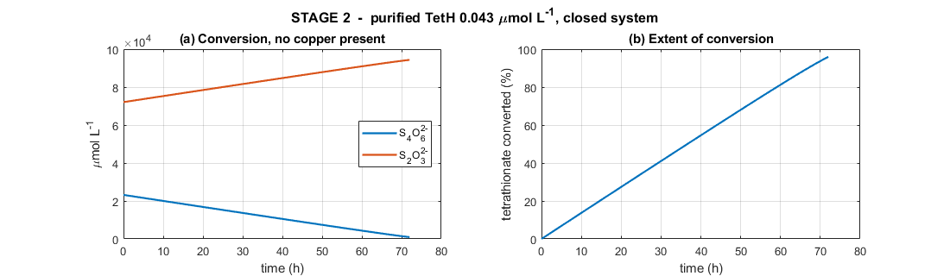
Figure 1. Stage 2: Purified TetH (0.043 µmol L⁻¹) acting on tetrathionate broth in a closed vessel. (a) conversion of tetrathionate to thiosulfate; (b) extent of conversion.
In a sequential model, tetrathionate shows the expected decreasing monotonic behaviour, falling from 23 200 to 941 µmol L⁻¹ as seen in Figure 1A. Meanwhile thiosulfate rises from 72 100 to 94 359 µmol L⁻¹ due to the lack of parasitic terms.
Figure 1B shows shows 95.9% conversion in three days at V_max = 5.375 µmol L⁻¹ min⁻¹. The reaction is effectively zero-order for almost the whole run: with 23 200 µmol L⁻¹ of substrate against K_m = 300, the saturation term is 0.987 initially, so the enzyme runs at its maximum rate until substrate is nearly exhausted. This could be why the curve is almost a straight line rather than an exponential decay curve.
The final product is 94.4 mM thiosulfate, which is close to the 0.1 M concentration reported as optimal for thiosulfate gold leaching. This is the single largest benefit of the sequential architecture: in the simultaneous model, thiosulfate and copper coexisted from the first minute and thiosulfate never accumulated beyond a few millimolar. Removing copper from this stage allows the full broth charge to be converted and banked before leaching begins.
Aiming for an enzyme concentration of E₂ = 0.043 µmol L⁻¹, conversion from tetrathionate ot thiosulphate takes 3 days and needs 9.1 L of culture per litre. Raising E₂ to 0.129 µmol L⁻¹ completes in 1 day but needs 27 L of culture; dropping to the in-situ value of 4.75×10⁻³ µmol L⁻¹ would take about 27 days. Thus, for practical engineering, trade-offs must be made between the needed size of the bacterial culture and the conversion time.

Stage 3: Leaching
The Stage-2 product stream is charged into the leaching vessel together with crushed PCB powder. There are no enzymes nor any tetrathionate feed, so thiosulfate has no source and can only be consumed.

3.1 Gold Leaching
Reactions
Gold is oxidised and complexed by thiosulfate in a single surface step ^{[8]}:
Au⁰ + 2S₂O₃²⁻ → Au(S₂O₃)₂³⁻ + e⁻ (anodic half-reaction)
4Au⁰ + 8S₂O₃²⁻ + O₂ + 2H₂O → 4Au(S₂O₃)₂³⁻ + 4OH⁻ (O₂ as terminal oxidant)
Copper leached from the board provides a second, faster oxidant pathway ^{[11][12]}:
Au⁰ + 2S₂O₃²⁻ + Cu(II) → Au(S₂O₃)₂³⁻ + Cu(I)
Gold Surface Area
Gold is a thin plated film, so it dissolves by thinning at constant face area until exhausted, independent of crush size:
$$A_{Au} = \frac{m_{Au}}{ρ_{Au}· t_{film}} = 2.07 × 10⁻³ m²$$
Model
Parallel oxidant pathways add; area, thiosulfate and passivation multiply. Oxygen enters only its own term, since Cu(II) does not require O₂ at the gold surface ^{[15]}:
$$R_{Au} = A_{Au}(t)·\frac{\left[S_{2}O_{3}^{2-}\right]}{K_{S}+\left[S_{2}O_{3}^{2-}\right]} · \left[k_{Au,O_{2}}·\frac{\left[O_{2}\right]}{K_{O_{2}}+\left[O_{2}\right]} + k_{Au,Cu}·\frac{\left[Cu\left(II\right)\right]}{K_{Cu}+\left[Cu\left(II\right)\right]} \right]$$
$$\frac{dn_{Au}}{dt} = -R_{Au}$$
$$d\frac{\left[AuO_{3}^{2-}\right]}{dt} = +\frac{R_{Au}}{V}$$

3.2 Copper Leaching & the Cu(I)/Cu(II) balance
Copper’s leaching is also modelled for two primary reasons:
- Cu(II) acts as a catalyst for gold leaching, leading to a faster leaching time. However, Cu(II) is not added externally is produced natively by thiosulphate leaching/
- Cu(II) ions react with thiosulphate to produce tetrathionate. Thus, it is important to track them to see if copper leaching will have a negative impact on the leaching ligand.
Reactions
4Cu⁰ + O₂ + 8S₂O₃²⁻ + 2H₂O → 4[Cu(S₂O₃)₂]³⁻ + 4OH⁻ (O₂ route)
Cu⁰ + Cu²⁺ + 4S₂O₃²⁻ → 2[Cu(S₂O₃)₂]³⁻ (comproportionating)
4Cu(I) + O₂ + 2H₂O → 4Cu(II) + 4OH⁻ (re-oxidation)
2Cu(II) + 2S₂O₃²⁻ → 2Cu(I) + S₄O₆²⁻ (parasitic)
Copper surface area
Copper is bulk metal, so it follows shrinking-particle geometry ^{[14]}:
$$A_{Cu}\left(0\right)= 6·\frac{m_{Cu}}{(ρ_{Cu} · d)}$$
$$A_{Cu}(t) = A_{Cu}(0) · {\left(\frac{n_{Cu}}{n_{Cu}\left(0\right)}\right)}^{\frac{2}{3}}$$
Rates
$$v_{1A} = {2k}_{Cu,O_{2}}·A_{Cu}\left(t\right)·\frac{\left[O_{2}\right]}{K_{O_{2}}+\left[O_{2}\right]}·\frac{\left[S_{2}O_{3}^{2-}\right]}{K_{S}+\left[S_{2}O_{3}^{2-}\right]}$$
$$v_{1B} = A_{Cu}(t)·\frac{\left[S_{2}O_{3}^{2-}\right]}{K_{S}+\left[S_{2}O_{3}^{2-}\right]}·\{ {2k}_{Cu,O_{2}}·\frac{\left[O_{2}\right]}{K_{O_{2}}+\left[O_{2}\right]} + {4k}_{Cu, Cu^{2+}}·\frac{\left[Cu\left(II\right)\right]}{K_{Cu}+\left[Cu\left(II\right)\right]} \}$$
$$v₂ = R_{Au} (gold-leaching rate, Section 4)$$
$$v₃ = k₃·[Cu(II)]·[S₂O₃²⁻]$$
$$v₄ = k₄·[O₂]·[Cu(I)]$$
Parameters
Symbol | Meaning | Unit | Value / source
n_Au | Solid gold remaining | µmol | state variable; initial 101.5
n_Cu | Solid copper remaining | µmol | state variable; initial 472 069
A_Au | Exposed gold area (thin film, constant) | m² | 2.07×10⁻³
A_Cu | Exposed copper area (shrinking particle) | m² | 3.35×10⁻³ initial
m_Au / m_Cu | Metal mass on the boards | Kg | 20×10⁻⁶ / 30×10⁻³ (100 g L⁻¹ PCB)
ρ_Au / ρ_Cu | Metal densities | kg m⁻³ | 19 300 / 8 960
t_film | Gold plating thickness | M | 0.5×10⁻⁶
D | Crushed particle size | M | 6×10⁻³
k_Au,O₂ | Gold rate constant, O₂ route | µmol m⁻² min⁻¹ | 6 [9][10]
k_Au,Cu | Gold rate constant, Cu(II) route | µmol m⁻² min⁻¹ | 21.0 (ammonia-free) [20] / 1500 (with ammonia) [11][12]
k_Cu,O₂ / k_Cu,Cu | Copper rate constants | µmol m⁻² min⁻¹ | 200 / 200 [13]
K_O₂ | O₂ half-saturation | µmol L⁻¹ | 50 [10]
K_S | Thiosulfate half-saturation | µmol L⁻¹ | 3,376 (= 1/K_ads) [18]
K_Cu | Cu(II) half-saturation | µmol L⁻¹ | 5×10⁴ [12]
k₁, k₃ | Parasitic rate constants | L µmol⁻¹ min⁻¹ | 1.20×10⁻⁵ (ammonia-free)/ 1×10⁻⁵ (with ammonia) [6][7]
k₄ | Cu(I) re-oxidation rate constant | L µmol⁻¹ min⁻¹ | 1×10⁻⁴ [7]
[O₂] | Dissolved oxygen (held constant) | µmol L⁻¹ | 500
Assumptions
The following assumptions were made when creating this model:
- Metallic gold is assumed to be a shrinking surface area due to its presence as thin metal surfaces.
- Metallic copper is assumed to be a shrinking volume due to its large presence in PCBs.
- Environmental conditions (pH, temperature, pulp density, agitation rate, etc) are optimised for gold leaching.
- There is no sulphur fouling on PCB particles.
- Oxygen is in excess.
- There are idealised physics conditions (perfect mixing, no mass-transfer resistance, uniform spherical particles with no agglomeration, isothermal operation, and a uniform gold film thickness across all particles)
- Other metals and their associated ions are not leached and thus have no influence on thiosulphate concentrations.
- Au(S₂O₃)₂³⁻, tetrathionate and thiosulphate are fully stable and does not degrade. No other sulphur species are relevant or present.
- A pulp density of 10% is optimum for gold leaching.
Analysis
WITH AMMONIA [266 mM]
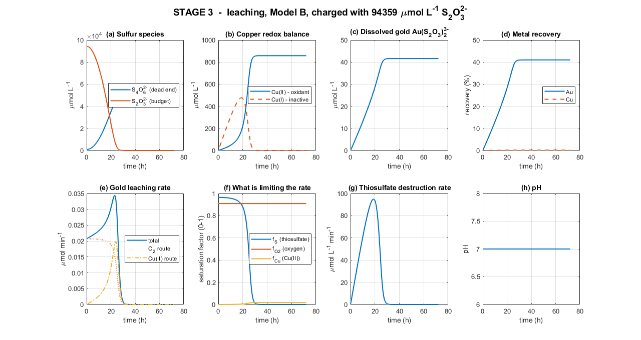
Figure 2. Stage 3 with ammonia — leaching over 72 h, charged with 94 359 µmol L⁻¹ thiosulfate from Stage 2. (a) sulfur species; (b) copper redox balance; (c) dissolved gold; (d) metal recovery; (e) gold leaching rate resolved by oxidant route; (f) saturation factors; (g) thiosulfate destruction rate; (h) pH.
Leaching seems to occur in two phases again. During the first 29 hours, thiosulfate is abundant (f_S ≈ 0.96) and gold leaching proceeds close to its saturated maximum. However, as copper dissolves, Cu(II) accumulates, and the Cu(II) oxidant route progressively switches on until at the rate peak of 0.0344 µmol min⁻¹ at 22.7 hours the two routes contribute almost equally (45% O₂, 55% Cu(II)). Gold recovery reaches 36.6% at 24 hours. Meanwhile, copper recovery is minimal. This is because, relative to the concentration of copper in PCBs, the amount leached is negligible.
In the second phase, after 29h of reactions, where a maximum of 40.97%, reactions stop due to lack of thiosulphate ions, due to Cu(II)’s reversion of it to tetrathionate. As seen in Figure 2F, thiosulphate saturation f_S collapses from 0.96 to near zero while f_O₂ remains flat at 0.91 and f_Cu continues to rise. Cu(II) is at its maximum of 858 µmol L⁻¹ precisely when leaching ceases. Thus, thiosulphate concentration is once again the limiting factor for gold leaching.
Looking at the table below, thiosulphate consumption is broken down.

Sink | Amount consumed (µmol L⁻¹) | Share
Gold leaching (2 per Au) | 83.2 | 0.088 %
Copper leaching | ≈ 1721.8 | 1.812 %
Parasitic Cu(II) reaction | 92554 | 98.1 %
Total consumed | 94359 | 100 %

WITHOUT AMMONIA [0 mM]
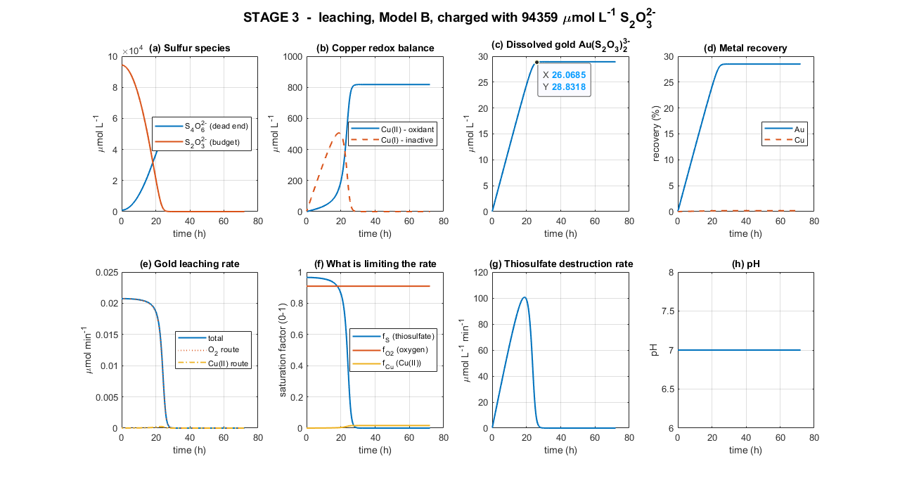
Figure 3. Stage 3 without ammonia — leaching over 72 h, charged with 94 359 µmol L⁻¹ thiosulfate from Stage 2. (a) sulfur species; (b) copper redox balance; (c) dissolved gold; (d) metal recovery; (e) gold leaching rate resolved by oxidant route; (f) saturation factors; (g) thiosulfate destruction rate; (h) pH.

The addition of a thiosulphate-protecting ligand, such as ammonia, prevents thiosulphate leaching and ultimately increased gold leaching. In a thiosulphate gold leaching solution, ammonia does the following:
● Slows the thiosulphate depletion reaction (k_1 and k_3) since ammonia competes with thiosulphate for Cu(II) binding.
● Catalyses gold leaching up to an optimum, then declines.
● Slows Cu(I) oxidation by oxygen (k_4)
With the corrected ammonia-free k_Au,Cu, the Cu(II) route never becomes competitive: f_Cu peaks at only 0.0149, so the Cu(II)-catalysed pathway contributes essentially nothing to gold leaching at any point in the run: R_Au is carried entirely (100%) by the O₂ route throughout. The characteristic shape of Figure 2E therefore also changes: instead of rising to a peak as Cu(II) builds up, the rate starts near its maximum (0.0207 µmol min⁻¹ at 0.6 hours, while f_S is still near its initial 0.965) and declines monotonically as thiosulfate is consumed. Gold recovery reaches ~19.69% at 24 hours.
Because the gold rate no longer depends on Cu(II), the collapse of thiosulfate is now the only thing that matters. As seen in Figure 2F, f_S falls below 0.5 by 23.7 hours and is effectively zero by 26–28 hours, while f_O₂ remains flat at 0.91. Gold recovery is 28.93% by 72 hours. Majority of it (~19.69%) already banked by 24 hours. Cu(II) continues to accumulate well after leaching has stopped, reaching its maximum of 818 µmol L⁻¹ at ~36 hours: more than a day after there is no thiosulfate left for it to act on. Thiosulfate concentration is therefore the limiting factor for gold leaching, exactly as before, but the mechanism by which copper contributes to the problem has changed: it no longer offers a meaningful leaching benefit in exchange for the thiosulfate it destroys.
Sink | Amount consumed (µmol L⁻¹) | Share
Gold leaching (2 per Au) | 57.9 | 0.061 %
Copper leaching | ≈ 1 640 | 1.7 %
Parasitic Cu(II) reaction | 92 661 | 98.2 %
Total consumed | 94 359 | 100 %

Limitations
- The parasitic constants are borrowed. k₄ has no come from ammoniacal systems, where ammonia deliberately stabilises Cu(II) has no reported ammonia-free value in the accessible literature and remains an unmeasured, borrowed parameter.
- Enzyme kinetics are optimal-condition values. k_cat = 125 min⁻¹ derives from assays at pH 3, 30 °C with molar sulfate. Stage 2 would need to run near those conditions to achieve the modelled conversion rate, which conflicts with the alkaline conditions thiosulfate prefers.
- Oxygen is imposed, not solved. [O₂] is held at 500 µmol L⁻¹, so the flat f_O₂ trace in Figure 2(f) is an assumption. A real reactor would show depletion during peak copper oxidation.
- Idealised physics. Perfect mixing, no mass-transfer resistance, uniform spherical particles, isothermal operation, and a uniform gold film thickness across all particles.

Recommendations
- Consider a copper pre-leach. Removing copper before gold leaching eliminates the problem at source, at the cost of an extra unit operation.
- Run Stage 3 for one day with ammonia, not three. The extra 48 hours add 3.3 percentage points. Batch turnaround is worth more than residence time.
- Choose Stage-2 duration deliberately. Enzyme loading trades directly against culture volume: 3 days needs 9 L of culture per litre, 1 day needs 27 L.

Supplementary Material: Calculated Parameters
k_syn
Reasoning: Built on protein synthesis model with a full collapsed expression. From the golB site density model, the number of active proteins secreted by a bacteria can be modelled as
$$\frac{dP_{a}}{dt}=\frac{f∙α∙N∙β∙k_{sec}}{(δ_{m}+μ)(k_{sec}+δ_{c}+μ)(δ_{p}+μ)}$$

Using the parameters below based on standard E. coli production values, the final k_syn term was calculated.
Symbol | Value | Unit
F | 0.5 | —
Α | 0.5 | mRNA copy⁻¹ min⁻¹
N | 20 | copies cell⁻¹
Β | 4.0 | protein mRNA⁻¹ min⁻¹
k_sec | 0.10 | min⁻¹
δ_m | 0.139 | min⁻¹
δ_c | 0.005 | min⁻¹
δ_p | 0.005 | min⁻¹
Μ | 0.0173 | min⁻¹
k_deg | 0.0011 | min⁻¹
N_A | 6.022×10¹⁷ | moleculesµmol⁻¹

$$\frac{dP_{a}}{dt}=\frac{0.5 × 0.5 × 20 × 4.0 × 0.10}{0.1563 × 0.1223 × 0.0223}=\frac{2}{4.26275427×{10}^{-4}}$$

$$\frac{dP_{a}}{dt}=4691.81 proteins∙{cell}^{-1}∙\min^{-1}$$
Converting this number of enzymes to a concentration can be done in the following manner.
$$\left[E\right]=P_{a}×\frac{X}{N_{A}}$$
Furthermore, at steady state…
$$\left[E\right]=\frac{k_{syn}∙X}{(k_{deg}+μ)}→\frac{k_{syn}∙X}{(k_{deg}+μ)}=P_{a}×\frac{X}{N_{A}}→k_{syn}=\frac{P_{a}∙(k_{deg}+μ)}{N_{A}}$$
$$k_{syn}=1.43356 ×{10}^{-16}µmol cell⁻¹ min⁻¹$$

k_cat
Reasoning: No specific turnover number has been established for bacterial TetH. Thus, it is derived from specific numbers that exist. The reported TetH activity when expressed in E. coli can be modelled as 2.2 U mg⁻¹ . TetH has a subunit mass of 50 kDa.
$$1 U ≡ 1 µmol substrate min⁻¹ mg⁻¹ enzymE$$
$$50 kDa = 50 000 g mol⁻¹ = 50 000 mg mmol⁻¹ = 50 mg µmol⁻¹$$
$$k_{cat} = 2.5 µmol min⁻¹ mg⁻¹ × 50 mg µmol⁻¹ = 125 min⁻¹$$

K_S
Reasoning: Thiosulphate has an adsorption equilibrium constant K_ads = 172–510 M⁻¹ (Senanayake 2005 [18]). A A Langmuir half-saturation is the reciprocal of the adsorption constant:
$$K_{S} =\frac{1}{K_{ads}}$$

$$K_{ads} = 172 M⁻¹ → K_{S} = 5 814 µmol L⁻¹$$
$$K_{ads} = 341 M^{-1} → K_{S} = 2 933 µmol L^{-1} \left(arithmetic mean\right)$$
$$K_{ads} = 510 M⁻¹ → K_{S} = 1 961 µmol L⁻¹$$

Thus, the base value used is the midpoint value for the adsorption constant. However, the maximum value of the K_ads range is at least 3 times larger than the minimum. Thus, K_ads is multiplicative, and not additive. Thus, the geometric mean is more appropriate.
$$K_{ads}={\left(172×510\right)}^{\frac{1}{2}}≈296 µmol L^{-1}→ K_{S} = 3 376 µmol L^{-1}$$

A_Cu
Reasoning: Copper is bulk metal in PCBs and thus, erodes inward. A_Cu ∝ 1/d, meaning crush size heavily impacts copper leaching. Assuming that copper makes up 30% of all PCBs on average and spherical PCB PARTICLES…
$$m_{Cu}= 30×10⁻³ kg, ρ_{Cu} = 8 960 kg m⁻³, d = 6×10⁻³ m$$

For spheres, A/V = 6/D, and total volume = m/ρ. Thus…
$$A_{Cu}\left(0\right)= 6·\frac{m_{Cu}}{ρ_{Cu} · d}= \frac{{6 × 30×10}^{-3}}{8 960 × 6×10⁻³} = \frac{0.18}{53.76}= 3.348×10⁻³ m²$$

To make the volume time dependent, ratios can be used. Area ∝ r² and volume ∝ r³. Therefore, A ∝ V^(2/3). Thus,
$$A_{Cu}(t) = A_{Cu}(0) · {\left(\frac{n_{Cu}}{n_{Cu,0}}\right)}^{\frac{2}{3}}$$

n_Au, n_Cu
Reasoning: Assuming that gold and copper make up 0.02% and 30% of a given PCB mass respectively, and that 100g of PCB will be dissolved per liter…
$$n_{Au} = \frac{20×10⁻⁶ kg}{196.97×10⁻³ kg mol^{-1} × {10}^{6}} = 101.5 µmol$$
$$n_{Cu} = \frac{30×{10}^{-3}kg}{63.55×10⁻³ kg mol⁻¹ × 10⁶} = 472069 µmol$$

$$Cu : Au molar ratio = \frac{472 069}{101.5} = 4 651 : 1$$

S₄O₆²⁻ (0) and S₂O₃²⁻ (0)
Reasoning: Using the standard tetrathionate broth protocol, the initial conditions for tetrathionate and thiosulphate were calculated. Starting with 30 g L⁻¹ Na₂S₂O₃·5H₂O in the 46 g L⁻¹ base, plus 6 g I₂ per 20 mL added to 1 L…
$$Thiosulfate in base: \frac{30}{248.18} = 120.88 mmol$$
$$Iodine added: \frac{6}{253.81} = 23.64 mmol$$

Based on the reaction below, the amount of thiosulphate produced and tetrathionate produced is as stated.
Reaction: I₂ + 2S₂O₃²⁻ → 2I⁻ + S₄O₆²⁻ (iodine is limiting)

$$Thiosulfate consumed = 2 × 23.64 = 47.28 mmol$$
$$Thiosulfate left = 120.88 - 47.28 = 73.60 mmol$$

$$Dilution: final volume = 1.02 L$$

$$[S₄O₆²⁻] =\frac{23.64}{1.02} = 23.2 mM = 23 200 µmol L⁻¹$$
$$[S₂O₃²⁻] =\frac{73.60}{1.02} = 72.1 mM = 72 100 µmol L⁻¹$$
μ (Growth Dilution Rate)
Reasoning: Assuming a double time of 40 min…
$$\frac{ln⁡(2)}{t_{double}} =\frac{0.6931}{40 min}=0.01733 min⁻¹$$

k_Au,O₂
Reasoning: Literature gives a magnitude of 10⁻⁷ mol m⁻² s⁻¹. Assuming a coefficient of 1.0…
$$1.0×10⁻⁷ mol m⁻² s⁻¹ × 10⁶ µmol/mol × 60 s/min = 6 µmol m⁻² min⁻¹$$

Intervention 1: No Excess Oxygen
Because of the assumption of excess oxygen I the gold leaching model, Cu(I) produced in copper leaching can continuously be oxidised into Cu(II), which parasitises available thiosulphate into tetrathionate. This alternative of the gold leaching model explores if oxygen produced from an air pump, not in excess, still leads to excessive Cu(II) and thus limited thiosulphate.

Reactions

4Au⁰ + 8S₂O₃²⁻ + O₂ + 2H₂O → 4Au(S₂O₃)₂³⁻ + 4OH⁻ (Gold leaching, O₂ route)
$$R_{Au} = A_{Au}(t)·\frac{\left[S_{2}O_{3}^{2-}\right]}{K_{S}+\left[S_{2}O_{3}^{2-}\right]} · \left[k_{Au,O_{2}}·\frac{\left[O_{2}\right]}{K_{O_{2}}+\left[O_{2}\right]} + k_{Au,Cu}·\frac{\left[Cu\left(II\right)\right]}{K_{Cu}+\left[Cu\left(II\right)\right]} \right]$$
Oxygen Used: $0.25R_{Au}$

4Cu⁰ + O₂ + 8S₂O₃²⁻ + 2H₂O → 4[Cu(S₂O₃)₂]³⁻ + 4OH⁻ (Copper leaching, O₂ route)
$$R_{Cu} = A_{Cu}(t)·\frac{\left[S_{2}O_{3}^{2-}\right]}{K_{S}+\left[S_{2}O_{3}^{2-}\right]}·\{ {2k}_{Cu,O_{2}}·\frac{\left[O_{2}\right]}{K_{O_{2}}+\left[O_{2}\right]} + {4k}_{Cu, Cu^{2+}}·\frac{\left[Cu\left(II\right)\right]}{K_{Cu}+\left[Cu\left(II\right)\right]} \}$$
Oxygen Used: $0.25R_{Cu}$
4Cu(I) + O₂ + 2H₂O → 4Cu(II) + 4OH⁻ (re-oxidation)
$$v_{4}= k_{4}· \left[O_{2}\right]· \left[Cu\left(I\right)\right]$$
Oxygen Used: ${0.25 v}_{4}$
However, oxygen is pumped into the bioreactor by an air pump. The concentration of oxygen pumped into the bioreactor can be modelled as a kLA value, which describes how well oxygen dissolves into water.
$$kLa = C·{\left(\frac{P}{V}\right)}^{a}·{\left(u_{g}\right)}^{b}$$
Where C, a, and b are constants that depend on the behaviour of the solvent. If a solvent is coalescing, bubbles readily merge back together into bigger bubbles once they form; this happens in clean water with no dissolved salts or surfactants to keep them. If a solvent is non-coalescing, dissolved ions get in the way of bubbles merging, so you end up with many small bubbles instead of a few big ones. As the bioreactor will have many dissolved ions, the leachate shall by modelled as a non-coalescing fluid.
$$kLa = 0.002·{\left(\frac{P}{V}\right)}^{0.70} ·{\left(u_{g}\right)}^{0.20}$$
Where u_g and P/V are the pump’s airflow expressed as an air velocity and the stirrer’s input expressed as a power input per volume respectively. Using these standard air pump and stirrer speeds below and the equations below, a standard kLA value was calculated.
$$u_{g}=\frac{Q_{air}}{A_{x}}$$

Symbol | Meaning | Value used | Unit | Source
Q_air | Air pump flow rate | 3.5 | L/min | Equipment specs
D_T | Tank internal diameter | 0.1 | M | Equipment specs
A_x | Cross-sectional area of the tank | 9.503×10⁻³ (calculated) | m² | Derived: π·(0.11)²/4
u_g | Superficial gas velocity | 1.06×10⁻³ (calculated) | m/s | Derived: Q_air/A_x

$$\frac{P}{V}= 0.6·N_{p}·ρ·{\left(\frac{rpm}{60}\right)}^{3} ∙\frac{D_{i}^{5}}{V}$$
Symbol | Meaning | Value used | Unit | Source
Rpm | Stirrer rotation speed | 800 | rev/min | Equipment specs
N_p | Shaped-based power number | 5.0 | dimensionless | Standard engineering constant for a Rushton turbine (a flat-bladed disc impeller); tabulated in mixing handbooks (e.g. Van't Riet's own paper, and standard bioreactor engineering references like Garcia-Ochoa & Gomez 2009)
Ρ | Density of the liquid being stirred | 1000 | kg/m³ | Standard physical constant for water at ~25°C
D_i | Impeller diameter | 0.04 | M | Equipment specs
V | Working liquid volume | 0.001292 | m³ | Equipment specs
0.6 | Gassing correction factor | 0.6 | dimensionless | Empirical rule of thumb from bioreactor engineering literature
P/V | Power input per unit volume | 307.2 (calculated) | W/m³ | Derived from the equation above

Therefore,
$$kLA= 0.002∙{\left(\frac{P}{V}\right)}^{0.70}·{\left(u_{g}\right)}^{0.20}=1.68082 \min^{-1}$$
Multiplying this term by a saturation effect based on the maximum concentration of oxygen water can naturally hold, the rate at which oxygen supplied to the leachate is derived.
$$Supply=kLA×\left(C^{*}-\left[O_{2}\right]\right)$$
Where C* is the maximum ceiling of oxygen water can hold is derived. Thus, oxygen in the leachate can be modelled as the following:
$$\frac{d[O_{2}]}{dt}=kLA×\left(C^{*}-\left[O_{2}\right]\right)-\left(\frac{0.25R_{Au}+0.25R_{cu}}{4V}+0.25v_{4}\right)$$

Parameters
Symbol | Meaning | Unit | Value / source
[O₂] | Dissolved oxygen concentration | µmol L⁻¹ | state variable; initial 259 (air-saturated water at t=0 — see note below)
Q_air | Air pump flow rate | L min⁻¹ | Equipment specs
Rpm | Stirrer rotation speed | rev min⁻¹ | Equipment specs
D_T | Tank internal diameter | M | Equipment specs
D_i | Impeller diameter | M | Equipment specs
V | Working liquid volume | m³ | Equipment specs
A_x | Tank cross-sectional area | m² | 7.854×10⁻³ [Derived]
u_g | Superficial gas velocity | m s⁻¹ | 1.06×10⁻³ (= Q_air/A_x, derived)
N_p | Power number (impeller shape factor) | — | 5.0; standard constant for a Rushton turbine [Van't Riet 1979]
Ρ | Liquid density | kg m⁻³ | 1000; standard physical constant, water at 25°C
gassing factor | Power reduction under aeration | — | 0.6;[Garcia-Ochoa & Gomez 2009]
P/V | Power input per unit volume | W m⁻³ | 307.2 [Derived]
kLa | Volumetric O₂ mass transfer coefficient | min⁻¹ | 1.68 [Derived] [Van't Riet 1979]
C* | O₂ saturation concentration (air, 25°C) | µmol L⁻¹ | 259 [APHA Standard Methods DO tables; cross-checked via Henry's Law, k_H=769 L·atm/mol]

Assumptions
- Van't Riet's kLa fitted correlation match the bioreactor’s geometry fitted on other people's vessels, not yours — a real gassing-out measurement would replace it.
- Non-coalescing (salty) correlation form assumed appropriate for a 94 mM thiosulfate liquor.
- C* = 259 µmol/L assumes air-saturated pure water at 25°C with a small salting-out correction/
- O₂ consumption counts only the direct O₂-route reactions (R_Au,O2, v1A, v4).
- Perfect mixing assumed.
- Temperature fixed at 25°C throughout (kLa, C*, and all rate constants are temperature-independent in this model).
Analysis
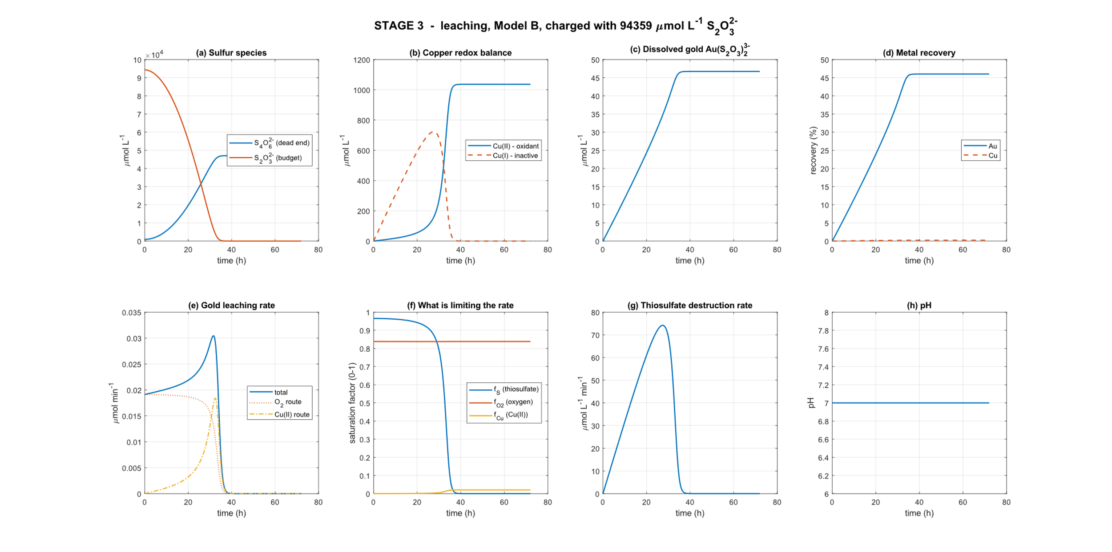
Figure 4. Stage 3 with pump-limited oxygen— leaching over 72 h, charged with 94 359 µmol L⁻¹ thiosulfate from Stage 2. (a) sulfur species; (b) copper redox balance; (c) dissolved gold; (d) metal recovery; (e) gold leaching rate resolved by oxidant route; (f) saturation factors; (g) thiosulfate destruction rate; (h) pH.

With excess oxygen saturation, thiosulphate depletion happens within the first 29 hours. With pump-limited oxygen saturation, this collapse is not prevented, merely delayed by around 8-9h. Figure 4B shows the reason why. Due to limited oxygen, Cu(II) is produced at a slower rate. Thus, there is more available thiosulphate, leading to a higher gold leaching peak of 46.02% compared to excess oxygen’s 40.97%. However, the excess oxygen reaches a higher, earlier leaching rate peak at ~26h due to having more Cu(II) as a catalyst, even though it also leads to a faster thiosulphate depletion. Meanwhile, the pump-limited oxygen reaches a later peak, around 34h.
If leaching is done in 72h cycles, then pump-limited oxygen provides the best net effect. However, if leaching is done is 24h cycles, then excess oxygen works best (36.6% vs 29.84%). Thus, the most efficient route depends on the leaching time and pump specifications. Further sweep studies will need to be done to see the effect of varying pump specifications on leaching efficiency.
However, pump-limited oxygen seems to have a net positive effect on gold leaching efficiency, regardless of the presence of ammonia. Without ammonia, percentage of gold recovered jumps from 28.93 to 35.98%, showing a ~7% increase.

Intervention 2: Gold Occurrence
The leaching phase assumes ideal physics, specifically, that all particles carry gold and that all particles are spherical. These assumptions are load-bearing because gold is only plated on certain parts of a PCB: surface pads, edge connectors, and through-hole barrels. Most of the board contains no gold at all. So, after crushing, some particles carry gold and some do not.
Thus, this intervention replaces the “all particles” assumption with a statistical one. Whether each particle has gold is treated as a yes/no event, and the number of gold-bearing particles in a batch is counted with a Poisson distribution. This is the same approach used in gold assaying in geology and mining, where gold grains are scattered among many tons of waste ore.

Number of Particles in the Charge
Each particle is a sphere of dimater d, so the total number of particles/fragments of a PCB, using a PCB thickness, fragment diameter, and PCB mass and densities is
$$N = \frac{m_{PCB}}{ρ_{PCB} ·\frac{π}{6}*d^{3}}=\frac{0.100}{\left(2455 ×\frac{π}{6}×{\left(6×{10}^{-3}\right)}^{3}\right)}≈360 particles$$
Expected Number of Gold-Bearing Particles
$$A_{Au}=\frac{m_{Au}}{ρ_{Au}×t_{film}}=\frac{20×{10}^{-6}}{19300×0.5×{10}^{-6}}=20.73 cm^{2}$$
The expected number of gold-bearing particles is thus the total gold area divided by the area of one particle.
$$λ = \frac{A_{Au}}{d^{2}}=\frac{20.73}{0.36}=57.6$$
Each gold-bearing particle carriers $\frac{m_{Au}}{λ}=0.347$ mg of gold.

Bernoulli Trial For Each Particle
Each particle either carries gold or does no, which is a Bernoulli trial with probability
$$p=\frac{λ}{N}=\frac{57.6}{360}=0.16$$
Thus, about 16% of particles carry gold and 84% carry none. The number of gold-bearing particles in a batch, N_{g}, is the sum of N Bernoulli trials, which is binomial. When N is large and p is large, the binomial distribution approaches a Poisson distribution.
$P\left(N_{g}=k\right)=\frac{λ^{k}∙e^{-λ}}{k!}$, with a mean = variance = $λ$

The scatter between batches follows directly from the Poisson variance:
$$CV=\frac{σ}{λ}=\frac{√λ}{λ}=\frac{1}{√λ}=\frac{1}{√57.6}=13.2\%$$
This is known as the nugget effect. When only a few particles carry valuable material, the amount in one batches varies widely, simply from which particles end up in it. Thus, the amount of gold in particles that gets leached varies widely.

When linked to the model, each batch draws its own N_{g}. That batch’s gold area and mass both scale with N_{g.}
$$A_{Au},batch= N_{g}·d^{2}, n_{Au,batch}=n_{Au,0}·\left(\frac{N_{g}}{λ}\right)$$
These values enter the existing gold leaching rate unchanged:
$$R_{Au} =(k_{Au,O_{2}}·f_{O_{2}}+ k_{Au,Cu}· f_{Cu})·f_{S}· A_{Au,batch}$$
Symbol | Meaning | Unit | Value / source
D | Crushed particle diameter (sphere) | m | 6×10⁻³; operating choice
ρ_PCB | Density of populated WPCB | kg m⁻³ | 2455; rule of mixtures, 40/30/30 metallic/ceramic/polymer [Abbadi 2024]; 8960 Cu, 2540 E-glass, 1227 cured epoxy
m_PCB | PCB mass in charge | kg | 0.100 (100 g L⁻¹)
N | Total particles in charge | – | 360 (derived)
A_Au | Total gold surface area | cm² | 20.73 (derived)
Λ | Expected gold-bearing particles | – | 57.6 (= A_Au/d²)
P | Probability a particle carries gold | – | 0.16 (= λ/N)
m_carrier | Gold per gold-bearing particle | mg | 0.347
CV | Nugget scatter between batches | % | 13.2 (= 1/√λ)
M_min | Minimum assay sample for ±10% | g | 174 at 6 mm [Clifton et al. 1969; Gy 1982]
n_MC | Monte Carlo batches simulated | – | 1000
Results

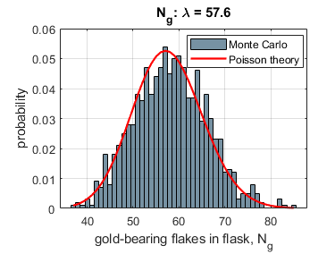 | 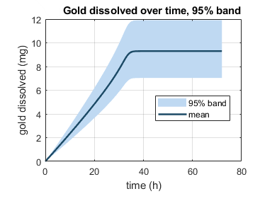

With a Monte Carlo simulation of 1000 batches, with copper treated as spheres and gold area kept constant, gold leached had a mean of 46.50%. The 95% range was 35.13% to 59.54%, which is −11.37 / +13.04 percentage points around the mean. The previous deterministic model, which assumes every particle carries gold, meanwhile, had an average 46.02%.
The spread matches a normal Poisson distribution curve. A CV of $13.2\%$ predicts a 95% confidence band of 26%. The actual spread is a near estimate, with ~24% band. The Monte Carlo mean is roughly equal to the deterministic value, which is within what a random sample of 1000 batches would be expected to show. Thus, for the average result, the assumption that all particles have gold holds. However, for batch-per-batch results, the assumption does not hold, and results generally fall between 35.12785% and 59.537%, or 11.37 / +13.04.

Revision 1: Particle Shape
The leaching model assumes crushed PCB particles are 6 mm spherical particles. However, printed PCBs are laminated sheets only about 1.6 mm thick, with ~ 3 mm as an upper limit [22]. Thus, 6 mm fragment cannot have a thickness that causes spherical shapes, even with significant circularity.

Shape matters because it sets surface area. A flaked exposes more surface area per unit mass than a sphere, so copper is more open to the leach. Thus, a new term shall be introduced, the Wandell sphericity, to the non-spherical particles into a sphere to not cause significant changes for gold and copper leaching.
$$ψ = \frac{A_{sphere}}{A_{actual}}$$
Where A_{sphere} is the surface area of a sphere and A_{actual} is the particle’s real surface area. ψ = 1 for a sphere and ψ < 1 for every other shape. Assuming a square plate of lateral dimension L and thickness h:
$$V = L^{2}h; A_{actual} = 2L² + 4Lh$$
$$d_{v} = {\left(\frac{6V}{π}\right)}^{\frac{1}{3}}$$
$$ψ = \frac{π d_{v}^{2}}{2L^{2} + 4Lh} = \frac{7.211×10⁻⁵}{1.104×10⁻⁴} = 0.653$$
For a sphere, surface area is 6/ρd . A non-spherical particle has 1/$ψ$times more surface area for the same volume. Thus, copper’s area would be the following:
$$A_{Cu,0} = \frac{6 m_{Cu}}{ρ_{Cu} · d}=\frac{6 ∙0.030}{ 8960· 0.006 }=33.48 {cm}^{2}$$
$$A_{Cu,0} = \frac{6 m_{Cu}}{ρ_{Cu} · d · ψ}=\frac{6 ∙0.030}{ 8960· 0.006 ·0.653}=51.25 {cm}^{2}$$
The new surface area is ~1.5 times the original one.

Treating particles as flakes also changes the particle count.
$$N = \frac{m_{PCB}}{ρ_{PCB} · d^{2} · h}=\frac{0.100}{\left(2455 ×3.6 ×{10}^{-5}×1.6×{10}^{-3}\right)}≈707 particles$$
However, time is not affected, as Gold is a 0.5 μm plated film, so its area is set by plating thickness, not particle shape.

Parameters
Symbol | Meaning | Unit | Value / source
D | Crushed particle diameter (sphere) | m | 6×10⁻³; operating choice
H | PCB laminate thickness | m | 1.6×10⁻³ [Abbadi 2024]
ρ_PCB | Density of populated WPCB | kg m⁻³ | 2455; rule of mixtures, 40/30/30 [Abbadi 2024]
V | Volume of one flake | m³ | 5.760×10⁻⁸ (= d²h)
d_v | Equal-volume sphere diameter | m | 4.792×10⁻³
Ψ | Wadell sphericity | – | 0.653 (derived) [Wadell 1935]
A_Cu,0 | Initial copper area, flake | cm² | 51.25 (sphere: 33.48)
N | Flakes in charge | – | 707
A_Au | Gold surface area | cm² | 20.73

Results

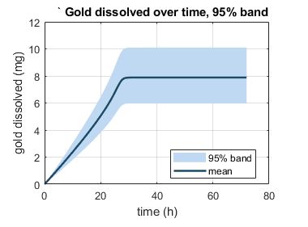
Switching copper from spheres to lowers gold leached after 72h. As there is a larger surface area of copper available, it is leached faster and thus uses up thiosulphate faster. Thus, gold leached drops from 46.02% to 39.02%, with thiosulphate being used up in 27.6 hours rather than the previous 34.2h.

Revision 2: Changing Gold Surface Area
The leaching model assumes the gold surface area stays constant at $A_{Au,0}=20.73 cm^{2}$ until the gold is used up. However, this assumption is load-bearing since gold-leaching rate is directly proportional to area. If area shrinks as gold dissolves, the rate falls with it.

Real plated films do not thin perfectly evenly. They dissolve at varying rates across various places, especiall pinholes, grain boundaries, and edges as they get thinner. This revision lets the gold area fall as gold dissolves.

Shrinking-surface equation.
The exposed gold area is linked to the fraction of gold remaining:
$$A_{Au}\left(t\right)=A_{Au,0}∙{\left(\frac{n_{Au}}{n_{Au,0}}\right)}^{γ}=A_{Au,0}×{\left(1-X\right)}^{γ}$$
The standard shrinking particle area exponents are as follows.
Shape | Dimensions that shrink, m | γ | What happens
Flat plate (film) | 1 (thickness only) | 0 | Area constant, film only thins
Long cylinder | 2 (radius) | 1/2 | Area falls with radius
Sphere | 3 (diameter) | 2/3 | Area falls in all directions

An ideal plated film is a flat plate, so γ = 0. This recovers the original constant-area model exactly. A real film that breaks up behaves partly like a plate and partly like shrinking patches, so 0 < γ. A 0.5 µm film is never a three-dimensional lump, so 2/3 is the upper bound. No fitted γ for a dissolving plated film was found in the literature. γ is therefore tested at 0, 1/3 (midpoint) and 2/3, and results are reported as a range.

This also actively affects the gold occurrence modelling changes made. Under occurrence modelling, the area lost can be read as gold-bearing particles going inactive as their gold is used up. The effective number of gold-bearing particles is
$$λ\left(t\right)=λ∙{\left(1-X\right)}^{γ}$$
Parameters
Symbol | Meaning | Unit | Value / source
A_Au,0 | Initial gold surface area | cm² | 20.73 (= m_Au/ρ_Au t_film)
n_Au,0 | Initial gold | µmol | 101.5 (20 mg)
X | Fraction of gold dissolved | – | Model output
γ | Area recession exponent | – | 0, 1/3, 2/3 [Levenspiel 1999]
m | Number of shrinking dimensions | – | 1 (plate), 2 (cylinder), 3 (sphere)
λ(t) | Live gold-bearing particles | – | λ(1 − X)^γ

Results
Results are calculated using pump-rated oxygen, gold occurrence modelling, and varying values of γ [0, 1/3, 2/3] to see the impact of varying values of gamma on gold leaching. Final values are tabulated below.
Copper shape | Γ | Recovery (%) | Gold leached (mg) | Change (percentage points) | Change in mg | Relative change
Spheres | 0 (baseline) | 46.02 | 9.20 | – | – | –
Spheres | 1/3 | 42.28 | 8.46 | −3.74 | −0.74 | −8.1%
Spheres | 2/3 | 39.32 | 7.86 | −6.70 | −1.34 | −14.6%
Flakes | 0 (baseline) | 39.02 | 7.80 | – | – | –
Flakes | 1/3 | 36.36 | 7.27 | −2.66 | −0.53 | −6.8%
Flakes | 2/3 | 34.17 | 6.83 | −4.85 | −0.97 | −12.4%

Thus, it s seen that allowing the gold area to recede lowers gold leached by 8.1% (γ=1/3) to 14.6% (γ = 2/3) relative to the constant area model. Thus, its effect is not negligible. For example, using γ = 2/3, the model change is as significant as the particle shape correction. However, γ=0 will be used because it is a defensive value in literature for a shrinking, one-dimensional flat plate with a small thickness relative to particle size, rather than $γ∈$ [0, 2/3], which are speculations.

References
[1] Y. Kanao et al., "Tetrathionate hydrolase from the acidophilic microorganisms," Front. Microbiol., vol. 15, 1338669, 2024.
[2] Y. Kanao, K. Kamimura, and T. Sugio, "Purification of a tetrathionate hydrolase from Acidithiobacillus ferrooxidans," J. Biotechnol., vol. 132, pp. 16–22, 2007.
[3] U. Alon, An Introduction to Systems Biology, 2nd ed. Boca Raton, FL: CRC Press, 2019.
[4] M. R. Maurizi, "Proteases and protein degradation in Escherichia coli," Experientia, vol. 48, pp. 178–201, 1992.
[5] G. E. Briggs and J. B. S. Haldane, "A note on the kinetics of enzyme action," Biochem. J., vol. 19, pp. 338–339, 1925.
[6] J. J. Byerley, S. A. Fouda, and G. L. Rempel, "Kinetics and mechanism of the oxidation of thiosulphate ions by copper(II) ions in aqueous ammonia solution," J. Chem. Soc. Dalton Trans., pp. 889–893, 1973.
[7] P. L. Breuer and M. I. Jeffrey, "The reduction of copper(II) and the oxidation of thiosulfate and oxysulfur anions in gold leaching solutions," Hydrometallurgy, vol. 70, pp. 163–173, 2003.
[8] G. Senanayake, "Analysis of reaction kinetics, speciation and mechanism of gold leaching and thiosulfate oxidation by ammoniacal copper(II) solutions," Hydrometallurgy, vol. 75, pp. 55–75, 2004.
[9] S. Zhang and M. J. Nicol, "An electrochemical study of the dissolution of gold in thiosulfate solutions Part I: Alkaline solutions," J. Appl. Electrochem., vol. 33, pp. 767–775, 2003.
[10] O. Sitando et al., "A review of factors affecting gold leaching in non-ammoniacal thiosulfate solutions," Hydrometallurgy, vol. 178, pp. 151–175, 2018.
[11] M. G. Aylmore and D. M. Muir, "Thiosulfate leaching of gold — a review," Miner. Eng., vol. 14, no. 2, pp. 135–174, 2001.
[12] D. Maharaj, T. Moyo, and J. Petersen, "Ammonium thiosulfate leaching of gold from electronic printed circuit boards," J. S. Afr. Inst. Min. Metall., vol. 124, no. 12, pp. 711–718, 2024.
[13] E. Salinas-Rodríguez et al., "Leaching of copper contained in waste printed circuit boards using the thiosulfate–oxygen system," Materials, vol. 15, no. 7, 2354, 2022.
[14] O. Levenspiel, Chemical Reaction Engineering, 3rd ed. New York, NY: Wiley, 1999.
[15] P. L. Breuer and M. I. Jeffrey, "An electrochemical study of gold leaching in thiosulfate solutions containing copper and ammonia," Hydrometallurgy, vol. 65, pp. 145–157, 2002.
[16] H. Bremer and P. P. Dennis, "Modulation of chemical composition and other parameters of the cell at different exponential growth rates," EcoSal Plus, vol. 3, no. 1, 2008.
[17] R. Milo et al., "BioNumbers — the database of key numbers in molecular and cell biology," Nucleic Acids Res., vol. 38, pp. D750–D753, 2010.
[18] G. Senanayake, "A surface adsorption/reaction mechanism for gold oxidation by copper(II) in ammoniacal thiosulfate solutions," J. Colloid Interface Sci., vol. 286, pp. 253–257, 2005.
[19] T. Kanao et al., "Recombinant tetrathionate hydrolase from Acidithiobacillus ferrooxidans requires exposure to acidic conditions for proper folding," FEMS Microbiol. Lett., vol. 309, no. 1, pp. 43–47, 2010.

