Bioleaching Modelling [Sequential] — Process Overview
Three-stage model: enzyme harvest → thiosulfate conversion → leaching
Unlike the simultaneous model, where it is assumed that the process is carried out simultaneously in one vessel, the sequential model assumes the bioleaching process occurs in three separate vessels. Bacteria express tetrathionate hydrolase (TetH), which is then harvested, extracted and purified. The purified enzyme is mixed with tetrathionate broth to generate thiosulfate. Only afterwards are crushed PCB powder and biosorbent cells introduced into the thiosulfate solution.
Stage | Vessel contents | Purpose
1 | E. coli culture | Express TetH, then harvest, extract and purify
2 | Purified TetH + tetrathionate broth | Convert tetrathionate to thiosulfate
3 | Thiosulfate liquor + crushed PCB | Leach gold (and unavoidably copper)

Separating the stages changes the simultaneous model structure in three ways:
- The enzyme concentration in Stage 2 becomes a fixed input rather than a state variable, so k_syn, k_deg and μ disappear from the reaction vessel because there are no cells in it.
- Stage 2 contains no copper, so the parasitic reaction and both leaching sinks vanish and what remains is a closed two-state system with an analytical solution.
- Stage 3 has no thiosulfate source: the leachant is a fixed budget charged at the start and depleted.

Stage 1: Enzyme Production and Harvest
Bacteria produce tetrathionate hydrolase, which is then extracted and purified. This stage determines how much enzyme is available per litre of culture, and therefore how much culture must be grown to charge Stage 2. It does not appear in the Stage-2 or Stage-3 differential equations.^{[1]}
Reaction
bacteria → TetH enzyme (E) → harvested, extracted, purified
Model
Within the culture vessel the enzyme is governed by production, first-order degradation and dilution by growth ^{[3]}:
$$\frac{d\left[E\right]}{dt} = k_{syn} · X - (k_{deg} + μ) · E$$
Because the culture reaches steady state in 1/(k_deg + μ) ≈ 55 min, far faster than any downstream process, only the steady state is needed:
$${\left[E\right]}_{culture} = \frac{k_{syn} · X}{k_{deg}+ μ} = 4.75 × 10⁻³ µmol L⁻¹ ≈ 2 860 molecules per cell$$
The culture volume required to charge one litre of Stage 2 to a target enzyme concentration E₂ follows directly:
$$\frac{V_{culture}}{V_{stage 2} } = \frac{E_{2}}{{\left[E\right]}_{culture}}$$
Parameters
Symbol | Meaning | Unit | Value / source
[E] | Active TetH in the culture | µmol L⁻¹ | 4.75×10⁻³ (steady state)
X | Biomass concentration | cell L⁻¹ | 1×10¹²
k_syn | Enzyme synthesis rate per cell | µmol cell⁻¹ min⁻¹ | 8.74×10⁻¹⁷ (cascade-matched) [17]
k_deg | Enzyme degradation rate | min⁻¹ | 1.1×10⁻³ [4]
Μ | Growth-dilution rate | min⁻¹ | 0.0173 (40 min doubling) [16]
Analysis
A litre of culture yields approximately 4.75 × 10⁻³ µmol L⁻¹ of TetH, if using generic E. Coli values for the enzyme production, rather than specific TetH parameter values. equivalent to about 2 860 molecules per cell — roughly 0.3% of the cell's total protein, which is a modest and realistic burden. Charging Stage 2 to 0.043 µmol L⁻¹ therefore requires 9.1 litres of culture per litre of conversion vessel, corresponding to 2.15 mg of purified TetH. The protein mass is trivial; the culture volume is the real constraint, and it is the quantity that expression engineering (promoter strength, copy number, RBS) acts on.

Stage 2: Tetrathionate to Thiosulfate
Reactions
TetH hydrolyses tetrathionate via a disulfane-monosulfonic-acid intermediate ^{[1]}, lumped into a single overall reaction:
S₄O₆²⁻ + H₂O → S₂O₃²⁻ + S⁰ + SO₄²⁻ + 2H⁺
Because there is no copper in this vessel, the parasitic regeneration reaction 2Cu(II) + 2S₂O₃²⁻ → 2Cu(I) + S₄O₆²⁻ cannot occur, and there is no gold or copper surface to consume thiosulfate. All loss terms vanish.
Feed Composition
The 46 g L⁻¹ broth base contains 30 g L⁻¹ sodium thiosulfate pentahydrate and no tetrathionate. Tetrathionate is generated in situ when the iodine solution (6 g I₂ + 5 g KI in 20 mL) is added at the point of use:
I₂ + 2S₂O₃²⁻ → 2I⁻ + S₄O₆²⁻
Iodine is the limiting reagent, so only part of the thiosulfate is converted:
30 g/L ÷ 248.18 g/mol = 120.88 mmol S₂O₃²⁻ 6 g ÷ 253.81 g/mol = 23.64 mmol I₂
→ S₄O₆²⁻ = 23.64/1.02 = 23.2 mM S₂O₃²⁻ = (120.88 − 47.28)/1.02 = 72.1 mM
Both are therefore initial conditions inherited from the medium, not model outputs.
Model
Consumption follows irreversible Michaelis–Menten kinetics ^{[5]}, with the enzyme concentration now a constant input:
$$\frac{d\left[S_{4}O_{6}^{2-}\right]}{dt} = - k_{cat} · E_{2}·\frac{\left[S_{4}O_{6}^{2-}\right]}{(K_m + [S₄O₆²⁻])}$$
$$\frac{d\left[S_{2}O_{3}^{2-}\right]}{dt} = Y· k_{cat} · E_{2}·\frac{\left[S_{4}O_{6}^{2-}\right]}{\left(K_{m}+ \left[S_{4}O_{6}^{2-}\right]\right)}$$
Since Y = 1, the total sulfur is conserved: [S₄O₆²⁻] + [S₂O₃²⁻] = constant. This gives a useful numerical check and means the integrated Michaelis–Menten equation can provide a final analytical solution.
$$K_{m}· ln\left(\frac{S_{0}}{S}\right) + (S₀ - S) = V_{max} · t where V_{max} = k_{cat} · E₂$$
Parameters
Symbol | Meaning | Unit | Value / source
[S₄O₆²⁻] | Tetrathionate concentration | µmol L⁻¹ | state variable; initial 23 200
[S₂O₃²⁻] | Thiosulfate concentration | µmol L⁻¹ | state variable; initial 72 100
E₂ | Purified TetH in the conversion vessel | µmol L⁻¹ | 0.043 (design variable)
k_cat | Turnover number of TetH | min⁻¹ | 125 (2.5 U mg⁻¹ × 50 kDa) [1][2]
K_m | Michaelis constant | µmol L⁻¹ | 300 (species range 50–2400) [2]
Y | Stoichiometric yield (S₂O₃ per S₄O₆) | — (dimensionless) | 1 [1]
t₂ | Stage-2 duration | Min | 4 320 (3 days)
Analysis
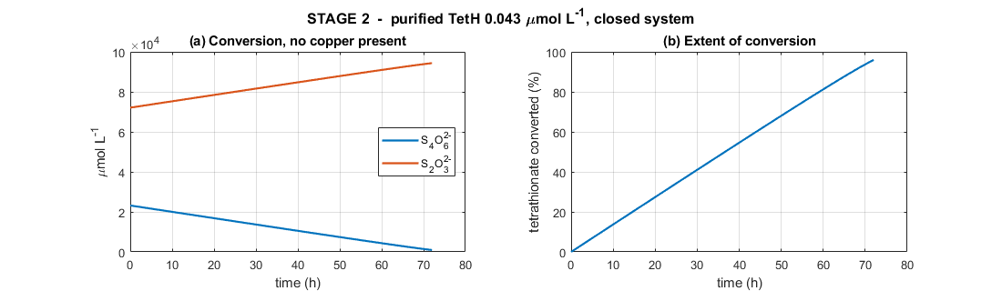
Figure 1. Stage 2: Purified TetH (0.043 µmol L⁻¹) acting on tetrathionate broth in a closed vessel. (a) conversion of tetrathionate to thiosulfate; (b) extent of conversion.
In a sequential model, tetrathionate shows the expected decreasing monotonic behaviour, falling from 23 200 to 941 µmol L⁻¹ as seen in Figure 1A. Meanwhile thiosulfate rises from 72 100 to 94 359 µmol L⁻¹ due to the lack of parasitic terms.
Figure 1B shows shows 95.9% conversion in three days at V_max = 5.375 µmol L⁻¹ min⁻¹. The reaction is effectively zero-order for almost the whole run: with 23 200 µmol L⁻¹ of substrate against K_m = 300, the saturation term is 0.987 initially, so the enzyme runs at its maximum rate until substrate is nearly exhausted. This could be why the curve is almost a straight line rather than an exponential decay curve.
The final product is 94.4 mM thiosulfate, which is close to the 0.1 M concentration reported as optimal for thiosulfate gold leaching. This is the single largest benefit of the sequential architecture: in the simultaneous model, thiosulfate and copper coexisted from the first minute and thiosulfate never accumulated beyond a few millimolar. Removing copper from this stage allows the full broth charge to be converted and banked before leaching begins.
Aiming for an enzyme concentration of E₂ = 0.043 µmol L⁻¹, conversion from tetrathionate ot thiosulphate takes 3 days and needs 9.1 L of culture per litre. Raising E₂ to 0.129 µmol L⁻¹ completes in 1 day but needs 27 L of culture; dropping to the in-situ value of 4.75×10⁻³ µmol L⁻¹ would take about 27 days. Thus, for practical engineering, trade-offs must be made between the needed size of the bacterial culture and the conversion time.

Stage 3: Leaching
The Stage-2 product stream is charged into the leaching vessel together with crushed PCB powder. There are no enzymes nor any tetrathionate feed, so thiosulfate has no source and can only be consumed.

3.1 Gold Leaching
Reactions
Gold is oxidised and complexed by thiosulfate in a single surface step ^{[8]}:
Au⁰ + 2S₂O₃²⁻ → Au(S₂O₃)₂³⁻ + e⁻ (anodic half-reaction)
4Au⁰ + 8S₂O₃²⁻ + O₂ + 2H₂O → 4Au(S₂O₃)₂³⁻ + 4OH⁻ (O₂ as terminal oxidant)
Copper leached from the board provides a second, faster oxidant pathway ^{[11][12]}:
Au⁰ + 2S₂O₃²⁻ + Cu(II) → Au(S₂O₃)₂³⁻ + Cu(I)
Gold Surface Area
Gold is a thin plated film, so it dissolves by thinning at constant face area until exhausted, independent of crush size:
$$A_{Au} = \frac{m_{Au}}{ρ_{Au}· t_{film}} = 2.07 × 10⁻³ m²$$
Model
Parallel oxidant pathways add; area, thiosulfate and passivation multiply. Oxygen enters only its own term, since Cu(II) does not require O₂ at the gold surface ^{[15]}:
$$R_{Au} = A_{Au}(t)·\frac{\left[S_{2}O_{3}^{2-}\right]}{K_{S}+\left[S_{2}O_{3}^{2-}\right]} · \left[k_{Au,O_{2}}·\frac{\left[O_{2}\right]}{K_{O_{2}}+\left[O_{2}\right]} + k_{Au,Cu}·\frac{\left[Cu\left(II\right)\right]}{K_{Cu}+\left[Cu\left(II\right)\right]} \right]$$
$$\frac{dn_{Au}}{dt} = -R_{Au}$$
$$d\frac{\left[AuO_{3}^{3-}\right]}{dt} = +\frac{R_{Au}}{V}$$

3.2 Copper Leaching & the Cu(I)/Cu(II) balance
Reactions
4Cu⁰ + O₂ + 8S₂O₃²⁻ + 2H₂O → 4[Cu(S₂O₃)₂]³⁻ + 4OH⁻ (O₂ route)
Cu⁰ + Cu²⁺ + 4S₂O₃²⁻ → 2[Cu(S₂O₃)₂]³⁻ (comproportionating)
4Cu(I) + O₂ + 2H₂O → 4Cu(II) + 4OH⁻ (re-oxidation)
2Cu(II) + 2S₂O₃²⁻ → 2Cu(I) + S₄O₆²⁻ (parasitic)
Copper surface area
Copper is bulk metal, so it follows shrinking-particle geometry ^{[14]}:
$$A_{Cu}\left(0\right)= 6·\frac{m_{Cu}}{(ρ_{Cu} · d)}$$
$$A_{Cu}(t) = A_{Cu}(0) · {\left(\frac{n_{Cu}}{n_{Cu}\left(0\right)}\right)}^{\frac{2}{3}}$$
Rates
$$v_{1A} = {2k}_{Cu,O_{2}}·A_{Cu}\left(t\right)·\frac{\left[O_{2}\right]}{K_{O_{2}}+\left[O_{2}\right]}·\frac{\left[S_{2}O_{3}^{2-}\right]}{K_{S}+\left[S_{2}O_{3}^{2-}\right]}$$
$$v_{1B} = A_{Cu}(t)·\frac{\left[S_{2}O_{3}^{2-}\right]}{K_{S}+\left[S_{2}O_{3}^{2-}\right]}·\{ {2k}_{Cu,O_{2}}·\frac{\left[O_{2}\right]}{K_{O_{2}}+\left[O_{2}\right]} + {4k}_{Cu, Cu^{2+}}·\frac{\left[Cu\left(II\right)\right]}{K_{Cu}+\left[Cu\left(II\right)\right]} \}$$
$$v₂ = R_{Au} (gold-leaching rate, Section 4)$$
$$v₃ = k₃·[Cu(II)]·[S₂O₃²⁻]$$
$$v₄ = k₄·[O₂]·[Cu(I)]$$
Parameters
Symbol | Meaning | Unit | Value / source
n_Au | Solid gold remaining | µmol | state variable; initial 101.5
n_Cu | Solid copper remaining | µmol | state variable; initial 472 069
A_Au | Exposed gold area (thin film, constant) | m² | 2.07×10⁻³
A_Cu | Exposed copper area (shrinking particle) | m² | 3.35×10⁻³ initial
m_Au / m_Cu | Metal mass on the boards | Kg | 20×10⁻⁶ / 30×10⁻³ (100 g L⁻¹ PCB)
ρ_Au / ρ_Cu | Metal densities | kg m⁻³ | 19 300 / 8 960
t_film | Gold plating thickness | M | 0.5×10⁻⁶
D | Crushed particle size | M | 6×10⁻³
k_Au,O₂ | Gold rate constant, O₂ route | µmol m⁻² min⁻¹ | 11.4 [9][10]
k_Au,Cu | Gold rate constant, Cu(II) route | µmol m⁻² min⁻¹ | 1 500 [11][12]
k_Cu,O₂ / k_Cu,Cu | Copper rate constants | µmol m⁻² min⁻¹ | 200 / 200 [13]
K_O₂ | O₂ half-saturation | µmol L⁻¹ | 50 [10]
K_S | Thiosulfate half-saturation | µmol L⁻¹ | 3 900 (= 1/K_ads) [18]
K_Cu | Cu(II) half-saturation | µmol L⁻¹ | 5×10⁴ [12]
k₁, k₃ | Parasitic rate constants | L µmol⁻¹ min⁻¹ | 1×10⁻⁵ [6][7]
k₄ | Cu(I) re-oxidation rate constant | L µmol⁻¹ min⁻¹ | 1×10⁻⁴ [7]
[O₂] | Dissolved oxygen (held constant) | µmol L⁻¹ | 500
Analysis
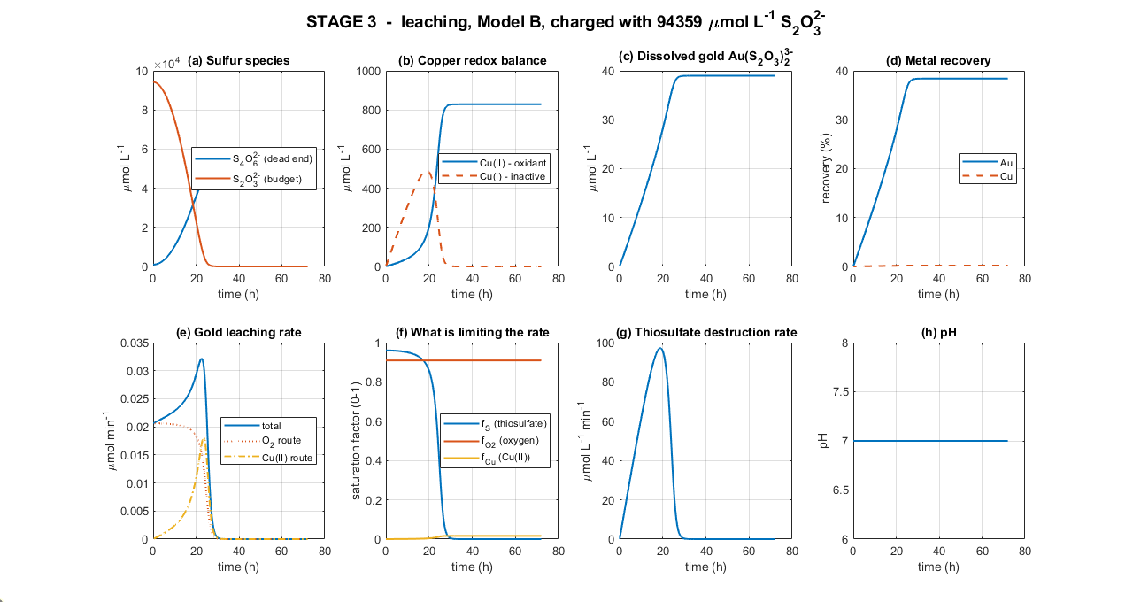
Figure 2. Stage 3 — leaching over 72 h, charged with 94 359 µmol L⁻¹ thiosulfate from Stage 2. (a) sulfur species; (b) copper redox balance; (c) dissolved gold; (d) metal recovery; (e) gold leaching rate resolved by oxidant route; (f) saturation factors; (g) thiosulfate destruction rate; (h) pH.
Leaching seems to occur in two phases again. During the first 27 hours, thiosulfate is abundant (f_S ≈ 0.96) and gold leaching proceeds close to its saturated maximum. However, as copper dissolves, Cu(II) accumulates, and the Cu(II) oxidant route progressively switches on until at the rate peak of 0.0322 µmol min⁻¹ at 22.6 hours the two routes contribute almost equally (47% O₂, 53% Cu(II)). Gold recovery reaches 35.1% at 24 hours.
In the second phase, after 27h of reactions, reactions stops due to lack of thiosulphate ions, due to Cu(II)’s reversion of it to tetrathionate. As seen in Figure 2F, thiosulphate saturation f_S collapses from 0.96 to near zero while f_O₂ remains flat at 0.91 and f_Cu continues to rise. Cu(II) is at its maximum of 829 µmol L⁻¹ precisely when leaching ceases. Thus, thiosulphate concentration is once again the limiting factor for gold leaching.
Looking at the table below, thiosulphate consumption is broken down.
Sink | Amount consumed (µmol L⁻¹) | Share
Gold leaching (2 per Au) | 78 | 0.08 %
Copper leaching | ≈ 1 660 | 1.8 %
Parasitic Cu(II) reaction | 92 618 | 98.2 %
Total consumed | 94 359 | 100 %

Limitations
- The parasitic constants are borrowed. k₁, k₃ and k₄ come from ammoniacal systems, where ammonia deliberately stabilises Cu(II) and slows the parasitic reaction. In an ammonia-free system k₁ may be substantially larger, which would shorten the productive phase further. These are the most consequential unmeasured parameters in the model.
- Enzyme kinetics are optimal-condition values. k_cat = 125 min⁻¹ derives from assays at pH 3, 30 °C with molar sulfate. Stage 2 would need to run near those conditions to achieve the modelled conversion rate, which conflicts with the alkaline conditions thiosulfate prefers.
- Oxygen is imposed, not solved. [O₂] is held at 500 µmol L⁻¹, so the flat f_O₂ trace in Figure 2(f) is an assumption. A real reactor would show depletion during peak copper oxidation.
- Idealised physics. Perfect mixing, no mass-transfer resistance, uniform spherical particles, isothermal operation, and a uniform gold film thickness across all particles.

Recommendations
- Protect thiosulfate from Cu(II). An ammonia ligand such as ammonia, citrate, glycine, oxalate or EDTA attacks the 98% loss term directly. This is the highest-value intervention.
- Consider a copper pre-leach. Removing copper before gold leaching eliminates the problem at source, at the cost of an extra unit operation.
- Run Stage 3 for one day, not three. The extra 48 hours add 3.3 percentage points. Batch turnaround is worth more than residence time.
- Choose Stage-2 duration deliberately. Enzyme loading trades directly against culture volume: 3 days needs 9 L of culture per litre, 1 day needs 27 L.

References
[1] Y. Kanao et al., "Tetrathionate hydrolase from the acidophilic microorganisms," Front. Microbiol., vol. 15, 1338669, 2024.
[2] Y. Kanao, K. Kamimura, and T. Sugio, "Purification of a tetrathionate hydrolase from Acidithiobacillus ferrooxidans," J. Biotechnol., vol. 132, pp. 16–22, 2007.
[3] U. Alon, An Introduction to Systems Biology, 2nd ed. Boca Raton, FL: CRC Press, 2019.
[4] M. R. Maurizi, "Proteases and protein degradation in Escherichia coli," Experientia, vol. 48, pp. 178–201, 1992.
[5] G. E. Briggs and J. B. S. Haldane, "A note on the kinetics of enzyme action," Biochem. J., vol. 19, pp. 338–339, 1925.
[6] J. J. Byerley, S. A. Fouda, and G. L. Rempel, "Kinetics and mechanism of the oxidation of thiosulphate ions by copper(II) ions in aqueous ammonia solution," J. Chem. Soc. Dalton Trans., pp. 889–893, 1973.
[7] P. L. Breuer and M. I. Jeffrey, "The reduction of copper(II) and the oxidation of thiosulfate and oxysulfur anions in gold leaching solutions," Hydrometallurgy, vol. 70, pp. 163–173, 2003.
[8] G. Senanayake, "Analysis of reaction kinetics, speciation and mechanism of gold leaching and thiosulfate oxidation by ammoniacal copper(II) solutions," Hydrometallurgy, vol. 75, pp. 55–75, 2004.
[9] S. Zhang and M. J. Nicol, "An electrochemical study of the dissolution of gold in thiosulfate solutions Part I: Alkaline solutions," J. Appl. Electrochem., vol. 33, pp. 767–775, 2003.
[10] O. Sitando et al., "A review of factors affecting gold leaching in non-ammoniacal thiosulfate solutions," Hydrometallurgy, vol. 178, pp. 151–175, 2018.
[11] M. G. Aylmore and D. M. Muir, "Thiosulfate leaching of gold — a review," Miner. Eng., vol. 14, no. 2, pp. 135–174, 2001.
[12] D. Maharaj, T. Moyo, and J. Petersen, "Ammonium thiosulfate leaching of gold from electronic printed circuit boards," J. S. Afr. Inst. Min. Metall., vol. 124, no. 12, pp. 711–718, 2024.
[13] E. Salinas-Rodríguez et al., "Leaching of copper contained in waste printed circuit boards using the thiosulfate–oxygen system," Materials, vol. 15, no. 7, 2354, 2022.
[14] O. Levenspiel, Chemical Reaction Engineering, 3rd ed. New York, NY: Wiley, 1999.
[15] P. L. Breuer and M. I. Jeffrey, "An electrochemical study of gold leaching in thiosulfate solutions containing copper and ammonia," Hydrometallurgy, vol. 65, pp. 145–157, 2002.
[16] H. Bremer and P. P. Dennis, "Modulation of chemical composition and other parameters of the cell at different exponential growth rates," EcoSal Plus, vol. 3, no. 1, 2008.
[17] R. Milo et al., "BioNumbers — the database of key numbers in molecular and cell biology," Nucleic Acids Res., vol. 38, pp. D750–D753, 2010.
[18] G. Senanayake, "A surface adsorption/reaction mechanism for gold oxidation by copper(II) in ammoniacal thiosulfate solutions," J. Colloid Interface Sci., vol. 286, pp. 253–257, 2005.
[19] T. Kanao et al., "Recombinant tetrathionate hydrolase from Acidithiobacillus ferrooxidans requires exposure to acidic conditions for proper folding," FEMS Microbiol. Lett., vol. 309, no. 1, pp. 43–47, 2010.

