Bioleaching Modelling — Process Overview
Bacteria express tetrathionate hydrolase (TetH), which breaks tetrathionate down into thiosulfate. The thiosulfate then leaches gold (and, unavoidably, copper) from crushed PCB particles. The chain of models is:
- Enzyme production rate
- Tetrathionate consumption rate
- Thiosulfate production rate (with Cu(II) coupling)
- Gold leaching rate — Model A (oxygen only) and Model B (oxygen + Cu(II))
- Copper leaching rate and the Cu(I)/Cu(II) balance
- pH change (to be built)

Enzyme Production
Bacteria produce tetrathionate hydrolase (TetH), which hydrolyses tetrathionate to thiosulfate.^{[1]}
Reaction
bacteria → TetH enzyme (E)
Model
Enzyme concentration is governed by three processes — production (proportional to biomass), first-order degradation, and dilution as the cells grow ^{[3]}:
$$\frac{d\left[E\right]}{dt}= k_{syn}·X - (k_{deg}+μ)·E$$
At steady state, [E]ₛₛ = k_syn·X / (k_deg + μ), reached over a characteristic time of 1/(k_deg+μ) ^{[3]}. Under the fixed-biomass assumption (no growth), μ = 0.
Parameters
Symbol | Meaning | Unit | Value / source
[E] | Active TetH concentration | µmol L⁻¹ | state variable
T | Time | min | —
X | Biomass concentration | cell L⁻¹ | 1×10¹² (chemostat, held constant)
k_syn | Enzyme synthesis rate per cell | µmol cell⁻¹ min⁻¹ | 8.74×10⁻¹⁷ (cascade-matched) [17]
k_deg | Enzyme degradation rate | min⁻¹ | 1.1×10⁻³ [4]
Μ | Growth-dilution rate (=ln2/t_double) | min⁻¹ | 0.0173 (assuming 40 min doubling) [16]

Analysis
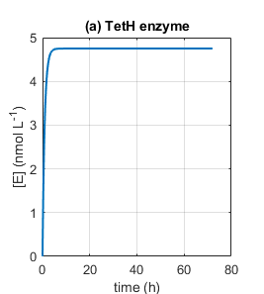

The enzyme curve rises to a plateau of 4.75 nmol L⁻¹ within roughly 3 hours and stays flat for the remaining 69 hours. This is the expected behaviour of a linear equation with constant coefficients: the steady state is k_syn·X/(k_deg+μ) and the approach time is 1/(k_deg+μ) ≈ 55 min, so the plateau is reached long before anything else in the system has moved. Enzyme build-up is therefore not a rate-limiting step, and no engineering effort spent on making the enzyme appear faster would change the outcome of this run.
A second point follows from the parameter values. At baseline μ = 0.0173 min⁻¹ dominates k_deg = 0.0011 min⁻¹ by a factor of about sixteen, so enzyme is lost overwhelmingly by dilution through cell division rather than by proteolysis. Engineering a more protease-resistant enzyme would achieve very little; slowing growth or raising expression would achieve considerably more.

Sulphur Species

Tetrathionate Consumption
Reactions
TetH hydrolyses tetrathionate via a disulfane-monosulfonic-acid (DSMSA) intermediate ^{[1]}:
S₄O₆²⁻ + H₂O → HS₂SO₃⁻ + HSO₄⁻
HS₂SO₃⁻ → S₂O₃²⁻ + S⁰ + H⁺
Lumped into a single overall reaction:
S₄O₆²⁻ + H₂O → S₂O₃²⁻ + S⁰ + SO₄²⁻ + 2H⁺
Copper(II) leached from the PCB re-oxidises thiosulfate back to tetrathionate, so a regeneration term is required ^{[6][7]}:
2Cu(II) + 2S₂O₃²⁻ → 2Cu(I) + S₄O₆²⁻
Model
Consumption follows irreversible Michaelis–Menten kinetics ^{[5]}; the parasitic reaction above adds tetrathionate back:
$$\frac{d\left[S_{4}O_{6}^{2-}\right]}{dt}= F_{in}-\frac{k_{cat}·E·\left[S_{4}O_{6}^{2-}\right]}{K_{m}+ \left[S_{4}O_{6}^{2-}\right]}+ k₁·[Cu(II)]·[S₂O₃²⁻]$$
Parameters
Symbol | Meaning | Unit | Value / source
[S₄O₆²⁻] | Tetrathionate concentration | µmol L⁻¹ | state variable; initial 23 200
F_in | Tetrathionate feed rate | µmol L⁻¹ min⁻¹ | 0 (batch operation)
k_cat | Turnover number of TetH | min⁻¹ | 125 (2.5 U mg⁻¹ × 50 kDa) [1][2]
K_m | Michaelis constant | µmol L⁻¹ | 300 (species range 50–2400) [2]
E | Active TetH concentration | µmol L⁻¹ | from Section 1
k₁ | Parasitic Cu(II)–thiosulfate rate constant | L µmol⁻¹ min⁻¹ | 1×10⁻⁵ (↑ without NH₃) [6][7]
[Cu(II)] | Copper(II) concentration | µmol L⁻¹ | from Section 5

Thiosulfate Production
Thiosulfate is produced as a stoichiometric multiple (Y) of tetrathionate consumed.
$$d\frac{\left[S_{2}O_{3}^{2-}\right]}{dt}=\frac{k_{cat}·E·\left[S_{4}O_{6}^{2-}\right]}{K_{m}+ \left[S_{4}O_{6}^{2-}\right]} [production only]$$
Adding the parasitic loss to Cu(II) (2 thiosulfate consumed per reaction extent) and the loss to gold leaching gives the full balance:
$\frac{d\left[S_{2}O_{3}^{2-}\right]}{dt}$ $=\frac{k_{cat}·E·\left[S_{4}O_{6}^{2-}\right]}{K_{m}+\left[S_{4}O_{6}^{2-}\right]}-2·k_{1}·\left[Cu\left(II\right)\right]·\left[S_{2}O_{3}^{2-}\right]-\left(\frac{2}{V}\right)·R_{Au}-\left(\frac{1}{V}\right)·R_{Cu}$
where R_Au is the gold-leaching rate (µmol min⁻¹) and R_Cu is the copper-leaching rate (µmol min⁻¹) from Sections 4 and 5. Each gold atom consumes 2 thiosulfate, and, depending on the oxidant, each copper atom consumes 2 or 4 thiosulfate. The 1/V converts the surface rate to a concentration rate.
Parameters
Symbol | Meaning | Unit | Value / source
[S₂O₃²⁻] | Thiosulfate concentration | µmol L⁻¹ | state variable; initial 72 100
Y | Stoichiometric yield (S₂O₃ per S₄O₆) | - (dimensionless) | 1 [1]
V | Reactor volume | L | 1.0
R_Au | Gold leaching rate | µmol min⁻¹ | from Section 4
R_Cu | Copper leaching rate | µmol min⁻¹ | from Section 5

Analysis of Sulphur Species Models
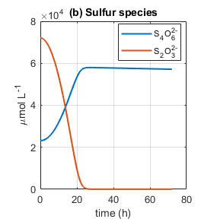
Tetrathionate concentration does not fall as initially expected. It rises from the initial concentration of 23 200 to about 57 900 µmol L⁻¹, plateauing at roughly 25 hours. This tells us that the parasitic tetrathionate regeneration term has a greater influence that they enzymatic consumption term and essentially accounts for majority of the tetrathionate percentage change, meaning the enzyme’s influence is marginal. This is concerning because the parameters used are from enzyme operation at optimum conditions.
This creates a futile cycle: the enzyme converts S₄O₆²⁻ into S₂O₃²⁻, and Cu(II) converts S₂O₃²⁻ straight back into S₄O₆²⁻. The two reactions run in opposition, and the copper arm runs far faster. At the peak of the parasitic rate the thiosulfate destruction term reaches 80 µmol L⁻¹ min⁻¹ against an enzymatic production capacity of 0.591 µmol L⁻¹ min⁻¹: a factor of 136. Integrated over the full 72 hours, the enzyme produced 2 517 µmol L⁻¹ of thiosulfate while 72 062 µmol L⁻¹ was destroyed, so the enzyme replaced only 3.5% of the loss. Thus, the tetrathionate dynamics are set by copper chemistry, not by the bacteria’s enzyme production.
Meanwhile, thiosulfate starts high, (at 72 100 µmol L⁻¹ from stoichiometric calculations of thiosulphate concentration in the tetrathionate broth) before falling monotonically and reaching near zero at about 25 hours. The broth is prepared by oxidising sodium thiosulfate with iodine (2S₂O₃²⁻ + I₂ → S₄O₆²⁻ + 2I⁻), and because iodine is the limiting reagent only part of the thiosulfate is converted. The 23 200 µmol L⁻¹ of tetrathionate and 72 100 µmol L⁻¹ of residual thiosulfate are both initial conditions inherited from the medium.
Tracing where that thiosulfate went, it seems that majority of it goes towards the parasitic tetrathionate concentration.
Sink | Amount consumed (µmol L⁻¹) | Share of total loss
Gold leaching (2 per Au) | 74 | 0.10 %
Copper leaching | ≈ 1 500 | 2.1 %
Parasitic Cu(II) reaction | 67 951 | 94.3 %
Total thiosulfate lost | 72 062 | 100 %
94% of the leachant was destroyed by a the parasitic tetrathionate production, not by gold leaching, implying that methods need to be made to reduce Cu (II) production.

Gold Leaching
Reactions
Metallic gold is oxidised and complexed by thiosulfate. The oxidation and complexation happen in a single surface step (free Au⁺ does not persist in solution) ^{[8]}:
Au⁰ + 2S₂O₃²⁻ → Au(S₂O₃)₂³⁻ + e⁻ (anodic half-reaction)
With oxygen as the terminal oxidant, the overall reaction is:
4Au⁰ + 8S₂O₃²⁻ + O₂ + 2H₂O → 4Au(S₂O₃)₂³⁻ + 4OH⁻
Because copper is leached from the PCB, a second, faster pathway exists in which Cu(II) is the oxidant ^{[11][12]}:
Au⁰ + 2S₂O₃²⁻ + Cu(II) → Au(S₂O₃)₂³⁻ + Cu(I)
Gold Surface-Area Equation
Gold on a PCB is a thin plated film, not a bulk particle, so it dissolves by thinning at roughly constant face area until it is exhausted (it does not shrink inward). The exposed area is fixed by the gold mass and plating thickness, independent of how finely the board is crushed:
$$A_{Au} =\frac{m_{Au}}{ρ_{Au} · t_{film}}$$
$A_{Au} (t) ≈ A_{Au}(0)$while gold remains, → 0 once exhausted
Derivation: a film of area A and thickness t has volume A·t = m/ρ, so A = m/(ρ·t).

Model A — Oxygen only (conservative)
Starting from simple mass action, gold leaching depends on oxygen (oxidant) and thiosulfate (ligand). Because gold sits on the particle surface, the rate scales with a time-dependent gold area — a shrinking-surface variant of the shrinking-core model
Since the surface has a finite number of reaction sites, each reactant enters through a saturating (Langmuir) term ^{[8][10]}. Tracking solid gold in mol and dissolved gold as a concentration:
$$R_{Au} = k_{Au},O_{2}· A_{Au}(t)·\frac{\left[O_{2}\right]}{K_{O_{2}}+\left[O_{2}\right]} ·\frac{\left[S_{2}O_{3}^{2-}\right]}{K_{S}+\left[S_{2}O_{3}^{2-}\right]}$$
$$\frac{dn_{Au}}{dt}= - R_{Au}$$
$$\frac{d\left[Au{\left(S_{2}O_{3}\right)}_{2}^{3-}\right]}{dt}=+\frac{R_{Au}}{V}$$

Model B — Oxygen + Copper(II) (realistic)
Cu(II) provides a parallel oxidant pathway. Parallel pathways add (either oxidant alone can dissolve gold), while area, thiosulfate, and passivation multiply everything (all are required regardless of oxidant). Oxygen enters only its own term — Cu(II) does not need O₂ at the gold surface ^{[15]}:
$$R_{Au} = A_{Au}(t)·\frac{\left[S_{2}O_{3}^{2-}\right]}{K_{S}+\left[S_{2}O_{3}^{2-}\right]} · \{k_{Au,O_{2}}·\frac{\left[O_{2}\right]}{K_{O_{2}}+\left[O_{2}\right]} + k_{Au,Cu}·\frac{\left[Cu\left(II\right)\right]}{K_{Cu}+\left[Cu\left(II\right)\right]} \}$$
$$\frac{dn_{Au}}{dt} = -R_{Au}$$
$$d\frac{\left[AuO_{3}^{3-}\right]}{dt} = +\frac{R_{Au}}{V}$$
Parameters
Symbol | Meaning | Unit | Value / Source
n_Au | Solid gold remaining | µmol | state variable; initial 101.5
[Au(S₂O₃)₂³⁻] | Dissolved gold complex (product) | µmol L⁻¹ | state variable
A_Au | Exposed gold area = m_Au/(ρ_Au·t_film) | m² | 2.07×10⁻³ (from geometry)
m_Au | Gold mass on the boards | kg | 20×10⁻⁶ (0.02 wt% of 100 g PCB)
ρ_Au | Gold density | kg m⁻³ | 19 300
t_film | Gold plating thickness | M | 0.5×10⁻⁶
k_Au,O₂ | Gold rate constant, O₂ route | µmol m⁻² min⁻¹ | 11.4 (1.9×10⁻⁷ mol m⁻² s⁻¹) [9][10]
k_Au,Cu | Gold rate constant, Cu(II) route | µmol m⁻² min⁻¹ | 1 500 (PCB optimum) [11][12]
K_O₂ | O₂ half-saturation | µmol L⁻¹ | 50 [10]
K_S | Thiosulfate half-saturation | µmol L⁻¹ | 3 900 (= 1/K_ads, K_ads 172–510 M⁻¹) [11]
K_Cu | Cu(II) half-saturation | µmol L⁻¹ | 5×10⁴ [12]

Analysis
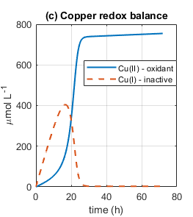 | 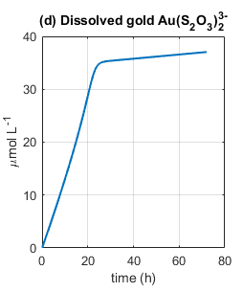
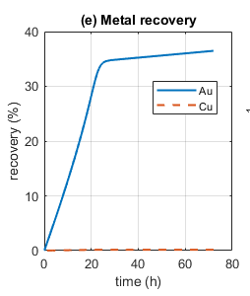 | 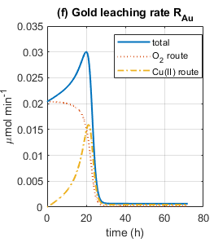
Dissolved gold (panel d) rises steeply and almost linearly to about 35 µmol L⁻¹ by 22 hours, then flattens sharply, reaching only 37 µmol L⁻¹ by 72 hours. The metal-recovery curve (panel e) is the same information expressed as a percentage of the gold originally present, which is why the two panels have identical shape: recovery reaches 33.8% at 24 hours and 36.5% at 72 hours. The additional 48 hours of operation buy only 2.7 percentage points. Operationally this is a one-day process; the second and third days are close to wasted.
Panel (f) explains why, and rewards close reading. The total rate rises from 0.020 to a peak of 0.030 µmol min⁻¹ at 19.9 hours and then collapses to near zero within about six hours. The decomposition into routes is informative: at t = 0 the oxygen route carries the entire rate because no copper has yet dissolved, but by the peak the two routes are almost exactly balanced (51% oxygen, 49% Cu(II)). Copper roughly doubles the gold leaching rate while it lasts, showing its superior catalytic effect.
The collapse, however, is not caused by copper running out. Panel (c) shows Cu(II) still rising to its plateau of 755 µmol L⁻¹ as the gold rate falls. Thus, looking at the previous sulphur species analysis, it seems gold leaching stops because of the minimum thiosulphate concentration. Thus, thiosulphate concentration is a limiting factor.

Copper Leaching and the Cu(I)/Cu(II) Balance
Reactions
Metallic copper dissolves as Cu(I)–thiosulfate. Two oxidant pathways exist ^{[13][7]}:
With oxygen as oxidant:
4Cu⁰ + O₂ + 8S₂O₃²⁻ + 2H₂O → 4[Cu(S₂O₃)₂]³⁻ + 4OH⁻
With Cu(II) as oxidant (comproportionating one Cu(II) plus one Cu⁰ gives two Cu(I)):
Cu⁰ + Cu²⁺ → 2Cu⁺
Cu⁺ + 2S₂O₃²⁻ → [Cu(S₂O₃)₂]³⁻
Cu⁰ + Cu²⁺ + 4S₂O₃²⁻ → 2[Cu(S₂O₃)₂]³⁻
Cu(I) is re-oxidised to Cu(II) by oxygen, and Cu(II) is reduced back to Cu(I) by thiosulfate and by gold leaching ^{[7][15]}:
4Cu(I) + O₂ + 2H₂O → 4Cu(II) + 4OH⁻
2Cu(II) + 2S₂O₃²⁻ → 2Cu(I) + S₄O₆²⁻
Au⁰ + 2S₂O₃²⁻ + Cu(II) → Au(S₂O₃)₂³⁻ + Cu(I)
Copper Surface-Area Equation
Copper is bulk metal (traces, planes, inner layers), so its particles genuinely erode inward — a true shrinking-particle geometry
The initial area follows the surface-to-volume ratio 6/d for crushed particles of size d; as copper is consumed, the area falls as the two-thirds power of the fraction remaining (area ∝ r², volume ∝ r³) ^{[14]}:
$$A_{Cu}\left(0\right)= 6·\frac{m_{Cu}}{(ρ_{Cu} · d)}$$
$$A_{Cu}(t) = A_{Cu}(0) · {\left(\frac{n_{Cu}}{n_{Cu}\left(0\right)}\right)}^{\frac{2}{3}}$$
Rates
Copper leaching, oxygen route (v₁A) and combined-oxidant route (v₁B); gold-leaching Cu(I) return (v₂); parasitic tetrathionate regeneration (v₃); Cu(I) re-oxidation by oxygen (v₄):
$$v_{1A} = {2k}_{Cu,O_{2}}·A_{Cu}\left(t\right)·\frac{\left[O_{2}\right]}{K_{O_{2}}+\left[O_{2}\right]}·\frac{\left[S_{2}O_{3}^{2-}\right]}{K_{S}+\left[S_{2}O_{3}^{2-}\right]}$$
$$v_{1B} = A_{Cu}(t)·\frac{\left[S_{2}O_{3}^{2-}\right]}{K_{S}+\left[S_{2}O_{3}^{2-}\right]}·\{ {2k}_{Cu,O_{2}}·\frac{\left[O_{2}\right]}{K_{O_{2}}+\left[O_{2}\right]} + {4k}_{Cu, Cu^{2+}}·\frac{\left[Cu\left(II\right)\right]}{K_{Cu}+\left[Cu\left(II\right)\right]} \}$$
$$v₂ = R_{Au} (gold-leaching rate, Section 4)$$
$$v₃ = k₃·[Cu(II)]·[S₂O₃²⁻]$$
$$v₄ = k₄·[O₂]·[Cu(I)]$$
Cu(I) model
Cu(I) is produced by copper leaching, by gold leaching, and by the parasitic reaction, and is consumed by oxygen re-oxidation. Reading coefficients off the balanced reactions (comproportionating gives 2 Cu(I) per extent; parasitic gives 2 Cu(I) per extent; O₂ re-oxidation consumes 4 Cu(I) per extent):
$$\frac{d\left[Cu\left(I\right)\right]}{dt} = \left(\frac{1}{V}\right)·2·v₁B + \left(\frac{1}{V}\right)·v₂ + 2·v₃ - 4·v₄$$
Cu(II) model
Cu(II) is produced only by oxygen re-oxidation of Cu(I), and consumed by the comproportionating leach, the parasitic reaction, and gold leaching:
$$d\frac{\left[Cu\left(II\right)\right]}{dt} = 4·v₄ - \left(\frac{1}{V}\right)·v₁B - \left(\frac{1}{V}\right)·v₂ - 2·v₃$$
Parameters
Symbol | Meaning | Unit | Value / source
[Cu(I)] | Copper(I) concentration (cannot leach gold) | µmol L⁻¹ | state variable
[Cu(II)] | Copper(II) concentration (gold oxidant) | µmol L⁻¹ | state variable
n_Cu | Solid copper remaining | mol | state variable; initial 472 069
A_Cu | Exposed copper area = 6m_Cu/(ρ_Cu·d)·(n/n₀)^⅔ | m² | 3.35×10⁻³ initial (from geometry)
m_Cu | Copper mass on the boards | kg | 30×10⁻³ (30 wt% of 100 g PCB)
ρ_Cu | Copper density | kg m⁻³ | 8 960
D | Crushed particle size | m | 6×10⁻³
k_Cu,O₂ | Copper rate constant, O₂ route | µmol m⁻² min⁻¹ | 200 (Ea ≈ 25.8 kJ mol⁻¹) [13]
k_Cu,Cu | Copper rate constant, Cu(II) route | µmol m⁻² min⁻¹ | 200 (calibrate)
k₃ | Parasitic (Cu(II)+S₂O₃) rate constant | L µmol⁻¹ min⁻¹ | 1×10⁻⁵ (= k₁) [6][7]
k₄ | Cu(I) re-oxidation rate constant | L µmol⁻¹ min⁻¹ | 1×10⁻⁴ [7]
[O₂] | Dissolved oxygen (held constant) | µmol L⁻¹ | 500 (sparged)

Analysis
The two copper species behave very differently. Cu(I) rises to a peak of 405 µmol L⁻¹ at 16.7 hours and then collapses to near zero by 30 hours. Cu(II) rises sigmoidally and monotonically to a plateau of 755 µmol L⁻¹, and never falls. The two curves cross at approximately 19.8 hours.
The Cu(I) peak has a clean mechanistic explanation. Cu(I) is produced mainly by the parasitic reaction (two Cu(I) per extent) and removed by oxygen re-oxidation at rate 4·k₄·[O₂]·[Cu(I)]. The parasitic rate v₃ = k₃·[Cu(II)]·[S₂O₃²⁻] is a product of a rising quantity and a falling one, so it necessarily peaks somewhere in the middle of the run; Cu(I) peaks with it. Once thiosulfate is exhausted the parasitic source shuts off while oxygen re-oxidation continues, so Cu(I) is swept into Cu(II) and the ratio inverts.
Copper recovery is 0.16% after 72 hours. This looks negligible and in fractional terms it is — but the board carries 472 069 µmol L⁻¹ of copper against 101.5 µmol L⁻¹ of gold, a ratio of 4 650 to 1. Even 0.16% of that copper is roughly 750 µmol L⁻¹ entering solution, which is precisely the Cu(II) plateau seen in panel (c) and precisely enough to destroy the entire thiosulfate charge. A metal can be quantitatively irrelevant as a product and simultaneously decisive as a reagent sink.

Combined Analysis
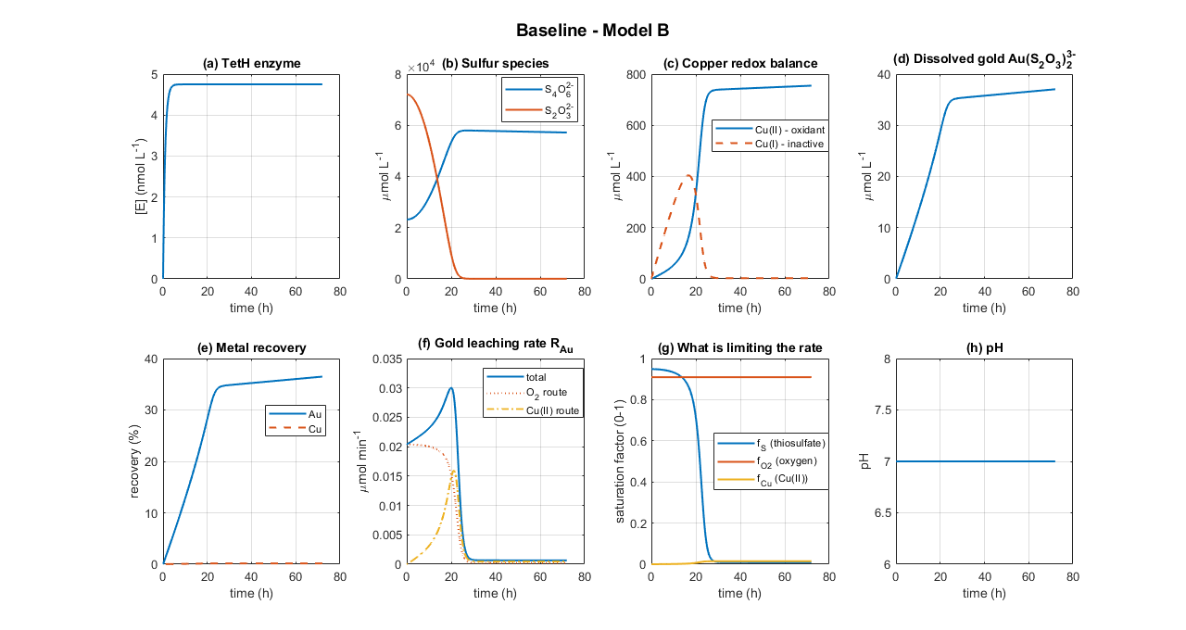
Key Numerical Results
Quantity | Value | Time
Enzyme plateau [E] | 4.75 nmol L⁻¹ | ≈ 3 h
Enzyme maximum turnover V_max | 0.594 µmol L⁻¹ min⁻¹ | —
Tetrathionate/thiosulfate crossover | ≈ 42 000 µmol L⁻¹ each | 13.7 h
Cu(I) maximum | 405 µmol L⁻¹ | 16.7 h
Gold leaching rate maximum | 0.0300 µmol min⁻¹ (51% O₂ / 49% Cu(II)) | 19.9 h
Cu(II) overtakes Cu(I) | ≈ 330 µmol L⁻¹ each | 19.8 h
Thiosulfate effectively exhausted | < 100 µmol L⁻¹ | ≈ 25 h
Cu(II) plateau | 755 µmol L⁻¹ | ≈ 30 h
Gold recovery at 24 h | 33.8 % | 24 h
Gold recovery at 72 h | 36.5 % | 72 h
Copper recovery at 72 h | 0.16 % | 72 h

From the summary and the combined models, it seems the runs occur in two phases:
Phase 1 (0–22 h): leaching works. The reactor begins with 72 100 µmol L⁻¹ of thiosulfate inherited from the broth, so f_S starts at 0.95 and gold leaching runs close to its thiosulfate-saturated maximum from the first minute. Copper dissolves steadily from the PCB, Cu(II) accumulates, and the Cu(II) oxidant route progressively switches on. By 19.9 h the two oxidant routes contribute almost equally and the gold rate peaks at 0.0300 µmol min⁻¹, about 50% above its starting value. Gold recovery climbs to roughly 32%.
Phase 2 (22 h onward): the reactor poisons itself. The same Cu(II) that accelerates gold leaching also destroys thiosulfate through 2Cu(II) + 2S₂O₃²⁻ → 2Cu(I) + S₄O₆²⁻. Because the rate is proportional to [Cu(II)], and Cu(II) is still accumulating, the destruction accelerates as the run proceeds. Thiosulfate falls below 1 000 µmol L⁻¹ at about 24 h and f_S collapses from 0.95 to 0.01. Thus, both leaching routes die.
The central tension of the system is therefore that copper is simultaneously the best catalyst and the fatal poison. It doubled the gold rate in Phase 1 and terminated the process in Phase 2. Nothing else in the model has comparable leverage, which makes k₁ and k₃, the parasitic rate constants, both currently taken from ammoniacal literature and unmeasured for an ammonia-free system, the most consequential unknown parameters in the entire model. If they are not true, the model results can vary greatly.

References
[1] Y. Kanao et al., "Tetrathionate hydrolase from the acidophilic microorganisms," Front. Microbiol., vol. 15, 1338669, 2024.
[2] Y. Kanao, K. Kamimura, and T. Sugio, "Purification of a tetrathionate hydrolase from Acidithiobacillus ferrooxidans," J. Biotechnol., vol. 132, pp. 16–22, 2007.
[3] U. Alon, An Introduction to Systems Biology, 2nd ed. Boca Raton, FL: CRC Press, 2019.
[4] M. R. Maurizi, "Proteases and protein degradation in Escherichia coli," Experientia, vol. 48, pp. 178–201, 1992.
[5] G. E. Briggs and J. B. S. Haldane, "A note on the kinetics of enzyme action," Biochem. J., vol. 19, pp. 338–339, 1925.
[6] J. J. Byerley, S. A. Fouda, and G. L. Rempel, "Kinetics and mechanism of the oxidation of thiosulphate ions by copper(II) ions in aqueous ammonia solution," J. Chem. Soc. Dalton Trans., pp. 889–893, 1973.
[7] P. L. Breuer and M. I. Jeffrey, "The reduction of copper(II) and the oxidation of thiosulfate and oxysulfur anions in gold leaching solutions," Hydrometallurgy, vol. 70, pp. 163–173, 2003.
[8] G. Senanayake, "Analysis of reaction kinetics, speciation and mechanism of gold leaching and thiosulfate oxidation by ammoniacal copper(II) solutions," Hydrometallurgy, vol. 75, pp. 55–75, 2004.
[9] S. Zhang and M. J. Nicol, "An electrochemical study of the dissolution of gold in thiosulfate solutions Part I: Alkaline solutions," J. Appl. Electrochem., vol. 33, pp. 767–775, 2003.
[10] O. Sitando et al., "A review of factors affecting gold leaching in non-ammoniacal thiosulfate solutions," Hydrometallurgy, vol. 178, pp. 151–175, 2018.
[11] M. G. Aylmore and D. M. Muir, "Thiosulfate leaching of gold — a review," Miner. Eng., vol. 14, no. 2, pp. 135–174, 2001.
[12] D. Maharaj, T. Moyo, and J. Petersen, "Ammonium thiosulfate leaching of gold from electronic printed circuit boards — effect of solution copper concentration," J. S. Afr. Inst. Min. Metall., vol. 124, no. 12, pp. 711–718, 2024.
[13] E. Salinas-Rodríguez et al., "Leaching of copper contained in waste printed circuit boards using the thiosulfate–oxygen system: a kinetic approach," Materials, vol. 15, no. 7, 2354, 2022.
[14] O. Levenspiel, Chemical Reaction Engineering, 3rd ed. New York, NY: Wiley, 1999.
[15] P. L. Breuer and M. I. Jeffrey, "An electrochemical study of gold leaching in thiosulfate solutions containing copper and ammonia," Hydrometallurgy, vol. 65, pp. 145–157, 2002.
[16] H. Bremer and P. P. Dennis, "Modulation of chemical composition and other parameters of the cell at different exponential growth rates," EcoSal Plus, vol. 3, no. 1, 2008.
[17] R. Milo et al., "BioNumbers — the database of key numbers in molecular and cell biology," Nucleic Acids Res., vol. 38, pp. D750–D753, 2010.
[18] G. Senanayake, "A surface adsorption/reaction mechanism for gold oxidation by copper(II) in ammoniacal thiosulfate solutions," J. Colloid Interface Sci., vol. 286, pp. 253–257, 2005.

