Modeling Surface Site Density for GolB-Based Gold Biosorption

1. Purpose and scope
Our project recovers gold from electronic waste in two stages: bioleaching mobilizes gold from the waste into a leachate, and biosorption then captures the dissolved gold using engineered bacteria. For biosorption we display the gold-binding protein GolB on the cell surface, so that gold ions in the leachate bind directly to accessible protein rather than having to enter the cell. The quantity that determines how much gold a single cell can capture is the surface site density — the number of active, gold-accessible GolB molecules on the outer membrane.
This model predicts that surface site density from first principles, tracing the gene-expression cascade that produces it: transcription of the GolB gene into mRNA, translation into cytoplasmic protein, export and anchoring of that protein at the surface, and finally the fraction of surface protein that is correctly folded and able to bind gold. Because our team works from published data rather than our own measurements, every parameter is a literature-grounded estimate, and the two parameters that cannot be read directly from the literature are treated as explicitly fitted values.

2. Model structure
We represent the system as four connected pools, expressed as molecules per cell. Each pool is fed by the process upstream of it and drained by degradation and by dilution as the cell grows and divides:
mRNA m → cytoplasmic protein P_{c} → surface-displayed protein P_{s} → active sites A
Dilution appears because a growing cell continually doubles its volume; even a perfectly stable protein is diluted at the growth rate. For fast-turnover species such as mRNA this term is small, but for stable proteins it is often the dominant loss.

3. Governing equations
The cascade is written as a system of ordinary differential equations. Transcription produces mRNA at a rate set by promoter strength and copy number, and mRNA is lost to degradation and dilution:
dm/dt = α·N − (δ_{m} + μ)·m
Translation converts each mRNA into protein; the cytoplasmic pool is drained by export to the surface, by degradation, and by dilution:
dP_{c}/dt = β·m − (k_sec + δ_{c} + μ)·P_{c}
Export anchors protein at the surface. Because the membrane holds a finite number of anchors, the arrival term saturates as the surface fills toward its capacity:
dP_{s}/dt = k_sec·P_{c}·(1 − P_{s}/P_{s,max}) − (δ_{s} + μ)·P_{s}
Finally, only a fraction of the displayed protein is correctly folded and gold-accessible, so the number of active binding sites is:
A = f·P_{s}

4. Parameters
The table below lists every parameter, the value used in the simulation, and its basis in the literature. The central-dogma constants are standard order-of-magnitude values for Escherichia coli. The surface capacity comes from characterized autodisplay systems. Two parameters — the display rate k_sec and the functional fraction f — depend on the specific construct and are treated as fitted; the gold dissociation constant K_d is a placeholder because no clean experimental value for GolB has been reported.
Symbol | Meaning | Value | Units | Basis / source
α | Transcription rate per plasmid copy (promoter strength) | 0.5 | mRNA·min⁻¹·copy⁻¹ | Typical E. coli promoter output (BioNumbers)
N | Plasmid copy number | 20 | copies/cell | Medium-copy backbone, pBR322-like (≈15–20)
δₘ | mRNA degradation rate | 0.20 | min⁻¹ | E. coli mRNA half-life ≈2–5 min (t½≈3.5 min)
β | Translation rate per mRNA (RBS strength) | 4.0 | protein·min⁻¹·mRNA⁻¹ | Typical E. coli translation efficiency (BioNumbers)
k_sec | Export / surface-display rate constant | 0.10 | min⁻¹ | Set by the display scaffold; fitted parameter
δ_c | Cytoplasmic protein degradation | 0.005 | min⁻¹ | ≈0 for a stable protein
δ_s | Surface protein loss | 0.005 | min⁻¹ | Assumed dilution-dominated
μ | Growth (dilution) rate | 0.02 | min⁻¹ | Doubling time ≈35 min (μ = ln2 / t_double)
f | Fraction folded + gold-accessible | 0.5 | – | Folding/accessibility; fitted parameter
P_s,max | Maximum surface anchor sites | 1×10⁵ | sites/cell | Autodisplay reaches >10⁵ molecules/cell (Jose & Meyer)
K_d | GolB–Au(I) dissociation constant | 10 | µM | Placeholder – no clean experimental K_d; source or fit

5. Steady-state site density
Setting the time derivatives to zero and substituting down the cascade gives closed-form steady-state values (in the non-saturating limit, valid whenever site density stays well below capacity, which holds here):
m* = αN / (δ_{m} + μ)
P_{c*} = βm* / (k_sec + δ_{c} + μ)
P_{s*} = k_secP_{c*} / (δ_{s} + μ)
Combining these yields a single expression for the quantity we care about:
A* = f·α·N·β·k_sec / [(δ_{m} + μ)(k_sec + δ_{c} + μ)(δ_{s} + μ)]
This makes the design logic explicit: site density scales linearly with promoter strength, copy number, and translation strength, while the secretion rate partitions protein between the cytoplasm and the surface. With the parameters above, the model gives roughly 45 mRNA, 1,460 cytoplasmic protein, 5,500 surface protein, and about 2,900 active sites per cell.

6. Coupling to gold uptake
The active-site count feeds a Langmuir adsorption isotherm that predicts how much gold a cell binds at a given leachate concentration C. Because GolB binds Au(I) through a single Cys-X-X-Cys motif, each site captures one gold ion, so the maximum uptake equals the site count A:
q(C) = A·C / (K_{d} + C)
This is the bridge between the expression model and the actual objective: whatever raises the active-site count raises the recovery ceiling proportionally.

7. Simulation results
Figure 1 shows the model run to steady state and two analyses derived from it.
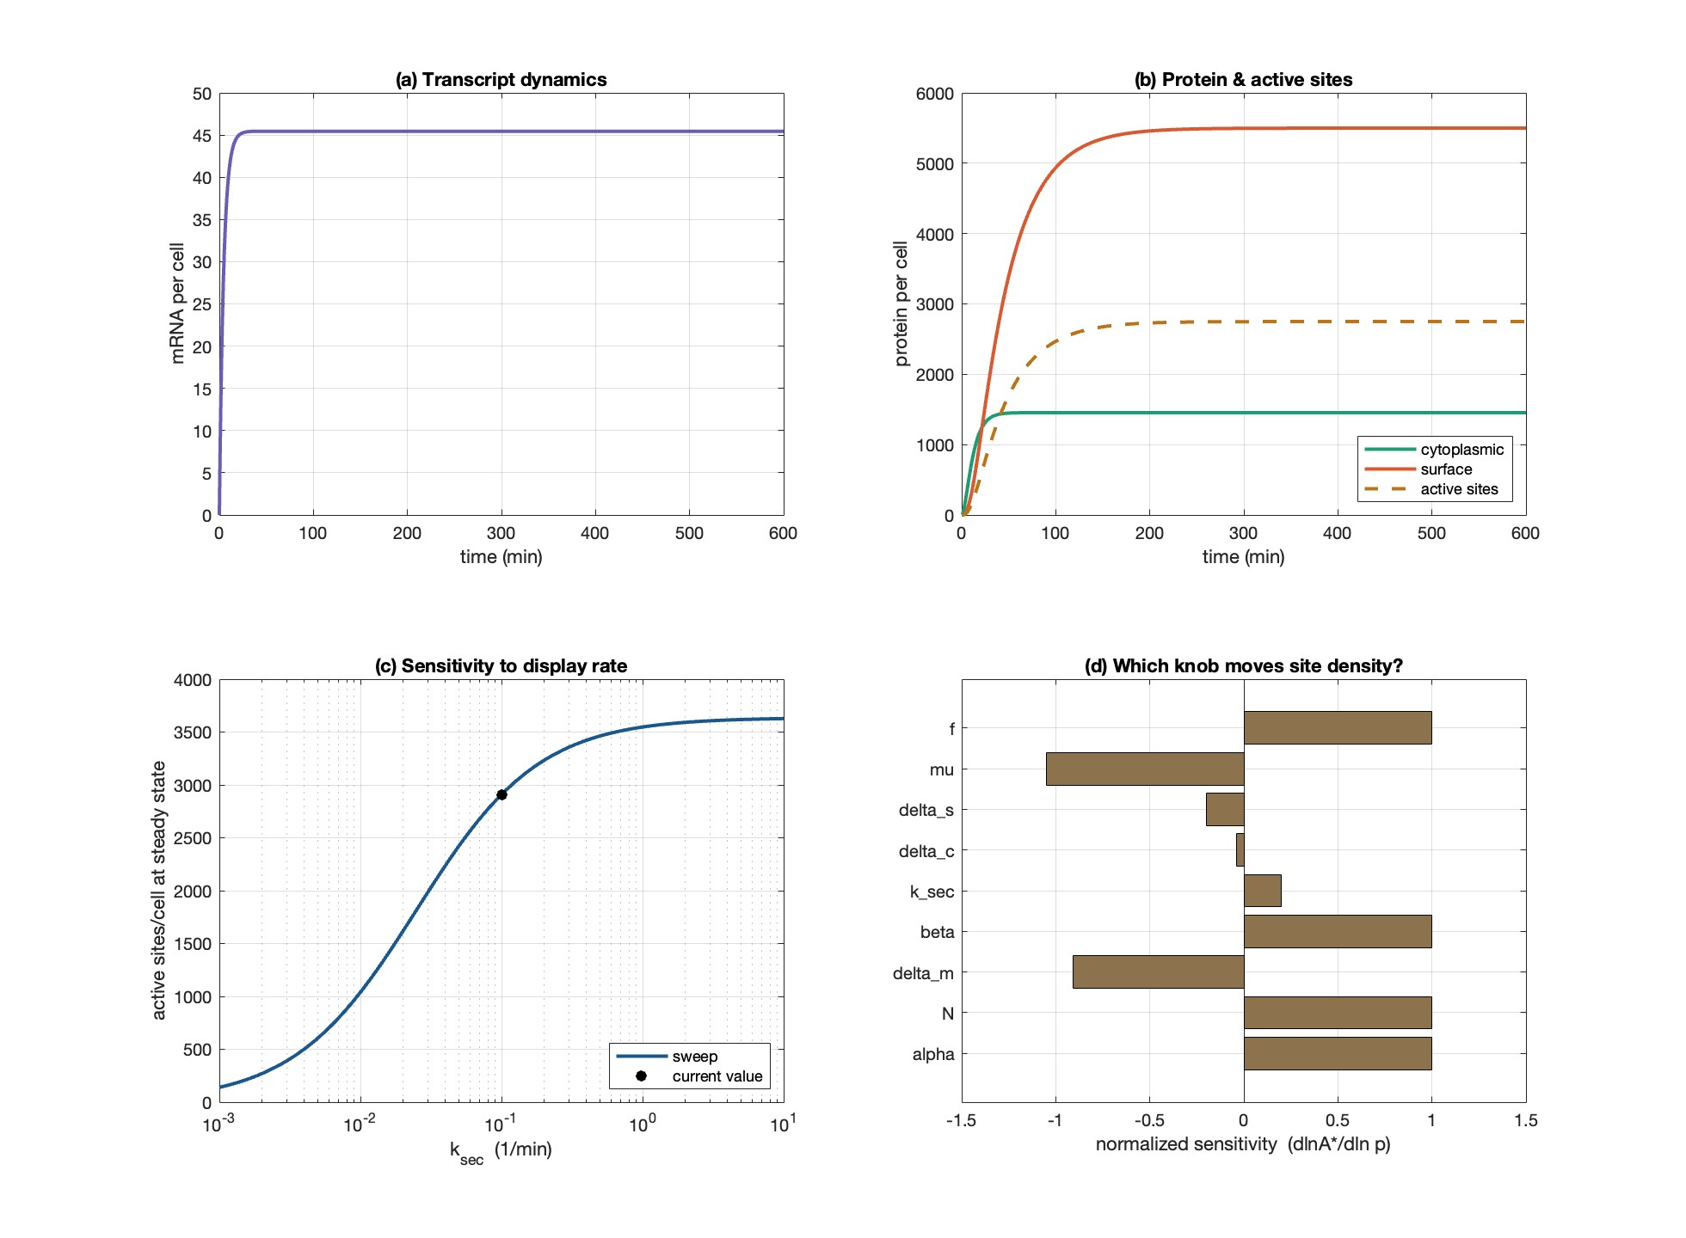
Figure 1. (a) Transcript dynamics; (b) protein and active-site dynamics; (c) steady-state site density versus display rate; (d) normalized parameter sensitivity of the steady-state site density.
Panel (a) — Transcript dynamics. mRNA reaches steady state (about 45 copies per cell) within roughly 20–30 minutes. This is fast because mRNA turns over quickly; a species equilibrates on the timescale of a few of its own half-lives, and mRNA half-life is only a few minutes.
Panel (b) — Protein and active sites. The cytoplasmic pool (≈1,460), the surface pool (≈5,500), and the active sites (≈2,900, being half the surface pool) rise much more slowly, taking around 150–200 minutes to plateau. The slowness comes from the protein loss being dominated by dilution, which is far slower than mRNA turnover. Notably the surface pool exceeds the cytoplasmic pool: export continuously drains the cytoplasm, whereas the surface pool is lost only to slow dilution, so displayed protein accumulates.
Panel (c) — Sensitivity to display rate. Steady-state site density is plotted against the export rate k_sec on a logarithmic axis, giving an S-shaped curve. When export is slow, protein remains trapped in the cytoplasm and few sites form. As export speeds up, more protein reaches the surface, but above roughly 1 min⁻¹ the curve flattens near 3,600 sites because transcription and translation, not export, now set the ceiling. The marked point is the operating value used (0.1 min⁻¹). The practical message is that simply making secretion faster yields diminishing returns.
Panel (d) — Which parameter moves site density. Each bar is a normalized sensitivity: the fractional change in steady-state site density per fractional change in that parameter. Promoter strength (α), copy number (N), translation strength (β), and functional fraction (f) all sit near +1, meaning a 1% increase in any of them gives about a 1% increase in sites — these are the highest-leverage engineering handles. The export rate k_sec is only about +0.2 (sublinear, because it appears in both the numerator and a denominator), confirming the diminishing returns seen in panel (c). Growth rate (μ) is the strongest negative influence because it appears in all three loss terms, and mRNA degradation (δₘ) is also strongly negative; cytoplasmic and surface degradation matter little at these values.
Figure 2 translates site density into predicted gold capture.
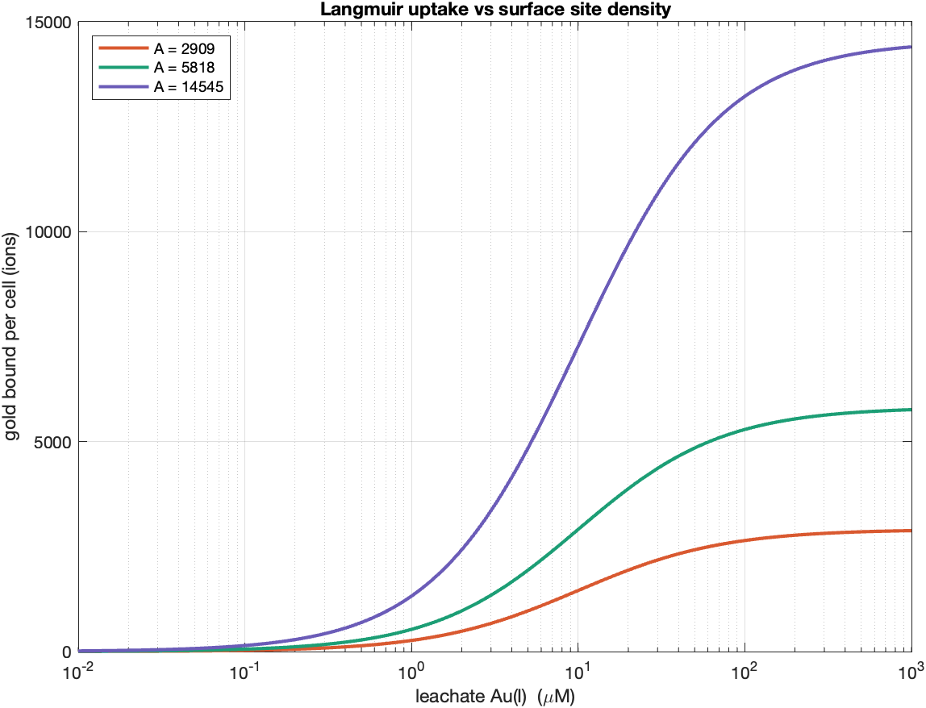
Figure 2. Langmuir uptake curves for three engineered site densities (base, 2×, and 5×), showing gold ions bound per cell as a function of leachate Au(I) concentration.
Each curve rises with leachate gold concentration and plateaus at its own site density — the plateau is simply the number of sites, since each binds one ion. The three curves correspond to the base design (≈2,900 sites) and to two- and five-fold improvements. Half-saturation occurs at a concentration equal to K_{d} (10 µM here), and above roughly 100 µM every design is near saturation. The key takeaway is that at any fixed leachate concentration, gold captured scales directly with engineered site density, so the expression-level improvements identified in Figure 1 carry straight through to recovery capacity.

8. Assumptions and limitations
The model is deterministic and describes an average cell, so it does not capture cell-to-cell variability. Expression is treated as constant and constitutive; induction timing, resource competition, and the growth burden of heavy membrane-protein overexpression are not included. The drain on the cytoplasmic pool is kept first-order so that a closed-form steady state exists, with saturation applied only to surface arrival; this is accurate while site density stays well below capacity, which is the case here (thousands of sites against a ceiling of 10⁵). Finally, the parameters are literature order-of-magnitude estimates rather than measurements of our exact construct, and the gold dissociation constant in particular is a placeholder that should be sourced from a biosorption isotherm or fitted.

9. Literature basis
Surface-display capacity. Jose J, Meyer TF. Autodisplay: efficient bacterial surface display of recombinant proteins. Applied Microbiology and Biotechnology (2006) — reports more than 10⁵ recombinant molecules displayed per cell via the AIDA-I autotransporter.
GolB structure and gold binding. Structural Insights and the Surprisingly Low Mechanical Stability of the Au–S Bond in the Gold-Specific Protein GolB. Journal of the American Chemical Society (2015) — apo- and Au(I)-bound GolB crystal structures and the Cys-X-X-Cys binding motif. Tolbatov I, Re N, Coletti C, Marrone A. An Insight on the Gold(I) Affinity of golB Protein via Multilevel Computational Approaches (2019).
Gold sensing and the gol system. Bacterial gold sensing and resistance. BioMetals (2011) — GolS/GolB selectivity for Au(I). GolS controls the response to gold by hierarchical induction of Salmonella-specific genes. Molecular Microbiology (2007) — GolB as a small cytoplasmic gold-binding protein.
Prior GolB display precedent. iGEM Registry part BBa_K1701000 — GolB displayed on the E. coli surface for selective enrichment of gold ions from mixed-metal media (parts.igem.org).
Central-dogma parameters. BioNumbers database (bionumbers.hms.harvard.edu) for E. coli mRNA half-lives, translation rates, and growth rates.

