**Name: Imran Nazir Udoy**

**Id: 22303286**

**Website Diagram for Fit Life website**

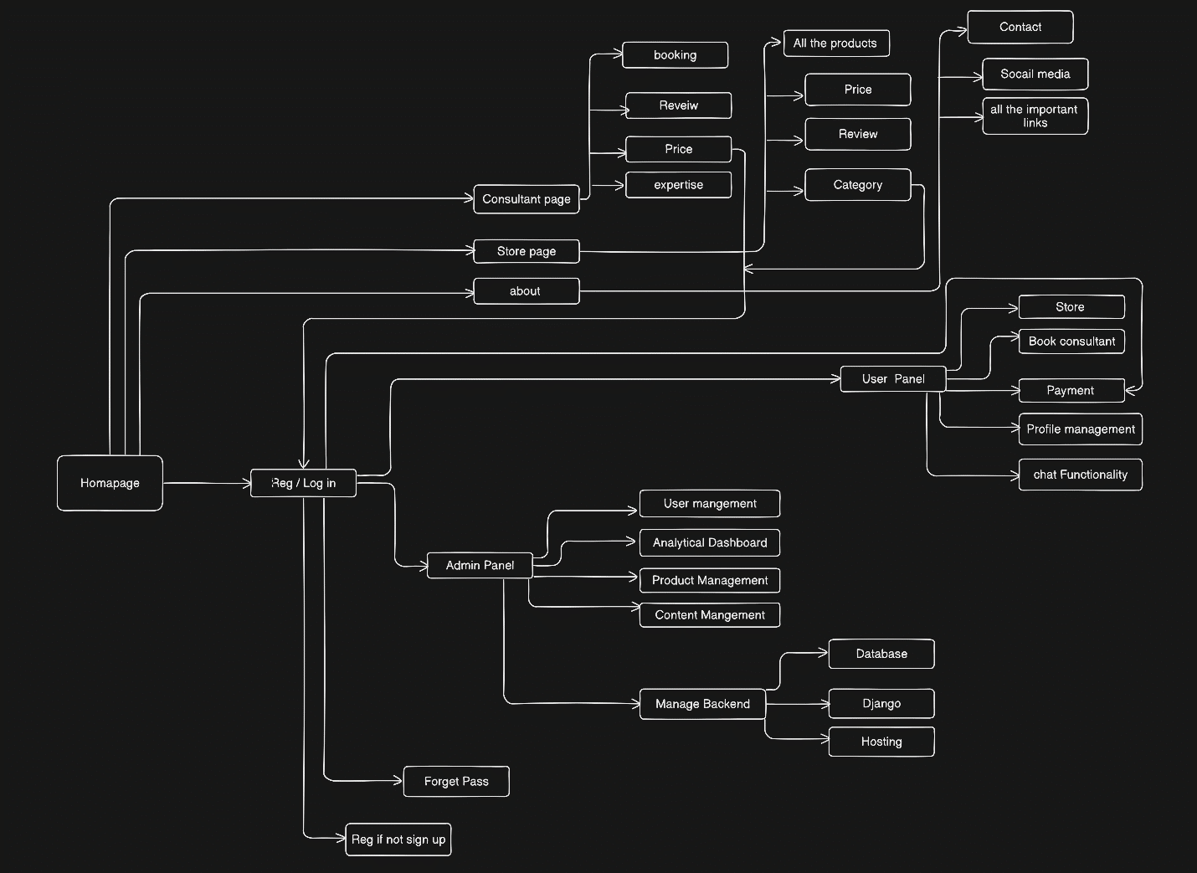

*Fig: Website Diagram*