**Computational Thinking Practices: Pattern Recognition**

**Directions**: For each set of challenges below, examine the two examples for each category (Numerical Sequences, Recipes, Poetry and Python Programming). Try to determine the patterns you see common to both.

I. **Numerical Sequences**. What is the pattern? What would the next number be in each sequence?

1. -2, 2, 6, 10

Pattern: Addition of 4

Next number: 14

1. -3, 6, -12, 24

Pattern: multiplication by -2

Next number: -48

1. 1, 1, 2, 3, 5, 8

Pattern: addition of consecutive numbers in the sequence

Next number: 13

II. **Poems**. What do you see the following poems have in common?

A. Pattern(s) seen in the poems:

I like to program

the output is like magic

unless it is not

B.

Nine months and she came

came with not one instruction

love my only guide

Pattern(s):

* Both talked about a positive atmosphere of love and happiness.
* Both talked about the possibility of having an experience opposite to the current one.
* Both use the “not” keyword to identify a negative outcome.
* Both talk about creation.

III. Recipes. What pattern do you see among these recipes below?

A. Chocolate Chip Cookie Recipe

**Ingredients** Pattern(s) seen:

2 ¼ cups all-purpose flour

½ teaspoon baking soda

½ teaspoon salt

1 cup packed light brown sugar

12 tablespoons salted melted butter

½ cup granulated sugar

2 large eggs

2 teaspoons vanilla extract

2 cups semi-sweet chocolate chips

**Instructions**

* Whisk together the dry ingredients in a medium bowl.
* Whisk together the sugars and melted butter in a large bowl.
* Add the eggs and vanilla extract to the butter mixture.
* Use a rubber spatula to stir the flour mixture into the wet ingredients.
* Fold in the chocolate chips.
* Cover the bowl and chill in the fridge for 15 minutes
* Roll the dough into 2 tablespoon portions.
* Arrange the cookie dough balls on baking sheets.
* Bake the cookies in a 325°F for about 15 minutes.

B. Pizza Recipe

**Ingredients**

1 cup warm water (105 degrees F)

1 Tablespoon granulated sugar

1 Tablespoon active dry yeast

1 Tablespoon olive oil

2 to 2 ½ cups all-purpose flour

1 tsp fine sea salt

**Instructions**

* Combine warm water, yeast and sugar in a large mixing bowl and stir.
* Let mixture sit for 5 minutes or until bubbles form.
* Gently stir in olive oil.
* Add 2 cups of flour and salt and mix with a spatula. Add more flour as needed to form a dough ball.
* Transfer to a floured surface and knead into a smooth dough, adding flour if needed.
* Cover the bowl with a damp tea towel and let it rise for 10 minutes to 1 hour.
* Roll the dough into desired shape.
* Add pizza sauce, cheese and toppings of choice.
* Transfer the pizza to the preheated pizza stone in the oven.
* Bake for 12-15 minutes, or until crust is golden brown.
* Remove the pizza from the oven and set on a wire rack to cool.

Pattern(s):

* Use of flour
* Use of a spatula
* Use of oven
* Both involve baking
* Both doughs were heated with the range of 0 – 15 mins.
* Dough rolling
* Both mixtures were left to stand for some time
* Use of sugar
* Use of salt
* Making of dough
* Use of a systematic sequence of methods for preparation

IV. **Python Programming**. How are these two programs similar? What patterns do you see?

1. *Seeing_stars.py*

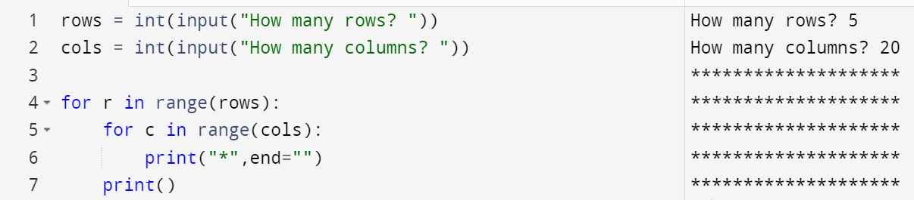

1. *Lets_play.py*

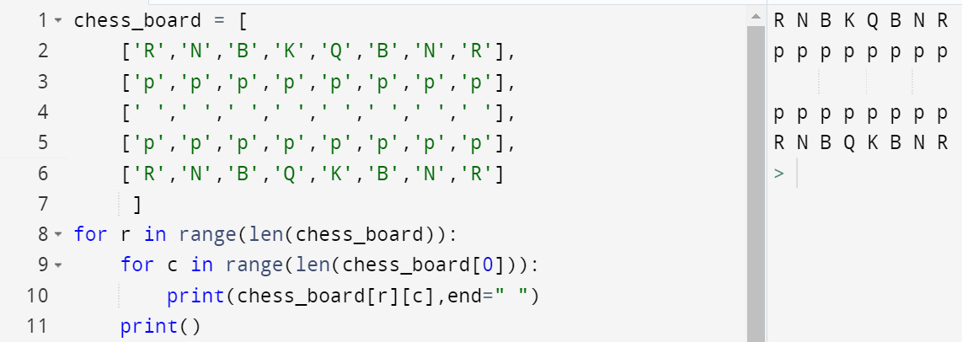

Pattern(s):

* Both use two Python range loops
* Both outputs are in a matrix form of rows and columns
* Both outputs consist of 5 rows
* Both alter the use of Python’s print statements end argument value.
* Both use the number of rows and columns to determine loop iteration.