**Assignment - 1**

**Semester: Spring 2023**

**Submission: 19/20 February, 2023 (in Class)**

**Total Marks: 30**

**Total Questions: 8**

**Q1.** Inspect the conversation between two friends:

Friend 1: Hey, I had some parcels for you. Are you at home?

Friend 2: Yes, I’m at home.

Friend 1: Okay, I’ll send you the parcels then.

Friend 2: I’ll receive your parcels.

Friend 1: Are you ready to receive the parcels?

Friend 2: Yes, I’m ready to receive the parcels.

Friend 1: I’ll send you 10 parcels in one shipment.

Friend 2: Can you send 5 parcels though?

Friend 1: Sure. I’ll send you 5 parcels.

Which layers of the OSI model do you think the communication is being carried out in and why? [4]

**Q2.** List two differences between IP and MAC Address. Suppose, Martin needs to log into his bank account several times a day. Due to the sensitive information related to bank accounts, the data needs to be secured. Select which of the OSI model layer(s) might be responsible for this? [3]

**Q3.** For n devices in a network, what is the number of cable links required for a mesh, ring, bus, and star topology? Show the calculation. [2]

**Q4:** How do we represent data? Name two different data types and their standards. [2]

**Q5:** Refer to figure below, identify the elements of communication. [3]

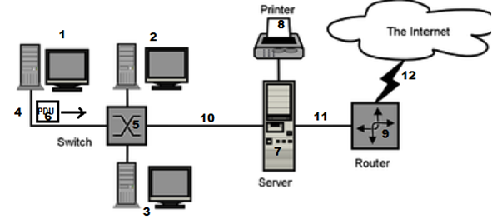

*\*\* Hint: 1 ----> end device, 11-----> transmission media*

**Q6:** What is a peer-to-peer process? Give some advantages and disadvantages of combining the session, presentation and application layer in the OSI model into one single application layer in the TCP/IP model. [2+4]

**Q7:** Draw a hybrid topology with a bus backbone and three ring networks. [4]

**Q8:** Complete the frames (x & y) given below with appropriate port, IP and MAC addresses. The sender Host E has two applications running; one for email with port number 49254 and the other for accessing the web server with port number 52167. The frame x is intended for the BRACU Web server and frame y is coming from the Email Server. (MAC addresses are alphabets and IP addresses are numbers) [6]

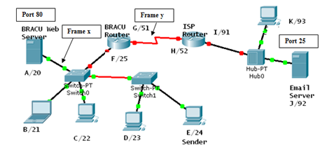

Frame X

|  |  |  |  |  |  |  |  |
| --- | --- | --- | --- | --- | --- | --- | --- |
| D. Mac | S. MAC | D. IP | S. IP | D. Port | S. Port | Data | Trailer |

Frame Y

|  |  |  |  |  |  |  |  |
| --- | --- | --- | --- | --- | --- | --- | --- |
| D. Mac | S. MAC | D. IP | S. IP | D. Port | S. Port | Data | Trailer |

**********************************END***************************************

