1. 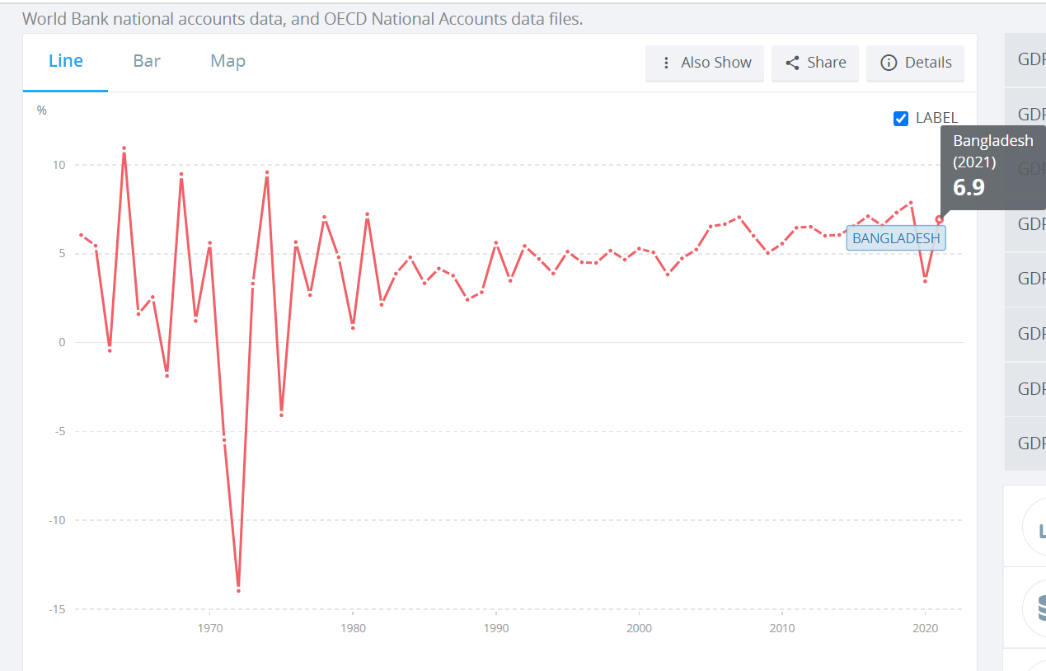World Bank, World Development Indicators. (n.d.). *GDP growth (annual %) - Bangladesh.* Retrieved August 10, 2022, from <https://data.worldbank.org/indicator/NY.GDP.MKTP.KD.ZG?locations=BD>
2. Anik, A. M. (2021, September 22). *Economic Growth of Bangladesh: Key Driving Factors Behind the Rapid Growth*. Business Inspection BD. <https://businessinspection.com.bd/economic-growth-of-bangladesh/>

**Export**

According to a survey conducted by the Indian Ministry of Finance for the fiscal year 2020-21, Bangladesh’s exports grew at an annual rate of 8.6% from 2011 to 2019. However, based on the [Bloomberg article](https://www.bloombergquint.com/economy-finance/economic-survey-2021-why-bangladesh-has-beat-india-in-export-growth), at the same time, the average growth rate of global exports was only 0.4%. As stated by the Bangladesh Bureau of Statistics, in the fiscal year 2018-19, Bangladesh’s total export volume has increased by 12.75% to more than 41 billion dollars compared to the previous year. According to the [Observation of Economic Complexity](https://oec.world/en/profile/country/bgd#:~:text=Product%20Trade,-%23permalink%20to%20section&text=In%202019%2C%20Bangladesh%20exported%20a,52%20exporter%20in%20the%20world.)%27%E0%A6%B0), Bangladesh ranks 52nd in the world in terms of exports. The RMG sector is the biggest contributor to Bangladesh’s success in terms of exports. At the end of the 2019-20 fiscal year, Bangladesh was able to export about 34 billion dollars worth of products, of which 83% were RMG products. Other than RMG, Bangladesh also exports home textile, leather & leather goods, jute and jute products, agricultural products, fisheries, ceramics, pharmaceuticals, ships and vessels, softwares & ICT products, and electronics and electrical products. Another notable reason behind Bangladesh’s success in exports is tariff-free access to the developed countries.

1. Anonymous. (2022, April 16). *Labour export posts whopping 220% growth in Jan-Mar'22*. DhakaTribune. [https://www.dhakatribune.com/business/2022/04/16/labour-export-posts-whopping-220-growth-in-jan-mar22#:~:text=The%20present%20trend%20shows%20that,of%20Commerce%20and%20Industry%20(DCCI)](https://www.dhakatribune.com/business/2022/04/16/labour-export-posts-whopping-220-growth-in-jan-mar22%23:~:text=The%20present%20trend%20shows%20that,of%20Commerce%20and%20Industry%20(DCCI))

Bangladesh exported a total of 1,008,525 workers in 2017, the highest number in one year, during the last 50 years.

Bangladesh sent a total of 10,57,223 workers to Malaysia during the period of 1976-2021.

The country exported 175,927 workers in 2018 and only 545 workers, 125 workers and 24 workers in 2019, 2020 and 2021 respectively.

The country exported only a total of 34 workers during the January-March period of the current calendar year

Bangladesh had exported a total of 10,57,056 skilled and unskilled workers to the Southeast Asian country during 1976--2019 period, according to Bureau of Manpower, Employment and Training (BMET).

The country exported a total of 14 workers to Malaysia in 2021, 125 workers in 2020, 545 workers in 2019, 175,927 workers in 2018 and 99,787 workers in 2017.

1. 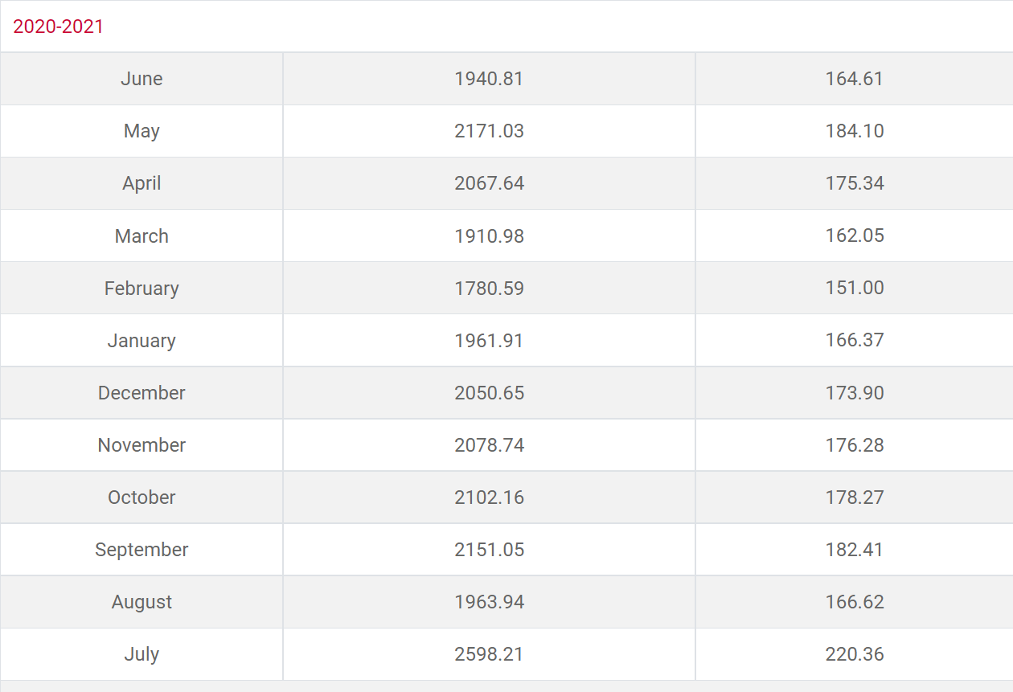Bangladesh Bank. (n.d.). *Monthly data of Wage earner's remittance.* Retrieved August 10, 2022, from <https://www.bb.org.bd/en/index.php/econdata/wageremitance>
2. 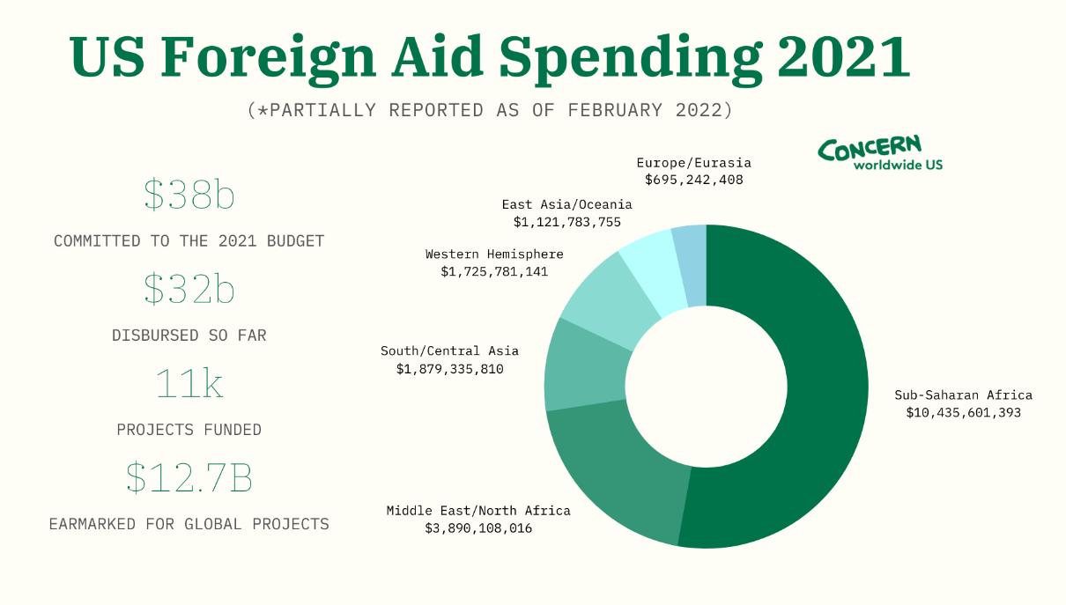Anonymous. (2022, February 7). *Foreign aid by country: who is getting the most — and how much?*. ConcernUSA. <https://www.concernusa.org/story/foreign-aid-by-country/>
3. World Bank. (n.d.). *Understanding poverty.* Retrieved August 10, 2022, from [https://www.worldbank.org/en/topic/skillsdevelopment#3](https://www.worldbank.org/en/topic/skillsdevelopment%233)

**Kenya**: In Kenya, where youth unemployment is high, the [Youth Employment and Opportunities Project](https://projects.worldbank.org/en/projects-operations/project-detail/P151831) is helping an estimated 280,000 young Kenyans develop in-demand skills and expand their opportunities. The project includes results-based contracts conditional on youth placement in internship and then employment, to encourage engagement of training providers with private sector employers. The project also supports self-employment by financing and training micro-enterprises as well as young firms with high growth potential, improves access to labor market information, and strengthens youth policy development.