**The Indian Ocean slave trade**

* Can be traced from the 7th century
* Known as the East African slave trade or Arab slave trade
* Was Multi-Directional
* Ships transporting the slaves are known as ‘Dhows’
* There was an established system of bonded labor
* Resulting in slave-based economies in East Africa

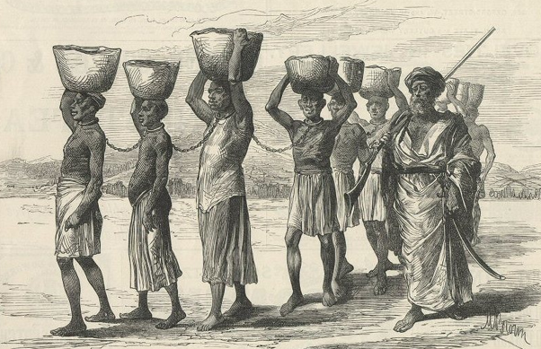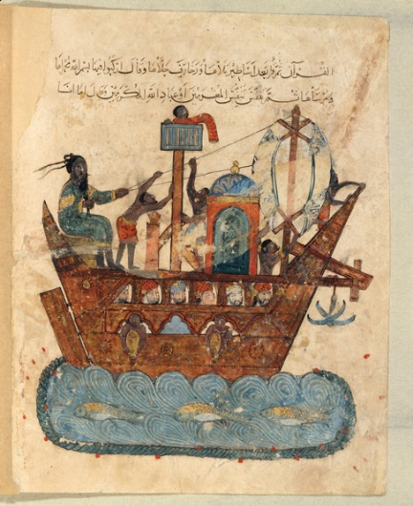

The Indian Ocean slave trade is said to be the oldest of the slave trades. However, it can be traced from the seventh century.

It was multi-directional. Africans were sent as slaves to the Middle East, to Indian Ocean islands (including Madagascar), to the Indian subcontinent, and later to America.

The Arab tradesmen dominated the slave trade who were mostly small business dealers and would typically transport only 10-25 slaves at a time in small ships known as ‘Dhows’.

Slavery was also a long-established and normalized aspect of some Arab and Islamic cultures as well as many African societies. People who were unable to pay their taxes or could not afford food during times of famine sold themselves into an established system of bonded labor.

In 1844, enslaved Africans could be purchased in Zanzibar for 6-12 dollars and sold for approximately 60-200 dollars the other side of the Indian Ocean.

One of the major consequences of the Indian Ocean slave trade was the creation of slave-based economies in East Africa. Slavery additionally led to anarchy, increased warfare, increased famine, and economic disparity in the Eastern African countries that were involved and gave rise to an African diasporic presence across the Indian Ocean.