Copy-paste this single master prompt into Wavel website builder. It includes your multi-sector work, the missing items (Child Protection/Safeguarding, Mental Health/PSS, WASH, Disability Inclusion, DRR, Peacebuilding/Post-crisis), governance + policies hub, partners, events, campaigns, knowledge hub, and social links (WhatsApp/LinkedIn/Instagram/Facebook/YouTube/X).

✅ MASTER PROMPT FOR WAVEL (ANUVATI WEBSITE)
Build a modern, credible, youth-led global development website for:
Brand name: ANUVATI
Legal name (footer only): Anuvati Global Development Initiative
Positioning: A Youth-Led Global Development Initiative
Meaning: Accelerating Nurturing Unified Vision & Action Towards Impact
Tone: youth-led and energetic, but institutional-credible for CSR/government/international donors
Style: clean, modern, high trust, strong hierarchy, minimal clutter
Theme colors: Purple + Gold gradient accents (premium, forward-looking)
CTA focus: Partner With Us • Join the Movement • Donate/Support • Volunteer/Intern
1) GLOBAL DESIGN RULES
- Mobile-first, fast, SEO-friendly, accessible contrast.
- Use a hero gradient (purple→gold) with plenty of whitespace.
- Use consistent card style for programs, partners, policies, events.
- Header with logo + sticky navigation + 1 primary CTA button.
- Footer with social icons + legal name + quick links + contact.
2) NAVIGATION / PAGES TO CREATE
Create these pages in the top menu:
- Home
- About ANUVATI
- Our Work (Sectors)
- Programs
- Impact
- Partners
- Governance
- Policies & Safeguarding
- Events
- Campaigns
- Knowledge Hub
- Get Involved
- Donate / Support
- Contact
Add a top mini-bar (optional) with quick links: WhatsApp | Email | Donate.
3) HOMEPAGE LAYOUT (SECTION-BY-SECTION)
Hero section (full width):
- Headline: “Vision into Action. Youth into Impact.”
- Subtext: “ANUVATI is a youth-led global development initiative advancing inclusive, resilient, future-ready communities across India and beyond.”
- CTAs: Join the Movement (primary), Partner With Us (secondary), Support Our Work (tertiary)
Who we are (2 columns):
- Short story: People-first development, participation not charity, measurable outcomes.
- Add quick bullets: Youth-led • Community-driven • Transparent • Multi-sector
Focus Areas grid (multi-sector cards):
Show 6–9 highlighted sectors on home; link to full “Our Work”.
Include these categories (must be on the full Work page):
- Art & Culture
- Digital Transformation
- Education
- Healthcare
- Nutrition & Food Security
- Livelihood & Entrepreneurship
- Skill Development
- Gender & Inclusion
- Environment & Clean Energy
- Sports & Youth Development
- Rural Development
- Urban Development
- Legal Aid & Access to Justice
- Old Age & Elder Care
- Disaster Relief & Rehabilitation
- Disaster Risk Reduction (DRR) & Preparedness ✅
- WASH (Water, Sanitation, Hygiene) ✅
- Mental Health & Psychosocial Support (MHPSS) ✅
- Child Protection & Safeguarding ✅
- Disability Inclusion ✅
- Peacebuilding / Conflict-sensitive & Post-crisis Support ✅
- Anti-substance abuse / De-addiction & Rehab
- Climate resilience / community preparedness
How we work (4 pillars):
- Community-led design
- Youth volunteer network
- Partnerships for scale
- Transparency & evidence-based impact
Presence / map section:
Add a map component with India highlighted and placeholder for:
- India → Uttar Pradesh → Lucknow
- “Blocks covered: [placeholder number]”
- “Expansion roadmap: [placeholder states/countries]”
Partners strip + categories:
Create a partner showcase with logo rows and headings:
- CSR Partners
- Government Partners
- Institutional Partners
- Academic Partners
- Community Partners
(Use placeholder logos with “Your Partner Logo Here” boxes; allow easy replacement.)
Impact metrics section:
Counters (editable):
- Communities reached
- Youth volunteers
- Schools/colleges engaged
- Programs delivered
- Districts/blocks covered
Safeguarding & Trust callout:
A visible trust banner:
“Safeguarding • Ethics • Accountability”
Buttons: Policies • Transparency
Latest updates section:
Show latest 3 from Events/Campaigns/Blogs.
Final CTA:
“Be part of the ANUVATI movement.”
Buttons: Volunteer • Partner • Donate
4) ABOUT PAGE CONTENT (WRITE IT INSTITUTIONAL STYLE)
Include sections:
- Our Story (Genesis): why ANUVATI was founded; youth potential; participation-driven development.
- Meaning of ANUVATI (Anu = continuity, Vati = embody/carry) + the acronym expansion.
- Vision, Mission, Values.
- India-first, global collaboration approach.
- Founder message (placeholder).
- Advisory board (placeholder list).
- Legal name note (footer): Anuvati Global Development Initiative.
5) OUR WORK PAGE (SECTORS) – STRUCTURE
Create a filterable grid by theme:
- People (Education, Health, Nutrition, MHPSS, Child Protection, Old Age, Disability)
- Prosperity (Livelihood, Skills, Digital, Legal Empowerment)
- Planet (Environment, Energy, Climate Resilience, DRR, WASH)
- Community (Rural, Urban, Culture, Sports, Peacebuilding/Post-crisis)
Each sector page/expandable panel should include:
- Problem statement
- What ANUVATI does
- Key activities
- Who benefits
- Expected outcomes
- How to partner
6) PROGRAMS PAGE (CMS-LIKE LIST)
Create a program card template with:
- Program name, location, duration
- Objectives
- Partners
- Outputs/outcomes
- Photo/video gallery
Add “Start a program with us” inquiry button.
7) IMPACT PAGE
Include:
- Impact dashboard counters
- Case studies cards (placeholders)
- Testimonials carousel (placeholders)
- Photos/videos gallery
- Annual report download section (placeholders)
8) PARTNERS PAGE
Separate sections for each category with:
- Logo grid
- Partner name + short line (optional)
- Partner website link
Add a “Partnership models” section:
- CSR project partnership
- Institutional collaboration
- Government program support
- Campus/Volunteer partnership
- Global donor partnership
9) GOVERNANCE PAGE (ORGANIZATIONAL STRUCTURE)
Include a visual org chart + descriptions:
- Governing Board
- Advisory Council
- Executive Team
- Program Leads (Sector-wise)
- District/Block Coordinators
- Volunteer Network
Add placeholders for names and roles.
10) POLICIES & SAFEGUARDING PAGE (VERY IMPORTANT)
Create a “Policy Library” with downloadable placeholders and short summaries.
Include at minimum:
- Safeguarding Policy ✅
- Child Protection Policy ✅
- Code of Conduct & Ethics ✅
- Anti-Harassment / PoSH (India) ✅
- Whistleblower Policy ✅
- Conflict of Interest Policy ✅
- Anti-Fraud & Anti-Corruption ✅
- Procurement Policy ✅
- HR / People Policy ✅
- Data Privacy Policy ✅
- Donor Privacy Policy ✅
- Grievance Redressal Policy ✅
- Finance & Internal Controls Framework ✅
- Volunteer Policy (recommended)
- Information Security basics (recommended)
Also add a “Report a Concern” section (with email placeholder and confidential reporting note).
11) EVENTS PAGE
List format + detail pages:
- Title, date, location
- Register button (optional)
- Photo gallery
12) CAMPAIGNS PAGE
Active campaigns + past campaigns:
- Banner, objective, duration, impact summary
- Donate/Support CTA
13) KNOWLEDGE HUB (RESOURCES)
Create categories:
- Blogs
- Articles
- Reports
- Case Studies
- Videos
- Testimonials
- Podcast: “The ANUVATI Dialogue Series”
Each item should have tags and share buttons.
14) GET INVOLVED PAGE
Create role-based blocks:
- Volunteer
- Internship
- Campus Ambassador
- Corporate Volunteering
- Partner Organization
Each with “Apply” button linked to a form.
15) DONATE / SUPPORT PAGE
Include:
- Why support ANUVATI
- What your support enables
- Donation methods placeholders:
  - UPI/Bank transfer (India)
  - International donations note (FCRA compliance when applicable)
- Transparency links (annual reports, policies)
16) CONTACT PAGE + SOCIAL LINKS
Include:
- Contact form
- Email: info@anuvati… (placeholder)
- Address (placeholder)
- Embedded map
- Social icons with links:
WhatsApp, LinkedIn, Instagram, Facebook, YouTube, X
Add a floating WhatsApp button on all pages.
17) SEO & FOOTER REQUIREMENTS
- Add meta titles/descriptions per page.
- Footer must include:
Legal name: Anuvati Global Development Initiative
Social icons
Quick links
Privacy policy link
Copyright
18) CONTENT PLACEHOLDERS TO GENERATE AUTOMATICALLY
Create placeholder content and dummy examples where not provided:
- 3 case studies
- 6 testimonials
- 3 blog posts
- 3 campaigns
- 3 events
- policy library entries (as placeholders)
Output a complete website with this structure and content placeholders ready for real updates.

Here’s a complete “Website Builder Handover Document Checklist” for ANUVATI. If you give these to your website builder at the start, they won’t need to keep asking you again and again.

1) Brand & Design Pack (Must-have)
- Logo Pack
  - Icon-only (PNG transparent + SVG)
  - Stacked logo (PNG transparent + SVG)
  - Horizontal logo (PNG transparent + SVG)
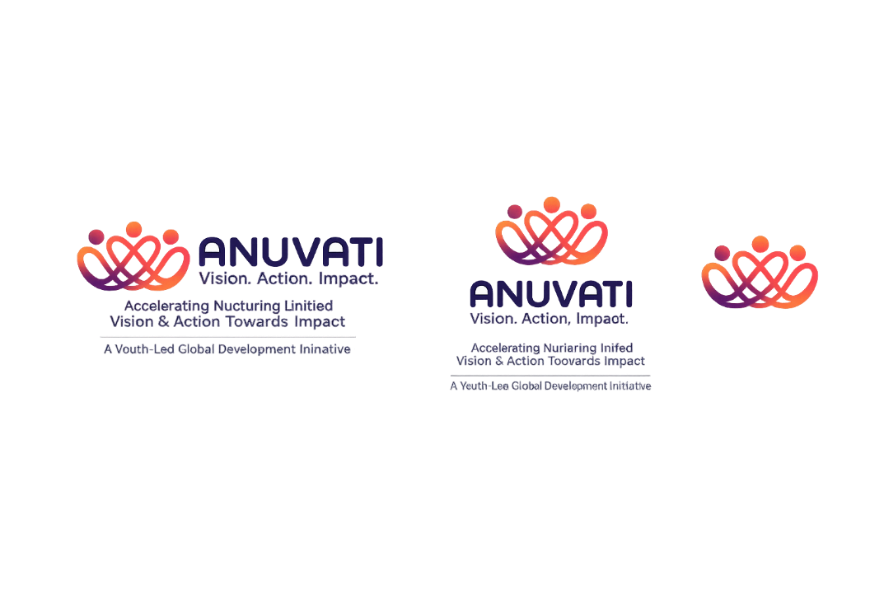
- Color Palette (Brand Colors)
  - Primary purple codes
  - Gold codes
  - Secondary/supporting colors
  - Background and text colors
- Typography / Font Names
  - Heading font + body font
- Brand Guidelines (1–5 pages)
  - Logo usage (minimum size, spacing, light/dark backgrounds)
  - Do’s & Don’ts
- Favicon + App Icons
  - 16x16, 32x32, 180x180, 512x512

2) Identity & Legal Documents (Trust-building)
- Legal Registration Proof
  - Certificate of incorporation/registration (Section 8/Trust/Society as applicable)
- PAN of Organization
- 80G Certificate (if available)
- 12A/12AB Certificate (if available)
- CSR-1 Certificate (if applicable)
- FCRA Certificate (if applicable for foreign donations)
- Registered Address Proof (rent agreement/utility bill)
- Board/Directors List (official)
- MOA + AOA / Trust Deed / Bye-laws (whatever applies)

3) Core Organization Content (Copy-ready docs)
- Master Profile Document
- About ANUVATI
- Story/Genesis
- Meaning of ANUVATI
- Vision, Mission
- Core values
- Goals (1-year, 3-year, 5-year)
- Short Description (50–80 words)
- Medium Description (150–200 words)
- Long Description (500–700 words)
- Founder’s Message (200–300 words, signed)
- Leadership Bios
- Founder bio + photo
- Executive team bios + photos
- Advisory Board Document
- Names, titles, 2–3 line bios, photos (or placeholders)

4) Programs / Sectors Documentation (Very important for you)
- Sectors List + Program Framework (single doc)
For each sector:
- Problem statement
- What ANUVATI does
- Target beneficiaries
- Key activities
- Expected outcomes
- Geography (where)
- Who can partner
Include all your sectors plus:
- Child Protection & Safeguarding
- Disability Inclusion
- Mental Health & Psychosocial Support
- WASH
- DRR & Preparedness
- Peacebuilding/Post-crisis support
- Programs List (actual or planned)
For each program: name, timeline, location, outcomes, photos.

5) Geography & Presence Documents (Map section)
- Operational Presence Sheet (Excel/Google Sheet)
Columns:
- State
- District
- Block
- Area/Village
- Start date
- Status (active/planned)
- Programs running there
- Expansion Roadmap (1 page)
- Next districts/states
- Next countries (future)
- Map coordinates (optional)
If you want precise map pins later.

6) Partner & Collaboration Documents
- Partners List Sheet (Excel)
Columns:
- Partner name
- Category (CSR/Gov/Institution/Academic/Community)
- Logo file name
- Website link
- Partnership description (1 line)
- Start year
- MOUs / Letters of Support (if any)
- CSR Pitch Deck / Partnership Note (optional but powerful)

7) Events / Campaigns / Resources Content
- Events List Sheet
- Title, date, location, description, registration link
- Campaigns List Sheet
- Title, status, goals, donors/partners, results
- Resources Folder
- Blogs (Word docs)
- Articles
- Reports (PDF)
- Case studies (PDF)
- Testimonials (text + photos)
- Videos links (YouTube links)
- Podcast plan (name, episodes list)

8) Policies & Governance (To publish under Policies/Transparency)
- Policy Library Folder (PDF/DOCX)
Minimum set (high trust):
- Safeguarding Policy
- Child Protection Policy
- Code of Conduct & Ethics
- PoSH Policy (India)
- Whistleblower Policy
- Conflict of Interest
- Anti-Fraud/Anti-Corruption
- Procurement Policy
- HR/People Policy
- Data Privacy Policy
- Donor Privacy Policy
- Grievance Redressal Policy
- Finance/Internal Controls Overview
- Volunteer Policy (recommended)
(Even if drafts, provide “Version 1.0” PDFs.)
- Governance Structure Doc
- Org chart + roles/responsibilities
- Safeguarding Reporting Process (1 page)
- How to report concern + email/phone + confidentiality statement

9) Donations & Finance (If donation page needed)
- Donation Details Document
- Bank account name
- Account number
- IFSC
- UPI ID
- QR code
- Donation email & phone
- Donation Policy / Refund Policy (short page)
- Utilization Plan (what donations support: education kits, camps etc.)

10) Digital Assets (Website-ready)
- Photo Library (Google Drive folder)
Folders:
- Events
- Programs
- Team
- Community
- Partners
- Video Library
- Raw clips
- Edited videos
- YouTube links
- Press/Media Coverage (if any)
- Links + screenshots

11) Technical Access & Admin
- Domain Access (login)
- Hosting Access (login)
- Business Email Setup (Google Workspace / Zoho)
- Social media handles list (links + login if needed)
- Google Analytics + Search Console access (if you want tracking)

