USE CASE DIAGRAM FOR FREE MARKET SYSTEM

2017-04-11796

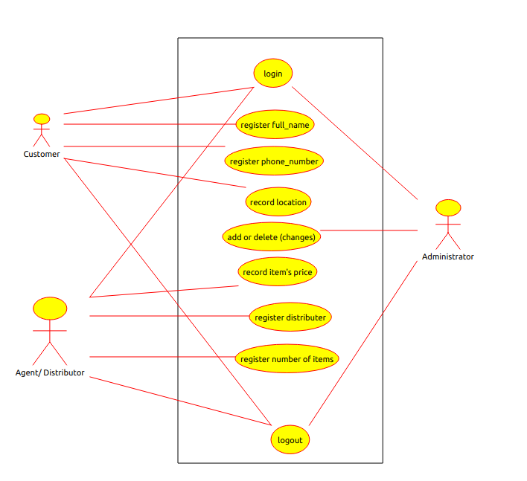

Basic functional requirements of the free market system;
- Login
- Register full_name
  - Register phone_number
  - Record location
  - Add or delete item
  - Register distributor
  - Record price
  - Record number of item
  - Logout

Non functional requirements of the free market system;
- Web based –php, java script, HTML.

