Step-1

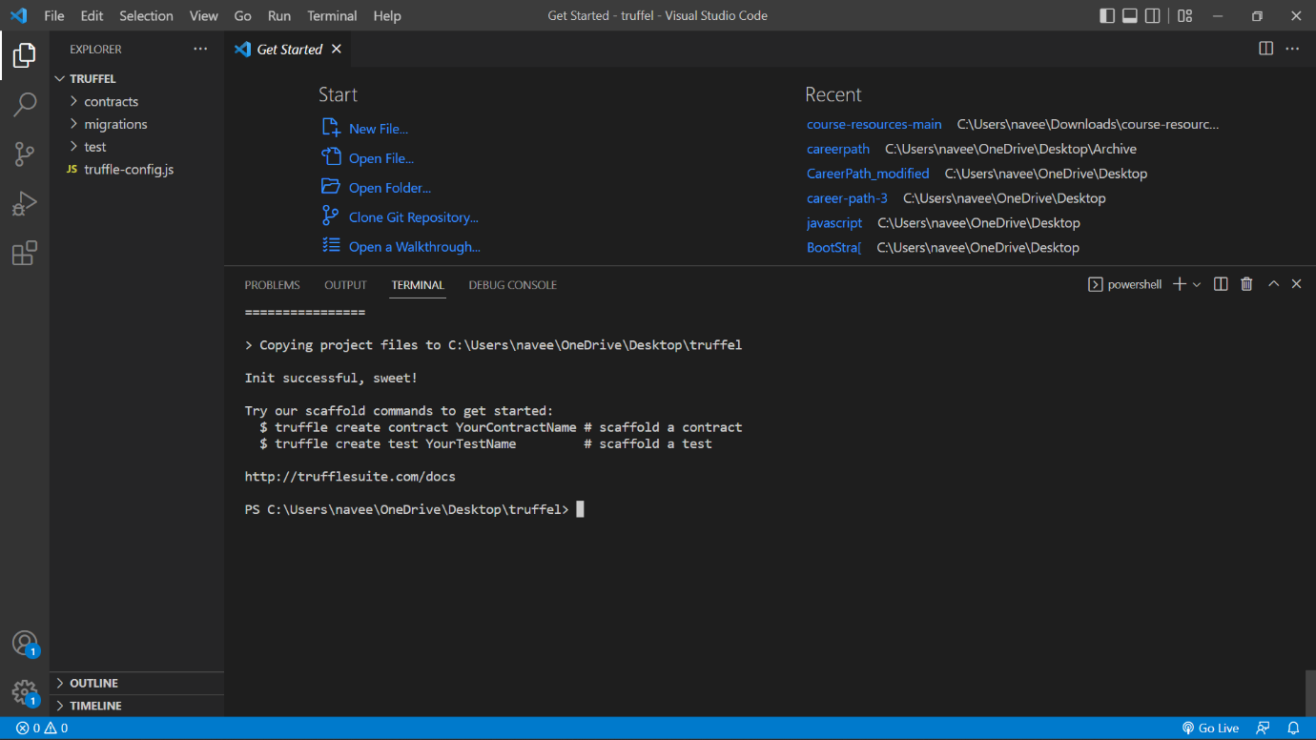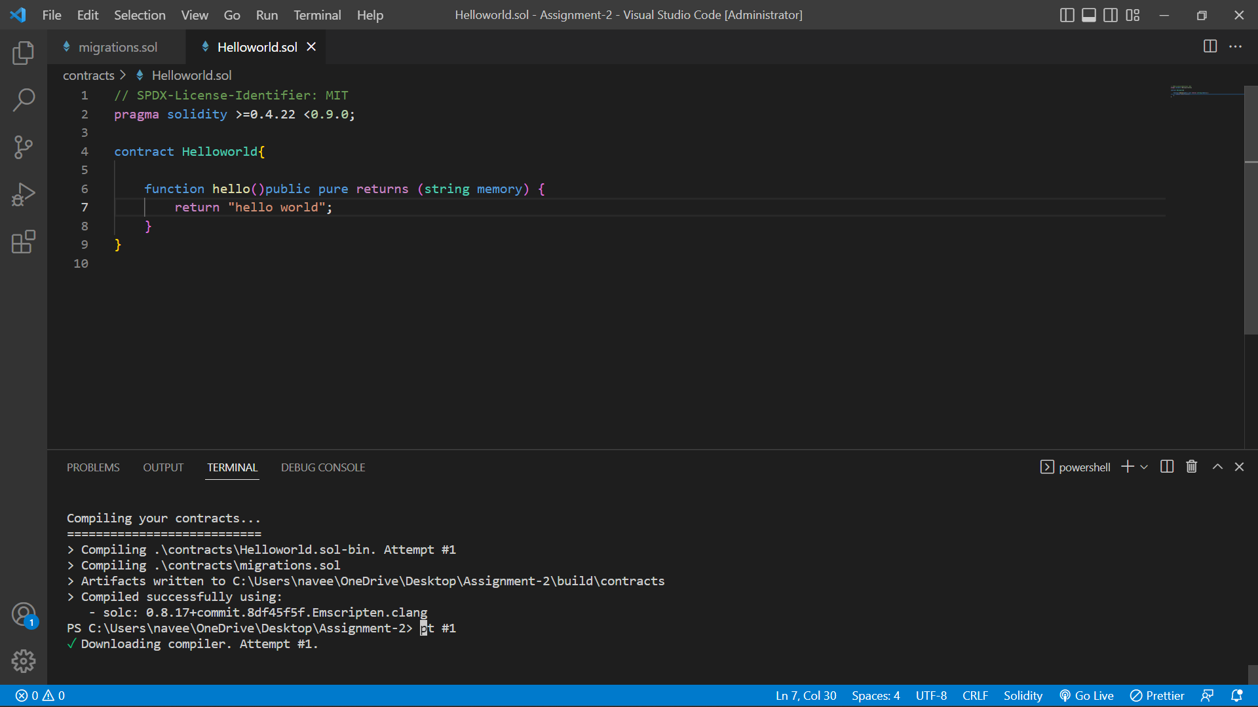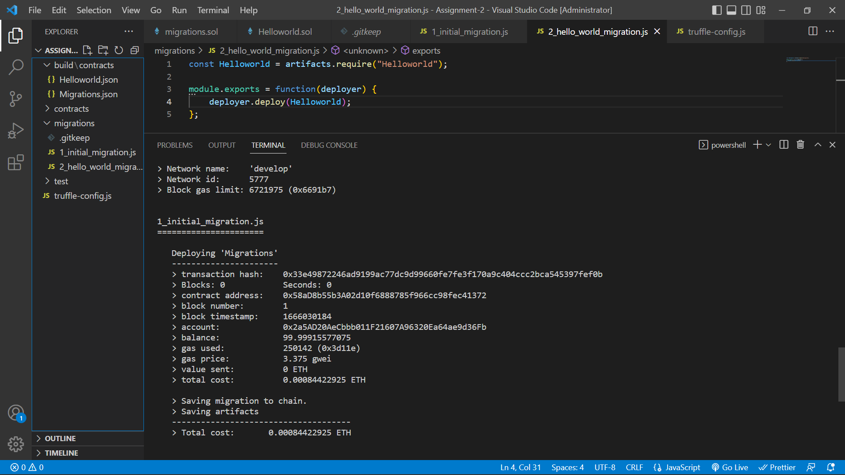

Step-2