

**HERITAGE WALK AND REGIONAL CRAFTS**

**“ Kamalashile Durgaparameshwari Temple ”**

Submitted by

|  |  |
| --- | --- |
|  |  |

**Chinmaya Udupa 4SF22IS025**

Submitted to

|  |
| --- |
| **Prof.Akshaya Kumari Shetty** |

Assistant professor

Department of humanities

**Kamalashile Durgaparameshwari Temple: A divine place**

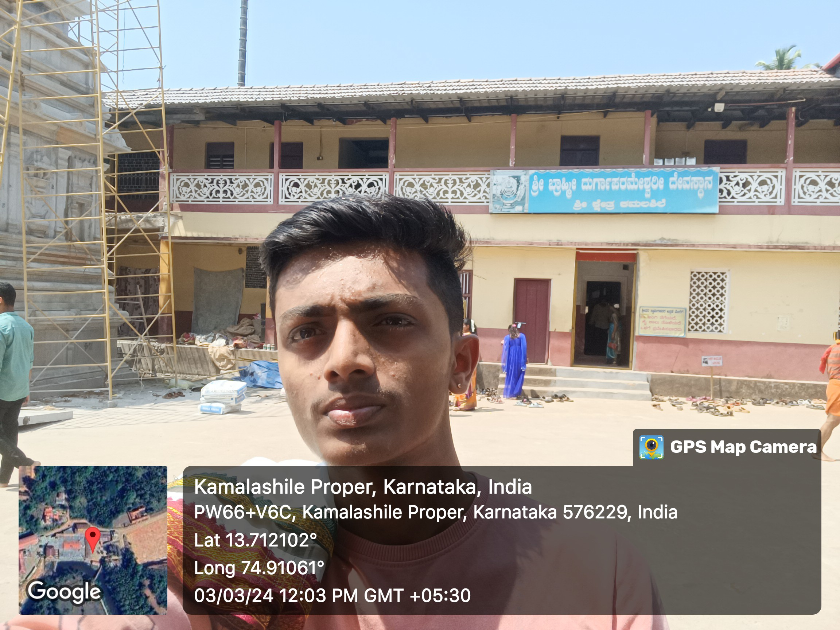

This ancient temple is in Kamalashile, about 35 kms from Kundapura and surrounded by beautiful hills and green forests nearby. The notable feature is the goddess here is worshipped in the form of a Linga! (Usually, only Lord Shiva is in the form of a Linga, so it is very rare to find the goddess in Linga form). The goddess is said to be the convergence of the three Devis – Kali, Lakshmi and Saraswathi. Another notable example of the religious harmony of this place is – every evening there is a special pooja performed to the goddess till date,and as a tribule to the rulers Hyder Ali and his son Tippu Sultan who are said to have patronized this temple!

**Historical Significance:**

The legendary story of this shrine is interesting. There was a dancer by name Pingala. She was arrogant and egoistic. She was asked to give a dance performance in the court of Lord Shiva and mother Goddess Parvathi. Pingala refused to dance. Mother Goddess Parvathi was angry on Pingala’s adamancy and cursed Pingala to lose her beauty and to born as ugly woman (Kubja) on earth. Shockingly realising her mistake Pingala cringed for mercy. At that time, as a coincident, one demon Kharatasura was harassing the people on earth. Then Parvathi said that She will go down to earth to kill Kharatasura and settle there in the form of Linga on lotus shaped stone in front of Raikwa Rushi ashram in Sahyadri, by name Kamalashile. Pingala should meet Her in that place.

Because of the curse Pingala became a hunch back woman. On account of her disordered shape of body she was identified as Kubja. There is a cave near this temple called Suparashwa cave. Pingala came to do meditation here on the bank of the river which came to be called as Kubja River. Pleased with penance Parvathi appeared and told Pingala to go to Mathura and wait for Lord Sri Krishna’s visit to her place. Now the story continues to the stage of Sri Krishna leaving Gokula (Gokula Nirgamana) to go to Mathura to kill his maternal uncle Kamsa. Then this Kubje was serving Kamsa by supplying flowers and garlands. Sri Krishna met her on the way in Mathura and on taking the garland from her removed her ugly hunch back and she resumed her original beautiful body and thanking Sri Krishna and with his permission went back to her abode in Devaloka.

**Deity and rituals:**

There is a distinction in performance of every day pooja in this temple compared to other temples. Here they call it as Vijaya-Agama system. According to it Pooja is done 5 times a day at Usha Kala (Early Morning 6am), Pratha Kala (Morning 8.30am), Maddyana Kala (Afternoon 12.30pm), Sandya Kala (Evening 5.30pm) and Ratri Kala (Night 8pm). Apart from this Thri-Kala Bali is also performed. But it is not animal sacrifice. ‘Bali’ is a procedure of offering rice to ashta-dikpalakas of goddess around the inner quadrangle in morning, afternoon and at night.

The practice here is as prevailing in other temples in coastal region. While entering the inner quadrangle the male devotees should remove their shirts and banyans and female devotes are required to wear a saree or a salwar. Devotees are requested to put their offerings in the temple hundi or pay at the office counter and collect receipt for what they pay.

Thousands of devotees gather here from far of places particularly during the performance of Chandika Shanti, Chandika Parayana, and Durga Shanti Homas every year

**Architectural Splendor:**

The temple's architectural brilliance is a testament to the skilled craftsmanship The towering gopuram, adorned with intricate sculptures, serves as a majestic gateway, welcoming devotees and visitors alike into a realm of cultural opulence.As soon as you enter the area you will see a tall metal covered pole (Dwajasthambha) standing in the temple precincts. As you go inside you will find in front of the main door of the temple. It is a said that it is about 75 feet height from its base to the tip, made from one lengthy stem of a tree (Bhogi Tree) that was particularly chosen from among the trees found on the banks of River Kubja. The metallic cover is made up of 200kgs of Silver. Dwaja-arohana namely the inauguration of Dwaja Stamba (Flag pole) was done on 2.4.2010.

**Cultural Practices and Festivals:**

Enveloped in a tapestry of cultural traditions, the temple pulsates with the rhythm of ageold rituals and vibrant festivities. From the resplendent celebrations of Navaratri, where

devotees immerse themselves in worship and revelry, to the solemn observance of sacred

ceremonies and rituals, each tradition reflects the deep-rooted heritage and devotion

ingrained in the local populace.

**Social Relevance**:

The Durgaparameshwari Temple serves as a cornerstone of societal cohesion, drawing

devotees from diverse backgrounds who converge to seek blessings and solace from the

goddess of abundance. It serves as a unifying force, transcending societal divides and

fostering a sense of community among pilgrims who gather to partake in rituals and

prayers, reaffirming their shared faith and reverence.

The temple becomes a social epicenter, fostering an environment where individuals from diverse backgrounds come together for a common cause.

**Preservation Efforts:**

Recognizing its historical and cultural significance, concerted efforts have been undertaken

to preserve the architectural splendor and sanctity of the Durgaparameshwari Temple.

through meticulous restoration projects, conservation initiatives, and community-driven

endeavors, stakeholders are steadfast in their commitment to safeguarding this sacred

edifice, ensuring its legacy endures for generations to come

**Tourist Attraction:**

Beyond its religious sanctity, the Durgaparameshwari Temple captivates tourists with its

picturesque vistas and serene ambiance. Visitors are drawn to its architectural marvels,

enveloped by the tranquility of nature’s embrace, and offered the opportunity to engage in

spiritual rituals, making it a cherished destination for seekers of both divine enlightenment

and cultural immersion

Tourists are not only captivated by the spiritual sanctity of the temple but also by the architectural grandeur that reflects the historical evolution of the region. The temple serves as a cultural bridge, inviting visitors to immerse themselves in the traditions and stories that have shaped Karnataka's cultural identity.

**Conclusion:**

In conclusion, the Kamalashile Durgaparameshwari Temple stands as more than a physical structure; it is a living, breathing testament to the values and aspirations. Its historical significance, architectural brilliance, cultural practices, social impact, preservation efforts, and allure as a tourist attraction collectively contribute to its status as a heritage marvel.

Its significance transcends mere religious symbolism, serving as a beacon of inspiration and enlightenment for all who tread its hallowed grounds. As we reflect on its timeless allure and profound impact, we are reminded of the enduring legacy it leaves behind—a testament to the enduring power of faith, unity, and cultural preservation.