**Prompt Innovators Chatbot User Guide**

Welcome to the **Prompt Innovators Chatbot**—an intelligent system designed to optimize and provide prompt templates based on your input queries. This chatbot helps you generate high-quality prompt templates that you can use with Large Language Models (LLMs) like GPT, Gemini, or others to get accurate and optimal responses to your queries.

**Interface Overview**

The Chat bot interface is simple and intuitive, allowing you to easily interact and receive prompt templates customized for your needs.

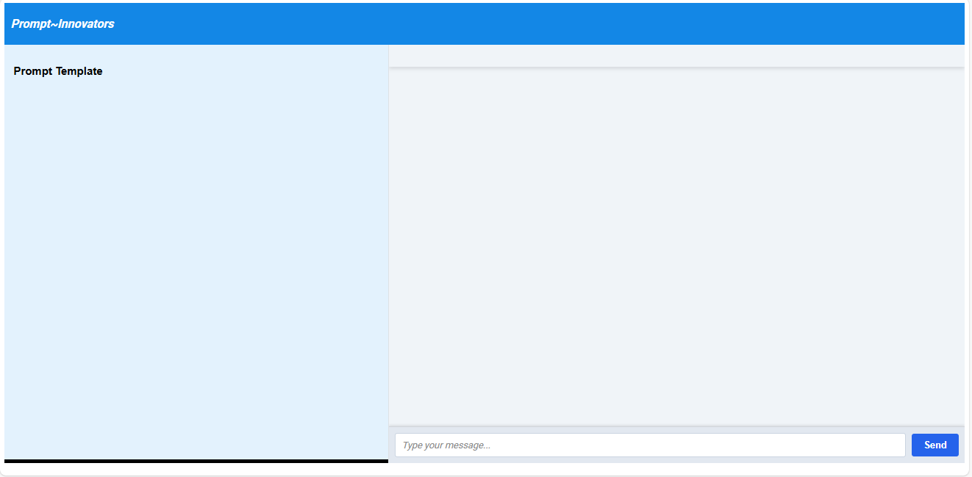

**How It Works**

**1. Submit a Query:**

You start by typing in your query or question in the input box provided. The chatbot processes the query and generates a relevant response based on the context of your question.

**2. View and Download the Generated Prompt Template:**

Along with the response, a **View Prompt Template** button is available for you to see and download the exact prompt template used by the system to generate the response. This template is tailored specifically for your query and optimized to work with LLMs. Clicking the **View Prompt Template** button will display the prompt and automatically give you the option to download it in PDF format.

**3. Use the Prompt with Any LLM:**

The prompt template provided by the system can be used with any LLM (such as GPT or Gemini) to generate the most effective and contextually accurate responses for your query. Simply take the prompt and input it into your preferred LLM to get the best output.

**Example Interaction**

Step 1: You type a question, such as “What is criminal law?"

Step 2: The chatbot provides a response to your query and offers a **View Prompt Template** button.

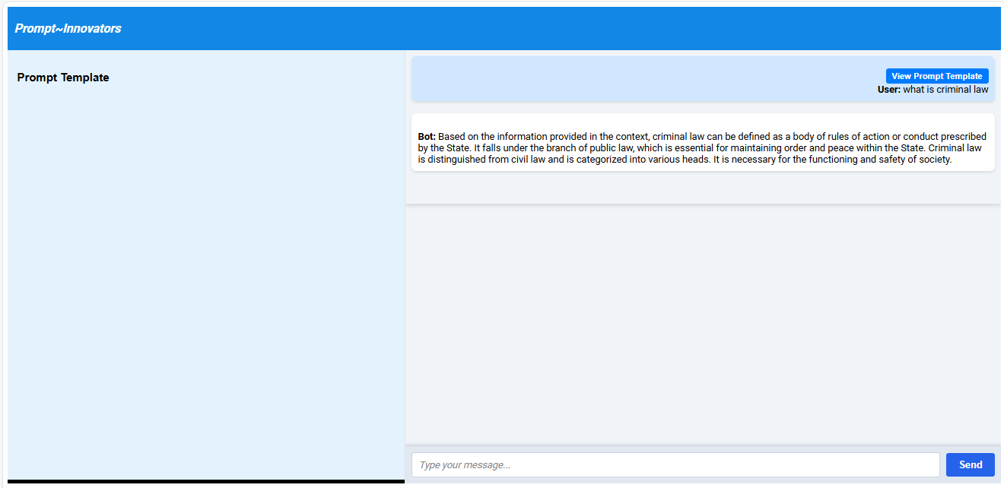

Step 3: After clicking the **View Prompt Template** button, you can see and download the exact prompt template that was used to generate the response.

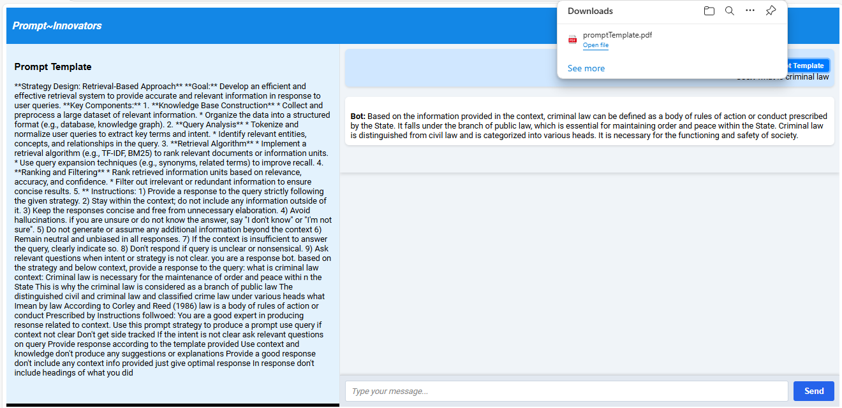

**Why Use the Prompt Innovators Chatbot?**

**Optimized Responses**: Get high-quality prompt templates tailored to your queries, ensuring LLMs provide the best possible answers.

**Seamless Integration:** Easily use these prompts with any LLM of your choice, such as GPT or Gemini.

**Downloadable Templates:** Save or share prompt templates in PDF format for future reference.

**Efficient Workflow**: Improve your workflow by generating templates that are compatible with a wide range of LLMs, speeding up your interaction with AI tools.