**ALGORITHM:**

Only the following numbers are supposed to be checked:

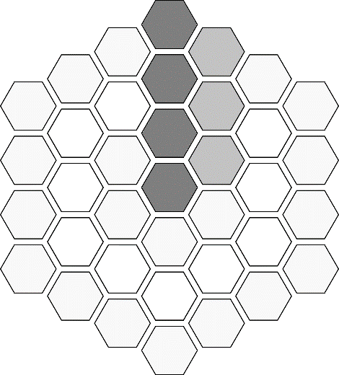

The ones with dark grey will cause only these to be checked for prime-ness:

$$k^{th} ⟶ {\left(k+1\right)}^{th}-1, {\left(k+1\right)}^{th}+1, {\left(k+2\right)}^{th}-1$$

The ones with light grey will cause only these to be checked for prime-ness:

$$k^{th}-1 ⟶ {\left(k-2\right)}^{th}, {\left(k-1\right)}^{th}, {\left(k+1\right)}^{th}-2$$

**WHY NOT TO CHECK OTHER TILES:**

Before we begin, note that for any tile, there are only 4 neighbor tiles that can ever give primes and they only lie on either the above ring or the below ring. The only exception to this is the last tile in any ring (or the right tile to the first tile in any ring).

**ELIMINATION 1:**

First we eliminate tiles which don’t lie on vertices of hexagonal rings. That means these ones:

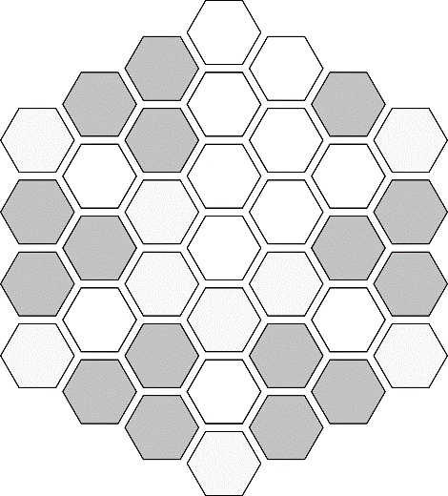

They can never give primes because they will always have two neighbors in below ring and two neighbors in above ring. The exception to this is the last tile in any ring (which has been marked with valid tiles in above image).

**ELIMINATION 2:**

These lines of tiles:

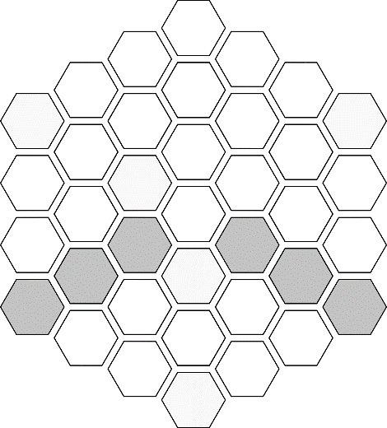

can be eliminated by following argument:  
Since the first tile in any ring is an even number, the numbers in these tiles will also be even because they are obtained by adding $r$ two times and four times for $r^{th}$ ring. Thus for any such tile, the tile below it will also be even and thus will be unable to give any prime. And the three above tiles can at max give 2 primes, thus these tiles can never give 3 primes.

**ELIMINATION 3:**

These lines of tiles:

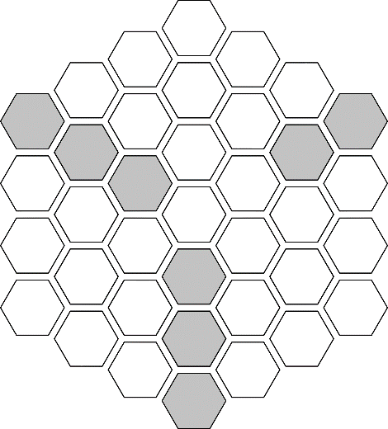

can be eliminated by following argument:  
If there’s an even number in a tile, then the one below it and the one above it will be odd. Thus the adjacent tiles to above one will be even and thus unable to give prime. So only immediate above and below tiles can give primes. Thus these tiles can never give 3 primes. Similar argument goes for a tile with odd number in it.